Intelligibility in multiword utterances in children with cerebral palsy

**Research questions**. Children with cerebral palsy (CP) commonly have a speech-motor disorder (*dysarthria*) with speech-subsystem impairments that can be observed and described. But this kind of description does not reveal how *functional* a child’s speech is for communication. *Intelligibility* measures the degree to which a listener can recover a speaker’s intended message, so it provides a practical measure of speech communication. For this study, we examined growth in intelligibility in multiword utterances from age 2 to age 8 and compared how developmental trajectories among children with CP differed across three speech-language profiles.

**Methods**. Data were collected as part of an ongoing longitudinal study. Children with CP visit the lab for data collection twice annually and complete a battery of speech and language assessments. Participants ranged in age from 24 to 96 months old, averaging 7.9 visits per child (SD: 2.3, range: 2–12). Prior work from our group has found three useful clinical profile groups in children with CP: no speech-motor impairment (NSMI), speech-motor impairment with typical language comprehension (SMI-LCT), and speech-motor impairment with impaired language comprehension (SMI-LCI). Children were classified into these profiles using data from their 48-month visit (or the earliest visit after 48 months): group counts were 22 NSMI, 25 SMI-LCT, 18 SMI-LCI.

Children completed a repetition task where they had to repeat recorded prompts in a structured elicitation task. The prompts ranged in length from 2 to 7 words with 10 prompts used for each length. Unfamiliar listeners transcribed the children’s utterances; they were played the productions and instructed to type out the words the child said. Every child’s visit had transcriptions by two listeners; each listener only heard the productions from a single visit. Therefore, 513 visits had 1026 unique listeners. A child’s intelligibility for a visit was the percentage of words correctly identified by listeners.

**Analysis and Results**. We used a Bayesian nonlinear mixed-effects beta regression model to estimate how the percentage of intelligible words changed with age. We modeled growth with a logistic curve using three parameters: asymptote, midpoint when growth is steepest, and scale which sets the curve’s slope. (See Figure 1.) These parameters can quantify group-level and individual differences in developmental trajectories. For the beta regression, we estimated a separate error (volatility) parameter for each group. Figure 2 shows raw data, and Figure 3 shows each child’s posterior median growth curve.

The estimated average asymptotes for each group were: NSMI, 86.5%, 95% CI [78.7%, 91.8%]; SMI-LCT, 74.8% [60.8%, 86.1%]; SMI-LCI, 67.7% [49.2%, 83.3%]. The SMI-LCI group had the lowest asymptote; the probability of an LCT group advantage over the LCI group, P(LCT−LCI > 0), was .76. The estimated average midpoints for each group were: NSMI, 39.8 months [35.5, 43.8]; SMI-LCT, 53.0 [48.0, 58.0]; SMI-LCI, 53.9 [45.5, 63.7]. Children without dysarthria had their period of sharpest growth at least a year ahead of their peers with dysarthria, NSMI−SMI-LCT = −13.2, [−18.5 −7.9].

**Implications**. The speech-language profiles used were designed to reflect information available to a speech pathologist assessing a four-year-old. Even though children with CP showed highly variable patterns of development, speech-language profiles captured some developmental similarities. Children without dysarthria develop earlier and reach a higher estimated intelligibility than their peers with dysarthria. Children with dysarthria *and* language impairment have noisier measurements but *probably* have lower intelligibility attainments than their peers. This finding could reflect how language impairment predicts greater overall motor impairment, or perhaps an interaction of speech and language on this task. (That is, impaired language might predict lower verbal working memory which makes repetition harder.) We will discuss further implications about when, developmentally, treatment might be most effective.

[599 words]

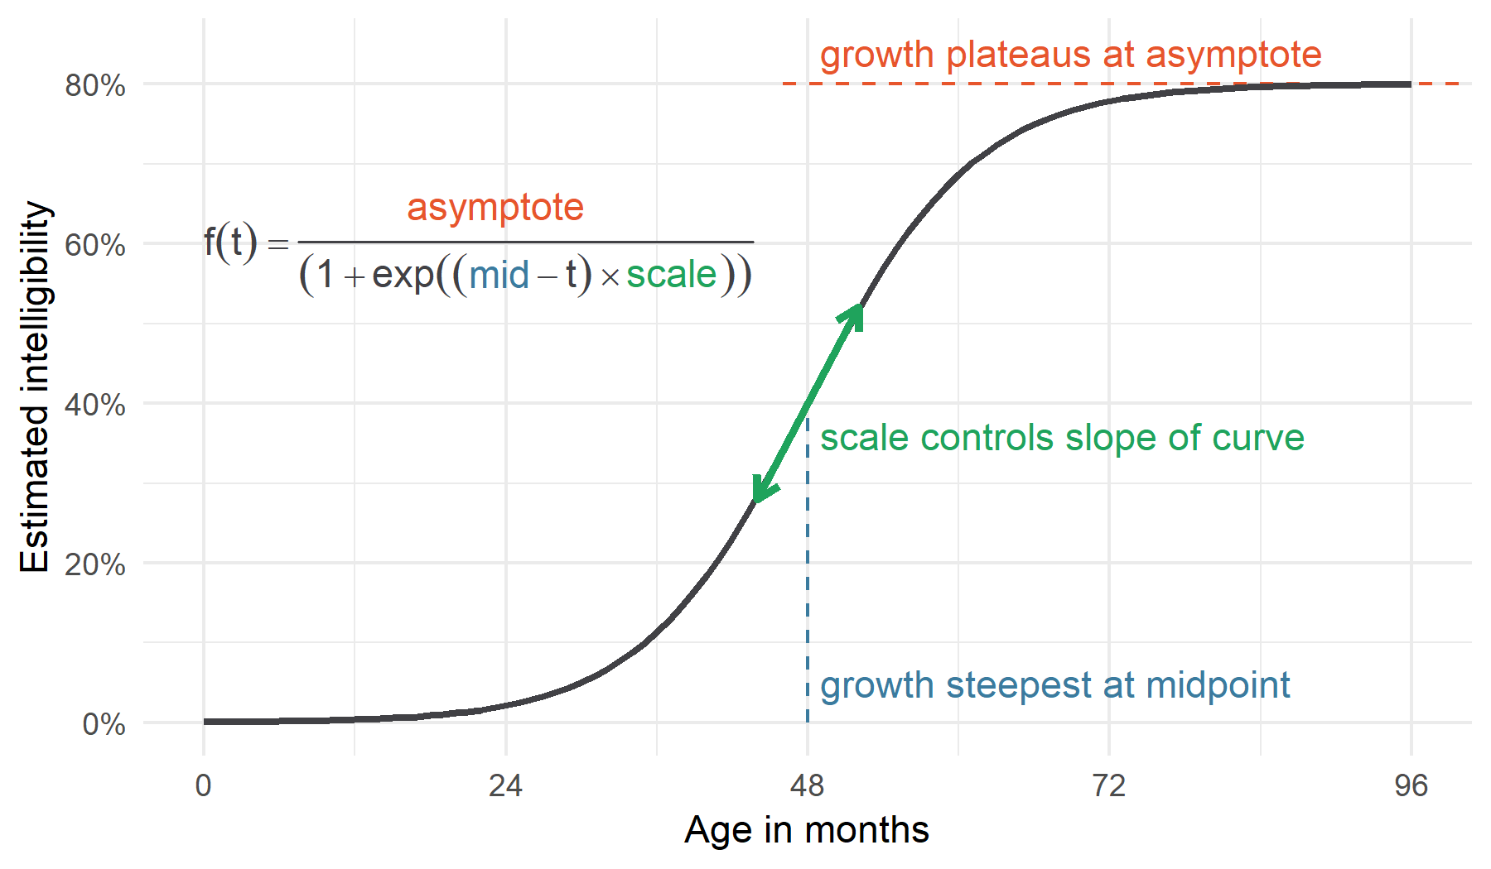

*Figure 1.* Logistic curve used to estimate development. We expected children to follow a certain developmental trajectory: Begin at zero intelligibility, show a period of accelerating then decelerating growth, and finally plateau at some level of ability. This pattern of growth can be modeled using a logistic growth curve using three parameters: an asymptote, a midpoint when growth is steepest, and a scale which sets the slope of the curve. This curve is flexible enough to capture many patterns—for example, sudden growth (sharp slope), delay (later midpoint), or no change at all (low asymptote)—so these parameters provide a way to estimate group-level and individual differences in developmental trajectories.

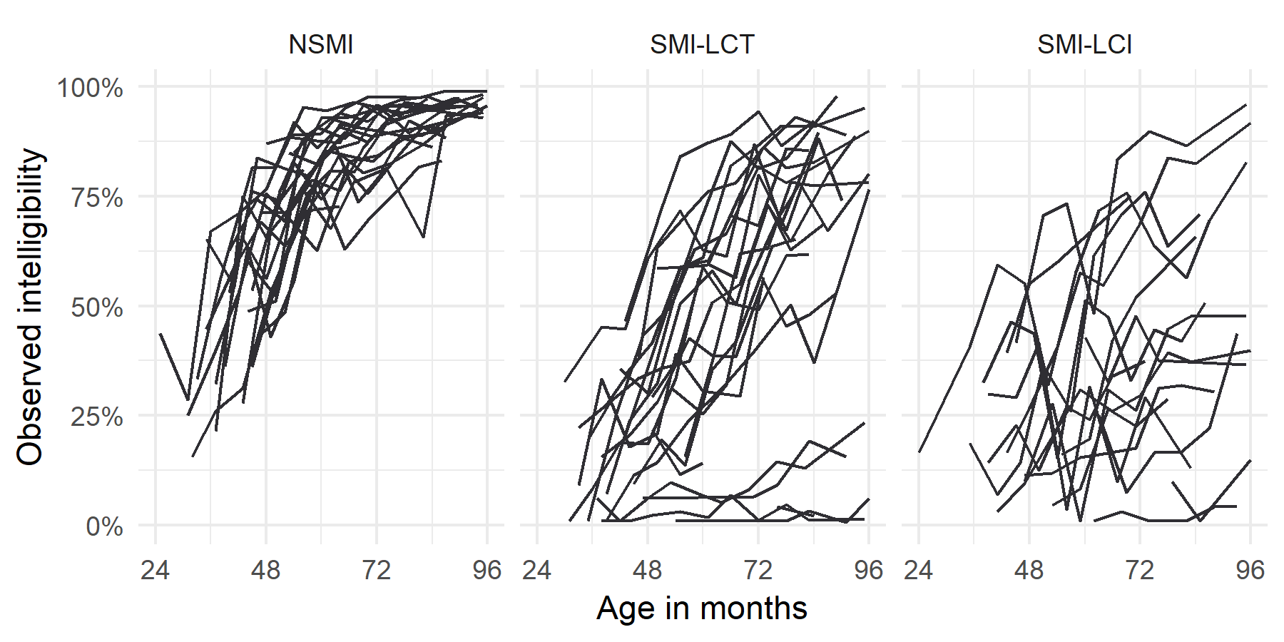

*Figure 2.* Observed intelligibility scores for each speech-language profile. Two things to note are heterogeneity of trajectories in each group and the volatility of the measurements—for instance, sometimes a line drops before rising again.

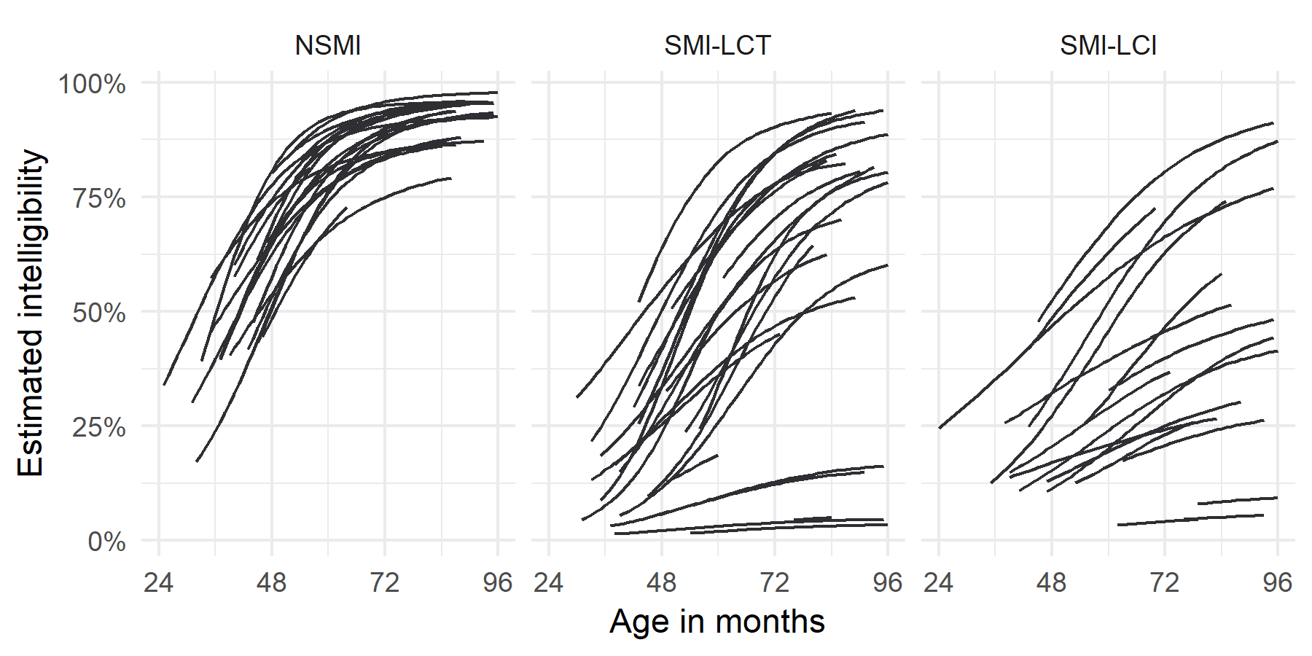

*Figure 3.* Estimated intelligibility trajectories for each speech-language profile. The model-derived trajectories preserve the heterogeneity in each panel but account for the volatility of the measurements to show the underlying developmental pattern.