MP_NORMING
CLOSED SET – TEST B
Total Correct:
SCORE SHEET
Research ID: Date:
Examiner’s Initials: Visit: A B C
Let’s play a word game. I’m going to show you some pictures that you’ve seen before. NOW, I want you to POINT to the picture that I say! Ready?

Score | Item | Prompt | Correct Response | Target Type | Incorrect Response
1 0 | 1 | Point to the /ʃæn/.  shan | Reed  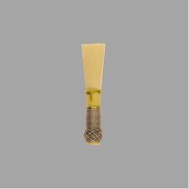 | MP
1 0 | 2 | Point to the /wais/.  “wice” | Anise  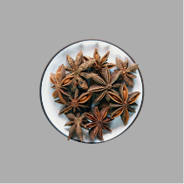 | NW
1 0 | 3 | Point to the /tʃim/.  cheem | Mixer  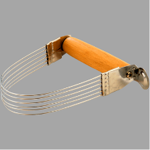 | MP
1 0 | 4 | Point to the /dɝl̩/.  “dirl” | Marmoset  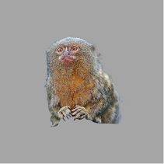 | NW
1 0 | 5 | Point to the /pʌm/.  “puhm” | Churn  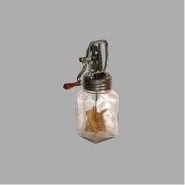 | MP
1 0 | 6 | Point to the /suz/.  “sues” | Flasks  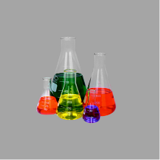 | NW
1 0 | 7 | Point to the /neɪdʒ/.  naydge | Holder  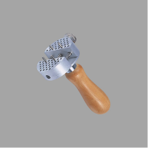 | MP
1 0 | 8 | Point to the /gʌk/.  “guck” | Bull  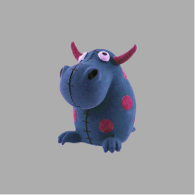 | NW
1 0 | 9 | Point to the /ʃup/.  “shoup” | Steamer  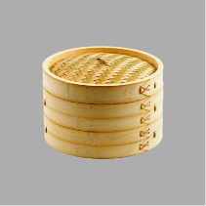 | NW
1 0 | 10 | Point to the /bep/.  bape | Sextant  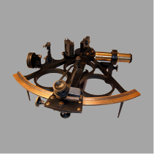 | MP
1 0 | 11 | Point to the /giv/.  geeve | Trolley  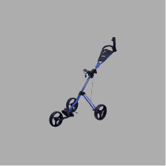 | MP
1 0 | 12 | Point to the /geɪk/.  “gake” | Melon  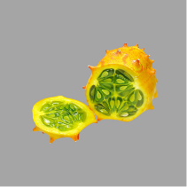  Update: TC/LH_UW 4/4/2015 | NW

