README: Grazioso Salvare Animal Dashboard
CS-340 Project Two
Dashboard by Taylor McDuffie

About the Project
This project is a full-stack dashboard designed for Grazioso Salvare, a company that identifies dogs for rescue training. The dashboard connects to a MongoDB database and enables filtering, visualization, and exploration of animal shelter data from Austin, Texas.

Motivation
Grazioso Salvare needs a visual, easy-to-use interface to help identify dogs suited for various rescue training types. This project enables that goal by allowing users to dynamically filter animals by breed, age, and sex to match desired training profiles.

Tools Used
- Python – General development language
- Dash by Plotly – For building the interactive web dashboard (View + Controller)
- MongoDB – NoSQL document store for animal records (Model)
- Pandas – Data manipulation and conversion for Dash
- Dash Leaflet – Geolocation visualization on map
- Plotly Express – Pie chart visualization

Why MongoDB?
MongoDB was used as the model component because of its document-based storage, flexible schema, and seamless integration with Python via pymongo. Its support for dynamic queries made it ideal for filtering shelter records in real time.

Dash Framework Overview
Dash provided the layout engine (View) and callback system (Controller) needed to build an interactive web app. Components like RadioItems, DataTable, dcc.Graph, and dash_leaflet created a cohesive experience without requiring HTML/CSS.

How to Reproduce the Project
- Launch Apporto and open the Client Server App.
- Upload the following into a project folder:
  - ProjectTwoDashboard.ipynb
  - AnimalShelter.py (CRUD module)
  - logo.png
- Run the Jupyter Notebook and click the Dash link (e.g., 127.0.0.1:27629)
- Use the radio buttons to filter rescue types.
- View updated results in the data table, pie chart, and geolocation map.

Functionality & Screenshots
Below are screenshots of each required feature and rescue type.
Unfiltered View:
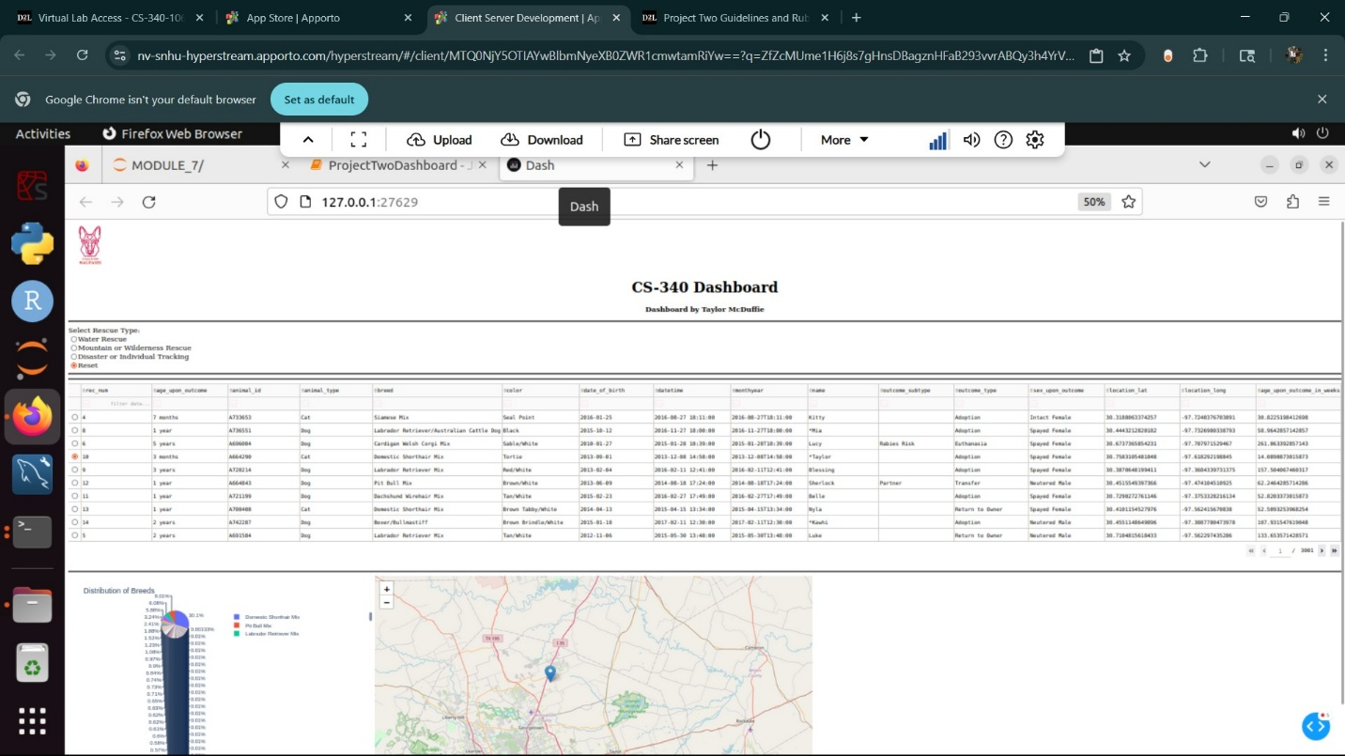
Water Rescue Filtered View:
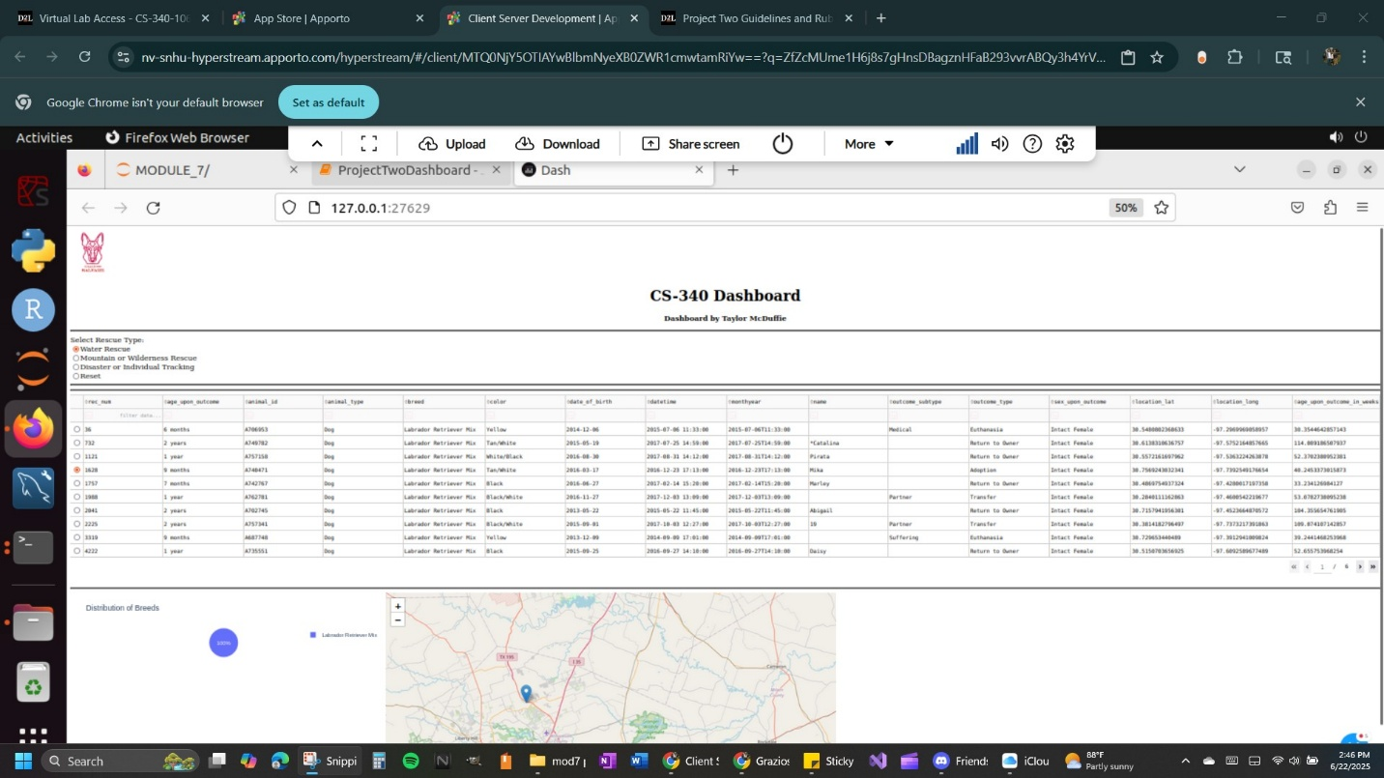
Mountain or Wilderness Rescue View:
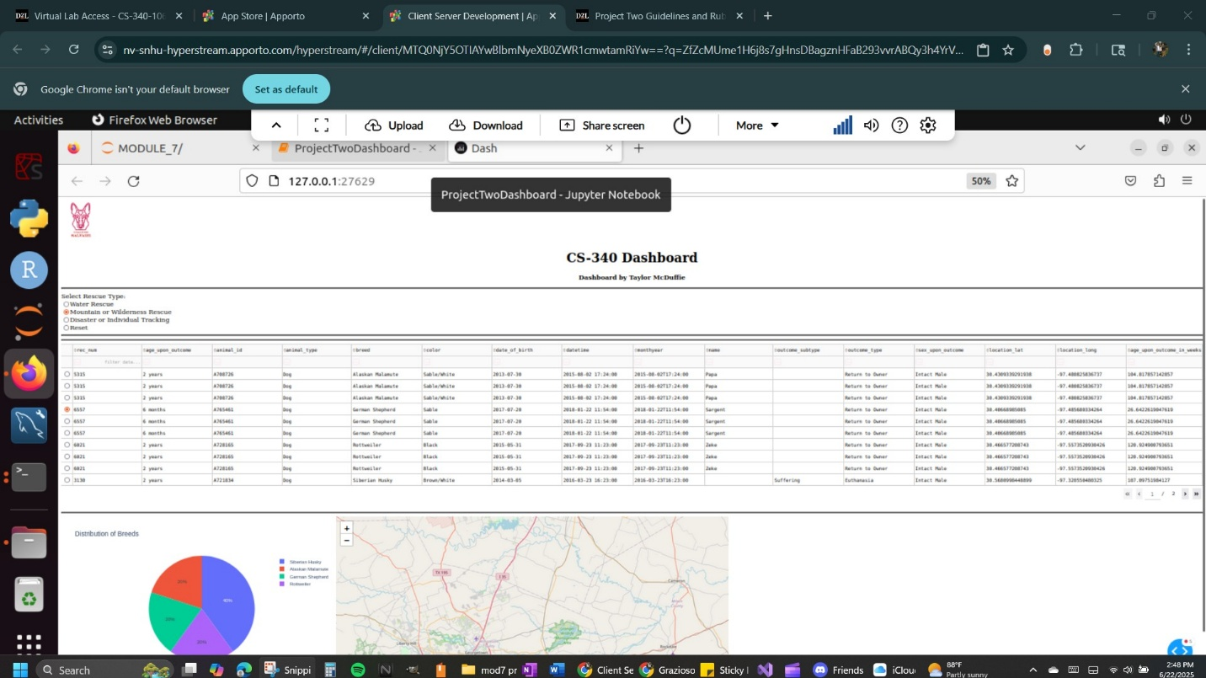
Disaster or Individual Tracking View:
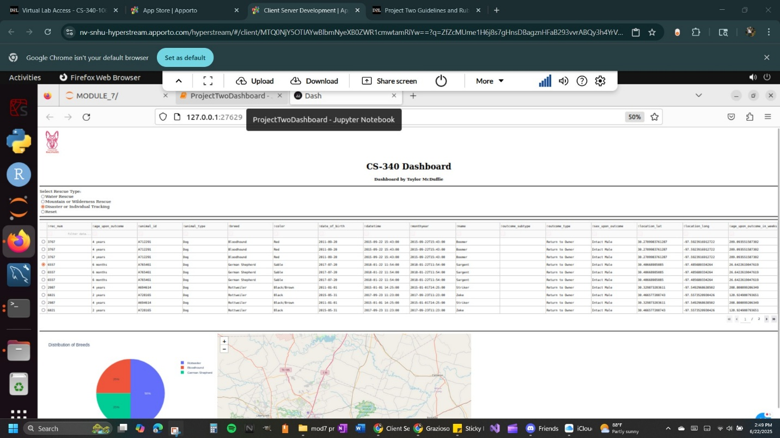
Reset View Again:
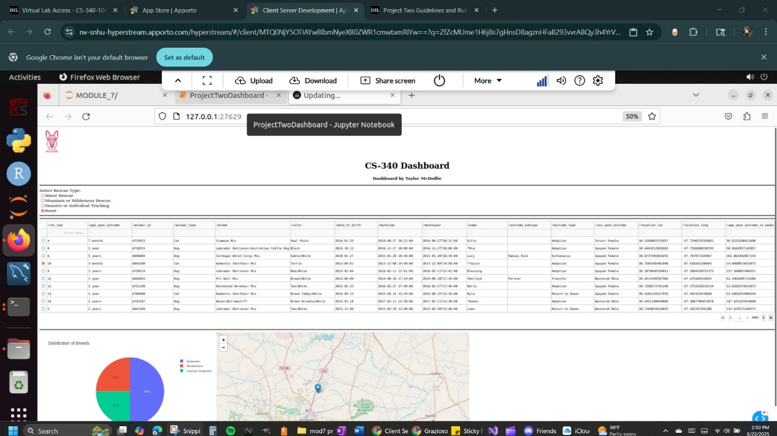

Project Structure
- AnimalShelter.py – Contains all CRUD operations and database connection logic
- ProjectTwoDashboard.ipynb – Main dashboard logic, layout, and controller code
- logo.png – Grazioso Salvare branding
- MongoDB – Stores shelter animal records in document format

Challenges Encountered
- Handling MongoDB _id fields that caused crashes in Dash tables
- Getting filters to return the correct document ranges based on breed, sex, and age
- Ensuring the pie chart and map updated correctly with each selection
Each challenge was resolved through testing queries in isolation, using projection in MongoDB, and adding fallback conditions in Dash callbacks.

Author
Dashboard developed by Taylor McDuffie
CS-340: Client/Server Development

