- I don’t understand the Gillespie algorithm. May be not important, but what is the stochastic model? As a possible user, I would like to see its formulation.
Detail transition. Petri net.

- # Plot the results
# It's not straightforward to see, but there is a green line at I = 0 which accounts for a lot of the trajectories.
I don’t understand. Do you mean green?

- Can we use number of training and validation points as in the deterministic tutorial? If not, ok, but why?
100 is just above the 90=9*100. 10*n is a lower bound. Less than that is a problem.
Can change number of replicates (to show that hmer deals with that)
Different reps: var D has extra term on the diagonal that is 0 for infinite reps.

- MaximinLHS vs lhs:randomLHS ? maximinLHS shit with high dimensions

- 50 reps for the training and 100 for the validation set?

- emulator_plot(stoch_emulators$variance$I350, params = c('sigma', 'alpha')) gives a plot with title “Emulator Expectation”, but I think this is confusing if on its own. Maybe Variance Emulator Expectation ?

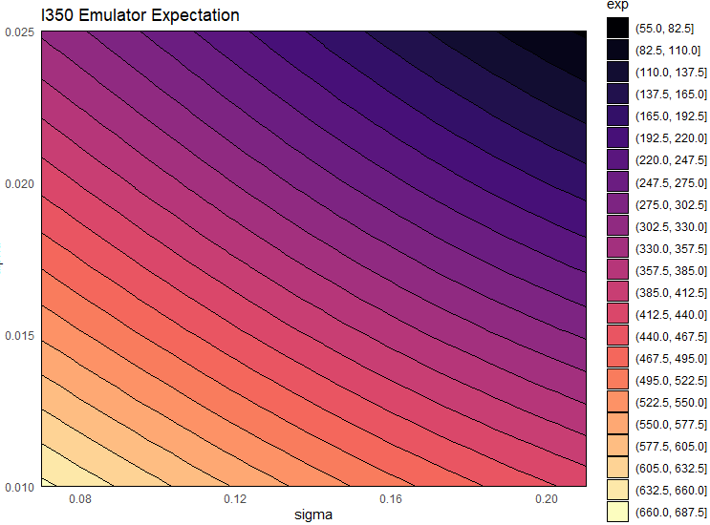

- Similarly, plot(stoch_emulators$expectation$I350, params = c('sigma', 'alpha')) gives “Emulator Expectation”, but maybe we should call it “Mean Emulator Expectation”?
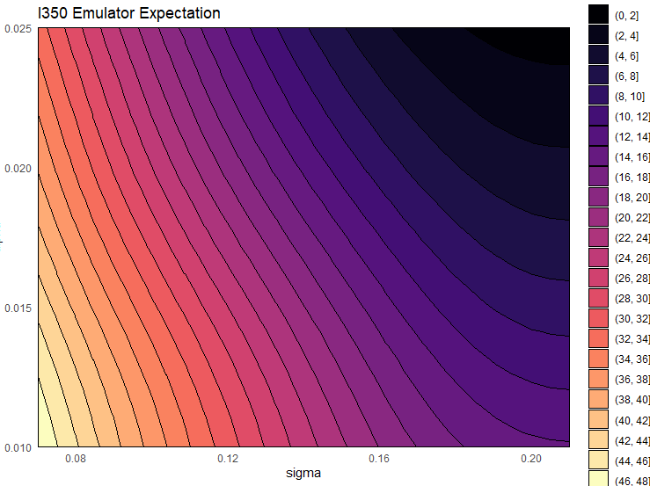
- emulator_plot(stoch_emulators$variance$I350, params = c('sigma', 'alpha'), plot_type = 'var') this gives super huge values…. Weird?
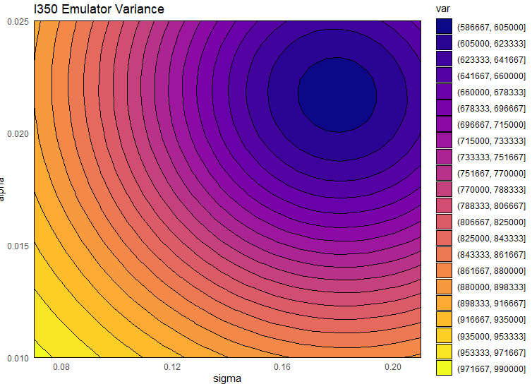

- Emulating the variance is technically the same as the expectation? You just use the various reps at training points to get the variance for each of them. Then use Bayes Linear Updates?
Calculate variance of all training points
Build trained variance emulators.
Now use variance emulators to inform our prior of the sigma

- # To demonstrate an important point: the variance at a 'known' point for the mean
# emulator is NOT zero. This is because the emulators are trying to predict the 'true'
# mean at the point but have only been given a sample mean, so we compensate for this.
How is this compensation done?

- What are we interested in doing? Do we care about the mean? Is the emulator for the mean influenced by the emulator for the variance?

- if we know that a model is expensive to run in some part of parameter space we can do fewer replicates there and the emulators will emulate at that point accordingly.
More on this?

- ## Unsurprisingly, the diagnostics are not great at later times.
Actually they are all good. Also the one for R450.
What is the use of targets in diagnostis?
For the emulator and simulator imp

- ## The function determines the bimodal structure across the output space, working# out the proportion of points in each mode. Then it looks at each output on its own,
# and figures out if the output is bimodal. For the ones it doesn't think are bimodal
# it trains stochastic emulators to them; for the ones it does think are bimodal it
# trains an emulator to each mode. It includes unimodal emulators in both the modes,
# so that we can treat a mode in isolation.
What does it mean? How is it done?
3 stages:
- Take all data input and output and do cluster: is there more than one?
- For each output do the same (with all inputs). If the output is not bimodal than normal stoch emulator. If there is bimodality, cluster outputs reps for each input point.
- And then create mode 1 and 2. Then we have two set and train two different emulators.
Point out we should first try stochastic and in case bimodal if we have a reason to think about that bimodality is possible.

- Don’t we care if a point is matched by one of the two modes only and that mode is super unlikely (looking at the proportions)?
Not at present.

- Diagnostics are just for mean? Or also for variance?
We care about diagnostics of the mean (we can do the other we have data)

Not-related to workshop: what if the good space is disconnected? How does it work with restricting the space?
If we have a big big blob and a small one some risk. Evolutionary MC would help.

