# **Wrap-up**

## Lab overview

Let’s do some wrap up tasks the various personas might do after completing the entire set of “core” labs for this workshop.

Note: if you have not completed all the “core” labs in this workshop, doing some of these exercises may not make sense.

## Data Scientist wrap-up



### **Saving an analytics project**

The Data Scientist saves her work by Exporting the project she just worked on to a file on the server in a location that the OS administrators consistently backup.

1. Click Navigation Menu 🢧 My Projects 🢧 CPD Workshop Analytics Project.

Click on the Export to Desktop (up arrow) icon (at the top of the screen).

1. Click the first box to select all the assets and then Export 🢧 Continue export.

1. Click Save file 🢧 OK.

(Note: the file will be in /home/ibmdemo/Download.)

## Data Engineer wrap-up

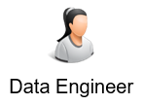

### **Saving a transform project**

The Data Engineer saves her work by Exporting the project she just worked on to a file on the server in a location that the OS administrators consistently backup.

1. Click Navigation Menu 🢧 Organize 🢧 Transform data.

1. Click on CPD_Workshop_Transform_Project.

1. Click ellipses 🢧 Export.

1. Here is where you choose which jobs in the project to Export. You can click them all with the top checkbox. Since there is only one job in this project, checking either box works the same.

Click Export.

1. The export is kicked off in the background. When it finishes, the file will be in /home/ibmdemo/Downloads if you are accessing via remote desktop. If using browser, you can save wherever you wish.
2. Review it in a terminal window.

1. You can also review it in your desktop browser.

## Administrator wrap-up



### **Granting Data Virtualization access**

The Administrator has been asked to open up Data Virtualization capabilities to a trusted user called Data Steward which allows the user to create them himself.

1. The Navigation Menu 🢧 Collect 🢧 Data virtualization.

1. Click the Menu dropdown (which now says: Data sources) 🢧 User management.

1. Click Add users +.

1. Select Name: Data Steward 🢧 Role: Steward 🢧 Add.

### **Environment management**

The Administrator may need to reclaim resources for environments that are long running and not in use.

1. Click Navigation Menu 🢧 My Instances.

Click the Environments tab.

1. Here you can delete any runtime environment that has been left running by a user to free up resources on the cluster.

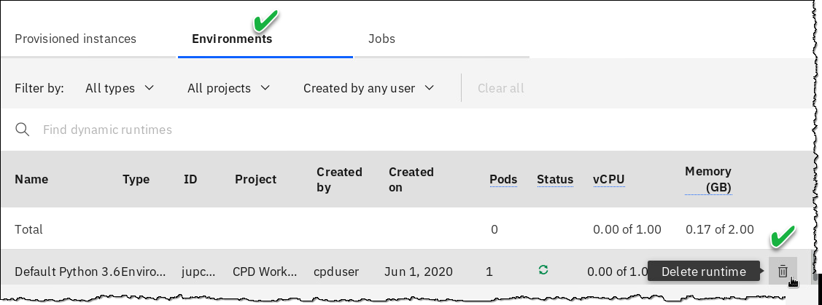

## Workshop conclusion

With this workshop, you can now see how Cloud Pak for Data turns your organization’s data into a critical corporate asset with end-to-end data integration and collaboration on a modern, cloud-native platform.

You have now completed your IBM Journey to Cloud and AI: Analytics Modernization using Cloud Pak for Data.

**\*\* End of Lab 10 - Wrap-up**

Lab by Burt Vialpando and Kent Rubin, IBM