**Hello Docker!!**

Contents

Lab 4 Hello Docker!! 3

4.1 Prerequisites 3

4.2 Setting up your Docker environment 3

4.3 Investigate the Docker Command 4

4.4 Creating a Build file 6

Appendix A. Notices 9

Appendix B. Trademarks and copyrights 11

# Hello Docker!!

This lab is a primer on how to use, build, deploy and run Liberty in a Docker container. In this lab you will pull Liberty from Docker hub, install it, review information about the container, access resources inside the container, add an application then test it.

Please refer to the following table for file and resource location references on different operating systems.

|  |  |  |
| --- | --- | --- |
| Location Ref. | OS | Absolute Path |
| *{LAB_HOME}* | Windows | C:\WLP_<version> |
| Linux | ~\WLP_<version> |
| Mac OSX |  |

## Prerequisites

The following preparation must be completed prior to beginning this lab:

1. Access to the internet and more specifically Docker Hub.
2. Download and install Docker to your machine. Go to <https://www.docker.com/> to get the version for the OS being used.
   1. If you are on Windows, Docker requires you to have Windows 10 installed

## Setting up your Docker environment

Docker has a set of infrastructure that is used to run and manage the Docker containers. When you install the Docker software it creates a daemon, command line tools and a quick start terminal.

1. Open a terminal window and verify that Docker is installed by running:
   1. docker --version

Docker version 1.12.1, build 6f9534c

* 1. docker run hello-world
     1. If it succeeds it will pull down the hello-world:latest confirming that Docker is working properly
     2. If it fails to start, start the Docker daemon

docker: Cannot connect to the Docker daemon. Is the docker daemon running on this host?.

## Investigate the Docker Command

1. Use the images option to find out which Docker images are in the local docker repository
   1. docker images

REPOSITORY TAG IMAGE ID CREATED SIZE

hello-world latest c54a2cc56cbb 11 weeks ago 1.848 kB

1. Investigate the history or layers that make up the container
   1. docker history hello-world

IMAGE CREATED CREATED BY SIZE COMMENT

c54a2cc56cbb 11 weeks ago /bin/sh -c #(nop) CMD ["/hello"] 0 B

<missing> 11 weeks ago /bin/sh -c #(nop) COPY file:21fb0ede514e588c7 1.848 kB

1. Let’s run a Liberty image Docker container. Docker will check if there is an image in the repository. If not it will download the latest image, then run it.
   1. docker run -d -p 9080:9080 --name wlp websphere-liberty

Unable to find image 'websphere-liberty:latest' locally

latest: Pulling from library/websphere-liberty

952132ac251a: Pull complete

cf88eb2790ed: Pull complete

b79bc15ccdb3: Pull complete

26eea697f093: Pull complete

f0772594b736: Pull complete

6d864bbed0dc: Pull complete

7c38edab1e5c: Pull complete

e58a7f9f5b7a: Pull complete

c0b1caf382fe: Pull complete

d43e1f127400: Pull complete

fa192947348f: Pull complete

2830387e6f06: Pull complete

969c2a1fc525: Pull complete

b2de9651a96a: Pull complete

d4d79c7cc2b4: Pull complete

f68a11cc2013: Pull complete

Digest: sha256:ac770677ec1f46f5ebd173d7abfc2b7dd6f431cd4f64d715cce3b328ee6dfdce

Status: Downloaded newer image for websphere-liberty:latest

5e8cf88eb88b747ea69323f0e0197950028f4a74a62e96633e4538cb7c7e2c4d

* 1. Review the Container’s process information:
     1. docker ps

CONTAINER ID IMAGE COMMAND CREATED STATUS

3f5066240ef7 websphere-liberty "/opt/ibm/docker/dock" 9 seconds ago Up 8 seconds

PORTS NAMES

0.0.0.0:9080->9080/tcp, 9443/tcp wlp

* + 1. docker stats

CONTAINER CPU % MEM USAGE / LIMIT MEM %

3f5066240ef7 1.57% 159 MiB / 1.952 GiB 7.95%

NET I/O BLOCK I/O PIDS

648 B / 648 B 0 B / 20.61 MB 111

* + 1. Ctrl + C to stop stats
  1. Open a browser and access <http://localhost:9080>

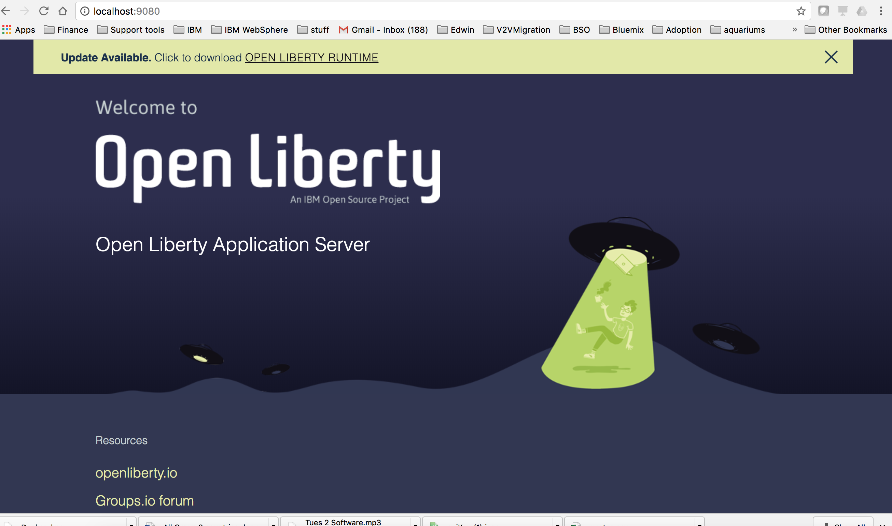

* 1. Look at the logs for the Liberty server running inside the Docker container.
     1. docker logs --tail=all -f wlp

Launching defaultServer (WebSphere Application Server 17.0.0.4/wlp-1.0.19.201712061531) on IBM J9 VM, version 8.0.5.7 - pxa6480sr5fp7-20171216_01(SR5 FP7) (en_US)

[AUDIT ] CWWKE0001I: The server defaultServer has been launched.

[AUDIT ] CWWKE0100I: This product is licensed for development, and limited production use. The full license terms can be viewed here: https://public.dhe.ibm.com/ibmdl/export/pub/software/websphere/wasdev/license/base_ilan/ilan/17.0.0.4/lafiles/en.html

[AUDIT ] CWWKG0093A: Processing configuration drop-ins resource: /opt/ibm/wlp/usr/servers/defaultServer/configDropins/defaults/keystore.xml

[WARNING ] CWWKS3103W: There are no users defined for the BasicRegistry configuration of ID com.ibm.ws.security.registry.basic.config[basic].

[AUDIT ] CWWKZ0058I: Monitoring dropins for applications.

[AUDIT ] CWWKS4104A: LTPA keys created in 1.266 seconds. LTPA key file: /opt/ibm/wlp/output/defaultServer/resources/security/ltpa.keys

[AUDIT ] CWPKI0803A: SSL certificate created in 3.267 seconds. SSL key file: /opt/ibm/wlp/output/defaultServer/resources/security/key.jks

[AUDIT ] CWWKI0001I: The CORBA name server is now available at corbaloc:iiop:localhost:2809/NameService.

[AUDIT ] CWWKF0012I: The server installed the following features: [servlet-3.1, beanValidation-1.1, ssl-1.0, jndi-1.0, jca-1.7, jms-2.0, ejbPersistentTimer-3.2, appSecurity-2.0, j2eeManagement-1.1, jdbc-4.1, wasJmsServer-1.0, jaxrs-2.0, javaMail-1.5, cdi-1.2, webProfile-7.0, jcaInboundSecurity-1.0, jpa-2.1, jsp-2.3, ejbLite-3.2, managedBeans-1.0, jsf-2.2, ejbHome-3.2, jaxws-2.2, jsonp-1.0, el-3.0, jaxrsClient-2.0, concurrent-1.0, appClientSupport-1.0, ejbRemote-3.2, javaee-7.0, jaxb-2.2, mdb-3.2, jacc-1.5, batch-1.0, ejb-3.2, json-1.0, jaspic-1.1, jpaContainer-2.1, distributedMap-1.0, websocket-1.1, wasJmsSecurity-1.0, wasJmsClient-2.0].

[AUDIT ] CWWKF0011I: The server defaultServer is ready to run a smarter planet.

* 1. Ctrl+C to stop the tail

1. Clean up the environment:
   1. First stop the container
      1. docker stop wlp

wlp

* 1. Second remove the container instance
     1. docker rm wlp

wlp

## Creating a Build file

To make the build process repeatable, create a Dockerfile which is the ordering of the layers of the runnable container.

1. Changed directories to {LAB_HOME}/labs/cloud/4_HelloDocker_<timestamp>
2. Investigate the Dockerfile

FROM websphere-liberty

COPY ServletApp.war /config/dropins/app.war

* 1. The first line FROM is the virtual machine image that is to be used. If this is not in the local repository, this will be pulled from Docker Hub.
  2. The second line COPY is a straight copy from the directory that you are running the build into the container at the designated directory.

1. From the 4_HelloDocker directory execute. This will build a template named app from the Dockerfile and place it in the local repository.

docker build -t app .

Sending build context to Docker daemon 12.03 MB

Step 1 : FROM websphere-liberty

---> a33cec241317

Step 2 : COPY ServletApp.war /config/dropins/app.war

---> ea7cb8b12dc2

Removing intermediate container 770d6a93e2cd

Successfully built ea7cb8b12dc2

1. Run the Docker container. Note you are running this with both HTTP and HTTPS ports.

docker run -d -p 9080:9080 -p 9443:9443 --name=app-instance app

73b1eed3d39c662c1acc231463499330d27ecb9636c5842f10aa87895a2fae5e

1. Open up a browser and enter <http://localhost:9080/app/>

Note: if this doesn’t render, there might be a port conflict from an earlier lab. Check that all servers are terminated on the machine.

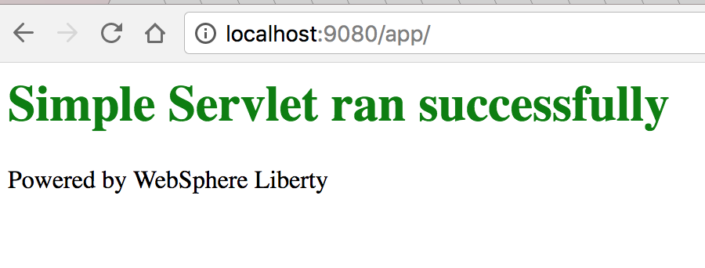

1. Open up a browser and enter <https://localhost:9443/app/>. Notice you get that this is a secured connection, so this is SSL.
2. Create a second instance of the same container, but this time make it listen on 9081 and 9444. Note the changes in red

docker run -d -p 9081:9080 -p 9444:9443 --name=app-instance1 app

1. Open a browser and enter <https://localhost:9444/app>. Note they are both running, yet the application server inside the container is using the same port 9080 and 9443

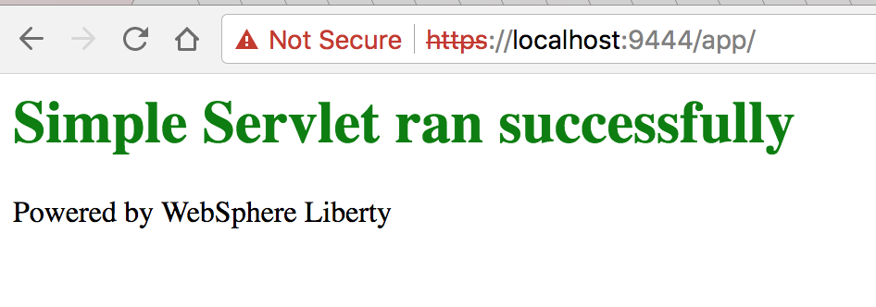

1. List the running containers

docker ps

CONTAINER ID IMAGE COMMAND CREATED STATUS

32c2db743837 app "/opt/ibm/docker/dock" 7 minutes ago Up 6 minutes

73b1eed3d39c app "/opt/ibm/docker/dock" 14 minutes ago Up 5 minutes

PORTS NAMES

0.0.0.0:9081->9080/tcp, 0.0.0.0:9444->9443/tcp app-instance1

0.0.0.0:9080->9080/tcp, 0.0.0.0:9443->9443/tcp app-instance

1. List the images to see that the same images were used for each instance

docker images

REPOSITORY TAG IMAGE ID CREATED SIZE

app latest ea7cb8b12dc2 27 minutes ago 442.8 MB

websphere-liberty latest a33cec241317 2 hours ago 442.8 MB

hello-world latest c54a2cc56cbb 11 weeks ago 1.848 kB

1. Stop the running containers

docker stop app-instance

app-instance

docker stop app-instance1

app-instance1

1. Remove the instances

docker rm app-instance

app-instance

docker rm app-instance1

app-instance1

1. Congratulations you have completed running Liberty in Docker!

1. Notices

This information was developed for products and services offered in the U.S.A.

IBM may not offer the products, services, or features discussed in this document in other countries. Consult your local IBM representative for information on the products and services currently available in your area. Any reference to an IBM product, program, or service is not intended to state or imply that only that IBM product, program, or service may be used. Any functionally equivalent product, program, or service that does not infringe any IBM intellectual property right may be used instead. However, it is the user's responsibility to evaluate and verify the operation of any non-IBM product, program, or service.

IBM may have patents or pending patent applications covering subject matter described in this document. The furnishing of this document does not grant you any license to these patents. You can send license inquiries, in writing, to:

IBM Director of Licensing  
IBM Corporation  
North Castle Drive  
Armonk, NY 10504-1785  
U.S.A.

For license inquiries regarding double-byte (DBCS) information, contact the IBM Intellectual Property Department in your country or send inquiries, in writing, to:

IBM World Trade Asia Corporation  
Licensing  
2-31 Roppongi 3-chome, Minato-ku  
Tokyo 106-0032, Japan

**The following paragraph does not apply to the United Kingdom or any other country where such provisions are inconsistent with local law:** INTERNATIONAL BUSINESS MACHINES CORPORATION PROVIDES THIS PUBLICATION "AS IS" WITHOUT WARRANTY OF ANY KIND, EITHER EXPRESS OR IMPLIED, INCLUDING, BUT NOT LIMITED TO, THE IMPLIED WARRANTIES OF NON-INFRINGEMENT, MERCHANTABILITY OR FITNESS FOR A PARTICULAR PURPOSE. Some states do not allow disclaimer of express or implied warranties in certain transactions, therefore, this statement may not apply to you.

This information could include technical inaccuracies or typographical errors. Changes are periodically made to the information herein; these changes will be incorporated in new editions of the publication. IBM may make improvements and/or changes in the product(s) and/or the program(s) described in this publication at any time without notice.

Any references in this information to non-IBM Web sites are provided for convenience only and do not in any manner serve as an endorsement of those Web sites. The materials at those Web sites are not part of the materials for this IBM product and use of those Web sites is at your own risk.

IBM may use or distribute any of the information you supply in any way it believes appropriate without incurring any obligation to you.

Any performance data contained herein was determined in a controlled environment. Therefore, the results obtained in other operating environments may vary significantly. Some measurements may have been made on development-level systems and there is no guarantee that these measurements will be the same on generally available systems. Furthermore, some measurements may have been estimated through extrapolation. Actual results may vary. Users of this document should verify the applicable data for their specific environment.

Information concerning non-IBM products was obtained from the suppliers of those products, their published announcements or other publicly available sources. IBM has not tested those products and cannot confirm the accuracy of performance, compatibility or any other claims related to non-IBM products. Questions on the capabilities of non-IBM products should be addressed to the suppliers of those products.

All statements regarding IBM's future direction and intent are subject to change or withdrawal without notice, and represent goals and objectives only.

This information contains examples of data and reports used in daily business operations. To illustrate them as completely as possible, the examples include the names of individuals, companies, brands, and products. All of these names are fictitious and any similarity to the names and addresses used by an actual business enterprise is entirely coincidental. All references to fictitious companies or individuals are used for illustration purposes only.

COPYRIGHT LICENSE:

This information contains sample application programs in source language, which illustrate programming techniques on various operating platforms. You may copy, modify, and distribute these sample programs in any form without payment to IBM, for the purposes of developing, using, marketing or distributing application programs conforming to the application programming interface for the operating platform for which the sample programs are written. These examples have not been thoroughly tested under all conditions. IBM, therefore, cannot guarantee or imply reliability, serviceability, or function of these programs.

1. Trademarks and copyrights

The following terms are trademarks of International Business Machines Corporation in the United States, other countries, or both:

|  |  |  |  |  |  |  |
| --- | --- | --- | --- | --- | --- | --- |
| IBM | AIX | CICS | ClearCase | ClearQuest | Cloudscape |  |
| Cube Views | DB2 | developerWorks | DRDA | IMS | IMS/ESA |  |
| Informix | Lotus | Lotus Workflow | MQSeries | OmniFind |  |  |
| Rational | Redbooks | Red Brick | RequisitePro | System i |  |  |
| *System z* | *Tivoli* | *WebSphere* | *Workplace* | *System p* |  |  |

Adobe, the Adobe logo, PostScript, and the PostScript logo are either registered trademarks or trademarks of Adobe Systems Incorporated in the United States, and/or other countries.

IT Infrastructure Library is a registered trademark of the Central Computer and Telecommunications Agency which is now part of the Office of Government Commerce.

Intel, Intel logo, Intel Inside, Intel Inside logo, Intel Centrino, Intel Centrino logo, Celeron, Intel Xeon, Intel SpeedStep, Itanium, and Pentium are trademarks or registered trademarks of Intel Corporation or its subsidiaries in the United States and other countries.

Linux is a registered trademark of Linus Torvalds in the United States, other countries, or both.

Microsoft, Windows, Windows NT, and the Windows logo are trademarks of Microsoft Corporation in the United States, other countries, or both.

ITIL is a registered trademark, and a registered community trademark of The Minister for the Cabinet Office, and is registered in the U.S. Patent and Trademark Office.

UNIX is a registered trademark of The Open Group in the United States and other countries.

Java and all Java-based trademarks and logos are trademarks or registered trademarks of Oracle and/or its affiliates.

Cell Broadband Engine is a trademark of Sony Computer Entertainment, Inc. in the United States, other countries, or both and is used under license therefrom.

Linear Tape-Open, LTO, the LTO Logo, Ultrium, and the Ultrium logo are trademarks of HP, IBM Corp. and Quantum in the U.S. and other countries.



© Copyright IBM Corporation 2018.

The information contained in these materials is provided for informational purposes only, and is provided AS IS without warranty of any kind, express or implied. IBM shall not be responsible for any damages arising out of the use of, or otherwise related to, these materials. Nothing contained in these materials is intended to, nor shall have the effect of, creating any warranties or representations from IBM or its suppliers or licensors, or altering the terms and conditions of the applicable license agreement governing the use of IBM software. References in these materials to IBM products, programs, or services do not imply that they will be available in all countries in which IBM operates. This information is based on current IBM product plans and strategy, which are subject to change by IBM without notice. Product release dates and/or capabilities referenced in these materials may change at any time at IBM’s sole discretion based on market opportunities or other factors, and are not intended to be a commitment to future product or feature availability in any way.

IBM, the IBM logo and ibm.com are trademarks of International Business Machines Corp., registered in many jurisdictions worldwide. Other product and service names might be trademarks of IBM or other companies. A current list of IBM trademarks is available on the Web at “Copyright and trademark information” at www.ibm.com/legal/copytrade.shtml.

