

COMPUTER SCIENCE
COURSEWORK
[Protein Folding Application]
Tristan Mesdaghi
tjmesdaghi@hotmail.com

Contents
Analysis 2
Interview 3
Evidence of analysis 5
Objectives 7
Modelling 15
Evaluation 22
Design 24
References 54
Testing 55
Technical Solution 57

Analysis

Background and introduction
I intend on designing a program for generating 3D images of polypeptides showcasing bonds between amino acids, there are several key considerations to address. Currently, there is a need within the scientific community for a more efficient method of visualizing polypeptide structures and their constituent amino acids. Traditional methods, such as manual drawing or basic computer graphics, lack the sophistication and flexibility required to accurately represent these complex molecular structures.
My program aims to revolutionize the visualization process by providing a comprehensive and user-friendly platform for generating high-fidelity 3D images of polypeptides. This program will not only facilitate the visualization of individual polypeptide chains but also allow for the depiction of intermolecular bonds between amino acids, providing invaluable insights into the structural dynamics of proteins.
By leveraging advanced computational algorithms and 3D rendering techniques, my program will enable researchers to create detailed and visually stunning representations of polypeptides with ease. The program will offer features such as customizable viewing angles, adjustable bond lengths, and color-coded representations of amino acids, allowing users to tailor the visualizations to their specific research needs. In order to project these 3D models, I will require a pdb (protein data bank) file to be inputted that contains all the relevant data that will be required for the desired polypeptide/protein
The transition from traditional visualization methods to my program offers numerous advantages. Firstly, it provides a more intuitive and interactive means of exploring polypeptide structures, enhancing understanding and analysis. Additionally, the program's ability to generate 3D images can aid in communication and presentation of research findings, facilitating collaboration and knowledge sharing within the scientific community.
My program represents a significant advancement in the field of molecular visualization, offering researchers a powerful tool for studying and understanding the complex structures of polypeptides. By providing a user-friendly interface, advanced features, and unparalleled accuracy, this program has the potential to revolutionize the way scientists approach the visualization of protein structures.
I intend for my end user to be my biology teacher, Ben Newell as he has had experience with protein folding program simulations.

Interview
Q1. Are there additional interactive elements or functionality’s you would like to see implemented, and what would they be?
A1. I would like the ability to, when the pdb file has been inputted, to press a button that will then open a new window with the initially inputted 3D image of the polypeptide and the user will then be capable of rotating the polypeptide
Objective 1: create a new button on the main form that will be labelled with the string “full screen 3D model” that when clicked will open the polypeptide in a new window and will allow the user to rotate the polypeptide
Q2. Are there any other forces of attraction between amino acids that you would like the program to display, if so what would they be?
A1. Hydrogen bond formation and allow the program to display the bonds via a different colour than yellow and red
Response: hydrogen bonds require a high amount of different properties that you cannot find in a pdb file thus I am unable to perform this task
Q3. Are there any other ways that the polypeptide and bonds between it could be displayed, if so what would it be?
A1. A 3D scatter graph is the best possible way in my opinion to display the polypeptide and the intermolecular forces within it, anything else would be overly complex or possibly too simple, only thing I can think of is a contact map
A2. A contact map would be incredibly useful as it will be able to provide the user with actual residues that the bonds are being formed between
Objective 1: create a button that will display a contact map via a graph
Q4. What would you like this system to be used on?
A1. Computers and possibly tablets, handheld devices would be too small to display the polypeptide on
Objective 2: only computer functionality will be used, touch screen ability would be too complex to program
Q5. Would a printed output be beneficial, if so why?
A1. A printed output would be especially useful simply for convenience’s sake and due to the fact the user won’t have to open the program and input the desired pdb file every time
Response: virtual basic doesn’t have the ability to print
Q6. What else could be displayed on the program?
A1. A contact map and a 3D model will be perfect
Q7. What is the current system in place and have you got any major problems with it?
A1. Currently, there is a need within the scientific community for a more efficient method of visualizing polypeptide structures and their constituent amino acids. Traditional methods, such as manual drawing or basic computer graphics, lack the sophistication and flexibility required to accurately represent these complex molecular structures.
Objective 3: My program aims to revolutionize the visualization process by providing a comprehensive and user-friendly platform for generating high-fidelity 3D images of polypeptides. This program will not only facilitate the visualization of individual polypeptide chains but also allow for the depiction of intermolecular bonds between amino acids, providing invaluable insights into the structural dynamics of proteins.
Q8. Are there any other values/important aspects of the polypeptide I should display, if so what would they be?
A1. I believe I’ve already mentioned this in a previous answer, yet bond lengths would be perfect but anything other than that would be unnecessary except from possibly the entire length of the polypeptide
Objective 4: create a new method that will extract the entire length of the polypeptide and display it in a text box in the form of the amount of amino acids present in the polypeptide
Q9. Would displaying the length between the amino acids with different units, angstroms are being planned to be used in the program, make it easier to understand?
A1. I don’t believe so, any other unit used will just be unnecessary.
Q10. How can this program be a significant improvement to the current systems that are in place?
A1. Save the initially inputted pdb files in another file and the creation of a new button that displays all the previously inputted pdb files and will display the one the user clicks on
Objective 5: create a new file, preferably in the root of the programs file folder, that will be used to store the whole history of the inputted pdb files and then create a new button labelled “pdb file input history” that when hovering over it will display all the names of the polypeptides inputted beneath it and will then input the pdb file of the polypeptide that the user clicks on

Evidence of analysis

Understanding the PDB File Format
The Protein Data Bank (PDB) file format is widely used to store three-dimensional structures of molecules, particularly proteins and nucleic acids. A PDB file contains detailed information about the atomic coordinates, secondary structure, and connectivity of the biomolecules. The format is text based and consists of several records (lines) with fixed columns specifying different types of information.

Extracting Amino Acid Information from a PDB File
To analyse a polypeptide and identify specific amino acids such as cysteines, you need to parse the PDB file. Each amino acid in a polypeptide is represented by a set of atoms, and these atoms are listed in the PDB file. The records of interest for amino acids typically start with the "ATOM" keyword, followed by columns specifying the atom number, atom name, residue name, chain identifier, residue sequence number, and coordinates.

Understanding and interpreting a contact map
A contact map for amino acids in a polypeptide shows which amino acids are close to each other or in contact within the protein chain. It helps us understand how the different amino acids interact spatially and how their positions relate to the protein's structure and function. By analysing these contacts, scientists can gain insights into the folding, stability, and biological activity of the protein. In my program there are going to be two intermolecular forces that are focused on throughout the whole program, disulphide bridges and salt bridges. On the contact map, the contacts caused by disulphide bridges are going to be represented by a red contact and salt bridges are going to be represented via a green dot

Method that will be used to create the 3D model
The first step in rendering the 3D model on a 2D screen involves using perspective projection. This is a method where 3D coordinates are converted into 2D screen coordinates, creating the effect of depth. I found formulas that scales the X and Y coordinates of each point in the 3D model based on the Z-coordinate (depth). The formulas used are:
𝑥 = ((𝑥 × 𝑠𝑐𝑎𝑙𝑒) ÷ (𝑧 + 𝑓𝑜𝑣)) + (𝑤𝑖𝑑𝑡ℎ ÷ 2)
𝑦 = ((𝑦 × 𝑠𝑐𝑎𝑙𝑒) ÷ (𝑧 + 𝑓𝑜𝑣)) + (ℎ𝑒𝑖𝑔ℎ𝑡 ÷ 2)
This formula was inspired by resources on how 3D graphics are rendered for interactive applications (like those on 3D Math Primer).
To make the 3D model interactive, I will implement rotation transformations based on mouse movement. By applying rotation matrices, I can rotate the model around the X and Y axes. The rotation around the X-axis adjusts the Y and Z coordinates, while the Y-axis rotation affects the X and
Z coordinates. (GeeksforGeeks, 2024)
X-axis rotation: 𝑦′ = 𝑦 × cos(𝑎𝑛𝑔𝑙𝑒𝑋) − 𝑧 × sin(𝑎𝑛𝑔𝑙𝑒𝑋) 𝑧′ = 𝑦 × sin(𝑎𝑛𝑔𝑙𝑒𝑋) + 𝑧 × cos(𝑎𝑛𝑔𝑙𝑒𝑋)
Y-axis rotation: 𝑥′ = 𝑥 × cos(𝑎𝑛𝑔𝑙𝑒𝑌) + 𝑧 × sin(𝑎𝑛𝑔𝑙𝑒𝑌)
𝑧′ = −𝑥 × sin(𝑎𝑛𝑔𝑙𝑒𝑌) + 𝑧 × cos(𝑎𝑛𝑔𝑙𝑒𝑌)
These formulas allow for the interactive rotation of the model as the user drags the mouse.
To visualize the structure, I will implement a method to render the 3D model as a collection of connected points. Each point is rendered as a small circle, and adjacent points are connected by lines, creating a wireframe-like structure. This method is based on techniques I found on Stack
Overflow and other forums discussing 3D graphics in C#, a very similar language to Visual Basic 2022.
(Stack Overflow, 2024)
An interesting feature I added involves highlighting special interactions between amino acids. For example, connections between cysteine residues (CYS) are highlighted with red lines, while other interactions are coloured green. This is based on principles of molecular biology, which I learned about from resources like Biology Stack Exchange. The distances between specific residues are checked, and if they are close enough, the connections are drawn with the appropriate colour. (Biology Stack Exchange, 2024)
Finally, to allow for user interaction, I added mouse events to enable dragging and rotating the model. The mouse movement tracks the difference in position to adjust the rotation angles, updating the model in real-time. This concept is commonly used in interactive graphics applications.
(CodeProject, 2024)

Calculating Distances Between Specific Amino Acids
The Euclidean distance between two atoms is calculated to determine the proximity of cysteine residues and residues responsible for the formation of salt bridges, potentially identifying disulphide bridges. The distance formula is:
Distance = √ ((x₂ - x₁) ² + (y₂ - y₁) ² + (z₂ - z₁) ²)

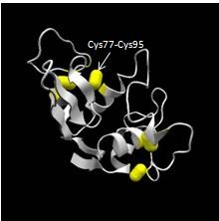
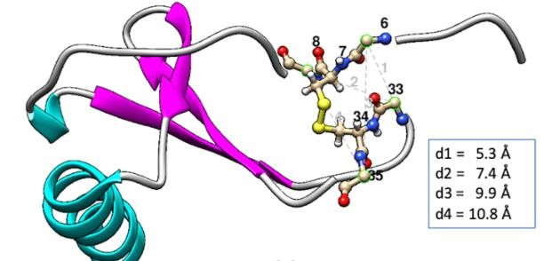
not display them yet, it will
More complex version of the 3d version of the
polypeptide that I will be
displaying yet very similar as it displays the disulphide bridges between
cystines as shown with “Cys77” and “Cys95”
.

This is also a more complex model
yet it does not display the disulphide
bridges between cystine amino
acids, instead it

calculates and

displays the lengths between
specific amino acids, my program
will be doing this yet most likely will
determine if
intermolecular forces
e.g. disulphide bridges will form
between the amino acids.

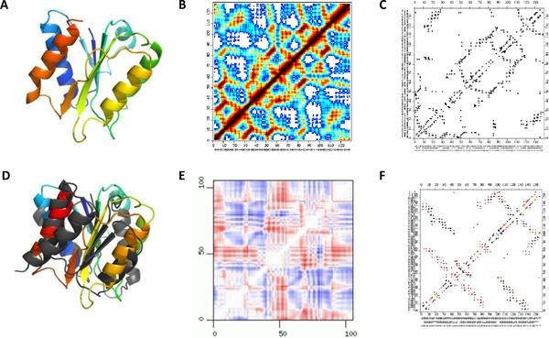
Shown above are 3D models of polypeptides paired with the corresponding contact map. My contact map will display all the bonds that are not caused by disulphide bridges and salt bridges in black and the disulphide bridges in red and the salt bridges in green and will look similar to the images C and F

Objectives
1.RecourcesForPDBFileProcessor Module
1.1. three separate error messages will occur corresponding to the error that occurs if the file was not processed properly
1.1.1. “FileNotFoundException” error, this will output to the user in a message box “ex.Message, "File Not Found", MessageBoxButtons.OK, MessageBoxIcon.Error”
1.1.2. “IOException” error, this will output to the user in a message box “ex.Message, ""An error occurred while reading or writing to the file: " & ex.Message, "IO Error", MessageBoxButtons.OK, MessageBoxIcon.Error”
1.1.3. “Exception” error that covers any other errors that were not the previous two, this will output to the user in a message box “"An unexpected
error occurred: " & ex.Message, "Error", MessageBoxButtons.OK, MessageBoxIcon.Error”
1.2. A two-dimensional list called atomsLinesList is created to store all the lines and words of the PDB file. This list will only contain lines that are relevant to atom details, specifically those starting with the keyword “ATOM.”
1.3. For each line in the file, the method iterates through the entire file, checking if each line starts with “ATOM.” If a line does start with “ATOM,” it is split into individual words. This split is performed using Regex.Split function to handle any whitespace-based separation. Each word in the line becomes a separate element in a temporary one-dimensional list that represents this line.
1.4. Each element of one line is then added to a one-dimensional list called row, which contains all the words in that line. row will typically include atom serial numbers, atom types, residue names, residue sequence numbers, and the x, y, and z coordinates, as well as occupancy and temperature factors, if available.
1.5. row is then added to the two-dimensional list atomsLinesList, which stores all ATOM lines from the PDB file in a structured format. Each entry in atomsLinesList corresponds to one line in the PDB file.
1.6. For each line in atomsLinesList, it will filter out every line that begins with “CA” (carbon alpha atoms of amino acids). Filtering for “CA” lines ensures that only carbon alpha atoms are considered in downstream calculations, as these atoms are often used to represent the backbone structure of a polypeptide in 3D modelling.
1.7. For every line that contains information regarding a carbon alpha residue, the coordinates (x, y, z) are extracted from the respective positions in the line and placed in a two-dimensional list named coordinates. Each entry in coordinates represents the spatial position of a carbon alpha atom in 3D space.
1.8. A one-dimensional list called carbonAlphas is created to store the amino acid type and sequence number for each carbon alpha atom, combining these as a single string in the format “AMINO_ACID_NAME + SEQ_NUMBER” (e.g., “ARG12”). This list provides a straightforward reference for identifying each amino acid by its type and position in the polypeptide chain.
1.9. The total number of amino acids is stored in a variable to be displayed later. This value is determined by counting entries in carbonAlphas and represents the length of the polypeptide sequence.
1.10. A for loop stores each CA pair (e.g., “ARG12”) along with its 3D coordinates (e.g., “23.56, 234.67, 24.67”) in a dictionary called CA_coordinates, where each CA pair is the key and its coordinates are the value. This structure allows quick access to the spatial position of each residue, which is essential for distance calculations.
1.11. Another for loop adds each carbon alpha residue pair to a one-dimensional list called CAcombos. This list provides an easy-to-access sequence of residue pairs, facilitating residue pair processing.
1.12. A for loop calculates Euclidean distances between CA atoms using the formula √((x2 - x1)^2 + (y2 - y1)^2 + (z2 - z1)^2) and stores each calculated distance in a list called distances. This calculation is critical for identifying potential disulfide and salt bridges, as these require residues to be within specific distance ranges. Each entry in distances represents the distance between two specific carbon alpha atoms.
1.13. Another dictionary is created to map CA pairs with calculated distances. Each CA pair, formatted as “RES1_SEQ1_RES2_SEQ2” (e.g., “ARG12_CYS78”), is the key, and the corresponding distance is the value. This dictionary allows for quick lookup of distances between any two residues, which is necessary for identifying bond formation criteria.
1.14. Values are stored in globally accessible dictionaries and lists so they can be accessed by other modules and forms. This step ensures that all extracted data is available for any functions responsible for displaying, analysing, or manipulating the polypeptide structure.
- 3DModelModule
  - first the program will check if there is a contact map present on the form already by checking if a graph is currently on the form and if there is, the program will remove it
  - the length of the amino acid will then be displayed via a label created dynamically
  - the name of the polypeptide will then be displayed via another label created dynamically
  - the panel is then created dynamically
  - all the coordinates that are held in the “coordinates” list are then turned into new 3D points and are added to “carbonAlphaCoords” list
    - the class “Point3D” is created that stores the X, Y and Z coordinates of a point in 3D space
    - a constructor is used to initialize a Point3D instance with given X, Y, and Z values
  - “RotatedCoords” list is created to store the rotated coordinates for rendering after transformations
  - event handlers to enable interactivity for the 3D model are added
    - one that’s triggered when the mouse is clicked
      - this method captures the current mouse position when the mouse button is pressed, the position is stored in “LastMousePos” which is used for tracking drag movements
    - one that’s triggered when the mouse is moved
      - the code will check if the mouse button is held down during the mouse move event
      - the rotation angles based on the mouse movement (vertical movement affects rotation around the x-axis, horizontal movement affects rotation around the y axis)
      - the last recorded mouse position is updated
      - the updated rotations are applied to the 3D model
        - the method “UpdateRotation” is called upon which iterates through each point in the original
“CarbonAlphaCoords” list, the rotation transformation for each point is then applied
2.7.2.4.1.1. the “RotatePoint” method is called
          - the program will convert the X-axis rotation angle and the Y-axis rotation angle from degrees to radians
          - the program will then precompute the sine and cosine values for the X-axis rotation aswell as the Y-axis rotation
          - the program will then rotate around the xaxis using the x-axis rotation matrix:
[ 1 0 0 ]
[ 0 cosX -sinX ]
[ 0 sinX cosX ]
This updates the Y and Z coordinates while keeping X unchanged
          - the program will then rotate around the yaxis using the y-axis rotation matrix:
[ cosY 0 sinY ]
[ 0 1 0 ]
[ -sinY 0 cosY ]
This updates the X and Z coordinates while keeping Y unchanged
          - the program will then return the new rotated point with updated X, Y, and Z coordinates
      - the panel is then requested to repaint itself
    - one that’s triggered when the panel needs to be repainted
      - this method renders the 3D model on the panel using the panels dimensions for scaling and centring
- resourcesForContactMapModule
  - “ContactMapCreation” method will first create a series variable
  - series is added to the contact map chart
  - “ChartPlotter” will be called that will pass in the series variable
  - this method iterate through each key value pair in the “GloballyAccessibleDistDictionary”
  - if the key value pair value (the euclidean distance) is lower than five then the following will occur
  - “parts” variable will split the key where the “_” is e.g. “ASP26_CYS76” would be split into “ASP26” and “CYS76”
  - “XCoString” and “YCoString” will store the corresponding coordinates with number identifiers
  - “AminoAcidNumberX” and “AminoAcidNumberY” will store just the amino acid numbers without the amino acids e.g. “67” using the “.Substring(3)” function
  - both variables are turned into integers via the “Integer.Parse” function
  - program will then check if it is dealing with a Cystine-Cystine bond by checking if “XCoString” and “YCoString” contains “CYS” string using the “.Contains” function
    - if this is the case, red data point will be plotted
  - program will then check if it is dealing with a the bonds responsible for salt bridge formation by checking if “XCoString” and “YCoString” contains “CYS” string using the “.Contains” function by calling the “IsSaltBridge” function that’s in the “ResourcesForProcessingPDBFile” module
    - if this is the case, a green point will be plotted
  - if neither of these are the case, then a black data point is plotted
3.15. “ChartConfiguration” is called that will configure chart area, set axis titles, set grid line colours, set axis ranges and intervals and will refresh chart
- PrimaryDisplayForm
  - InputPDBFile_Click
    - variable string “FileName” is created
    - input box will appear and tell the user to enter the file name then store the answer into the “FileName” variable
    - “ProteinDataBankFileProcessor” method is called passing in and processing the “FileName” variable
  - Generate3DModel_Click
    - “ModelPanelForPrimaryDisplayForm” is cleared
    - iterates through every entity on the form and if a contact map is present, it is removed
    - length of polypeptide label is displayed by adding it to the form
    - name of polypeptide label is displayed by adding it to the form
    - model panel is added to form
    - “ModelCreation” method is called to then display the polypeptide in the panel that was created
  - SaltBridge_Click
    - “ToggleSaltBridge” is called to toggle salt bridges on the polypeptide
  - DisulphideBridge_Click
4.3.2. “ToggleDisulphideBridge” is called to toggle disulphide bridges on the polypeptide
  - ToggleSaltBridge method
    - the method will check if the “ShowSaltBridgesForContactMap” is true, if it is then it will add all the salt bridge points (green points), it will also check which bonds to toggle (either the bonds on the model or contact map) this will be detected by iterating through every entity present on the form and will perform separate instructions depending on which is present
  - ToggleDisulphideBridge method
    - the method will check if the “ShowDisulphideBridgesForContactMap” is true, if it is then it will add all the disulphide bridge points (red points), it will also check which bonds to toggle (either the bonds on the model or contact map) this will be detected by iterating through every entity present on the form and will perform separate instructions depending on which is present
  - GenerateContactMap_Click
    - will check if panel is present on the form, if it is it will then be removed
    - length of polypeptide label is displayed by adding it to the form
    - name of polypeptide label is displayed by adding it to the form
    - chart is added to the form
4.8.5. “ContactMapCreation” is called upon which will display the contact map in the chart that was created
  - FullScreen3DModel_Click
    - “FullScreenModel” form will be shown
  - FullScreenContactMap_Click
    - “FullScreenContactMap” form will be shown
  - ProteinDataBankFileHistory_Click
    - checks if file exists
    - reads all lines in the file
    - it will then display the lines in a new form
      - new form is created to display the history
      - program will then dock a list box to the top of the form
      - the heights for the list box are then set
  - list box is then set up
    - lines are added to the list box
    - list box is then docked to the top of the form
4.12.3. height of list box is then set
  - “OK” button is then set up
    - the button is docked to the bottom of the form
  - handler is then set up for “OK” button
    - program then checks if an item is selected in the list box 4.13.2. the form is then closed after selection
  - “ProteinDataBankFileProcessor” method is then called to process selected pdb file
4.11. CreateButtons
    - following buttons are created: InputPDBFile, GenerateContactMap,
Generate3DModel, ToggleDisulphideBridge, ToggleSaltBridge, FullScreen3DModel, FullScreenContactMap, PDBFileHistory
4.12. PrimaryDisplayForm_Load
4.13.1. “CreateButtons” method is called to create and show buttons on form
- FullScreenContactMap
  - FullScreenContactMap_Load
    - the form will be maximised to make it full screen
    - “ContactMapPanel” is created
    - “ContactMapCreation” method is called upon and passes in “ContactMapChart”
    - “CreateToggleButtons” method is called upon and passes in “ContactMapPanel”
  - CreateToggleButtons
    - “SaltBridgeButton” and “DisulphideButton” are created and displayed on the form
  - ToggleSaltBridgesForContactMap
    - toggles the salt bridges on the contact map
  - ToggleDisulphideBridgesForContactMap
    - toggles the disulphide bridges on the contact map
- FullScreenModel
  - CreateButtons method
  - following buttons are created: ModelPanelForFullScreenModel, SaltBridgeButton, DisulphideBridgeButton
  - ToggleSaltBridges method
    - toggles the salt bridges on the model
6.3. ToggleDisulphideBridges method
6.3.1. toggles the disulphide bridges on the model
6.4. FullScreenModel_Load
    - sets form state to maximised to make it full screen
    - “InitializeComponent” is then called
    - “CreateButtons” method is then called to create buttons and display them on the form
    - “ModelCreation” method is called that will display the 3D model of the polypeptide

Modelling

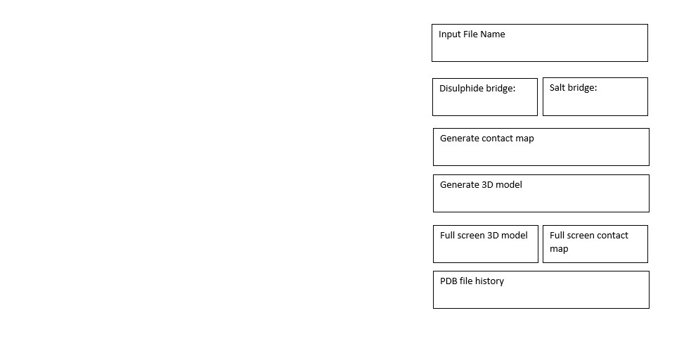
The program presents a form for users to input and analyse a PDB file, offering various options for examining protein structures. The form components include a label, "Input Text File," which prompts users to enter a file name. An input box allows for typing the name or path of the PDB file, and a "Confirm" button validates and processes the input file, updating the 3D graph if the file is valid. The form also includes a "Disulphide Bridge" button for analysing and highlighting disulphide bridges in the protein structure, and a "Salt Bridge" button for toggling salt bridges. Above the 3D graph, updating with the file name once confirmed. The 3D graph, initially empty or displaying a placeholder, updates to show the protein structure upon file confirmation, and is interactive with options to, rotate, and highlight specific bonds. The user interaction flow involves entering the file name and clicking "Confirm," after which the program checks the file and updates the 3D graph if it is valid and when the user presses the “Generate3DModelButton”. Users can then click "Disulphide
Bridge" or "Salt Bridge" to perform specific analyses, which update the 3D graph and label
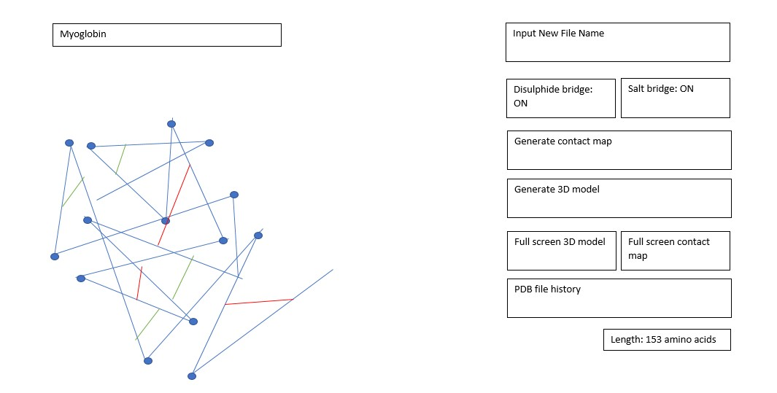

The process remains consistent with the previous method however, in this case, a polypeptide PDB (Protein Data Bank) file has been provided as input. As a result, detailed information about the intermolecular forces presents in the polypeptide structure, including salt bridges and disulphide bridges will be displayed. Additionally, the specific name or identification of the polypeptide will be shown
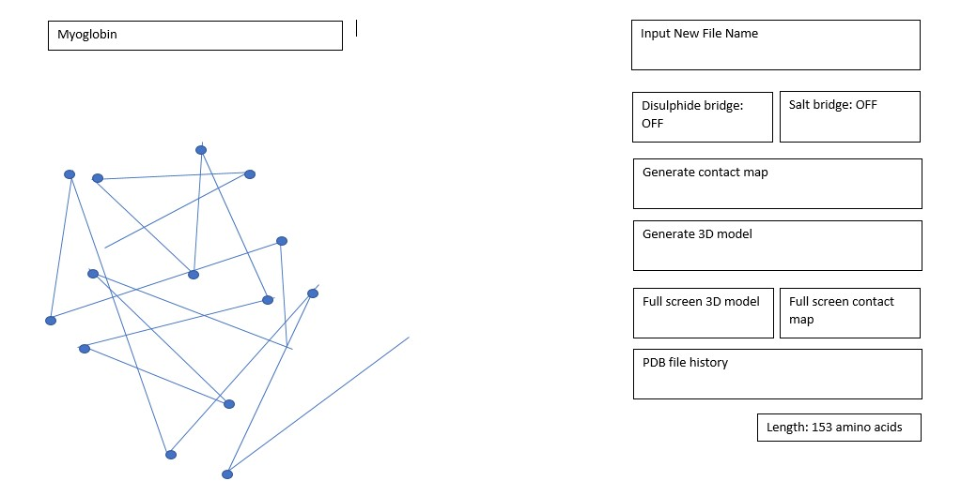

Same as previous model yet both intermolecular forces have been switched off
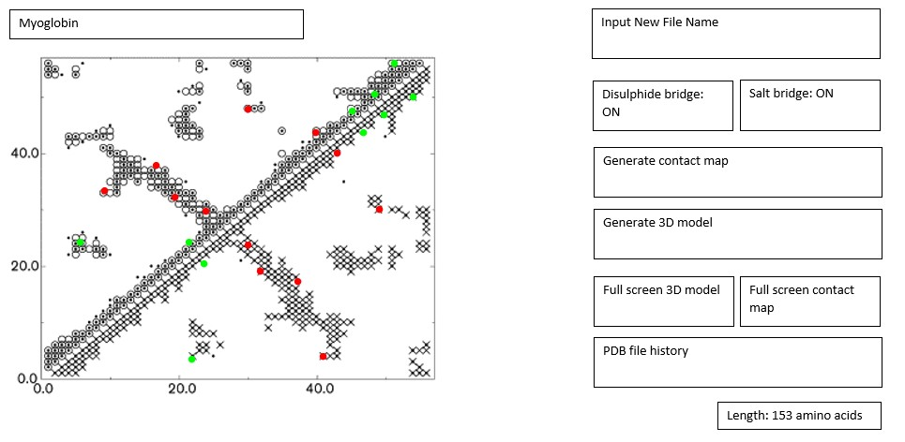
Model of the program if the pdb file “myoglobin” has been inputted and then the user has pressed the button “generate contact map”, the length of the polypeptide is then displayed in the bottom right, the length is displayed if either “generate 3D model” button has been pressed or “generate contact map” button has been pressed
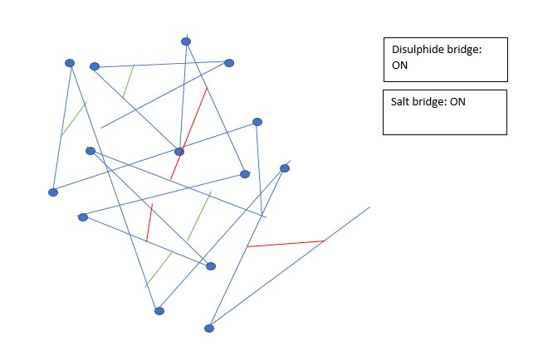
When the “Full screen 3D model” button is pressed it will then present a new window with the polypeptide contained in it that the user can then rotate. The buttons that are used to toggle the bonds are also present on the window
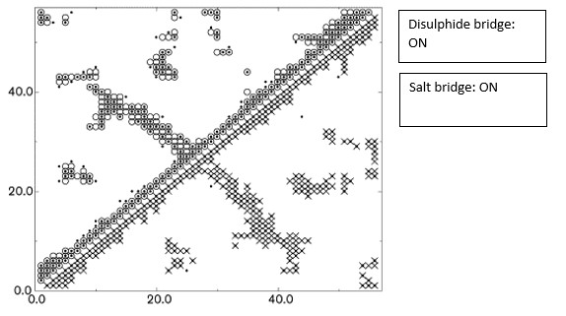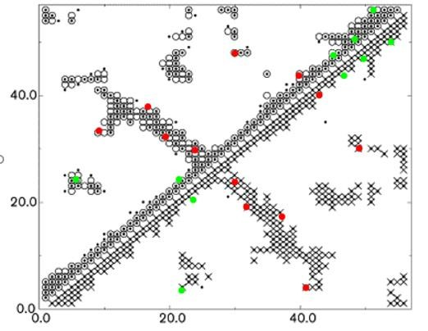
When the “Full screen contact map” button is pressed it will then present a new window with the contact map contained in it to present a larger version of the initial contact map. The buttons that are used to toggle the bonds are also present on the window
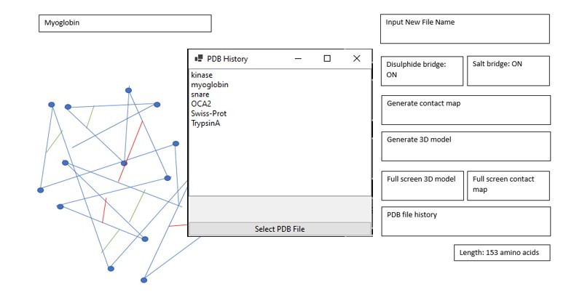
When the “PDB file history” button is pressed, the program will then display a selection box that contains all the previously inputted pdb files and also anything that has been inputted in the past and will allow the user to select one, the “pdb file processor” function is automatically called when a pdb file is selected that (must also be in the correct pdb file format otherwise an error message will be displayed), which will then display the 3D model or the contact map depending on which the user selects.

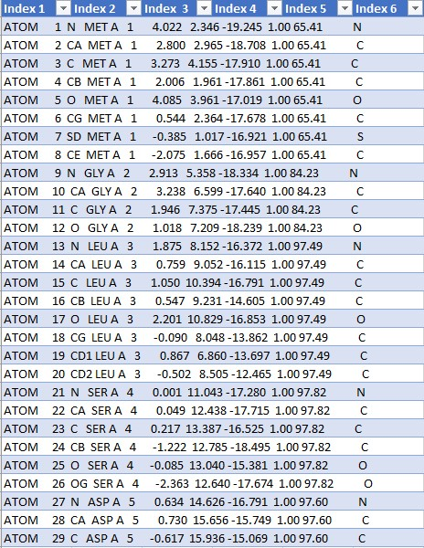
When the pdb file has been inputted it will only extract lines from the file that begin with “ATOM” and place all these lines in a two-dimensional list that will appear as the model above if the contents were outputted. The first column simply states “ATOM” indicating the information on the line is for an atom. Second column indicates the number provided the atom in the sequence of amino acids. Third column contains the type of atom in the amino acid that the information is regarding e.g. N correlates to nitrogen and CA indicates carbon alpha which is the atom I will be working with the most in this project. The column that contains the triplet of decimal numbers e.g. “4.022 2.346 19.245” are the coordinates for the atom in the amino acid, this will be the main data in the pdb file we will be focusing on. All the other information the pdb file holds most likely will not be used in the program. An additional feature of the PDB file will be the name of the polypeptide which will have to be extracted as the name will be displayed
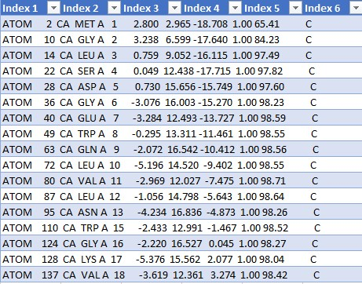

After the program has stored the contests of the pdb file into the list, the program will then extract every single line that contains the phrase “CA” (indicating the information the line contains corresponds to a carbon alpha) and will then place this information in another two-dimensional list. The model above would appear as this list is outputted

List containing all the carbon alpha amino acids
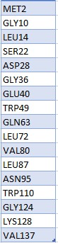

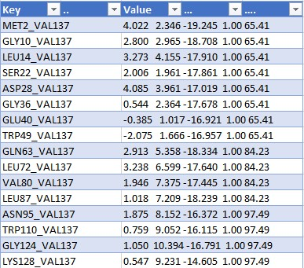

Dictionary containing the coordinates between amino acids (in this case it’s a few of them between VAL137). The key is the two amino acids the program is working with e.g. MET2_VAL137 would be the two amino acids MET2 and VAL137. The value corresponding to the key is the distance between the amino acids stated in the key. The picture above is the model of the dictionary if it was outputted.

Evaluation

Achievements and objectives
I have successfully created a program that is able to produce accurate three-dimensional models of polypeptides when the user inputs the relevant PDB file. I have also granted the user the ability to rotate the polypeptide so specific sections of the polypeptide can be observed and analysed. In addition to this, I have also provided the user with the ability to produce a contact map of the polypeptide. I have also created buttons that will toggle the disulphide and salt bridges. I have been able to complete every single objective I have set myself.

Broad objective 1 – extraction of relevant information from the PDB file
This objective was successful, first I extracted all the lines that begin with the word “ATOM” as that indicates that the information on the line regards a carbon alpha which we will be working with. second, I extracted all the lines that began with “CA” as that indicates that the information that’s on the line regards a carbon alpha which are the residues we are going to be working with to present the polypeptide. The program then maps the carbon alpha residues with the correlated coordinate triplet. The program then calculates the distances between every single CA residue and puts them into a dictionary e.g. “CYS34_ARG45” (key) “45.44” (value)

Broad objective 2 – displaying the polypeptide via a 3D model
Again, this objective was successful; first, I set up two panels for displaying the protein model, one for the main view and another for full-screen visualization. Next, I implemented rotation angles around the X and Y axes, allowing for dynamic manipulation of the protein's orientation. The rotation angles work by adjusting the model based on user input; when you move the mouse while holding down a button, the program captures the change in mouse position and calculates how much to rotate the model.

To perform these rotations, the program uses rotation matrices. For rotation around the X-axis, the matrix is structured to adjust the Y and Z coordinates of the points in the protein model, effectively tilting it up or down. Conversely, for rotation around the Y-axis, the matrix modifies the X and Z coordinates, turning the model left or right. These matrices are defined using trigonometric functions, such as sine and cosine, based on the angle of rotation in degrees. As the user drags the mouse, the program updates these angles in real time, applying the corresponding rotation matrices to the model's coordinates, creating a smooth and interactive experience. The program also tracks the last mouse position, enabling users to easily drag and rotate the model. Overall, this setup allows for an interactive and detailed exploration of protein structures from PDB files.

Broad objective 3 – displaying the polypeptide via a contact map
The program effectively establishes a framework for generating a contact map, focusing on protein interactions. Initially, I configured two Boolean properties to manage the visibility of salt and disulphide bridges, crucial for understanding molecular connections. These properties allow for easy toggling, enhancing user control over the displayed data.

To create the contact map, the ContactMapCreation subroutine is employed. It initializes a new series within the chart, specifically designed to represent interactions between protein residues. The series is set to a point chart type, which visually conveys the data points effectively. The program then utilizes the ChartPlotter to populate this series with relevant interaction points based on a predefined distance threshold.

The ChartPlotter subroutine meticulously examines a global distance dictionary, filtering out entries that exceed a distance of 5 angstroms. This ensures that only significant interactions are visualized, providing a clear representation of the protein's structural relationships. By leveraging this approach, the contact map offers insights into the molecular dynamics and stability, facilitating a deeper understanding of protein behaviour.

Broad objective 4 – primary display form
I have been successful at creating the GUI that includes everything I initially desired, I have achieved this via the creation of objects (via dynamic creation)

layout of the form
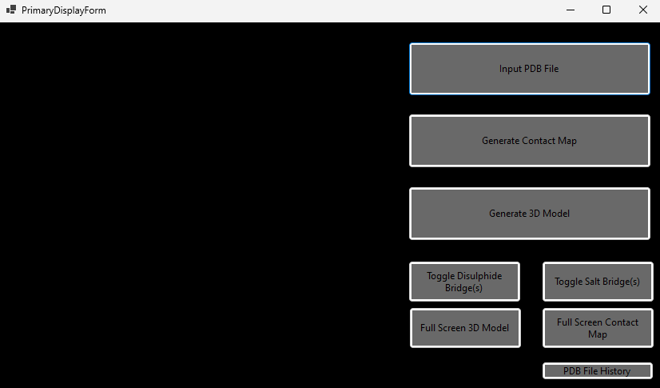

Broad objective 5 – full screen model form
I have been successful at creating the GUI that includes everything I initially desired, I have achieved this via the creation of objects (via dynamic creation)

layout of the form
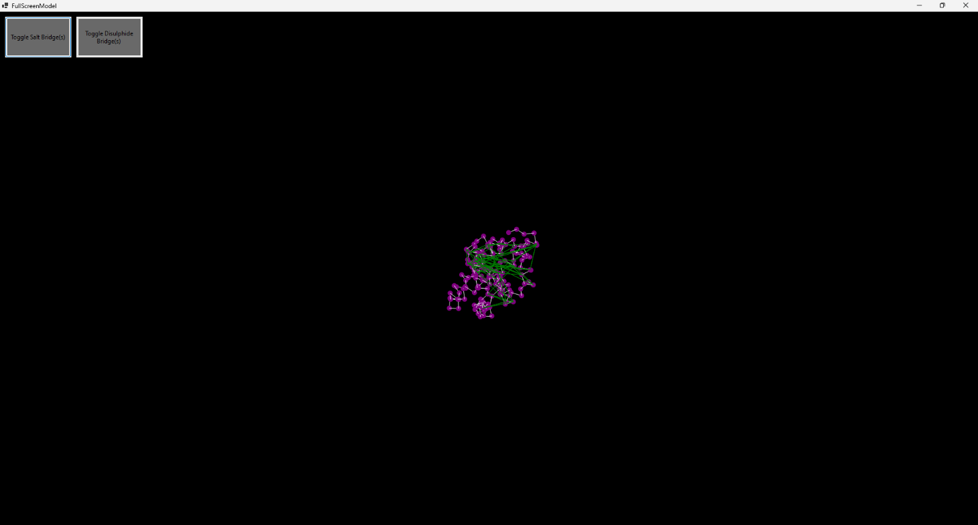

Broad objective 6 – full screen contact map form
I have been successful at creating the GUI that includes everything I initially desired, I have achieved this via the creation of objects (via dynamic creation)

layout of the form
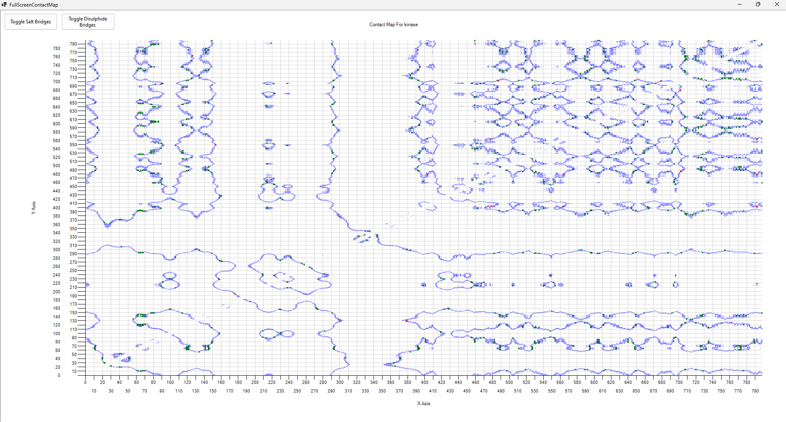

Broad objective 7 – PDB file history form
I have been successful at creating the GUI that includes everything I initially desired, I have achieved this via the creation of objects (via dynamic creation)

layout of the form
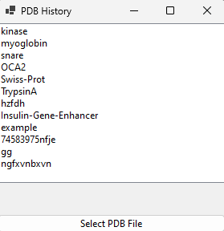

Possible improvements of the program that have been suggested by my end user
I decided to interview my end user with the intention to obtain suggestions on how to further improve my program, here are his suggestions:

Highlight active site of enzymes and provide a suggestion of the possible substrate
This would be incredibly beneficial if my program had the intention on finding possible competitive inhibitors for enzymes

Produce alpha helices or beta plated sheets determined by hydrogen bonds in the secondary structure of the polypeptide
This would show further interactions between the polypeptide and would provide further detail of interactions between the polypeptide

Show the separate amino acid chains formed when the polypeptide if further modified at the golgi
Specific polypeptides (e.g. insulin) are produced as one chain of amino acids (thus does not have a quaternary structure) yet is then transported to the golgi where specific peptide bonds between amino acids are hydrolysed and then forms a quaternary structure and then forms the required shape of the enzyme so it can therefor bind to a specific substrate

Design

Overview
I will be using visual basic 2022 as it has an inbuilt 2d graphics engine for windows forms which I am going to require when rendering the 3D model. It also has an importable NuGet package that will be used when producing the contact map. Modules are also including this language that are going to be essential when grouping methods and variables that will be accessible by the different forms

The primary aspects of the algorithm that require the most attention will be the “PrimaryDisplayForm” which will be able to read and extract information from a protein data bank file and then via button clicks will be able to display these polypeptides via either a contact map with togglable disulphide and salt bridges or a 3D model with a built-in ability to rotate and toggle disulphide and salt bridges

Primary Display Form
This window will be the centre of the program, the first form that will load when the program is ran. It will have an “Input PDB File” button that, when pressed, will prompt the user to enter a PDB file and perform all the necessary error handling while also extracting all the required information from the PDB file and storing them in the correlated variables. “Generate 3D Model” button that, when pressed, will present the 3D model within a panel. “Generate Contact Map” button that, when pressed, will generate the contact map. “Toggle Salt Bridge” button that, when pressed, will toggle salt bridges on and off. “Toggle Disulphide Bridge” button that, when pressed, will toggle disulphide bridge. “Full Screen Contact” that will open a new form that contains a full screen version of the contact map. “Full Screen 3D Model” that will open a new form that contains a full screen version of the 3D model.

Example layout of the form

Full screen model form
This UI will provide the user with the ability to display, rotate and toggle the interactions between amino acids in a full screen form

Example layout of the form

PDBFileHistory form
This form will be produced when the user presses the “PDB file history” button that will contain all the previously inputted files

Example layout of the form

Full screen contact map
This UI will allow the user to display the contact map in a full screen form while also having the ability to toggle to interactions

Example layout of the form

PDB files and PDBFileHistory text file
Files are going to be essential in my program in order to obtain relevant information regarding the polypeptide therefor I will be keeping all the PDB files as well as the PDBFileHistory text file in one folder (named PDBFiles)

Example layout of PDB files and PDBFileHistory text file on the computer
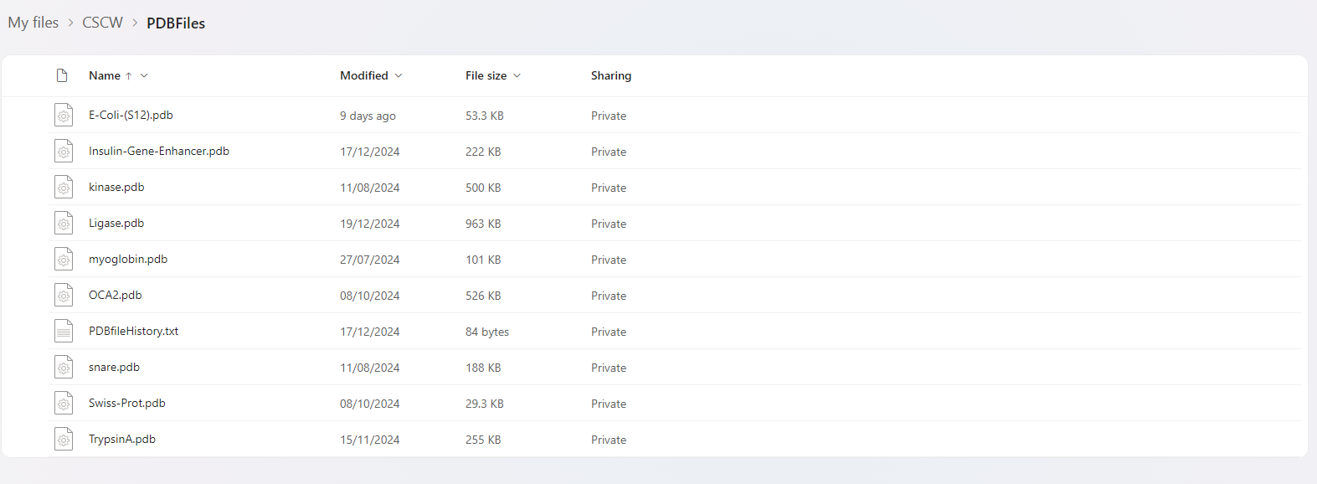

Creation of buttons
A subroutine will be created that will create all required buttons in the primary form named “CreateButtons”

Code
Sub CreateButtons()
// Input PDB File Button
InputPDBFile ← New Button()
InputPDBFile.Name ← "InputPDBFile"
InputPDBFile.Text ← "Input PDB File"
InputPDBFile.BackColor ← ControlDarkDark
InputPDBFile.Size ← (304, 68)
InputPDBFile.Location ← (513, 24)
AddHandler InputPDBFile.Click, InputPDBFile_Click
Add InputPDBFile to Controls

// Generate Contact Map Button
GenerateContactMap ← New Button()
GenerateContactMap.Name ← "GenerateContactMap"
GenerateContactMap.Text ← "Generate Contact Map"
GenerateContactMap.BackColor ← ControlDarkDark
GenerateContactMap.Size ← (304, 68)
GenerateContactMap.Location ← (513, 114)
AddHandler GenerateContactMap.Click, GenerateContactMap_Click
Add GenerateContactMap to Controls

// Generate 3D Model Button
Generate3DModel ← New Button()
Generate3DModel.Name ← "Generate3DModel"
Generate3DModel.Text ← "Generate 3D Model"
Generate3DModel.BackColor ← ControlDarkDark
Generate3DModel.Size ← (304, 68)
Generate3DModel.Location ← (513, 205)
AddHandler Generate3DModel.Click, Generate3DModel_Click
Add Generate3DModel to Controls

// Toggle Disulphide Bridge Button
ToggleDisulphideBridge ← New Button()
ToggleDisulphideBridge.Name ← "ToggleDisulphideBridge"
ToggleDisulphideBridge.Text ← "Toggle Disulphide Bridge(s)"
ToggleDisulphideBridge.BackColor ← ControlDarkDark
ToggleDisulphideBridge.Size ← (141, 52)
ToggleDisulphideBridge.Location ← (513, 298)
AddHandler ToggleDisulphideBridge.Click, DisulphideBridge_Click
Add ToggleDisulphideBridge to Controls

// Toggle Salt Bridge Button
ToggleSaltBridge ← New Button()
ToggleSaltBridge.Name ← "ToggleSaltBridge"
ToggleSaltBridge.Text ← "Toggle Salt Bridge(s)"
ToggleSaltBridge.BackColor ← ControlDarkDark
ToggleSaltBridge.Size ← (141, 52)
ToggleSaltBridge.Location ← (680, 298)
AddHandler ToggleSaltBridge.Click, SaltBridge_Click
Add ToggleSaltBridge to Controls

// Full Screen 3D Model Button
FullScreen3DModel ← New Button()
FullScreen3DModel.Name ← "FullScreen3DModel"
FullScreen3DModel.Text ← "Full Screen 3D Model"
FullScreen3DModel.BackColor ← ControlDarkDark
FullScreen3DModel.Size ← (141, 52)
FullScreen3DModel.Location ← (514, 356)
AddHandler FullScreen3DModel.Click, FullScreen3DModel_Click
Add FullScreen3DModel to Controls

// Full Screen Contact Map Button
FullScreenContactMap ← New Button()
FullScreenContactMap.Name ← "FullScreenContactMap"
FullScreenContactMap.Text ← "Full Screen Contact Map"
FullScreenContactMap.BackColor ← ControlDarkDark
FullScreenContactMap.Size ← (141, 52)
FullScreenContactMap.Location ← (680, 356)
AddHandler FullScreenContactMap.Click, FullScreenContactMap_Click
Add FullScreenContactMap to Controls

// PDB File History Button
PDBFileHistory ← New Button()
PDBFileHistory.Name ← "PDBFileHistory"
PDBFileHistory.Text ← "PDB File History"
PDBFileHistory.BackColor ← ControlDarkDark
PDBFileHistory.Size ← (140, 23)
PDBFileHistory.Location ← (680, 424)
AddHandler PDBFileHistory.Click, ProteinDataBankFileHistory_Click
Add PDBFileHistory to Controls
End Sub

Inputting the Protein Data Bank file
There will be two possible ways of inputting the PDB file in my program, these include:

Inputting via message box (1st method)
When the “Input PDB File” is press, a text box will appear that will prompt the user to enter the file name (program will automatically add the “.pdb” at the end so it is read correctly from the computer), the program will pass the name of the file into the “ProteinDataBankFileProcessor” subroutine in located in the “PDBFileProcesorResorces” module and all the relevant pieces of data required to display the polypeptide and information required to determine intermolecular forces between residues will be extracted and stored in the corresponding variables. (appropriate error detection will also be included)

Code
Private Sub InputPDBFile_Click(sender As Object, e As EventArgs)

FileName ← New String

FileName = InputBox("Please enter file name")

ProteinDataBankFileProcessor(FileName)

End Sub

Inputting PDB file via PDB file history button (2nd method)
When the “PDBFileHistory” button is pressed, a new form will appear that will allow the user to select a previously inputted PDB file, whichever PDB file is selected, the program will pass the name of the file into the “ProteinDataBankFileProcessor” subroutine in located in the “PDBFileProcesorResorces” module and all the relevant pieces of data required to display the polypeptide and information required to determine intermolecular forces between residues will be extracted and stored in the corresponding variables. (appropriate error detection will also be included). Any polypeptides that have not been imputed before will be added to the PDBFileHistory text file

Code
BEGIN ProteinDataBankFileHistory_Click(sender, e)
SET filePath TO "C:\Users\tjmes\OneDrive\CSCW\PDBFiles\PDBfileHistory.txt"

IF filePath does not exist THEN
DISPLAY "The file does not exist."
RETURN

SET lines TO ReadLines(filePath) as List

CREATE PDBFileHistoryForm
CREATE historyListBox
CREATE okButton

historyListBox ADD lines
historyListBox SET DockStyle TO Top
historyListBox SET Height TO 200

okButton SET Text TO "Select PDB File"
okButton SET DockStyle TO Bottom

DECLARE FileName

ON okButton CLICK
IF historyListBox has selected item THEN
SET selectedPDBFile TO selected item from historyListBox
SET FileName TO selectedPDBFile
ELSE
DISPLAY "Please select a file from the history."
CLOSE PDBFileHistoryForm

PDBFileHistoryForm ADD historyListBox
PDBFileHistoryForm ADD okButton

PDBFileHistoryForm SET Title TO "PDB History"
PDBFileHistoryForm SET Size TO (300, 300)
PDBFileHistoryForm SET Position TO CenterParent

DISPLAY PDBFileHistoryForm
CALL ProteinDataBankFileProcessor(FileName)
END

Flow Chart
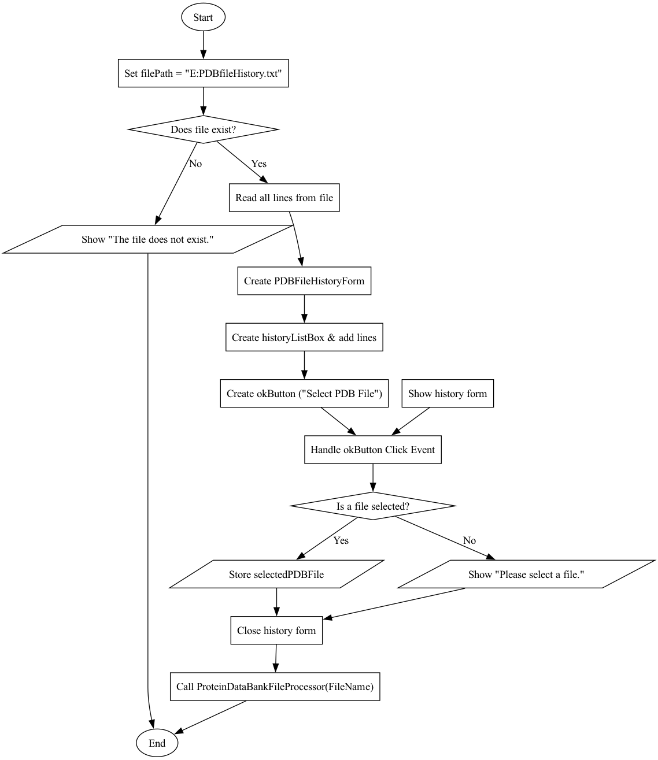

Processing the data within the PDB file
In both cases the “ProteinDataBankFileProcessor” subroutine is called that will first create a list of a list of string (called “PDBFileLinesList”) that will store the lines and words from the PDB file.
Subroutine will then also check if the PDB file has already been inputted previously by iterating through a text file and check if the name of the PDB file is contained within it, if not then the name of the file will be added to the text file, if it is then the name will not be added to the text file.
The program will then iterate through the contents of the PDB file and if the line begins with “ATOM” it will split the line into words and add them to “PDBFileLinesList”
Appropriate error detection will then be coded
“ProcessAtomData” will then be called with the parameter “PDBFileLinesList” being passed in.

Code
Function ProteinDataBankFileProcessor(fileName)
FilePath ← "E:\PDBfileHistory.txt"
PDBFilePath ← ""
PDBFileLinesList ← new List of Lists

Try
If File.Exists(FilePath) Then
fileContent ← ReadAllText(FilePath)
If fileName NOT in fileContent Then
Append fileName to FilePath
End If
Else
ShowMessage("History file does not exist: " + FilePath)
End If

PDBFilePath ← "E:\" + fileName + ".pdb"

If NOT File.Exists(PDBFilePath) Then
Throw FileNotFoundException("PDB file not found at: " + PDBFilePath)
End If

lines ← ReadAllLines(PDBFilePath)

For Each line in lines Do
If line.StartsWith("ATOM") Then
elements ← Split(line, whitespace)
Add elements to PDBFileLinesList
End If
End For

Catch FileNotFoundException ex
ShowMessage(ex.Message, "File Not Found")
Catch IOException ex
ShowMessage("IO Error: " + ex.Message)
Catch Exception ex
ShowMessage("Unexpected Error: " + ex.Message)
End Try

GloballyAccessibleFileName ← fileName
ProcessAtomData(PDBFileLinesList)
End Function

Flowchart
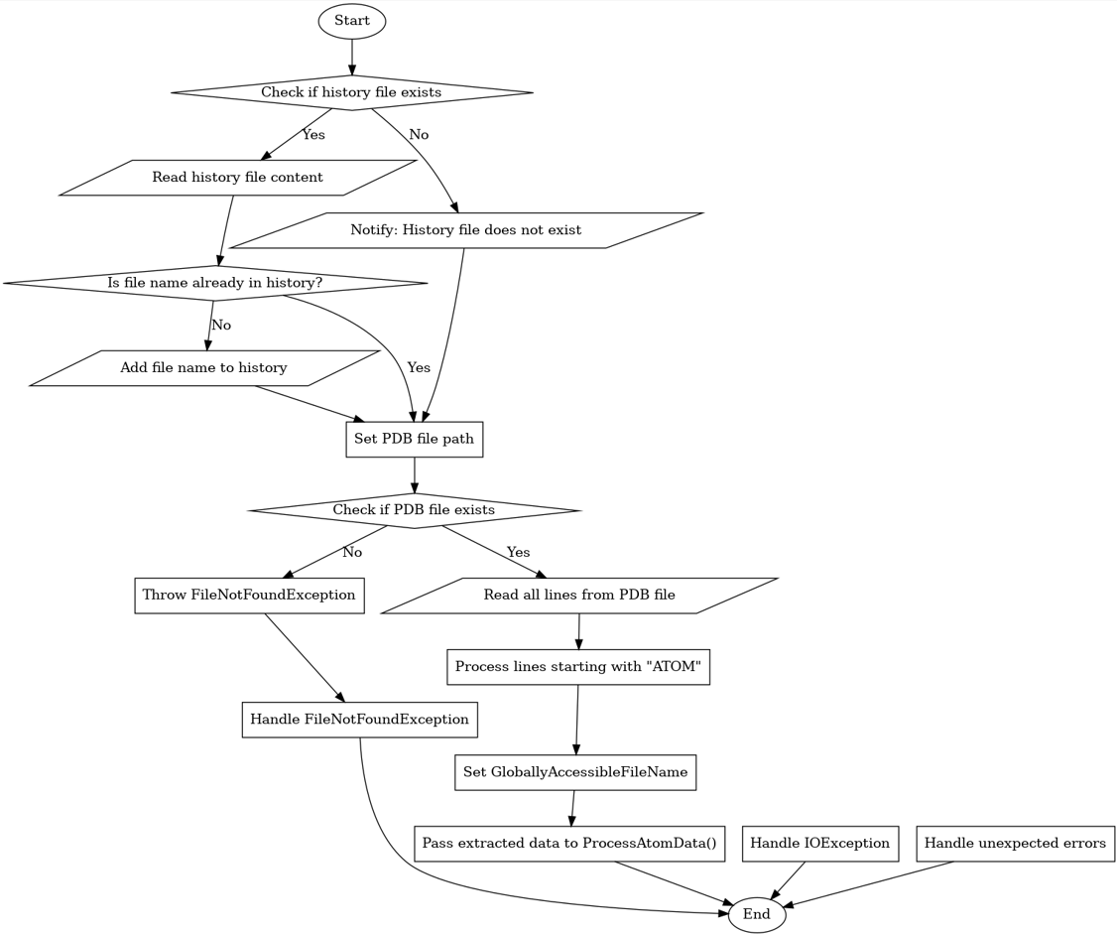

Following variables are also going to be created: CarbonAlphas As New List, CACombinations As New List, Distances As New List, Coordinates As New List, CACoordinates As New Dictionary
ProcessCoordinates subroutine is called that passes in the variables PDBFileLinesList, CarbonAlphas and Coordinates
The program will then iterate through all the lines in “PDBFileLinesList” (the list of all the lines that contain the word “ATOM”) and will extract all the carbon alpha residues via adding all the lines to a list that contain the phrase “CA” indicating that the line contains all the relevnt information regarding a carbon alpha residue
The subroutine will then extract all the coordinates from the carbon alpha residues and store them in the list “SingleCoordinates”
Coordinate triplet then stores in a two-dimensional list (Coordinates)
Identifier for the residues are then stored in the list “CarbonAlphas” (amino acid concatenated with the residue number e.g. CYS13)

Code
Sub ProcessCoordinates(PDBFileLinesList, CarbonAlphas, Coordinates)
Index1 ← 0
Index2 ← 0
LengthOfPolypeptide ← 0

For Each line In PDBFileLinesList Do
If line Contains "CA" Then
LengthOfPolypeptide ← LengthOfPolypeptide + 1
SingleCoordinates ← New List()

Index1 ← 6
For Index2 From 1 To 3 Do
SingleCoordinates.Add(line[Index1])
Index1 ← Index1 + 1
End For

Coordinates.Add(SingleCoordinates)
CarbonAlphas.Add(line[3] + line[5])
End If
End For

GloballyAccessibleLengthOfPolypeptide ← LengthOfPolypeptide
GloballyAccessibleCoordinates ← Coordinates
End Sub

Flow chart
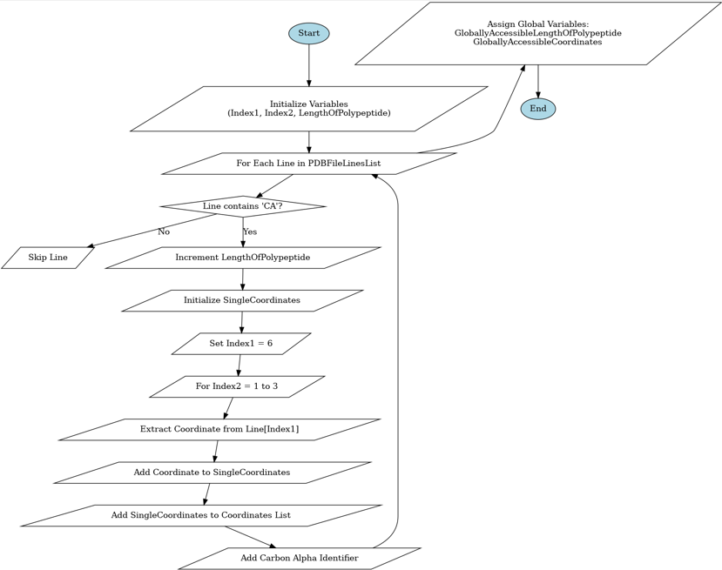

CarbonAlphaProcessor sub routine is then called which requires the parameters CarbonAlphas, Coordinates and CACoordinates
This subroutine will obtain the coordinate triplet for each amino acid and store them in a list that will hold them temporarily
The program will then store these coordinates within a multi-dimensional dictionary called “CACoordinates” and will add the coordinates via the amino acid concatenated with its correlated residue number e.g. “CYS13” as the key followed by the corresponding coordinate triplet
this entire process will loop until all the CA residues have been added to the dictionary

Code
Start
For i = 0 To Coordinates.Count - 1
Initialize placeHolderList
For j = 0 To 2
Add Coordinates(i)(j) to placeHolderList
Next j
Add CarbonAlphas(i) -> placeHolderList to CACoordinates
Next i
Set GloballyAccessibleCACoordinates = CACoordinates
End

“CreationOfCarbonAlphaPairs” subroutine is called with parameters “CarbonAlphas” and “CACombinations”
For every carbon alpha amino acid residue, a pair is created via the concatenation of every single possible combination of residues, e.g. “CYS34_ARG56” (excluding identical residues)
Each combination is added to the list “CACombo”

Flowchart
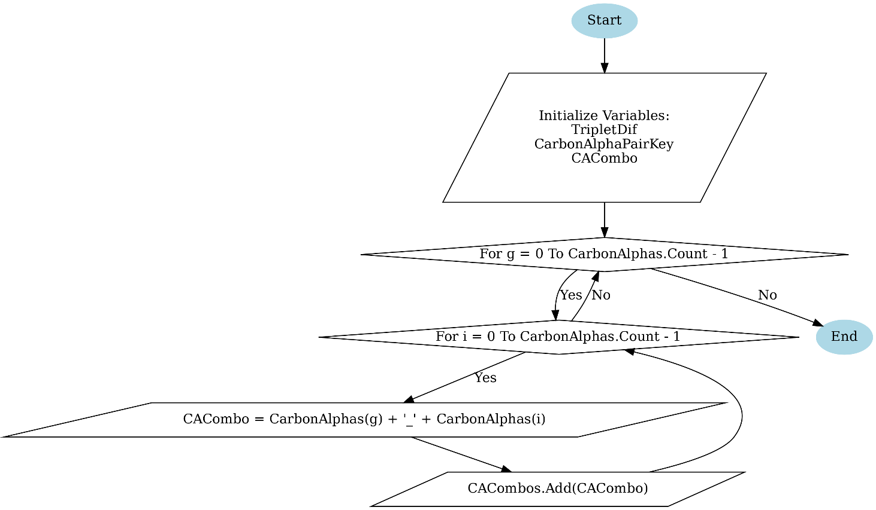

Subroutine “EuclideanDistanceCalculator” is called with the parameters “Distances” and “Coordinates” passed in
The program will loop through all the contents of coordinates and will calculate the distances between the amino acids via the equation Distance = √ ((x₂ - x₁) ² + (y₂ - y₁) ² + (z₂ - z₁) ²)
These calculations will then be stored in the “Distances” variable

Code
PROCEDURE EuclideanDistanceCalculator(Distances, Coordinates)

DECLARE placeHolderDecimal AS Decimal
DECLARE distance AS Decimal

FOR i ← 0 TO LENGTH(Coordinates) - 1
FOR j ← 0 TO LENGTH(Coordinates) - 1

x1 ← Coordinates[i][0]
x2 ← Coordinates[i][1]
y1 ← Coordinates[i][2]
y2 ← Coordinates[j][0]
z1 ← Coordinates[j][1]
z2 ← Coordinates[j][2]

placeHolderDecimal ← (x1 - x2 + (y1 - y2) + (z1 - z2)) ^ 2
distance ← SQRT(placeHolderDecimal)

ADD distance TO Distances

END FOR
END FOR

END PROCEDURE
The subroutine “MapCarbonAlphaPairsWithDistances” is called with parameters “CACombos” and “Distances”
This method simply maps the residue pairs initially created with their corresponding calculated Euclidean Distance

Code

Flowchart
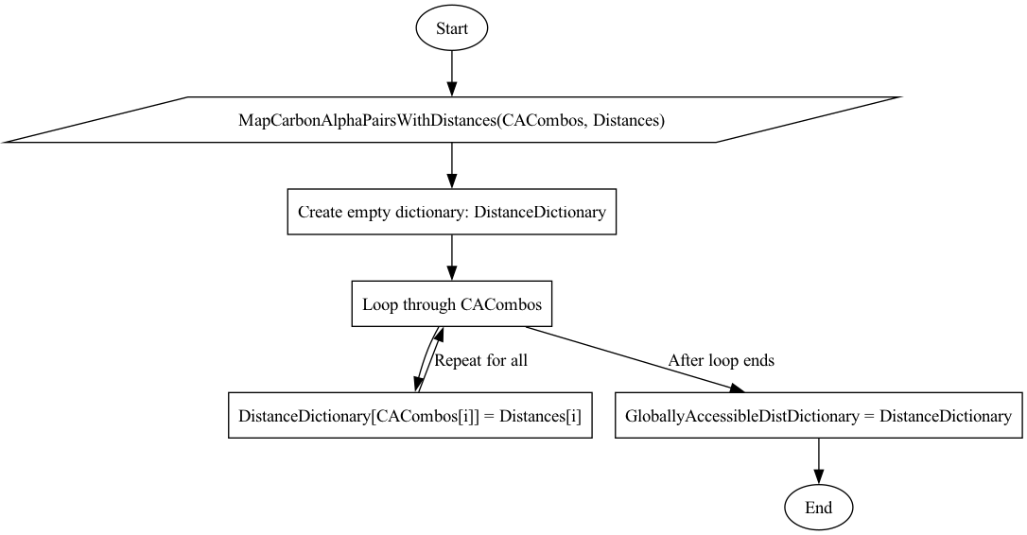

Subroutine “IsSaltBridge” is also created that is used in another model to check if residue interactions form salt bridges

Code
BEGIN IsSaltBridge(a, b) RETURNS Boolean
SET pairs TO List of Tuples:
("ASP", "LYS")
("GLU", "ARG")
("ASP", "ARG")
("GLU", "LYS")

FOR EACH pair IN pairs
IF (a CONTAINS pair.Item1 AND b CONTAINS pair.Item2) OR
(a CONTAINS pair.Item2 AND b CONTAINS pair.Item1) THEN
RETURN True
END FOR

RETURN False

END

Producing a three-dimensional model of the polypeptide
The ModelCreation subroutine initializes a 3D model by first converting globally stored 3D coordinates into a list of Point3D objects (CarbonAlphaCoords), ensuring each coordinate has exactly three values before adding it. It then creates a duplicate list (RotatedCoords) to store transformed versions of these coordinates for rendering. To enable interactivity, it adds event handlers to ModelPanel, allowing the model to respond to mouse actions (MouseDown and MouseMove) and repainting requests (Paint).

Code
PROCEDURE ModelCreation(ModelPanel)

CarbonAlphaCoords ← NEW LIST

FOR EACH coord IN GloballyAccessibleCoordinates
IF LENGTH(coord) = 3 THEN
ADD (coord[0], coord[1], coord[2]) TO CarbonAlphaCoords
END IF
END FOR

RotatedCoords ← COPY OF CarbonAlphaCoords

ATTACH_EVENT_HANDLER(ModelPanel, "MouseDown", Panel1_MouseDown)
ATTACH_EVENT_HANDLER(ModelPanel, "MouseMove", Panel1_MouseMove)
ATTACH_EVENT_HANDLER(ModelPanel, "Paint", Panel1_Paint)

END PROCEDURE

Flowchart

The Panel1_Paint subroutine handles rendering the 3D model by determining whether a fullscreen model window is open and then calling Draw3DModel with the appropriate panel's graphics, width, and height for scaling and centering. If the fullscreen model is active, it uses ModelPanelForFullScreenModel; otherwise, it defaults to ModelPanelForPrimaryDisplayForm.

Code
PROCEDURE Panel1_Paint(sender, e)

IF IsFormOpen("FullScreenModel") THEN
CALL Draw3DModel(e.Graphics, ModelPanelForFullScreenModel.Width, ModelPanelForFullScreenModel.Height)
ELSE
CALL Draw3DModel(e.Graphics, ModelPanelForPrimaryDisplayForm.Width, ModelPanelForPrimaryDisplayForm.Height)
END IF

END PROCEDURE

The IsFormOpen function checks if a specific form, identified by its name, is currently open by iterating through Application.OpenForms; if a match is found, it returns True, otherwise, it returns False, helping determine which ModelPanel to use for rendering the 3D model.

Code
FUNCTION IsFormOpen(formName)

FOR EACH frm IN Application.OpenForms
IF frm.Name = formName THEN
RETURN TRUE
END IF
END FOR

RETURN FALSE

END FUNCTION

Flowchart
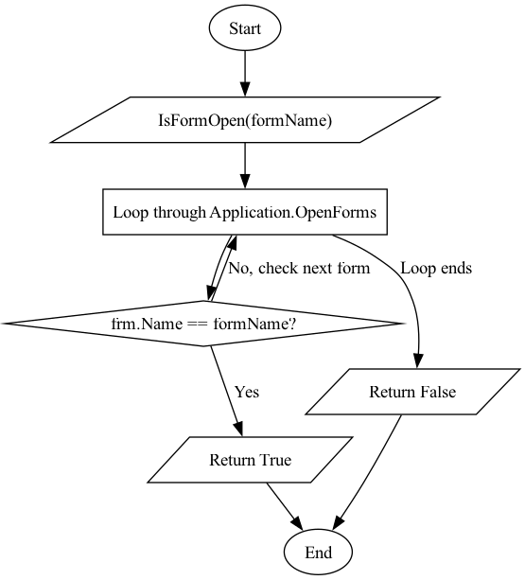

The Draw3DModel subroutine renders a 3D model onto a Graphics object by applying perspective projection to each point in RotatedCoords, scaling and centring them within the given width and height. It enables anti-aliasing for smoother visuals, then iterates through the points, drawing each as a circle and connecting consecutive points with lines to form the structure. The function also calls InteractionIdentifierAndPlotter to handle additional interactions or plotting based on the model's transformation.

Code
PROCEDURE Draw3DModel(g, width, height)

scale ← 500
fov ← 100
radius ← 5

ENABLE AntiAlias ON g

FOR i ← 0 TO LENGTH(RotatedCoords) - 1
p ← RotatedCoords[i]

x ← (p.X * scale) / (p.Z + fov) + width / 2
y ← (p.Y * scale) / (p.Z + fov) + height / 2

DRAW circle AT (x, y) WITH radius

IF i < LENGTH(RotatedCoords) - 1 THEN
nextP ← RotatedCoords[i + 1]

x2 ← (nextP.X * scale) / (nextP.Z + fov) + width / 2
y2 ← (nextP.Y * scale) / (nextP.Z + fov) + height / 2

DRAW line FROM (x, y) TO (x2, y2)
END IF
END FOR

CALL InteractionIdentifierAndPlotter(scale, fov, width, height, g)

END PROCEDURE

Flowchart
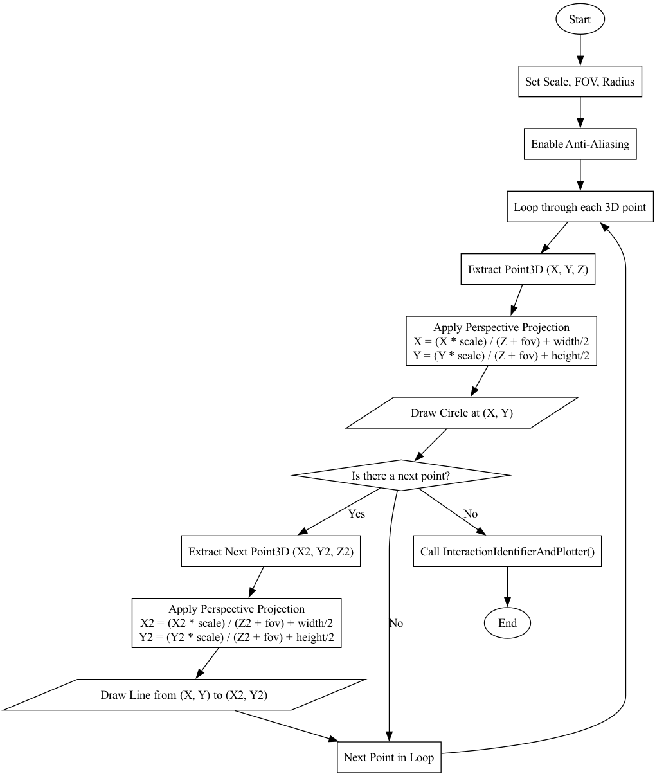

The InteractionIdentifierAndPlotter subroutine identifies and visualizes special molecular interactions by iterating through GloballyAccessibleDistDictionary, which maps point connections to distance values. If a connection's distance is below 5 units, it extracts the indices of the connected points, applies perspective projection to their coordinates, and ensures they are sufficiently spaced. Based on interaction type, it draws red lines for disulfide bridges (CYS-CYS) if enabled and green lines for salt bridges when detected, visually distinguishing these interactions in the 3D model.

Code
PROCEDURE Draw3DModel(g, width, height)

scale ← 500
fov ← 100
radius ← 5

ENABLE AntiAlias ON g

FOR i ← 0 TO LENGTH(RotatedCoords) - 1
p ← RotatedCoords[i]

x ← (p.X * scale) / (p.Z + fov) + width / 2
y ← (p.Y * scale) / (p.Z + fov) + height / 2

DRAW circle AT (x, y) WITH radius

IF i < LENGTH(RotatedCoords) - 1 THEN
nextP ← RotatedCoords[i + 1]

x2 ← (nextP.X * scale) / (nextP.Z + fov) + width / 2
y2 ← (nextP.Y * scale) / (nextP.Z + fov) + height / 2

DRAW line FROM (x, y) TO (x2, y2)
END IF
END FOR

CALL InteractionIdentifierAndPlotter(scale, fov, width, height, g)

END PROCEDURE

Flowchart
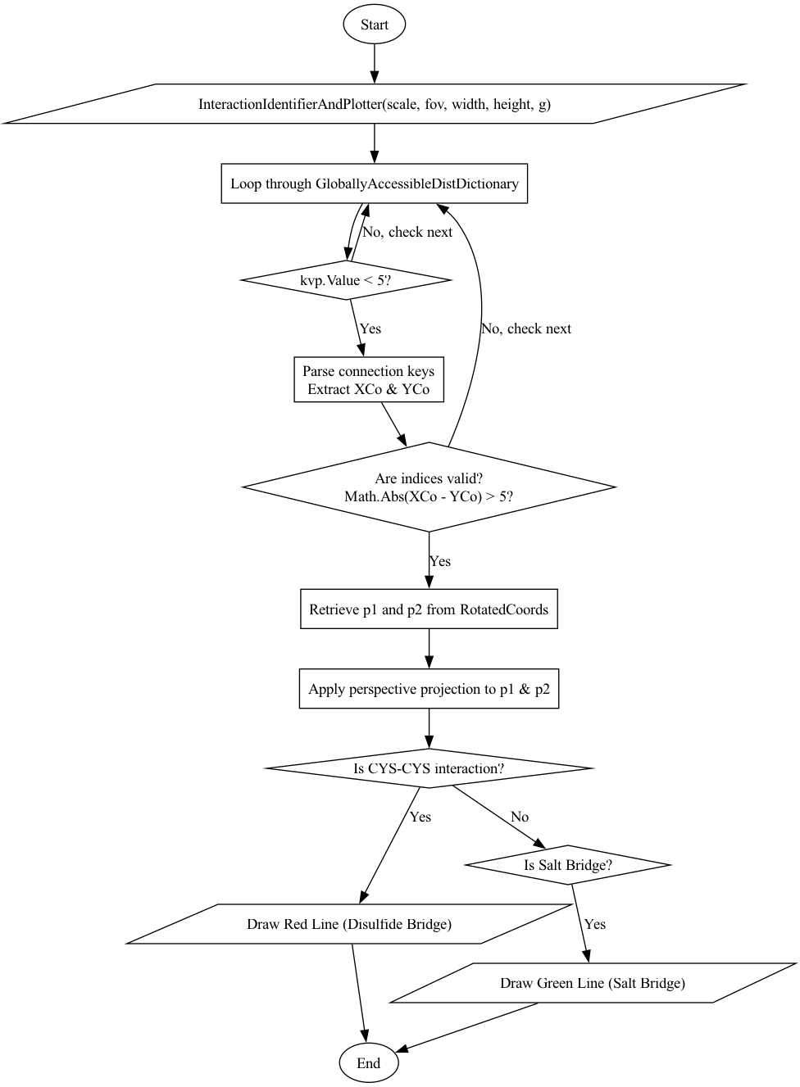

The Panel1_MouseDown subroutine stores the current mouse position (e.Location) in LastMousePos when the mouse button is pressed, allowing the program to track drag movements for interactive 3D model manipulation.

Code
PROCEDURE Panel1_MouseDown(sender, e)

LastMousePos ← e.Location

END PROCEDURE

The Panel1_MouseMove subroutine enables interactive rotation of the 3D model by detecting left mouse button drags, calculating the movement difference (deltaX and deltaY), and adjusting RotationX and RotationY accordingly with a smoothing factor. It updates the last mouse position, applies the new rotations via UpdateRotation(), and triggers a repaint of both the primary and fullscreen model panels to reflect the changes.

Code
PROCEDURE Panel1_MouseMove(sender, e)

IF e.Button = MouseButtons.Left THEN
deltaX ← e.X - LastMousePos.X
deltaY ← e.Y - LastMousePos.Y

RotationX ← RotationX + (deltaY * 0.5)
RotationY ← RotationY + (deltaX * 0.5)

LastMousePos ← e.Location

CALL UpdateRotation()

REFRESH ModelPanelForPrimaryDisplayForm
REFRESH ModelPanelForFullScreenModel
END IF

END PROCEDURE

The UpdateRotation subroutine updates the 3D model’s orientation by iterating through CarbonAlphaCoords and applying a rotation transformation to each point using RotatePoint, modifying RotatedCoords based on the current RotationX and RotationY angles to reflect the model's new orientation.

Code
PROCEDURE UpdateRotation()

FOR i ← 0 TO LENGTH(CarbonAlphaCoords) - 1
RotatedCoords[i] ← RotatePoint(CarbonAlphaCoords[i], RotationX, RotationY)
END FOR

END PROCEDURE

The RotatePoint function applies a 3D rotation to a Point3D by first converting the given X and Y rotation angles from degrees to radians, which is necessary because trigonometric functions use radians. It then precomputes the sine and cosine values for both axes. The first step involves rotating around the X-axis using the X-axis rotation matrix, which modifies the Y and Z coordinates while keeping the X coordinate unchanged. The second step rotates around the Y-axis using the Y-axis rotation matrix, which adjusts the X and Z coordinates while preserving the Y coordinate. The result is a new Point3D with updated X, Y, and Z coordinates, reflecting the combined rotation around both axes.

Code
FUNCTION RotatePoint(p, angleX, angleY) RETURNS Point3D

radX ← (PI * angleX) / 180
radY ← (PI * angleY) / 180

cosX ← COS(radX)
sinX ← SIN(radX)

cosY ← COS(radY)
sinY ← SIN(radY)

y ← (p.Y * cosX) - (p.Z * sinX)
z ← (p.Y * sinX) + (p.Z * cosX)

x ← (p.X * cosY) + (z * sinY)
z ← (-p.X * sinY) + (z * cosY)

RETURN Point3D(x, y, z)

END FUNCTION

The Point3D class defines a 3D point in space with public properties for the X, Y, and Z coordinates, each stored as a Single (floating-point number). The class includes a constructor that initializes a new Point3D instance by accepting three Single values—x, y, and z—which represent the point’s position in 3D space. When a new Point3D is created, these values are assigned to the respective properties (X, Y, and Z) of the class instance. This allows easy manipulation and storage of 3D coordinates for use in graphical applications.

Code
CLASS Point3D

DECLARE X AS Single
DECLARE Y AS Single
DECLARE Z AS Single

PROCEDURE New(x, y, z)
SET X ← x
SET Y ← y
SET Z ← z
END PROCEDURE

END CLASS

Producing a contact map for the polypeptide
The ChartPlotter subroutine populates a chart's series with data points based on the entries in GloballyAccessibleDistDictionary, considering only those with a distance value less than 5. It splits the dictionary keys to extract X and Y coordinates, ensuring they represent valid amino acid numbers. For each valid pair, it creates a DataPoint and checks if the coordinates correspond to specific interactions like disulfide bridges (CYS-CYS) or salt bridges. Disulfide bridges are marked in red, salt bridges in green, and other points in blue. The data points are added to the series, with their colour and size adjusted based on the interaction type. Points that meet the criteria for disulfide or salt bridges are also stored in respective lists (DisulphideBridgePoints and SaltBridgePoints).

Code
PROCEDURE ChartPlotter(series)

FOR EACH kvp IN GloballyAccessibleDistDictionary
IF kvp.Value < 5 THEN
parts ← SPLIT(kvp.Key, "_")
XCoString ← parts[0]
YCoString ← parts[1]
AminoAcidNumberX ← SUBSTRING(parts[0], 3)
AminoAcidNumberY ← SUBSTRING(parts[1], 3)
XCo ← CONVERT_TO_INTEGER(AminoAcidNumberX)
YCo ← CONVERT_TO_INTEGER(AminoAcidNumberY)

IF ABS(XCo - YCo) > 5 THEN
DataPoint ← NEW DataPoint(XCo, YCo)

IF CONTAINS(XCoString, "CYS") AND CONTAINS(YCoString, "CYS") THEN
DataPoint.Color ← RED
DataPoint.MarkerSize ← 3
ADD DataPoint TO DisulphideBridgePoints
ELSE IF IsSaltBridge(XCoString, YCoString) THEN
DataPoint.Color ← GREEN
DataPoint.MarkerSize ← 3
ADD DataPoint TO SaltBridgePoints
ELSE
DataPoint.Color ← BLUE
DataPoint.MarkerSize ← 1
END IF

ADD DataPoint TO series.Points
END IF
END IF
END FOR

END PROCEDURE

Flowchart
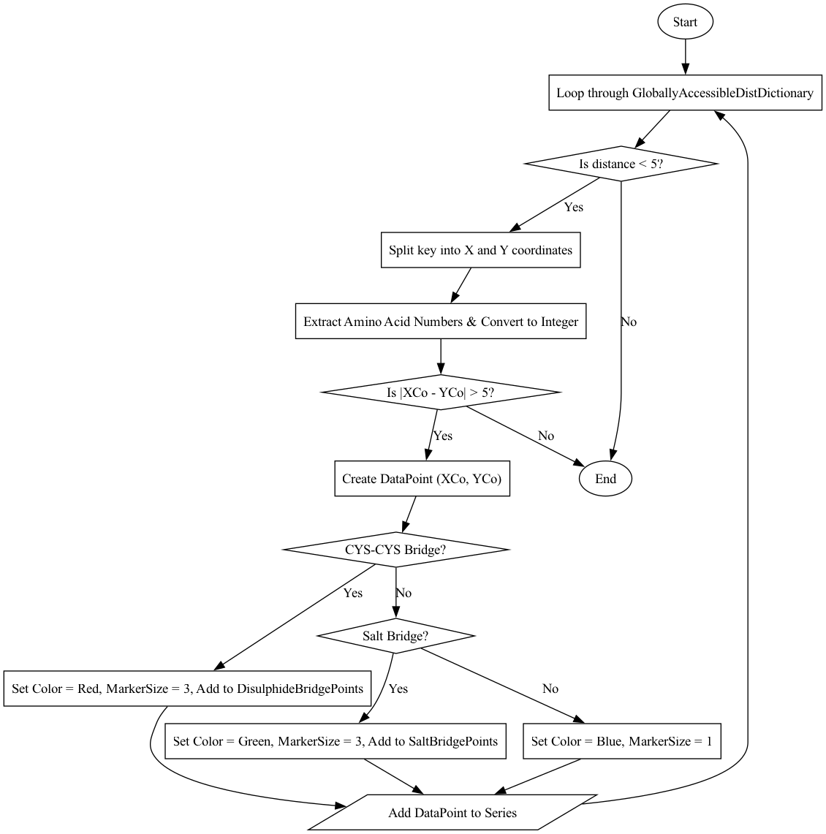

The ChartConfiguration subroutine sets up the visual properties of the ContactMapChart for displaying a contact map. It begins by creating a new ChartArea and clearing any existing chart areas in the chart. The X and Y axes are labeled with titles ("X Axis" and "Y Axis"), and the grid lines are set to a light gray color for better readability. It then defines the axis ranges based on the total count of GloballyAccessibleCACoordinates, ensuring that the chart scales appropriately. The axis intervals are set to 10, so the ticks appear every 10 units. Finally, the chart is invalidated to trigger a refresh, ensuring the updated configuration and points are immediately displayed.

Code
PROCEDURE ChartConfiguration(ContactMapChart)

chartArea ← NEW ChartArea
CLEAR ContactMapChart.ChartAreas
ADD chartArea TO ContactMapChart.ChartAreas

chartArea.AxisX.Title ← "X Axis"
chartArea.AxisY.Title ← "Y Axis"

chartArea.AxisX.MajorGrid.LineColor ← LIGHT_GRAY
chartArea.AxisY.MajorGrid.LineColor ← LIGHT_GRAY

chartArea.AxisX.Minimum ← 0
chartArea.AxisX.Maximum ← LENGTH(GloballyAccessibleCACoordinates)
chartArea.AxisY.Minimum ← 0
chartArea.AxisY.Maximum ← LENGTH(GloballyAccessibleCACoordinates)
chartArea.AxisX.Interval ← 10
chartArea.AxisY.Interval ← 10

CALL ContactMapChart.Invalidate()

END PROCEDURE

References

3D Math Primer for Graphics and Game Development
3Dgep. (2024). 3D math primer for graphics and game development. 3Dgep. Retrieved from https://www.3dgep.com/3d-math-primer-for-graphics-and-game-development/

GeeksforGeeks - Rotation Matrix in 3D
GeeksforGeeks. (2024). Rotation matrix in 3D. GeeksforGeeks. Retrieved from https://www.geeksforgeeks.org/rotation-matrix-in-3d/

Stack Overflow - 3D to 2D Projection in C#
Stack Overflow. (2024). 3D to 2D projection in C#. Stack Overflow. Retrieved from https://stackoverflow.com/questions/11423456/3d-to-2d-projection-in-c

Biology Stack Exchange - Interactions Between Amino Acids in Proteins
Biology Stack Exchange. (2024). What are the main interactions between amino acids in proteins? Biology Stack Exchange. Retrieved from https://biology.stackexchange.com/questions/22560/whathttps://biology.stackexchange.com/questions/22560/what-are-the-main-interactions-between-amino-acids-in-proteinsare-the-main-interactions-between-amino-acids-in-proteins
CodeProject - 3D Graphics Programming in C#
CodeProject. (2024). 3D graphics programming in C#. CodeProject. Retrieved from https://www.codeproject.com/Articles/1551/3D-Graphics-Programming-in-C Imports System.IO

Testing
Test No. | Objective(s) tested | Test | Test procedure | Expected result | Passed? | Evidence
1 | 1.1.1, 1.1.2, 1.1.3 | Testing input of PDB file | Input specific PDB files with intention to cause errors via a button and entered via an input box | Correct error message will appear, these include:  “FileNotFoundException” error, this will output to the user in a message box “ex.Message, "File Not Found", MessageBoxButtons.OK, MessageBoxIcon.Error”  “IOException” error, this will output to the user in a message box “ex.Message, ""An error occurred while reading or writing to the file: " & ex.Message, "IO Error", MessageBoxButtons.OK, MessageBoxIcon.Error”  “Exception” error that covers any other errors that were not the previous two, this will output to the user in a message box “"An unexpected  error occurred: " & ex.Message, "Error", MessageBoxButtons.OK, MessageBoxIcon.Error” | Y | 32:00-34:00  2:30-2:00  6:50-7:40
2 | 1.2, 1.3, 1.4, 1.5, 1.5, 1.6, 1.7, 1.8, 1.9, 1.10, 1.11, 1.12, 1.13, 1.14 | Testing input of actual PDB file | Input PDB file name that correlates to an actual PDB file e.g. “kinase” via a button | Will calculate and store variables correctly | Y | 6:30-16:30
3 | 2.1 | check if the 3D model will be displayed correctly even if a contact map is present on the form | via the press of a button | Press “generate 3D model” | Y | 1:10-4:30  17:00-25:40
4 | 2.2 | Check if a label will appear (that contains the amino acid count) if a 3D model of the polypeptide is displayed | via the press of a button | Press “generate 3D model” | Y | 1:10-4:30  6:00-16:20
5 | 2.3 | Check if a label containing the name of the polypeptide will be displayed when the model is generated | Via the press of a button | Press “generate 3D model” | Y | 1:10-4:30
6 | 2.4, 2.5, 2.6 | See if the polypeptide is displayed correctly | Via the press of a button | Press “generate 3D model” and press “generate contact map” | Y | 1:10-4:30  16:30-27:30
7 | 2.7 | Use mouse to rotate the polypeptide and make sure everything is calculated correctly | Via a button press and screenshots of code | Press “generate 3D model” | Y | 1:10-4:30  16:30-27:30
8 | 3 | Check if the contact map will appear and compare the disulphide bridge interactions on the contact map with the ones on the 3D model to make sure they have been calculated and represented correctly | Via a button press and screenshots of the code | Press “generate 3D model” and press “generate contact map” | Y | 1:10-4:30  27:30 – 29:00
9 | 4, 5, 6 | Check if the toggle buttons work with the contact map, 3D model, full screen 3D model and full screen contact map, check if the PDB file history button works and is displayed correctly, check if all the other remaining buttons work correctly | Via button presses and possibly code | Press toggle buttons while contact map is present then test them when the 3D model is present | Y | 1:10-4:30  29:00-33:00

Technical Solution
Imports System.Text.RegularExpressions

Public Module ResourcesForProcessingPDBFile

' Label to display the name of the polypeptide
Private _NameOfPolypeptideLabel As New Label()
Public Property NameOfPolypeptideLabel As Label
Get
Return _NameOfPolypeptideLabel
End Get
Set(value As Label)
_NameOfPolypeptideLabel = value
End Set
End Property

' A globally accessible string variable to hold the filename of the current model
Private _GloballyAccessibleFileName As String
Public Property GloballyAccessibleFileName As String
Get
Return _GloballyAccessibleFileName
End Get
Set(value As String)
_GloballyAccessibleFileName = value
End Set
End Property

' A dictionary to store distance data associated with a string key,
' representing Distances between specific coordinates or atoms
Private _GloballyAccessibleDistDictionary As New Dictionary(Of String, Decimal)
Public Property GloballyAccessibleDistDictionary As Dictionary(Of String, Decimal) Get
Return _GloballyAccessibleDistDictionary
End Get
Set(value As Dictionary(Of String, Decimal))
_GloballyAccessibleDistDictionary = value
End Set
End Property

' A dictionary to store coordinates of alpha-carbon atoms,
' with the string key representing an atom or residue identifier and a list of decimals as the coordinates
Private _GloballyAccessibleCACoordinates As New Dictionary(Of String, List(Of Decimal))
Public Property GloballyAccessibleCACoordinates As Dictionary(Of String, List(Of Decimal))
Get
Return _GloballyAccessibleCACoordinates
End Get
Set(value As Dictionary(Of String, List(Of Decimal)))
_GloballyAccessibleCACoordinates = value
End Set
End Property

' A list of lists of decimals representing coordinates of all atoms (in the structure)
Private _GloballyAccessibleCoordinates As New List(Of List(Of Decimal))
Public Property GloballyAccessibleCoordinates As List(Of List(Of Decimal))
Get
Return _GloballyAccessibleCoordinates
End Get
Set(value As List(Of List(Of Decimal)))
_GloballyAccessibleCoordinates = value
End Set
End Property

' An integer representing the length of the polypeptide chain (the amount of amino acids)
Private _GloballyAccessibleLengthOfPolypeptide As Integer
Public Property GloballyAccessibleLengthOfPolypeptide As Integer
Get
Return _GloballyAccessibleLengthOfPolypeptide
End Get
Set(value As Integer)
_GloballyAccessibleLengthOfPolypeptide = value
End Set
End Property

' Label to display the length of the polypeptide
Private _LengthOfPolypeptideLabel As New Label()
Public Property LengthOfPolypeptideLabel As Label
Get
Return _LengthOfPolypeptideLabel
End Get
Set(value As Label)
_LengthOfPolypeptideLabel = value
End Set
End Property

Public Sub ProteinDataBankFileProcessor(fileName As String)
' Define the file path for storing the PDB file history
Dim FilePath As String = "E:\PDBfileHistory.txt" ' Replace with your file path
Dim PDBFilePath As String
Dim PDBFileLinesList As New List(Of List(Of String)) ' 2D list to store lines and words from PDB file

Try
' Check if the history file exists
If System.IO.File.Exists(FilePath) Then
' Read the entire content of the file to check if the filename is already present
Dim fileContent As String = System.IO.File.ReadAllText(FilePath)
If Not fileContent.Contains(fileName) Then
' Append the filename to the history file if not already present Using writer As New System.IO.StreamWriter(FilePath, True)
writer.WriteLine(fileName)
End Using
End If
Else
' Notify the user if the history file does not exist
MessageBox.Show("The history file does not exist: " & FilePath, "File Not Found", MessageBoxButtons.OK, MessageBoxIcon.Warning)
End If

' Create full path for the PDB file
PDBFilePath = ("E:\" & fileName & ".pdb")

' Check if the PDB file exists before attempting to read it
If Not System.IO.File.Exists(PDBFilePath) Then
Throw New FileNotFoundException("The PDB file was not found at the specified path: " & PDBFilePath)
End If

' Read all the lines from the PDB file
Dim lines = System.IO.File.ReadAllLines(PDBFilePath)

' Loop through each line and process lines starting with "ATOM"
For Each line In lines
If line.StartsWith("ATOM") Then
' Split the line into elements based on whitespace and add to PDBFileLinesList
Dim elements = Regex.Split(line, "\s+")
Dim row As New List(Of String)(elements)
PDBFileLinesList.Add(row)
End If
Next

Catch ex As FileNotFoundException
' Handle file not found exception
MessageBox.Show(ex.Message, "File Not Found", MessageBoxButtons.OK, MessageBoxIcon.Error)
Catch ex As IOException
' Handle other IO exceptions
MessageBox.Show("An error occurred while reading or writing to the file: " & ex.Message, "IO Error", MessageBoxButtons.OK, MessageBoxIcon.Error)
Catch ex As Exception
' Handle any other unexpected errors
MessageBox.Show("An unexpected error occurred: " & ex.Message, "Error", MessageBoxButtons.OK, MessageBoxIcon.Error)
End Try

GloballyAccessibleFileName = fileName

' Pass extracted data for further processing
ProcessAtomData(PDBFileLinesList)

End Sub

Private Sub ProcessAtomData(PDBFileLinesList As List(Of List(Of String)))

Dim CarbonAlphas As New List(Of String) ' Stores the amino acid identifier for each CA atom
Dim CACombinations As New List(Of String) ' Stores combination of Carbon Alpha residues
Dim Distances As New List(Of Decimal) ' Stores Distances between amino acids
Dim Coordinates As New List(Of List(Of Decimal)) ' Stores coordinates of each atom
Dim CACoordinates As New Dictionary(Of String, List(Of Decimal)) ' Dictionary to store each CA atom's coordinates

ProcessCoordinates(PDBFileLinesList, CarbonAlphas, Coordinates)
CarbonAlphaProcessor(CarbonAlphas, Coordinates, CACoordinates)
CreationOfCarbonAlphaPairs(CarbonAlphas, CACombinations)
EuclideanDistanceCalculator(Distances, Coordinates)
MapCarbonAlphaPairsWithDistances(CACombinations, Distances)

End Sub

Private Sub ProcessCoordinates(PDBFileLinesList As List(Of List(Of String)), CarbonAlphas As List(Of
String), Coordinates As List(Of List(Of Decimal)))

Dim Index1 As Integer
Dim Index2 As Decimal
Dim LengthOfPolypeptide As Integer

' Process each line in PDBFileLinesList to identify Carbon Alpha (CA) atoms
For Each line In PDBFileLinesList
If line.Contains("CA") Then
LengthOfPolypeptide += 1
Dim SingleCoordinates As New List(Of Decimal)

' Extract coordinates of the CA atom
Index1 = 6
For Index2 = 1 To 3
SingleCoordinates.Add(line(Index1)) ' Add the coordinates to the list
Index1 += 1
Next
Coordinates.Add(SingleCoordinates) ' Add the coordinates to the main list
CarbonAlphas.Add(line(3) + line(5)) ' Stores identifier for the CA atom (e.g., chain and residue)
End If
Next

GloballyAccessibleLengthOfPolypeptide = LengthOfPolypeptide
GloballyAccessibleCoordinates = Coordinates

End Sub

Private Sub CarbonAlphaProcessor(CarbonAlphas As List(Of String), Coordinates As List(Of List(Of
Decimal)), CACoordinates As Dictionary(Of String, List(Of Decimal)))

For i = 0 To Coordinates.Count - 1
Dim placeHolderList As New List(Of Decimal) For j = 0 To 2 placeHolderList.Add(Coordinates(i)(j)) ' Add the 3D coordinates for each CA atom
Next
CACoordinates.Add(CarbonAlphas(i), placeHolderList) ' Add the atom to the dictionary
Next
CACoordinates = CACoordinates

GloballyAccessibleCACoordinates = CACoordinates

End Sub

Private Sub CreationOfCarbonAlphaPairs(CarbonAlphas As List(Of String), CACombos As List(Of String))
' Variables for pairing CA atoms and calculating Distances
Dim TripletDif As New List(Of Decimal)
Dim CarbonAlphaPairKey As New List(Of String)
Dim CACombo As String

' Create combinations of CA pairs
For g = 0 To CarbonAlphas.Count - 1
For i = 0 To CarbonAlphas.Count - 1
CACombo = CarbonAlphas(g) + "_" + CarbonAlphas(i) ' Pair two CA atoms CACombos.Add(CACombo) ' Add the pair to the combo list
Next
Next
End Sub

Private Sub EuclideanDistanceCalculator(Distances As List(Of Decimal), Coordinates As List(Of List(Of Decimal)))
' Calculate Euclidean Distances between CA atoms and store results
Dim placeHolderDecimal As Decimal
Dim distance As Decimal
For i = 0 To Coordinates.Count - 1
For j = 0 To Coordinates.Count - 1
' Calculate the Euclidean distance between two atoms (x1, y1, z1) and (x2, y2, z2)
Dim x1 = Coordinates(i)(0)
Dim x2 = Coordinates(i)(1)
Dim y1 = Coordinates(i)(2)
Dim y2 = Coordinates(j)(0)
Dim z1 = Coordinates(j)(1) Dim z2 = Coordinates(j)(2)
placeHolderDecimal = (x1 - x2 + (y1 - y2) + (z1 - z2)) ^ 2 ' Squared difference in each coordinate distance = Math.Sqrt(placeHolderDecimal) ' Square root of the Total of squared differences Distances.Add(distance) ' Add the calculated distance to the list
Next
Next
End Sub

Private Sub MapCarbonAlphaPairsWithDistances(CACombos As List(Of String), Distances As List(Of Decimal))
' Dictionary to map CA pairs with calculated Distances
Dim DistanceDictionary As New Dictionary(Of String, Decimal)
For i = 0 To CACombos.Count - 1
DistanceDictionary.Add(CACombos(i), Distances(i)) ' Map the pair with its distance
Next

GloballyAccessibleDistDictionary = DistanceDictionary

End Sub

Public Function IsSaltBridge(a As String, b As String) As Boolean
' Define a list of amino acid pairs that represent special interactions
' Each pair is defined using Tuple, ensuring bidirectional matching
Dim pairs = New List(Of Tuple(Of String, String)) From {
Tuple.Create("ASP", "LYS"), ' Interaction between aspartic acid (ASP) and lysine (LYS)
Tuple.Create("GLU", "ARG"), ' Interaction between glutamic acid (GLU) and arginine (ARG)
Tuple.Create("ASP", "ARG"), ' Interaction between aspartic acid (ASP) and arginine (ARG)
Tuple.Create("GLU", "LYS") ' Interaction between glutamic acid (GLU) and lysine (LYS)
}

' Check if the input strings (a and b) match any of the defined pairs
' Uses the Any function to iterate through the pairs
' Ensures the interaction is bidirectional (e.g., "ASP-ARG" is equivalent to "ARG-ASP")
Return pairs.Any(Function(pair) (a.Contains(pair.Item1) AndAlso b.Contains(pair.Item2)) OrElse
(a.Contains(pair.Item2) AndAlso b.Contains(pair.Item1)))
End Function

End Module
Imports System.Windows.Forms.DataVisualization.Charting

Module ResourcesForModel

' A Panel objects to represent the main model display
Private _ModelPanelForPrimaryDisplayForm As New Panel
Public Property ModelPanelForPrimaryDisplayForm As Panel
Get
Return _ModelPanelForPrimaryDisplayForm
End Get
Set(value As Panel)
_ModelPanelForPrimaryDisplayForm = value
End Set
End Property

Private _ModelPanelForFullScreenModel As New Panel
Public Property ModelPanelForFullScreenModel As Panel
Get
Return _ModelPanelForFullScreenModel
End Get
Set(value As Panel)
_ModelPanelForFullScreenModel = value
End Set
End Property

' Rotation angles (in degrees or radians) for rotating the model around the X and Y axes
Private _RotationX As Single = 0
Private Property RotationX As Single
Get
Return _RotationX
End Get
Set(value As Single)
_RotationX = value
End Set
End Property

Private _RotationY As Single = 0
Public Property RotationY As Single
Get
Return _RotationY
End Get
Set(value As Single)
_RotationY = value
End Set
End Property

' Variable to store the last mouse position, used to drag and rotate controls
Private _LastMousePos As Point
Public Property LastMousePos As Point
Get
Return _LastMousePos
End Get
Set(value As Point)
_LastMousePos = value
End Set
End Property

' Flag to toggle the visibility of salt bridges in the 3D model
Private _ShowSaltBridgesForModel As Boolean = True
Public Property ShowSaltBridgesForModel As Boolean
Get
Return _ShowSaltBridgesForModel
End Get
Set(value As Boolean)
_ShowSaltBridgesForModel = value
End Set
End Property

' Flag to toggle the visibility of disulphide bridges in the 3D model
Private _ShowDisulphideBridgesForModel As Boolean = True
Public Property ShowDisulphideBridgesForModel As Boolean
Get
Return _ShowDisulphideBridgesForModel
End Get
Set(value As Boolean)
_ShowDisulphideBridgesForModel = value
End Set
End Property

' A list of rotated coordinates for the model, used for updating the view after applying rotations
Private _RotatedCoords As List(Of Point3D)
Public Property RotatedCoords As List(Of Point3D)
Get
Return _RotatedCoords
End Get
Set(value As List(Of Point3D))
_RotatedCoords = value
End Set
End Property

' Lists to store data points representing salt bridges and disulphide bridges for visual representation
Private _SaltBridgePoints As New List(Of DataPoint)
Public Property SaltBridgePoints As List(Of DataPoint)
Get
Return _SaltBridgePoints
End Get
Set(value As List(Of DataPoint))
_SaltBridgePoints = value
End Set
End Property

Private _DisulphideBridgePoints As New List(Of DataPoint)
Public Property DisulphideBridgePoints As List(Of DataPoint)
Get
Return _DisulphideBridgePoints
End Get
Set(value As List(Of DataPoint))
_DisulphideBridgePoints = value
End Set
End Property

' A list of 3D points representing the coordinates of the alpha-carbon atoms in the polypeptide
Private _CarbonAlphaCoords As List(Of Point3D)
Public Property CarbonAlphaCoords As List(Of Point3D)
Get
Return _CarbonAlphaCoords
End Get
Set(value As List(Of Point3D))
_CarbonAlphaCoords = value
End Set
End Property

Public Sub ModelCreation(ModelPanel As Panel)

' Convert global 3D coordinate data into a list of Point3D objects for the model
CarbonAlphaCoords = New List(Of Point3D)() ' Initialize the list to hold 3D coordinates
For Each coord In GloballyAccessibleCoordinates
If coord.Count = 3 Then ' Ensure the coordinate is valid (has three dimensions)
CarbonAlphaCoords.Add(New Point3D(coord(0), coord(1), coord(2))) ' Create a new Point3D and add it to the list
End If
Next

' Initialize RotatedCoords to match the original CarbonAlphaCoords
' This will store the rotated coordinates for rendering after transformations RotatedCoords = New List(Of Point3D)(CarbonAlphaCoords)

' Add event handlers to enable interactivity for the 3D model in ModelPanel
AddHandler ModelPanel.MouseDown, AddressOf Panel1_MouseDown ' Triggered when the mouse is clicked
AddHandler ModelPanel.MouseMove, AddressOf Panel1_MouseMove ' Triggered when the mouse is moved
AddHandler ModelPanel.Paint, AddressOf Panel1_Paint ' Triggered when the panel needs to be repainted
End Sub

Private Sub Panel1_Paint(sender As Object, e As PaintEventArgs)
' Render the 3D model on the panel
' Uses the panel's dimensions for scaling and centering
If IsFormOpen("FullScreenModel") Then
Draw3DModel(e.Graphics, ModelPanelForFullScreenModel.Width,
ModelPanelForFullScreenModel.Height)
Else
Draw3DModel(e.Graphics, ModelPanelForPrimaryDisplayForm.Width, ModelPanelForPrimaryDisplayForm.Height)
End If
End Sub

Private Function IsFormOpen(ByVal formName As String)
' Functin to check which form is open and will display the correlated modelpanel
For Each frm As Form In Application.OpenForms
If frm.Name = formName Then
Return True
End If
Next
Return False
End Function

Private Sub Draw3DModel(g As Graphics, width As Integer, height As Integer)
' Scale factor for converting 3D coordinates to 2D space
Dim scale As Single = 500.0F
' Field of View (FOV) for perspective projection
Dim fov As Single = 100.0F
' Radius for rendering individual points
Dim radius As Integer = 5

' Enable anti-aliasing for smoother rendering
g.SmoothingMode = Drawing2D.SmoothingMode.AntiAlias

' Loop through each 3D point in the rotated coordinates
For i As Integer = 0 To RotatedCoords.Count - 1
Dim p As Point3D = RotatedCoords(i)

' Apply perspective projection:
' Objects farther away (larger Z) appear smaller due to division by (Z + fov).
Dim x As Single = (p.X * scale) / (p.Z + fov) + width / 2
Dim y As Single = (p.Y * scale) / (p.Z + fov) + height / 2

' Draw the current point as a circle
g.FillEllipse(Brushes.Purple, x - radius, y - radius, radius * 2, radius * 2)

' Draw a line connecting the current point to the next point
If i < RotatedCoords.Count - 1 Then
Dim nextP As Point3D = RotatedCoords(i + 1)

' Apply perspective projection for the next point
Dim x2 As Single = (nextP.X * scale) / (nextP.Z + fov) + width / 2
Dim y2 As Single = (nextP.Y * scale) / (nextP.Z + fov) + height / 2

' Draw a line connecting the two points to form the structure
g.DrawLine(Pens.White, x, y, x2, y2)
End If
Next

InteractionIdentifierAndPlotter(scale, fov, width, height, g)

End Sub

Private Sub InteractionIdentifierAndPlotter(scale As Single, fov As Single, width As Integer, height As Integer, g As Graphics)
' Draw special connections based on the distance dictionary
For Each kvp As KeyValuePair(Of String, Decimal) In GloballyAccessibleDistDictionary
If kvp.Value < 5 Then ' Only consider distances below 5 units
' Parse the connection keys to extract coordinate indices
Dim parts() As String = kvp.Key.Split("_"c)
Dim XCo As Integer = Integer.Parse(parts(0).Substring(3))
Dim YCo As Integer = Integer.Parse(parts(1).Substring(3))

' Ensure indices are valid and represent points far enough apart
If Math.Abs(XCo - YCo) > 5 AndAlso XCo < RotatedCoords.Count AndAlso YCo < RotatedCoords.Count Then
' Retrieve the two points involved in the connection
Dim p1 As Point3D = RotatedCoords(XCo)
Dim p2 As Point3D = RotatedCoords(YCo)

' Apply perspective projection to both points
Dim x1 As Single = (p1.X * scale) / (p1.Z + fov) + width / 2
Dim y1 As Single = (p1.Y * scale) / (p1.Z + fov) + height / 2
Dim x2 As Single = (p2.X * scale) / (p2.Z + fov) + width / 2
Dim y2 As Single = (p2.Y * scale) / (p2.Z + fov) + height / 2

' If the points represent specific interactions, draw connections
' Red lines for "CYS" (cysteine connections)
If ShowDisulphideBridgesForModel AndAlso parts(0).Contains("CYS") AndAlso parts(1).Contains("CYS") Then
g.DrawLine(Pens.Red, x1, y1, x2, y2)
' Green lines for other special interactions
ElseIf ShowSaltBridgesForModel AndAlso IsSaltBridge(parts(0), parts(1)) Then
g.DrawLine(Pens.Green, x1, y1, x2, y2)
End If
End If
End If
Next
End Sub

Private Sub Panel1_MouseDown(sender As Object, e As MouseEventArgs)
' Capture the current mouse position when the mouse button is pressed
' The position is stored in LastMousePos, which is used for tracking drag movements
LastMousePos = e.Location
End Sub

Private Sub Panel1_MouseMove(sender As Object, e As MouseEventArgs)
' Check if the left mouse button is held down during the mouse move event
If e.Button = MouseButtons.Left Then
' Calculate the change in mouse position since the last recorded position
Dim deltaX As Integer = e.X - LastMousePos.X
Dim deltaY As Integer = e.Y - LastMousePos.Y

' Adjust the rotation angles based on the mouse movement
' Vertical movement (deltaY) affects RotationX (rotation around the X-axis)
' Horizontal movement (deltaX) affects RotationY (rotation around the Y-axis)
' The scaling factor (0.5F) smooths the rotation to make it more manageable
RotationX += deltaY * 0.5F RotationY += deltaX * 0.5F

' Update the last recorded mouse position
LastMousePos = e.Location

' Apply the updated rotations to the 3D model
UpdateRotation()

' Request the panel to repaint itself to reflect the changes
ModelPanelForPrimaryDisplayForm.Invalidate()
ModelPanelForFullScreenModel.Invalidate()
End If
End Sub

Private Sub UpdateRotation()
' Iterate through each point in the original CarbonAlphaCoordinates list
For i As Integer = 0 To CarbonAlphaCoords.Count - 1
' Apply a rotation transformation to each point
' The rotation angles (RotationX and RotationY) represent rotations around the X and Y axes
RotatedCoords(i) = RotatePoint(CarbonAlphaCoords(i), RotationX, RotationY)
Next
End Sub

Private Function RotatePoint(p As Point3D, angleX As Single, angleY As Single) As Point3D
' Convert the X-axis rotation angle from degrees to radians
Dim radX As Single = Math.PI * angleX / 180.0F
' Convert the Y-axis rotation angle from degrees to radians
Dim radY As Single = Math.PI * angleY / 180.0F

' Precompute the sine and cosine values for the X-axis rotation
Dim cosX As Single = Math.Cos(radX)
Dim sinX As Single = Math.Sin(radX)

' Precompute the sine and cosine values for the Y-axis rotation
Dim cosY As Single = Math.Cos(radY)
Dim sinY As Single = Math.Sin(radY)

' Step 1: Rotate around the X-axis ' Using the X-axis rotation matrix:
' [ 1 0 0 ]
' [ 0 cosX -sinX ]
' [ 0 sinX cosX ]
' This updates the Y and Z coordinates while keeping X unchanged
Dim y As Single = p.Y * cosX - p.Z * sinX
Dim z As Single = p.Y * sinX + p.Z * cosX

' Step 2: Rotate around the Y-axis ' Using the Y-axis rotation matrix:
' [ cosY 0 sinY ]
' [ 0 1 0 ]
' [ -sinY 0 cosY ]
' This updates the X and Z coordinates while keeping Y unchanged Dim x As Single = p.X * cosY + z * sinY z = -p.X * sinY + z * cosY

' Return the new rotated point with updated X, Y, and Z coordinates
Return New Point3D(x, y, z)
End Function

Public Class Point3D
' Public properties to store the X, Y, and Z coordinates of a point in 3D space
Public X As Single
Public Y As Single Public Z As Single

' Constructor to initialize a Point3D instance with given X, Y, and Z values
Public Sub New(x As Single, y As Single, z As Single)
Me.X = x ' Set the X-coordinate
Me.Y = y ' Set the Y-coordinate
Me.Z = z ' Set the Z-coordinate
End Sub
End Class

End Module
Imports System.Windows.Forms.DataVisualization.Charting

Module ResourcesForContactMap

' Flags to toggle the visibility of salt and disulphide bridges in the contact map view
Private _ShowSaltBridgesForContactMap As Boolean = True
Public Property ShowSaltBridgesForContactMap As Boolean
Get
Return _ShowSaltBridgesForContactMap
End Get
Set(value As Boolean)
_ShowSaltBridgesForContactMap = value
End Set
End Property

Private _ShowDisulphideBridgesForContactMap As Boolean = True
Public Property ShowDisulphideBridgesForContactMap As Boolean
Get
Return _ShowDisulphideBridgesForContactMap
End Get
Set(value As Boolean)
_ShowDisulphideBridgesForContactMap = value
End Set
End Property

Public Sub ContactMapCreation(ContactMapChart As Chart)
' Create a new series for the contact map points Dim series As New Series("Contact") series.ChartType = SeriesChartType.Point ' Points will be plotted in the chart ContactMapChart.Series.Add(series)

ChartPlotter(series)
ChartConfiguration(ContactMapChart)
End Sub

Private Sub ChartPlotter(series As Series)
' Loop through the globally accessible distance dictionary to add points
For Each kvp In GloballyAccessibleDistDictionary
' Only consider entries where the distance is less than 5
If kvp.Value < 5 Then
' Split the key into X and Y coordinates
Dim parts = kvp.Key.Split("_"c)
Dim XCoString = parts(0)
Dim YCoString = parts(1)
Dim AminoAcidNumberX = parts(0).Substring(3)
Dim AminoAcidNumberY = parts(1).Substring(3)
Dim XCo = Integer.Parse(AminoAcidNumberX)
Dim YCo = Integer.Parse(AminoAcidNumberY)

If Math.Abs(XCo - YCo) > 5 Then
Dim DataPoint As New DataPoint(XCo, YCo)

' Check for disulphide bridges (CYS-CYS) and salt bridges
If XCoString.Contains("CYS") AndAlso YCoString.Contains("CYS") Then
DataPoint.Color = Color.Red
DataPoint.MarkerSize = 3
DisulphideBridgePoints.Add(DataPoint)
ElseIf (IsSaltBridge(XCoString, YCoString)) Then
DataPoint.Color = Color.Green
DataPoint.MarkerSize = 3
SaltBridgePoints.Add(DataPoint)
Else
DataPoint.Color = Color.Blue
DataPoint.MarkerSize = 1
End If

series.Points.Add(DataPoint)
End If
End If
Next
End Sub

Private Sub ChartConfiguration(ContactMapChart As Chart)
' Configure the chart area for the contact map
Dim chartArea As New ChartArea
ContactMapChart.ChartAreas.Clear()
ContactMapChart.ChartAreas.Add(chartArea)

' Set axis titles chartArea.AxisX.Title = "X Axis" chartArea.AxisY.Title = "Y Axis"

' Set grid line colors chartArea.AxisX.MajorGrid.LineColor = Color.LightGray chartArea.AxisY.MajorGrid.LineColor = Color.LightGray

' Set axis ranges and intervals chartArea.AxisX.Minimum = 0 chartArea.AxisX.Maximum = GloballyAccessibleCACoordinates.Count chartArea.AxisY.Minimum = 0 chartArea.AxisY.Maximum = GloballyAccessibleCACoordinates.Count chartArea.AxisX.Interval = 10 chartArea.AxisY.Interval = 10

' Invalidate the chart to force it to refresh and display the updated points
ContactMapChart.Invalidate()
End Sub

End Module
Public Class FullScreenModel

Private Sub CreateButtons()
' Create a panel to hold the buttons for the fullscreen model
ModelPanelForFullScreenModel = New Panel()
ModelPanelForFullScreenModel.Dock = DockStyle.Fill
ModelPanelForFullScreenModel.BackColor = Color.Black
Me.Controls.Add(ModelPanelForFullScreenModel)

' Create a button to toggle salt bridges for the model
Dim SaltBridgeButton As New Button()
SaltBridgeButton.Text = "Toggle Salt Bridge(s)"
SaltBridgeButton.Location = New Point(10, 10)
SaltBridgeButton.Size = New Size(130, 80)
AddHandler SaltBridgeButton.Click, AddressOf ToggleSaltBridges
SaltBridgeButton.BackColor = SystemColors.ControlDarkDark
Me.Controls.Add(SaltBridgeButton)
SaltBridgeButton.BringToFront()

' Create a button to toggle disulphide bridges for the model
Dim DisulphideBridgeButton As New Button()
DisulphideBridgeButton.Text = "Toggle Disulphide Bridge(s)"
DisulphideBridgeButton.Location = New Point(150, 10)
DisulphideBridgeButton.Size = New Size(130, 80)
AddHandler DisulphideBridgeButton.Click, AddressOf ToggleDisulphideBridges
DisulphideBridgeButton.BackColor = SystemColors.ControlDarkDark
Me.Controls.Add(DisulphideBridgeButton)
DisulphideBridgeButton.BringToFront()
End Sub

Private Sub ToggleSaltBridges(sender As Object, e As EventArgs)
' Toggle the visibility of salt bridges on the model
ShowSaltBridgesForModel = Not ShowSaltBridgesForModel
ModelPanelForFullScreenModel.Invalidate() ' Redraw the panel to update the model display End Sub

Private Sub ToggleDisulphideBridges(sender As Object, e As EventArgs)
' Toggle the visibility of disulphide bridges on the model
ShowDisulphideBridgesForModel = Not ShowDisulphideBridgesForModel
ModelPanelForFullScreenModel.Invalidate() ' Redraw the panel to update the model display End Sub

Private Sub FullScreenModel_Load(sender As Object, e As EventArgs) Handles MyBase.Load
' Maximize the window when the form is loaded
Me.WindowState = FormWindowState.Maximized

' Initialize the components of the form
InitializeComponent()

' Create the toggle buttons for controlling salt and disulphide bridges CreateButtons()

' Call the ModelCreation function to populate the model in the panel
ModelCreation(ModelPanelForFullScreenModel)
End Sub

End Class

Imports System.IO
Imports System.Windows.Forms.DataVisualization.Charting

Public Class PrimaryDisplayForm

Private ContactMapChart As New Chart

Private Sub InputPDBFile_Click(sender As Object, e As EventArgs)
Dim FileName As String
FileName = InputBox("Please enter file name")
'prompts the user to enter the disired file name with an input box where they will type in the name of the file
ProteinDataBankFileProcessor(FileName)
End Sub

Private Sub Generate3DModel_Click(sender As Object, e As EventArgs)

' Clear ModelPanel and remove existing components that may interfere with the rendering
ModelPanelForPrimaryDisplayForm.Controls.Clear() ' Remove any child controls from ModelPanel

' Remove existing charts from the main form
' Iterate through all controls on the form to find charts and remove them
For Each ctrl As Control In Me.Controls
If TypeOf ctrl Is DataVisualization.Charting.Chart Then
Me.Controls.Remove(ctrl) ' Remove the chart from the form
Exit For ' Exit loop after removing a chart (assumes only one chart at a time)
End If
Next

' Update the label displaying the length of the polypeptide
LengthOfPolypeptideLabel.Text = "Amino Acid Count:" & Environment.NewLine & GloballyAccessibleLengthOfPolypeptide
LengthOfPolypeptideLabel.ForeColor = Color.White ' Set text color to white for visibility
LengthOfPolypeptideLabel.Size = New Size(1000, 1000) ' Set the size of the label (unusually large for debugging)
LengthOfPolypeptideLabel.Location = New Point(515, 420) ' Position the label at the desired location
Controls.Add(LengthOfPolypeptideLabel) ' Add the label to the form

' Update the label displaying the name of the polypeptide
NameOfPolypeptideLabel.Text = GloballyAccessibleFileName ' Set text to the global file name
NameOfPolypeptideLabel.ForeColor = Color.White ' Set text color to white for visibility
NameOfPolypeptideLabel.Size = New Size(250, 21) ' Set size to fit the text content
NameOfPolypeptideLabel.Location = New Point(12, 9) ' Position the label in the top-left corner
Controls.Add(NameOfPolypeptideLabel) ' Add the label to the form
NameOfPolypeptideLabel.BringToFront() ' Ensure the label is on top of other controls

' Configure the ModelPanel to serve as a container for the 3D rendering
ModelPanelForPrimaryDisplayForm.Size = New Size(480, 440) ' Set the size of the panel
ModelPanelForPrimaryDisplayForm.Location = New Point(10, 10) ' Position the panel at the topleft corner
Controls.Add(ModelPanelForPrimaryDisplayForm) ' Add the panel to the form

ModelCreation(ModelPanelForPrimaryDisplayForm)

End Sub

Private Sub SaltBridge_Click(sender As Object, e As EventArgs)
ToggleSaltBridge()
End Sub

Private Sub DisulphideBridge_Click(sender As Object, e As EventArgs)
ToggleDisulphideBridge()
End Sub

Public Sub ToggleSaltBridge()
' Iterate through all controls on the form
For Each ctrl As Control In Me.Controls
' Check if the control is a Chart (from DataVisualization.Charting namespace)
If TypeOf ctrl Is DataVisualization.Charting.Chart Then
' Toggle the state of ShowSaltBridgesForContactMap (used to control salt bridge visibility)
ShowSaltBridgesForContactMap = Not ShowSaltBridgesForContactMap

' Get the series named "Contact" from the chart
Dim contactSeries As Series = ContactMapChart.Series("Contact")

If ShowSaltBridgesForContactMap Then
' If ShowSaltBridgesForContactMap is True, add salt bridge points to the series For Each point As DataPoint In SaltBridgePoints contactSeries.Points.Add(point)
Next
Else
' If ShowSaltBridgesForContactMap is False, remove all points with Color.Green from the series
For i As Integer = contactSeries.Points.Count - 1 To 0 Step -1 If contactSeries.Points(i).Color = Color.Green Then contactSeries.Points.RemoveAt(i)
End If
Next
End If

' Redraw the chart to reflect the updated points
ContactMapChart.Invalidate()

' Exit the loop after processing the first chart (assumes only one chart needs to be handled at a time)
Exit For
Else
' If the control is not a chart, toggle the visibility of green lines (used to represent salt bridges or specific interactions)
ShowSaltBridgesForModel = Not ShowSaltBridgesForModel

' Request the ModelPanel control to be redrawn to reflect the updated visibility of green lines
ModelPanelForPrimaryDisplayForm.Invalidate()
End If
Next
End Sub

Public Sub ToggleDisulphideBridge()
' Iterate through all controls on the form
For Each ctrl As Control In Me.Controls
' Check if the control is a Chart (from DataVisualization.Charting namespace)
If TypeOf ctrl Is DataVisualization.Charting.Chart Then
' Toggle the state of ShowDisulphideBridgesForContactMap (used to control disulphide bridge visibility)
ShowDisulphideBridgesForContactMap = Not ShowDisulphideBridgesForContactMap

' Get the series named "Contact" from the chart
Dim contactSeries As Series = ContactMapChart.Series("Contact")

If ShowDisulphideBridgesForContactMap Then
' If ShowDisulphideBridgesForContactMap is True, add disulphide bridge points to the series
For Each point As DataPoint In DisulphideBridgePoints contactSeries.Points.Add(point)
Next
Else
' If ShowDisulphideBridgesForContactMap is False, remove all points with Color.Red from the series
For i As Integer = contactSeries.Points.Count - 1 To 0 Step -1 If contactSeries.Points(i).Color = Color.Red Then contactSeries.Points.RemoveAt(i)
End If
Next
End If

' Redraw the chart to reflect the updated points
ContactMapChart.Invalidate()

' Exit the loop after processing the first chart (assumes only one chart needs to be handled at a time)
Exit For
End If
Next

' Toggle the visibility of the "red lines" (used to represent disulphide bridges or specific interactions)
ShowDisulphideBridgesForModel = Not ShowDisulphideBridgesForModel

' Request the ModelPanel control to be redrawn to reflect the updated visibility of red lines
ModelPanelForPrimaryDisplayForm.Invalidate()
End Sub

Private Sub GenerateContactMap_Click(sender As Object, e As EventArgs)
' Remove the first Panel control from the form (if any exists)
For Each ctrl As Control In Me.Controls
' Check if the control is of type Panel
If TypeOf ctrl Is Panel Then
Me.Controls.Remove(ctrl) ' Remove the panel from the form
Exit For ' Exit the loop once the panel is removed
End If
Next

' Update the label displaying the length of the polypeptide
LengthOfPolypeptideLabel.Text = "amino acid count:" & Environment.NewLine &
GloballyAccessibleLengthOfPolypeptide
LengthOfPolypeptideLabel.ForeColor = Color.White
LengthOfPolypeptideLabel.Size = New Size(1000, 1000)
LengthOfPolypeptideLabel.Location = New Point(515, 420)
Controls.Add(LengthOfPolypeptideLabel)

' Update the label displaying the name of the polypeptidejuz
NameOfPolypeptideLabel.Text = GloballyAccessibleFileName
NameOfPolypeptideLabel.ForeColor = Color.White
NameOfPolypeptideLabel.Size = New Size(250, 21)
NameOfPolypeptideLabel.Location = New Point(12, 9)
Controls.Add(NameOfPolypeptideLabel)
NameOfPolypeptideLabel.BringToFront()

' Set up and add the Contact Map chart to the form
ContactMapChart.Size = New Size(480, 410)
ContactMapChart.Location = New Point(10, 30)
Controls.Add(ContactMapChart)

' Clear any existing data series in the chart
ContactMapChart.Series.Clear()

ContactMapCreation(ContactMapChart)
End Sub

Private Sub FullScreen3DModel_Click(sender As Object, e As EventArgs)
' Opens full screen version of the model
FullScreenModel.Show()
End Sub

Private Sub FullScreenContactMap_Click(sender As Object, e As EventArgs)
' Opens full screen version of the model
FullScreenContactMap.Show()
End Sub

Private Sub ProteinDataBankFileHistory_Click(sender As Object, e As EventArgs) Dim filePath = "E:\PDBfileHistory.txt" ' Replace with your file path

' Check if the file exists
If Not File.Exists(filePath) Then
MessageBox.Show("The file does not exist.")
Return
End If

' Read all lines from the file
Dim lines = File.ReadLines(filePath).ToList

' Display the lines in a MessageBox or a new Form
Dim PDBFileHistoryForm As New Form ' Create a new form to display history
Dim historyListBox As New ListBox ' Create a ListBox to hold the history
Dim okButton As New Button ' Button to select the PDB file

' Set up the ListBox historyListBox.Items.AddRange(lines.ToArray) ' Add lines to the ListBox historyListBox.Dock = DockStyle.Top ' Dock the ListBox to the top of the form historyListBox.Height = 200 ' Set height for the ListBox

' Set up the OK Button okButton.Text = "Select PDB File" okButton.Dock = DockStyle.Bottom ' Dock the button to the bottom of the form

Dim FileName As String

' Add handler for the OK Button click
AddHandler okButton.Click, Sub(s, ev)
' Check if an item is selected in the ListBox
If historyListBox.SelectedItem IsNot Nothing Then
Dim selectedPDBFile = historyListBox.SelectedItem.ToString
FileName = selectedPDBFile
' Perform any action with the selectedPDBFile here
Else
MessageBox.Show("Please select a file from the history.")
End If
' Close the form after selection
PDBFileHistoryForm.Close()
End Sub

' Add controls to the history form
PDBFileHistoryForm.Controls.Add(historyListBox)
PDBFileHistoryForm.Controls.Add(okButton)

' Set up the history form properties
PDBFileHistoryForm.Text = "PDB History"
PDBFileHistoryForm.Size = New Size(300, 300) ' Set size of the history form
PDBFileHistoryForm.StartPosition = FormStartPosition.CenterParent ' Center the form

' Show the history form
PDBFileHistoryForm.ShowDialog(Me)
ProteinDataBankFileProcessor(FileName)
End Sub

Private Sub CreateButtons()
' Create and configure the "Input PDB File" button
Dim InputPDBFile As New Button()
InputPDBFile.Name = "InputPDBFile"
InputPDBFile.Text = "Input PDB File"
InputPDBFile.BackColor = SystemColors.ControlDarkDark
InputPDBFile.Size = New Size(304, 68)
InputPDBFile.Location = New Point(513, 24) ' Set position manually
' Add click event handler for InputPDBFile button
AddHandler InputPDBFile.Click, AddressOf InputPDBFile_Click
' Add the button to the form
Me.Controls.Add(InputPDBFile)

' Create and configure the "Generate Contact Map" button
Dim GenerateContactMap As New Button()
GenerateContactMap.Name = "GenerateContactMap"
GenerateContactMap.Text = "Generate Contact Map"
GenerateContactMap.BackColor = SystemColors.ControlDarkDark
GenerateContactMap.Size = New Size(304, 68)
GenerateContactMap.Location = New Point(513, 114)
' Add click event handler for GenerateContactMap button
AddHandler GenerateContactMap.Click, AddressOf GenerateContactMap_Click
' Add the button to the form
Me.Controls.Add(GenerateContactMap)

' Create and configure the "Generate 3D Model" button
Dim Generate3DModel As New Button()
Generate3DModel.Name = "Generate3DModel"
Generate3DModel.Text = "Generate 3D Model"
Generate3DModel.BackColor = SystemColors.ControlDarkDark
Generate3DModel.Size = New Size(304, 68)
Generate3DModel.Location = New Point(513, 205)
' Add click event handler for Generate3DModel button
AddHandler Generate3DModel.Click, AddressOf Generate3DModel_Click
' Add the button to the form
Me.Controls.Add(Generate3DModel)

' Create and configure the "Toggle Disulphide Bridge" button
Dim ToggleDisulphideBridge As New Button()
ToggleDisulphideBridge.Name = "ToggleDisulphideBridge"
ToggleDisulphideBridge.Text = "Toggle Disulphide Bridge(s)"
ToggleDisulphideBridge.BackColor = SystemColors.ControlDarkDark
ToggleDisulphideBridge.Size = New Size(141, 52)
ToggleDisulphideBridge.Location = New Point(513, 298)
' Add click event handler for ToggleDisulphideBridge button
AddHandler ToggleDisulphideBridge.Click, AddressOf DisulphideBridge_Click
' Add the button to the form
Me.Controls.Add(ToggleDisulphideBridge)

' Create and configure the "Toggle Salt Bridge" button
Dim ToggleSaltBridge As New Button()
ToggleSaltBridge.Name = "ToggleSaltBridge"
ToggleSaltBridge.Text = "Toggle Salt Bridge(s)"
ToggleSaltBridge.BackColor = SystemColors.ControlDarkDark
ToggleSaltBridge.Size = New Size(141, 52)
ToggleSaltBridge.Location = New Point(680, 298)
' Add click event handler for ToggleSaltBridge button
AddHandler ToggleSaltBridge.Click, AddressOf SaltBridge_Click
' Add the button to the form
Me.Controls.Add(ToggleSaltBridge)

' Create and configure the "Full Screen 3D Model" button
Dim FullScreen3DModel As New Button()
FullScreen3DModel.Name = "FullScreen3DModel"
FullScreen3DModel.Text = "Full Screen 3D Model"
FullScreen3DModel.BackColor = SystemColors.ControlDarkDark
FullScreen3DModel.Size = New Size(141, 52)
FullScreen3DModel.Location = New Point(514, 356)
' Add click event handler for FullScreen3DModel button
AddHandler FullScreen3DModel.Click, AddressOf FullScreen3DModel_Click
' Add the button to the form
Me.Controls.Add(FullScreen3DModel)

' Create and configure the "Full Screen Contact Map" button
Dim FullScreenContactMap As New Button()
FullScreenContactMap.Name = "FullScreenContactMap"
FullScreenContactMap.Text = "Full Screen Contact Map"
FullScreenContactMap.BackColor = SystemColors.ControlDarkDark
FullScreenContactMap.Size = New Size(141, 52)
FullScreenContactMap.Location = New Point(680, 356)
' Add click event handler for FullScreenContactMap button
AddHandler FullScreenContactMap.Click, AddressOf FullScreenContactMap_Click
' Add the button to the form
Me.Controls.Add(FullScreenContactMap)

' Create and configure the "PDB File History" button
Dim PDBFileHistory As New Button()
PDBFileHistory.Name = "PDBFileHistory"
PDBFileHistory.Text = "PDB File History"
PDBFileHistory.BackColor = SystemColors.ControlDarkDark
PDBFileHistory.Size = New Size(140, 23)
PDBFileHistory.Location = New Point(680, 424)
' Add click event handler for PDBFileHistory button
AddHandler PDBFileHistory.Click, AddressOf ProteinDataBankFileHistory_Click
' Add the button to the form
Me.Controls.Add(PDBFileHistory)

End Sub

Private Sub PrimaryDisplayForm_Load(sender As Object, e As EventArgs) Handles MyBase.Load
Me.BackColor = Color.Black
' Call the CreateButtons method to create and add buttons to the form.
CreateButtons()
End Sub

End Class
Imports System.Windows.Forms.DataVisualization.Charting

Public Class FullScreenContactMap

Private ContactMapChart As New Chart

Private Sub FullScreenContactMap_Load(sender As Object, e As EventArgs) Handles MyBase.Load
' Maximize the window when the form is loaded
Me.WindowState = FormWindowState.Maximized

' Create a panel to host the chart and the buttons
Dim ContactMapPanel As New Panel()
ContactMapPanel.Dock = DockStyle.Fill ' Set the panel to fill the form
Me.Controls.Add(ContactMapPanel) ' Add the panel to the form's controls

' Create and configure the chart dynamically
ContactMapChart = New Chart()
ContactMapChart.Dock = DockStyle.Fill ' Set the chart to fill the panel
ContactMapPanel.Controls.Add(ContactMapChart) ' Add the chart to the panel
ContactMapChart.Titles.Add("Contact Map For " & GloballyAccessibleFileName) ' Set the chart title

' Call the ContactMapCreation function to populate the chart with data ContactMapCreation(ContactMapChart)

' Create the toggle buttons on the panel
CreateToggleButtons(ContactMapPanel)
End Sub

Private Sub CreateToggleButtons(Panel As Panel)
' Create a button to toggle salt bridges on the contact map
Dim SaltBridgeButton As New Button()
SaltBridgeButton.Text = "Toggle Salt Bridges" ' Set the button text
SaltBridgeButton.Location = New Point(10, 10) ' Set the button position on the panel
SaltBridgeButton.Size = New Size(130, 40) ' Set the button size
AddHandler SaltBridgeButton.Click, AddressOf ToggleSaltBridgesForContactMap ' Attach event handler for the button click
Panel.Controls.Add(SaltBridgeButton) ' Add the button to the panel
SaltBridgeButton.BringToFront() ' Ensure the button is in front of other controls

' Create a button to toggle disulphide bridges on the contact map
Dim DisulphideButton As New Button()
DisulphideButton.Text = "Toggle Disulphide Bridges" ' Set the button text
DisulphideButton.Location = New Point(150, 10) ' Set the button position on the panel
DisulphideButton.Size = New Size(130, 40) ' Set the button size
AddHandler DisulphideButton.Click, AddressOf ToggleDisulphideBridgesForContactMap ' Attach event handler for the button click
Panel.Controls.Add(DisulphideButton) ' Add the button to the panel
DisulphideButton.BringToFront() ' Ensure the button is in front of other controls End Sub

Public Sub ToggleSaltBridgesForContactMap(sender As Object, e As EventArgs)
' Toggle the visibility of salt bridges on the contact map
ShowSaltBridgesForContactMap = Not ShowSaltBridgesForContactMap
Dim contactSeries As Series = ContactMapChart.Series("Contact") ' Get the series for the contact map

' If salt bridges should be shown, add the points to the series
If ShowSaltBridgesForContactMap Then
For Each point As DataPoint In SaltBridgePoints contactSeries.Points.Add(point) ' Add each salt bridge point to the series
Next
Else
' If salt bridges should be hidden, remove the points that are colored green (representing salt bridges)
For i As Integer = contactSeries.Points.Count - 1 To 0 Step -1 If contactSeries.Points(i).Color = Color.Green Then contactSeries.Points.RemoveAt(i) ' Remove the salt bridge points
End If
Next
End If

' Refresh the chart to reflect the changes
ContactMapChart.Invalidate()
End Sub

Public Sub ToggleDisulphideBridgesForContactMap(sender As Object, e As EventArgs)
' Toggle the visibility of disulphide bridges on the contact map
ShowDisulphideBridgesForContactMap = Not ShowDisulphideBridgesForContactMap
Dim contactSeries As Series = ContactMapChart.Series("Contact") ' Get the series for the contact map

' If disulphide bridges should be shown, add the points to the series
If ShowDisulphideBridgesForContactMap Then
For Each point As DataPoint In DisulphideBridgePoints contactSeries.Points.Add(point) ' Add each disulphide bridge point to the series
Next
Else
' If disulphide bridges should be hidden, remove the points that are colored red (representing disulphide bridges)
For i As Integer = contactSeries.Points.Count - 1 To 0 Step -1 If contactSeries.Points(i).Color = Color.Red Then contactSeries.Points.RemoveAt(i) ' Remove the disulphide bridge points
End If
Next
End If

' Refresh the chart to reflect the changes
ContactMapChart.Invalidate()
End Sub

End Class

