**The Model**

The program AnyLogic was used to create a model of disaster relief distribution in the Port St Lucie area after a hurricane has powered through the area. The model consists of several elements including agents/populations, state diagrams, process flow blocks, parameters, graphs and statistics. This model serves as a great framework to build upon in future. The table below and following image show the main page of the AnyLogic model. The table describes different elements used to create the model.

**Table 1**

|  |  |  |  |
| --- | --- | --- | --- |
| Agent/Population | Name | Role | Attributes |
| Distribution Sites | Sebastian  Stuart  Fort Pierce  Port St Lucie  Boynton Beach  Okeechobee or  Indiantown | Served as distribution sites for a local area. The site received the supplies and unloaded them. | * Event: Request Supply * Service Block: Unloading * Resource Pool: Unloaders * 2D Image: |
| Supply Depot | Okeechobee or  Indiantown | Served as the hub for the truck agents to resupply before delivering supplies. | * GIS Point * 2D Image: |
| PSLNPP | Port St Lucie Nuclear Power Plant | Served as the location in need of water. | * Event: Request Water * Service Block: Unloading * Resource Pool: Release * 2D Image: |
| Patrick AFB | Patrick Air Force Base | Served as the hub for the helo agents to stage before receiving a request for water. | * GIS Point * 2D Image: |
| Trucks | Truck | The agent that delivered the supplies to the distribution sites for dispensing. | * Variable: Supply * Parameter: Start Time * State Diagrams: Dictates agent behavior * Various statistics to track where each agent is within a state * 2D Image: |
| Helos | Helo | The agent that brought water to the Power Plant after a request was sent. | * Variable: Water * Parameter: Start Time * State Diagrams: Dictates agent behavior * Various statistics to track where each agent is within a state * 2D Image: |
| Supplies | Supply | Agent created to hold parameters. | * Parameters: amount, distribution site |
| Water | Water | Agent created to hold parameters. | * Parameters: amount, PSLNPP |
| GIS Map | Port St Lucie Area | Provides a map for visualization. | * GIS Map |
| GIS Point | Distribution Sites | Provides a location for the generation of the distribution sites | * GIS Point |

**Figure 1**

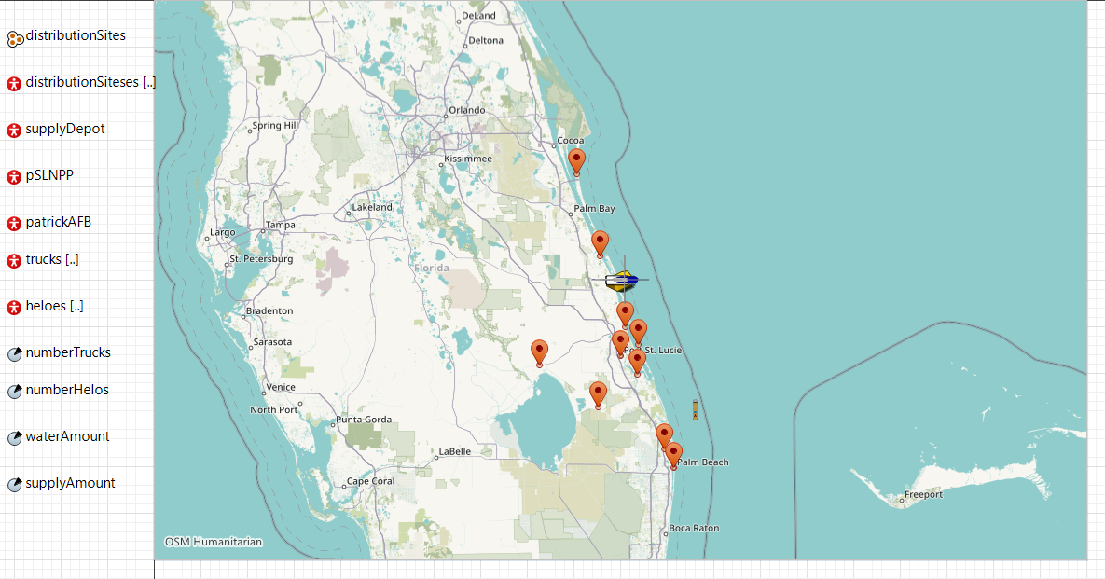

Placing the adjustable parameters on the main page of the model allows for multiple iterations of runs without changes to the underlying model’s framework. This enables the creation of multiple experiments as standalone instances of the model with the new parameters. Unfortunately, we were unable to accomplish this for every data point. Two of the plots would not accept the number of trucks and number of helos parameters so each one had to changed manually for each run. Both the water and supply amount remained constant for our particular experiments, but they are included to provide expansion for future work. The table below describes the parameters used on the main page.

**Table 2**

|  |  |  |
| --- | --- | --- |
| Parameters | Inputs | Run Parameters |
| Number of Trucks | Sets number of trucks in the agent Trucks population. | 3, 7, 15 |
| Number of Helos | Sets number of helos in the agent Helos population. | 3, 2, 1 |
| Water Amount | Sets the amount of water that PSLNPP requests. | 17,806 lbs. constant for this experiment |
| Supply Amount | Sets the number of supplies that the distribution sites request. | 62,017 lbs. constant for this experiment |

Underlying behavior of the agents (trucks and helos) was accomplished through the use of state diagrams. Only the truck state diagrams are described below as the helo ones are almost identical in structure. The state diagrams are responsible for moving the agents from state to state. Each of the agent populations are tracking what states each agent is in for reporting information on the simulation. The table and image below describe the behavior used to accomplish the delivery of supply requests.

**Table 3**

|  |  |  |
| --- | --- | --- |
| State Diagrams | Elements | Purpose |
| Truck | State Chart Entry | Starts the agent’s behavior. |
| At Supply Depot | Holds truck agents at the supply depot until they receive a ‘request supply’ order from the distribution sites. |
| Message Transition | Sends a message to the trucks to deliver supplies to the requesting site. |
| Moving to Distribution Sites | Truck agent moves to the requesting distribution site. A timer is started to track how long it takes to deliver supplies. |
| Arrival Transition | Stops the truck at the distribution site and handover the supplies. |
| Unloading | Holds the truck for unloading. Hold is accomplished by a service block. Timer stops once unloading is complete. |
| Message Transition | Receives unloaded message from the distribution site. Tells the truck to go back to the supply depot. |
| Moving to Supply Depot | Truck moves to the supply depot. |
| Arrival Transition | Has the truck wait for another order for supplies at the depot. |

**Figure 3**

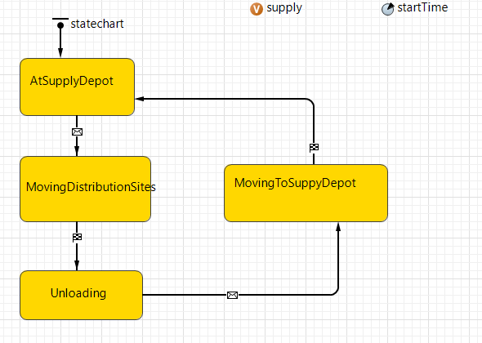

Simulating the unloading of the requested resources was accomplished using process model blocks. The model blocks are housed in the distribution site and PSLNPP population pages. Once the agents arrive at the requested site they enter the process modeling blocks. Tracking the number of deliveries at each location was achieved by using the process blocks. Whenever an agent exited the service block it was counted and displayed in a plot on the main page. The table and image show how this was structured.

**Table 4**

|  |  |  |
| --- | --- | --- |
| Process Modeling | Blocks | Purpose |
| Distribution Sites | Enter | Truck agent enters the unloading service block. |
|  | Service | Simulates an unloading time based on the amount of supplies and number of unloaders. |
|  | Exit | Sends the unloaded message to the truck at the distribution site. |
|  | Unloaders | Sets an amount of resources to use for unloading operations. |
|  | Request Supply | Generates an order for all the distribution sites. Grabs the nearest truck at the supply depot. Sends the truck to the distribution site requesting the order. |

**Figure 4**

