Extended Data

Extended Data Figures

Extended Data Fig. 1: Geographic split map (EPA regions by train/val/test)
Map of the contiguous United States showing the geographic stratification used for all benchmark tasks. The 10 EPA regions are partitioned into training (Regions 1, 3, 4, 5, 6; blue), validation (Regions 2, 7; amber), and test (Regions 8, 9, 10; orange) sets, maintaining a 60/15/25 ratio. Split membership is derived from the PWSID state prefix. 1,818 systems are excluded from this map only, not from the benchmark: their geocoded coordinate falls inside a state belonging to a different EPA region than their PWSID prefix, which marks a wrong-ZIP geocoding artifact when judged against US Census state boundary polygons (Supplementary S7b).
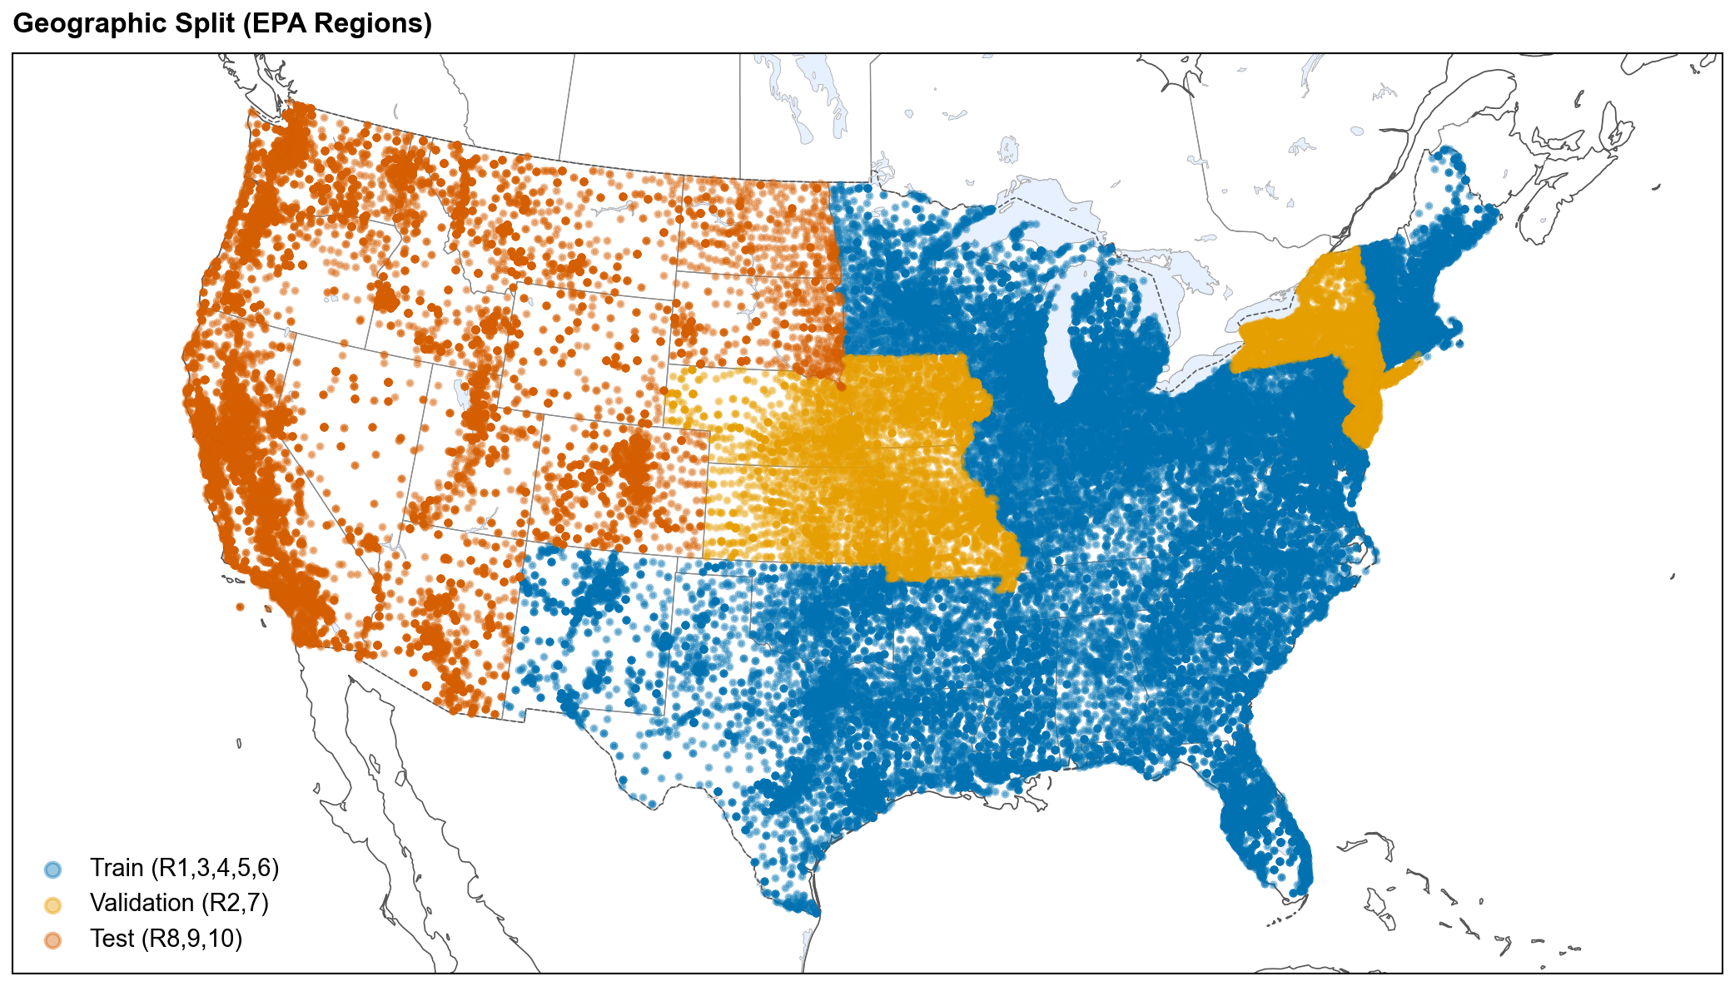
Extended Data Fig. 1

Extended Data Fig. 2: SHAP vs DML adjusted association comparison
Horizontal twin-bar chart comparing SHAP importance (correlational) and DML adjusted effects (standardized, per 1-s.d.) for the top 12 features in the T1 XGBoost model. The aggregate rank correlation between DML-adjusted and correlational feature rankings is modest but significant (Spearman ρ = 0.24, p = 0.032, n = 80), and a grouped permutation test finds no feature category displacing more than chance (Supplementary S14). Individual features nonetheless reorder substantially: 69 of 130 FDR-corrected DML coefficients are significant, and the largest displacements are environmental rather than demographic (pct_wetland_5km falls 48 positions). Among demographics, pct_less_hs_education and pct_people_of_color both retain significant adjusted associations once monitoring confounders are adjusted for (education SHAP rank 76 → DML rank 39; people-of-color standardized +0.022 per 1-s.d., p_FDR < 0.001), whereas pct_low_income does not (p_FDR = 0.54), consistent with its correlational signal being largely monitoring-mediated. Monitoring intensity shows the opposite pattern: high SHAP but smaller adjusted effects, consistent with confounding. Industrial-proximity and Superfund-proximity features retain the strongest adjusted effects (p_FDR < 0.001), with airport, landfill, and WWTP distances also significant (p_FDR < 0.05), supporting mechanistic relevance.
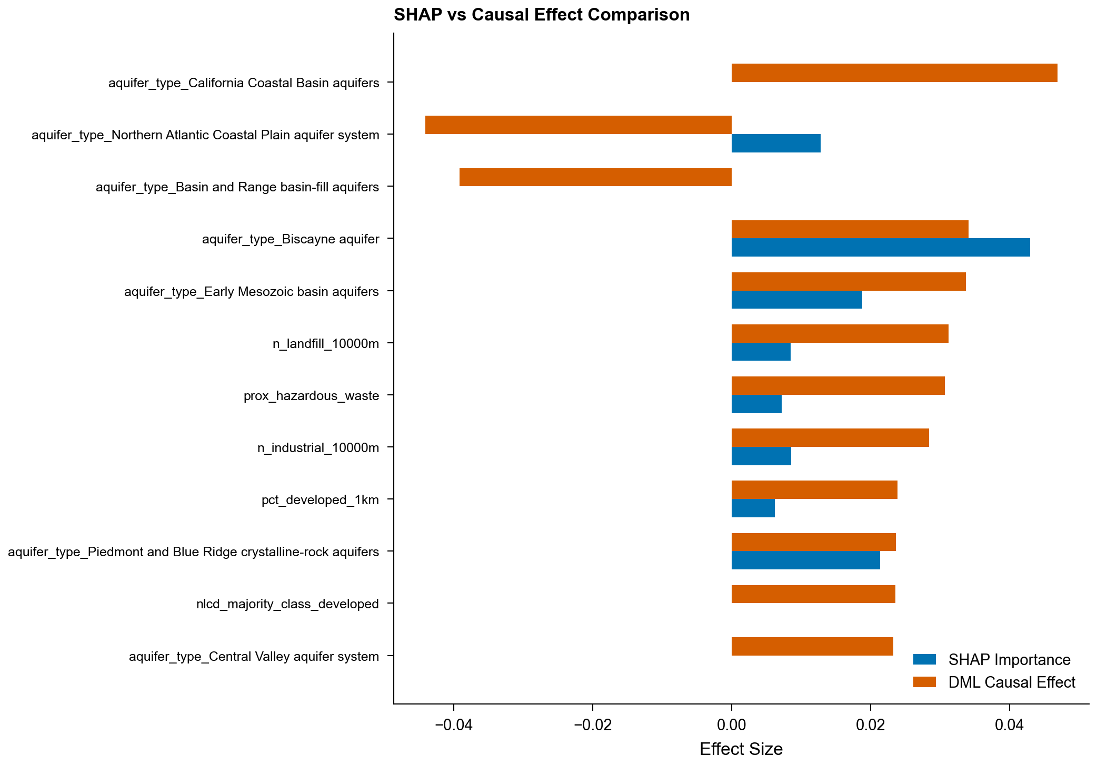
Extended Data Fig. 2

Extended Data Fig. 3: Conformal prediction per-region coverage
Per-EPA-region coverage of split conformal prediction sets at α = 0.05 (target 95%). Marginal coverage over the pooled test set is 0.910; per-region coverage varies from 0.878 (Region 9, n = 2,410) to 0.967 (Region 8, n = 538). Because calibration data come from the validation regions, coverage is guaranteed only marginally; per-region distribution-free guarantees are not claimed, and Region 9 under-covers at every significance level examined (Supplementary S6).
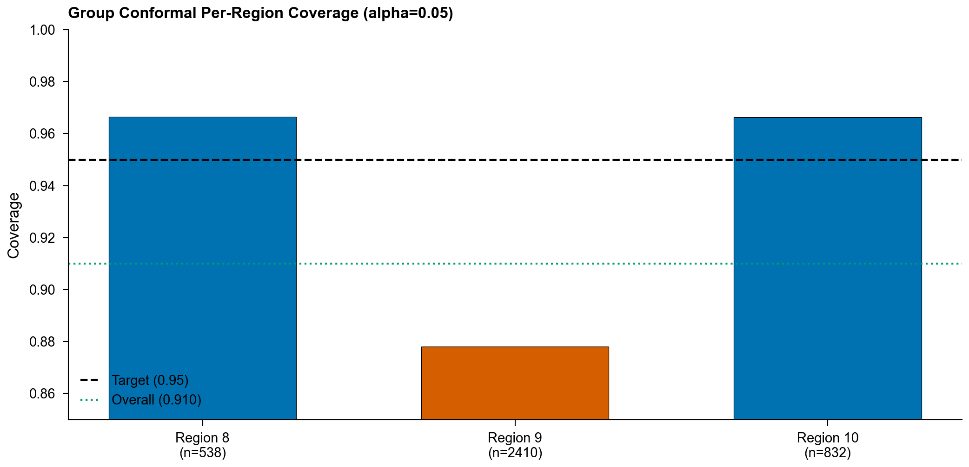
Extended Data Fig. 3

Extended Data Fig. 4: ICP training dynamics and metrics
a, Training dynamics of the Invariant Contamination Predictor showing task loss, adversary (monitoring-head) loss, and the λ_adv schedule over epochs. This is the training trace of the T1 ICP run captured through the canonical pipeline (seed 42); the same run reproduces the panel-b test AUROC, so panel a is the training history of the panel-b model rather than a separate re-fit. Task loss decreases steadily. After the warmup period λ_adv ramps to its maximum and the adversary’s monitoring-prediction loss remains high and approximately flat, indicating the representation does not encode the targeted confounders. A held-out probe confirms that data-source provenance is also suppressed (Supplementary S17). b, ICP classification performance (AUROC, AUPRC) across benchmark tasks (T1 AUROC 0.731). See Table 3 for the full monitoring-invariance decomposition.
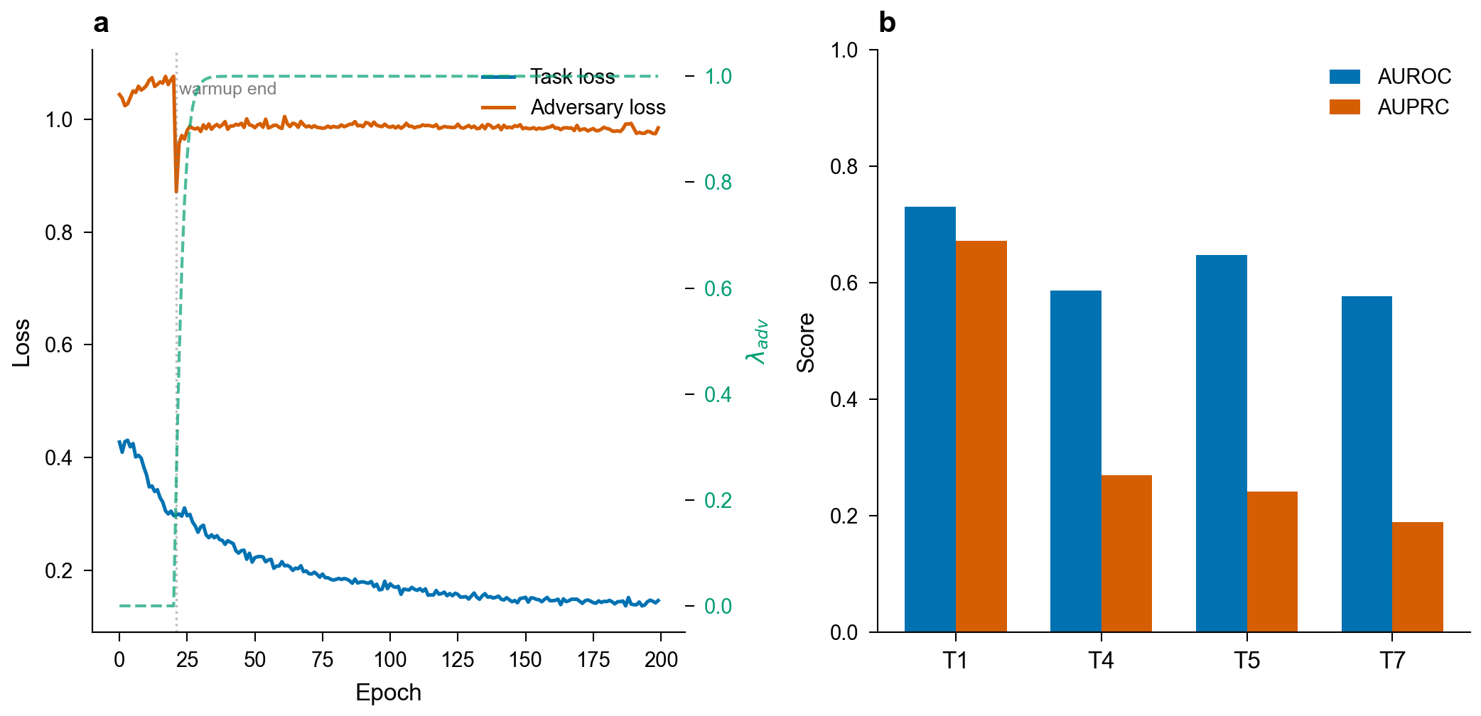
Extended Data Fig. 4

Extended Data Fig. 5: Benchmark performance overview
Test-set AUROC and AUPRC for the condensed model set on T1 (PFAS detection) and T4 (lead action-level exceedance) under geographic stratification, with 95% bootstrap confidence intervals. Companion visualization to Table 2; T4’s nominally strong performance is monitoring-confounded (see Fig. 2 and Table 3).
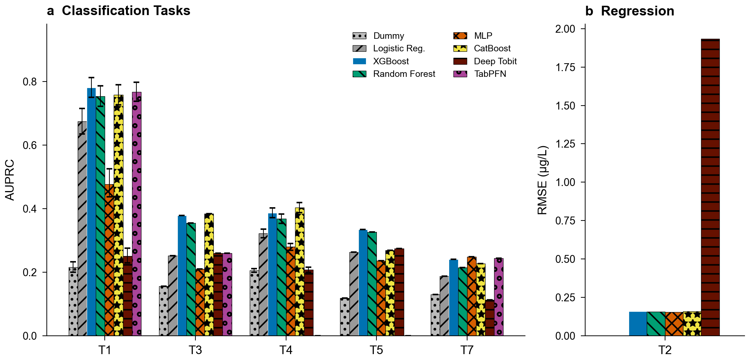
Extended Data Fig. 5

Extended Data Tables

Extended Data Table 1: Feature category ablation results
Drop-one-category ablation study for T1 (PFAS detection) and T4 (heavy metal action level) using XGBoost with train-only imputation. For each feature category, the number of features removed, baseline and ablated AUPRC, performance delta, and paired bootstrap p-value with Benjamini-Hochberg FDR correction (n = 1,000; T4 uses concatenated LORO out-of-fold predictions) are reported. On the small T1 geographic test set the monitoring-intensity ablation reduces AUPRC on both tasks, with a substantially larger and more robust effect for T4 once a target-leakage artifact inflating the T4 baseline is removed.
See paper/tables/table_ext3_ablation.csv for full results.

Extended Data Table 2: Equity analysis summary
Environmental justice burden ratios across three evaluable demographic dimensions (percent people of color, percent low income, education attainment). Linguistic isolation was excluded because no test-set systems fell below the 50th percentile (an empty reference group precludes burden ratio computation). The PFAS detection burden ratio along percent-people-of-color is 1.88 in the geographically stratified test set (EPA Regions 8, 9, 10; n_high = 618, n_ref = 1,544). Across the test set, inverse-propensity-of-monitoring weighting attenuates the people-of-color burden from 1.88 to 1.62 (still significant, permutation p < 0.001), so the disparity is not an ascertainment artifact; the LORO-weighted national mean is 1.48 (Supplementary Table 20). Permutation test p-values with Benjamini-Hochberg FDR correction. Per-group AUROC is similar across groups (0.799 high-burden vs 0.750 reference).
See paper/tables/table_ext4_equity_summary.csv for full results.

Extended Data Table 3: Literature comparison
Comparison of AquaContam (XGBoost, controlled configuration) with prior ML studies for water contamination prediction. Prior studies report high AUROC under random cross-validation without geographic holdout. In our controlled comparison the same XGBoost configuration (baseline feature set) yields AUROC 0.869 under random splitting and 0.699 under geographic stratification. A size-matched random control (training set subsampled to the geographic training-set size) reproduces the random-split result, so the drop reflects the evaluation protocol rather than model, feature, or training-set-size differences.
See paper/tables/table_ext5_literature_comparison.csv for full results.

Extended Data Table 4: Random versus geographic split comparison
Controlled three-model × three-feature-set comparison (XGBoost, Random Forest, Logistic Regression × baseline, literature-equivalent, and full feature sets; 14,405 systems) of performance under random versus geographically stratified splits for T1 (PFAS detection). AUPRC inflation under random splitting reaches up to 58%, largest for logistic regression with the full feature set (0.723 random vs 0.457 geographic); the benchmark XGBoost/baseline cell inflates by 40% (0.744 vs 0.532). A size-matched random control preserves inflation of a similar magnitude (Supplementary Table 1), ruling out training-set size as the driver. The DeLong column reports a paired test of Full-feature versus Baseline-feature AUROC on the shared geographic test set, shown on the geographic/Full rows, together with the signed difference (ΔAUROC = Full minus Baseline). That difference is negative for logistic regression, whose Full-feature model performs significantly worse.
See paper/tables/table_brennan_comparison.csv for full results.

Extended Data Table 5: Cross-source and geographic external validation
T1 (PFAS detection) model performance evaluated on independent state databases. The fitted XGBoost model (trained on UCMR5/UCMR3 with geographic stratification) is applied to each state database separately. 95% bootstrap CIs (1,000 iterations) are reported for AUROC. For states whose EPA region overlaps the training set, overlapping PWSIDs are excluded.
Panel A: Cross-source validation (independent PWS databases within validation-region geography):
State DB | EPA Region | Split Role | n Systems | AUROC [95% CI] | AUPRC | Detection Rate
NJ DEP | R2 | val | 1,310 | 0.789 [0.765-0.812] | 0.792 | 0.473
MO DNR | R7 | val | 1,208 | 0.829 [0.767-0.885] | 0.281 | 0.052
Panel B: Geographic external validation (test-region geography, non-PWS monitoring domain):
State DB | EPA Region | Split Role | n Systems | AUROC [95% CI] | AUPRC | Detection Rate
CA GeoTracker | R9 | test | 1,421 | 0.813 | 0.707 | 0.297
†On the larger external sample the model performs above chance (DeLong test vs. AUROC = 0.5: p < 0.001).
Panel C: Detection-only databases (single-class data precludes AUROC). Two detection-only sources are retained for validation (MI MPART, WA DOH); Ohio EPA is excluded because its PWSIDs overlap SDWIS, and NC DEQ provides no usable records:
State DB | EPA Region | Split Role | n Systems | AUROC | AUPRC | Detection Rate
MI MPART | R5 | train | 153 | — | — | 100% (single-class)
WA DOH | R10 | test | 256 | — | — | 100% (single-class)
OH EPA | R5 | — | — | — | — | Excluded (SDWIS PWSID overlap)
NC DEQ | R4 | — | — | — | — | Unavailable

