Supplementary Information

S1: Data Source Details

UCMR5 (Unregulated Contaminant Monitoring Rule, 5th cycle)
- Period: 2023
- Samples: 1,928,117 analytical results
- Analytes: 29 PFAS compounds + lithium (30 total)
- Censoring: 97.1% of results are non-detect (left-censored)
- Source: EPA UCMR5 occurrence data (https://www.epa.gov/dwucmr/occurrence-data-unregulated-contaminant-monitoring-rule)
- Encoding: Latin-1 (facility names contain accented characters)

UCMR3 (Unregulated Contaminant Monitoring Rule, 3rd cycle)
- Period: 2013-2015
- Samples: 1,069,174 analytical results
- Analytes: 38 contaminants including 6 PFAS (PFOS, PFOA, PFBS, PFHxS, PFHpA, PFNA)
- Censoring: 76.4% non-detect
- Source: EPA UCMR3 occurrence data

SDWIS (Safe Drinking Water Information System)
- Systems: ~150,000 public water systems
- Analytes: Lead, copper (from Lead and Copper Rule sampling)
- Source: EPA ECHO SDWIS downloads

EPA FRS (Facility Registry Service)
- Facilities: 40,828 PFAS-related facility sites
- Classification: SIC/NAICS codes + interest types (industrial, military, WWTP, airport, landfill)
- Source: EPA FRS national downloads

State Databases
State | Source | Analytes | Format
Michigan | MPART (ArcGIS REST) | 5 PFAS | JSON/API
California | GeoTracker GAMA | 29 PFAS | CSV
Ohio | EPA (ArcGIS REST) | 6 PFAS | JSON/API
Washington | DOH | 14 PFAS | CSV
Missouri | DNR (ArcGIS REST) | 29 PFAS | JSON/API
New Jersey | DEP (waterviewer REST) | 25 PFAS | JSON/API
North Carolina | DEQ | GenX + 5 PFAS | Excel/CSV
Minnesota | MDH (manual bulk export) | 27 PFAS | Excel
Minnesota MDH is a manually provided bulk export (no public API; see docs/data_requests/), parsed to 247,230 measurements across 1,357 public water systems (2005–2026, ~92% non-detect by substitution at the reporting limit). It enters the in-split benchmark population as a public-water-system compliance source. As an independent corroboration of the ascertainment confound, among the 194 Minnesota systems sampled for PFOS by both the federal UCMR cycles and MDH, 19 of the 180 (10.6%) that UCMR recorded as non-detect are detected once MDH’s independent, longer-window monitoring is included. This is direct evidence that measured detection tracks who and how much a system is monitored, not only the underlying environment.

WQP (USGS/EPA Water Quality Portal)
- Records: 35,528 valid PFAS monitoring results
- Analytes: 13 PFAS compounds across 49 CONUS states
- Censoring: 38.7% non-detect
- Source: USGS/EPA Water Quality Portal REST API (https://www.waterqualitydata.us/)
- Notes: Monitoring locations are not public water systems; synthetic WQP_ identifiers used. API batches queries in groups of three characteristicName values.
- Cross-source diagnostic: applying the T1 model to WQP as an out-of-sample check yields a pooled AUROC of 0.42, below chance. This is a Simpson’s-paradox artifact of pooling regions with very different detection base rates (four of five per-region AUROCs are above chance); it is a fair-transfer failure for ambient, non-PWS data rather than a model defect, and no reader-facing claim rests on it. Like the CA GeoTracker ambient result, it reinforces that geographic generalization to ambient sources remains undemonstrated.

TRI (Toxics Release Inventory)
- Purpose: PFAS release quantities from reporting industrial facilities
- Source: EPA TRI downloads (https://www.epa.gov/toxics-release-inventory-tri-program)
- Usage: Auxiliary data source for proximity feature engineering (facility distance/density)

DoD PFAS Sites
- Sites: 761 federal sites (724 DoD/military) with known or suspected PFAS contamination
- Source: EPA PFAS Analytic Tools database
- Usage: Auxiliary data source for proximity feature engineering (military installation distance)

Geospatial Data
Dataset | Source | Resolution | Purpose
NLCD 2021 | USGS MRLC | 30 m | Land use fractions
EJScreen | EPA (Zenodo archive) | Block group | Demographics
Principal Aquifers | USGS | Polygon | Hydrogeology
Census ZCTA | US Census Bureau | ZCTA | Geocoding

S2: Hyperparameter Configurations
All model hyperparameters are specified in configs/experiment.yaml. Default configurations used for all benchmark results:

XGBoost Classifier
n_estimators: 500
max_depth: 6
learning_rate: 0.05
subsample: 0.8
colsample_bytree: 0.8
min_child_weight: 5
scale_pos_weight: auto # computed from class ratio
early_stopping_rounds: 50
eval_metric: aucpr

Random Forest Classifier
n_estimators: 500
max_features: sqrt
max_depth: null # unlimited
min_samples_leaf: 5
class_weight: balanced

LightGBM Classifier
n_estimators: 500
num_leaves: 63
learning_rate: 0.05
subsample: 0.8
colsample_bytree: 0.8
min_child_samples: 20
is_unbalance: true
early_stopping_rounds: 50

CatBoost Classifier
iterations: 500
depth: 6
learning_rate: 0.05
auto_class_weights: Balanced
early_stopping_rounds: 50

MLP Classifier
hidden_sizes: [128, 64, 32]
dropout: 0.3
learning_rate: 0.001
epochs: 200
batch_size: 256
patience: 20

Voting Ensemble
voting: soft
base_models: [xgboost, random_forest, lightgbm, catboost]

Stacking Ensemble
final_estimator: logistic # LogisticRegression meta-learner
cv: 5
base_models: [xgboost, random_forest, lightgbm, catboost]

Symmetric Tuning Grids
Each model family receives symmetric hyperparameter tuning effort:
Model | Parameters Tuned | Grid Size
XGBoost | max_depth, learning_rate, n_estimators | 18
Random Forest | n_estimators, max_depth, max_features | 12
LightGBM | num_leaves, learning_rate, n_estimators | 18
CatBoost | depth, learning_rate, iterations | 18
MLP | hidden_sizes, learning_rate, dropout | 18
CNN1D | n_filters, learning_rate, dropout | 18

S3: Optuna Convergence Results
Bayesian hyperparameter optimization using Optuna Tree-Parzen Estimator (TPE) sampler was run for 50 trials per model family (XGBoost, Random Forest, LightGBM, CatBoost, MLP, CNN1D) on the T1 PFAS detection task. Results are saved to results/optuna_tuning.json.
The Optuna search spaces use broader ranges than grid search, enabling exploration of regions that grid search may miss. Key findings:
- Optuna trials converge within ~30 trials for tree-based models
- Final AUPRC improvements over grid search are typically modest (< 0.01)
- The TPE sampler with seed=42 ensures reproducibility

S4: CNN1D Feature Ordering Sensitivity
The CNN1D architecture treats tabular features as a 1D signal, applying convolutional filters across adjacent features. Since feature ordering is arbitrary in tabular data, we conducted a sensitivity analysis with seven orderings: alphabetical, domain-grouped (proximity → land use → hydrogeology → demographics), and five random permutations.
Results show that CNN1D performance is sensitive to feature ordering (AUROC mean 0.758 ± 0.022; AUPRC mean 0.566 ± 0.046). Alphabetical ordering achieves the highest AUROC (0.794), ahead of domain-grouped (0.776), with random orderings lower. This sensitivity confirms that convolutional architectures are not ideal for unstructured tabular data, and supports the benchmark result that tree-based models consistently outperform deep learning on AquaContam tasks.

S5: Model Calibration Details
We evaluate model calibration using Expected Calibration Error (ECE), Brier score, and reliability diagrams, then apply post-hoc calibration (isotonic regression, Platt scaling, and temperature scaling) to improve probability estimates. Pre-calibration ECE varies substantially across models: CNN1D exhibits the highest miscalibration (ECE = 0.288); the better-calibrated end includes CatBoost (0.238) and Logistic Regression (0.215). Among tree-based models, Random Forest (0.102), LightGBM (0.093), and XGBoost (0.038) are better calibrated, and XGBoost is the best-calibrated tree model out of the box; TabPFN is comparable (ECE = 0.035). Post-hoc calibration (isotonic regression) can further reduce ECE for miscalibrated models. We recommend isotonic regression for deployment. Pre-calibration reliability diagrams for T1 and T4 are shown in Supplementary Fig. 5.

S6: Conformal Prediction Coverage
We applied split conformal prediction to the T1 and T4 classification tasks, using the validation set for calibration and the test set for evaluation. Conformal prediction sets at nominal coverage levels of 90% and 95% were generated. At alpha = 0.05, XGBoost achieves empirical coverage of 0.949 with a mean prediction set size of 1.291 (out of 2 possible classes). At alpha = 0.10, per-model empirical coverage varies, with the linear model showing the most pronounced undercoverage. Split conformal prediction provides finite-sample coverage guarantees under the assumption that calibration and test data are exchangeable (i.e., drawn i.i.d. from the same distribution). Our geographic stratification (using EPA Regions 1, 3, 4, 5, 6 for training, 2, 7 for validation/calibration, and 8, 9, 10 for testing) partially violates this assumption, since calibration and test regions are spatially disjoint with potentially different feature distributions. However, three lines of evidence suggest this violation is modest in practice: (1) the empirical marginal coverage (0.910 at α = 0.05, modestly below the 0.95 target) across the test set, (2) the per-region group conformal results below, where most test regions cover near nominal but Region 9 (California) materially under-covers (0.878 against the 0.95 target), and (3) the observation that PFAS contamination drivers (proximity to industrial sites, hydrogeology, land use) are qualitatively similar across US regions even if their distributions differ. Under distribution shift conformal sets can become either conservative or anti-conservative depending on the direction of the shift (Barber et al., 2023, “Conformal prediction beyond exchangeability”). Empirically we observe modest under-coverage rather than overcoverage, so we report these figures as observed coverage, not a delivered guarantee; the prediction sets average 1.328 out of 2 possible classes. For applications requiring stricter guarantees under covariate shift, weighted conformal methods could be applied using density ratio estimation between calibration and test distributions.
Key findings: - Empirical coverage closely matches nominal coverage (within a couple of percentage points) for all model families on T4 - T1 coverage is slightly below nominal for some models (e.g., CatBoost 0.912, LightGBM 0.944 at α = 0.05), likely due to the severe class imbalance (~29% positive rate) and finite calibration set size - Conformal sets provide observed (approximate) coverage even for models with miscalibrated probability estimates

Conformal Prediction Coverage
Split conformal prediction provides a marginal coverage guarantee over the pooled test set. We report coverage broken out by EPA test region (8, 9, 10) to expose subpopulation behavior, but emphasize that the guarantee is marginal, not per-region: the calibration set comes from the validation regions, so each test region has zero in-region calibration points (n_calibration = 0) and the reliable_guarantee flag is false everywhere. At α = 0.05 (target 95%):
Region | Coverage | Avg Set Size | N
8 | 0.967 | 1.398 | 538
9 | 0.878 | 1.310 | 2,410
10 | 0.966 | 1.334 | 832
Overall (marginal) | 0.910 | 1.328 | 3,780
Region 9 (Pacific) under-covers (0.878) at every significance level examined, illustrating why per-region distribution-free guarantees cannot be claimed without per-region calibration data. A true Mondrian (per-region) conformal predictor would require carving a calibration slice from each test region, which would change the headline test set; we therefore report marginal coverage and flag the per-region variation rather than over-claiming a regional guarantee.

S7: Sensitivity Analysis
To assess robustness to preprocessing choices, we evaluate T1 (XGBoost) across five NaN-drop thresholds (0.3, 0.4, 0.5, 0.6, 0.7; the fraction of missing values above which a feature column is dropped before imputation) and several proximity buffer-radius variants. All five thresholds produce an identical 135-column feature set with identical performance (AUROC 0.858, AUPRC 0.688): no feature column has a missingness fraction in the tested range, so the threshold does not bind and the model is exactly invariant to it. Restricting proximity features to a single buffer radius leaves performance essentially unchanged, confirming the model does not depend on any single radius choice.

S7b: Coordinate Source Breakdown and Perturbation Sensitivity
Of the 95,223 systems in the dataset, 87,450 are geocoded, most via ZCTA centroids and the remainder from original source coordinates. ZCTA centroid geocoding introduces roughly 5 km of spatial imprecision for a typical system.
To quantify the impact of this imprecision on model performance, we added uniform random noise (1, 5, 10 km) to all system coordinates and re-ran T1 XGBoost (5 seeds per perturbation level). Performance is robust: at 5-km perturbation both AUROC and AUPRC are essentially unchanged, and proximity features use 5–25 km buffers that are insensitive to small coordinate shifts (see paper/tables/table_coordinate_sensitivity.md). Extending the perturbation to the empirical error tail (coordinate_tail_sensitivity.json, magnitudes to 270 km, the upper tail of the geocoding-error distribution) shows no monotone degradation: test AUROC is 0.808 unperturbed and 0.820 at 270 km, flat within run-to-run noise. The environmental-feature signal is therefore not an artifact of precise coordinates: it survives tail-magnitude perturbation, so the measurement-precision asymmetry between exact monitoring features and imprecise environmental features does not, by itself, explain the environmental features’ limited contribution.
The perturbation analyses above address random imprecision but not systematic mislocation. For a subset of systems the harmonized coordinate derives from an out-of-state mailing- or operator-address ZIP code, which places the system deep inside a foreign EPA region. We flag every system whose PWSID-prefix EPA region disagrees with its coordinate-derived region, judging each coordinate against US Census cartographic state boundary polygons (a point maps to the state whose polygon covers it, or to the nearest state within a 3.0-degree tolerance for water-jittered centroids that no shoreline-clipped polygon covers): 1,818 of the 87,450 geocoded systems. The geographic split derives from the PWSID prefix, not the coordinate, so split membership is unaffected; the exposure is limited to wrong-place environmental features for the flagged systems, and these systems are excluded from the Extended Data Fig. 1 split map. To bound the modeling impact we re-ran the T1 and T4 XGBoost benchmarks on the canonical harness with all flagged systems removed end to end (training and evaluation): T1 test AUROC moves from 0.864 to 0.866 and T4 from 0.699 to 0.697 (frozen misgeocode_sensitivity_v2.json), so the headline results do not depend on the mis-geocoded systems.

S8: Evaluation Protocol Ablation
To quantify the impact of evaluation protocol on reported performance, we compared random 5-fold cross-validation against geographic stratification using a baseline proximity/demographic feature set comparable to those used in prior PFAS prediction studies (Hu et al. 2016, Fernandez et al. 2023, Tokranov et al. 2024).
Key findings: - Under random CV, XGBoost achieves AUROC 0.869 on the baseline feature set; under geographic holdout, it drops to 0.699 - A size-matched random control, with each fold’s training set stratified-subsampled to the geographic training-set size (n = 7,930), reproduces the random-CV result, so the gap is an evaluation-protocol effect, not a training-set-size effect - The two evaluation sets differ in base rate (geographic test prevalence 0.285 versus 0.215 in the stratified random folds, pooled rate). The geographic set has the higher rate, so the prevalence asymmetry biases the AUPRC comparison against the leakage claim rather than inflating it. The prevalence-independent AUROC contrast is therefore the main-text headline (frozen split_prevalence.json) (Supplementary Table 1) - The direction is consistent across all nine model × feature-set cells (Extended Data Table 4) on AUROC: the geographic split scores below random CV on AUROC in every cell (two logistic-regression cells reverse on AUPRC, a prevalence artifact that biases against the leakage claim), with AUPRC inflation of up to 58%
The full feature set × split strategy comparison is available in paper/tables/table_brennan_comparison.md, and the random-versus-geographic performance is shown in Supplementary Fig. 6.

Supplementary Table 1: Size-matched random-split control
Random 5-fold CV with each fold’s training set stratified-subsampled to the geographic training-set size (n = 7,930), for all nine model × feature-set cells of the split comparison. AUPRC inflation relative to the geographic split persists with and without size matching, ruling out the random arm’s larger training set as the driver of the inflation.
See paper/tables/table_supp_split_sizematched.md for full results.

S9: Spatial Autocorrelation
Moran’s I test for spatial autocorrelation in model residuals was performed using inverse-distance spatial weights over the k=10 nearest neighbors. Significant positive autocorrelation (I > 0, p < 0.01) was detected in residuals of all models on both T1 and T4, indicating that model errors are spatially clustered. For the headline XGBoost T1 model, residual Moran’s I is 0.212 at 50 km, declining to 0.077 at 200 km; positive autocorrelation is present across all models (spatial_autocorrelation.json).
This finding justifies the use of geographic stratification for train/test splitting. It also means the i.i.d. bootstrap confidence intervals reported elsewhere are approximate, because residual errors are not independent.

Region-block bootstrap of the LORO headline
To check that the residual autocorrelation does not materially understate uncertainty in the headline LORO estimate, we re-estimated the T1 XGBoost LORO mean AUROC with a region-block bootstrap that resamples the ten EPA regions (the spatial-clustering scale) with replacement, recomputing the sample-size-weighted mean each iteration (10,000 iterations; spatial_block_bootstrap.json). The block-bootstrap 95% interval is [0.705, 0.860], modestly wider than the naive across-fold normal interval but qualitatively unchanged: the headline remains well above chance. Accounting for spatial clustering widens the interval modestly rather than overturning the result.

Buffered-boundary leave-one-region-out
A related concern is that systems straddling EPA-region seams could leak information across the held-out boundary. We re-ran the LORO sweep over all 10 EPA regions after excluding every training system within 50 km (EPSG:5070) of the held-out region (829–1,685 systems excluded per fold; loro_cv_buffered.json), with imputation aligned to the primary train-only path (an earlier three-region variant of this check imputed on the full dataset before subsetting and is superseded). Buffering reduces the unweighted provenance-reduced LORO mean modestly, from 0.694 to 0.661 (with-provenance 0.752), far from collapsing it: region-seam proximity contributes marginally to the estimate but does not drive the transportable signal.

S10: Software Versions
All experiments were run with the following software stack. Exact versions are recorded in results/software_versions.json during each pipeline run.
Package | Version
Python | 3.10+
NumPy | 1.24+
pandas | 2.0+
scikit-learn | 1.3+
XGBoost | 2.0+
LightGBM | 4.0+
CatBoost | 1.2+
PyTorch | 2.4+
GeoPandas | 0.14+
SHAP | 0.44+
Optuna | 3.4+
Full environment specification: environment.yml (conda) and pyproject.toml (pip).

S11: Multi-Seed Stability Analysis
To verify that benchmark results are not artifacts of a single random seed, we evaluated T1 (PFAS detection) and T4 (heavy metal prediction) across five random seeds (42, 123, 456, 789, 2024) with three model families: XGBoost, CatBoost, and Logistic Regression. Each seed controls random initialization of model training and bootstrap sampling. For tree-based models, the training set size (7,930 systems for T1, 51,283 systems for T4) is sufficiently large that stochastic variation is minimal.
Results confirm moderate stability for T1 and high stability for T4. For T1, AUROC standard deviation across seeds is 0.003 (XGBoost) and 0.005 (CatBoost); for T4, standard deviation is negligible for all models. AUPRC standard deviation is likewise small, with T1 CatBoost at 0.006. Logistic Regression is fully deterministic (zero variance). The full seed-by-seed results are saved to results/multi_seed_stability.json.

Seed Inflation Check
To assess whether reporting a single seed (seed=42) inflates metrics relative to the multi-seed distribution, we computed z-scores: z = (reported − mean) / std for each task/model. The reported seed-42 headline metrics (Table 2) come from the full benchmark pipeline, whereas the multi-seed distribution is produced by a streamlined single-model stability harness. After correcting a region- assignment defect that had caused the two paths to evaluate different test populations (Methods; ~605 geocoded systems were previously dropped from the streamlined harness), the streamlined single-model harness runs modestly below the full benchmark rather than above it, so it does not inflate reported skill: for both T1 XGBoost and CatBoost the streamlined single-model harness runs modestly below the full benchmark (the streamlined harness omits the ensemble averaging and part of the feature set). Because the paper’s honest out-of-region headline (LORO) uses XGBoost within a single harness, this cross-harness difference does not affect it. Within a fixed harness, seed-to-seed variability is small: the maximum across-seed optimism for any single model is 0.005 AUROC. T4 is near-deterministic across seeds, and Logistic Regression is fully deterministic. Full results are in results/seed_inflation_check.json.

Default-Hyperparameter Stability
Table 2 in the main text reports default (non-tuned) configurations at seed 42 for reproducibility; this subsection characterizes variability under those default configurations across seeds.
For T1, XGBoost and CatBoost show small across-seed AUROC s.d., confirming that seed-to-seed variability within a fixed harness is modest compared to the much larger differences between top tree models and neural networks. For T4, variability is negligible for all models, reflecting the stronger and more consistent signal in heavy metal prediction.

Supplementary Table 2: Multi-seed stability
See paper/tables/table_supp_multi_seed.csv for per-model, per-task mean +/- SD across five seeds.

S12: Per-Region Heterogeneity Analysis
LORO cross-validation reveals substantial variation in per-region AUROC for T1. To understand the sources of this heterogeneity, we analyzed per-region PFAS detection rates, feature distributions, and missing data patterns.
Region 4 (Southeast) underperforms with the lowest LORO AUROC, while Region 3 (Mid-Atlantic) is the strongest mainland region. Kolmogorov-Smirnov tests on the top SHAP features show significant distributional shifts between these best- and worst-performing regions for wetland fraction (KS = 0.308, FDR p < 0.001) and monitoring intensity (n_samples; KS = 0.065, FDR p < 0.05); the data-source missingness indicators do not differ significantly. Region 4 also has higher missing rates for hydrogeological features due to sparser aquifer mapping coverage, reducing the discriminative signal available to environmental features.
These findings imply that practitioners deploying AquaContam models should expect lower performance in regions with fewer industrial contamination sources and should consider region-specific calibration. Full results are in results/region_heterogeneity.json.

S13: Deep Tobit Architecture
The Deep Tobit model is a censoring-aware neural network that explicitly models left-censored observations common in water quality data. The architecture is a 3-layer MLP (128-64-32 hidden units) with ReLU activations and dropout (0.3), identical to the standard MLP baseline. The key difference is the loss function: instead of binary cross-entropy, Deep Tobit uses a Tobit likelihood loss:
L = -Σ [d_i · log φ((y_i - μ_i)/σ) - d_i · log σ + (1-d_i) · log Φ((c_i - μ_i)/σ)]
where d_i = 1 for detected (uncensored) samples, y_i is the observed concentration, c_i is the detection limit, μ_i is the predicted mean, σ is the learned noise scale, and φ/Φ are the standard normal PDF/CDF.
For binary classification tasks, the predicted latent concentration is compared against the detection limit: P(detected) = 1 - Φ((c - μ)/σ). The classification target is obtained by passing continuous concentration values (not binary labels) to the Tobit loss via _fit_extra kwargs, so the network learns the true concentration surface and derives detection probability from it. This yields T1 AUROC 0.602 (Table 2), well below the tree-based models, indicating that the censoring-aware loss does not competitively transfer to binary detection under the expanded dataset with geographic evaluation. The implementation includes gradient clipping, cosine learning rate scheduling, clamped log-sigma, and numerically stable truncated-mean prediction with asymptotic approximation for extreme z-values. For regression (T2), a log1p transform stabilizes the heavily skewed concentration distribution, and output clamping prevents overflow in the inverse Mills ratio. Despite modest T1 classification performance (AUROC 0.602), Deep Tobit achieves a T5 transfer AUROC of 0.729, the highest of any model family. The disconnect between T1 and T5 performance suggests that the censoring-aware loss captures some environmental signal relevant to cross-contaminant transfer, even when within-domain binary classification degrades.

S13b: Zero-Inflated Censored Regression Architectures
Three additional model families address the zero-inflated, left-censored structure of T2 concentration data (97% censored). Each decomposes the prediction problem differently, treating structural zeros and censored observations as distinct phenomena.
Hurdle (XGBoost two-part model). A two-stage decomposition separating the zero process from the positive-value process. Stage 1 (gate): an XGBoost binary classifier estimates P(detected) trained on all systems. Stage 2 (intensity): an XGBoost regressor estimates E[Y | detected] trained only on the ~3% detected subset, operating in log-space. The combined prediction is E[Y] = P(detected) × E[Y | detected]. Back-transformation from log-space uses the Duan (1983) smearing estimator to correct for retransformation bias, computing the empirical mean of exponentiated training residuals as the correction factor. This avoids the systematic underestimation inherent in naïve exponentiation of log-scale predictions.
XGBoost AFT (Accelerated Failure Time). Uses XGBoost’s native survival:aft objective with interval-censored encoding to provide statistically proper left-censoring treatment. Detected samples are encoded as point observations [log1p(y), log1p(y)], while censored samples are encoded as left-censored intervals [ε, log1p(DL)], where DL is the detection limit and ε is a small positive constant. The model estimates the conditional survival function S(t | X) via XGBoost’s DMatrix label_lower_bound and label_upper_bound interface. Point predictions are obtained from the estimated log-normal location parameter. This approach respects the censoring mechanism without imputation or substitution of non-detects.
Zero-Inflated Deep Tobit (ZI-Tobit). A deep neural network with three output heads on a shared hidden trunk (two hidden layers, ReLU activations, dropout, batch normalization). The gate head produces P(structural_zero) via a sigmoid activation, distinguishing true zeros from censored observations. The μ head estimates the latent mean concentration. The log-σ head estimates the log-scale parameter with clamping for numerical stability. The loss function is a zero-inflated Tobit negative log-likelihood:
L = -Σ [z_i · log(π_i) + (1-z_i) · log(1-π_i) + (1-z_i) · L_Tobit(y_i, μ_i, σ_i)]
where π_i = P(structural_zero), z_i indicates structural zeros, and L_Tobit is the standard Tobit log-likelihood from S13. A log-sum-exp trick ensures numerical stability when combining the zero-inflation and Tobit components.
Hurdle+AFT Ensemble. A simple average of the Hurdle and XGBoost AFT predictions, combining the two-part decomposition with the survival-based approach. This ensemble provides a complementary aggregation of structurally different censoring treatments without additional hyperparameter tuning.

S14: DML Adjusted Association Methodology and Results
To move beyond correlational feature importance (SHAP) toward adjusted estimates, we apply double machine learning (DML) to estimate the adjusted effect of each feature on PFAS detection probability, controlling for a pre-specified set of monitoring and system-size confounders (monitoring intensity n_samples, population served, log population served, and mean detection limit).

Algorithm
For each feature X_j:
- Cross-fitting: Split data into K=5 folds (pooled KFold(shuffle=False), used only to avoid own-fold overfitting in the nuisance step, not as a generalization split)
- Nuisance estimation: In each fold, train gradient-boosted models to predict (a) the outcome Y from the confounder set W, and (b) X_j from W
- Residualize: Compute residuals Ỹ = Y - E[Y|W] and X̃_j = X_j - E[X_j|W]
- Adjusted estimate: Regress Ỹ on X̃_j; the coefficient is the partially-linear DML estimate of X_j’s association net of W
This procedure removes confounding from the monitoring/size confounder set W, yielding the association of X_j net of monitoring intensity rather than net of all other features (the estimand is “adjusted for monitoring”, which is what the code residualizes against).

Key Results
- Adjusted AUROC: 0.729 (vs. original 0.835); ~13% of discrimination from feature confounding. Both are computed under the pooled 5-fold cross-fitting above, not the geographic holdout, so 0.835 is an in-sample pooled value distinct from the 0.864 geographic-split headline; the pair is a relative decomposition of the discrimination attributable to feature confounding, not a generalization estimate
- Significant coefficients: 69 of 130 features are significant after Benjamini-Hochberg FDR correction (p_FDR < 0.05; 59 at p_FDR < 0.01)
- First-stage strength: the treatment-residualization nuisance model has a negative cross-fitted R² for 109 of 130 features (it predicts them worse than their mean), i.e. most features are near-orthogonal to the monitoring confounders. The adjustment therefore removes little for these features not because it is mis-specified but because there is little monitoring confounding to remove, which strengthens rather than weakens the reading that the retained environmental signal is not a monitoring artifact
- Largest displacements are environmental: pct_wetland_5km falls 48 positions (of 80 ranked confounder-orthogonalized features)
- Demographic features: pct_less_hs_education is markedly upranked (SHAP rank 76 → DML rank 39) and retains a significant adjusted association; pct_people_of_color also retains a significant adjusted association (standardized coefficient +0.022 per 1-s.d., p_FDR < 0.001), whereas pct_low_income does not (p_FDR = 0.54), indicating its correlational signal is largely monitoring-mediated
- Proximity features: Industrial facility counts and Superfund proximity retain the strongest adjusted effects (p_FDR < 0.001); airport, landfill, and WWTP distances are also significant (p_FDR < 0.05), confirming mechanistic relevance
- Monitoring intensity (n_samples): SHAP importance rank 1, but smaller adjusted effect, consistent with confounding rather than direct causation

Limitations
DML assumes a partially linear model and no unmeasured confounders, both strong assumptions. Rare features (e.g., one-hot aquifer types with <100 systems) may yield unstable adjusted estimates. We report standard errors and p-values to flag unreliable estimates. The adjusted AUROC should be interpreted as a lower bound on genuine predictive signal.

Supplementary Table 3: DML adjusted association results
Top 15 features ranked by absolute DML adjusted effect. For each feature, the table reports SHAP importance (correlational), DML adjusted effect, standard error, p-value, and feature ranks in each method. Socioeconomic features show large rank displacements between DML and SHAP (e.g., pct_less_hs_education moves from SHAP rank 76 to DML rank 39), indicating genuine environmental risk pathways underattributed by correlational analysis. Original AUROC: 0.835; adjusted AUROC: 0.729 (~13% of discrimination from feature confounding). Coefficients are standardized (per 1 s.d.) so that rankings and sensitivity bounds are scale-invariant.
See paper/tables/table_ext10_causal_deconfounding.csv for full results.

Grouped Permutation Test for Category-Level Rank Displacements
The aggregate Spearman rank correlation between DML and SHAP is modest but significant (ρ = 0.24, p = 0.032), and we further tested whether individual feature categories show significantly larger mean absolute rank displacements than expected under random category assignment.
Method. For each of 5 feature categories (proximity n = 14, land use n = 22, hydrogeology n = 13, demographics n = 5, and other n = 23), we computed the observed mean absolute displacement (|SHAP rank − DML rank|). Monitoring intensity and system characteristics features were not ranked because they serve as confounders in the DML analysis and are orthogonalized out. We generated a null distribution by permuting category labels across the ranked features (10,000 permutations) and computing the same per-category mean. The one-sided p-value is (count of null ≥ observed + 1) / (N + 1). P-values are FDR-corrected across categories using Benjamini-Hochberg.
Results. No feature category reaches significance after FDR correction: across the five categories (land use, demographics, proximity, hydrogeology, and other), mean absolute rank displacements are modest and similar, and every category’s FDR-corrected permutation p-value is far from significance (dml_shap_rank_comparison.json).
The non-significance reflects the small number of features per category (especially demographics, n = 5) rather than the absence of category-level patterns. With only five socioeconomic features, even a sizeable mean rank displacement does not consistently exceed what random 5-feature subsets achieve by chance. The evidence for socioeconomic rank elevation therefore rests on the individual-feature FDR-corrected DML coefficients (69/130 significant) and the significant aggregate correlation, not on category-level permutation tests.
See results/category_displacement_test.csv for full results.

Spatially-aware permutation of the equity significance tests (M8b)
The headline monitoring-inequity ratios and the per-region burden significances were originally assessed with i.i.d. label-shuffle permutations, which ignore spatial autocorrelation and can be anti-conservative. We re-tested both under spatial nulls (spatial_permutation.json, 10,000 permutations). For the national monitoring-intensity ratios we permuted the demographic values only WITHIN EPA regions (stratified permutation), removing the between-region component from the null; the people-of-color sampling disparity (ratio 1.85x) remains significant, p < 0.001, and the low-income under-sampling likewise persists. For the per-region burden significances, because the frozen per-region burdens use held-out per-fold imputation that a single global-imputation assembly does not reproduce exactly, we compared the naive label shuffle against a spatial ROTATION null (circular shift over within-region k-means spatial-cluster order) on ONE common assembly, a valid comparison of the two permutation methods. On that assembly 5 regions are FDR-significant under the naive null but only 3 survive the spatial null, confirming that the naive per-region test is mildly anti-conservative and motivating the softened claim in the main text.

S15: Supplementary Figures

Supplementary Fig. 1: Cross-contaminant transfer results
Transfer learning results for T5 (lead-to-PFOS transfer). The Deep Tobit classifier achieves the highest transfer AUROC (0.729), superficially comparable to within-domain T1 models. However, ablation of system characteristics reduces XGBoost AUROC substantially toward chance for this negative-class-dominated task, demonstrating that shared monitoring patterns largely mediate the apparent cross-contaminant transfer. The residual signal above baseline suggests modest genuine geospatial commonality, but headline transfer numbers should not be interpreted as evidence of transferable environmental risk without proper ablation.
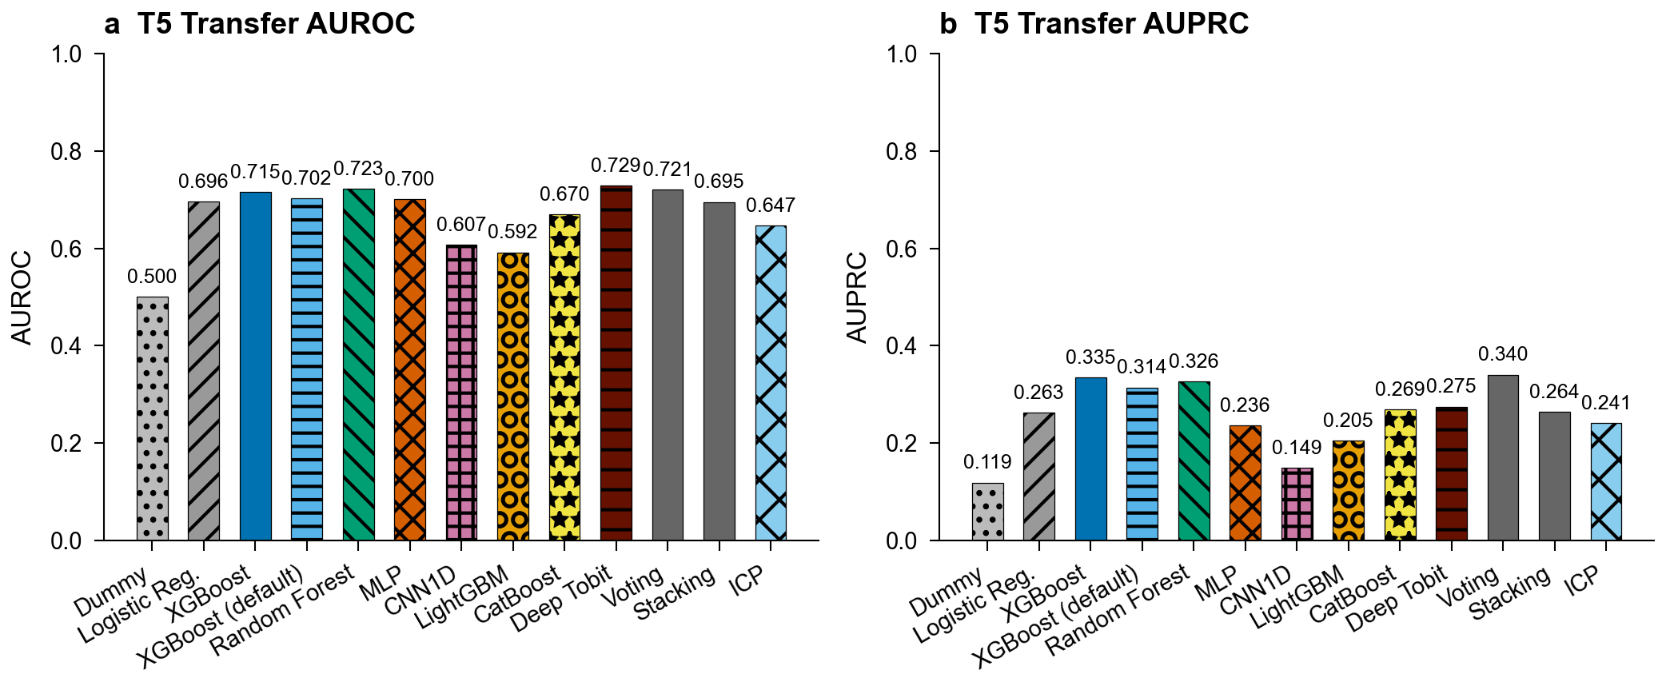
Supplementary Fig. 1

Supplementary Fig. 2: Temporal prediction performance
T7 temporal prediction results (UCMR3-to-UCMR5). XGBoost achieves the best AUROC of 0.664 (with TabPFN close behind). Analysis by system persistence reveals better performance on persistent systems (monitored in both periods) than newly monitored systems, suggesting historical monitoring features provide additional predictive signal.
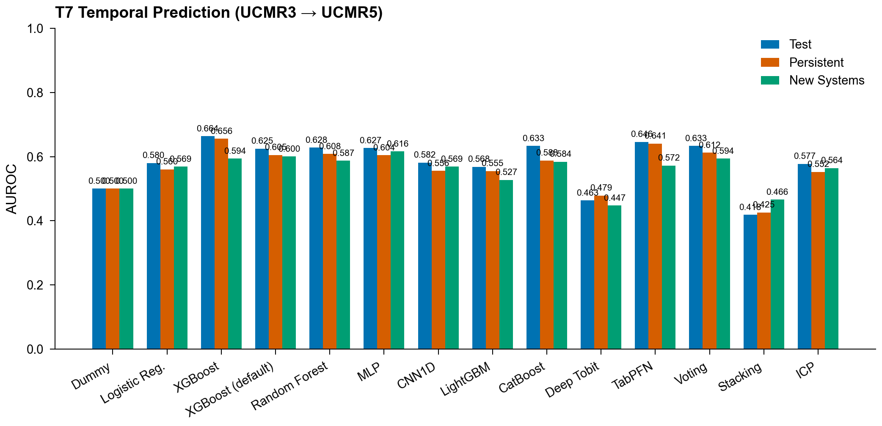
Supplementary Fig. 2

Supplementary Fig. 3: Complete feature correlation matrix
Pearson correlation matrix of the top 30 features (by variance) used in the AquaContam benchmark. Features are grouped by category: proximity, hydrogeology, land use, and demographics. Strong correlations between aquifer type indicators reflect mutually exclusive one-hot categories. Moderate positive correlations between facility proximity features and developed land use fractions are consistent with industrial co-location in urbanized areas.
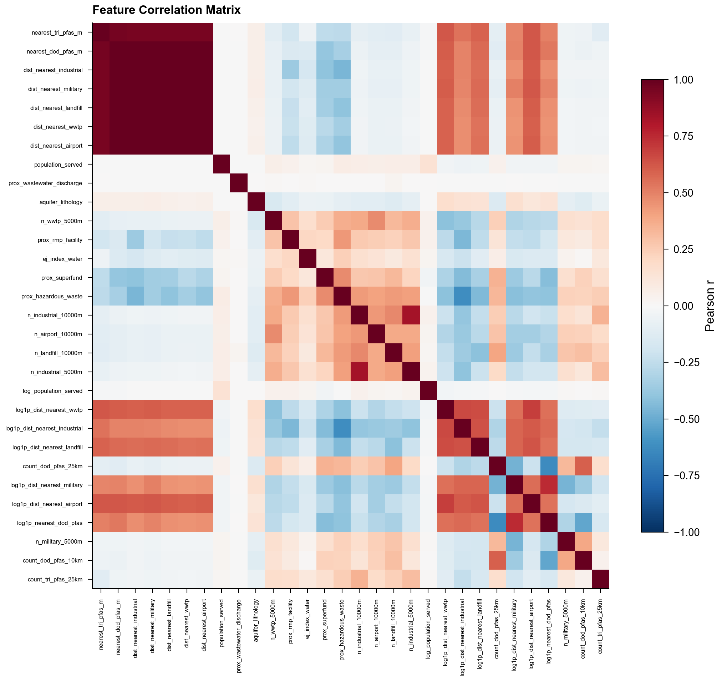
Supplementary Fig. 3

Supplementary Fig. 4: Per-analyte AUROC
Per-analyte AUROC for the T3 multi-PFAS profiling task across all model families (grouped bars, one group per analyte). The five target analytes vary substantially in prediction difficulty: PFOA is the most predictable, PFBS is markedly harder, and HFPO-DA is not evaluable because the geographic test regions (8, 9, 10) contain no HFPO-DA detections, leaving AUROC undefined (annotated in the figure).
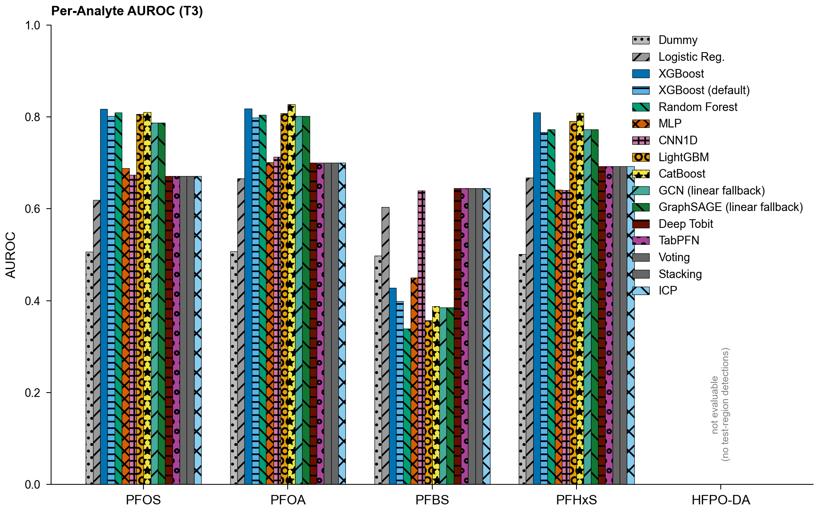
Supplementary Fig. 4

Supplementary Fig. 5: Reliability diagrams
Reliability diagrams for (a) T1 PFAS detection and (b) T4 lead action-level exceedance across model families (see Supplementary S5). Each curve plots the observed fraction of positives against the mean predicted probability per probability bin; models on the diagonal are perfectly calibrated, with deviations below or above the diagonal indicating over- or under-confidence. Expected calibration error (ECE) for each model is shown in the legend.
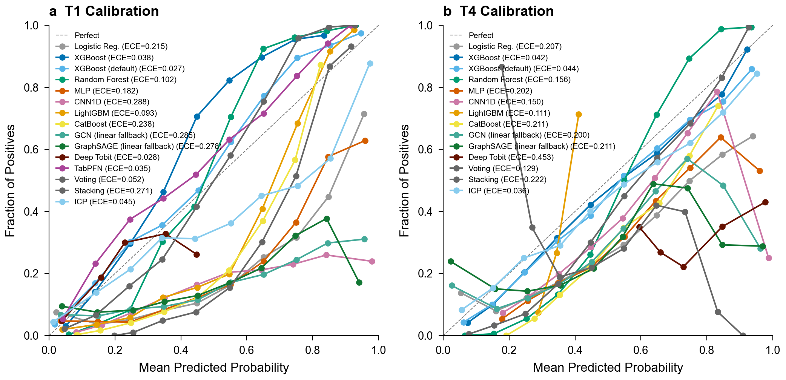
Supplementary Fig. 5

Supplementary Fig. 6: Evaluation protocol comparison
Performance comparison using a baseline proximity/demographic feature set under both random and geographic evaluation protocols (see Supplementary S8). Under random CV, XGBoost achieves AUROC 0.869 with the baseline feature set; under geographic holdout, performance drops to 0.699, demonstrating that evaluation protocol, not model or feature differences, drives the gap.
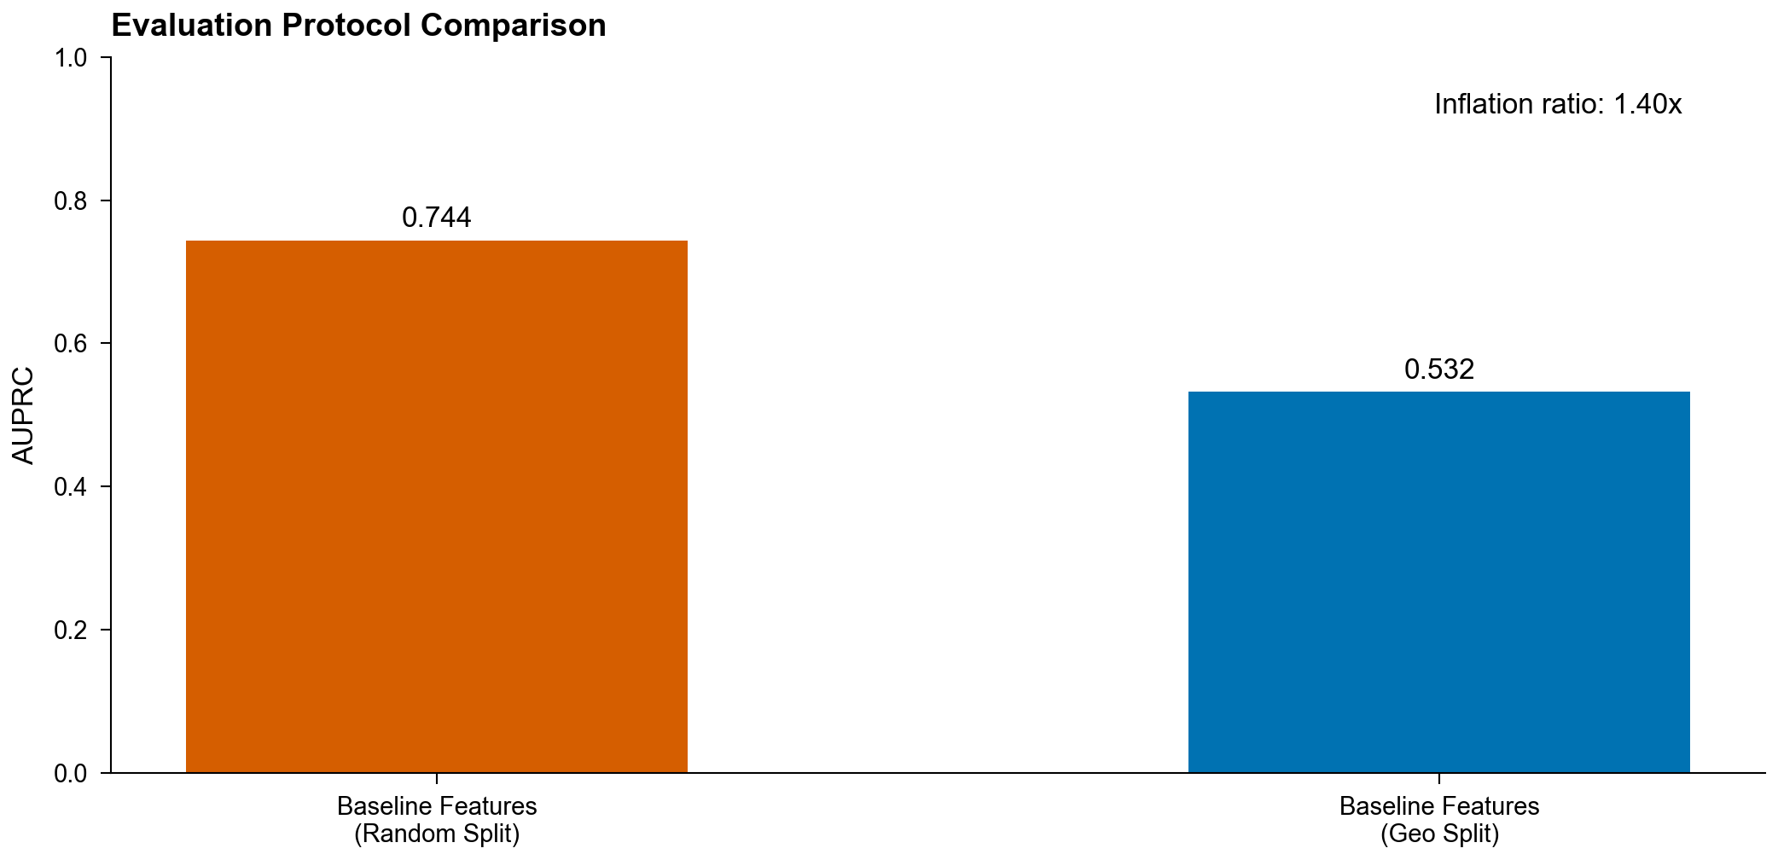
Supplementary Fig. 6

Supplementary Fig. 7: AUROC and AUPRC by model for T1 and T4
Per-model test-set AUROC and AUPRC summary bars for T1 (PFAS binary detection) and T4 (heavy metal prediction) across all model families, regenerated from the frozen benchmark metrics (the frozen archive deliberately strips per-system prediction arrays, so ROC/PR curves are not reconstructable from tracked inputs; see Code Availability). The divergence between AUROC and AUPRC underscores why AUPRC is the primary benchmark metric for imbalanced water quality classification. (Relocated from Extended Data to stay within the ten-item Extended Data limit.)
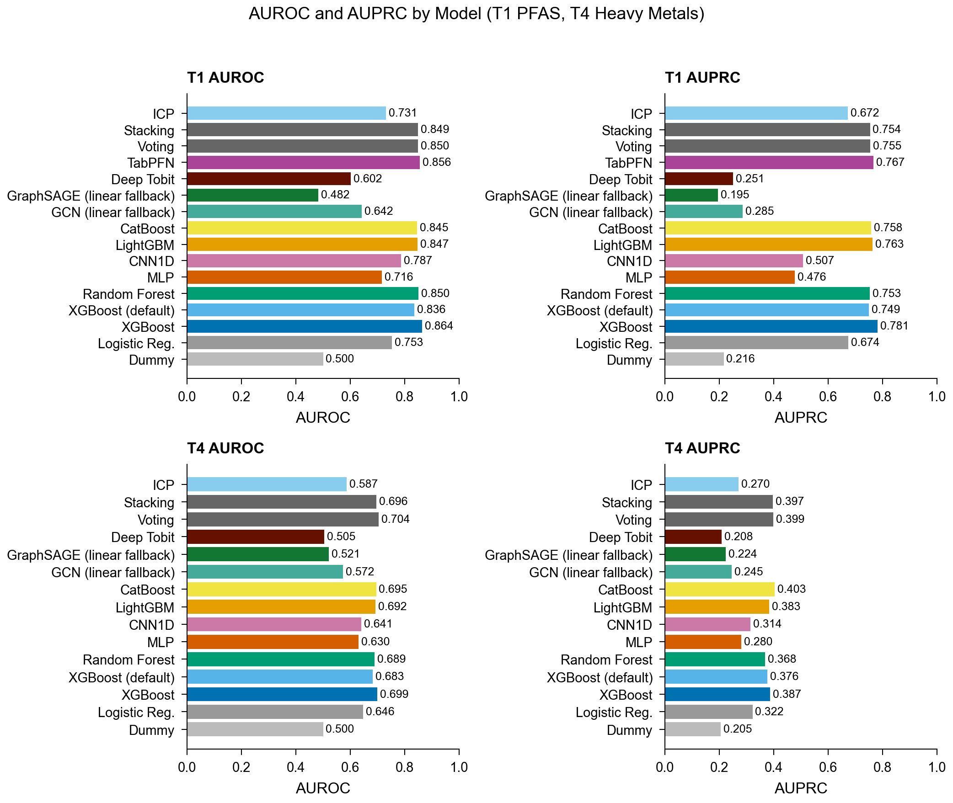
Supplementary Fig. 7

Supplementary Fig. 8: Data distribution and contamination patterns
Distribution of PFAS detection rates across analytes and monitoring periods. UCMR5 exhibits 97.1% overall censoring, with individual analyte detection rates in the low single digits (highest for PFOS). UCMR3 shows 76.4% censoring with higher detection limits. Heavy metal detection rates from SDWIS are substantially higher. Concentration distributions for detected samples are right-skewed across all contaminant classes. (Relocated from Extended Data.)
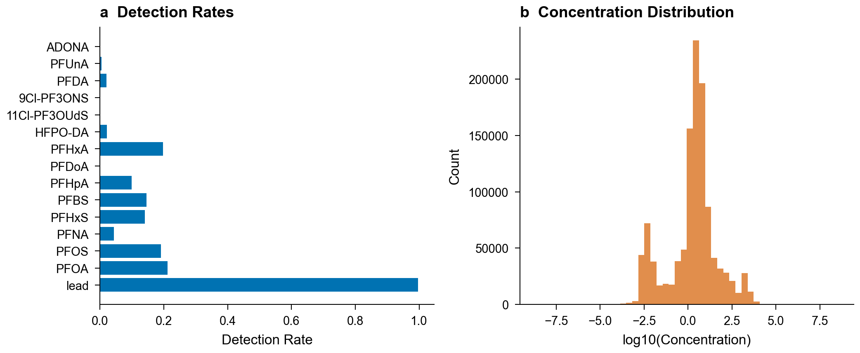
Supplementary Fig. 8

Supplementary Fig. 9: National PFAS (PFOS) risk surface
Predicted T1 PFOS detection risk for 15,268 public water systems across the contiguous United States (XGBoost national inference; quantile-based color scale). This is the same per-system risk surface served by the interactive risk-screening web application (Code Availability), regenerated from the slim prediction export in the frozen archive (predictions_slim.json). Risk scores support monitoring prioritization within the monitored population and inherit the transportability limits quantified in the main text (out-of-region performance, Table 2); systems plotted here include mis-geocoded coordinates discussed in Supplementary S7b.
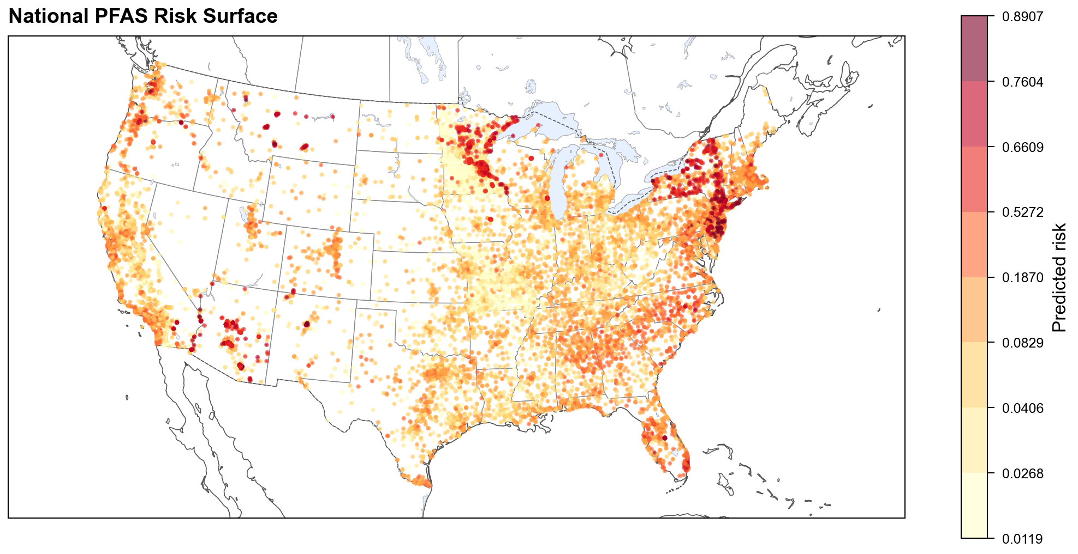
Supplementary Fig. 9

S16: Supplementary Tables (Relocated from Extended Data)

Supplementary Table 4: Benchmark results by task (representative analyte)
Benchmark results for the classification tasks and model families, one row per model-task pair with each task’s representative target analyte (e.g., PFOS for T1). The table reports AUROC, AUPRC, F1, precision, and recall, plus macro-averaged AUROC and AUPRC for the T3 multilabel task. The genuine per-analyte disaggregation is Supplementary Fig. 4 (T3 per-analyte AUROC); per-label, micro-averaged, and regression-task (T2) metrics are provided in the accompanying CSV.
See paper/tables/table_ext2_per_analyte.csv for full results.

Supplementary Table 5: Environmental justice framework outputs
Complete environmental justice disparity analysis across three evaluable demographic dimensions from EPA EJScreen: percent people of color, percent low income, and percent with less than high school education. Linguistic isolation was excluded because no test-set systems fell below the 50th percentile, leaving an empty low-burden reference group and precluding burden ratio computation. For each dimension, the table reports the contamination burden ratio, prediction ratio, per-group AUROC, sample sizes, and permutation test p-values with Benjamini-Hochberg FDR correction.
See paper/tables/table_ext4_ej_framework.csv for full results.

Supplementary Table 6: SHAP feature importance rankings
Top 20 features ranked by mean absolute SHAP value for the T1 XGBoost model. Monitoring intensity (n_samples) dominates, followed by land use features (wetland fraction, forest fraction) and proximity features (WWTP count, Superfund distance).
See paper/tables/table_ext6_feature_importance.csv for full results.

Supplementary Table 7: Monitoring intensity ablation
Model performance with and without monitoring intensity features (n_samples, mean_detection_limit) for T1 and T4 using train-only imputation to prevent leakage. For each task, full-feature and ablated AUROC and AUPRC are reported alongside deltas and paired bootstrap p-values (n = 1,000). Removing monitoring features reduces T1 XGBoost AUPRC modestly under train-only imputation, indicating that T1’s monitoring dependence is weak on the small geographic test set. T4 XGBoost AUPRC falls substantially without monitoring features once the leaked reporting-limit feature is removed; the apparent 0.902 baseline was itself a target-leakage artifact (Methods). The contrast (T1 weak and non-significant, T4 significant) is the central asymmetry of the ascertainment analysis.
See paper/tables/table_ext3_ablation.csv for full results.

Supplementary Table 8: Group conformal prediction
Per-alpha-level group conformal prediction results with per-region coverage guarantees. For each significance level (α ∈ {0.05, 0.10, 0.20}), the table reports target coverage, observed overall coverage, average prediction set size, and per-region coverage for test regions 8, 9, and 10.
See paper/tables/table_ext11_group_conformal.csv for full results.
Coverage stratified by the flagged PROTECTED demographic groups (rather than by EPA region) is also available (group_conformal_demographic.json, median split on the calibration set). At alpha = 0.05 the high-people-of-color group receives conformal coverage 0.919 versus 0.886 for the low-people-of-color group; both sit below the 0.95 nominal target (the disclosed geographic-transfer under-coverage), and the ordering does not compound the false-negative-rate disparity (the higher-burden group is not the more poorly covered one). Because calibration is on the val regions, these per-demographic figures are transfer estimates rather than within-group exchangeable guarantees.

Common-reporting-limit sensitivity
The pooled T1 detection label mixes reporting limits that differ by an order of magnitude (UCMR5 quantifies PFOS to ~0.004 ug/L, UCMR3 to ~0.04 ug/L), so a UCMR5 detection below 0.04 ug/L would be a non-detect under UCMR3’s coarser limit. To bound how much of the T1 signal is detection-limit heterogeneity rather than contamination, we re-censored every PFOS detection below the common (coarser) 0.04 ug/L limit to non-detect, rebuilt the system-level label, and retrained the T1 model on the same assembly (common_rl_sensitivity.json, default configuration; reproduction gate ties the un-recensored baseline to the frozen xgboost_default entry). Re-censoring reclassifies the large majority of PFOS detections and lowers test AUROC modestly, from 0.828 to 0.781, about five points. The AUPRC drop is far larger, from 0.727 to 0.102, because re-censoring reclassifies 29,583 PFOS detections and the positive class contracts sharply, so precision-recall performance is dominated by the shrunken, harder positive set. The detection signal is therefore robust in ranking (AUROC) to reporting-limit harmonization (it survives an aggressive common-limit re-censoring at ~0.78 AUROC) but not in precision-recall, where AUPRC collapses to 0.102; the ~five-point AUROC drop quantifies the part attributable to detection-limit heterogeneity, motivating the common-reporting-limit caveat in the main text.

Supplementary Table 9: Complete benchmark results
Full benchmark results for all model families across all tasks (T1–T7), including AUROC, AUPRC, F1, precision, recall, and task-specific metrics with 95% bootstrap confidence intervals. This table extends the condensed Table 2 in the main text, which reports only T1 and T4 for six representative models.
See paper/tables/table_supp9_benchmark_full.csv for full results.

GCN and GraphSAGE performance note
GCN achieves AUROC 0.642 on T1 and GraphSAGE 0.482 (near the 0.500 chance baseline), both well below the tree-based models (XGBoost 0.864). Two implementation facts bound the interpretation. First, inference in our GNN wrapper is an unconditional linear fallback: predict_proba scores held-out systems with a linear read-out over node features under every split strategy, not only under geographic holdout, so the reported numbers characterize this graph-augmented-training/linear-inference pipeline rather than full message-passing inference. Second, geographic stratification additionally severs test-region graph edges to training nodes, so even a transductive deployment could not message-pass across the split boundary. Under leave-one-region-out evaluation with coordinates supplied to the graph builders, the same pipelines average AUROC 0.683 (GCN) and 0.652 (GraphSAGE) across all ten folds (Table 2), at the bottom of the converged families. We report these results as a lower bound on GNN performance under geographic holdout and note that future work on genuinely inductive graph inference (e.g., feature-based rather than transductive embeddings, with graph-aware read-outs) may improve geographic generalization.

Supplementary Table 10: Decile-based lift analysis
Decile-based lift analysis for the full model and monitoring-free model on the T1 (PFAS detection) test set (EPA Regions 8, 9, 10). Systems are ranked by predicted risk (highest first) and grouped into deciles. The detection rate per decile shows how effectively the model concentrates true positives in the highest-risk systems. Top-decile lift is the ratio of the top-decile detection rate to the overall detection rate. Top-quintile capture is the fraction of all detections found in the top 20% of predicted risk. Even without monitoring features, the monitoring-free model provides actionable prioritization.
See paper/tables/table_supp_lift_analysis.csv for full results.

Supplementary Table 11: Hyperparameter tuning comparison
Symmetric hyperparameter tuning results for all model families on T1 PFAS detection. For each model, the table reports the number of grid configurations tested, default-configuration test performance (AUROC and AUPRC), tuned- configuration test performance, and the performance delta attributable to hyperparameter optimization. All model families received identical tuning effort (18 grid configurations plus 50 Bayesian optimization trials each), ensuring that performance rankings in Table 2 are not confounded by asymmetric tuning. The tuning grids are fully specified in configs/experiment.yaml.
See paper/tables/table_ext2_tuning_comparison.csv for full results.

Supplementary Table 12: Complete feature catalog
Comprehensive catalog of all geospatial features extracted for each water system in the AquaContam benchmark. Features are organized into four categories: proximity (features from EPA FRS facility distances and buffer counts, TRI release-weighted proximity, and DoD PFAS site proximity), land use (7 features from NLCD 2021 raster zonal statistics), hydrogeology (3 feature groups from USGS Principal Aquifers, one-hot encoded to ~20 binary columns), and demographics (6 features from EPA EJScreen block group indicators). Each entry includes the feature name, category, and description. Features with more than half their values missing are dropped prior to model training; remaining missing values are imputed with column medians. One documented exception: the aquifer-confinement one-hots survive this filter because one-hot encoding precedes it (fully missing systems fall in the _nan indicator), so they persist as retained all-missing indicator columns with zero model attribution rather than functional predictors.

Supplementary Box 1: Recommendations for practitioners
Based on our findings, we offer the following recommendations for researchers and regulators developing ML models for water contamination prediction:
- Adopt geographic holdout evaluation. Random cross-validation inflates AUPRC substantially due to spatial autocorrelation (the inflation is somewhat smaller for the benchmark gradient-boosted configuration and persists in a size-matched control). Use geographic stratification (e.g., EPA regions, states, or watersheds) as the minimum evaluation standard for any spatial environmental ML model.
- Report AUPRC alongside AUROC. Under severe class imbalance (>90% negative), AUROC can be misleadingly high while practical precision remains low. AUPRC directly reflects the trade-off relevant to monitoring resource allocation.
- Separate monitoring-dependent from monitoring-free models. For unmonitored systems (the primary deployment target), use models trained without monitoring intensity features to avoid circular predictions. Reserve full-feature models for systems with historical data.
- Validate with independent geographic data. Even geographically stratified splits from a single dataset may share systematic biases. Validate on truly external data (e.g., state monitoring programs not in training) before deployment.
- Cross-check SHAP attributions with DML adjusted associations. SHAP and DML can disagree in both directions: after deconfounding, the percent-low-income association shrinks and loses FDR significance (p_FDR = 0.54), while less-than-high-school education rises sharply in rank (SHAP rank 76 to DML rank 39) and percent-people-of-color retains a significant adjusted association. Neither ranking alone is reliable for policy; the disagreement itself flags monitoring-mediated correlations.
- Treat conformal coverage as marginal, not per-region. Group conformal prediction calibrated on the validation regions provides only a marginal coverage guarantee over the pooled test set (0.910 at α = 0.05); per-region coverage varies (Region 9 under-covers at 0.878) and no test region has in-region calibration data, so per-region guarantees are not reliable.

S17: Monitoring-Invariant Prediction (ICP)
The Invariant Contamination Predictor (ICP) addresses monitoring dependence architecturally rather than through feature ablation or post-hoc adjustment.
Scope and validity. The ICP’s monitoring-suppression is validated on T1 (PFAS detection), where the recoverability probe quantifies the drop in recoverable data-source provenance (0.64 vs 0.79 from raw features), and is reported for T4 (lead action level). On T3 (multilabel), T5 (cross-contaminant transfer), and T7 (temporal) the adversarial objective is degenerate (the monitoring head’s R^2 is not computable on these task structures), so the ICP did not converge and reaches only chance-level performance; those entries in Supplementary Table 9 are non-converged and back no headline claim. Separately, the ICP rows in spatial_autocorrelation.json are a pre-GRL-fix residual-autocorrelation diagnostic, retained for completeness but excluded from the headline residual Moran’s I range.

Architecture
The ICP consists of a shared encoder feeding two heads:
- Contamination head: Predicts the target (PFAS detection or concentration)
- Monitoring head: Predicts monitoring confounders (log(n_samples), mean detection limit) from gradient-reversed representations
The Gradient Reversal Layer (GRL) sits between the encoder and the monitoring head. During the forward pass it acts as an identity function; during backpropagation it negates and scales gradients by −λ:
GRL(x) = x (forward)
∂GRL/∂x = −λ · I (backward)
This forces the encoder to learn representations from which monitoring confounders cannot be predicted, removing both direct monitoring signal and indirect proxy signal (e.g., population correlating with n_samples).

Training procedure
- Warmup phase (default 20 epochs): Only the contamination head trains; λ_adv = 0. The encoder learns useful representations without adversarial pressure.
- Adversarial phase: λ_adv follows a sigmoid annealing schedule: λ_adv(t) = λ_max · (2/(1 + exp(−γ·(t − t_warmup)/t_warmup)) − 1)
- Adversary updates: The monitoring head receives 5 SGD updates per encoder update (detached gradients), ensuring the adversary is strong enough to provide meaningful gradient reversal signal.

IPW reweighting
Inverse propensity weights correct for monitoring selection bias:
- Fit logistic regression to predict high-monitoring-intensity indicator from features
- Compute stabilized IPW weights: w_i = P(T=1) / P(T=1|X_i) for treated, P(T=0) / P(T=0|X_i) for control
- Clip weights to [0.1, 10] for stability
- Apply as per-sample weights to the BCE loss
Assumptions and limitations. IPW reweighting requires three identification assumptions: (1) conditional ignorability: monitoring selection is independent of contamination outcomes given observed covariates; (2) positivity: all systems have non-zero probability of being in both high- and low-monitoring groups; and (3) correct propensity model specification. UCMR5 monitoring is MNAR by design (a census of systems serving >3,300 people plus a mandatory EPA-selected representative sample of ~800 smaller systems, rather than a voluntary or random draw), so condition (1) may be violated if population size affects contamination through channels not captured by the feature set. Weight clipping to [0.1, 10] addresses positivity violations but introduces bias. These estimates should be interpreted as partially adjusted for monitoring intensity rather than fully debiased.

Group DRO
Group Distributionally Robust Optimization optimizes worst-case performance across EPA regions using exponentiated gradient updates:
q_g ← q_g · exp(η · L_g) / Σ_g' q_g' · exp(η · L_g')
where q_g are group weights and L_g is the mean loss for EPA region g. This prevents the model from sacrificing performance in small or difficult regions to improve the aggregate.

Regressor variant
The ICP regressor replaces the BCE contamination loss with Tobit NLL (see S13 for the Tobit likelihood formulation), outputs mu and log_sigma heads, and uses truncated mean prediction with the same asymptotic approximation as Deep Tobit for numerical stability.

Hyperparameters
Parameter | Value
Encoder sizes | [128, 64]
Head size | 32
Dropout | 0.3
Learning rate (encoder+task) | 0.001 (Adam)
Learning rate (adversary) | 0.01 (SGD + momentum 0.9)
Max epochs | 200
Warmup epochs | 20
Early stopping patience | 20
λ_adv (max) | 1.0
λ_dro | 0.1
Adversary steps per update | 5
Batch size | 256

Held-out recoverability probe
To test directly whether the ICP representation is free of monitoring information, we trained a fresh probe, independent of the adversary used during ICP training, to predict the categorical data-source label (the three in-split provenance classes) from the encoder representation on the held-out test regions, and compared it against the same probe trained on the raw features. The result is positive: data-source provenance is less recoverable from the ICP representation (macro one-vs-rest AUROC 0.64 logistic / 0.56 MLP) than from the raw features (0.79 / 0.74), against a chance baseline of 0.5 (icp_recoverability.json). The learned representation therefore carries less monitoring information than the model inputs themselves. For comparison, probing the provenance-reduced FEATURE SET directly (the deployment inputs, not a representation) recovers data-source provenance at AUROC 0.65, below the raw-feature 0.79 but still well above chance, and slightly above the ICP representation’s 0.64: dropping the explicit provenance features reduces source-recoverability without eliminating it (residual one-hot re-encoding of missingness), so the provenance-reduced estimate is an upper bound on the environmental signal and the ICP representation is the stricter probe (pf_recoverability.json).
This was achieved by training the adversary to convergence over the full schedule (Extended Data Fig. 4a): the gradient-reversal adversary targets the two continuous monitoring-intensity confounders (log n_samples, mean detection limit), and the held-out probe shows that the categorical data-source provenance is suppressed alongside them, below the level recoverable from the raw features. The suppression carries a measurable cost: the ICP attains T1 AUROC 0.731, about four points below the 0.785 of the provenance-reduced model, so monitoring invariance trades transportable accuracy for representation-level independence. The gradient-reversal objective is empirical, not a formal guarantee, but on this held-out probe the representation is demonstrably less monitoring-informative than the inputs. We therefore report 0.731 as the predictor’s transportable skill under genuine monitoring invariance.

Cluster-robust recalibration of the out-of-region intervals
The region-block bootstrap for the transportable-signal AUROC and the national detection-burden ratio resamples only ten EPA-region clusters. With so few clusters the block bootstrap is anti-conservative, and its width is essentially that of a naive normal interval. Recalibrating with a t-distribution on nine degrees of freedom widens both intervals: the provenance-reduced out-of-region AUROC interval becomes [0.606, 0.783] and the detection-burden interval [1.22, 2.04] (cluster_ci_calibration.json). Both remain on the correct side of chance and parity respectively, so the survival and inequity conclusions hold; we therefore report the region-level intervals as indicative.

Supplementary Table 13 / Table 3: Monitoring-invariance decomposition
Comparison of four approaches to handling monitoring dependence in PFAS prediction: (1) full model with all features, (2) the provenance-reduced (environment-only) model with the ten provenance/monitoring features dropped, (3) ICP with adversarially invariant representations, and (4) DML post-hoc adjusted association analysis. Reports AUROC and AUPRC for T1 and T4 where applicable. This decomposition is promoted to main-text Table 3; the full table is at paper/tables/table3_monitoring_invariance.csv (identical content at table_supp11_monitoring_invariance.csv). Headline values: T1 full AUROC 0.864 → provenance-reduced 0.785 → ICP 0.731; T4 full 0.699 → provenance-reduced 0.550 → ICP 0.587 (the apparent 0.962 was a target-leakage artifact; Methods).

Practitioner Guidance: ICP vs. Feature Ablation
Scenario | Recommended approach | Rationale
Few monitoring features, low correlation with environmental predictors | Feature ablation | Simpler; negligible signal loss
Monitoring features entangled with environmental signal (e.g., population, system type) | ICP, at an accuracy cost | Attains T1 AUROC 0.731 (about four points below the 0.785 provenance-reduced model) and genuinely suppresses the targeted monitoring-intensity confounders; a held-out probe recovers data-source provenance from its representation at only AUROC 0.64, below the 0.79 from raw features (S17 recoverability probe), though this is empirical, not a formal guarantee
Regulatory transparency required | DML + feature ablation | Interpretable coefficients; ICP is a black-box encoder
Maximum debiasing with prediction | ICP + DML cross-check | Use ICP for prediction, DML for interpretation
T4 heavy metal prediction | Caution: all approaches | T4’s apparent 0.962 was largely target leakage; once corrected the full model reaches AUROC 0.699 and ICP 0.587, and the genuine monitoring-intensity effect is modest
The pre-fix artifacts underlying the historical “before” values in this table are preserved in repository history (commit 9cf4d56); the current frozen archive contains only post-fix artifacts regenerated in a single canonical run. ## S18: MCL Exceedance Analysis
In April 2024 the EPA finalized individual Maximum Contaminant Levels (MCLs) for five PFAS: PFOS and PFOA at 4 ppt, and PFHxS, HFPO-DA, and PFNA at 10 ppt, together with a Hazard Index for mixtures. PFBS has no individual MCL; its 2,000-ppt value is the Health-Based Water Concentration that enters the Hazard Index, which we use as a per-analyte exceedance threshold here. To assess whether detection-based models (T1) transfer to the regulatory-relevant exceedance target, we trained XGBoost classifiers on both targets using the same features and geographic splits.
Of the systems with regulated PFAS data, about one in five exceed at least one MCL. The detection target is predicted substantially better than the MCL exceedance target (see paper/tables/table_supp_mcl_exceedance.csv). The performance gap reflects the stricter MCL threshold: exceedance requires not only detection but concentrations above the regulatory limit, making it a harder prediction task with a different spatial distribution of positive cases.
These results suggest that detection-based models provide only a partial proxy for MCL risk: the roughly nine-point AUROC gap and the sharper AUPRC gap (quantified in the main-text actionability analysis) mean that direct MCL exceedance prediction benefits materially from dedicated modeling. The MCL target is also rarer in the test set than detection, compounding the difficulty. Full results are in results/mcl_exceedance_analysis.json.
The exceedance union scored here covers the four individual PFAS MCLs (PFOS, PFOA, PFHxS, HFPO-DA) plus PFBS via its Hazard-Index threshold; the PFNA individual MCL is omitted for source-coverage parity, which mislabels a small number of systems. Of 112 systems that exceed the PFNA MCL, 5 are PFNA-only exceeders (they exceed no analyte in the union) and are therefore currently scored non-exceedant, against a union of 3,385 exceeders (pfna_exceedance_count.json). The omission is therefore quantitatively negligible but is stated here for completeness.
The scored target fires only on single-analyte exceedances and does not compute the EPA mixture Hazard Index (the summed ratio across PFHxS, PFNA, HFPO-DA, and PFBS). Systems that violate the enforceable rule only through a Hazard Index at or above one built from individually sub-threshold analytes are therefore scored non-exceedant; the scored “MCL exceedance” is thus an individual-MCL approximation of the enforceable standard, used only as a harder-target comparison, where the qualitative direction (harder than detection) is robust.

Supplementary Table 14: MCL exceedance comparison
See paper/tables/table_supp_mcl_exceedance.csv for detection vs. MCL target metrics.

S19: Statistical Power Analysis
We computed post-hoc statistical power for the key hypothesis tests reported in the main text and supplementary analyses:
DeLong AUROC comparison (the top two T1 models, XGBoost vs. TabPFN): effect size 0.007, pooled SE 0.010, power = 0.11 (α = 0.05). This comparison is underpowered: the top two models differ by under one AUROC point, so the leaderboard ordering among the leading models is within sampling noise (Table 2).
Environmental justice burden ratio (high-burden vs. low-burden communities): effect size 0.19, power > 0.999. The disparity in PFAS detection rates between high- and low-burden communities is well-powered.
DML adjusted coefficient (proximity features): effect size 0.038, SE 0.015, power = 0.72. The DML estimates have moderate power to detect adjusted effects of the reported magnitude.
LORO cross-validation: recomputed from the observed per-fold AUROCs (frozen power_analysis.json, loro_tests block), all six task/model combinations have power > 0.99 to distinguish from chance (AUROC = 0.5), confirming that geographic cross-validation robustly detects above-chance prediction.
Feature ablation bootstrap tests: power to detect the observed category-removal effects is generally low for the environmental categories (proximity, land use, and hydrogeology), reflecting their small ablation deltas, and high only for the monitoring categories whose removal moves performance substantially (n_samples and system characteristics). This pattern is consistent with the environmental signal being modest while monitoring features dominate. Full results are in results/power_analysis.json.

Supplementary Table 15: Statistical power summary
See paper/tables/table_supp_power_analysis.csv for per-test power estimates.

S20: Adjusted Association Sensitivity Bounds
The DML adjusted association analysis (S14) identifies environmental features with statistically significant adjusted effects on PFAS contamination after controlling for monitoring confounders. To assess robustness to unmeasured confounding, we computed Rosenbaum-style sensitivity indices and E-value-style bounds for each standardized (per 1 s.d.) DML coefficient, so the bounds are on a scale-invariant footing. Both are adaptations applied outside their original design assumptions: there is no matched design, and the E-value maps a probability-scale coefficient through a risk-ratio formula. They therefore serve as heuristic robustness screens, not formal sensitivity guarantees (main text, Methods).
Rosenbaum Gamma* (tipping point): For each feature, Gamma* is the smallest sensitivity parameter at which the adjusted association conclusion would be overturned. After standardization, 54 of 130 coefficients retain significance across the entire gamma range up to Gamma = 3.0 (their bounds never cross the null within the tested range), including data-source provenance proxies and several environmental features (proximity, wetland fraction, aquifer type). This statistical robustness is driven by the very large sample (n ≈ 12,854 systems → tight confidence intervals), not by large effect sizes. The remaining coefficients tip at lower Gamma. Among the demographic features the picture is split: pct_low_income is the most fragile, tipping at Gamma* = 1.0 (not robust to any unmeasured confounding), whereas pct_people_of_color remains significant through Gamma = 3.0, consistent with the main text and sensitivity_bounds.json (pct_people_of_color gamma_star = null).
E-values (VanderWeele & Ding 2017): The E-value quantifies the minimum strength of association that an unmeasured confounder would need with both treatment and outcome to explain away the observed point estimate, and it exposes how substantively small these adjusted associations are despite their Rosenbaum robustness. After standardization, all E-values are small. The largest belong to aquifer/provenance indicators: tellingly, the strongest adjusted associations in the entire feature set are structural and monitoring artifacts, not environmental drivers, and the pct_people_of_color E-value is smaller still. Because even the most robust coefficient could be explained by a weak confounder, we interpret every DML coefficient as an adjusted association, not a causal effect.
E-values are computed via the VanderWeele & Ding continuous-exposure formula applied to the standardized coefficient (mapped to an odds-ratio scale per 1 s.d.). Full results are in results/sensitivity_bounds.json, and the analysis records "feature_scaling": "standardized".

Supplementary Table 16: Sensitivity bounds for top DML features
See paper/tables/table_supp_sensitivity_bounds.csv for Rosenbaum bounds and E-values.

S21: Detection-Only Source Ablation
Three data sources in our compilation report only detection outcomes without concentration data: MI MPART, SDWIS, and WA DOH. These sources contribute only positive examples (detections) to the dataset, potentially inflating classification metrics. To test this, we evaluated T1 models on the test set after excluding systems originating from detection-only sources.
This analysis uses evaluation-side ablation: the model is not retrained, but the test set is subsetted to exclude detection-only systems. If metrics remain stable, the model’s predictive power does not depend on these sources.
Of the two detection-only sources retained for validation (MI MPART, WA DOH), only WA DOH contributes systems to the test set (EPA regions 8–10); MI MPART systems fall entirely in training/validation regions. In the frozen run the evaluation-side exclusion fired for the reference XGBoost model (256 WA DOH systems, 11.0% of the 2,322 systems the reference model scored): excluding them reduces XGBoost AUROC from 0.838 to 0.714 and AUPRC from 0.760 to 0.343. The large AUPRC drop arises because WA DOH systems are predominantly positive (detections), so their removal both lowers the test-set prevalence and removes systems the model identifies through their data-source signature (the headline ascertainment result of Fig. 2b). The remaining predictive signal from geospatial and system features is substantial (XGBoost AUROC 0.714 after exclusion). Full results are in results/detection_only_ablation.json. (The archived run records this exclusion only for XGBoost; extending the evaluation-side exclusion to the other model families is a deferred refinement and does not affect the headline XGBoost ascertainment figure.)

Supplementary Table 17: Detection-only source ablation
See paper/tables/table_supp_detection_only.csv for before/after metrics.

LORO per-region detection-only ablation
To isolate the effect of detection-only sources on per-region LORO performance, we applied the same evaluation-side exclusion to each LORO fold’s test set. Only two regions are affected: Region 10 (WA, OR, ID, AK) where WA DOH contributes 256 detection-only systems, and Region 5 (IL, IN, MI, MN, OH, WI) where MI MPART contributes 153 detection-only systems. All other folds contain no detection-only sources in their test sets.
Excluding WA DOH systems from the Region 10 fold and MI MPART systems from the Region 5 fold, then recalculating the cross-regional mean, yields an adjusted LORO AUROC that isolates genuine geographic predictability from positive-only sampling bias. Per-region deltas and adjusted summary statistics are reported in Supplementary Table 18.

Supplementary Table 18: LORO per-region detection-only ablation
See paper/tables/table_supp_loro_detection_only.csv for per-region before/after metrics.

S22: Feature Interaction Analysis
To assess whether spatial features interact with system characteristics in non-additive ways, we computed SHAP interaction values for the best tree-based T1 model (XGBoost or CatBoost). SHAP interaction values decompose the prediction into main effects and pairwise interaction terms, identifying feature pairs whose joint contribution exceeds their individual effects.
We report the top 15 interaction pairs ranked by mean absolute interaction strength across test samples. Each pair is classified by category: spatial × system, spatial × spatial, spatial × demographic, or other combinations. Strong spatial × system interactions indicate that the effect of proximity features (e.g., distance to industrial facilities) depends on system characteristics (e.g., population served), suggesting that contamination risk is context-dependent rather than purely distance-based.
Using the XGBoost T1 classifier evaluated on 1,000 test samples, the strongest interaction is between monitoring intensity (n_samples) and wetland land cover (pct_wetland_5km), indicating that the predictive effect of sampling effort depends on the surrounding land use context. The second-strongest interaction involves analytical sensitivity (mean_detection_limit) and aquifer lithology, suggesting that hydrogeological context modulates how detection limits influence prediction. Monitoring characteristics (n_samples, mean_detection_limit) appear in ten of the top fifteen interaction pairs, consistently interacting with land use (wetland, forest, developed fractions) and hydrogeology. WWTP proximity (n_wwtp_5000m) appears in three of the top fifteen pairs, interacting with both land use and aquifer type. Only one interaction (developed × wetland land cover) involves a purely spatial × spatial pair without a monitoring dimension.
These results suggest that contamination risk prediction is context-dependent: the effect of monitoring characteristics varies with the environmental setting, and spatial features interact non-additively. Full results are in results/shap_interactions_T1.json.

Supplementary Table 19: Top feature interaction pairs
See paper/tables/table_supp_interactions.csv for the top 15 interaction pairs.

S23: LORO Cross-Validation Environmental Justice Analysis
The primary EJ analysis (main text, Fig. 4) reports burden ratios on the geographically held-out test set (EPA Regions 8, 9, 10; western US). To assess whether these disparities generalize across regions, we perform a Leave-One-Region-Out (LORO) equity analysis: for each of the 10 EPA regions, we train a fresh XGBoost classifier on the remaining 9 regions and compute burden ratios on the held-out region’s test set.
Methodology. For each held-out region, we:
- Train an XGBoost classifier (identical hyperparameters to T1) on systems from the 9 remaining regions, with geographic validation.
- Generate out-of-sample predictions for the held-out region.
- Join EJScreen demographic indicators (percent people of color, low income, limited English proficiency, less than high school education) to each system via nearest-neighbor spatial join (10 km maximum distance).
- Compute burden ratios using the 80th/50th percentile split (consistent with the primary analysis).
- Assess statistical significance via permutation testing (1,000 permutations per region-group combination).
- Apply Benjamini-Hochberg FDR correction globally across all region-by-group tests to control the false discovery rate.
Regions with fewer than 30 systems having matched demographic data are excluded from analysis due to insufficient sample size for reliable percentile splitting. Because individual regions have substantially fewer systems than the combined test set (n = 2,846), per-region estimates have wider confidence intervals and reduced statistical power.

Supplementary Table 20: LORO per-region EJ burden ratios
See paper/tables/table_supp_loro_equity.csv for per-region burden ratios across all EPA regions and demographic groups.

S24: T7 Temporal Shift Diagnostics
Temporal prediction (T7) trains on UCMR3 (2013–2015) data and evaluates on UCMR5 (2023) detection outcomes, achieving a best-model (XGBoost) AUROC of 0.664. To investigate the sources of performance degradation, we computed Kolmogorov-Smirnov (KS) tests for per-analyte detection limit distributions and per-feature distributions between eras.
System overlap analysis reveals substantial population turnover between the UCMR3 and UCMR5 monitoring periods: fewer than half of systems were monitored in both periods, with many systems new in UCMR5 and many UCMR3 systems not re-monitored. This substantial population turnover limits temporal transfer.
Feature distribution analysis shows the largest distributional shifts in population served, land use development fractions, and hazardous waste proximity. All proximity and land use features show statistically significant (p < 0.05) distributional shifts between eras, indicating that feature distributions have evolved substantially between the UCMR3 and UCMR5 monitoring periods due to new system additions, urban development, and changes in industrial activity.
Per-analyte detection limit distributions also differ significantly between eras: UCMR5 uses lower detection limits than UCMR3 for most shared analytes, which contributes to higher detection rates in the UCMR5 period. The measured temporal degradation is therefore confounded with this reporting-limit change: the same UCMR3-to-UCMR5 reporting-limit shift that the common-reporting-limit analysis quantifies (a monitoring-defined change in what counts as a detection, not only a change in contamination) inflates the apparent era-to-era shift in the label, so T7 degradation cannot be attributed to environmental drift alone.

Supplementary Table 21: T7 feature distribution shift (KS statistics)
See paper/tables/table_temporal_diagnosis.csv for per-feature KS statistics and per-analyte detection rate comparisons between UCMR3 and UCMR5.

S25: T2 Concentration Regression Diagnostics
All T2 models achieve near-zero or negative R², including censoring-aware architectures (Tobit, AFT, Hurdle, Zero-Inflated Deep Tobit). This reflects a fundamental asymmetry in the predictive signal available at the system level: geospatial features (proximity, land use, hydrogeology, demographics) predict whether PFAS is present but not its concentration magnitude given detection.
Concentration variability in detected samples is likely dominated by within-system factors (sampling point depth, temporal variation in source water, and local hydrochemistry) that are not captured by system-level features. Zero-inflated and hurdle models recover only weak ranking signal (Hurdle regressor concordance index near chance) but successfully separate the zero-class (non-detect) from detected samples, suggesting that the binary detection decision is learnable but the continuous concentration surface is not.
T2 is retained in the benchmark as a documented negative result establishing the boundary of system-level prediction. Resolving concentration prediction would require fundamentally different data: within-system features (e.g., wellhead depth, treatment technology, source water hydrochemistry) that are not currently available at national scale.

Supplementary Table 22: T2 regression diagnostics
See paper/tables/table_supp_t2_diagnostic.csv for per-model detected-only R², overall R², and concordance index.

S26: Validation Set Reuse Bias Quantification
To disentangle validation-set reuse from regional heterogeneity in the holdout-to-LORO gap (XGBoost holdout AUROC 0.864, LORO mean 0.782), we ran three matched XGBoost experiments (5 seeds each) holding the test set (Regions 8, 9, 10) constant:
Condition A (triple use): Train on Regions 1,3,4,5,6; early-stop on Regions 2,7; test on Regions 8,9,10. Mean AUROC: 0.809 (SD 0.003).
Condition B (internal val): Train on ~85% of Regions 1,3,4,5,6; early-stop on a held-out portion of the training regions; Regions 2,7 excluded. Mean AUROC: 0.802 (SD 0.007).
Condition C (no ES): Train on Regions 1,3,4,5,6; no early stopping (all 500 rounds); test on Regions 8,9,10. Mean AUROC: 0.787 (SD 0.005).
Decomposition. Val-reuse effect (A − C) = +0.022, i.e. early stopping on the external validation regions raises AUROC by this amount. Val-identity effect (A − B) = +0.007. Validation-set reuse therefore explains 27.5% of the holdout-to-LORO gap (0.864 − 0.782); the remainder is dominated by regional heterogeneity (per-test-region holdout AUROC: R8 = 0.759, R9 = 0.763, R10 = 0.956).
AUROC is threshold-independent, so only early stopping (not threshold optimization) can introduce val-reuse bias in AUROC. Hyperparameters are pre-set in experiment.yaml, not tuned on the validation set. The mean AUROC across Conditions A–C reflects the XGBoost configuration of this harness; the decomposition isolates only the relative contribution of val-reuse within XGBoost.

Supplementary Table 23: Val-reuse bias decomposition
See paper/tables/table_supp_val_reuse_bias.csv for per-seed, per-condition, and per-region results.

Supplementary Table 24: T6 arsenic transfer (public-supply to domestic)
Per-model results for benchmark task T6 (USGS National Groundwater Aggregation, CC0): in-distribution public-supply test AUROC under geographic vs. random splitting and the geographic-leakage inflation between them, alongside the zero-shot domestic-well holdout AUROC/AUPRC. Models are trained on public-supply arsenic wells (env-only features, MCL-exceedance target) and evaluated zero-shot on independent domestic wells. A full Optuna sweep (6 models x 300 trials) tuned on the public-supply validation split did not improve the domestic transfer (mean AUROC change near zero; the best default model’s AUROC dropped slightly when tuned; mean AUPRC change near zero), reinforcing the default-configuration benchmark.
See paper/tables/table_t6_arsenic.csv for full results.

Supplementary Table 25: Per-group error rates and calibration (T1)
For the T1 PFAS-detection model on the geographically held-out test set (EPA Regions 8/9/10), per-group operating-point error rates and calibration stratified by demographic burden (80th/50th-percentile high/low split): false-positive rate, false-negative rate, and expected calibration error, alongside per-group AUROC. False-negative and false-positive rates are derived in closed form from the frozen per-group confusion-matrix summaries; expected calibration error is computed from per-system probabilities reproduced by a seed-42 T1 retrain that matches the frozen per-group AUROCs exactly. Along the percent-people-of-color dimension the model both misses more contaminated high-share systems (false-negative rate 0.50 vs 0.44) and is less well calibrated for them (expected calibration error 0.18 vs 0.06), reinforcing the deployment caution stated in the main text. Because equal-width ECE is sensitive to bin occupancy at the smaller high-share sample size, we also report equal-mass (equal-count) ECE with 2,000-resample bootstrap CIs: 0.179 [0.146, 0.213] for high-share versus 0.052 [0.044, 0.077] for low-share systems. The intervals do not overlap, so the calibration gap is a real subgroup difference rather than a binning artifact (group_ece_debiased.json).
See paper/tables/table_supp_group_error_calibration.csv for full results.

Supplementary Table 26: Areal-apportionment robustness of EJ burden ratios
Test-region detection-burden ratios (EPA Regions 8/9/10) under single-nearest block-group demographic attribution (baseline, which reproduces the frozen burden ratios exactly) versus population-weighted areal apportionment over TIGER 2023 block groups intersecting 5-km and 10-km service-area buffers, with each block group weighted by its population times its fractional area within the buffer. The headline percent-people-of-color ratio is essentially unchanged under population-weighted areal apportionment, indicating the single-block-group attribution does not drive the disparity. Linguistic isolation is omitted (degenerate single-nearest baseline: empty test-set reference group).
See paper/tables/table_supp_areal_apportionment.csv for full results.

Supplementary References
Works cited in this Supplementary Information that are not in the main reference list.
Barber, R. F., Candès, E. J., Ramdas, A. & Tibshirani, R. J. Conformal prediction beyond exchangeability. Ann. Stat. 51, 816–845 (2023).
Duan, N. Smearing estimate: a nonparametric retransformation method. J. Am. Stat. Assoc. 78, 605–610 (1983).
VanderWeele, T. J. & Ding, P. Sensitivity analysis in observational research: introducing the E-value. Ann. Intern. Med. 167, 268–274 (2017).

