|  |
| --- |
|  |
| User Guide of the Harbour Online Booking System |
|  |



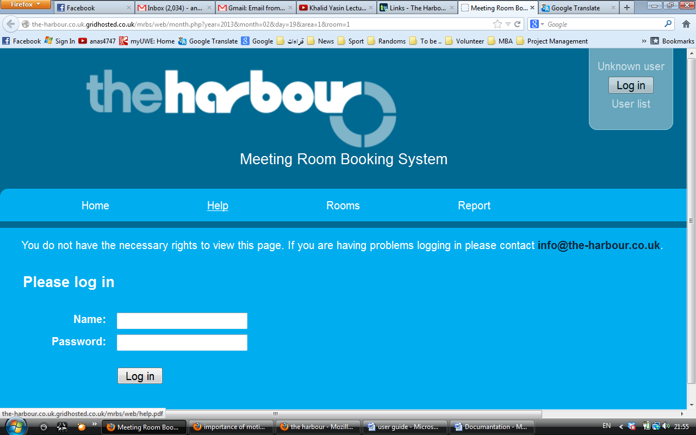

**Contents**:

Welcome

Access the webpage

Login Page

Operating the webpage

Making booking

Booking conflict

Editing booking

Log Off

**Welcome**This User Guide introduces you to features and functions of the Harbour online room booking system. It contains detailed information of the online system including snapshots of all pages and requirements you may face while browsing the system.

**Access the webpage**

To open the online room booking system of the Harbour:

1. Open up the relevant web browser you normally use,  
   e.g. Google Chrome, Mozilla Firefox, Internet Explorer or Apple Safari

1. Write the following URL: http://www.the-harbour.co.uk/rooms
2. This will lead you to the login page, as shown below. Please note you cannot create a login

details, all login details are provided by the Harbour administration office.

**Login page**

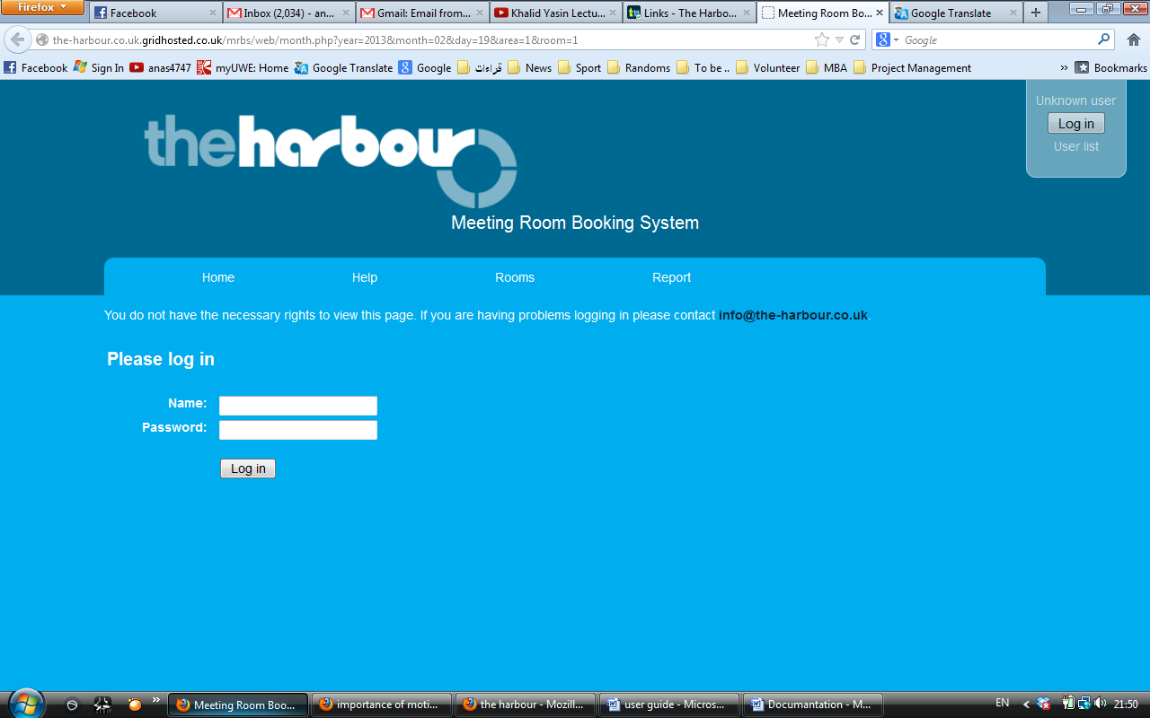

Then press login

Enter your login name on the name box

Enter your login password

**Operating the webpage**

Once you login this is the how the front page would look like. This is the monthly colander including the booking of other therapists

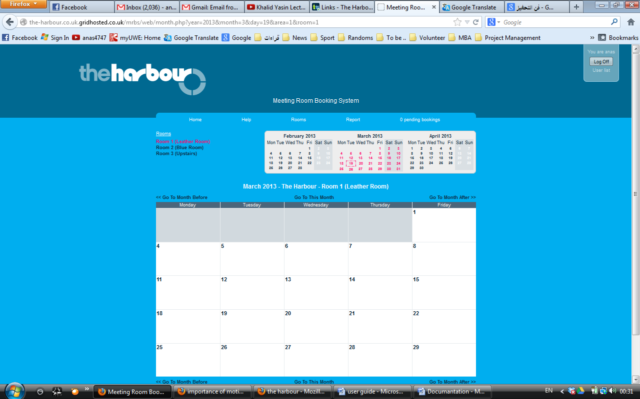

Here you can choose the room you want to view

Click here to view next month calendar

Click here to view previous month calendar

**Making booking**

Click on the day you want to book for, Once you click, you will be transferred to the booking page where you will be required to fill out a booking form in order to make a booking.

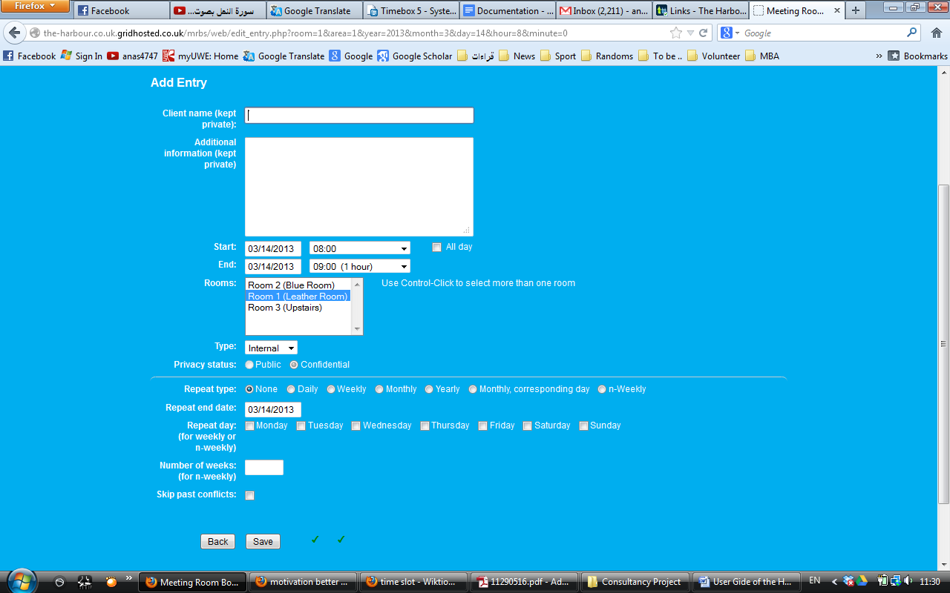**Booking page**

Information required for booking are:

* **Client Name**: Insert the client name
* **Additional Information**: Add any additional information about the booking
* **Start**: Starting time for the booking
* **End**: End time for the booking
* **Rooms**: Choose the room you want your session to take place in
* **Type**: Choose whether you are an internal or external therapist

From here onwards is for repeating booking:

* **Repeat Type**: Choose how you want to repeat the booking
  + *Daily* – Repeat every following day after the start date
  + *Weekly* – Repeat booking every week
  + *Monthly* – repeat booking on the same date each month
  + *Yearly* – repeat booking on the same date every year
  + *Monthly correspondent day* – repeat booking on the same date each month
  + *N-weekly* – repeat bookings every nth week, for example to make a booking every other week choose n-weekly and set the number of weeks to 2.
* **Repeat until date**: Choose the end date for the booking to occur. Note the end date that will appear is the same date of the start date, this must be changed to the end date of the repeat booking in order for the booking to be repetitive.
* **Repeat day**: Ending day for the repeating booking
* **Number of weeks**: Enter the number of weeks this booking will be repeating for
* **Skip past conflict**: Click here to skip the repeating section

**Booking Conflict**

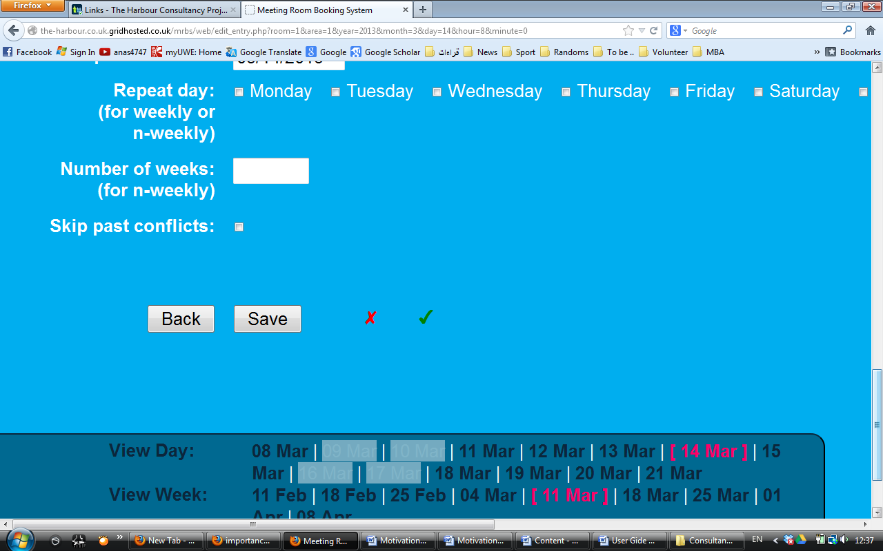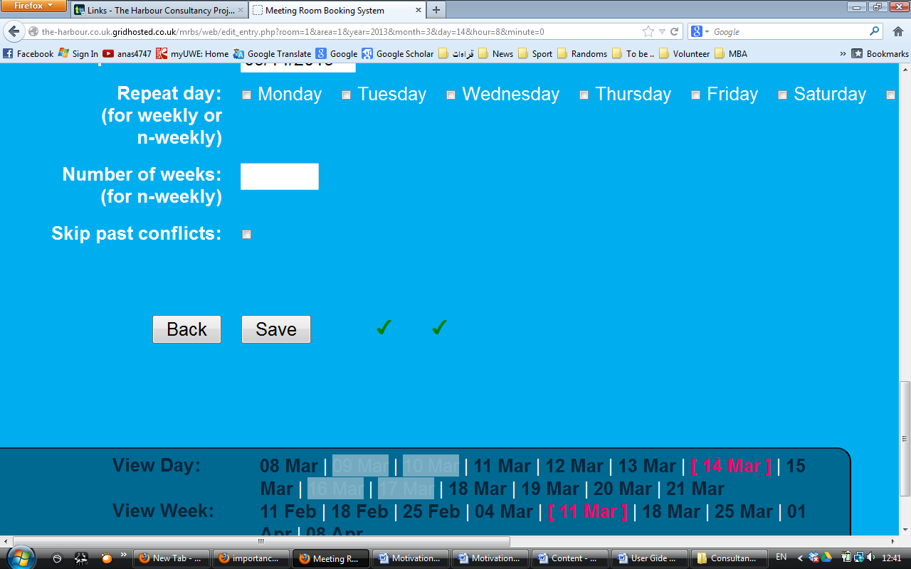

These two tick marks means the booking has no scheduling or policy conflict.

A cross mark after the save button means the booking conflict with another booking. Thus timing must be changed

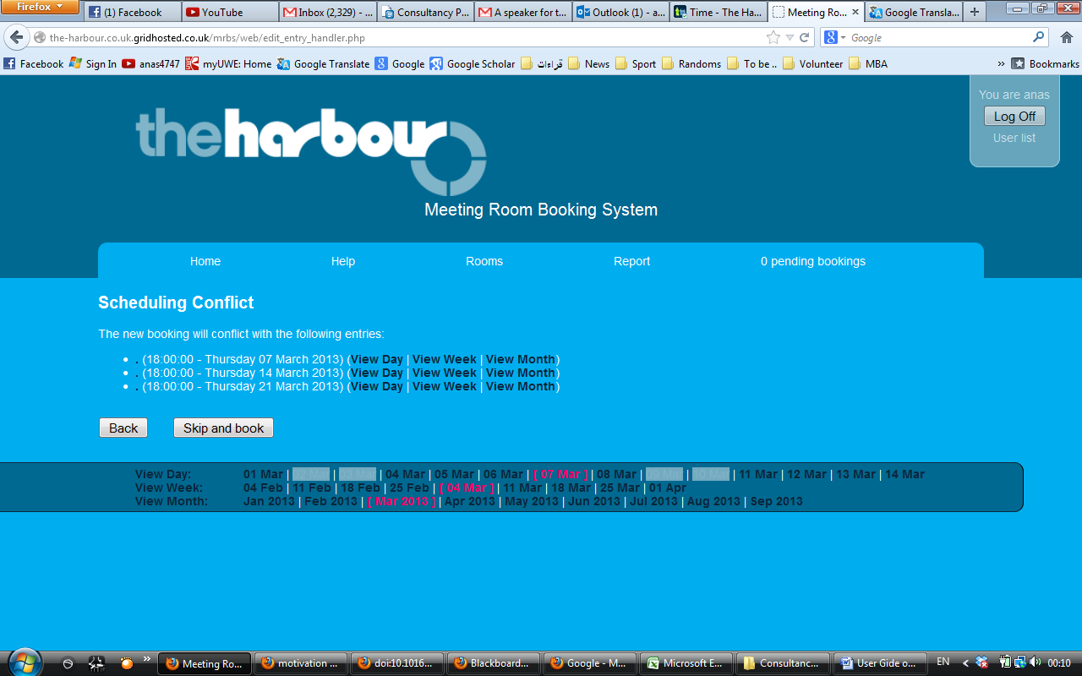In a case of saving a repeat booking that conflict with other bookings, then only date that does not conflict with other booking will processed

Complete all booking requirements and press save, you will then be transferred to the main booking page with your booking completed. Note the booking is not confirmed until it is proved by the administration.

**Edit booking**

To edit the booking click on your booking at the main page

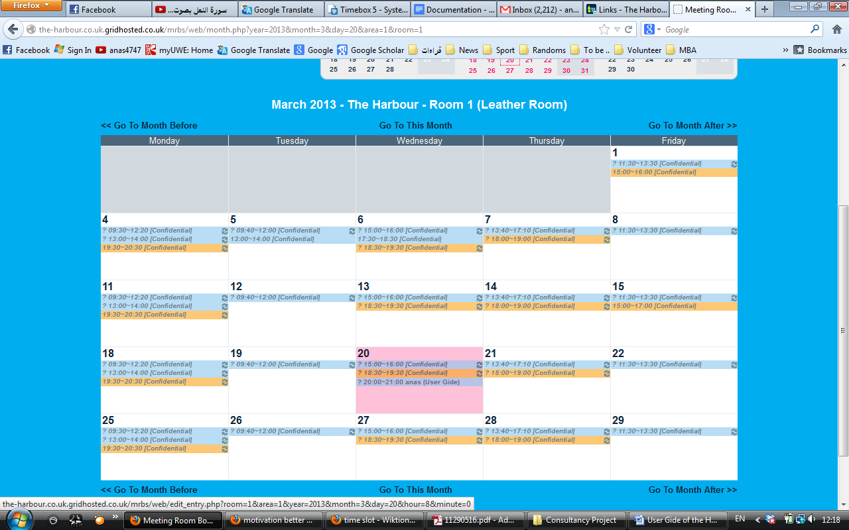

As shown above the booking completed is listed with different bookings from other therapists. The booking is under the name ‘User Gide’ to edit the booking click on the name of the booking.

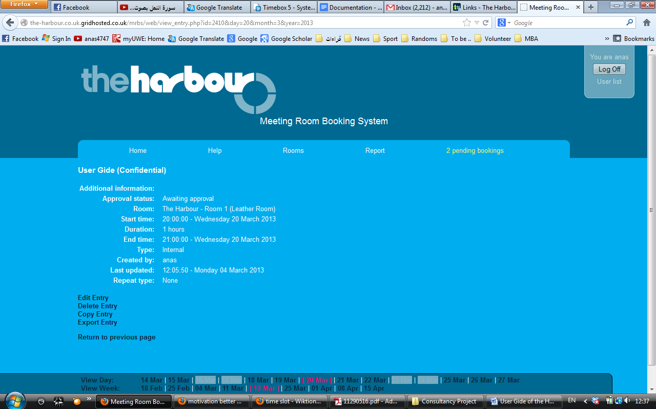Once you click, booking details will be shown to you

Booking details as inserted previously

* 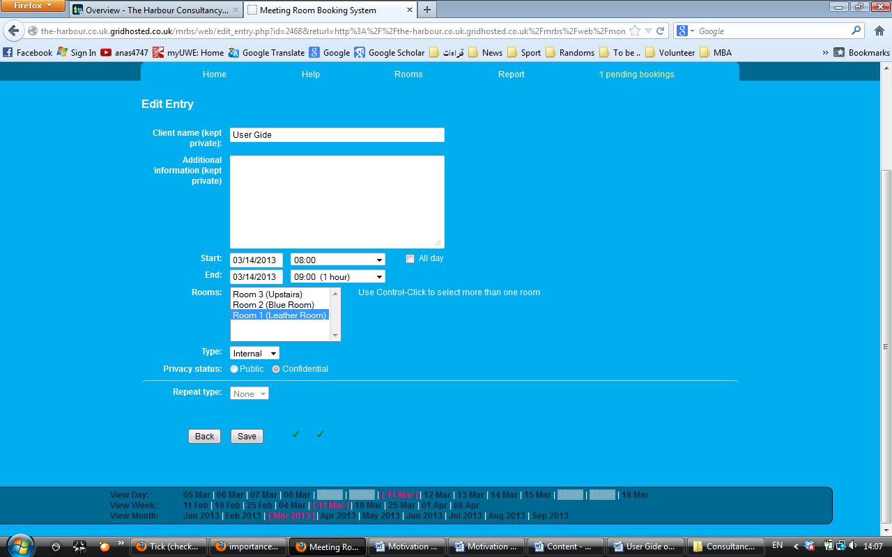**Edit Entry**: Click here to edit time, date or room of your booking

Here you can change your previous entry including date, time and room

* 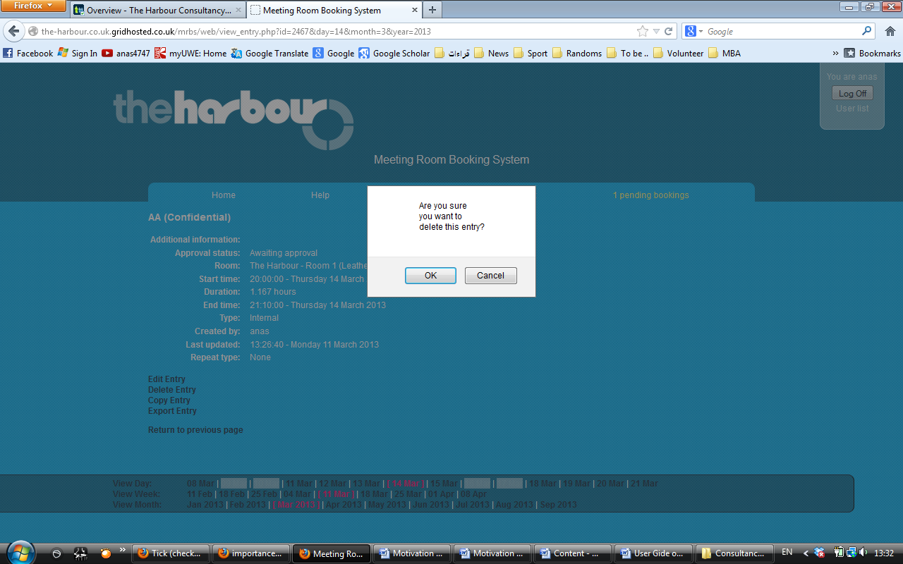**Delete Entry**: Click here to delete the entire booking

This massage will appear in your screen, press OK to delete the booking

* 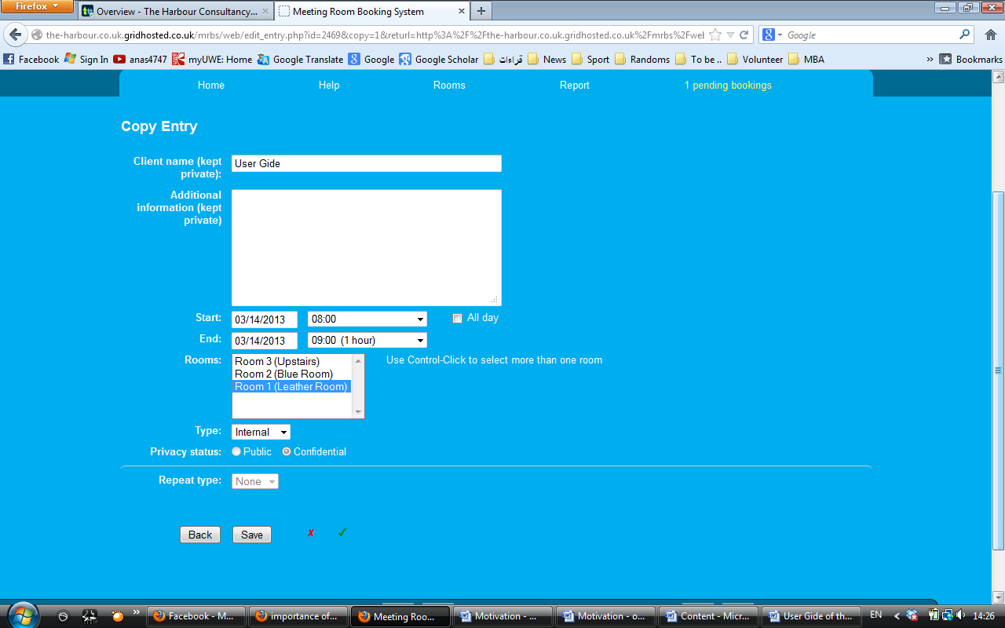**Copy Entry**: Click here to copy the details of the previous booking in a new booking. Note that you have to change the time of the booking as

Note that you have to change the time of the booking, so it does not conflict with the previous booking

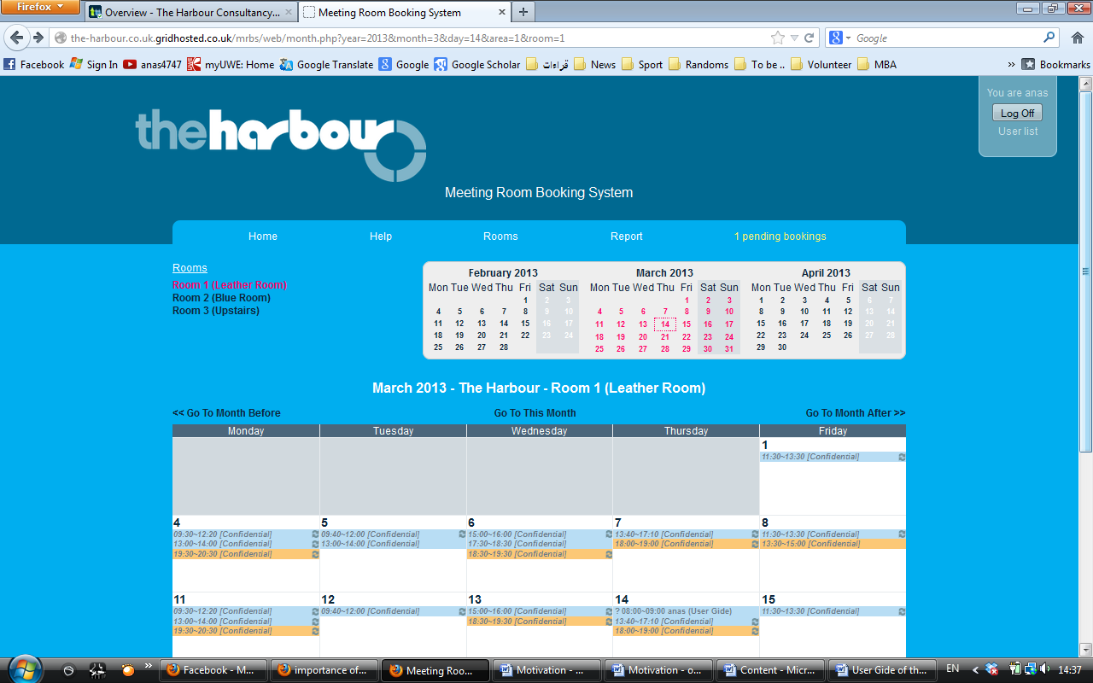**Log Off**

Once you complete all your enquires, you can log off at the top of the page. Not your enquiry has is not confirmed until you receive an email from the administration.