# StandardValueSet

It is not supported by Unlocked Package.

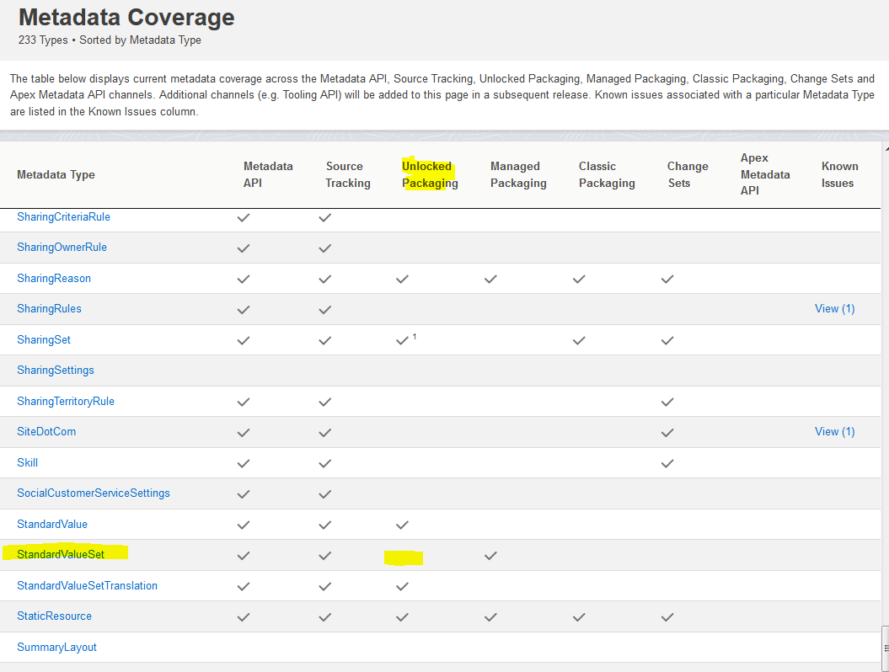

## Product2.Family

So we need to populate after Package Installation :

Update the Product Family field on the Product2 sObject to only have the following values: Entree, Side, Dessert, Beverage

Delete the none value