**Inferential Statistics**

To look for statistically significant associations, I ran general linear models on most of the exploratory relationships.

## 1) A 10,000 dollar increase in family income increases SAT scores by on average 13.6 points and this relationship is statistically significant

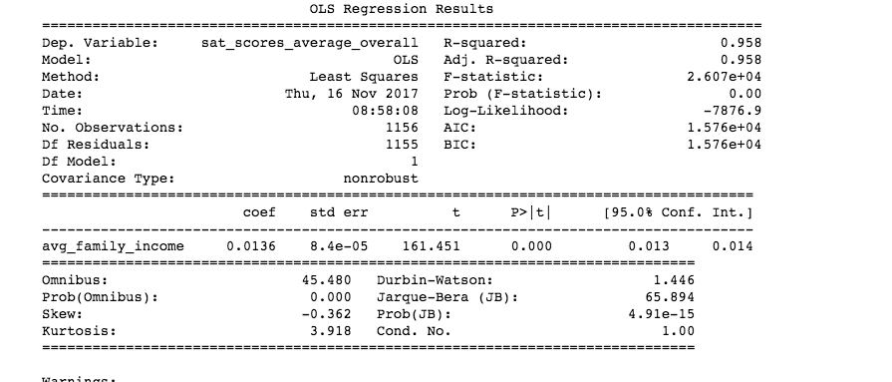

## 2) College selectivity (SAT scores) have a small positive effect on mobility rate. i.e more selective colleges have marginally higher mobility. The response variable is sqrt transformed to meet assumptions of normality so a little difficult to interpret the slope parameter.

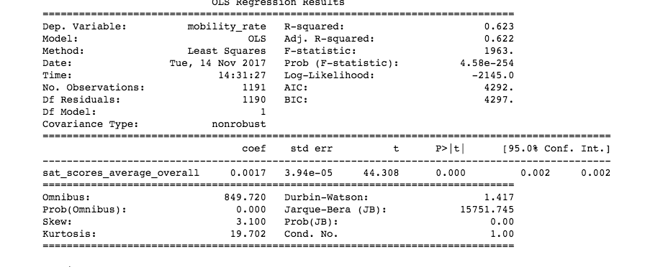

### 3) College selectivity (SAT scores) have a small positive effect on mobility rate. i.e more selective colleges have marginally higher mobility. However, for low-income students who can get into more selective colleges, mobility is much higher. The response variable (mobility_rate) is sqrt transformed to meet assumptions of normality so a little difficult to interpret the slope parameter.

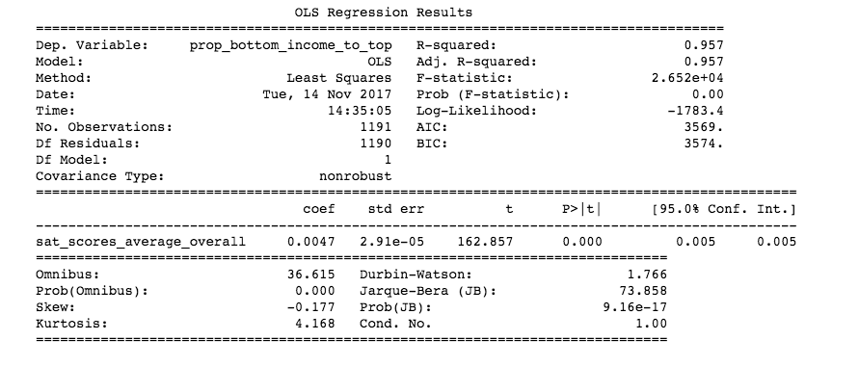

4) Which factors significantly predict mobility rate? I ran a multiple regression but there are very likely problems with multicollinearity with these data (many of the predictors are very correlated with each other e.g. underrep_minorities and underrep_minorities_census). The solution is dimension reduction (pca) followed by a regression of pca loadings against the response. Nevertheless, most terms are significant at alpha = 0.05. The effect sizes are large for debt: income ratio, the number of first generation students and the number of international students. Schools that support a lot of first generation students increase mobility by almost 1%!

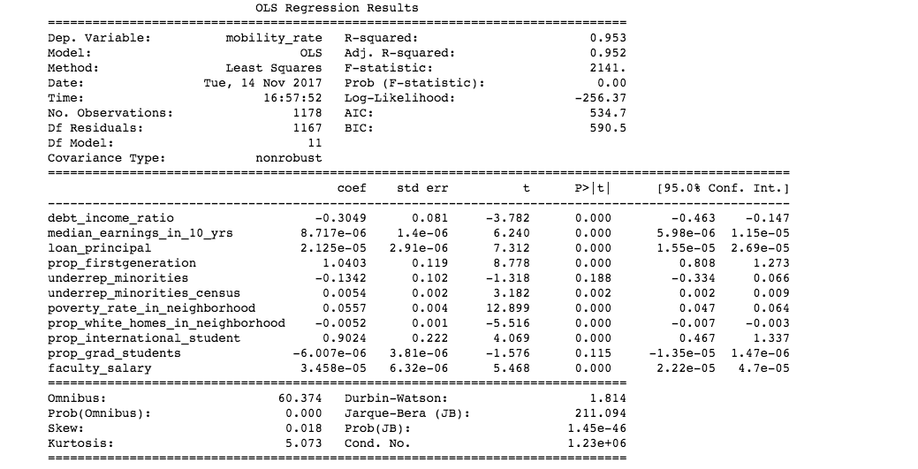

### 5) Minority serving institutions for a single underrepresented minority increases mobility by 0.2 percent. Those that serve two or more minorities increase mobility by 1%

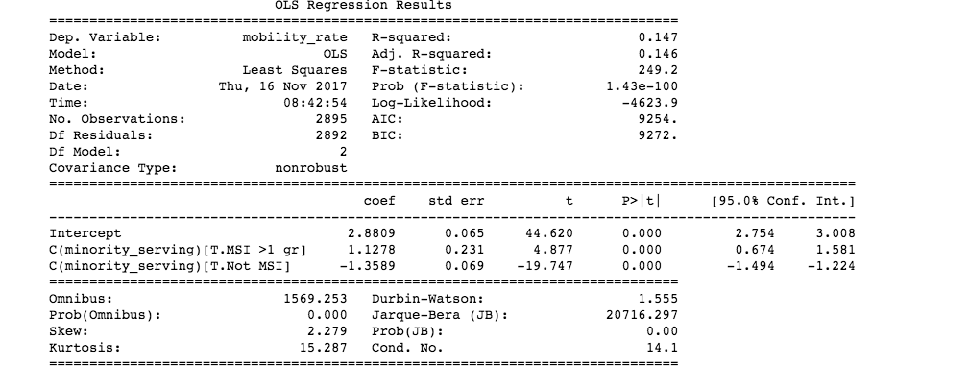

### 6) Two-year, junior colleges decrease mobility by 2.12% and colleges with shorter programs decrease mobility by almost 2.9%

