Pining of A20-SOM-EVB (https://www.olimex.com/Products/SOM/A20/A20-SOM-EVB/resources/A20-SOM-EVB-UM.pdf)

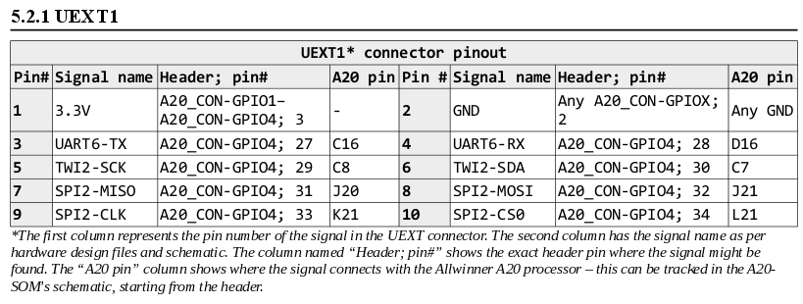

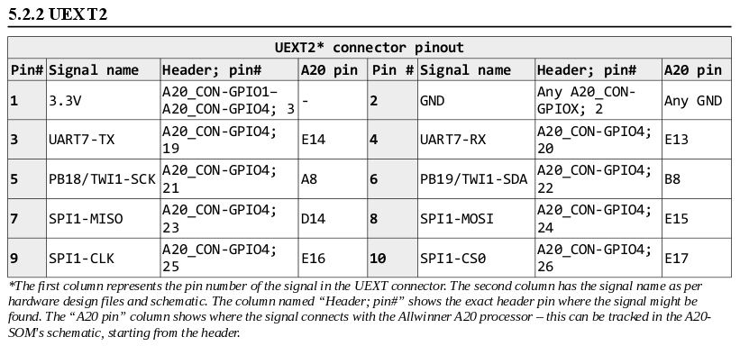

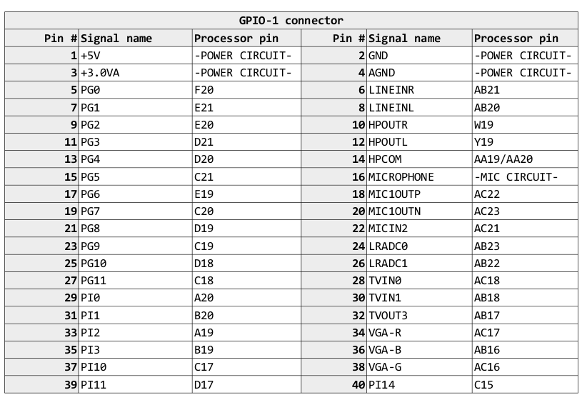
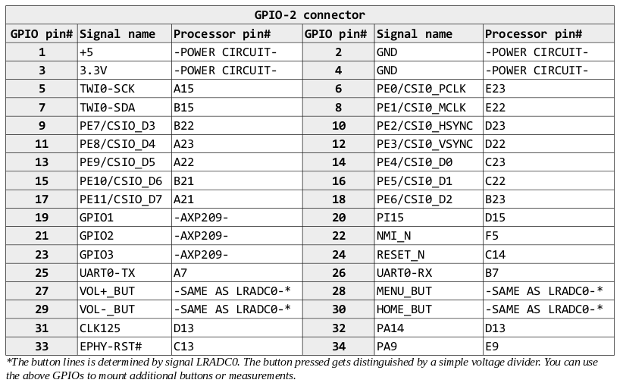

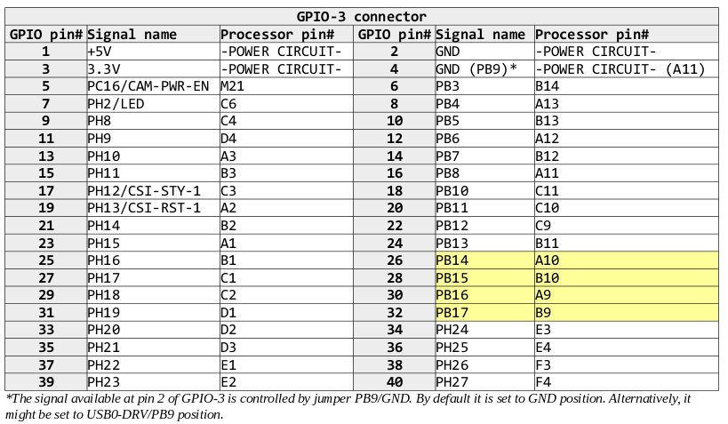
(Yellow → JTAG)

