Which social media platform has the most negative effect on sleep between different academic levels, and which level has the worst effect out of them all?
Travis Ohm
AI Disclosure: AI was used in assisting in the brainstorming, structure, and proofreading of this project
1. Background
Sleep affects attention, mood and how well students perform in school, and sleep experts generally recommend at least 7 hours a night for adults and 8 to 10 hours for teenagers. Yet the average student in the dataset I use sleeps only about 6.7 hours. I see this in my own life: I still catch myself scrolling on Instagram or TikTok until 2 A.M. knowing I have somewhere to be at 9 A.M. the next day. Late-night scrolling is common among students at every academic level, so it is worth asking whether one platform, or one group of students, is hit harder than the others. In this report, I aim to find out which social media platform has the most negative effect on sleep for students at each academic level, and which academic level has the worst effect on sleep due to social media.
2. Problem Statement
Which social media platform has the most negative effect on sleep between different academic levels, and which level has the worst effect out of them all?
To answer this one question, I work through three smaller steps:
1. How does each social media platform compare to the others within each academic level?
2. How does each academic level compare to the others on sleep statistics?
3. Does more social media use go with worse sleep in the first place?
3. Data
Where the data came from?:
(Kaggle): survey data on digital screen time, sleep patterns, stress levels & student GPA. Link: https://www.kaggle.com/datasets/harishyadav0506/impact-of-social-media-on-life
What does one row represent?:
Each row represents 1 student. The row contains a unique student id, demographics, attributes about their social media usage, and quantitative or qualitative measurements on how social media affects different areas of their individual health.
How many rows and how many columns?:
This dataset has 16 columns of attributes and 4,500 rows of students.
Which columns did you actually use?
In this report, I use the following columns: Academic_Level (current education tier), Primary_Platform (most frequently used social media network), Daily_Usage_Hours (self-reported average daily active screen time spent across social media), Sleep_Duration_Hours (average nocturnal sleep duration per night), Sleep_Quality_Score (self-reported subjective sleep quality rating on a discrete Likert scale), and Late_Night_Usage (a True/False self-report of whether students use social media late at night).
4. Analysis
What I kept and changed. I kept all 4,500 rows. The six columns I used have no missing values and there are no duplicate Student_IDs, so nothing had to be dropped. I made three changes: Late_Night_Usage became True/False, Academic_Level was put in order (High School, Undergraduate, Postgraduate), and I built one new column, the Sleep Harm Index.
Sleep Harm Index. Sleep harm shows up in three columns that point in different directions, so I converted each to a z-score (how many standard deviations a student is from the dataset average), flipped sleep duration and sleep quality so that higher always means worse, and averaged the three. An index of 0 is an average student and a positive value is worse than average.
Step 1: does usage hurt sleep at all? I correlated daily social media hours with sleep duration and sleep quality across all 4,500 students. The correlations are r = −0.72 with sleep duration and r = −0.68 with sleep quality, so more hours goes with less and worse sleep.
Step 2: platform within each level. I grouped by Academic_Level and Primary_Platform (21 groups) and computed the student count, mean sleep hours, mean sleep quality, late-night share, mean daily hours and mean Sleep Harm Index. Some groups are tiny (only 9 postgraduates use LinkedIn), so I only named a "worst platform" from groups with at least 30 students. Without that filter the worst high school platform would be LinkedIn, from just 23 students.
Table 1. Worst platform in each academic level (groups with n ≥ 30), ranked by Sleep Harm Index.
Academic level | Worst platform | n | Mean sleep (h) | Sleep quality | Late-night share | Harm index
High School | Instagram | 471 | 6.60 | 2.41 | 58.4% | 0.046
Undergraduate | Reddit | 139 | 6.59 | 2.41 | 59.7% | 0.059
Postgraduate | YouTube | 40 | 6.74 | 2.35 | 60.0% | 0.038

Step 3: level against level. I then grouped by academic level alone, using the same measures, and ranked the levels by mean Sleep Harm Index.
Table 2. Sleep measures by academic level (rank 1 = worst sleep).
Academic level | n | Mean sleep (h) | Sleep quality | Late-night share | Harm index | Rank
High School | 1,477 | 6.68 | 2.44 | 59.5% | 0.021 | 1 (worst)
Undergraduate | 2,777 | 6.71 | 2.48 | 58.7% | −0.007 | 2
Postgraduate | 246 | 6.74 | 2.53 | 55.3% | −0.054 | 3
5. Visualization
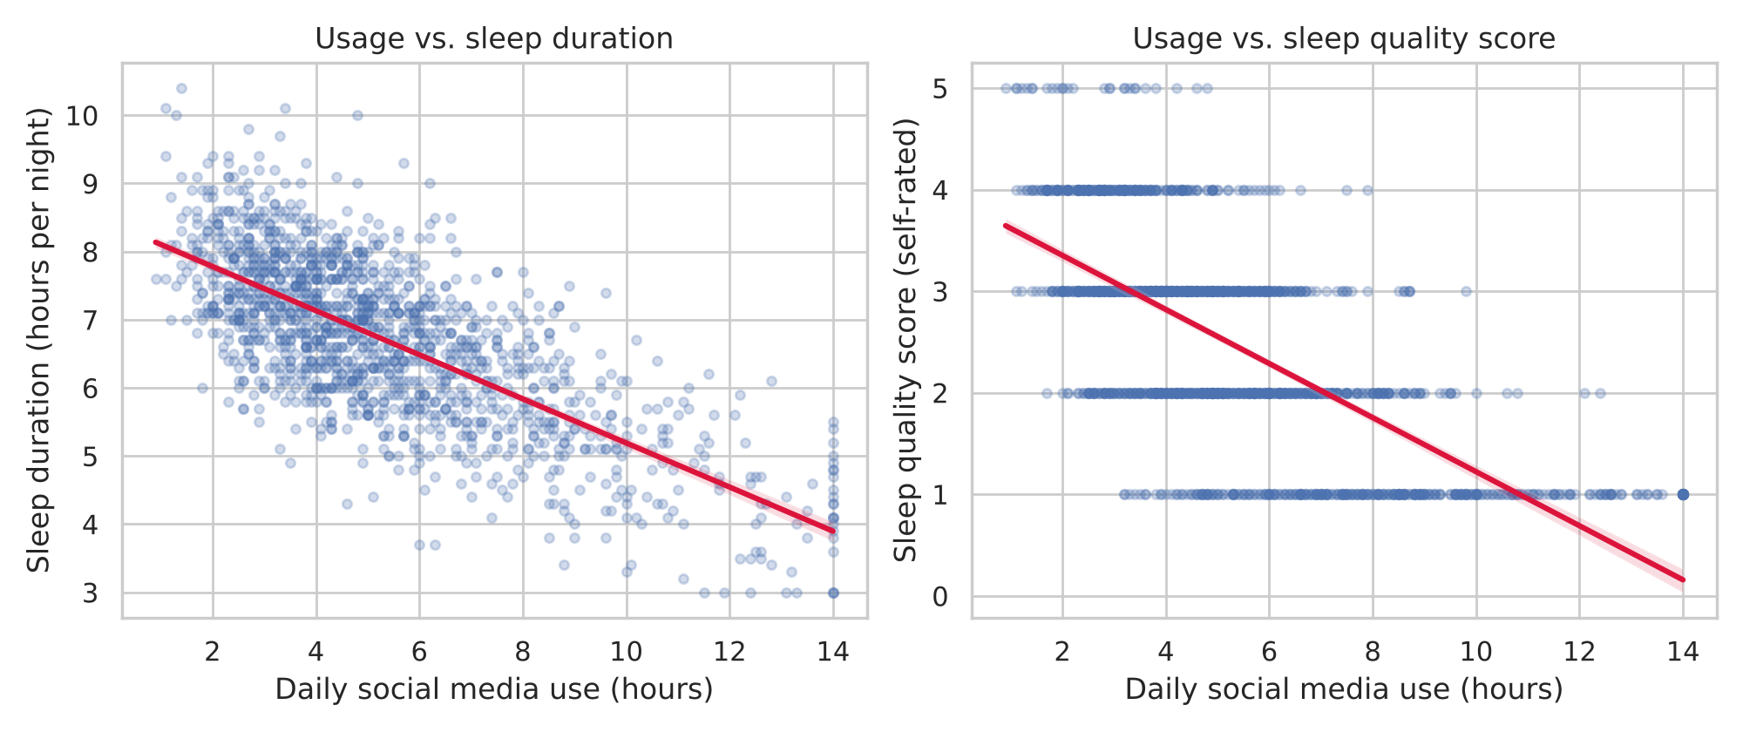
Figure 1. Daily social media hours against sleep duration (left) and sleep quality score (right), for a random sample of 1,500 of the 4,500 students. The red line is the linear trend.
What it shows: Students who spend more hours on social media sleep fewer hours and rate their sleep lower, falling from roughly 8 hours of sleep at 1 hour of use to roughly 4 hours at 14 hours.
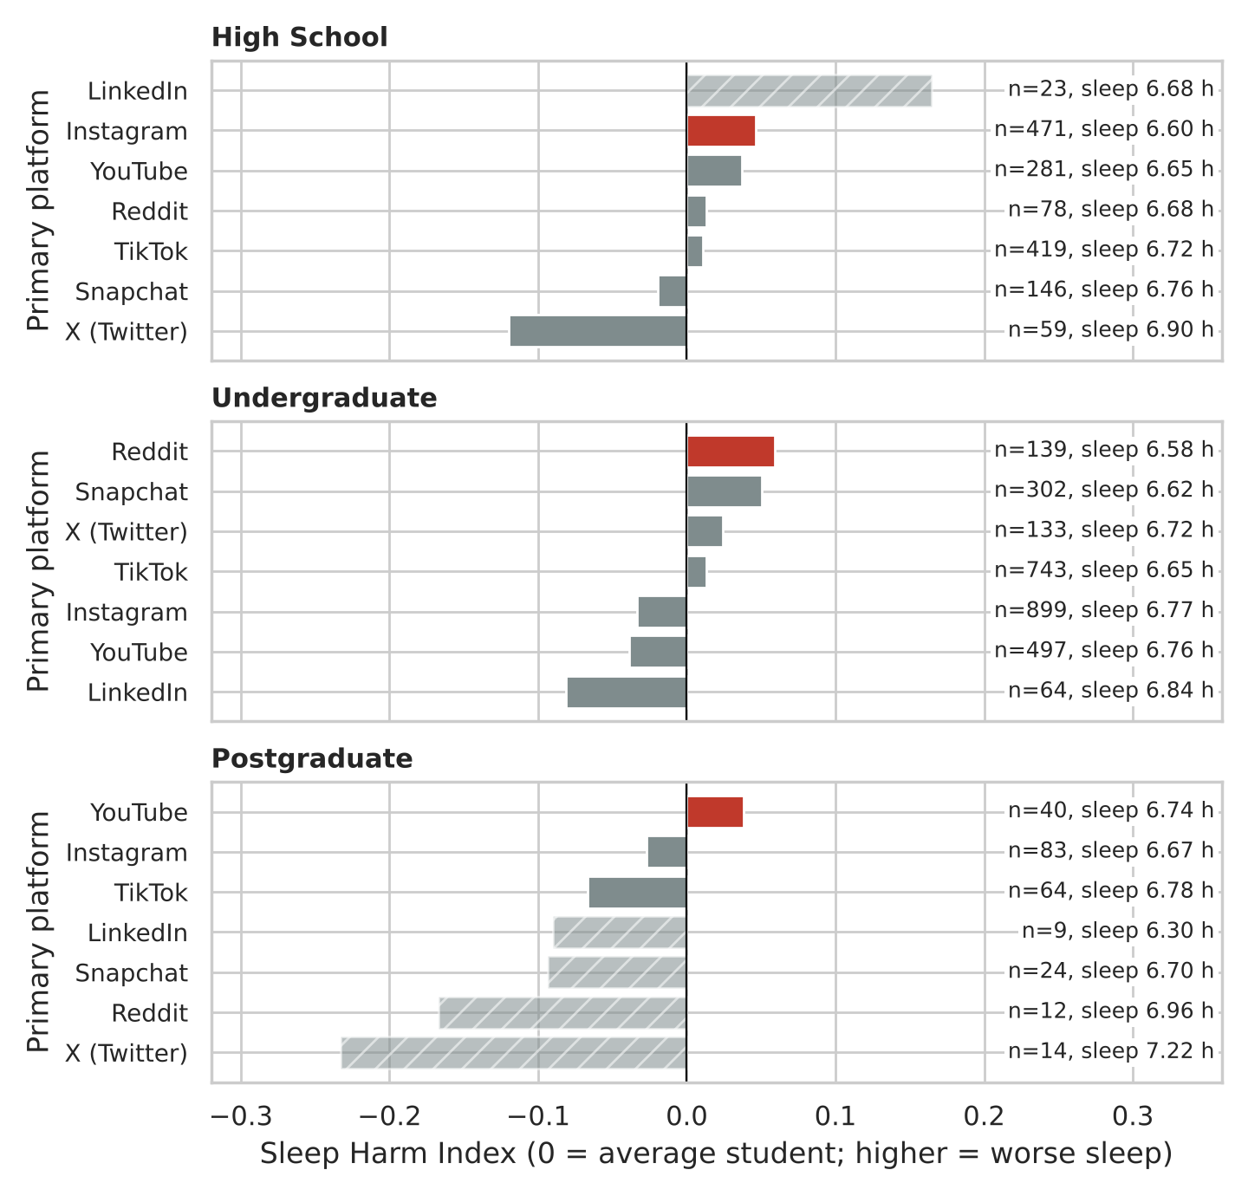
Figure 2. Sleep Harm Index by primary platform within each academic level (red = worst platform among groups with at least 30 students; hatched = fewer than 30 students). Labels give group size and mean sleep hours.
What it shows: The worst platform is different at every level (Instagram for high school, Reddit for undergraduates, YouTube for postgraduates), but the winning margins are only a few hundredths of a standard deviation, so no platform clearly stands out. The much larger bars belong to groups of fewer than 30 students and are not trusted.
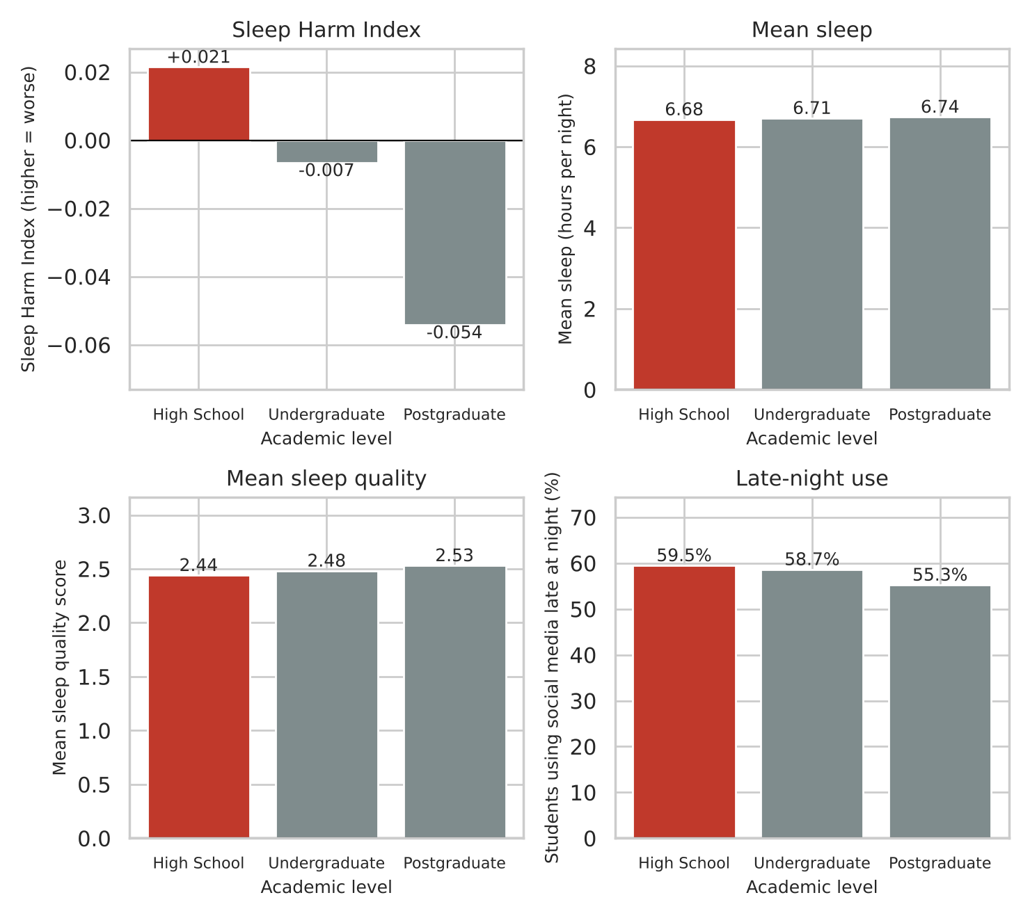
Figure 3. Sleep Harm Index, mean sleep hours, mean sleep quality and late-night usage share for each academic level (red = worst level on each measure). Every panel except the Sleep Harm Index starts at zero, so bar heights are not exaggerated.
What it shows: High school students have the worst sleep on all four measures, but the levels are very close: they sleep only about four minutes less per night than postgraduates (6.68 vs. 6.74 hours).
6. Conclusion
Answer: The platform with the worst Sleep Harm Index was Instagram for high school students (0.046, 6.60 hours of sleep per night), Reddit for undergraduates (0.059, 6.59 hours) and YouTube for postgraduates (0.038, with the lowest sleep quality, 2.35, and the highest late-night share, 60.0%, although its 6.74 hours of sleep is about average for postgraduates). High school was the academic level with the worst sleep overall, with the shortest sleep (6.68 hours), the lowest sleep quality (2.44) and the highest Sleep Harm Index (0.021).
What I did not expect: I started out assuming the apps I scroll myself, Instagram and TikTok, would be the worst, and that the platform would matter more than anything. Instead, the number of hours a student spends on social media predicts sleep far more strongly (r = −0.72 with sleep duration) than which platform they use, and TikTok sits close to average at every level. Mean daily usage is also almost the same across levels (5.1 to 5.3 hours), which helps explain why the levels look so alike. I also found that LinkedIn looked like the worst platform for high school students (Sleep Harm Index 0.165), driven by a 78% late-night share even though their sleep (6.68 hours) was average, but only 23 students use it as their main platform, so I did not count it.
7. Limitations
This data cannot tell me whether social media causes the shorter sleep, because it is a one-time self-reported survey, so it only shows that heavy users sleep less and cannot separate scrolling that costs sleep from poor sleepers who scroll more.

