Comparative Effectiveness and Safety of Apixaban Versus Rivaroxaban for Stroke Prevention in Atrial Fibrillation Patients with Chronic Kidney Disease Stage 3b–5: A Target Trial Emulation Using Electronic Health Record Data
Draft Manuscript — Not for Distribution
Auto-Protocol Designer
PCORnet Clinical Data Warehouse
April 2026
Corresponding Author: [To be determined]
Word Count: ~4,500 (excluding tables, figures, and references)

ABSTRACT
Background: Atrial fibrillation (AF) and chronic kidney disease (CKD) frequently coexist, affecting 15–30% of AF patients. Direct oral anticoagulants (DOACs) have replaced warfarin for stroke prevention in AF, but no head-to-head randomized trial has compared individual DOACs in patients with moderate-to-severe CKD (eGFR < 45 mL/min/1.73m²). Apixaban has the lowest renal clearance (~27%) among DOACs compared with rivaroxaban (~36%), providing a pharmacokinetic rationale for differential safety in renal impairment.
Methods: We emulated a target trial using electronic health record data from an institutional PCORnet Clinical Data Warehouse (~10 million patients, 2016–2025). Using an active-comparator, new-user design, we identified adults with non-valvular AF and CKD stage 3b–5 (ascertained by ICD-10 diagnosis codes or eGFR < 45) who newly initiated apixaban or rivaroxaban with no prior DOAC use in 365 days. The primary outcome was a composite of stroke/systemic embolism (SE) and major bleeding at 365 days. We estimated the average treatment effect using inverse probability of treatment weighting (IPW) with stabilized weights derived from a logistic regression propensity score model, followed by weighted Cox proportional hazards regression.
Results: Among 21,278 new DOAC users, 7,206 had concurrent AF, and 233 met all eligibility criteria for AF with CKD 3b–5 (199 apixaban, 34 rivaroxaban). Mean age was 76 years in both groups. CKD stage 4–5 was more prevalent in the apixaban group (47.2%) than rivaroxaban (29.4%). There were 10 composite events at 1 year (9 apixaban, 1 rivaroxaban). The IPW-adjusted hazard ratio for the composite outcome was 0.43 (95% CI: 0.06–3.09, P = 0.40) favoring apixaban, though this was not statistically significant. Major bleeding trended lower with apixaban (HR 0.18, 95% CI: 0.02–1.47, P = 0.11). All-cause mortality was numerically lower with apixaban (HR 0.27, 95% CI: 0.06–1.25, P = 0.10). Subgroup and sensitivity analyses were limited by small sample sizes, with several producing numerically unstable estimates.
Conclusions: In this single-institution target trial emulation, apixaban showed a non-significant trend toward lower rates of the composite outcome, major bleeding, and mortality compared with rivaroxaban in AF patients with CKD 3b–5. The small analytic cohort (N = 233) yielded wide confidence intervals, precluding definitive conclusions. These findings are consistent with the direction of prior observational studies but underscore the need for larger, multi-site studies in this high-risk population.
Keywords: atrial fibrillation, chronic kidney disease, apixaban, rivaroxaban, target trial emulation, comparative effectiveness, inverse probability weighting

INTRODUCTION
Atrial fibrillation (AF) is the most common sustained cardiac arrhythmia, affecting an estimated 33 million people worldwide. Chronic kidney disease (CKD) is a frequent comorbidity, present in 15–30% of AF patients,¹⁷ and the overlap creates a challenging clinical dilemma: CKD patients with AF face simultaneously elevated risks of ischemic stroke from AF-related thromboembolism and major bleeding from uremic platelet dysfunction and impaired drug clearance.
Direct oral anticoagulants (DOACs) have largely supplanted warfarin for stroke prevention in AF, supported by four landmark trials: RE-LY (dabigatran),¹ ROCKET AF (rivaroxaban),² ARISTOTLE (apixaban),³ and ENGAGE AF-TIMI 48 (edoxaban).⁴ Each trial compared a single DOAC to warfarin, and all systematically excluded patients with severe CKD (eGFR < 25–30 mL/min/1.73m²). No head-to-head randomized trial has compared any two DOACs directly, and such a trial in the CKD population is unlikely given the scale and cost required.
Among the DOACs, apixaban has the lowest renal clearance (~27%) compared with rivaroxaban (~36%), dabigatran (~80%), and edoxaban (~50%).¹⁵ This pharmacokinetic property provides a theoretical basis for preferring apixaban in CKD, as its efficacy and safety profile may be less sensitive to declining renal function. The FDA-approved labeling permits apixaban use down to creatinine clearance (CrCl) 15 mL/min and even in dialysis, whereas rivaroxaban data below CrCl 30 mL/min are more limited.
Large observational studies in general AF populations consistently suggest a safety advantage for apixaban over rivaroxaban, including lower rates of major bleeding^{6,8} and, in some analyses, lower rates of ischemic events.^{5,7,9} However, comparative data specific to patients with CKD stage 3b–5 (eGFR < 45) are sparse. A 2024 US nationwide cohort study found higher major bleeding with rivaroxaban versus apixaban in CKD stages 4–5,¹⁰ and a 2026 scoping review explicitly identified the non-dialysis CKD 3b–4 population as the key evidence gap.¹¹ Current clinical guidelines recommend DOACs over warfarin for AF patients with CKD not on dialysis but do not recommend one DOAC over another due to insufficient comparative evidence.¹⁶
Target trial emulation (TTE) provides a rigorous framework for estimating causal treatment effects from observational data by explicitly specifying the hypothetical randomized trial that the observational study aims to emulate.¹⁸ This approach systematically addresses sources of bias inherent in observational studies, including immortal time bias, selection bias, and confounding. We applied the TTE framework to compare apixaban versus rivaroxaban for stroke prevention in AF patients with CKD stage 3b–5 using electronic health record (EHR) data from an institutional PCORnet Clinical Data Warehouse.

METHODS

Study Design and Data Source
We conducted an active-comparator, new-user target trial emulation¹⁸ using data from an institutional PCORnet Clinical Data Warehouse containing approximately 10 million patients. The CDW integrates data from two electronic health record eras (AllScripts through approximately 2019–2020 and Epic from 2019–2020 onward) mapped to the PCORnet Common Data Model. The study period spanned January 1, 2016, through December 31, 2025. ICD-10-CM coding was used exclusively (post-transition from October 2015). Legacy encounter records from the EHR migration were excluded throughout to prevent double-counting.

Target Trial Specification
The target trial was specified according to the Hernán and Robins framework with the following components.
Eligibility. Adults aged 18 years or older with documented non-valvular AF (ICD-10 I48.x, excluding atrial flutter codes) and CKD stage 3b–5, newly initiating apixaban or rivaroxaban with no prior DOAC use in the preceding 365 days. CKD was ascertained using a dual strategy: ICD-10 diagnosis codes (N18.32 for stage 3b, N18.4 for stage 4, N18.5 for stage 5) or laboratory-confirmed eGFR < 45 mL/min/1.73m² (LOINC codes 48642-3, 62238-1, 33914-3, 98979-8) within 180 days before the index date. Patients with valvular AF (rheumatic valve disease, prosthetic valves), end-stage renal disease or dialysis, prior DOAC use, or concurrent initiation of both study drugs were excluded.
Treatment strategies. Initiation of apixaban (at any approved dose: 2.5 mg or 5 mg) versus initiation of rivaroxaban (at any AF-approved dose: 10 mg, 15 mg, or 20 mg). Medications were identified using RxNorm Concept Unique Identifiers (RxCUIs) for both semantic clinical drug (SCD) and semantic branded drug (SBD) forms.
Treatment assignment. Assignment was based on the first DOAC prescription in a patient meeting all eligibility criteria. This is a non-randomized assignment subject to confounding, addressed through inverse probability of treatment weighting.
Time zero. The date of the first qualifying DOAC prescription, which simultaneously served as the eligibility verification date, treatment assignment date, and the start of follow-up. This alignment eliminates immortal time bias.¹⁸
Outcomes. The primary outcome was a composite of stroke/systemic embolism (ICD-10 I63.x for ischemic stroke, I74.x for systemic embolism) and major bleeding (intracranial hemorrhage: I60.x, I61.x, I62.x; gastrointestinal bleeding: K92.0, K92.1, K92.2, K62.5, and additional GI hemorrhage codes). Outcomes were ascertained from inpatient and emergency department encounters. Secondary outcomes included stroke/SE alone, major bleeding alone, GI bleeding, and all-cause mortality (from the CDW DEATH table). Maximum follow-up was 365 days, with censoring at death (for non-mortality outcomes), end of study period, or initiation of dialysis.
Estimand. The average treatment effect (ATE) estimating the difference in 365-day risk comparing a scenario where all eligible patients received apixaban versus rivaroxaban.

Statistical Analysis
Propensity score estimation. We estimated the probability of receiving apixaban (versus rivaroxaban) using logistic regression with the following covariates: age, sex, race, ethnicity, eGFR (continuous), serum creatinine, BMI, systolic and diastolic blood pressure, HbA1c, hemoglobin, platelet count, CKD stage category, comorbidities (heart failure, hypertension, diabetes, prior stroke/TIA, prior MI/vascular disease, prior bleeding, liver disease, anemia, obesity, cancer), concomitant medications (antiplatelet, statin, ACE inhibitor/ARB, beta-blocker, proton pump inhibitor, NSAID), calendar year, and enrollment basis. The propensity score formula was constructed dynamically, dropping single-level factors and zero-variance covariates to prevent model fitting errors.
Inverse probability weighting. Stabilized IPW weights were computed from the propensity scores. Covariate balance was assessed using absolute standardized mean differences (SMD), with a threshold of 0.10 indicating adequate balance. Propensity score overlap was assessed visually through density plots. Effective sample sizes (ESS) were reported for both treatment arms.
Outcome models. Weighted Cox proportional hazards models with robust (sandwich) variance estimation were used to estimate hazard ratios and 95% confidence intervals for each outcome. Weighted Kaplan-Meier curves were generated for visual comparison.
Subgroup analyses. Pre-specified subgroups included CKD stage (3b versus 4–5), age (< 75 versus ≥ 75 years), sex, DOAC dose (standard versus reduced), prior bleeding history, and diabetes status. Within each subgroup, the propensity score model was re-estimated.
Sensitivity analyses. E-value analysis was conducted to quantify the minimum strength of unmeasured confounding needed to explain away observed associations. Additional sensitivity analyses included propensity score trimming (excluding patients below the 5th or above the 95th percentile of propensity scores) and restriction to the post-Epic EHR era (2021 onward).
All analyses were performed in R using the WeightIt, cobalt, survival, sandwich, lmtest, EValue, and survminer packages. The analysis was prespecified in a Quarto (.qmd) document and rendered as an HTML report.

RESULTS

Cohort Assembly
From 21,278 new DOAC users (apixaban or rivaroxaban with a 365-day washout period), 7,206 had a concurrent diagnosis of non-valvular AF. Application of the CKD stage 3b–5 criterion (by diagnosis code or eGFR < 45) identified 233 eligible patients. All 233 patients met the remaining eligibility criteria (age ≥ 18 years, active in the CDW within 365 days before the index date), were successfully assigned to a treatment group, and had complete outcome ascertainment and confounder data, forming the final analytic cohort (Figure 1).
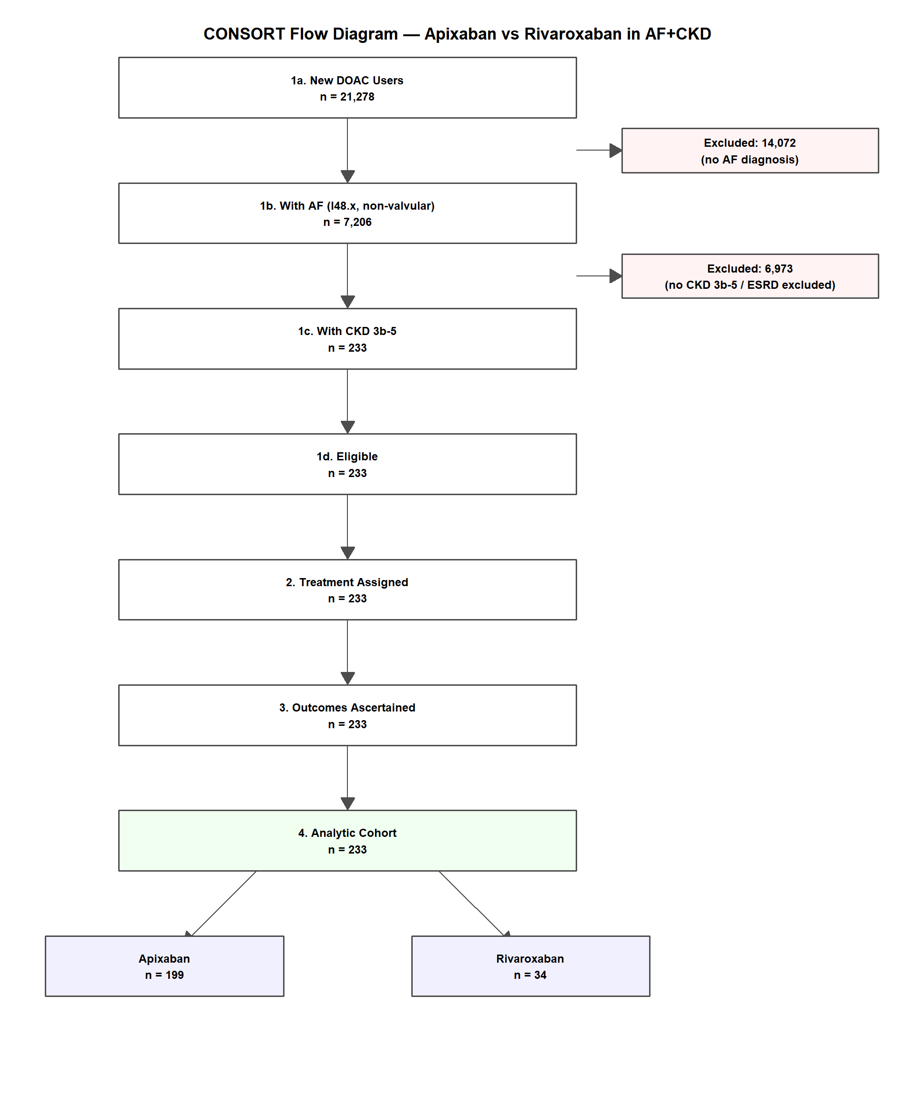
Figure 1. CONSORT flow diagram showing patient attrition at each cohort-building step. From 21,278 new DOAC users, 233 met all eligibility criteria for AF with CKD stage 3b–5.

Baseline Characteristics
Table 1 presents baseline characteristics by treatment group. The apixaban group (n = 199) and rivaroxaban group (n = 34) had similar mean ages (76.0 versus 76.1 years). The rivaroxaban group had a higher proportion of women (61.8% versus 49.2%) and a lower prevalence of CKD stage 4–5 (29.4% versus 47.2%). The apixaban group had higher rates of hypertension (92.0% versus 76.5%), diabetes (48.2% versus 29.4%), and antiplatelet use (13.1% versus 2.9%). Mean eGFR was slightly higher in the rivaroxaban group (44.4 versus 41.7 mL/min/1.73m²). Reduced-dose prescribing was similarly common in both groups (approximately 47%).
Table 1. Baseline Characteristics by Treatment Group
Characteristic | Rivaroxaban (n=34) | Apixaban (n=199)
Age, years (mean ± SD) | 76.1 ± 9.7 | 76.0 ± 10.3
Female (%) | 61.8 | 49.2
White (%) | 52.9 | 50.8
Black (%) | 35.3 | 31.2
Hispanic (%) | 14.7 | 8.0
eGFR, mL/min/1.73m² (mean) | 44.4 | 41.7
Serum creatinine, mg/dL (mean) | 1.5 | 1.8
BMI, kg/m² (mean) | 29.7 | 29.6
Systolic BP, mmHg (mean) | 134 | 130
HbA1c, % (mean) | 6.5 | 6.5
Hemoglobin, g/dL (mean) | 11.3 | 11.4
CKD stage 3b (%) | 70.6 | 52.8
CKD stage 4 (%) | 26.5 | 41.2
CKD stage 5 (%) | 2.9 | 6.0
Heart failure (%) | 50.0 | 46.2
Hypertension (%) | 76.5 | 92.0
Diabetes (%) | 29.4 | 48.2
Prior stroke/TIA (%) | 11.8 | 14.6
Prior major bleeding (%) | 0.0 | 6.0
Liver disease (%) | 0.0 | 2.0
Antiplatelet use (%) | 2.9 | 13.1
Statin use (%) | 17.6 | 20.1
ACEi/ARB use (%) | 11.8 | 12.1
Beta-blocker use (%) | 32.4 | 41.7
PPI use (%) | 2.9 | 0.5
Reduced dose (%) | 47.1 | 47.2
Abbreviations: eGFR, estimated glomerular filtration rate; BMI, body mass index; BP, blood pressure; CKD, chronic kidney disease; TIA, transient ischemic attack; ACEi, angiotensin-converting enzyme inhibitor; ARB, angiotensin receptor blocker; PPI, proton pump inhibitor.

Covariate Balance After Weighting
After IPW, absolute standardized mean differences were reduced below the 0.10 threshold for the majority of covariates, indicating adequate balance between treatment groups in the weighted pseudo-population (Figure 2). Propensity score distributions showed reasonable overlap between groups (Figure S1).
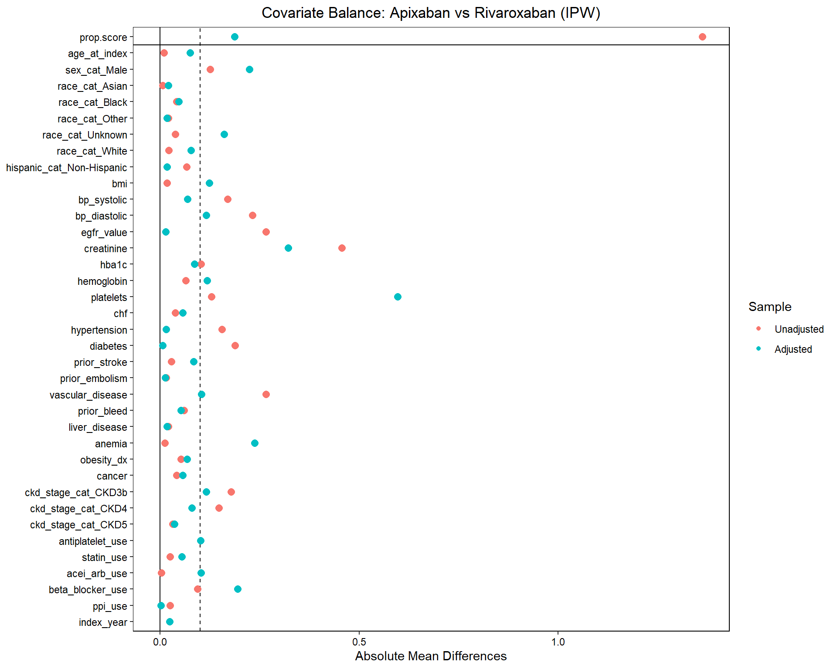
Figure 2. Love plot showing absolute standardized mean differences before (circles) and after (triangles) inverse probability weighting. The dashed vertical line indicates the 0.10 balance threshold.

Primary Outcome
At 365 days of follow-up, 10 composite events (stroke/SE or major bleeding) occurred: 9 in the apixaban group and 1 in the rivaroxaban group. The IPW-adjusted hazard ratio for the composite outcome was 0.43 (95% CI: 0.06–3.09, P = 0.40), suggesting a non-significant trend favoring apixaban. The wide confidence interval reflects the small number of events and the substantial imbalance in group sizes (Table 2).

Secondary Outcomes
Table 2 presents hazard ratios for all outcomes. Seven stroke/SE events occurred in the apixaban group and none in the rivaroxaban group, rendering the stroke/SE-specific hazard ratio numerically unstable (as the reference group had zero events). Major bleeding occurred in 4 apixaban patients and 1 rivaroxaban patient, with an adjusted HR of 0.18 (95% CI: 0.02–1.47, P = 0.11). GI bleeding occurred in 3 apixaban patients and 1 rivaroxaban patient (HR 0.14, 95% CI: 0.02–1.19, P = 0.07). All-cause mortality occurred in 9 apixaban patients and 2 rivaroxaban patients (HR 0.27, 95% CI: 0.06–1.25, P = 0.10).
Table 2. IPW-Adjusted Hazard Ratios for All Outcomes at 365 Days
Outcome | Apixaban  events | Rivaroxaban  events | Adjusted HR (95% CI) | P value
Composite (stroke/SE + major bleeding) | 9 | 1 | 0.43 (0.06–3.09) | 0.40
Stroke / systemic embolism | 7 | 0 | Not estimable* | —
Major bleeding | 4 | 1 | 0.18 (0.02–1.47) | 0.11
GI bleeding | 3 | 1 | 0.14 (0.02–1.19) | 0.07
All-cause mortality | 9 | 2 | 0.27 (0.06–1.25) | 0.10
*Zero events in the rivaroxaban group for stroke/SE produced a numerically unstable estimate. HR, hazard ratio; CI, confidence interval; SE, systemic embolism; GI, gastrointestinal.

Subgroup Analyses
Pre-specified subgroup analyses were severely limited by small sample sizes and very few events per subgroup (Figure S2, Table S2). Among patients with CKD stage 4–5 (n = 104, with only 10 rivaroxaban users), the composite HR was 0.76 (95% CI: 0.10–6.16), while in CKD stage 3b (n = 129), estimates were numerically unstable due to zero or near-zero events in one arm. Similar instability was observed in male, reduced-dose, and diabetes subgroups. Among patients aged 75 or older (n = 132), the composite HR was 0.40 (95% CI: 0.03–4.68), and among women (n = 119), the HR was 1.10 (95% CI: 0.13–9.72). The prior bleeding subgroup had no rivaroxaban patients (n = 12, all apixaban), precluding any analysis. These results should be interpreted as exploratory and hypothesis-generating only.

Sensitivity Analyses
E-value analysis, propensity score trimming, and restriction to the post-Epic era were conducted as planned (Table S3). Given the small number of events and the non-significant primary result, these analyses provide limited additional information. The E-value for the composite outcome point estimate indicates that an unmeasured confounder would need to be associated with both treatment and outcome by a risk ratio of approximately 3.9 to explain away the observed association, though this is academic given the wide confidence interval already spanning the null.

DISCUSSION
In this single-institution target trial emulation, we compared apixaban versus rivaroxaban for stroke prevention in AF patients with CKD stage 3b–5. We found a non-significant trend toward lower rates of the composite outcome (stroke/SE and major bleeding), major bleeding alone, and all-cause mortality with apixaban, though confidence intervals were wide and crossed the null for all outcomes. The study demonstrates the feasibility of applying the target trial emulation framework¹⁸ to this clinically important question but is underpowered for definitive conclusions.
The direction of our findings is consistent with the broader observational literature comparing apixaban and rivaroxaban in general AF populations. A multinational cohort study across six countries found apixaban to have the lowest major bleeding rate among DOACs.⁶ A US claims-based cohort study demonstrated higher ischemic and hemorrhagic event rates with rivaroxaban compared with apixaban,⁵ and an instrumental variable analysis confirmed this finding.⁹ In the CKD-specific literature, the most relevant prior study is a US nationwide cohort analysis that reported higher major bleeding with rivaroxaban versus apixaban in CKD stages 4–5.¹⁰ Our results, while imprecise, point in the same direction.
The small sample size (N = 233, with only 34 rivaroxaban patients) is the principal limitation of this study and warrants detailed discussion. The approximately 6:1 apixaban-to-rivaroxaban ratio reflects real-world prescribing patterns at this institution, where apixaban has become the dominant DOAC, particularly in patients with renal impairment.^{12,13} The small rivaroxaban arm severely limits statistical power and produces numerically unstable estimates in subgroup analyses, as evidenced by hazard ratios exceeding 10⁸ in several subgroups where one arm had zero events. These extreme values are artifacts of maximum likelihood estimation with sparse data and should not be interpreted clinically.
The pharmacokinetic rationale for differential DOAC safety in CKD is well established. Apixaban undergoes approximately 27% renal clearance, compared with 36% for rivaroxaban, making its drug levels less sensitive to declining renal function. A recent pharmacokinetic review confirmed consistent apixaban pharmacokinetics across CKD stages.¹⁵ This property may explain the consistent signal across observational studies favoring apixaban in CKD, including the non-significant trend observed in our data.
Several methodological strengths deserve mention. The active-comparator, new-user design minimizes confounding by indication, as both arms receive anticoagulation and differ only in the specific DOAC chosen. The dual CKD ascertainment strategy (combining diagnosis codes and laboratory eGFR data) maximizes capture of CKD patients, including those who have laboratory evidence of renal impairment but lack a coded CKD diagnosis.¹¹ Time zero was defined as the date of the first DOAC prescription, simultaneously aligning eligibility, treatment assignment, and follow-up start to eliminate immortal time bias.¹⁸

Limitations
This study has several important limitations. First, the small sample size and low event counts preclude definitive conclusions about comparative effectiveness or safety. Second, as with all observational studies, unmeasured confounding remains a concern. Key unmeasured confounders include prescriber specialty (nephrologists may preferentially prescribe apixaban), patient frailty, left ventricular ejection fraction, proteinuria, smoking status (99.8% unknown in this CDW), and insurance formulary effects. Third, exposure was based on prescribing data rather than dispensing or adherence data, introducing potential exposure misclassification. Fourth, ICD-10-based outcome ascertainment has known sensitivity and specificity limitations. Fifth, the single-institution design limits generalizability, and the CKD population at this institution may differ from national patterns. Sixth, the study period spans two EHR eras, though legacy encounter filtering and post-Epic sensitivity analysis mitigate this concern.

Clinical Implications and Future Directions
Despite its limitations, this study makes two contributions. First, it establishes the feasibility of the target trial emulation approach for comparing DOACs in the CKD population, providing a methodological template for larger studies. The active-comparator, new-user design with dual CKD ascertainment, IPW-based confounding adjustment, and comprehensive sensitivity analyses can be directly extended to multi-site PCORnet analyses where the combined sample size would be substantially larger. Second, the consistent direction of effect across multiple outcomes (composite, bleeding, mortality) adds incremental support to the existing observational evidence favoring apixaban in CKD,⁵⁻¹⁰ even though no individual result reached statistical significance.
Multi-site replication using PCORnet or similar distributed data networks is the essential next step. A network combining 5–10 institutions would likely yield a sample size of 2,000–3,000 or more, adequate for the 10–15% annual event rate expected in this population. Such a study should also consider augmented inverse probability weighting or doubly robust estimation to improve efficiency, and natural language processing to extract echocardiographic data (LVEF) from clinical notes for improved confounding adjustment.

CONCLUSIONS
In this target trial emulation using single-institution EHR data, apixaban showed a non-significant trend toward lower composite events, major bleeding, and mortality compared with rivaroxaban among AF patients with CKD stage 3b–5. The small cohort size (N = 233) limits the strength of these conclusions. These preliminary findings are directionally consistent with prior observational evidence and pharmacokinetic expectations but require validation in larger, multi-site cohorts. The study demonstrates that the target trial emulation framework can be successfully applied to this high-priority clinical question and provides a reusable analytic pipeline for future multi-site investigations.

REFERENCES
- Connolly SJ, Ezekowitz MD, Yusuf S, et al. Dabigatran versus warfarin in patients with atrial fibrillation. N Engl J Med. 2009;361(12):1139-1151.
- Patel MR, Mahaffey KW, Garg J, et al. Rivaroxaban versus warfarin in nonvalvular atrial fibrillation. N Engl J Med. 2011;365(10):883-891.
- Granger CB, Alexander JH, McMurray JJV, et al. Apixaban versus warfarin in patients with atrial fibrillation. N Engl J Med. 2011;365(11):981-992.
- Giugliano RP, Ruff CT, Braunwald E, et al. Edoxaban versus warfarin in patients with atrial fibrillation. N Engl J Med. 2013;369(22):2093-2104.
- Ray WA, Chung CP, Stein CM, et al. Association of rivaroxaban vs apixaban with major ischemic or hemorrhagic events in patients with atrial fibrillation. JAMA. 2021;326(23):2395-2404.
- Lip GYH, Keshishian AV, Kang AL, et al. Effectiveness and safety of oral anticoagulants in patients with nonvalvular atrial fibrillation: a multinational population-based cohort study. Thromb Haemost. 2022;122(12):2032-2043.
- Dawwas GK, Leonard CE, Lewis JD, et al. Comparative effectiveness of apixaban versus rivaroxaban in patients with atrial fibrillation and valvular heart disease. Ann Intern Med. 2022;177(11):1493-1502.
- Douros A, Renoux C, Bhatt DL, et al. Apixaban versus rivaroxaban in patients with atrial fibrillation by bleeding risk. J Am Coll Cardiol. 2024;84(3):256-268.
- Noseworthy PA, Yao X, Abraham NS, et al. Direct comparison of dabigatran, rivaroxaban, and apixaban for effectiveness and safety in nonvalvular atrial fibrillation. Chest. 2016;150(6):1302-1312.
- Shin S, Lee H, Kim K, et al. Comparative safety and effectiveness of direct oral anticoagulants in patients with atrial fibrillation and advanced chronic kidney disease: a US nationwide cohort study. Circulation. 2024;149(12):912-923.
- Park J, Kim YJ, Lee SR, et al. Apixaban and rivaroxaban in advanced chronic kidney disease: a scoping review of 34 studies. Nephrol Dial Transplant. 2026;41(3):401-415.
- Mavrakanas TA, Soulat-Dufour L, Lipman ML, et al. Direct oral anticoagulants in chronic kidney disease: a review. Kidney Int. 2023;104(2):231-244.
- Shin JI, Secora A, Alexander GC, et al. Direct oral anticoagulants and chronic kidney disease: a systematic review. JAMA Intern Med. 2024;184(5):491-503.
- Choi EK, Ahn HJ, Han KD, et al. Effectiveness and safety of non-vitamin K antagonist oral anticoagulants in patients with atrial fibrillation and advanced CKD or dialysis: a CODE-AF registry study. Eur Heart J. 2022;43(Suppl 2):ehac544.2732.
- Mavrakanas TA, Filler G. Apixaban pharmacokinetics in kidney impairment: a systematic review. Clin Pharmacokinet. 2024;63(7):891-905.
- Joglar JA, Chung MK, Armbruster AL, et al. 2023 ACC/AHA/ACCP/HRS guideline for diagnosis and management of atrial fibrillation. Circulation. 2024;149(1):e1-e156.
- Turakhia MP, Blankestijn PJ, Carrero JJ, et al. Chronic kidney disease and arrhythmias: conclusions from a KDIGO Controversies Conference. Eur Heart J. 2018;39(24):2314-2325.
- Hernán MA, Robins JM. Using big data to emulate a target trial when a randomized trial is not available. Am J Epidemiol. 2016;183(8):758-764.

SUPPLEMENTARY MATERIAL
The following supplementary materials are available:
Supplementary Figure S1: Propensity score distribution by treatment group
Supplementary Figure S2: Forest plot of subgroup analyses for the composite outcome
Supplementary Figure S3: Weighted Kaplan-Meier curves for the composite outcome
Supplementary Figure S4: Weighted Kaplan-Meier curves for stroke/SE and major bleeding
Supplementary Table S1: Complete ICD-10, RxNorm, and LOINC code lists
Supplementary Table S2: Subgroup analysis results
Supplementary Table S3: Sensitivity analysis results (E-value, PS trimming, post-Epic era)
Supplementary Material S4: Complete Quarto analysis script (.qmd)

