Cache

Cache=read.csv("artificial cache data.csv",header=TRUE)  
TotalEaten=colSums(Cache[,2:5])  
NotEaten=60-TotalEaten  
mytable=rbind(TotalEaten,NotEaten)  
mytable=as.data.frame(mytable)  
names(mytable)=names(Cache)[2:5]  
library(ggplot2)  
library(tidyverse)

## -- Attaching packages --------------------------------------- tidyverse 1.3.0 --

## v tibble 3.1.0 v dplyr 1.0.4  
## v tidyr 1.1.2 v stringr 1.4.0  
## v readr 1.4.0 v forcats 0.5.1  
## v purrr 0.3.4

## -- Conflicts ------------------------------------------ tidyverse_conflicts() --  
## x dplyr::filter() masks stats::filter()  
## x dplyr::lag() masks stats::lag()

mytablelong=pivot_longer(mytable,cols=1:4,names_to="treatment",values_to="nuts")  
mytablelong$eaten=c(rep("yes",4),rep("no",4))  
  
ggplot(mytablelong,aes(x=treatment,y=nuts,fill=eaten))+geom_bar(stat="identity")

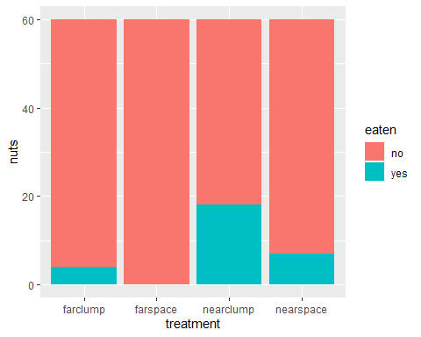

chisq.test(mytable)

##   
## Pearson's Chi-squared test  
##   
## data: mytable  
## X-squared = 28.044, df = 3, p-value = 3.556e-06

Days=read.csv("daystaken.csv",header=TRUE)  
library(survival)  
dayslong=pivot_longer(Days,cols=3:6,names_to="treatment",values_to="time")  
dayslong$status=as.numeric(dayslong$time!=60)  
survfit(Surv(time,status)~treatment,data=dayslong)

## Call: survfit(formula = Surv(time, status) ~ treatment, data = dayslong)  
##   
## n events median 0.95LCL 0.95UCL  
## treatment=farclump 36 4 NA NA NA  
## treatment=farspace 36 0 NA NA NA  
## treatment=nearclump 36 18 10 3 NA  
## treatment=nearspace 36 7 NA NA NA

plot(survfit(Surv(time,status)~treatment,data=dayslong),col=1:4)  
legend(0,0.4,c("farclump","farspace","nearclump","nearspace"),col=1:4,bty="n",lwd=1)

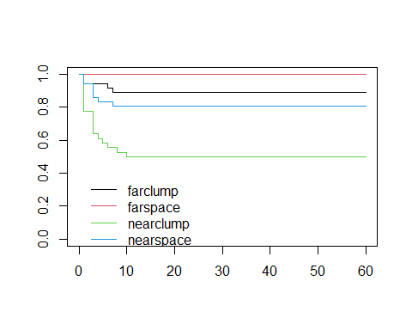

survdiff(Surv(time,status)~treatment,data=dayslong)

## Call:  
## survdiff(formula = Surv(time, status) ~ treatment, data = dayslong)  
##   
## N Observed Expected (O-E)^2/E (O-E)^2/V  
## treatment=farclump 36 4 7.55 1.6718 2.3749  
## treatment=farspace 36 0 7.88 7.8757 11.3692  
## treatment=nearclump 36 18 6.27 21.9719 29.7340  
## treatment=nearspace 36 7 7.30 0.0127 0.0178  
##   
## Chisq= 33.5 on 3 degrees of freedom, p= 3e-07