# **DP200 - Implementing a Data Platform Solution**

## Lab 8 – Securing Azure Data Platforms

### Exercise 1: Introduction to security

Below is a diagram that represents the layered support to security:

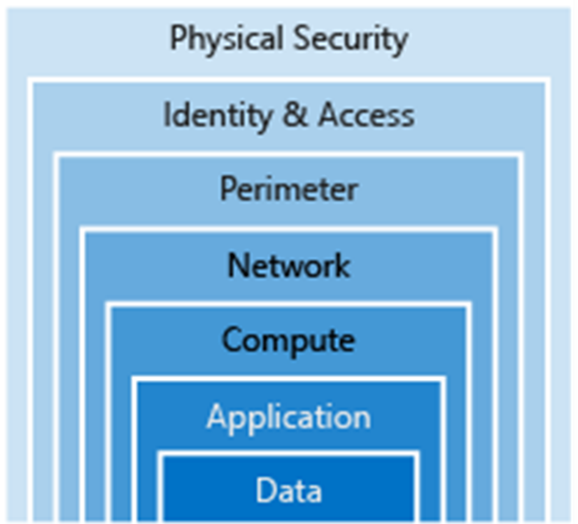

From the course content, case study and the scenarios taken in the course so far, spend 10 minutes in a group identify the layers of security that you have impacted so far to secure AdventureWorks in the labs. Find three examples.

|  |  |  |
| --- | --- | --- |
| Task | High level security task | Layer |
| 1 |  |  |
| 2 |  |  |
| 3 |  |  |
| 4 |  |  |
| 5 |  |  |
| 6 |  |  |

Which security layers have we not dealt with in this course? Can you make a suggestion of what you would do in this area?

|  |  |  |
| --- | --- | --- |
| # | Layer | Suggestion |
| 1 |  |  |
| 2 |  |  |
| 3 |  |  |