2.8 Proportions and Similar Figures

Lets take a look ahead at a geometry subject where we can apply or knowledge of proportions. First we will take a look at similar triangles.

We can use PROPORTIONS to find a missing length of similar triangles!!!!!!!! Check out the example below

EX 1

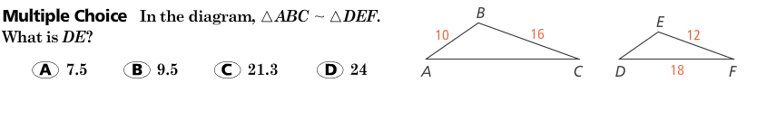

Now your try to find the missing side!!! U got dis.

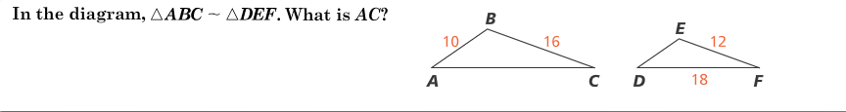

Now lets try to apply this knowledge of similar triangles in a word problem

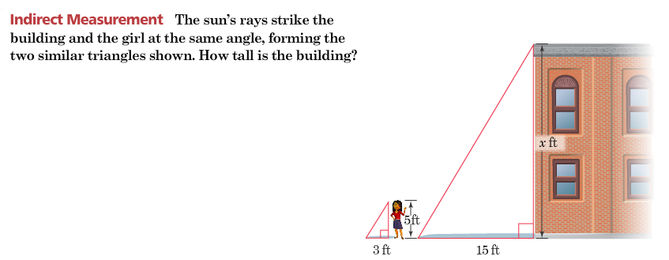

You can use a similar concept to compare things that are scaled to size. Lets check out an example of using proportions to determine a scale.

Hint: Always make sure that your units are lined up correctly ( if miles are the top part of the fraction on the scale, miles should be the top part of the fraction on the actual distance)

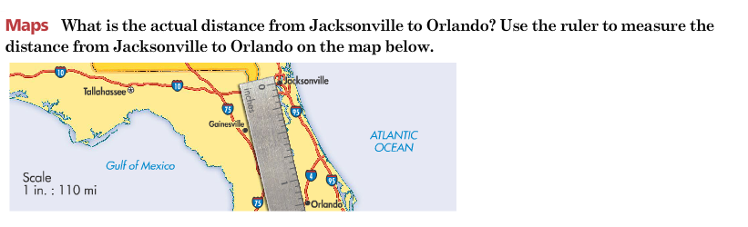

Here’s a scale problem to try on your own!!!

