**Friday 2/7/2020**

In my last journal report, I mentioned how one cannot expect data to be perfectly ordered all the time. Well, while that is true in a general sense, I actually figured out why my data was out of order. As seen in the picture below, I needed to toggle the “Name” column so that the files were sorted numerically.

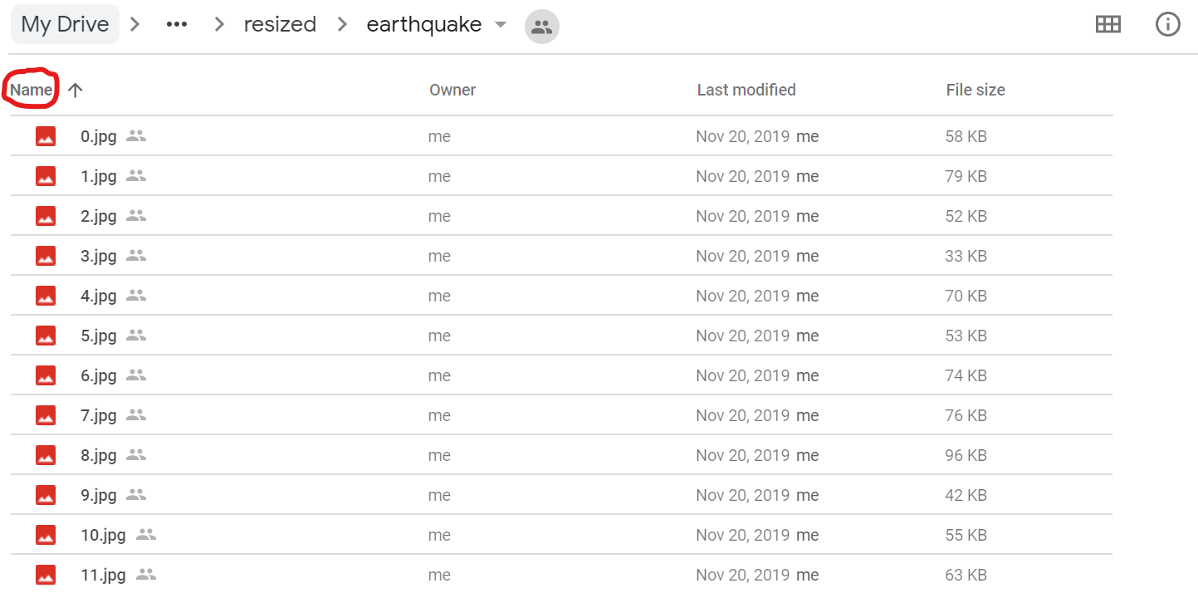

I supposed then Google liked to randomly toggled things out of order sometimes. Now, I also realized I needed to change the .csv annotations file-paths. For example, the format was, as an example:

“finished/google_images/flooding_aerial_resized/50.jpg,” and I needed to figure out a way to parcel out this string so that it matched to something along the lines of “finished/google_images/first_100s/50.jpg.” In addition, I just felt overwhelmed by this entire process, from having to change the name of the file paths to making copies of images, moving from one folder to “first_100s,” and then relabeling those recently moved files to the appropriate disaster type. I knew this was how the process of research went in general, but I did not realize one simple step of simply reformatting my data took many thorough tasks. They took me by surprise.

As I talked about my feeling of being overwhelmed with my partner, he reminded that it was vital to break things down task by task and to calm down. I thanked him for that.

**Saturday 2/8/2020**

I thought about the user point of view again and I decided it would be best if I put my sources on the website under “For more info.”, since that would be a proper thing to do in general research. I used the APA format, and I had a challenging time trying to get the fonts (Times New Roman) and the indents to display correctly. In the end, I decided to take a screenshot of the references by first converting the .docx document I had my citations in, then converting that into .pdf, then using an online .pdf → .jpg converter, then uploading that image on Director, and finally using Streamlit methods as necessary to display the references screenshot.

**Monday 2/10/2020**

I had my friend test out the page and see if he could give me any valuable feedback about improving the user experience on the page. Here were the tips:

* Have the image link bar near the top of the page so that the user would not have to scroll down
* On “Greetings”, use bullet points to show the user step by step how to look for images on Google Images and use their image addresses
* Have “For more info” “streamlit2.sites.tjhsst.edu/about” page
* Show the actual image from the example image link on my web app, and have the example link have a copy button next to it for seamless copying and pasting.
* “Unvalid Image URL” should be “Invalid Image URL.” Check for typos.
* Have a header. Do something to make the sides less empty (e.g. put some logos/pictures). He felt that the website was missing something without something filling up the sides.

**Wednesday 2/12/2020**

I switched back gears to focusing on the multi-label network feature. However, the bulk majority of the time ended up spent on my one-on-one conference with Dr. Gabor. First, we discussed the issue of not being able to scrape off certain images from Google Images (i.e. the “Invalid Image URL” error) during my demo of the website to him. Next, we went over my next two milestones (and probably final two). Finally, he shared general suggestions to make on my web application.

For the “Invalid Image URL” error, Dr. Gabor suspected that perhaps certain websites do not like bots scraping off their data (in this case, their photos). However, those same websites would not mind a browser viewing those images close up because then developers of those websites can be ensured a human is viewing those photos. Therefore, there has to be some logical way to scrape off images from any / the vast majority of websites with another Python package from the one I was using that scrapes off data with browser-based access.

The two next milestones I shared with Dr. Gabor were:

1. For the web application to have the ability to not only classify what disaster is in a given aerial photo but also classify more relevant details in that photo, such as structural damage and vegetation. Details like those could be more useful for disaster team responders.
2. For the web application to then take in a folder of images that the Civil Air Patrol, annotate all the photos, put them into a severity scale, and plot the locations of the most severe locations on a map.

Dr. Gabor approved of these two ideas. Dr. Gabor’s ideas to improve the web application were the following:

* Find websites that I like and try to find out which elements of those websites I particularly enjoy. Then, replicate some (or all) of those elements into my own website.
* Phrase the “Greetings” section more professionally. Avoid a nice tone because then that implies for the user to have fun testing out something experimental. Well, I have a completely working feature on my website, and a good way to imply/communicate that is by displaying a professional tone in my text.
* Where I highlight “Make sure NOT to input ground-level nor satellite-level images,” give an immediate explanation for that. While it is nice I have an explanation in “Fore more info.,” chances are my users are not going to stick around long enough to read all my explanation text. Perhaps a good idea is to make the “Make sure …” text into a hyperlink that users can click on, and that will take them to another page that will explain why not to input ground-level nor satellite-level images. As for the initial impression of explanation text itself, Dr. Gabor said it was exactly what he was looking for, so that was nice to hear. I just needed to maybe migrate some of that into a hyperlink / that other page I was just talking about.
* Perhaps have a menu to the side. One option could be a setup page (although that seems less relevant to my project) where users could tweak certain parameters. I could also have the option of displaying the main page and an “Explanations” page.
* Change the phrasing of “We want normal users like you…” to be more professional.

Dr. Gabor and I also talked about the issue of how I was not able to have users upload their own local images. Unfortunately, I forgot the exact explanation of why, but I told him it had to do with Streamlit’s capabilities. I told him that I would come back later with more specific reasoning.

**Thursday 2/14/2020**

After a brief discussion with my partner, I found out that Streamlit did not have a built-in method of a button where someone can input an image. However, Streamlit developers say that they are in the middle of working on that feature along with other highly requested features.