**Friday 2/14/2020**

I finally figured out the first concrete step I would take for my next milestone. I decided that since it was challenging to use Google Drive alone, I decided to use this workflow:

For each disaster photo folder:



This workflow worked well, and at that point, I finally could move on to the task I originally focused on, which was to rename the file paths in the “all.csv” file.

In addition, Dr. Gabor told us that if we made any changes to our website, he would want a screenshot of the relevant section(s) of our website on the next journal report. This implied to me that while we, as a class, are working on our next milestones, he wanted to ensure we are incorporating his suggestions / making our website be better by the next journal report. So, I grabbed the low hanging fruits first.

The top two low hanging fruits I could think of was shifting the “Link to Image” bar to the top of my website and to rewrite parts of the “Greetings” section so that it could sound more professional. The result is on the back of this page.

**Saturday 2/15/2020**

Earlier, I remember my partner told me that he attempted to, but failed at rounding the certainties off and multiplying each certainty by 100 so that the results could be given as percentages. However, what came to my mind was that pandas data frames actually makes these sort of operations pretty seamless. It turned out that my partner was trying to modify each element in the data frame, and somehow that gave an error earlier. When I tried these tasks the “Pandanic” way (analogous to “Pythonic” in Python), it worked. The results are also on the back of this page.

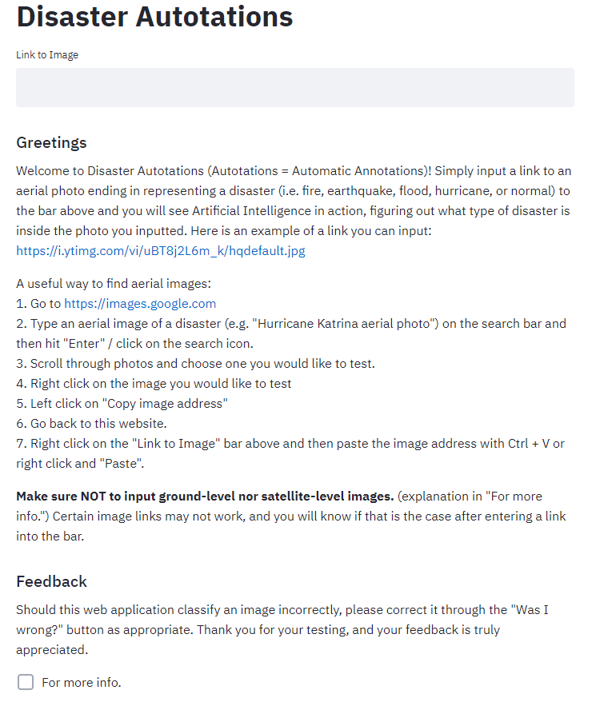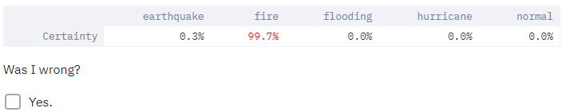

**Tuesday 2/18/2020**

Considering professionalism again, I checked the “Greetings” section and deleted a couple words/phrases, such as “Certain images links may not work, and you will know if that is the case after entering a link into the bar” since that puts on a negative light to the introduction of my web application. I also got rid of the exclamation mark after the beginning sentence, since generally, exclamation marks are informal. I then analyzed the text throughout and made phrases/sentences more concise. below is the result:

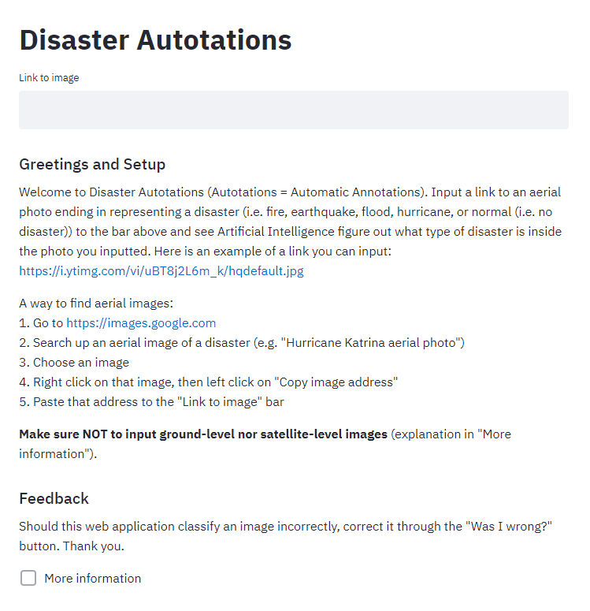

**Wednesday 2/19/2020**

Today, I was able to get the rest of the disaster images properly labeled and uploaded to the “first_100s” Google Drive folder. I then showed Dr. Gabor how I attempted to make the text on my website more professional, and one thing he suggested was that I could have a plus sign next to the instructions (essentially the same function as a checkbox) since if the user reads them once, there is a good chance that user will not have to reference them again. This is the exact reasoning as to why I had a “More information” checkbox. Another suggestion he mentioned was that I should be able to override Streamlit so that I am able to adjust the white space margin as necessary up on the top right before the title “Disaster Autotations” appears. He implied the first direction I should look towards is looking at the HTML page source.