**Friday 2/28/2020**

I confirmed that “fire59.jpg” through “fire99.jpg” were “.jpeg” extensions instead of “.jpg” ones. However, it also seemed that some of the photos in general did not match up with the annotations seen on “all.csv.” I wondered why that was the case.

Then, I found out that for some reason, the fire aerial dataset we had with photos in raw dimensions did not have the equivalent photos as the dataset that had fire aerial images resized.

That was when I realized that the “resized” dataset was entirely different from the raw-dimension dataset. I suppose somehow the google image search results had different results each time I constructed a dataset. I did not remember exactly why the two datasets were different, but I decided to first convert the .jpeg files into .jpg first before moving on with the dataset concern.

I saw an online convertor that worked, but unfortunately I had to pay if I wanted to convert more than two images at a time. I then searched for Python code that could convert .jpeg to .jpg files. There was still no luck, unfortunately. The best I could find were conversions between PNG and JPG files. I was beginning to lose hope, until I researched the difference between JPG and JPEG files. Google gave me that there was virtually no difference. For a while, the JPEG format was used until it was shortened to JPG due to certain versions of Windows requesting it that way. From that information, I simply changed the name of a photo from “fire#.jpeg” to “fire#.jpg” and see if that worked. Indeed, it did.

I tried opening the Google Colab file for the multilabel nerual net, but it resulted with an unknown error:

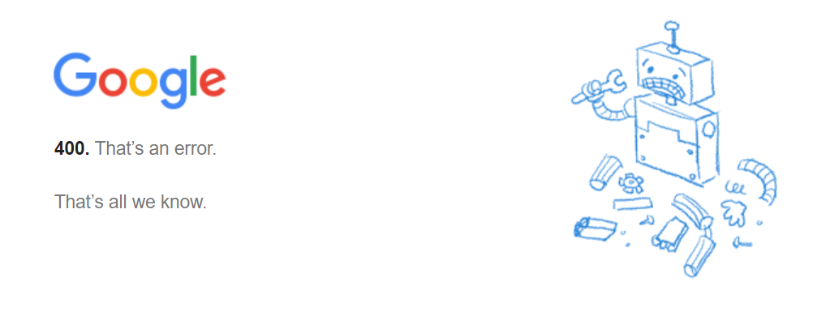

That was really unfortunate. I researched into the issue, but there was no luck, unfortunately.

**Sunday 3/1/2020**

My partner and I found out that the reason this error was occuring was that Fairfax County Public Schools once again decided to block a precious tool for CS students: Google Colab. We originally had tried to figure out this error by removing Google Colab as an installed app on Google Drive and then installing it. However, installing was not an option since the following came up (see next page):

This was how we knew FCPS was the cause of our issue.

**Wednesday 3/4/2020**

Connor had the idea of using PyDrive so that I could transfer my Google Colab files from my FCPS drive to my personal drive. When I had tried downloading a Colab file earlier, they did not download properly. When I tried reuploading that file onto my personal drive, Google Drive did not recognize it as a Colab file. Therefore, I became glad when I heard Connor’s plan.

I checked out the folder he shared with me on my personal drive to see if the transfers worked out alright. It turns out they did.

Focused back on the dataset concern mentioned earlier, I had to decide on one of two possibilities:

1. Do the annotations all over again to ensure alignment between the annotations and their respective photos
2. See if by any chance, the saved photos on my desktop matches up with the annotations. (I had a desktop and laptop, and before I received the laptop I am typing on, I had used my desktop. There was a chance that the right photos for my multilabel annotations were stored locally. However, I also remembered uploading them to Google Drive. Unfortunately, I had no idea where those photos went to/how they got deleted.