- Executive Summary
Through the initial analysis and further analysis performed, it is clear that UVA can be doing much better in its soliciting of donations. In the analysis I was able to narrow the list of countries down to the following:
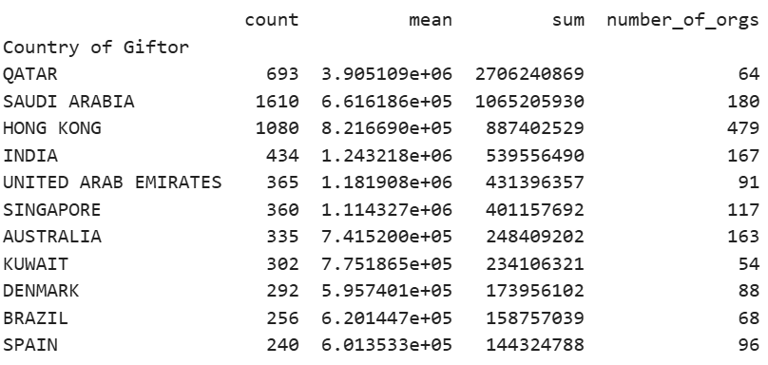
These countries are all above average in the count of gifts, average gift, and total gifts given. This means that they are all great candidates for success in solicitation of donations for the University. It would be possible to do deeper analysis into the independent organizations within each of the top countries to be even more specific about exactly who to solicit.
- Analysis Summary
The results of my analysis were quite telling. It is clear that Qatar makes the largest donations in both average gift and total amount – and they still make a substantial count of gifts in total. Universities who received gifts from Qatar often had the majority of their gifts received accounted for by Qatar. It was interesting that not every country that gifted in large quantities (high count) also gifted in large amounts (high total gifted). This means that an analysis of only the total count of gifts given would not be sufficient.
When we view UVA’s gifts received, we can see that the majority of their gifts received came from countries that do not fall on the list above, where we determined which countries would result in the most successful solicitation of gifts. UVA’s top donation was from Bangladesh ($4.2M), which pales when compared to VCU’s top donation from Qatar ($78.9M, nearly 19x more). Overall, UVA needs to reconsider what countries it prioritizes in soliciting donations, as its current selection is underperforming the market quite significantly (UVA’s received donations accounted for 0.1% of the total donations in the market, and fell in the 68.4th percentile for total donation dollars received).
- Strategy
In my analysis, I identified a new strategy for selecting donors to pursue. To begin, we consider the countries which perform above the mean in each of three categories: 1) number of gifts donated on average, 2) the average size of those gifts, 3) the total amount of gifts (in dollars) the country gave. We then find the intersection of these three lists, and pursue further qualitative research to narrow this list down. Once countries to pursue have been selected, we then perform the same analysis as we did for the countries for each giftor in the countries we selected. This will help us to narrow down the search for donors to our desired quantity. Then we can create a function to evaluate each giftor in terms of the count, mean, and sum of gifts they donated in our dataset, giving weights to each statistic, and then selecting those giftors which score the highest per our function. This should help us to spend our time soliciting donors who will give graciously and often.
- Conclusion

UVA has excellent prospects for increasing their foreign gifts received. It appears that Qatar is the most valuable giftor (giving many gifts, in large quantities on average, resulting in a massive total of $2.7B). Saudi Arabia and Hong Kong come closely behind, each donating a massive volume of total gifts in high amounts – with the additional benefit that there are many more organizations that can be solicited from. Any selection from this list would improve UVA’s foreign giving, but with a bit of further qualitative and quantitative analysis, UVA’s selection of candidates could be optimized further.

