This trial performed a comparison between three treatment methods to reduce the pre-diabetic progression to full diabetes. The 3 treatments were Metformin, Rosiglitazone, and lifestyle adjustments. A total of 699 observations were included in the dataset, with each observation being marked as either a success or failure to reduce pre-diabetic progression to full diabetes. We begin with a cross-tabulation of the results:
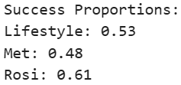
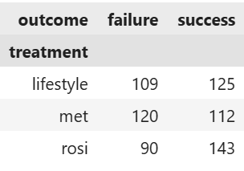
We observed that from our sample, Rosiglitazone showed the greatest success proportion, however we want to quantify the level of variance around this point estimate. To do this we performed a bootstrap and observed the following:
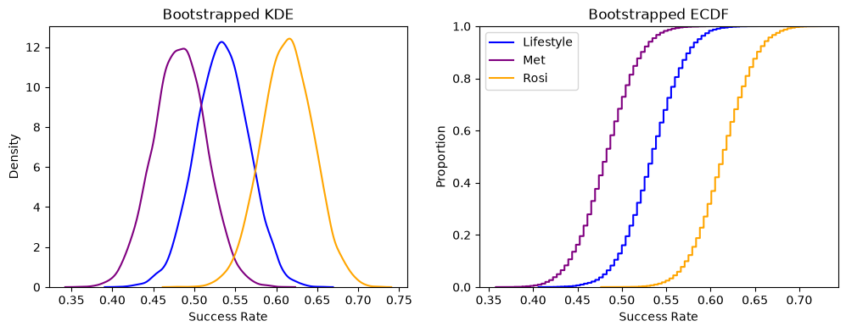
We can see that Rosiglitazone performed noticeably better than lifestyle changes or Metformin based upon the ECDF showing Rosiglitazone at higher success rates given any proportion of the data, and the KDE showing a concentration of data above that of the other two treatments. However, this alone is not convincing evidence that Rosiglitazone has higher success rates at a statistically significant level. Below are the bootstrapped KDE and ECDF’s of the average treatment effects between each pair of medications:
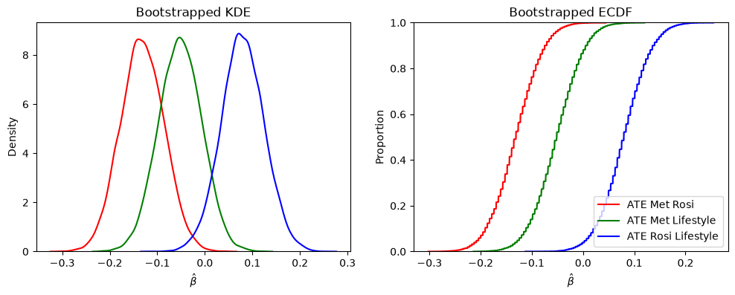
From these graphs we can observe that Rosiglitazone performs better than lifestyle changes, and better than Metformin (based upon the KDE’s concentration around positive and negative $\hat{β}$’s, respectively). We perform confidence interval testing on these results below:
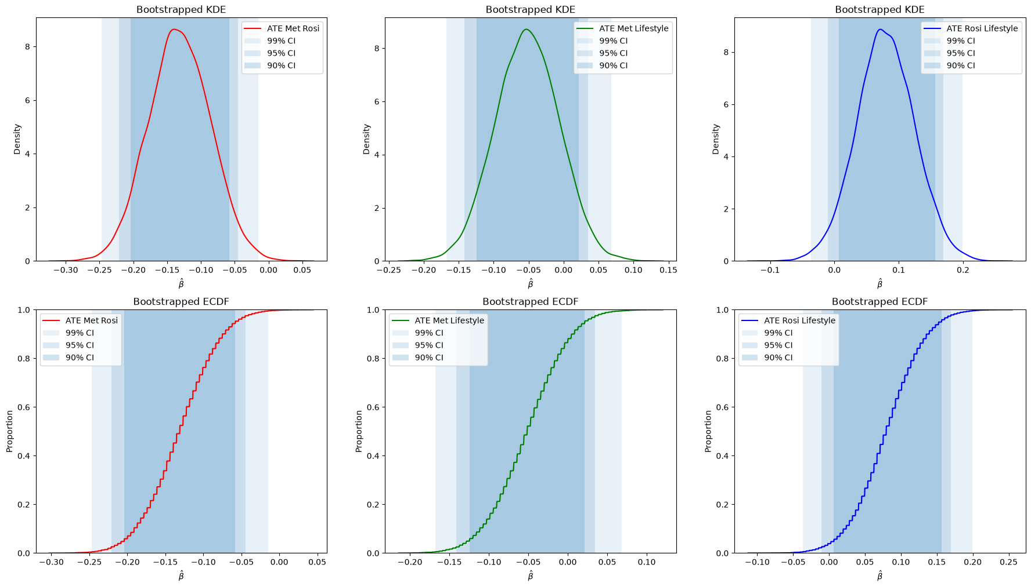
From these results, we can see that the only statistically significant results we achieved were the 99% significant $\hat{β}$ (ATE) between Metformin and Rosiglitazone (indicating that Rosiglitazone performs more effectively than Metformin), and the 90% significant $\hat{β}$ between Rosiglitazone and lifestyle changes (indicating that Rosiglitazone performed more effectively than lifestyle changes). Taken all together, with an $α= 0.10$ we can say that Rosiglitazone performed more effectively than Metformin or Lifestyle changes, and we reject the null hypothesis that there is no difference between these treatment methods.

