In this lab, we are attempting to identify an optimal price to use for a product where the number of customers that arrived follows a Poisson distribution, and each customer’s probability of purchasing falls with price according to a mix of three logistic curves. We want to maximize the revenue per customer (RPC), as this metric accounts for both the price charged and the number of customers who made a purchase. Because we know the demand curve, the maximum possible RPC is $11.925 at a price of about $27.73. However, our algorithm needs to estimate this value, along with the price when it occurs using a combination of grid search and gradient ascent. We will use grid search to first locate the general area in which we will find the global maximum, then we will find the local peak in that area (which should be the global maximum) using gradient ascent.
Working with Claude, I was able to create a series of functions that perform needed procedures for us to make these determinations. Most of these functions were necessary to perform the experiments to gather data about the revenue per customer at given price points; however, there are two functions that help us with uncertainty around our estimates. summarize determines the RPC with an SE and a confidence interval based on a given z-score, which helps us understand our uncertainty around each RPC estimate. Additionally, eliminate performs a two-sample z-test against the price that has the highest RPC and drops any price whose confidence interval for the difference does not contain 0 (meaning there is statistically significant evidence that its RPC is lower). As shown in the graph below, during the grid and elimination stages, we measured our estimates of RPC with uncertainty and used the eliminate function multiple times until we had narrowed our estimate at the highest RPC to two prices ($27 and $29). We used z = 2 (about 95% confidence) for elimination, since that stage only eliminates clearly worse prices, and we used a more strict z-score of z = 2.576 (99%) for the final stage, where any remaining prices would be compared before setting the final price. Because the results at each price are cached, each time we run the eliminate function, it adds new customers to the data we already have rather than starting over, which keeps experimental costs down.
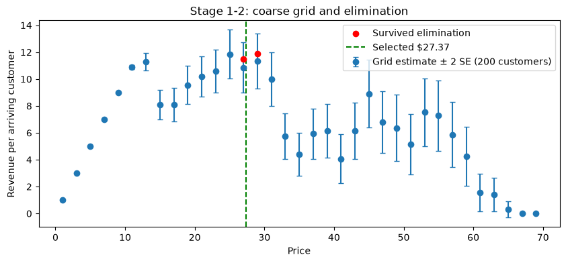
When we did gradient ascent to determine the optimal price, we reported the average of the final 15 iterations of our gradient ascent, which helps to reduce sampling noise between the RPC estimates. These final iterations varied with a standard deviation of about $0.31, which shows us that there is some remaining uncertainty in our final price estimate. Below is a graph showing the steps our gradient ascent took.
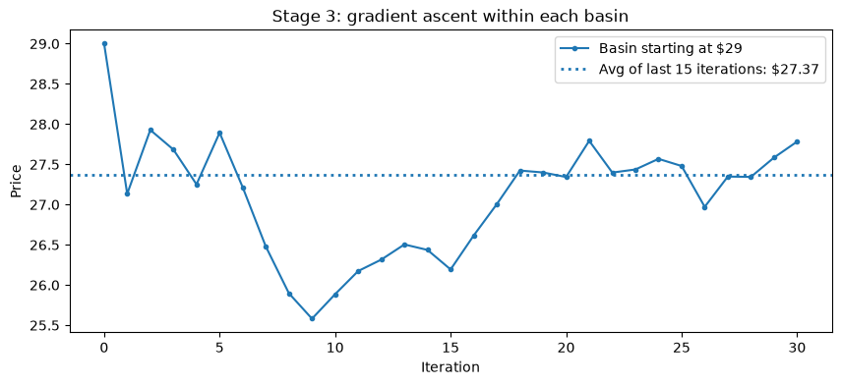
When working through this with Claude, one issue I kept running into was gradient ascent leading to an optimal price of about $12. This is only a local maximum, but because it lies at a lower price than the global maximum, my algorithm kept converging there. Claude suggested that I solve this by repeating the elimination step in rounds, doubling the number of customers at each surviving price every round, until the survivors fell into a single basin. Gradient ascent was then performed within that single basin, so it couldn’t drift toward the $12 peak. The $13 grid price, near the top of that local peak, was surprisingly persistent: it survived three rounds and was only eliminated after about 3,000 customers, because that peak’s RPC (about $11.49) is very close to the global maximum.
A second problem is visible in the Stage 3 graph above. My gradient ascent was giving me inconsistent estimates of the optimal price, and after graphing the iterations, I noticed that they jumped around near the optimal price. I did some research and learned about Polyak-Ruppert averaging, where several of the final iterations are averaged together to help reduce the noise caused by these little jumps due to sampling error. Claude helped me write the line of code that accomplished this, and it brought me closer to the true optimal price.
The results of this algorithm are excellent. It selected a price of $27.37, close to the true optimum of about $27.73. At this price, the true expected RPC is $11.905, or 99.83% of the optimal $11.925. Because only one basin survived elimination, Stage 4 served as a final confirmation sample at the selected price rather than a comparison between candidates. Our own estimate from those 536 customers was $11.49 (SE $0.58; 99% CI $9.98 to $12.99), an interval that contains the true optimal RPC. Below is a graph showing the true diagnostic curve with our selected price marked.
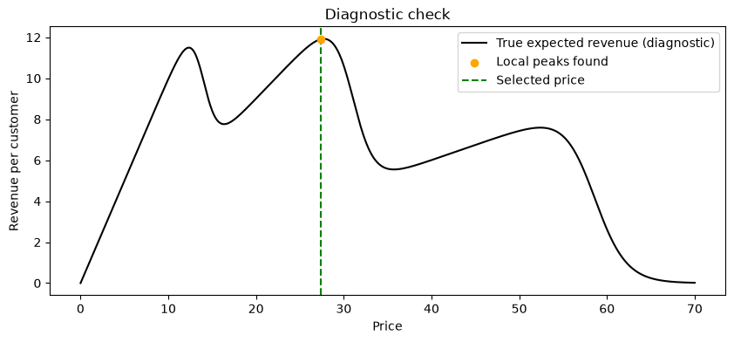
This estimate could also be improved by using larger sample sizes of customers; however, this would increase the cost of our experiment substantially. Thus, as we can see in the graph below, our current sample size is an excellent trade-off between experimental cost and accuracy, as the percentage of optimal RPC captured was beginning to show diminishing returns. Additionally, below is a table showing the costs associated with our experimentation.
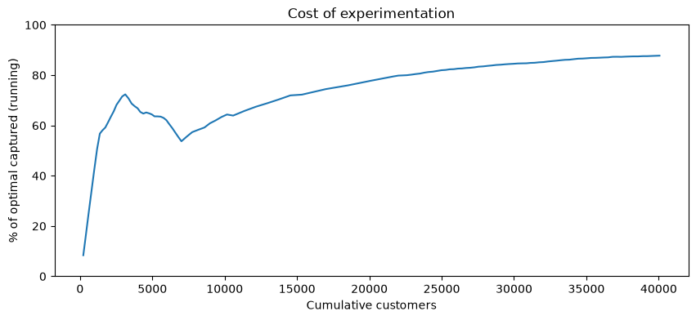
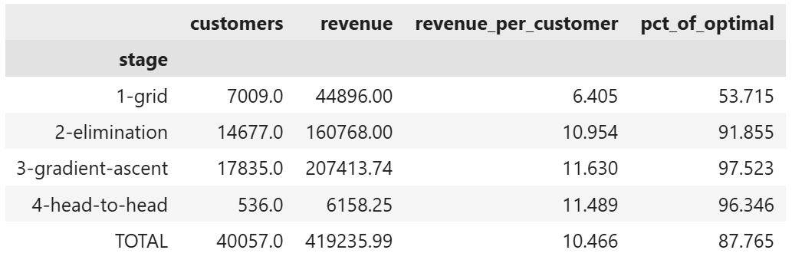
In total, we experimented on 40,057 customers and earned $419,235.99 in revenue during experimentation, or $10.47 per customer. This is about 88% of the revenue we would have earned by charging the optimal price throughout, which is excellent. We could work to improve the grid stage, as this is where we lost the most revenue; however, this makes sense, because at that stage we tested a wide range of prices (which could be narrowed to a more realistic range to reduce costs).
Overall, this algorithm did an excellent job estimating the true optimal price, while keeping the cost of experimentation low.

