Django:

* Django is a framework that acts as the backend of our website, handling the HTTP responses, and making serving content easier. It will also make dealing with security much easier due to making it easier to store tokens and hash passwords.

Render and Redirect Code snippets

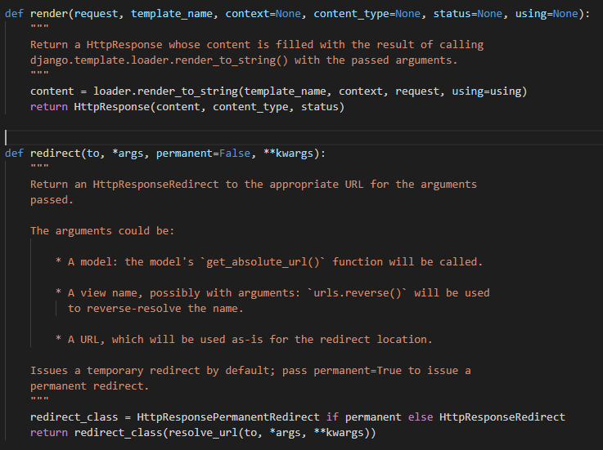

Here django is defining two helper methods that take in certain arguments. The first is render which will take in the template (html, etc) and send a http response to the server, writing the content to the path. Redirect takes in a path and will write a redirect response to the server using the given location. (shortcuts.py)

Authentication

Django uses its own authentication database to store and authenticate users. Django uses sessions and cookies to store the login status of the user. It will remove these cookies when logout is called. (client.py) This is seen below.

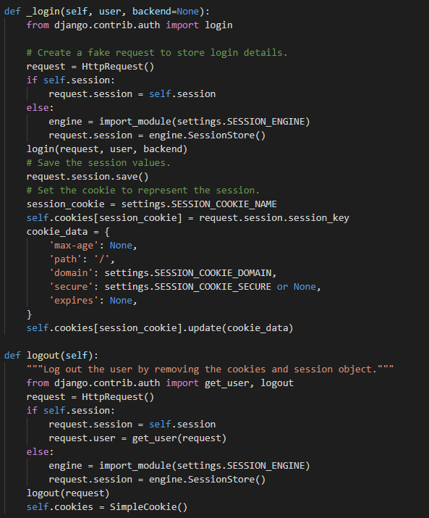

Sessions in django are created as follows