**Experiment No.02**

**PART A**

(PART A: TO BE REFFERED BY STUDENTS)

**To implement basic connection establishment by using Packet Tracer Software**

**A.1—Aim:**

The purpose of this session is to implement the basic connection and sending echo messages from one device to another using packet tracer software

**A.2--- Prerequisite:**

Understanding the basic knowledge of connecting devices

**A.3--- Outcome:**

After successful completion of this experiment students will be able to:

* Interact the basic interface of the Packet tracer software

**A.4--- Procedure:**

**Task:**

1. To connect client to server

2. See the simulation of sent and received packet using simple and complex PDU

3. Check the OSI layers of the packet

*4.* Observe the output and complete PART B of lab manual

5. Save and close the file and name it as **EXP4_ your Roll no.**

**(PART - B)**

|  |  |
| --- | --- |
| Roll. No.: N049 | Name: Tarun Tanmay |
| Sem/Year: 5, third year | Batch: B3 |
| Date of Experiment :13/07/2020 | Date of Submission: |
| Grade |  |

**B.1: Procedure of performed experiment**

Network made:

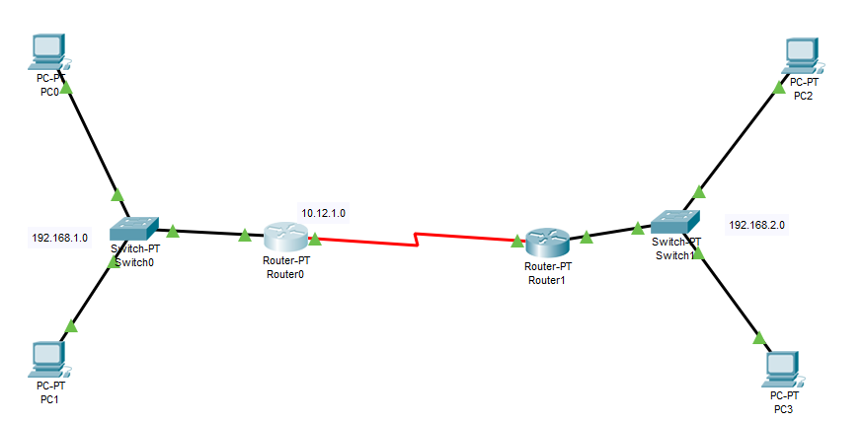

The network was made as shown above. Each LAN had two PCs, one Switch and one Router. The PCs were connected to the Switch, which in turn was connected to the Router. The Routers were then connected to each other. The left network was assigned the IP address 192.168.1.0 and the components connected to it were assigned IP addresses corresponding to it. The right network was assigned the IP address 192.168.2.0 and the components connected to it were assigned IP addresses corresponding to it. The network connecting the Routers was assigned the IP address 10.12.1.0. No configurations had to be made on the switch as it works on the data link layer.

Configurations of one LAN:

PC0:

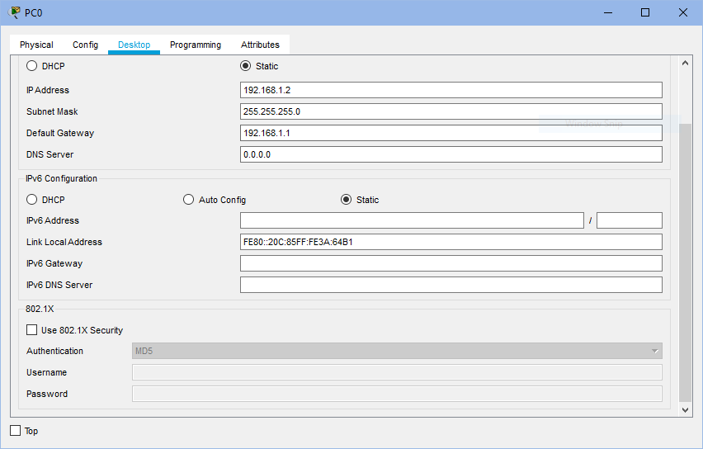

For the PC, the IP configuration section under Desktop was filled as follows:

* The IP address assigned to it in the LAN it is connected to was entered (192.168.1.2)
* The default gateway, i.e., the address of router connected to its network, was entered (192.168.1.1)

PC1:

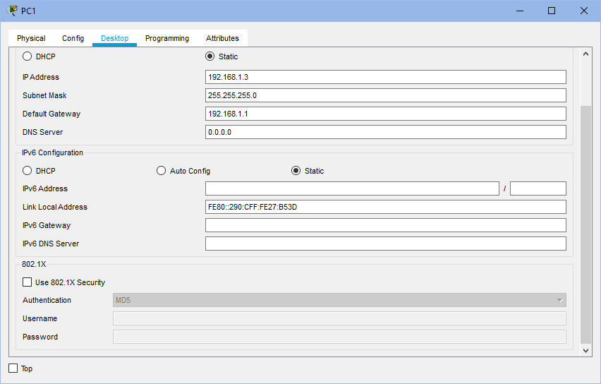

For the PC, the IP configuration section under Desktop was filled as follows:

* The IP address assigned to it in the LAN it is connected to was entered (192.168.1.3)
* The default gateway, i.e., the address of router connected to its network, was entered (192.168.1.1)

Router:

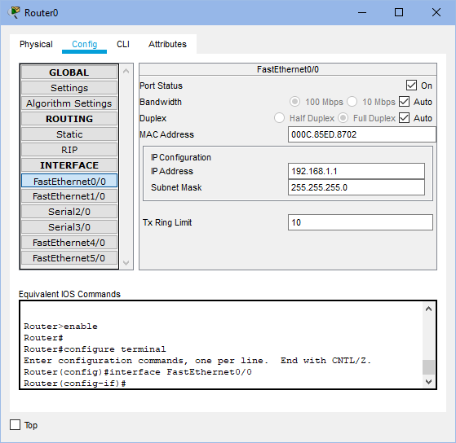

For the router, the FastEthernet0/0 section under Config was filled as follows:

* The IP address assigned to that router in the LAN it is connected to was entered (192.168.1.1)
* The port status was set as ON.

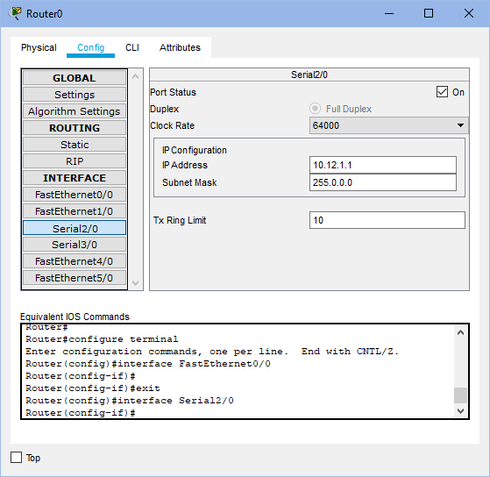

The Serial2/0 section under Config tab was filled as follows:

* The IP address assigned to it in the network between the two routers was entered. (10.12.1.1)
* The clock rate for this router was set as 64000 while for the other router was set as ‘Not Set’.
* The port status was set as ‘ON’.

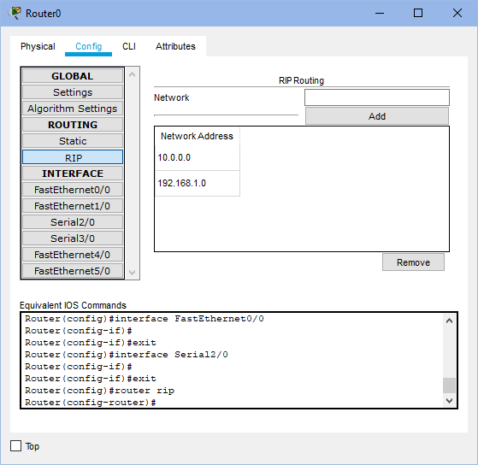

The RIP section under Config tab was filled as follows:

* The addresses of the networks connected to it were entered
  + 10.12.1.0 (corresponding to network between the two routers)
  + 192.168.1.0 (corresponding to the LAN it is connected to)

Packet Transmission:

Cross Network PC-to-PC transmission: (from PC0 to PC3)

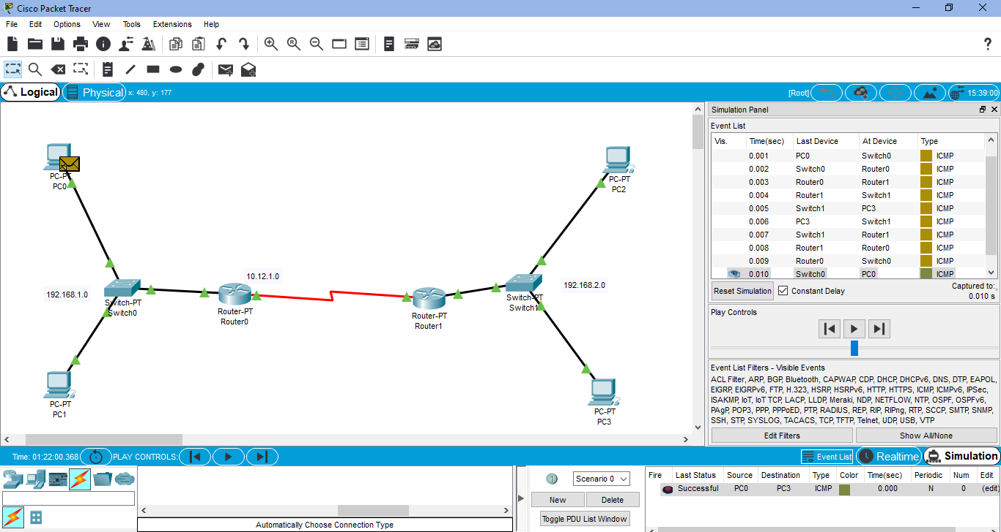

Router-to-Router transmission: (Router1 to Router0)

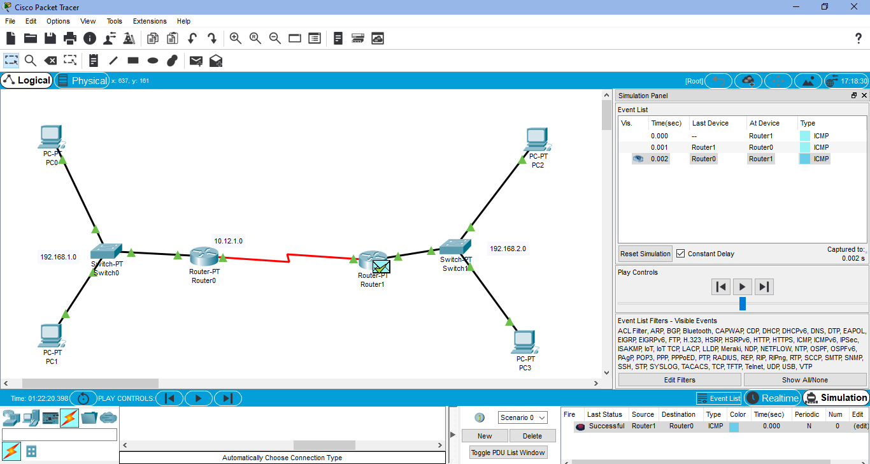

**B.2: Observations and Learning’s:**

Cisco Packet Tracer helps create network topologies using connecting devices, end devices, connections, etc. and simulate the transmission of packets through the network. It gives information about how the packet travels from the source and the destination as well as the components and path used. Changing the IP information of the devices and creating a functional LAN is also possible.

**B.3: Conclusion:**

I have learnt how to use Packet Tracer and create a network as well as see a packet travel in a network from one device to another.