**Practical 3**

**PART A**

(PART A : TO BE REFFERED BY STUDENTS)

**PC Network TCP/IP Configuration**

**A.1—Aim:**

The purpose of this session is to gather network information (IP address, MAC

address…etc), learn to use the TCP/IP Packet Internet Groper (ping) command,

and learn to use the Traceroute & other commands from the workstation.

**A.2--- Prerequisite:**

Understanding the basic knowledge of TCP/IP, Mac address and router

**A.3--- Outcome:**

After successful completion of this experiment students will be able to:

* Get IP address through command prompt
* Trace the router and gateway path
* Execute other commands to examine a network

**A.4--- Theory:**

Internet Protocol Address: "IP" stands for Internet Protocol. Every machine on a network has a unique identifier. Just as you would address a letter to send in the mail, computers use the unique identifier to send data to specific computers on a network. Most networks today, including all computers on the Internet, use the TCP/IP protocol as the standard for how to communicate on the network. In the TCP/IP protocol, the unique identifier for a computer is called its IP address.

* **loopback IP address:** The loopback IP address is the address used to access itself. The IPv4 designated **127.0.0.1** as the loopback address with the 255.0.0.0 subnet mask. A loopback interface is also known as a virtual IP, which does not associate with hardware interface.
* TCP/IP is the suite of communications protocols used to connect hosts on the Internet.
* A default **gateway** is a node (a router) on a TCP/IP network that serves as an access point to another network. A default gateway provides an entry point and an exit point in a network.

**The basic commands to examine a computer networks are as under:**

* Packet Internet Groper (**ping**) command is used to provide a basic test of whether a particular host is operating properly and is reachable on the network from the testing host.
* The traceroute (**tracert**) traces all the routers that a network layer packet has to pass through to get to a destination.
* **hostname:** finding host/domain name and IP address
* **ipconfig** (Internet Protocol Configuration) for getting network configuration
* **netstat** : Network connections, routing tables, interface statistics
* **nslookup:** query DNS lookup name
* **pathping**
* **route**

**A.5--- Procedure:**

**Task:**

1. Gather TCP/IP configuration information
2. Ping the Loopback IP address of your computer
3. Ping using names like websites
4. Trace the route to any website
5. Execute other commands to examine a network
6. MAC address/ Mobile and laptop speed
7. Observe the output and complete PART B of lab manual
8. Save and close the file and name it as **EXP3_ your Roll no.**

**(PART - B)**

(TO BE COMPLETED BY STUDENTS)

|  |  |
| --- | --- |
| Roll. No. : N049 | Name: Tarun Tanmay |
| Sem/Year : 5/ third year | Batch:3 |
| Date of Experiment : 22-07-2020 | Date of Submission:22-07-2020 |
| Grade |  |

**B.1: Procedure of performed experiment**

1. Gather TCP/IP configuration information

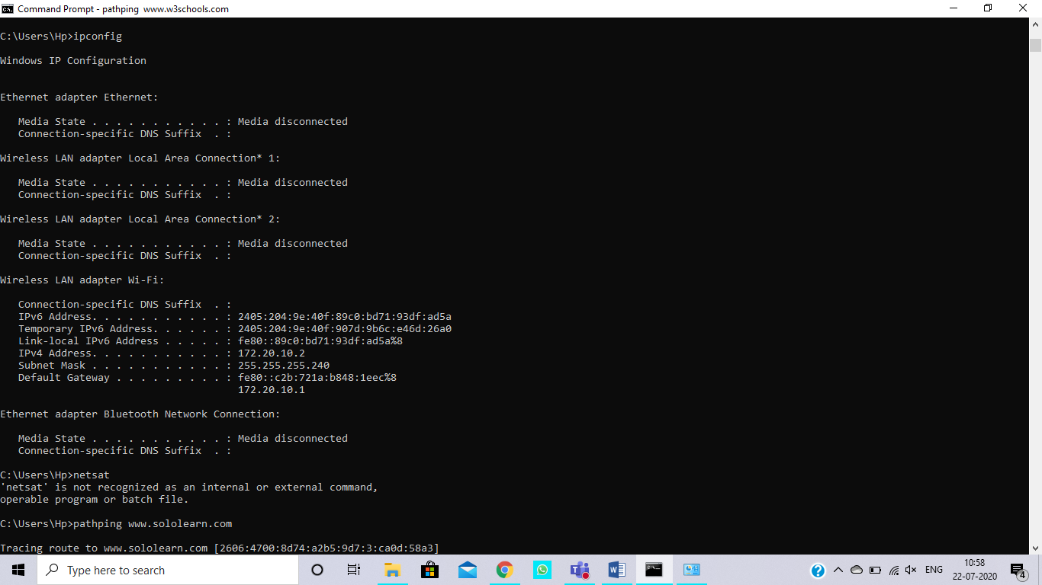

1. Ping the Loopback IP address of your computer

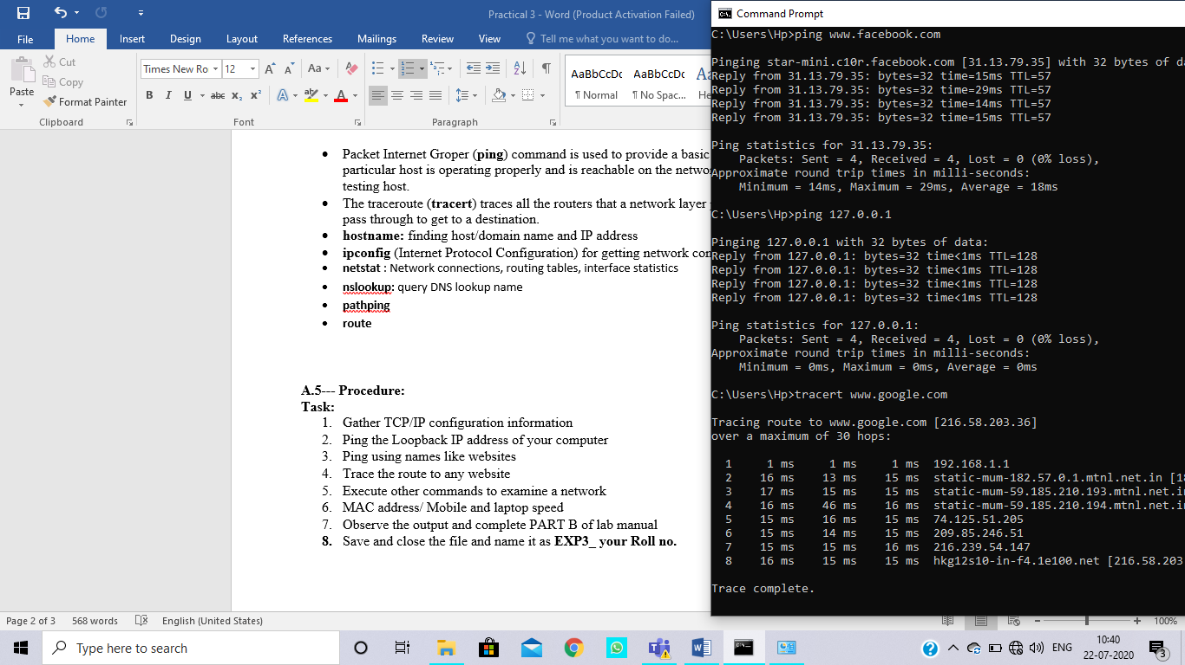

1. Ping using names like websites

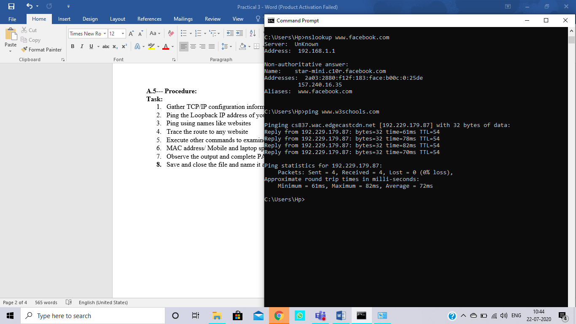

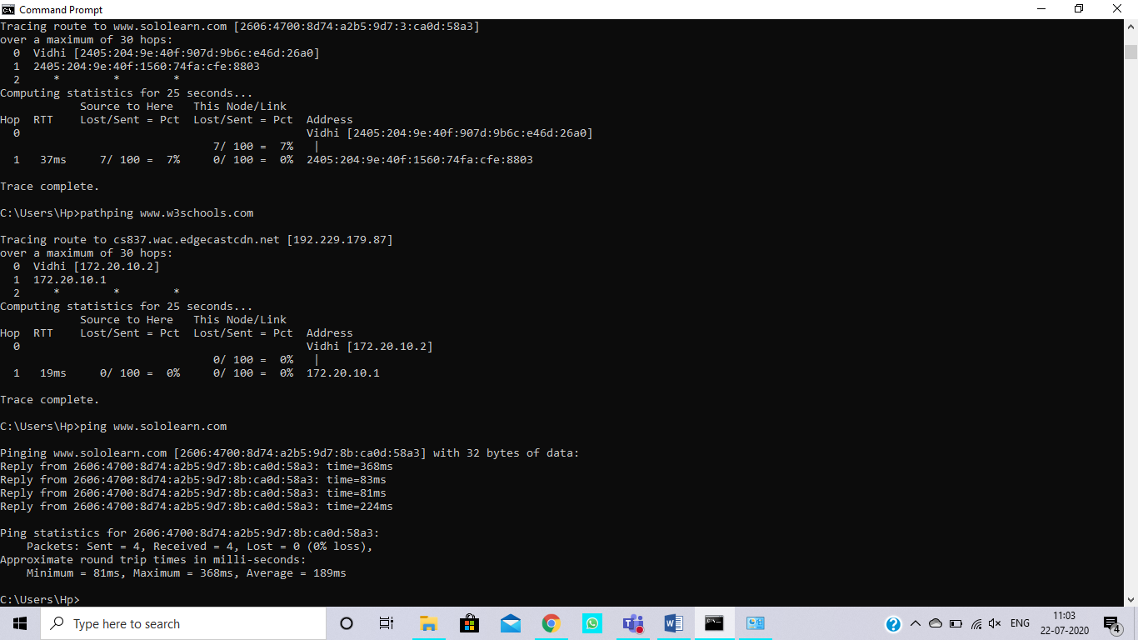

1. Trace the route to any website

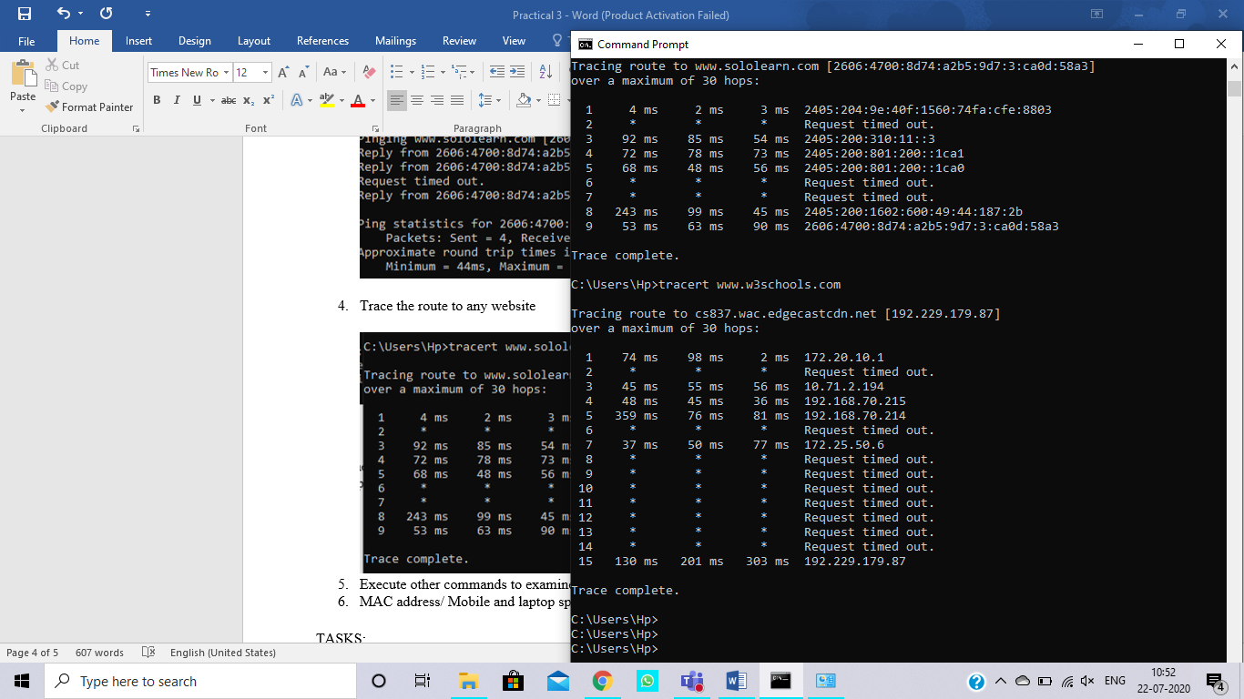

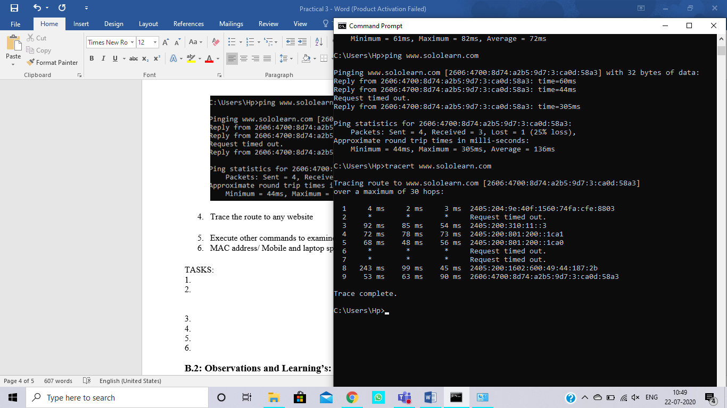

1. Execute other commands to examine a network

PATH PING:

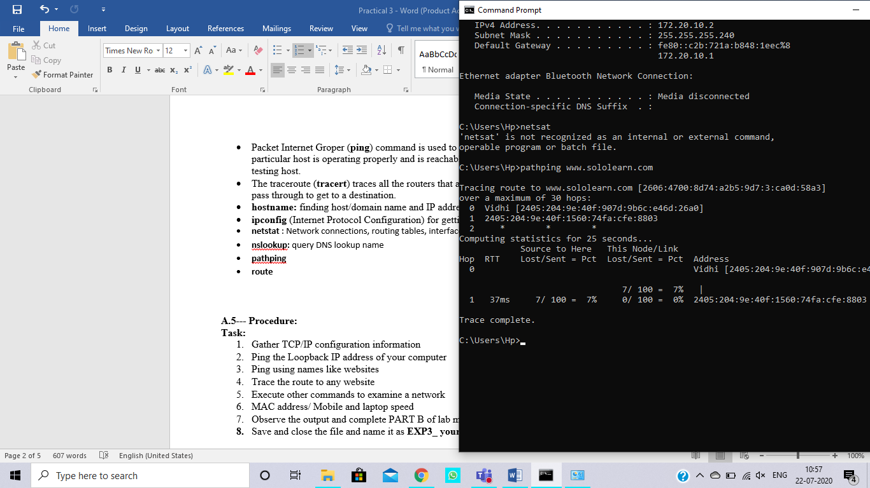



ipconfig:



Netstat:

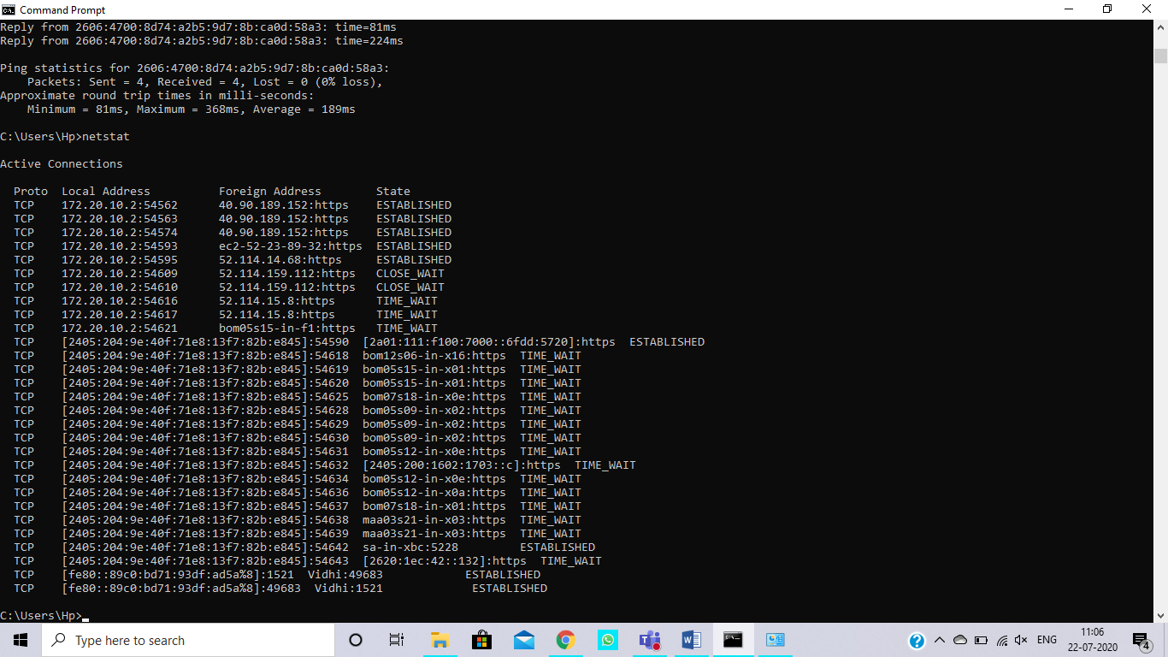

Nslookup

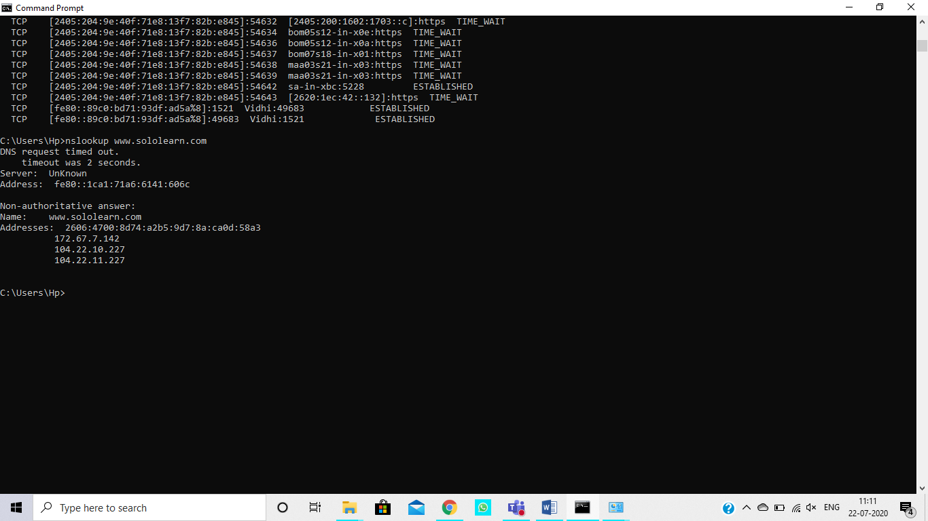

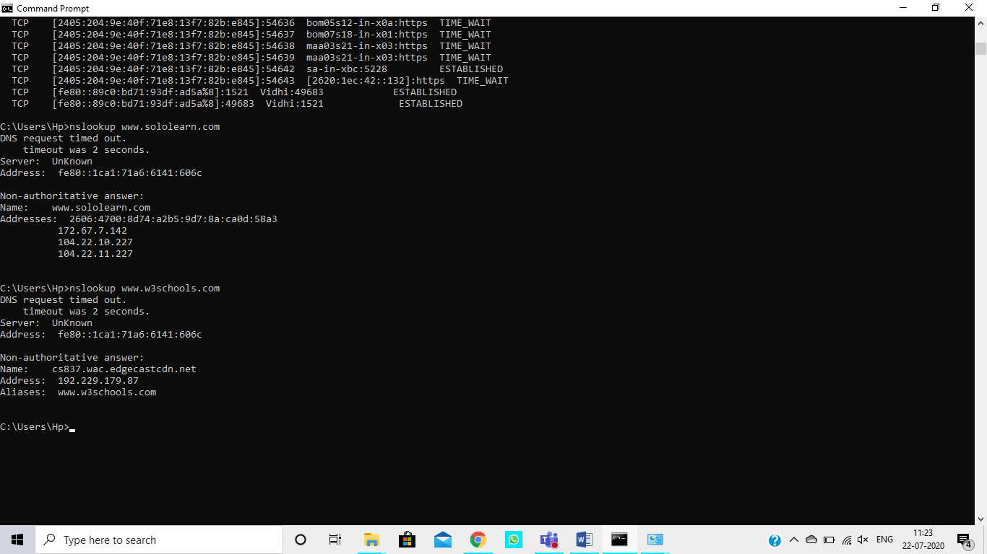

Route:

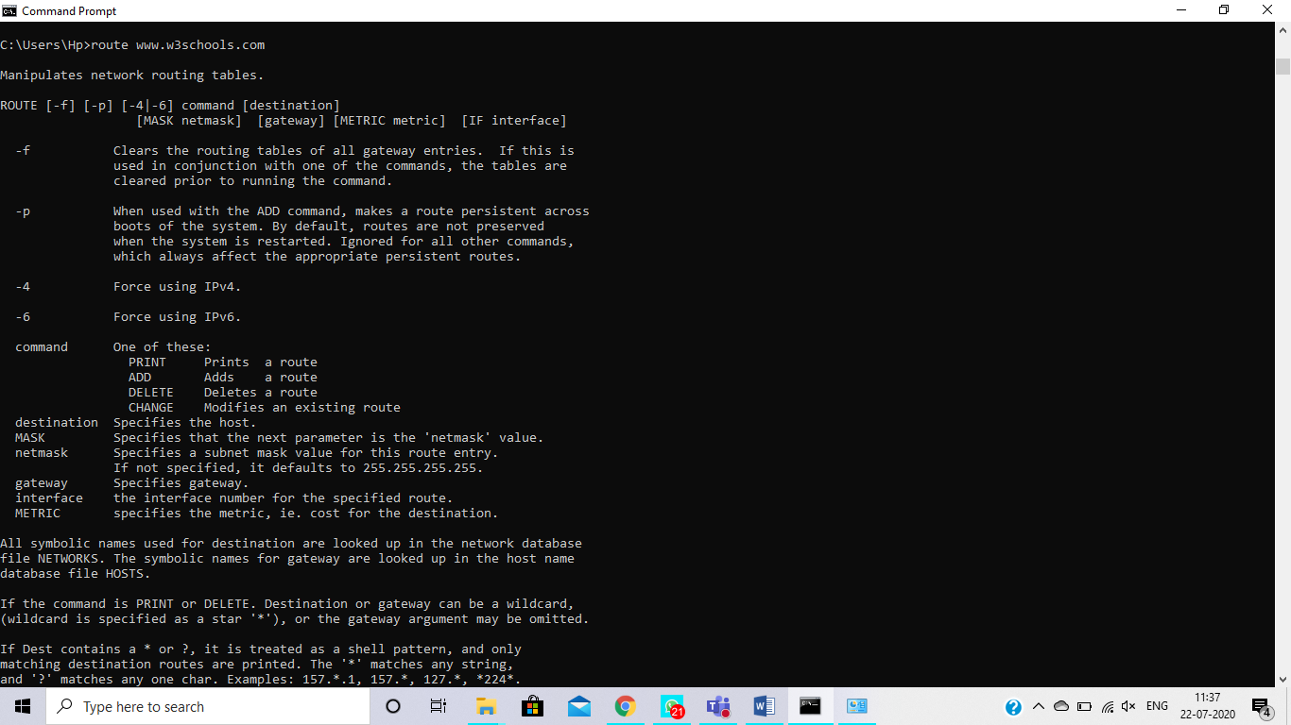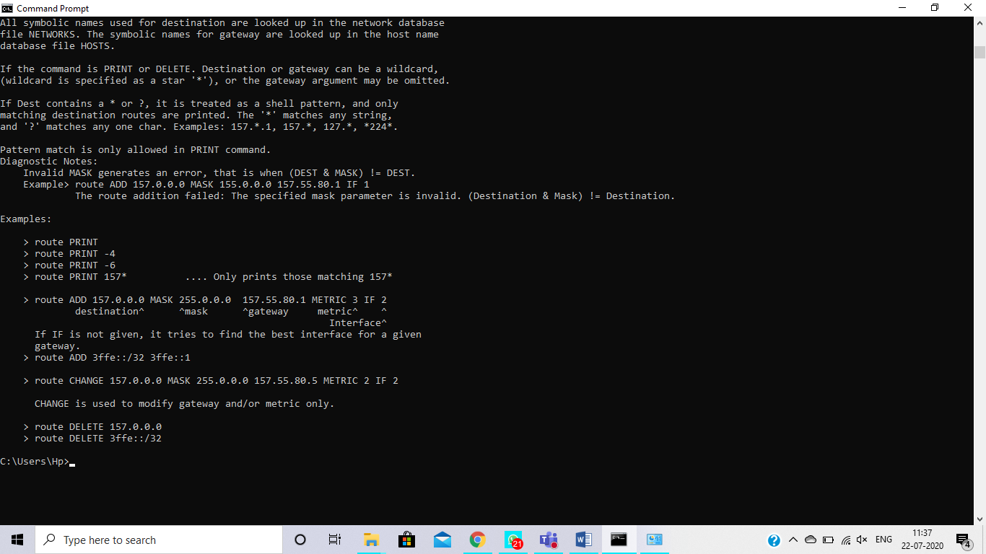

1. MAC address/ Mobile and laptop speed

LAPTOP:

MAC address: 80-C5-F2-F64A-69

Speed:

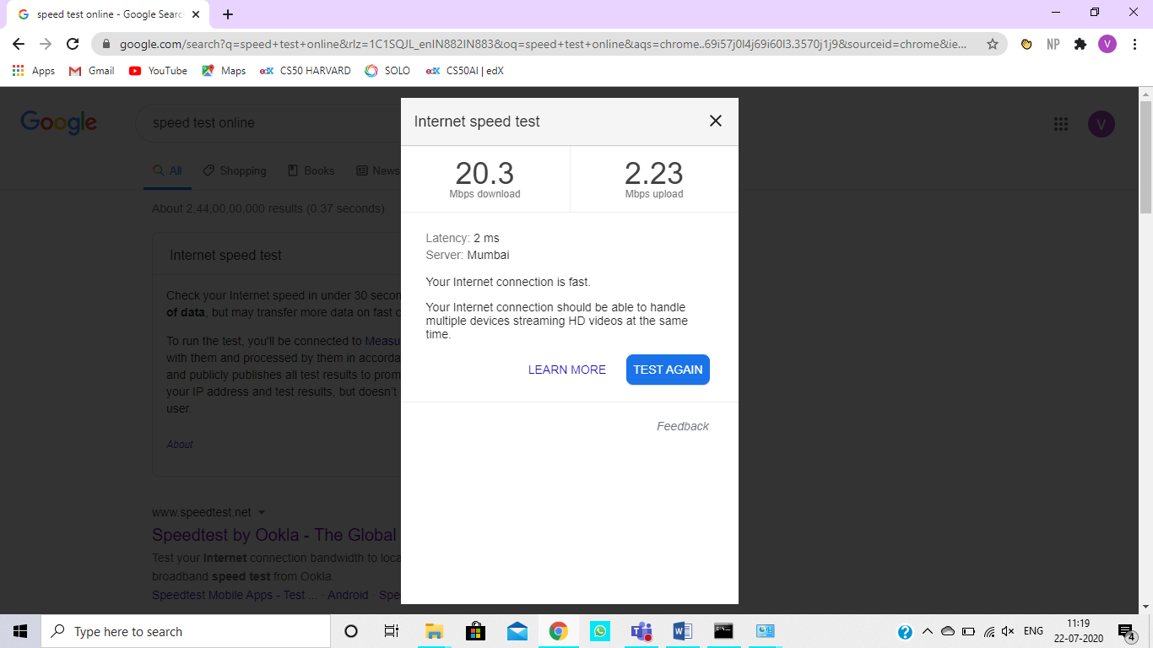

MOBILE:

MAC address: 64:A5:C3:55:99:EA

Speed:

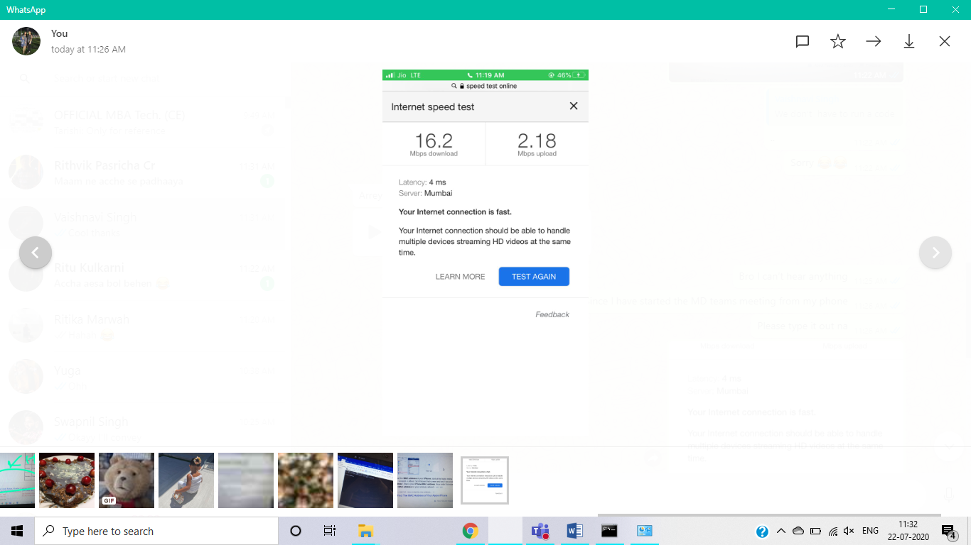

**B.2: Observations and Learning’s:**

In the above experiment, we learnt various commands that will give us details regarding our network. We found out how a request travels from our devices to the server and back. We also checked the speed of internet of out=r laptops and mobile phones.

**B.3: Conclusion:**

An error in connecting to a website can be easily decoded using the commands we learnt in this experiment. We can also find the speed of various networks easily.