**Experiment No.04**

**PART A**

(PART A : TO BE REFFERED BY STUDENTS)

**To implement basic wireless connection establishment by using Cisco Packet Tracer Software**

**A.1—Aim:**

Configure WEP security between n end wireless devices like smartphone, printer, laptop, tablet etc and a wireless router

**A.2--- Prerequisite:**

Understanding the basic knowledge of connecting devices

**A.3--- Outcome:**

After successful completion of this experiment students will be able to:

• Interact the basic interface of the Packet tracer software

**A.4--- Procedure:**

**Task:**

1. To connect various wireless end devices to wireless access point.

2. See the simulation of sent and received packet using PDU

*3.* Observe the output and complete PART B of lab manual

4. Save and close the file and name it as **EXP4_ your Roll no.**

**(PART - B)**

|  |  |
| --- | --- |
| Roll. No. : N049 | Name: Tarun Tanmay |
| Sem/Year : V/ third year | Batch: B3 |
| Date of Experiment : 29/07/2020 | Date of Submission: |
| Grade |  |

**B.1: Procedure of performed experiment**

Router0:

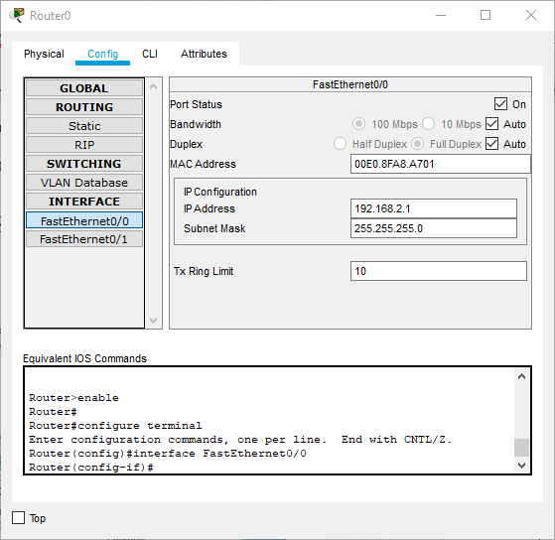

* Under Config, choose FastEthernet0/0 tab and do the following:
  + Enter IP address as 192.168.2.1
  + Set Port Status as “On”.

PC0:

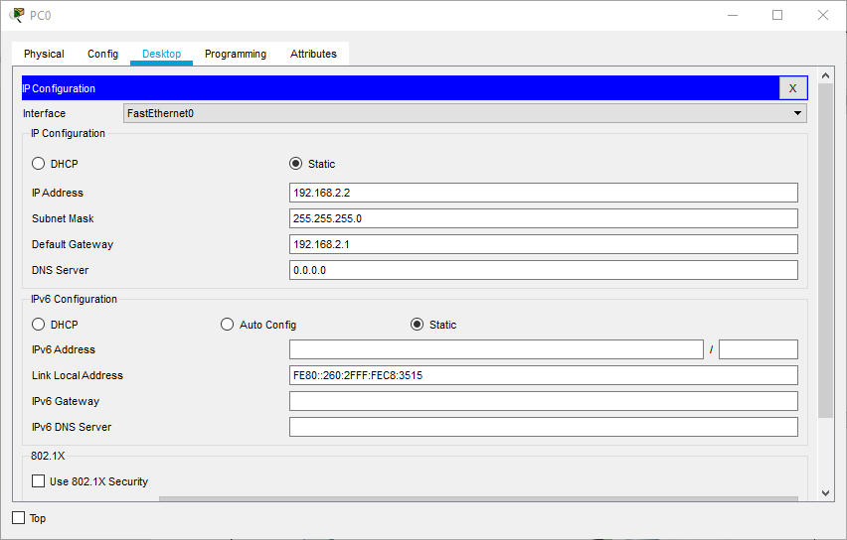

* Under desktop, choose IP configuration and:
  + Set IP Address as 192.168.2.2
  + SetDefault Gateway as 192.168.2.1

AccessPoint0:

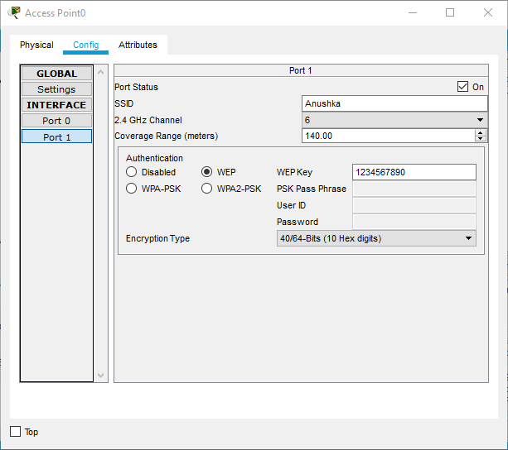

* Under Config, choose Port1 and do the following:
  + Choose WEP
  + Set WEP Key as 1234567890
  + Set SSID as name, here Anushka.

PC1:

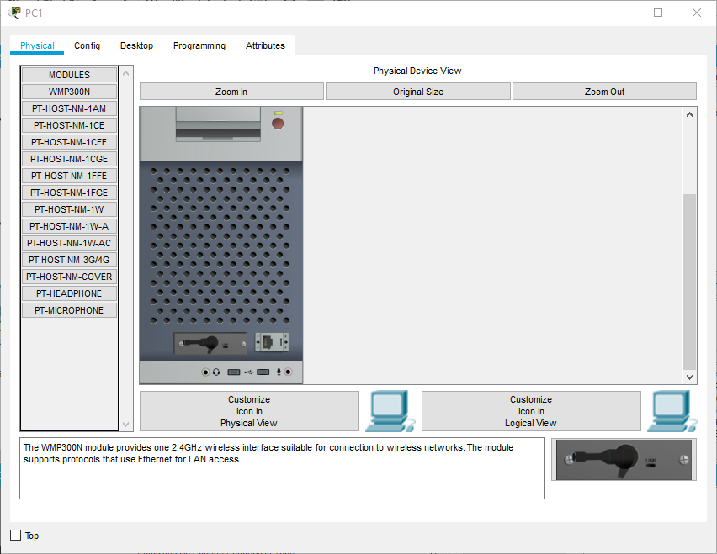

* Under Physical tab, click to Switch Off, change connector to WMP300N and switch back On.

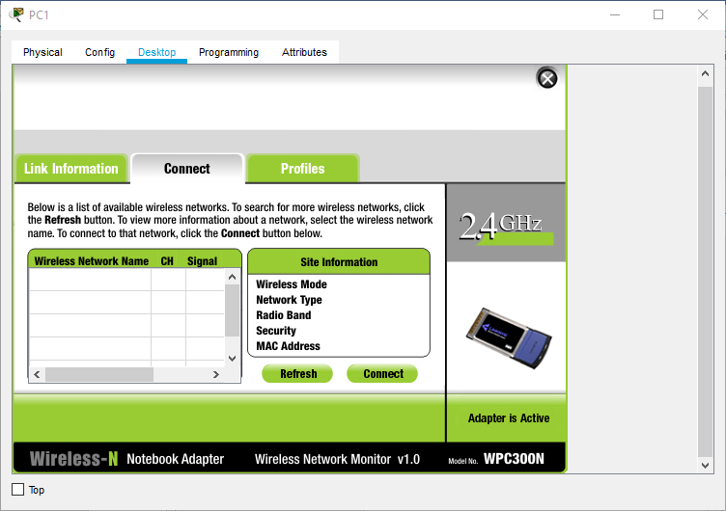

* Under Desktop, choose PC Wireless and do the following:
  + Under Connect-
    - Refresh
    - Choose “Anushka” from Networks
    - Click Connect and enter WEP Key to connect.

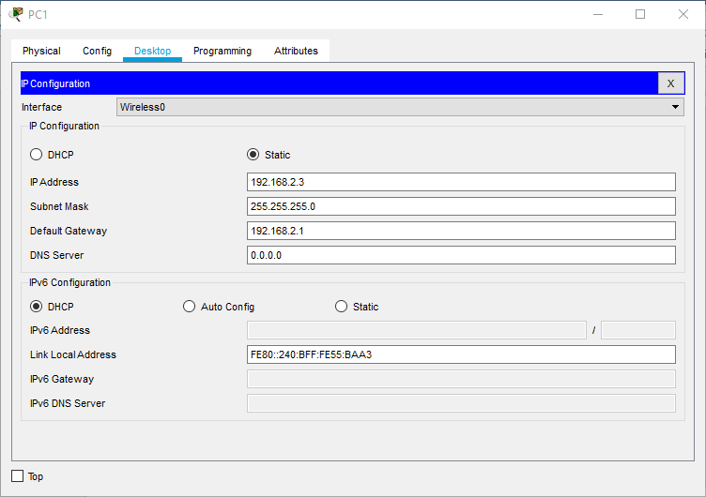

* Under Desktop, choose IP Configuration and do the following:
  + Set IP Configuration as Static
  + Enter IP address as 192.168.2.3
  + Set Default Gateway as 192.168.2.1.

Laptop0:

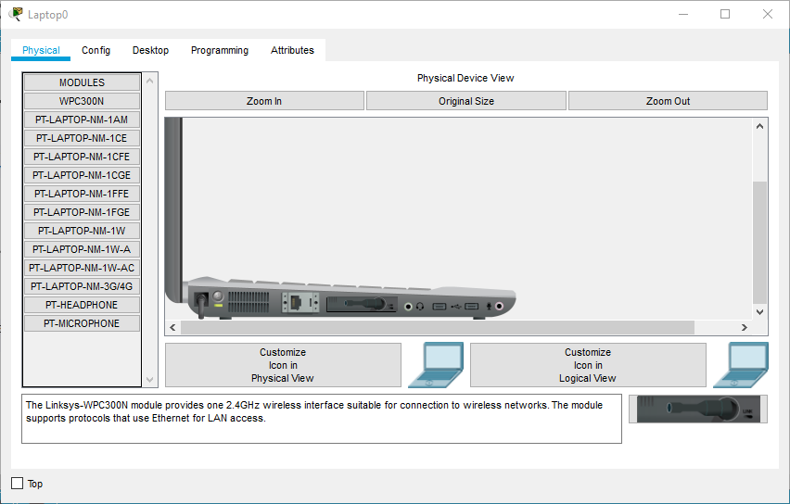

* Under Physical tab, click to Switch Off, change connector to WMP300N and switch back On.

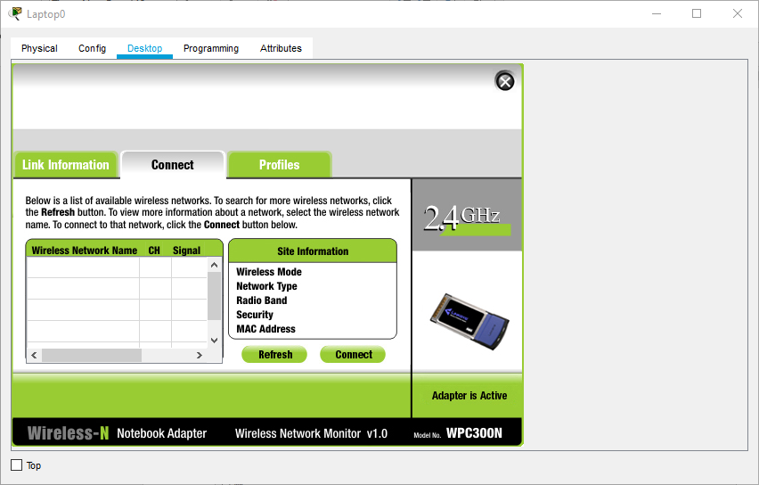

* Under Desktop, choose PC Wireless and do the following:
  + Under Connect-
    - Refresh
    - Choose “Anushka” from Networks
    - Click Connect and enter WEP Key to connect.

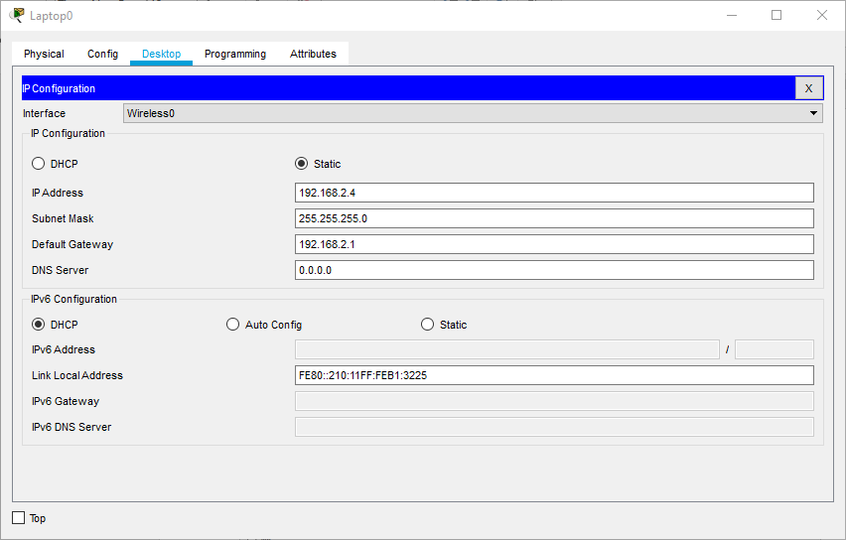

* Under Desktop, choose IP Configuration and do the following:
  + Set IP Configuration as Static
  + Enter IP address as 192.168.2.4
  + Set Default Gateway as 192.168.2.1.

Tablet PC0:

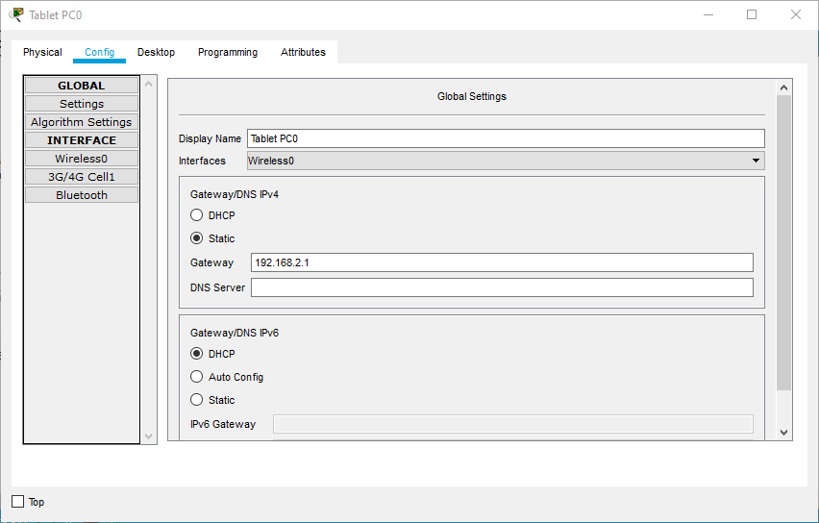

* Under config, set as Static.

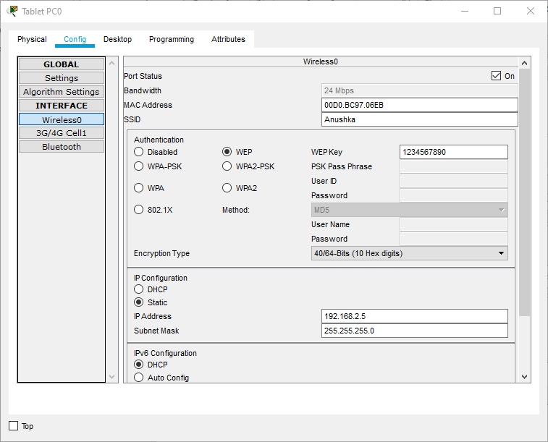

* Under Config, choose Wireless0 and do the following:
  + Choose WEP
  + Set WEP Key as 1234567890
  + Set SSID as name, here Anushka.

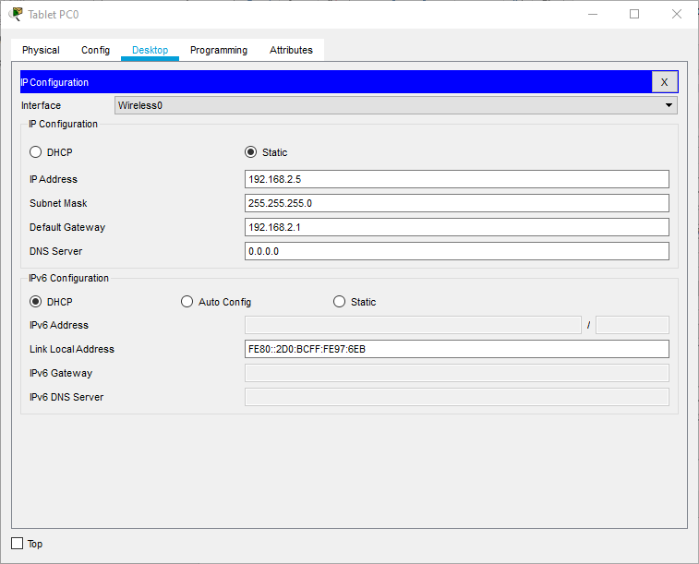

* Under Desktop, choose IP Configuration and do the following:
  + Set IP Configuration as Static
  + Enter IP address as 192.168.2.5
  + Set Default Gateway as 192.168.2.1.

Smartphone0:

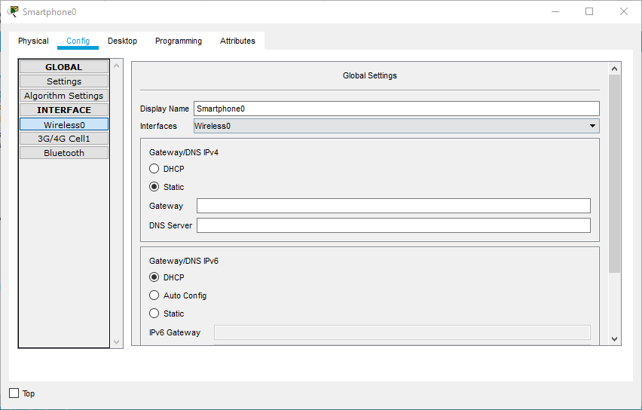

* Under config, set as Static.

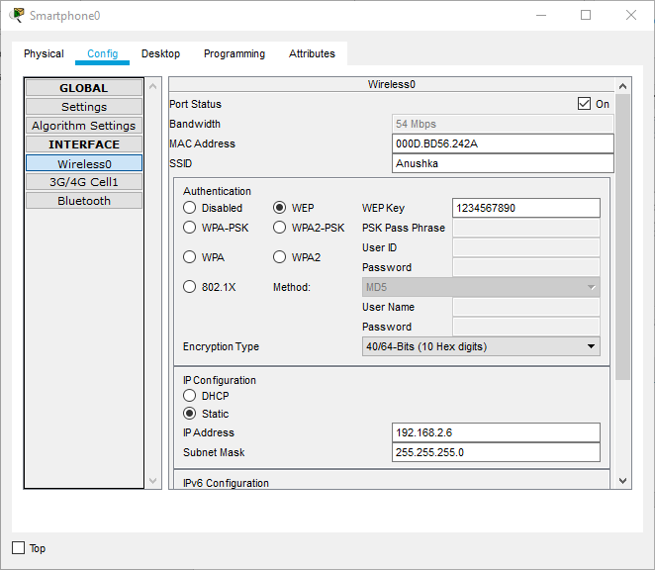

* Under Config, choose Wireless0 and do the following:
  + Choose WEP
  + Set WEP Key as 1234567890
  + Set SSID as name, here Anushka.

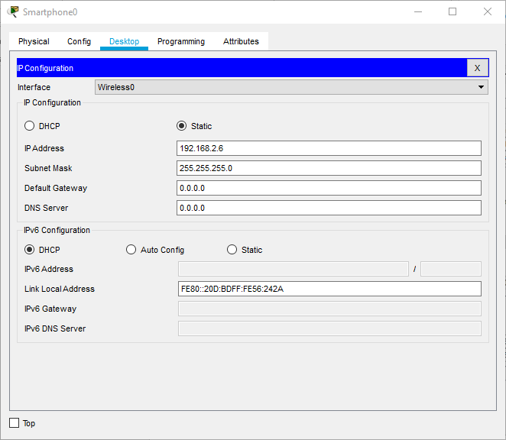

* Under Desktop, choose IP Configuration and do the following:
  + Set IP Configuration as Static
  + Enter IP address as 192.168.2.6

Printer0: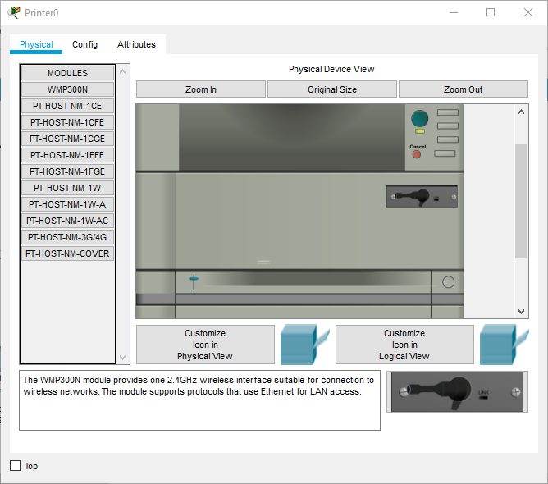

* Under Physical tab, click to Switch Off, change connector to WMP300N and switch back On.

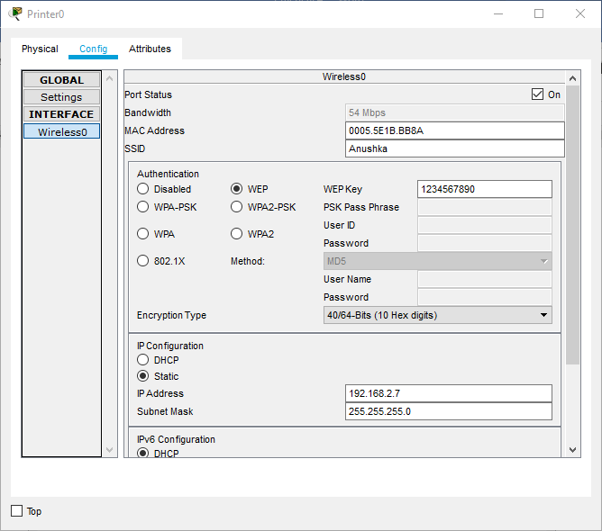

* Under Desktop, choose IP Configuration and do the following:
  + Set IP Configuration as Static
  + Enter IP address as 192.168.2.3
  + Set Default Gateway as 192.168.2.1.
* Under IP Configuration:
  + Set as Static
  + Enter IP address as 192.168.2.7.

Final Network:

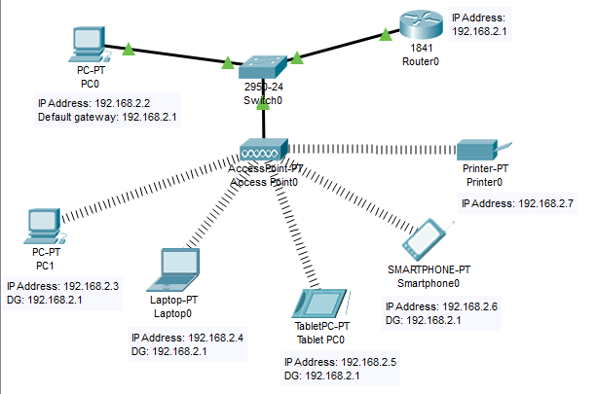

Successful Tests:

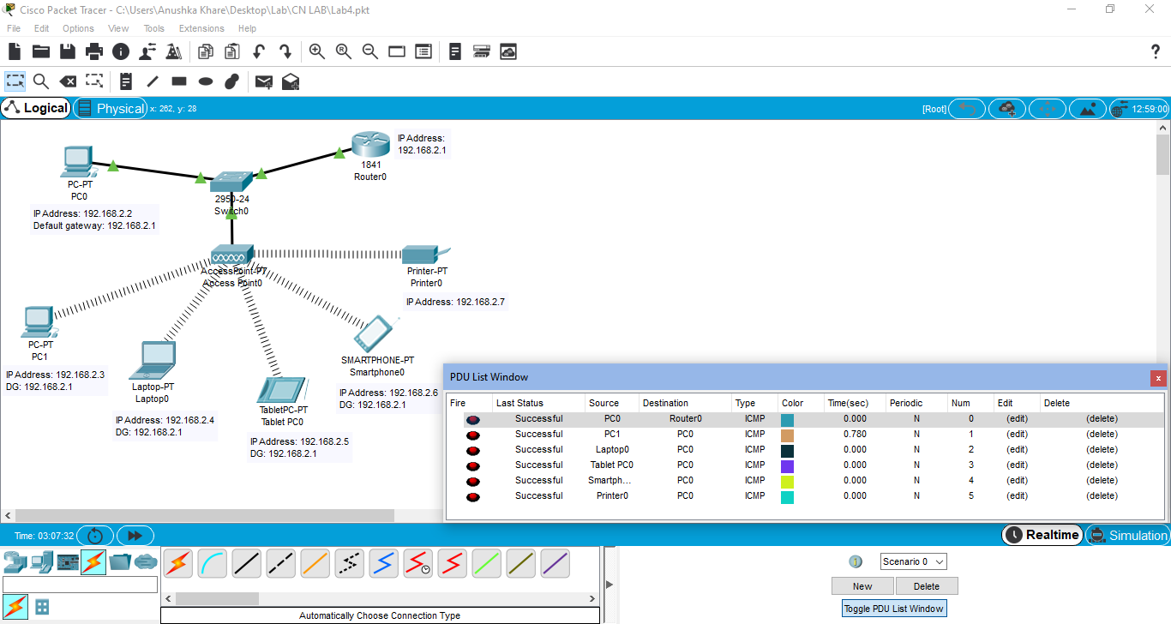

**B.2: Observations and Learning’s:**

Cisco Packet Tracer helps create wireless connections using connecting devices, end devices, connections, etc. and simulate the transmission of packets through the network. It gives information about how the packet travels from the source and the destination as well as the components and path used. Changing the IP information of the devices and creating a functional wireless LAN is also possible. It even lets us change the physical features of end devices as per our requirement.

**B.3: Conclusion:**

I have learnt about the interface of Cisco Packet Tracer and implemented a basic wireless connection establishment by using the same software.