LAB Manual

PART A

(PART A: TO BE REFFERED BY STUDENTS)

**Experiment No.09**

**A.1 Aim:**

To configure a network using routing information protocol in cisco packet tracer.

**A.2 Prerequisite:**

Knowledge about Distance Vector Routing Algorithm

**A.3 Outcome:**

**After successful completion of this experiment students will be able to:**

1. Understand the concept of routing algorithms

**A.4 Theory:**

A router transmits its distance vector to each of its neighbors in a routing packet.

Each router receives and saves the most recently received distance vector from each of its neighbors.

* A router recalculates its distance vector when:
* It receives a distance vector from a neighbor containing different information than before.
* It discovers that a link to a neighbor has gone down.

The DV calculation is based on minimizing the cost to each destination

Dx(y) = Estimate of least cost from x to y

C(x, v) = Node x knows cost to each neighbor v

Dx = [Dx(y): y ∈ N] = Node x maintains distance vector

Node x also maintains its neighbors' distance vectors

– For each neighbor v, x maintains Dv = [Dv(y): y ∈ N]

From time-to-time, each node sends its own distance vector estimate to neighbors.

When a node x receives new DV estimate from any neighbor v, it saves v’s distance vector and it updates its own DV using B-F equation:

Dx(y) = min {C(x, v) + Dv(y)} for each node y ∈ N

**A.5 Procedure/Algorithm:**

**A.5.1 TASK:**

1. Develop a Topology shown in figure given below

2. Configure all Routers.

3. Implement RIP protocols in Router to configure network.

.

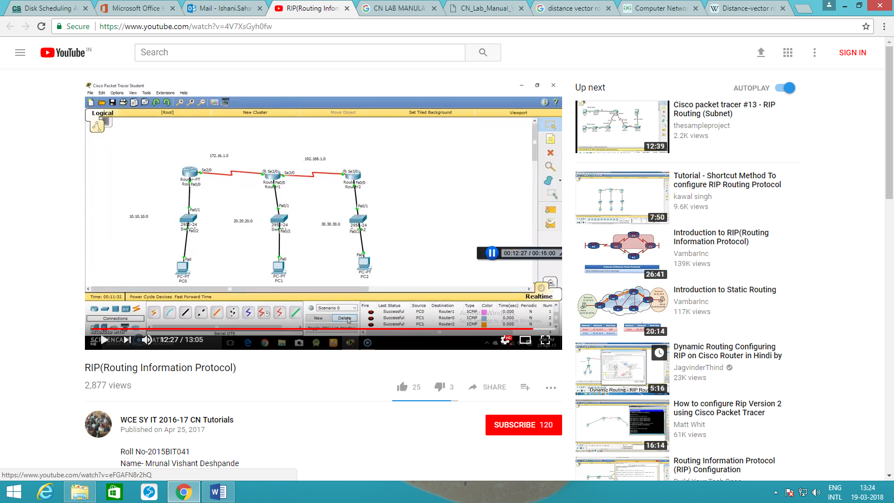

PART B

|  |  |
| --- | --- |
| Roll No.: N049 | Name: Tarun Tanmay |
| Class: MBATech CE/ third year | Batch: B3 |
| Date of Experiment: 23/09/2020 | Date of Submission |
| Grade: |  |

**B.1 Answers of Task to be written by student:**

Network:

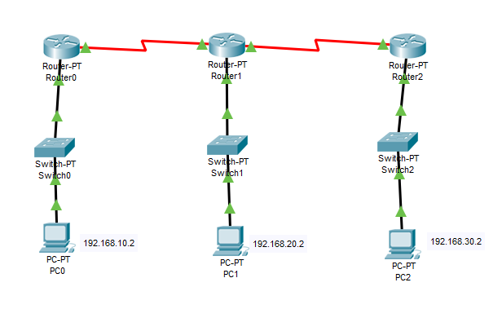

Successful Tests:

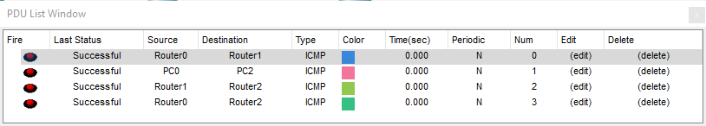

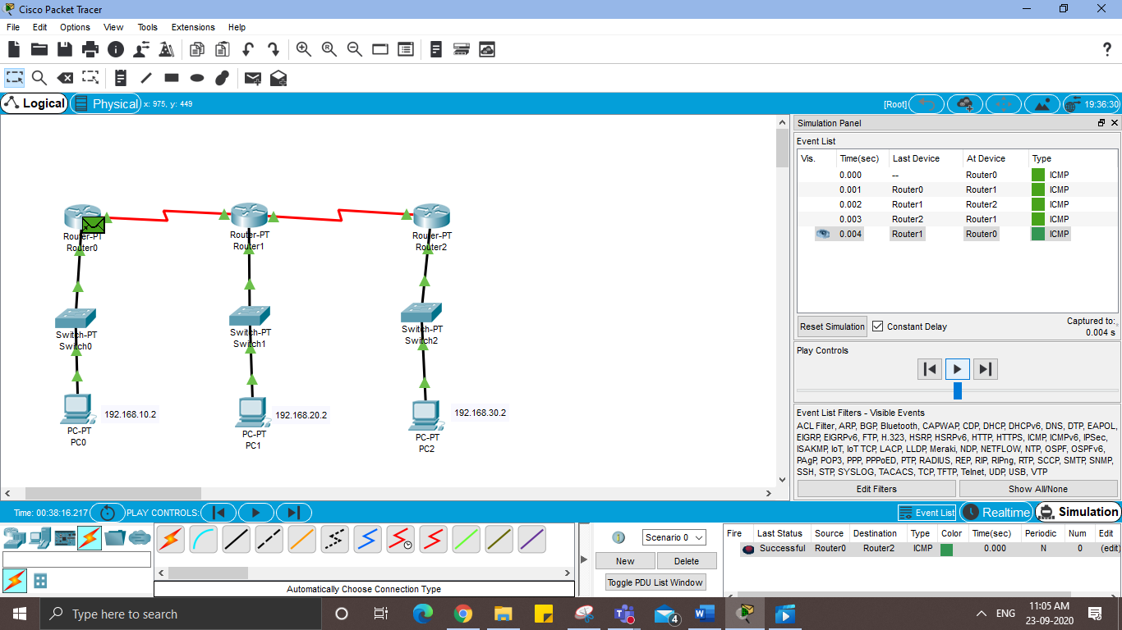

Configurations:

PC0-

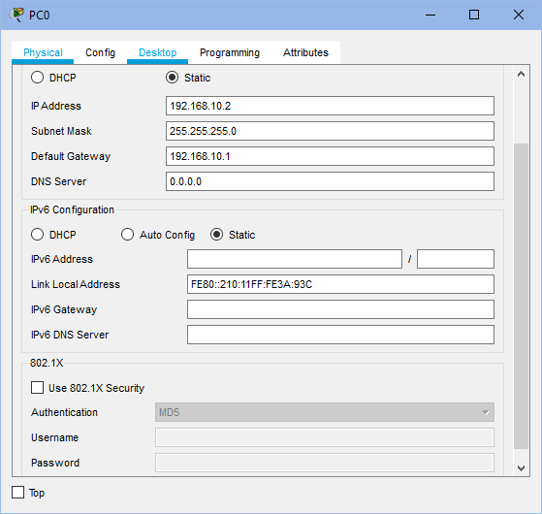

* Under Desktop, choose IP Configuration and do the following:
  + Set IP Address as 192.168.10.2
  + Set Default Gateway as 192.168.10.1

PC1-

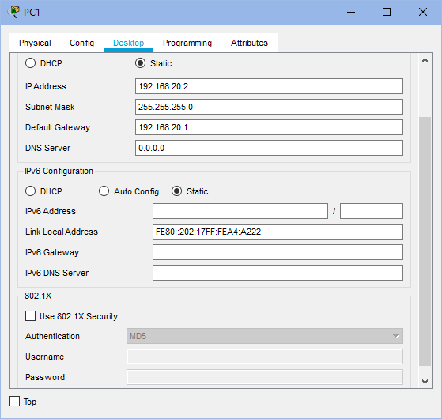

* Under Desktop, choose IP Configuration and do the following:
  + Set IP Address as 192.168.20.2
  + Set Default Gateway as 192.168.20.1

PC2-

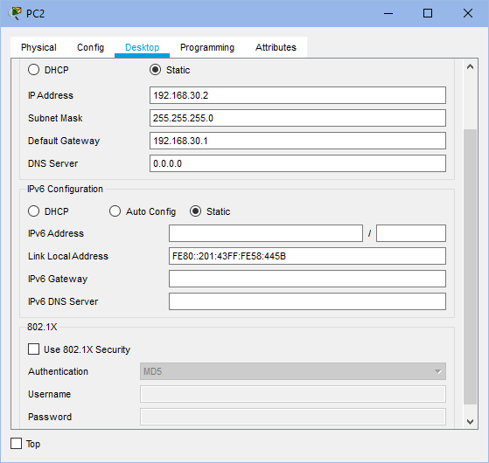

* Under Desktop, choose IP Configuration and do the following:
  + Set IP Address as 192.168.30.2
  + Set Default Gateway as 192.168.30.1

Router0-

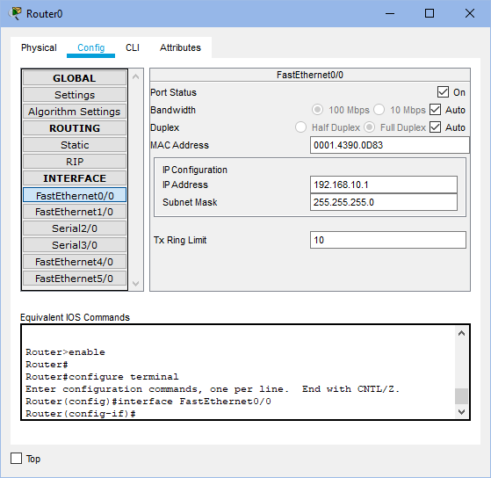 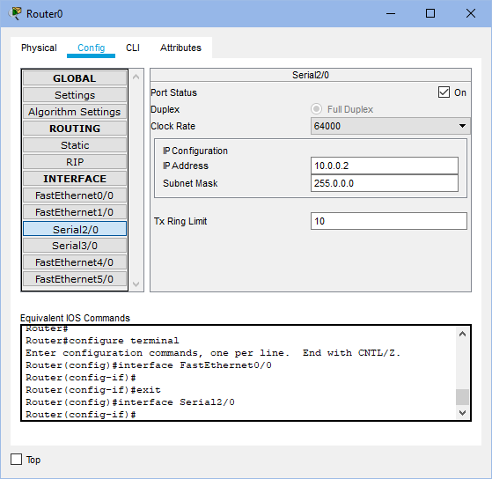

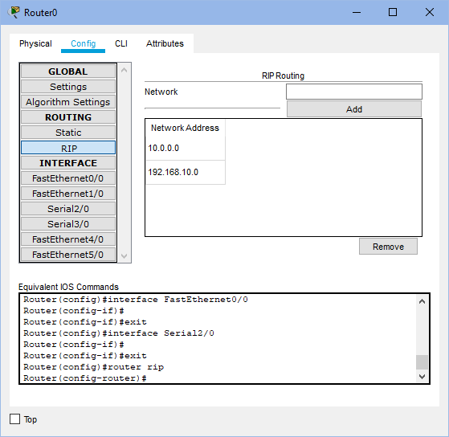

* Under Config tab, do the following:
  + Under FastEthernet0/0-
    - Set IP Address as 192.168.10.1
    - Set Port Status as “ON”
  + Under Serial 2/0-
    - Set IP Address as 10.0.0.2
    - Set Port Status as “ON”
    - Set Clock Rate as 64000
  + Under RIP, add networks 192.168.10.1 and 10.0.0.2

Router1-

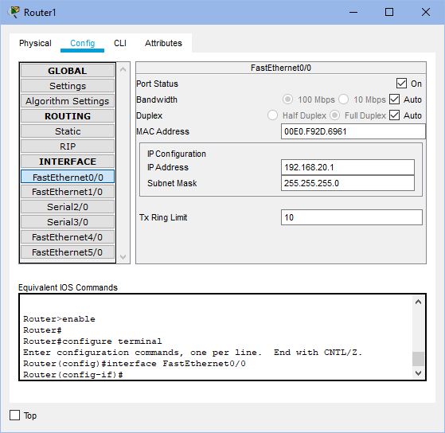 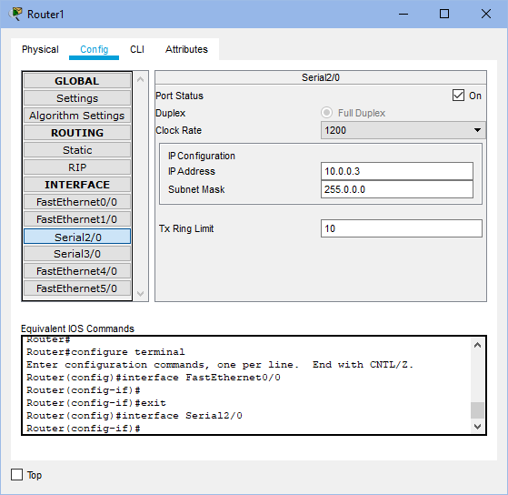

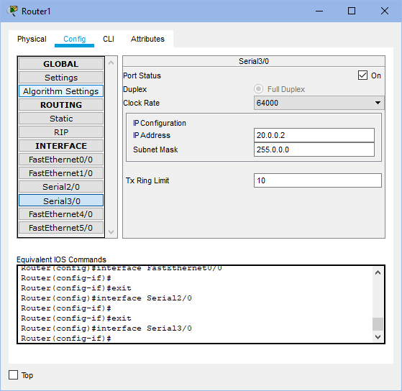 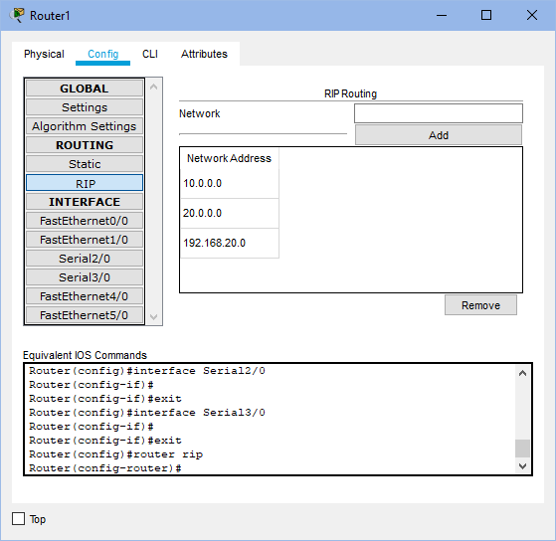

* Under Config tab, do the following:
  + Under FastEthernet0/0-
    - Set IP Address as 192.168.20.1
    - Set Port Status as “ON”
  + Under Serial2/0-
    - Set IP Address as 10.0.0.3
    - Set Port Status as “ON”
  + Under Serial3/0-
    - Set IP Address as 20.0.0.2
    - Set Port Status as “ON”
    - Set Clock rate as 64000
  + Under RIP, add networks 192.168.20.1, 10.0.0.3 and 20.0.0.2

Router2-

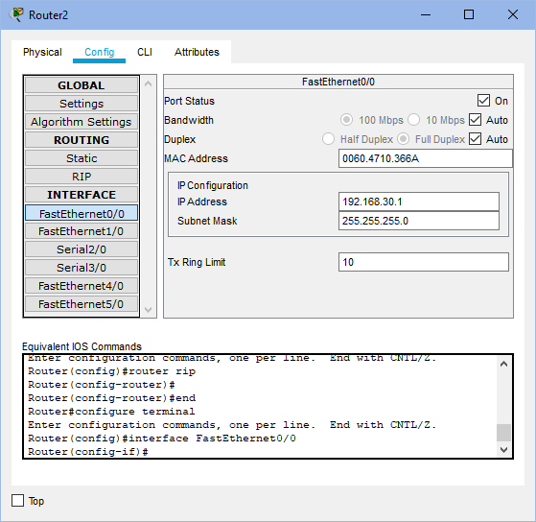 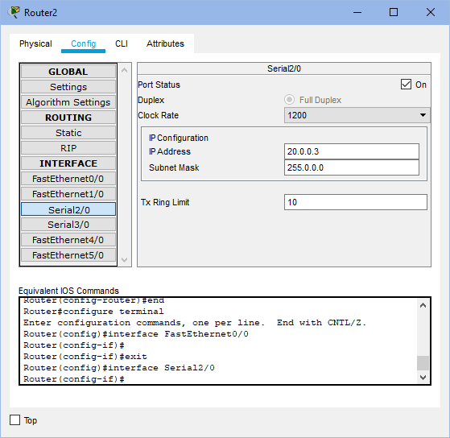

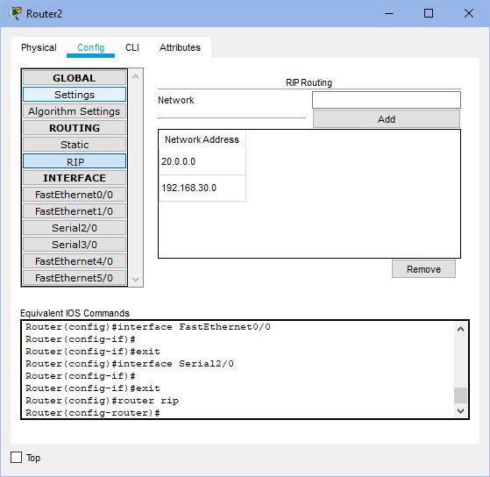

* Under Config tab, do the following:
  + Under FastEthernet0/0-
    - Set IP Address as 192.168.30.1
    - Set Port Status as “ON”
  + Under Serial 2/0-
    - Set IP Address as 20.0.0.3
    - Set Port Status as “ON”
  + Under RIP, add networks 20.0.0.3 and 192.168.30.1

**B.2 Observations and learning:**

Distance Vector Routing is a dynamic routing protocol for intra-domain data transmission in autonomous systems. Each router has its own routing table or distance vector which holds the distance till every other router in the network. Distance vector routing updates the routing table for all the routers parallelly to help decide the next hop for a packet. First, the router checks the direct neighbors and updates its distance vector/table. Then, it uses its direct neighbors’ tables and updates its table again and so on till a path is found to all the other routers in the network.

**B.3 Conclusion:**

I have understood the concept of distance vector routing algorithm and have successfully made a network using Routing Information Protocol in Cisco Packet Tracer.

**B.4 Question of Curiosity**

Q1. Explain Count to infinity problem.

**Answer:** One of the important issues in Distance Vector Routing is County of Infinity Problem or Routing loop. In distance vector routing, routing loops occurs when an interface goes down or when two routers send updates to each other at the same time.  One way to solve this problem is for routers to send information only to the neighbors that are not exclusive links to the destination. Example: there are three routers A, B and C which are connected in series at distance of 1. So, A is directly connected to B, B is directly connected to C but to go from A to C, we have to go via B. If the link between B and C is disconnected, then B will know that it can no longer get to C via that link and will update its table. Before it can send any updates, it’s possible that B will receive an update from A which saying that it can get to C at a cost of 2. B can get to A at a cost of 1, so it will update a route to C via A at a cost of 3. A will then receive updates from B later and update its cost to 4. They will then go on feeding each other bad information toward infinity. This is count to infinity problem.