PART A
(PART A: TO BE REFFERED BY STUDENTS)

Experiment No.05

A.1—Aim:
Study of different types of network cable and practically implement the cross wired cable and straight through cable for designing LAN cable

A.2--- Prerequisite:
Understanding the basic knowledge of Ethernet cable and RJ-45 connector

A.3--- Outcome:
After successful completion of this experiment students will be able to:
• Learn various types or network cables
• Design LAN cable using straight and cross wired cable

A.4--- Theory:
Common Ethernet network cables are straight and crossover cable. Both end of cable is called RJ45 connector.

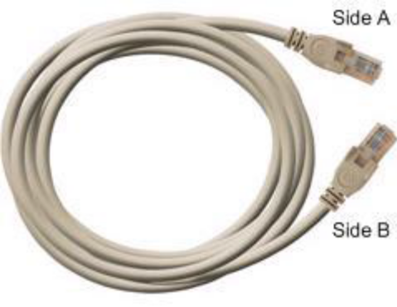

Straight Cable

Both side (side A and side B) of cable have wire arrangement with same color.
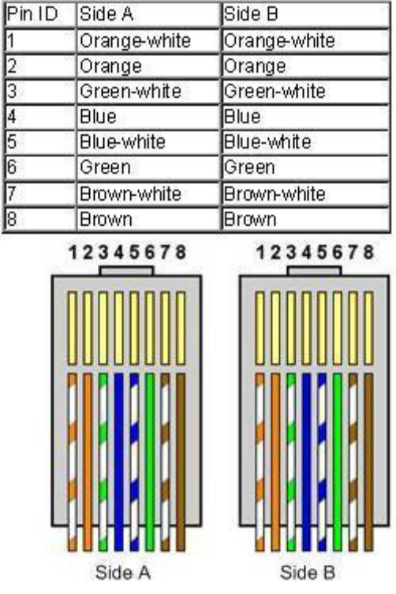

Cross wired Cable

If we need to check how crossover cable looks like, both side (side A and side B) of cable have wire arrangement with following different color:

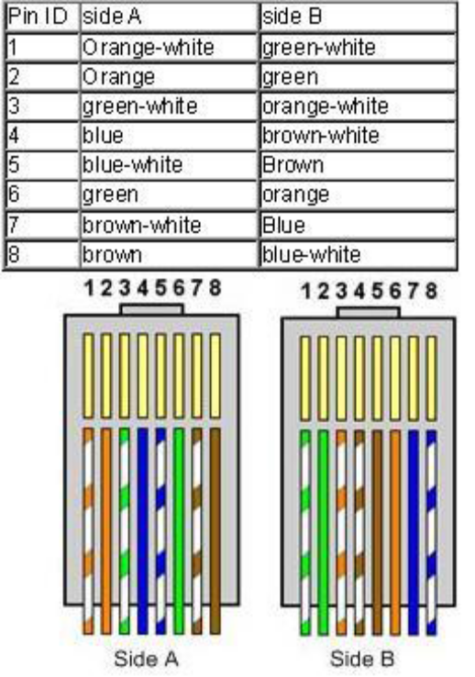
A.5--- Procedure:
Task:
1. Write usage of cross wired and straight wired cable
2. Write the steps to form LAN cable using straight and cross wired connections. (Refer the video)
3. Explain the following:
a) Ethernet
b) RJ-45
c) CAT 5 & CAT 6
4. Complete PART B of lab manual. Save and close the file and name it as EXP5_ your Roll no.

(PART - B)

(TO BE COMPLETED BY STUDENTS)

(Students must submit the soft copy as per following segments within two hours of the practical. The soft copy must be uploaded on the Blackboard or emailed to the concerned lab in charge faculties at the end of the practical in case there is no Black board access available)

Roll.No: N049 | Name: Tarun Tanmay
Sem/Year: 5/ third year | Batch: B3
Date of Experiment: 5/8/20 | Date of Submission: 5/8/20
Grade --

B.1: Procedure of performed experiment

1. Write usage of cross wired and straight wired cable
Ans:
1.Cross Wired:
a) Connect two computers directly.
b) Connect a router's LAN port to a switch/hub's normal port. (Normally used for expanding network)
c)Connect two switches/hubs by using a normal port in both switches/hubs.
2.Straight wired:
a. Connect a computer to a switch/hub's normal port.
b. Connect a computer to a cable/DSL modem's LAN port.
c. Connect a router's WAN port to a cable/DSL modem's LAN port.
d. Connect a router's LAN port to a switch/hub's uplink port. (Normally used for expanding network)
e. Connect two switches/hubs with one of the switches/hubs using an uplink port and the other one using a normal port.
f. If you need to check how a straight cable looks, it's easy. Both sides (side A and side B) of cable have wire arrangement with the same colour.

2. Write the steps to form a LAN cable using straight and cross wired connections. (Refer the video)
Ans:
Step 1: Strip the cable jacket down from the end.
Step 2: Spread the four pairs of twisted wire apart.
Step 3: Untwist the wire pairs and neatly align them in orientation. Be sure not to untwist them any farther down the cable than where the jacket begins
Step 4: Cut the wires as straight as possible, above the end of the jacket.
Step 5: Carefully insert the wires all the way into the connector, making sure that each wire passes through the appropriate guides inside the connector.
Step 6: Push the connector inside the crimping tool and squeeze the crimper all the way down.

3. Explain the following:
a) Ethernet
Ans: ​ Ethernet is a communication standard that was developed in the early ’80s to network computers and other devices in a local environment such as a home or a building. Ethernet is a wired system that started with using coaxial cable and has successfully progressed to now using twisted pair copper wiring and fiber optic wiring.

b) RJ-45
Ans: ​ RJ45 is a type of connector commonly used for ​Ethernet​ networking. It looks similar to a telephone jack, but is slightly wider. Since Ethernet cables have an RJ45connector on each end, Ethernet cables are sometimes also called RJ45 cables. The "RJ" in RJ45 stands for "registered jack, "since it is a standardized networking interface. The "45" simply refers to the number of the interface standard. Each RJ45 connector has eight pins, which means an RJ45 cable contains eight separate wires. If you look closely at the end of an Ethernet cable, you can actually see the eight wires, which are each a different color. Four of them are solid colors, while the other four are striped.

c) CAT 5 & CAT
Ans: CAT 5: ​Alternatively known as an Ethernet cable or LAN cable, a Cat 5 or category5 is a network cable that consists of four twisted pairs of copper wire terminated by an RJ-45 connector. Cat 5 cable is used in home and business networks, providing data transmission speeds of up to 100 MB per second.CAT 6:​ Cable (Cat 6), is a standardized twisted pair cable for Ethernet and other network physical layers that is backward compatible with the Category 5/5e and Category 3 cable standards. Cat 6 has to meet more stringent specifications for cross talk and system noise than Cat5e and Cat 5e. The cable standard specifies performance of up to 250 MHz, compared to 100 MHz for Cat 5 and Cat 5e.

B.2: Observations and Learning’s:

Observed how to arrange each cable properly for LAN cable and how to install it properly.

B.3: Conclusion:

Learned how to form a LAN cable using cable, connector, and some other tools.

