**Creating a New Login**

**Step1:** First navigate to the Security tab on the left-hand side and then open up the tables and then Login tables. This shows you all the user and logins in your database. Next right click on Logins and select create New Login.

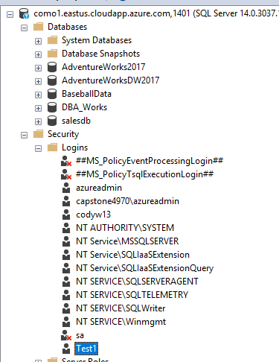

**Step 2:** You can now type in or search for your new user that you just created and then give them a password. Also make sure that you select the database that where you created the user at the bottom.

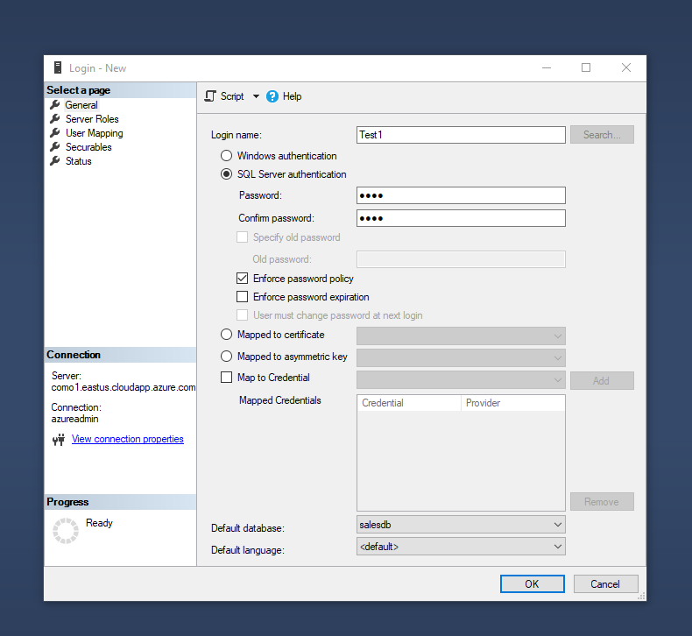

**Step 3:** Next you want to give your new user the correct Permissions within the server. For this example the Test1 user is a Security Admin.

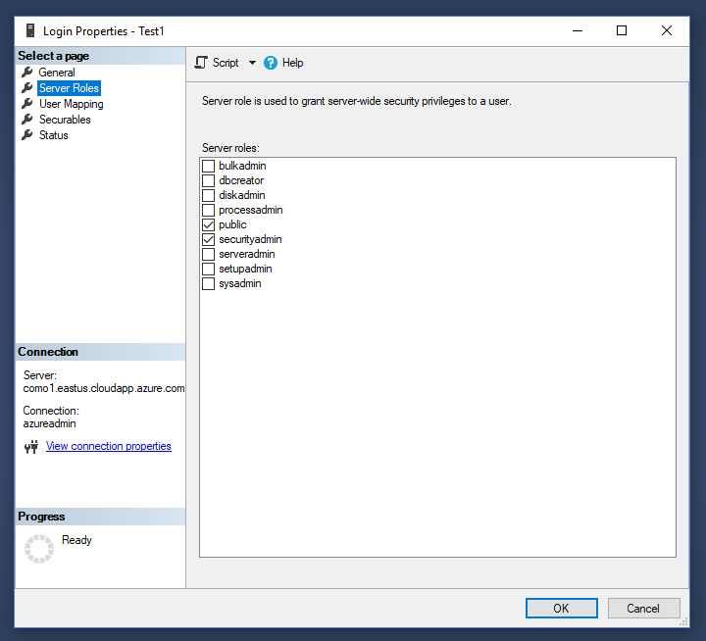

**Step 4:** Next you will want to map that user to the correct schemas that they will be using.

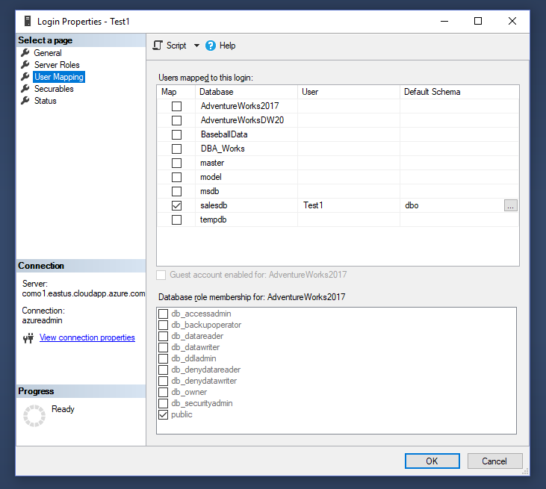

**Step 5:** Once you have put the user into all of the correct roles you can select OK and it will create the Login for this new user that you have crated.