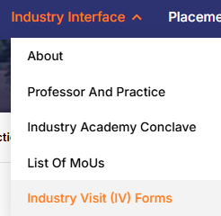

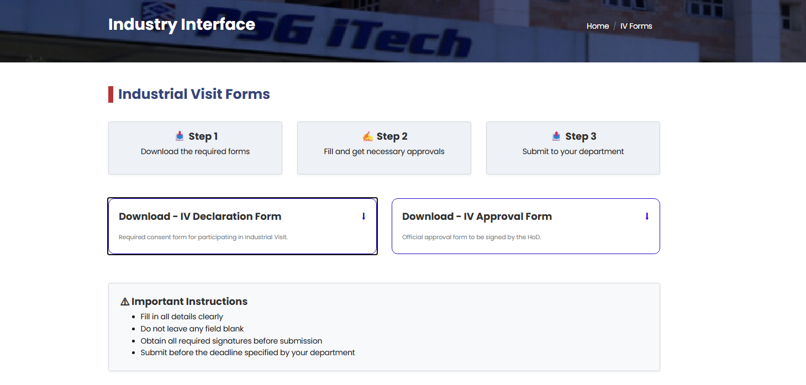

When we click Download IV Declaration Form is need to be downloaded

Same for IV-Approval form

