Placement

Career Development Centre
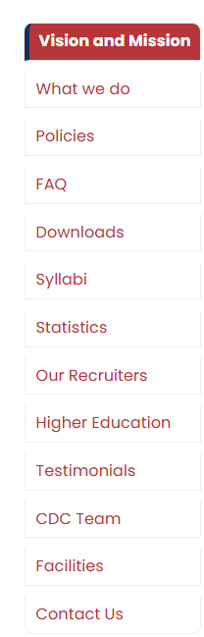

Vision of Career Development Center (CDC)
To empower students with the skills, confidence, and professional competencies required to achieve successful careers and contribute meaningfully to industry and society.

Mission of Career Development Center (CDC)
- To provide effective career guidance, counselling, and employability training to students.
- To enhance students’ technical, communication, aptitude, and professional skills.
- To facilitate meaningful interaction with industries and create diverse career opportunities.
- To support students in securing internships, placements, and sustainable career pathways.
- To strengthen industry–institution collaboration in alignment with emerging workforce requirements.
What we do

What is CDC and What we do?

Career Development Centre (CDC)
The Career Development Centre (CDC) is a dedicated student-support facility that facilitates career planning, employability enhancement, higher education guidance, and placement opportunities. The CDC works towards developing students’ professional competencies and preparing them to meet the evolving requirements of industry and society.

Key Functions of CDC
- Provide career guidance and counselling to help students make informed career decisions.
- Enhance students’ technical, aptitude, communication, soft skills, and employability competencies.
- Facilitate internships, industrial exposure, placement training, and recruitment opportunities.
- Support students in pursuing higher education, competitive examinations, and professional certifications.
- Strengthen industry–institution interaction through training programmes, expert sessions, industry collaborations, and recruitment activities.
- Promote leadership, teamwork, entrepreneurship, innovation, and professional ethics.
- Monitor and support students’ career progression through appropriate career development initiatives and guidance.

Objective
To bridge the gap between academic learning and professional requirements by providing structured career development activities that enhance students’ employability, career readiness, and professional growth.

CDC Functions
The Career Development Centre (CDC) plays a key role in enhancing students’ career readiness by providing structured guidance, training, industry exposure, and placement support. Its major functions include:
- Career Guidance & Counselling – Supporting students in identifying suitable career pathways and making informed career decisions.
- Employability Skill Development – Conducting programmes to strengthen aptitude, communication, soft skills, technical skills, and professional competencies.
- Training & Placement Support – Organizing placement-oriented training, recruitment drives, interviews, and related activities.
- Industry Interaction – Facilitating industry visits, expert interactions, internships, guest sessions, and industry-oriented programmes.
- Higher Education Guidance – Supporting students interested in higher studies, competitive examinations, and professional certifications.
- Career Awareness – Creating awareness about emerging career opportunities, industry trends, and evolving skill requirements.
- Recruiter Engagement – Establishing and maintaining professional relationships with organizations to facilitate diverse career opportunities.
- Student Progress Support – Encouraging continuous improvement, professional development, leadership, teamwork, and career preparedness.
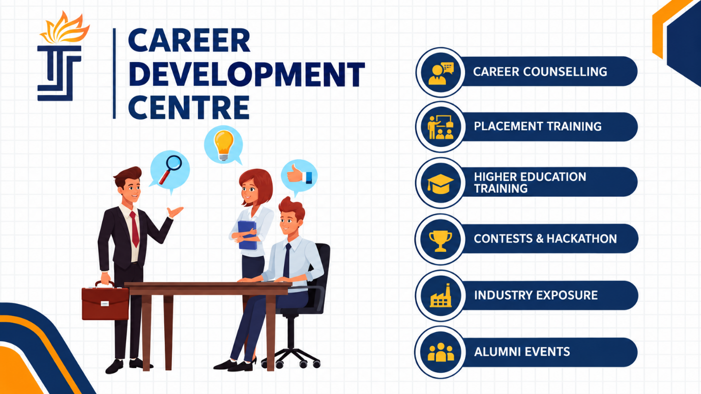

Training & Placement Calendar
The Career Development Centre (CDC) Training & Placement Calendar provides an overview of the planned training, career development, and placement activities for students.
The calendar is subject to change based on academic schedules, industry requirements, recruitment activities, and other institutional commitments. Students are advised to regularly check for updates and follow the latest schedule communicated by the CDC.
Note: Any changes to the calendar will be communicated through the appropriate official channels.

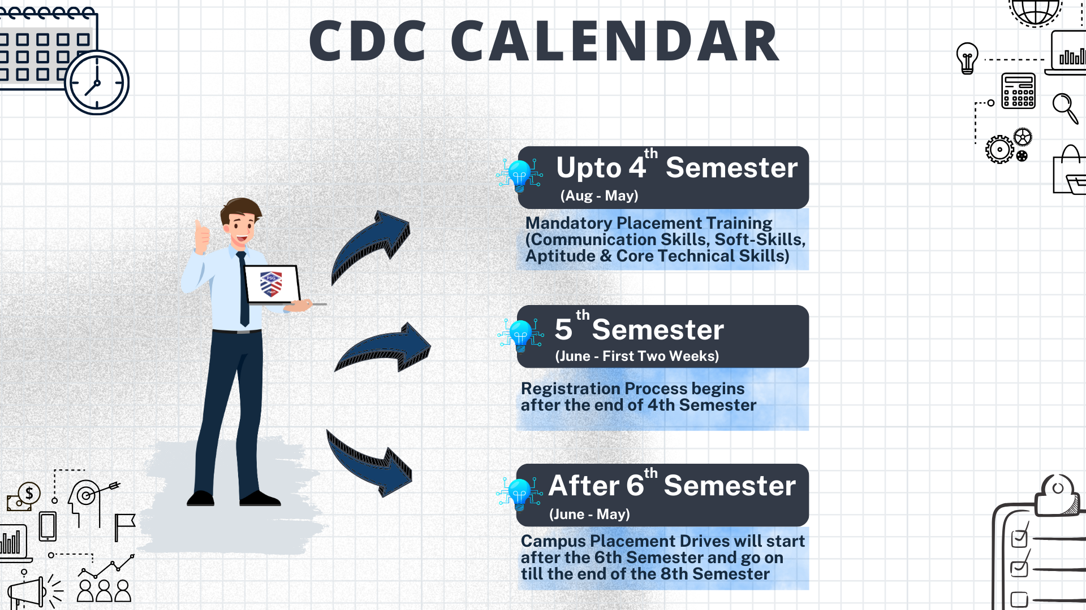

Training Offered
The Career Development Centre (CDC) provides structured training programmes to enhance students’ employability and prepare them for professional careers. The training focuses on developing technical, aptitude, communication, soft skills, and professional competencies, enabling students to meet industry expectations and confidently pursue their career goals.

Key Training Areas
- Communication & Soft Skills Training
- Aptitude & Logical Reasoning Training
- Technical & Programming Skills
- Industry-Specific Training
- Higher Education & Competitive Examination Guidance
- Mock Tests, Group Discussions & Interview Preparation
- Placement Readiness Programmes
.

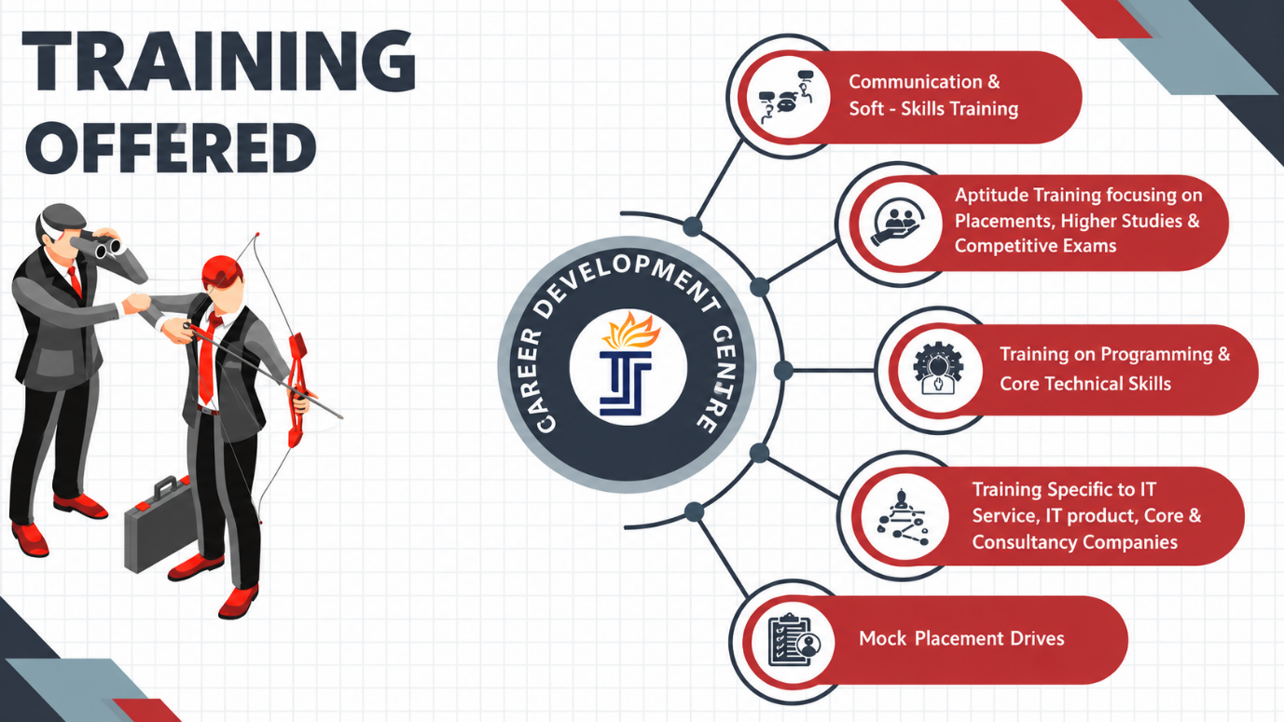

Placement Process
The Career Development Centre (CDC) facilitates a structured placement process to support students in achieving their career aspirations. The process is designed to provide students with appropriate guidance, training, industry exposure, and placement opportunities.
Students are expected to actively participate in the placement activities and follow the procedures and guidelines communicated by the CDC to ensure a smooth and effective recruitment experience.

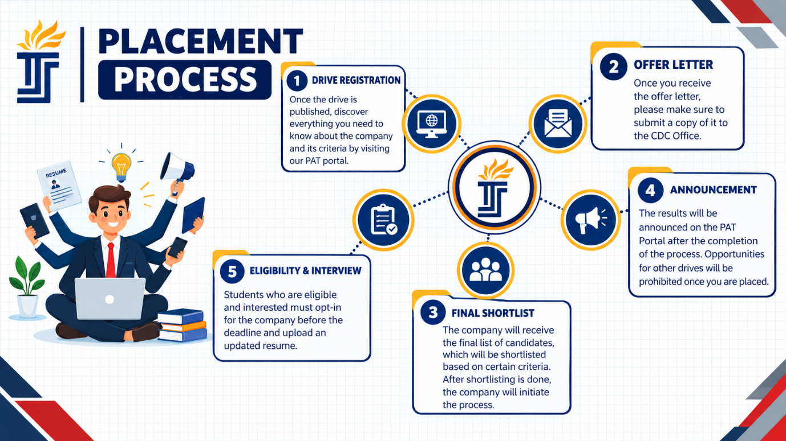

Recruitment Process
- Companies are invited to participate in the campus recruitment process by the Placement & Training / Career Development Centre (CDC).
- Upon confirmation, the details of eligible final-year students who have opted for placements are shared with the company based on its recruitment requirements.
- A mutually convenient date is finalized for conducting the campus recruitment process.
- Following confirmation from the company, a Pre-Placement Talk (PPT) is organized to familiarize students with the organization, job roles, eligibility criteria, and recruitment process.
- The company conducts aptitude/technical tests and/or Group Discussions (GD) to assess and shortlist eligible and interested candidates.
- Shortlisted candidates participate in the interview process, including technical and/or HR rounds, as specified by the recruiting organization.
- The company announces the final selection results upon completion of the recruitment process.
  - .

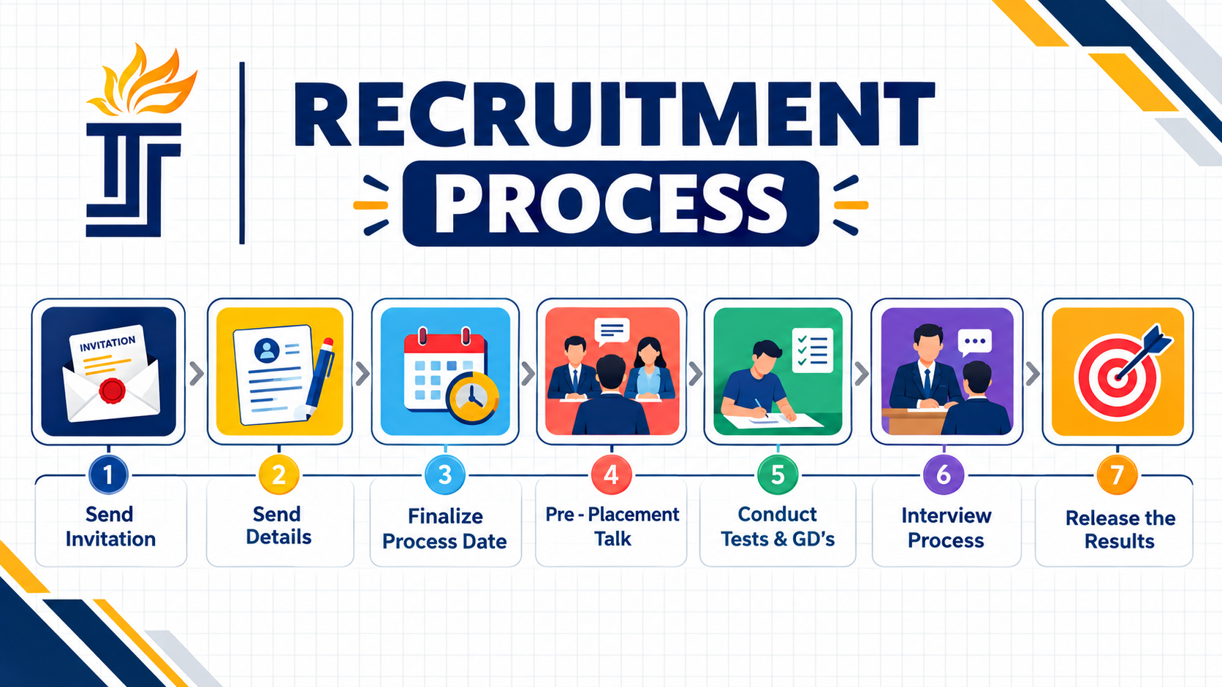

Hospitality

Facilities & Support for Recruiters
- Transportation: Pick-up and drop-off facilities to and from the railway station or airport can be arranged by the Placement Office upon request, provided the visiting representatives are accommodated at the Institute Guest House.
- Accommodation & Meals: Accommodation and meals can be arranged at the Institute Guest House with prior intimation. The associated expenses will be borne by the college. If the company representatives prefer accommodation outside the campus, necessary arrangements can be facilitated upon request.
- Recruitment Facilities: State-of-the-art facilities are available for conducting Pre-Placement Talks, Written Tests, Group Discussions, Technical Activities, and Personal Interviews.
- Online Assessments: Companies wishing to conduct online assessments or tests for candidates can utilize the Computer Centre. The required arrangements will be made upon prior intimation.
This version is more suitable for a professional placement brochure, website, or recruiter information page.

CDC Placement Policies
- Students with no current backlogs are eligible to register for campus placements. Students with backlogs should clear them before registration.
- Students should maintain a minimum of 80% attendance in CDC training programmes.
- Placement eligibility will be based on attendance, assessment performance, CGPA, and company-specific criteria.
- Campus placement registration is voluntary. Interested students must register through the prescribed process.
- Students should carefully check company details and apply only if they are genuinely interested.
- Once opted in, withdrawal from a placement process may lead to debarment from future drives.
- The CDC may revise eligibility criteria, including minimum CGPA, based on company requirements.
- Violation of CDC policies may result in restriction from placement drives and training programmes.
- For clarification regarding placement procedures and rules, students should contact the CDC or Department Placement Coordinator.

Frequently Asked Questions (FAQ)
NOTE:Question is need to be there when we click the Question Answer is need to be in dropdown

CDC – Frequently Asked Questions
1. Can I ask about the upcoming placement schedule?
The CDC will announce the schedule. Students are requested to wait for official announcements.
2. What happens if I cheat or engage in malpractice?
Cheating, copying, malpractice, or misbehavior may result in immediate removal from the training or placement process.
3. How many placement offers can I accept?
Students can accept only one placement offer, as per CDC policy.
4. Who decides the eligibility criteria?
The recruiting company decides the eligibility criteria. Students must meet the criteria specified by the company.
5. Can I round off my CGPA or percentage?
No. Students must provide their exact CGPA and percentage. Rounding off is not permitted.
6. Can I withdraw after registering for a placement drive?
Once registered, students are expected to complete the selection process. Withdrawal may affect participation in future placement drives.
7. Can I reject an offer after being selected?
Once a student is selected and the result is officially announced, the offer cannot be declined as per CDC policy.
8. Who updates my CGPA in the PAT Portal?
Students are responsible for entering their correct CGPA and submitting the required proof to the Department Placement Coordinator.
9. How are students shortlisted?
Shortlisting is done by the recruiting company based on its selection criteria, which may include CGPA, skills, aptitude, technical performance, and interviews.
10. Is placement training attendance compulsory?
Yes. Students should maintain a minimum of 80% attendance in placement training programmes to remain eligible for campus placements.
11. What if two companies conduct selection on the same day?
Students should follow the instructions issued by the CDC regarding the placement schedule.
12. What documents should I submit after getting placed?
Students must submit the required offer letter and other placement-related documents to their department and the CDC.
13. What is the dress code for placement drives?
Students should wear formal, neat, and professional attire and maintain a well-groomed appearance.
14. How early should I report for a placement drive?
Students should report at the venue at least 20 minutes before the scheduled time. Late arrival may result in disqualification.

Downloads
Downloads-Willingness Form

Downloads-Long Duration Internship Form

Downloads-Short Duration Internship Form
Syllabus
Its need to redirect to
/regulation-and-curriculum

Our Recruiters
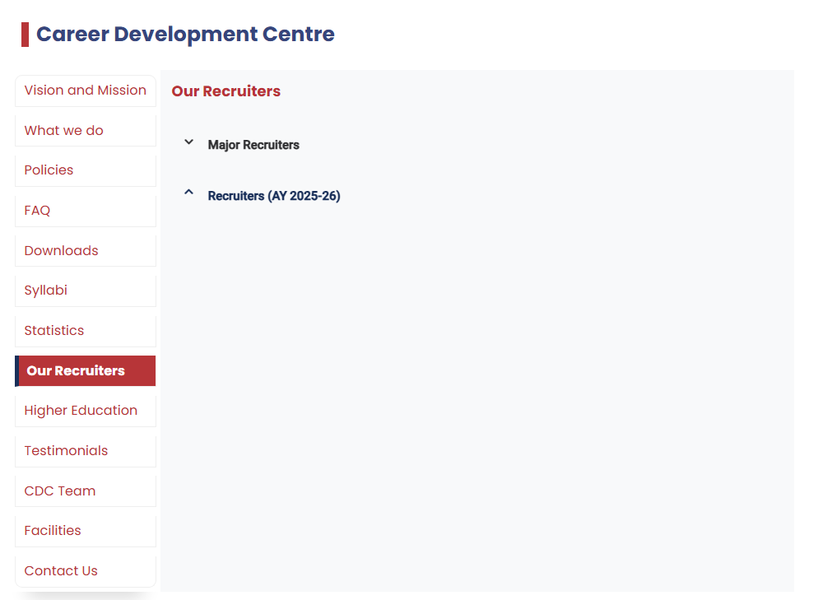

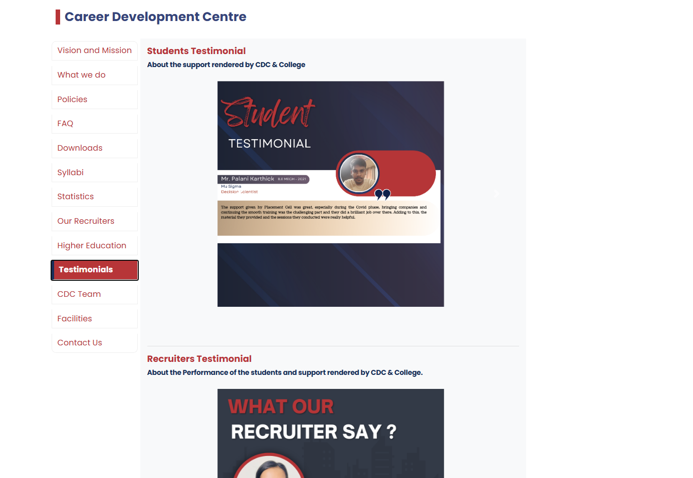
Content will give later

Career Development Centre

Placement Coordinator
Photos will give later

Facilities
The Career Development Centre (CDC) is well equipped with the necessary infrastructure and facilities to efficiently coordinate and support the placement process at every stage. The CDC provides a professional and student-friendly environment for conducting recruitment activities such as interviews, group discussions, pre-placement talks, aptitude tests, and other selection processes.
The following facilities are available for the smooth and effective conduct of placement activities:
- Well-Furnished Interview & Group Discussion Rooms – Dedicated and comfortable spaces for interviews, group discussions, and recruitment activities.
- Fully Computerized and Interconnected Office – Modern office infrastructure with reliable computer systems and communication facilities for efficient coordination.
- Student CDC Volunteers – Trained student volunteers assist recruiters and students throughout the recruitment process and during company visits.
- Video Conferencing Facilities – High-quality facilities to support virtual interviews, meetings, pre-placement talks, and online recruitment activities.
- Students' Waiting Hall – A dedicated and comfortable waiting area for students participating in placement activities.
- Placement Coordination Facilities – Dedicated arrangements to coordinate company visits, student registrations, interview schedules, and selection procedures efficiently.
- Recruiter Support Facilities – Necessary arrangements and assistance are provided to visiting recruiters to ensure a smooth and well-organized recruitment experience.

