1) General 2
1.1) Introduction 2
1.2) How to Use FITS 2
1.2.1) Command Line 2
1.2.2) Command Line Options 2
1.2.3) API 3
1.3) Overview of FITS Life Cycle 3
1.4) Output Format 3
1.4.1) Tool Output Consolidation Notes 3
2) Configuration 4
2.1) Configuration File 4
2.1.1) Tools 4
2.1.2 output 4
2.2) Mapping File 5
2.3) Format Tree 5
2.4) How to Add a New Format 5
3) Tools 5
3.1) Jhove 5
3.2) Exiftool 6
3.3) National Library of New Zealand Metadata Extractor (NLNZ) 6
3.4 File Utility 6
3.5) Droid 6
3.6) FFIdent 7
3.7) FileInfo 7
3.8) XmlMetadata 7
4) Developer Information 7
4.1) Using the API 7
4.2) Adding a Tool 8
4.3) Overview of Interfaces 9
4.3.1) Tool 9
4.3.2) ToolOutputConsolidator 9
4.4) Test Suite 10
4.5) UML Diagrams 10
4.5.1) Fits Overview 10
4.5.2) Tools 11
4.5.3) Consolidation 12
4.5.4) Identity 12
4.5.5) Mapping 12
5) Future Tools 13
5.1) Apache Tika 13
5.2) Jhove 2 13
5.3) Aduna Aperture 13
5.4) Mediainfo 13

1) General

#summary Introduction to FITS

1.1) Introduction

The File Information Tool Set (FITS) identifies, validates and extracts technical metadata for a wide range of file formats. It acts as a wrapper, invoking and managing the output from several other open source tools. Output from these tools are converted into a common format, compared to one another and consolidated into a single XML output file. FITS is written in Java and is compatible with Java 1.5 or higher. The external tools currently used are:
* [http://hul.harvard.edu/jhove/ Jhove]
* [http://www.sno.phy.queensu.ca/~phil/exiftool/ Exiftool]
* [http://meta-extractor.sourceforge.net/ National Library of New Zealand Metadata Extractor]
* [http://droid.sourceforge.net/ DROID]
* [http://schmidt.devlib.org/ffident/index.html FFIdent]
* [http://unixhelp.ed.ac.uk/CGI/man-cgi?file File Utility] ([http://gnuwin32.sourceforge.net/ windows])

1.2) How to Use FITS

FITS can be used as a command line tool or within other projects using its API. It relies on an environment variable named FITS_HOME to find the needed configuration and xsl transforms directories.

1.2.1) Command Line

Windows .bat file and Linux/OS X shell launcher scripts are provided. These scripts build the necessary Java classpath and set the FITS_HOME environment variable automatically.

1.2.2) Command Line Options
* -i The input file you want to examine
* -o The destination fo the output XML file.
* -h Prints the usage message
* -v Displays the FITS version number

If -o is not specified then the output is sent to the console window.

The general syntax is:

`>fits.[bat|sh] -i input_file -o output_file`

1.2.3) API

When using the API the FITS_HOME environment variable must be passed in with the Fits() constructor. See the Developer section for more information.

1.3) Overview of FITS Life Cycle

- configuration load
  - FITS_HOME environment variable set up
  - Fits.xml configuration file loaded
  - Tool wrappers created
  - Output consolidator configured.
- for each tool wrapper
  - each tool executed on file creating a ToolOutput object containing a fits xml document
    - If necessary, XSLT is applied to tool output to create the FITS compatible xml
  - FITS mapping file applied (xml/fits_xml_map.xml)
- consolidation
  - Identities consolidated
    - format tree (xml/fits_format_tree.xml) consulted
  - Output from tools unable to identify the file or those who identified a less specific type are thrown out
  - Fileinfo sections merged
  - Filestatus sections merged
  - metadata sections merged
- Output
  - The consolidated fits xml file is written to a file or the console
  - If using the API a FitsOutput object is returned

1.4) Output Format

Each tool wrapper must implement the Tool interface and return a ToolOutput object. ToolOutput must contain a valid fits xml JDOM object. Each tool's output is validated against the local FITS xml schema when the ToolOutput object is created. The schema is located in xml/fits_output.xsd.

During consolidation tool output conflicts are accounted for by adding a status attribute to the element.

After consolidation a single fits xml file will reference the online schema located at http://hul.harvard.edu/ois/xml/xsd/fits/fits_output.xsd

1.4.1) Status attributes

If multiple tools disagree on an identity or other metadata values, a status attribute is added to the element with a value of "CONFLICT". If only a single tool reports an identity or other metadata value a status attribute is added to the element with a value of "SINGLE_RESULT" If multiple tools agree on a an identity or value the status attribute is omitted.

1.4.2) Tool Ordering Preference

The ordering preference of the tools in xml/fits.xml determines the ordering of conflicting values. If the report-conflict configuration option is false then only the tool that first reported the element is displayed. The other conflicting values are discarded.

1.4.3) Identities and Technical Metadata

All tools that agree on an identity are consolidated into a single <identity> section. Technical metadata is only output (and a part of the consolidation process) for tools that were able to identify the file and that are listed in the first <identity> section. All other output is discarded.

1.4.4) Tool Output Normalization

It’s possible for tools output conflicting data when they actually mean the same thing. One tool could report the format of a PNG image as “Portable Network Graphics”, while another may report “PNG”. A tool could report a sampling frequency unit of “2”, while another may report the text string “inches”. If left alone, these would cause conflicts to appear in the FITS consolidated output. These differences are converted in the XSLT that converts the native tool output into FITS XML. In general FITS prefers text strings to numeric values (“inches” instead of “2”), and complete format names to abbreviations (“portable network graphics” instead of “PNG”). If new tools or formats are being added to FITS then thorough testing should be done to ensure that any false positive conflicts are resolved.

2) Configuration

#Configuration files overview

2.1) Configuration File

The primary configuration file is xml/fits.xml.

2.1.1) Tools

Tool wrappers are defined by <tool> elements. The order of these elements determines the preference in favoring one tool over another. Tool elements must have a 'class' attribute specifying the full java classpath to the class that implements the Tool interface. The 'exclude-exts' attribute is optional. It specifies file extensions that the tool should not process. This is useful if you know a tool misidentifies or generates inaccurate metadata for specific types of files.

2.1.2 output

<dataConsolidator> Specifies the class to use for the consolidating the tool output.
It's possible to use custom logic to control the tool output consolidation processes by creating a class implementing the ToolOutputConsolidator interface.

<display-tool-output> Option for appending the native output for each tool onto the end of the final consolidated FITS xml output.

<report-conflicts> Option for controlling the display of conflicts. If set to true conflicts will be shown in the final fits xml output. If set to false only the output from the most preferred tool (controlled by the ordering of the tool elements) will be displayed.

<validate-tool-output> Generally this should be set to true. Setting it to false will disable schema validation of the output from each tool.

<internal-output-schema> Local reference to the fits xml schema used for validating tool output.

<external-output-schema> Remote location of the schema referenced when creating the final consolidated fits xml.

2.2) Mapping File

The mapping file allows for substituting one value for another on a tool by tool, element by element basis. Rules are defined in the xml file xml/fits_xml_map.xml.

For example, if a tool outputs the value "2" as the sampling frequency unit for an image, but you want to use the text string "inches" instead, you could add an entry to fits_xml_map.xml. Mappings are applied automatically when a tool creates its FITS output, prior to output consolidation. You must specify the tool name, version, and element name that you want mapped. Currently all mapping related needs are handled in the tool's XSLT.

2.3) Format Tree

Certain formats are a more specific subset of a more general format. The format tree (xml/fits_format_tree.xml) specifies these relationships. During output consolidation the format tree is consulted, and any less specific identities are throw out. For example, Open Office document formats are ZIP based. Some tools identify these files as ZIP, and others as ODT. Any tools identifying the file as a ZIP would be discarded according to the rules set by the format tree.

2.4) How to Add a New Format

Certain tools can identify and extract technical metadata for files (Jhove, Exiftool, NLNZ ME), others can only identify files (Droid, FFident, File Utility). Support for which formats can have technical metadata extracted varies depending on the tool. Jhove and NLNZ ME support a small set of popular formats, while Exiftool supports a wide range. All formats that Jhove and NLNZ ME support are already represented in FITS.

To add FITS supported technical metadata for a tool:
- Decide if the new format fits into one of the already supported format types: image, text, audio, document
- If it does not, add the new metadata type to the fits schemas.
- Decide if XSLT will be used to transform the tool output into FITS XML
  - If so, create an XSLT file to transform the technical metadata output into FITS XML.
  - If a XSLT to format mapping file exists, add the new format to it. For example: xml/exiftool/exiftool_xslt_map.xml

3) Tools

#Tools overview

FITS is currently configured to use a set of 8 tools for identifying, validating, and extracting technical metadata.

3.1) Jhove

Capabilities: Identifies, extracts technical metadata, and validates files.

Details: Jhove is written in Java. The FITS tool wrapper uses the provided API. The Jhove xml output is converted to FITS XML using XSLT. xml/jhove/jhove_xslt_map.xml is used to determine which xslt to apply for the given identified format.

Formats Supported: jpg,tiff,jp2,gif,wave,aiff,xml,html,ascii,utf-8,pdf.

3.2) Exiftool

Capabilities: Identifies and extracts technical metadata.

Details: Exiftool is written in Perl. A windows executable is also provided. The Exiftool tool wrapper detects the operating system type and calls the appropriate version of the tool. The tab delimited output is captured, converted to a simple XML structure, and then converted to FITS XML using xslt. xml/exiftool/exiftool_xslt_map.xml is used to determine which xslt to apply for the given identified format.

Formats Supported:
Technical Metadata: jpg,tiff,jp2,gif,bmp,dib,png,psd,dng,3fr,btf,cr2,crw,ciff,cs1,dcr,erf,fpx,hdp,wdp,itc,k25,kdc,mef,mif,mos,mrw,nef,orf,pef,jng,ppm,pgm,pgm,qti,qif,raf,raw,rw2,rwz,sr2,srf,thm,x3f,wav,mp3,m4a,aif,ra,ogg,flac,aifc,ape,mpc,wma,xml,html,icc,icm,ram,rpm,svg,xmp,pdf,doc

3.3) National Library of New Zealand Metadata Extractor (NLNZ)

Capabilities: Identifies and extracts technical metadata.

Details: The FITS NLNZ tool wrapper uses the provided Java API. The NLNZ native XML output is converted to FITS XML using XSLT. xml/nlnz/fits/nlnz_xslt_map.xml is used to determine which xslt to apply to the given identified format.

Formats Supported: jpg,tiff,gif,bmp,wav,mp3,xml,html,pdf,doc,wordperfect,msworks,odt

3.4 File Utility

Capabilities: Identifies files.

Details: File Utility is usually bundled with Linux, UNIX and OS X. The GnuWin32 port is provided for use on Windows. Due to variations in versions this may cause different output when run on different platforms. File Utility is called in its default mode (no arguments), and also with -i to determine the mime type. The output is converted into a simple XML document and then converted to FITS XML using xml/fileutility/fileutility_to_fits.xslt.

Formats Supported: many

3.5) Droid

Capabilities: Identifies files.

Details: Droid is written in Java. The fits tool wrapper uses the provided API. The output is converted into a simple XML document and then converted to FITS XML using xml/droid/droid_to_fits.xslt. The Droid configuration file and signature file are located in the tools/droid directory.

Formats Supported: Listed in Droid signature file

3.6) FFIdent

Capabilities: Identifies files.

Details: FFIdent is written in Java. The FITS tool wrapper uses the provided API. Output is converted into a simple xml document and then converted to FITS XML using xml/ffident/ffident_to_fits.xslt.

Formats Supported: List in the configuration file tools/ffident/formats.txt

3.7) FileInfo

Capabilities: Extracts technical metadata.

Details: FileInfo creates FITS XML natively. It determines basic file information like file name, size, file system last modified date, and md5 checksums. It uses the fast md5 jar from http://www.twmacinta.com/myjava/fast_md5.php.

Formats Supported: Any

3.8) XmlMetadata

Capabilities: Identifies and extracts technical metadata.

Details: XmlMetadata creates FITS XML natively. Its sole purpose is to identify XML and parse out the default namespace and schema location. This is used as FITS text metadata.

Formats Supported: XML

4) Developer Information

#developer, testing and API information

4.1) Using the API

{{{

Fits fits = new Fits("FITS_HOME");
FitsOutput fitsOut = fits.examine(input);
fitsOutput.saveToDisk("output/path/to/file");

}}}

FITS_HOME is the directory containing the xml and tools directories. All required FITS jars need to be on the classpath.

The FITS XML can be retrieved from FitsOutput as a JDOM object:
`FitsOutput.getFitsXml()`

Several convenience methods are provided. (Not a complete list)

Test for an element with name:
`boolean hasElement = fitsOutput.hasMetadataElement("name");`

Lookup a single element by name:
`FitsMetadataElement element = fitsOutput.getMetadataElement("name");`

Lookup a list of all elements by name:
`List<FitsMetadataElement> elements = fitsOutput.getMetadataElements("name");`

Get a list of all elements in the FileInfo section:
`List<FitsMetadataElement> elements = fitsOutput.getFileInfoElements();`

Get a list of all elements in the FileStatus section:
`List<FitsMetadataElement> elements = fitsOutput.getFileStatusElements();`

Get Technical metadata type of the output (image, text, audio, document):
`String type = fitsOutput.getTechMetadataType();`

Get a list of all elements in the technical metadata section:
`List<FitsMetadataElement> elements = fitsOutput.getTechMetadataElements();`

Test for conflicting metadata values by name:
`Boolean hasConflict = hasConflictingMetadataElements("name");`

4.2) Adding a Tool

Any type of tool, whether it's based on Perl, Java, or something else entirely, can be added to FITS.
A tool wrapper must be created that encapsulates the complexities of invoking the tool, capturing the output, and converting it to FITS XML.

For example Exiftool is written in Perl. The Exiftool tool wrapper checks for the operating system type and if Perl is installed. It then can decide if it should use the standard Perl version of Exiftool or the windows executable.

A tool wrapper must implement the Tool interface. If the tool depends on a specific operating system, the necessary checks should be made within the tool wrapper to prevent execution on incompatible systems.

It is the responsibility of the tool wrapper to convert the tool output into FITS XML and return a valid ToolOutput object.

For tools that natively return XML, XSLT can be used to convert the output to FITS XML. For tools that do not return XML, the output can either be a) directly converted to FITS XML, or b) converted to a basic intermediate XML format and then converted using XSLT.

Any new tool wrappers must be added to the xml/fits.xml configuration file. FITS handles initializing the wrapper and sending the input file to it.

FITS generally prefers to use text labels rather than numeric values for technical metadata. For example an image's Resolution Unit should be "inches" instead of the value 2. If a tool prefers to output numeric values then these can be converted either using either the FITS mapping file, or during the conversion process from the native tool output to FITS xml.

The ToolBase abstract class implements the Tool interface and provides methods for applying XSLT transforms, checking for unknown identities and excluded extensions. The current tool wrappers all extend ToolBase.

4.3) Overview of Interfaces

4.3.1) Tool

The Tool interface defines the following methods:
`ToolOutput extractInfo(File file)` -- Called by FITS to invoke the tool against the input file. It must return a ToolOutput object containing valid FITS XML

`boolean isIdentityKnown(FileIdentity identity)` -- Logic for determining if the tool was able to identify the input file

`ToolInfo getToolInfo()` -- Returns a ToolInfo object describing the tool.

`Boolean canIdentify()` -- indicates if the tool can identify file formats. This is important to know for output consolidation purposes.

`void addExcludedExtension()` -- Adds a file extension that FITS should not use this tool wrapper to processes (set from xml/fits.xml tool definitions)

`boolean hasExcludedExtension(String ext)` -- Checks if the tool can processes the provided file extension.

4.3.2) ToolOutputConsolidator
The ToolOutputConsolidator interface defines one method:
`FitsOutput processResults(List<ToolOutput> results);`

Classes implementing the ToolOutputConsolidator must accept a list of ToolOutput objects, merge them, and return a FitsOutput object.

4.4) Test Suite

A basic test suite is provided. The launcher scripts (testoutput.bat, testoutput.sh) can be run in 'create' or 'test' mode. Running in create mode will call fits on all files in the tests/input directory, writing the output to tests/output. Running in 'test' mode will call fits against all files in tests/input and compare the output to the corresponding output file in tests/output. All structure and element values are compared, but any attribute differences are ignored. Attributes in the fits output generally contain timestamps or tool version numbers, which could change if a tool is updated to newer version.

Note that changing the fits.xml configuration or adding a new tool will require running the output test in 'create' mode to rebuild the output files.

4.5) UML Diagrams

4.5.1) Fits Overview

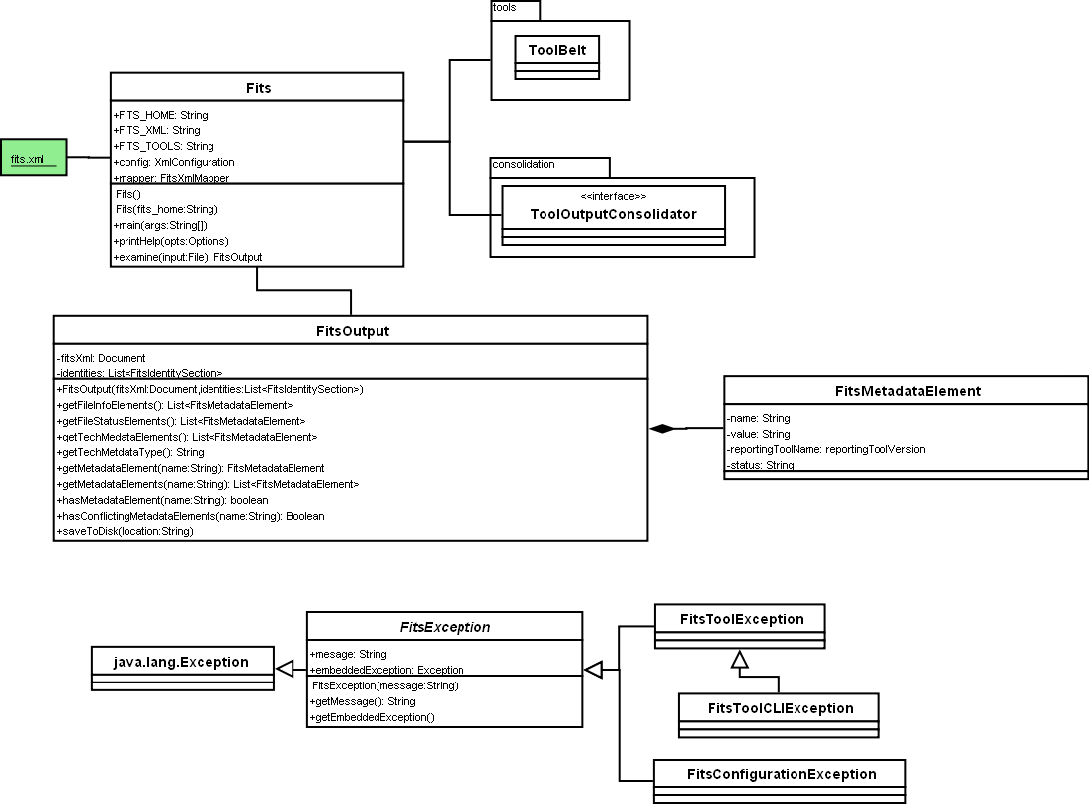

4.5.2) Tools

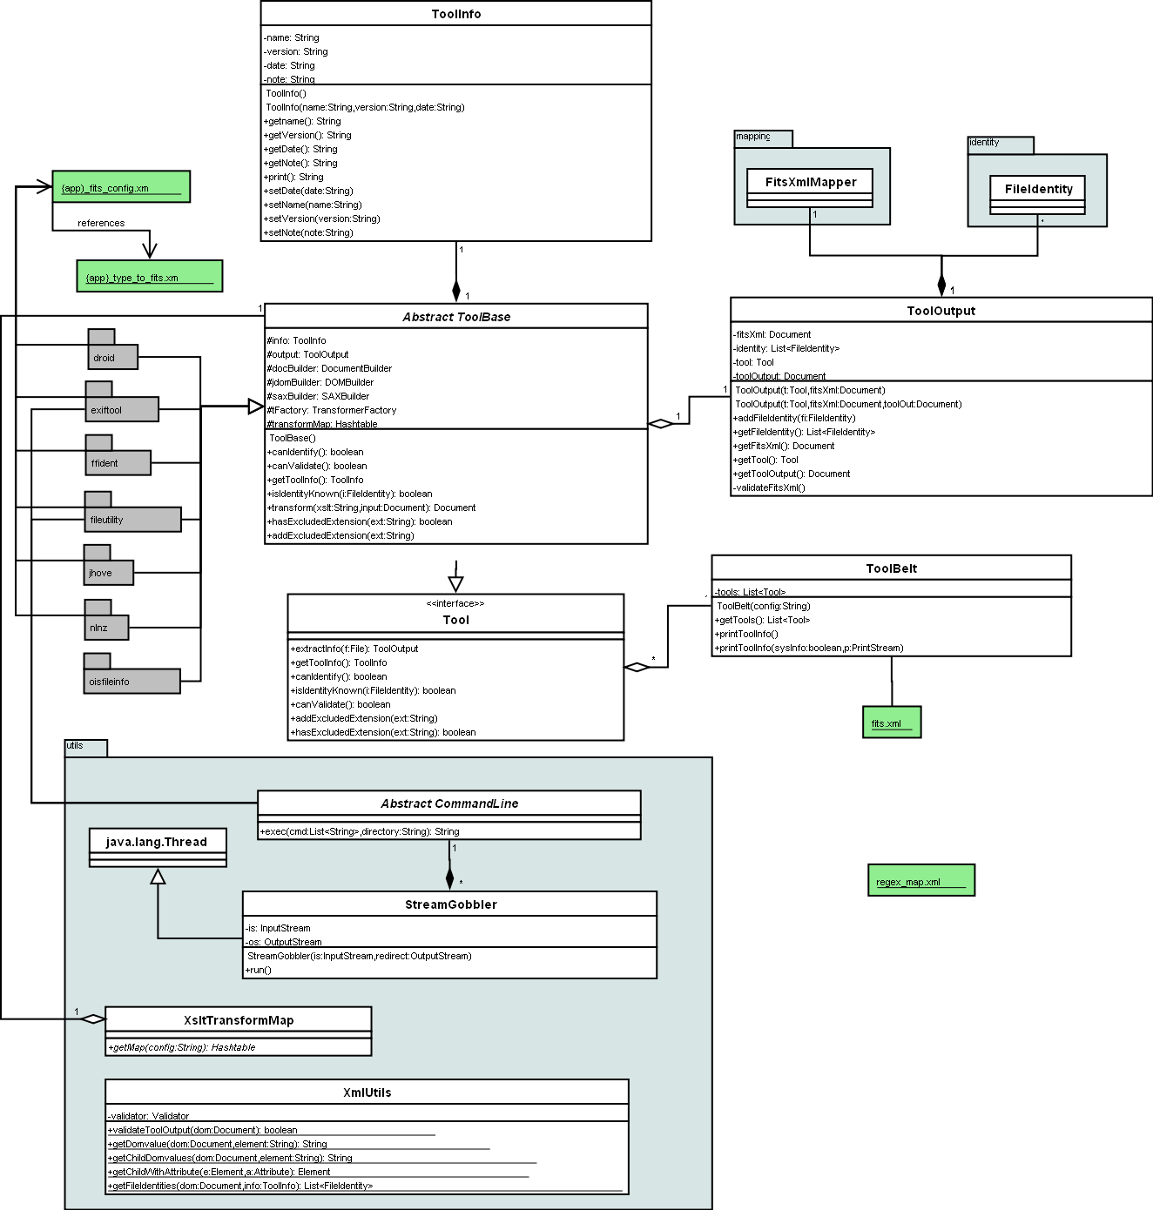

4.5.3) Consolidation
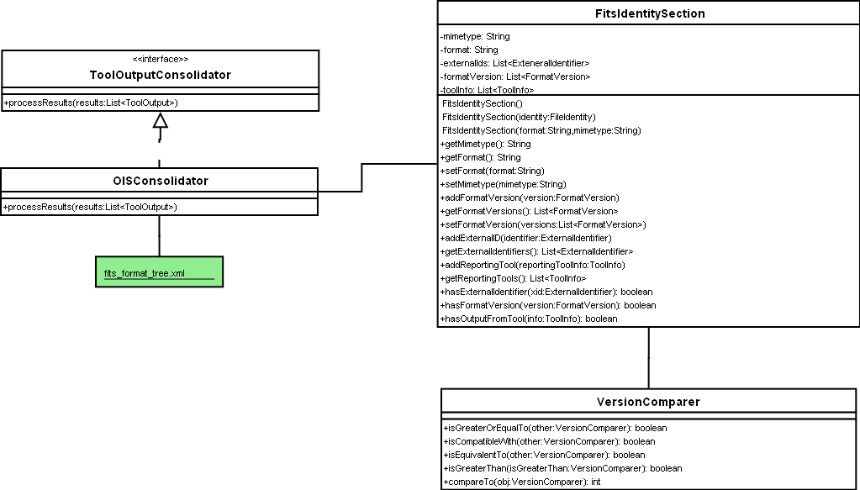

4.5.4) Identity
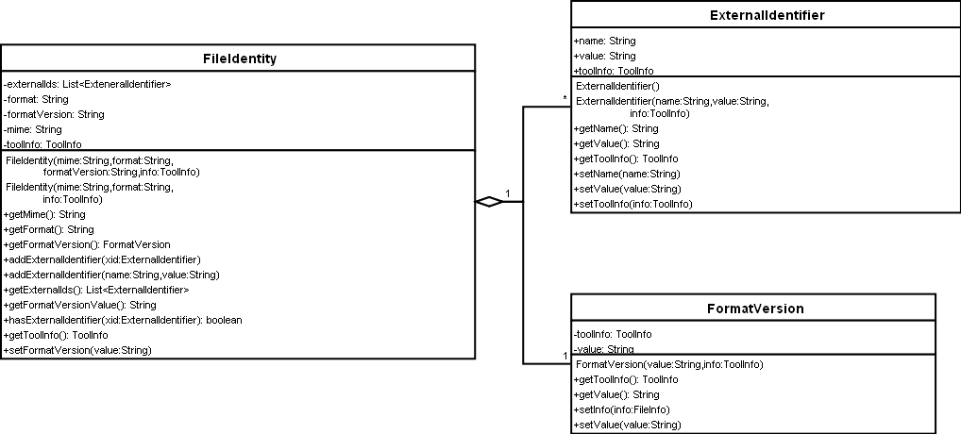

4.5.5) Mapping

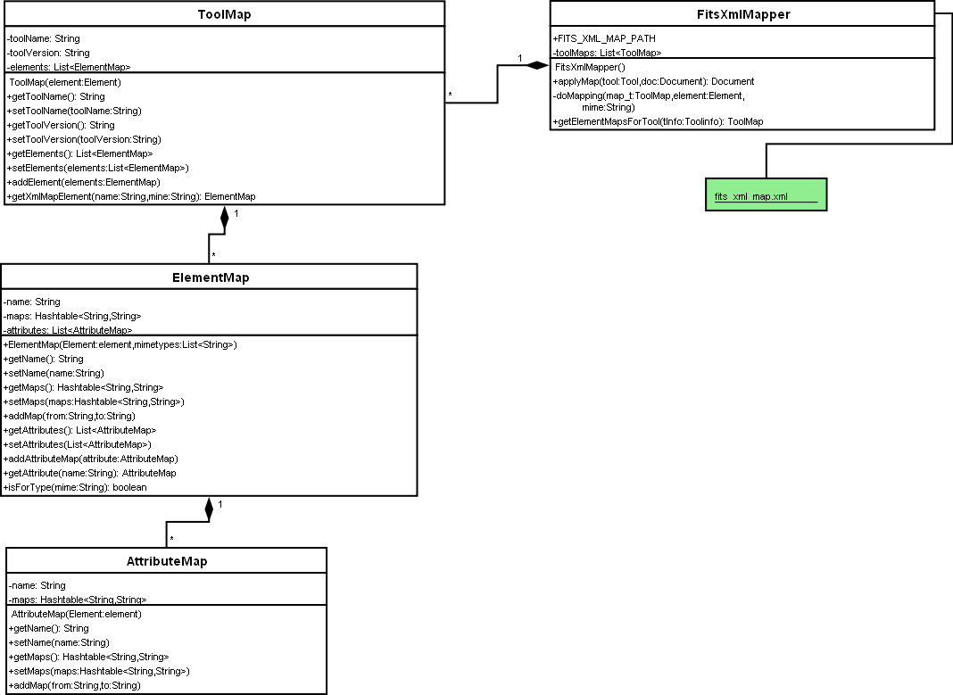

5) Future Tools

5.1) Apache Tika
http://lucene.apache.org/tika/Apache Tika
Document formats

5.2) Jhove 2
http://confluence.ucop.edu/display/JHOVE2Info/Home

5.3) Aduna Aperture
http://www.aduna-software.com/technologies/aperture/overview.view
Text, document and email support.

5.4) Mediainfo
http://mediainfo.sourceforge.net
Audio and video support

