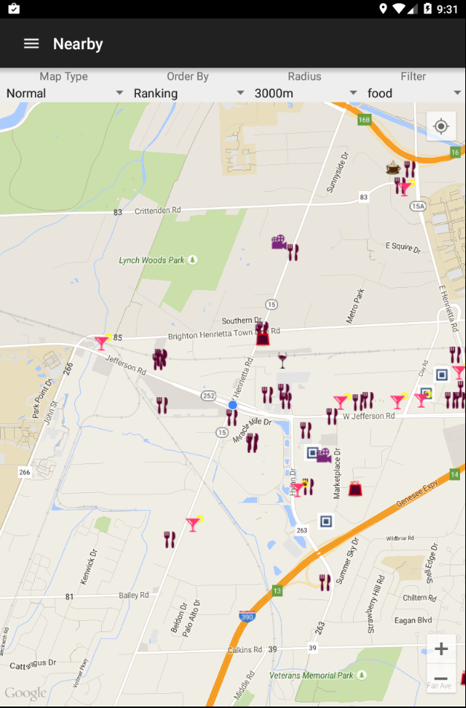

This is the main screen that displays a map with icons. The icons represent the categories of the different POIs.

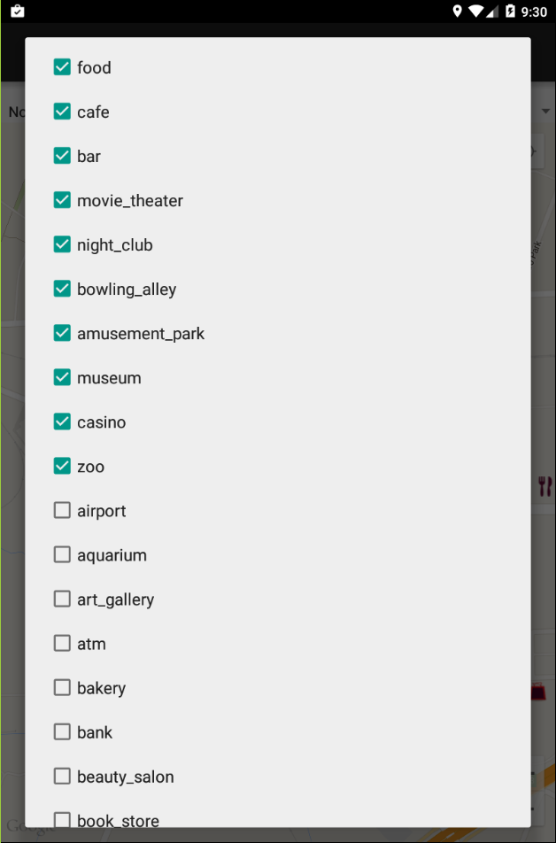

When the user clicks on the “Filter’ menu, he/she is able to check/uncheck the various categories. Only the checked categories will be displayed on the map.

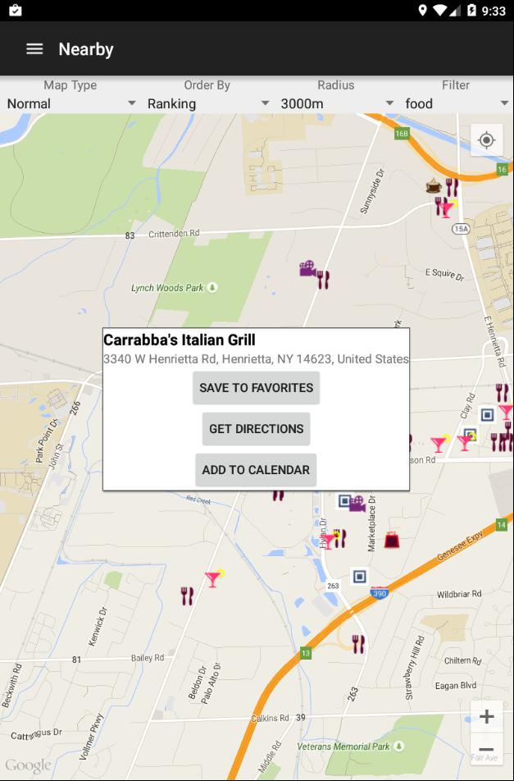

When the user clicks on one of the icons, there will be a popup listing the name and address of the place. The popup allows the user to ‘save to favorites’, ‘get directions’, and ‘add to calendar’.