**.Netcore developer Technical test**

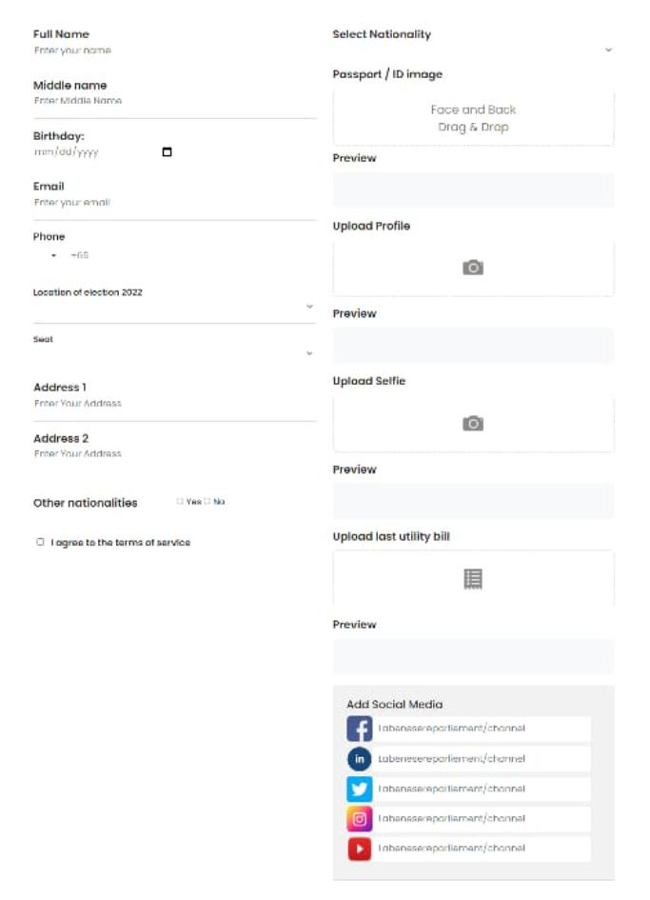

**.**

Create Crude Api for sign up also store images in local directory that is being uploaded.