1）

BG=1 Z=2 frameAmount=100000

codeRate=[1/3 1/2 2/3 3/4 5/6 8/9]

snr=[1 2 3 4 5]

errorBitsRate=

1/3：0.010211 0.001385 0.000183 2.181818e-05 2.5e-06

1/2：0.103255 0.052803 0.019013 0.004662 0.000740

2/3：0.158202 0.129097 0.099803 0.071758 0.047307

3/4：0.164101 0.138681 0.113743 0.090321 0.068421

5/6：0.167934 0.143326 0.120717 0.100115 0.082369

8/9：0.177309 0.153074 0.131084 0.111246 0.094242

**1/3码率时matlab仿真和vs结果比较**

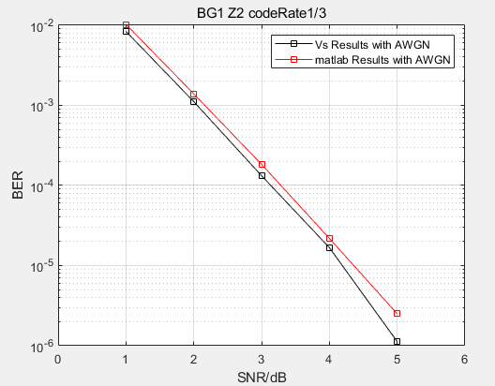

2）

BG=1 Z=24 frameAmount=10000

codeRate=[1/3 1/2 2/3]

snr=[-0.5 -0.1 0 0.2 0.3]

errorBitsRate=

1/3：0.005437 0.000281 0.000120 2.31e-05 3.787e-07

1/2：0.188055 0.169800 0.164217 0.153012 0.145427

2/3：0.199738 0.188978 0.186402 0.180746 0.177749

**1/3码率时matlab仿真和vs结果比较**

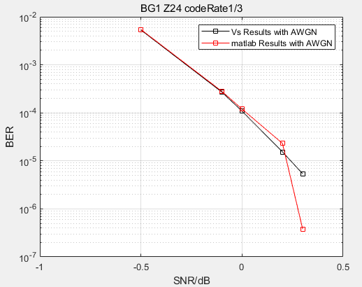

3）

BG=1 Z=64 frameAmount=5000

codeRate=[1/3 1/2]

snr=[-0.8 -0.6 -0.4 -0.2]

errorBitsRate=

1/3：0.007593 0.000986 8.991e-05 1.846e-06

1/2：0.200519 0.192806 0.184717 0.175993

**1/3码率时matlab仿真和vs结果比较**

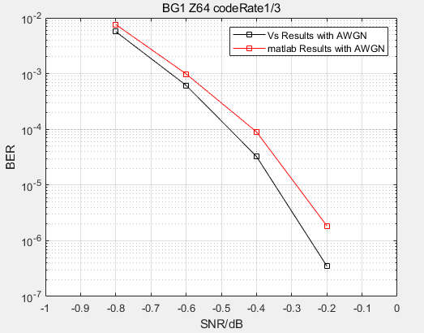

4）

BG=1 Z=32 frameAmount=10000

codeRate=[1/3 1/2 2/3 3/4 5/6 8/9]

snr/errorBitsRate

|  |  |  |  |  |  |  |
| --- | --- | --- | --- | --- | --- | --- |
|  | 1/3 | 1/2 | 2/3 | 3/4 | 5/6 | 8/9 |
| -1 | 0.044696 |  |  |  |  |  |
| -0.6 | 0.005502 |  |  |  |  |  |
| -0.2 | 0.000168 |  |  |  |  |  |
| 0 | 7.244e-06 |  |  |  |  |  |
| 1 | 0 | 0.073635 |  |  |  |  |
| 1.5 |  | 0.016822 |  |  |  |  |
| 2 |  | 0.000801 |  |  |  |  |
| 2.5 |  | 3.835e-06 |  |  |  |  |
| 3 |  |  |  |  |  |  |
| 3.5 |  |  |  |  |  |  |
| 4 |  |  | 0.028752 |  |  |  |
| 4.5 |  |  | 0.007406 |  |  |  |
| 5 |  |  | 0.001279 |  |  |  |
| 5.5 |  |  | 0.000110 |  |  |  |
| 6 |  |  | **9.943e-06** | 0.037849 |  |  |
| 6.5 |  |  | **1.065e-06** | 0.020327 |  |  |
| 7 |  |  |  | 0.007337 |  |  |
| 7.5 |  |  |  | 0.001740 |  |  |
| 8 |  |  |  | 0.000229 |  |  |
| 8.5 |  |  |  | 2.038e-05 |  |  |
| 9 |  |  |  | 2.232e-06 |  |  |
| 11 |  |  |  |  | 0.013272 |  |
| 11.5 |  |  |  |  | 0.006778 |  |
| 12 |  |  |  |  | 0.002712 |  |
| 12.5 |  |  |  |  | 0.000981 |  |
| 13 |  |  |  |  | 0.000191 |  |
| 13.5 |  |  |  |  | 3.15e-05 | 0.009449 |
| 14 |  |  |  |  | 5e-06 | 0.003754 |
| 14.5 |  |  |  |  |  | 0.001046 |
| 15 |  |  |  |  |  | 0.000205 |
| 15.5 |  |  |  |  |  | 3.359e-05 |
| 16 |  |  |  |  |  | 1.562e-06 |

