Java EE Project Report
Party History Learning & Examination System
Name | Matriculation Number | Email Address
崔振浩 | 2053776 | 1278493070@qq.com
孟香帆 | 1952493 | 2080874233@qq.com
卢嘉霖 | 2050633 | 1640889387@qq.com

s


Tongji University

A.System Functionalities
This system was designed for university students, faculty, and administrators to complete tasks of learning the Party's history. The functionalities of this system can be divided into three independent parts: for students, for faculty, and for administrators.

Part I. Functionalities for students
(1) Article Viewing
After logging in, student users can view the pushed articles displayed on the home page and click to browse.

(2) Self Testing
Student users can practice the test on the self-test page. The only difference from the formal examination is that the test score does not factor into the final grade.

(3) Examination
Student users can take examinations on the formal examination page. The examination score will be recorded and stored in the database.

(4) Grades Recording and Viewing
Information on all formal examinations the student has taken is displayed in detail on the examination records page.

Part II. Functionalities for Faculty
(1) Students Management
Faculty users can view the profile of all students in a form. The system also provides functionalities for adding a new entry, editing the current profile, and deleting an entry.

(2) Paper Management
The paper management module allows faculty users to generate new papers with custom questions, delete redundant examination papers, and assign examination papers to students.

(3) Article Management
The articles shown on the home page are pushed by faculty on the article-pushing page, where faculty users can also write or edit an article.

(4) Grades Recording
Faculty users can record students' scores in a table. On this page, faculty users can also view entries in order and edit them.

(5) Question Editing
This system maintains a question database. Faculty users can add, edit and delete questions. Subjective and objective questions are displayed in two tables, respectively.

(6) Statistic Data Viewing
Faculty users can check academic performance, assessment completion, and the number of activists in each school on the statistics page.

Part III. Functionalities for Administrators
(1) Students Management
The functionality is the same as that used by teacher users.

(2) Organization Management
The faculty's accounts are displayed in a table on the organization management page. Administrator users can view their party branch, school, and other information. The system also provides functionalities for adding, editing, and modifying entries.

(3) Question Editing
The functionality is the same as that used by teacher users.

(4) Statistic Data Viewing
The functionality is the same as that used by teacher users.

B.User Manual
The major users of this system are students, faculty, and administrators. Student users can view pushed articles to learn the Party's history and take examinations. As they complete the tasks, the score of each test will be recorded in the database.
Faculty users are responsible for editing and pushing articles. They can also edit the question database, compose a paper with these questions, and check students' grades on this system.
Administrator users have the highest authority. Besides functionalities offered to faculty users, they are also allowed to manage the faculty team of each school.

Part I. Sample Scenarios for students
(1) On the log-in page, type in the account number and password and choose the student radio button before clicking the log-in button.
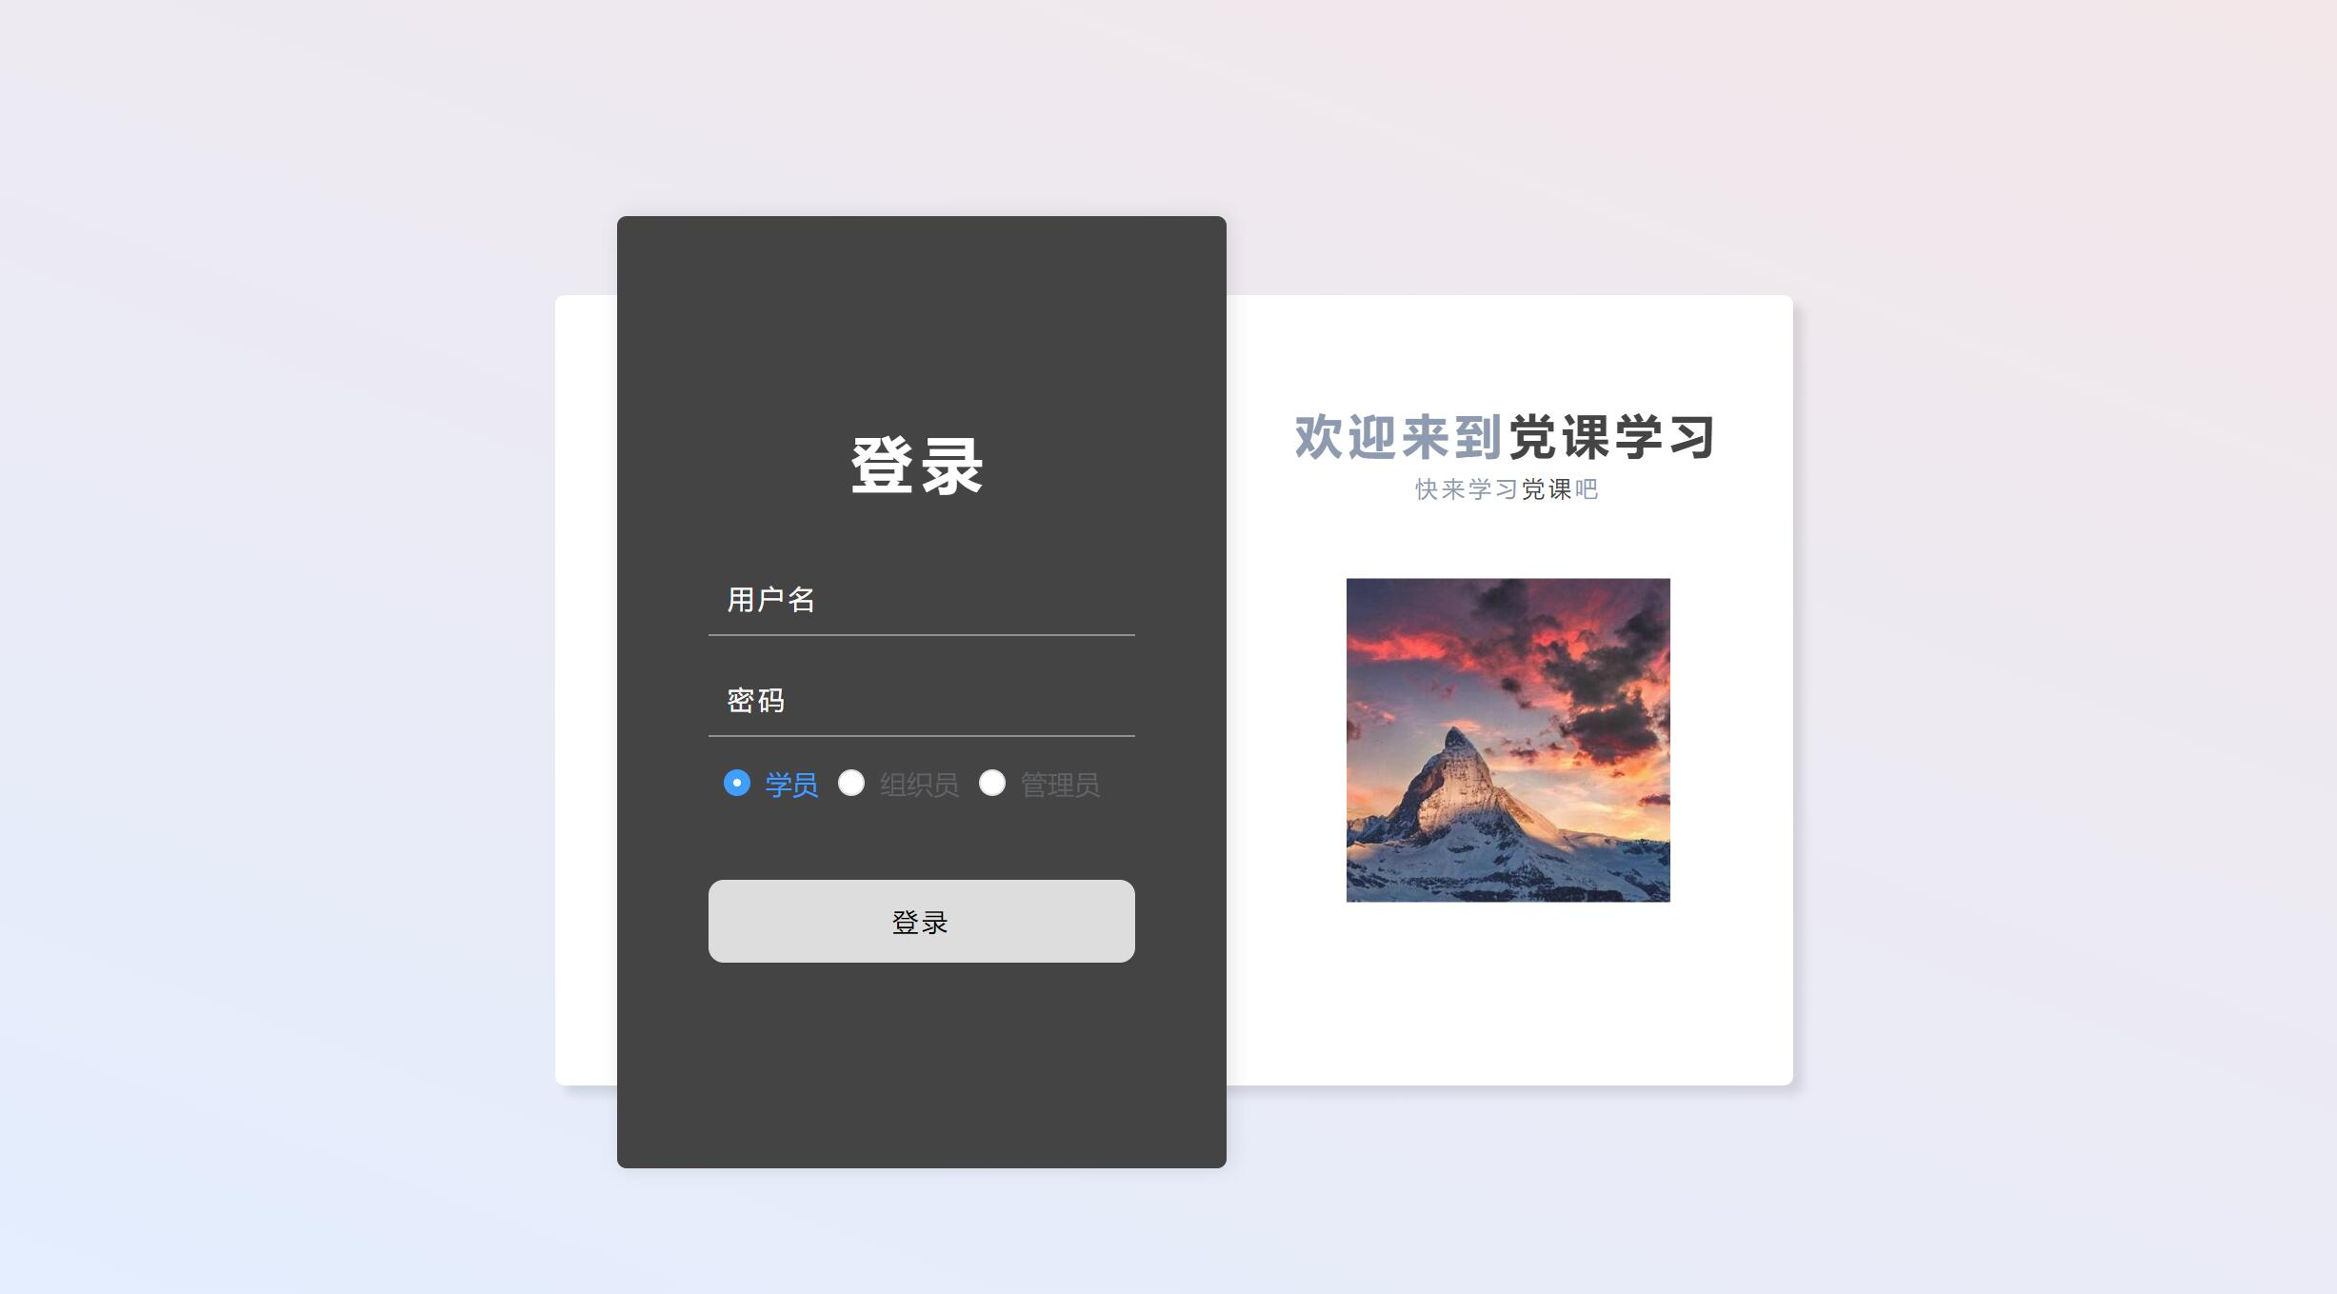
Fig 1. Log-in page

(2) The home page shows the pushed articles. The picture slide presents the title and cover of each of them. Click the corresponding cover to jump to the details page to browse.
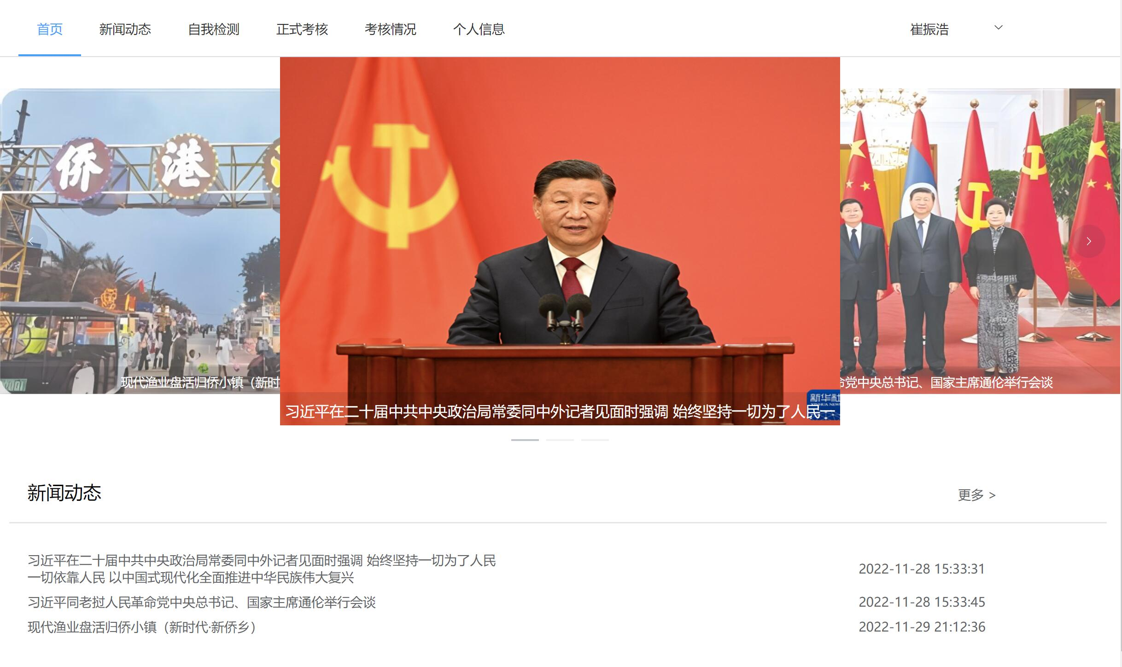
Fig 2. Home page
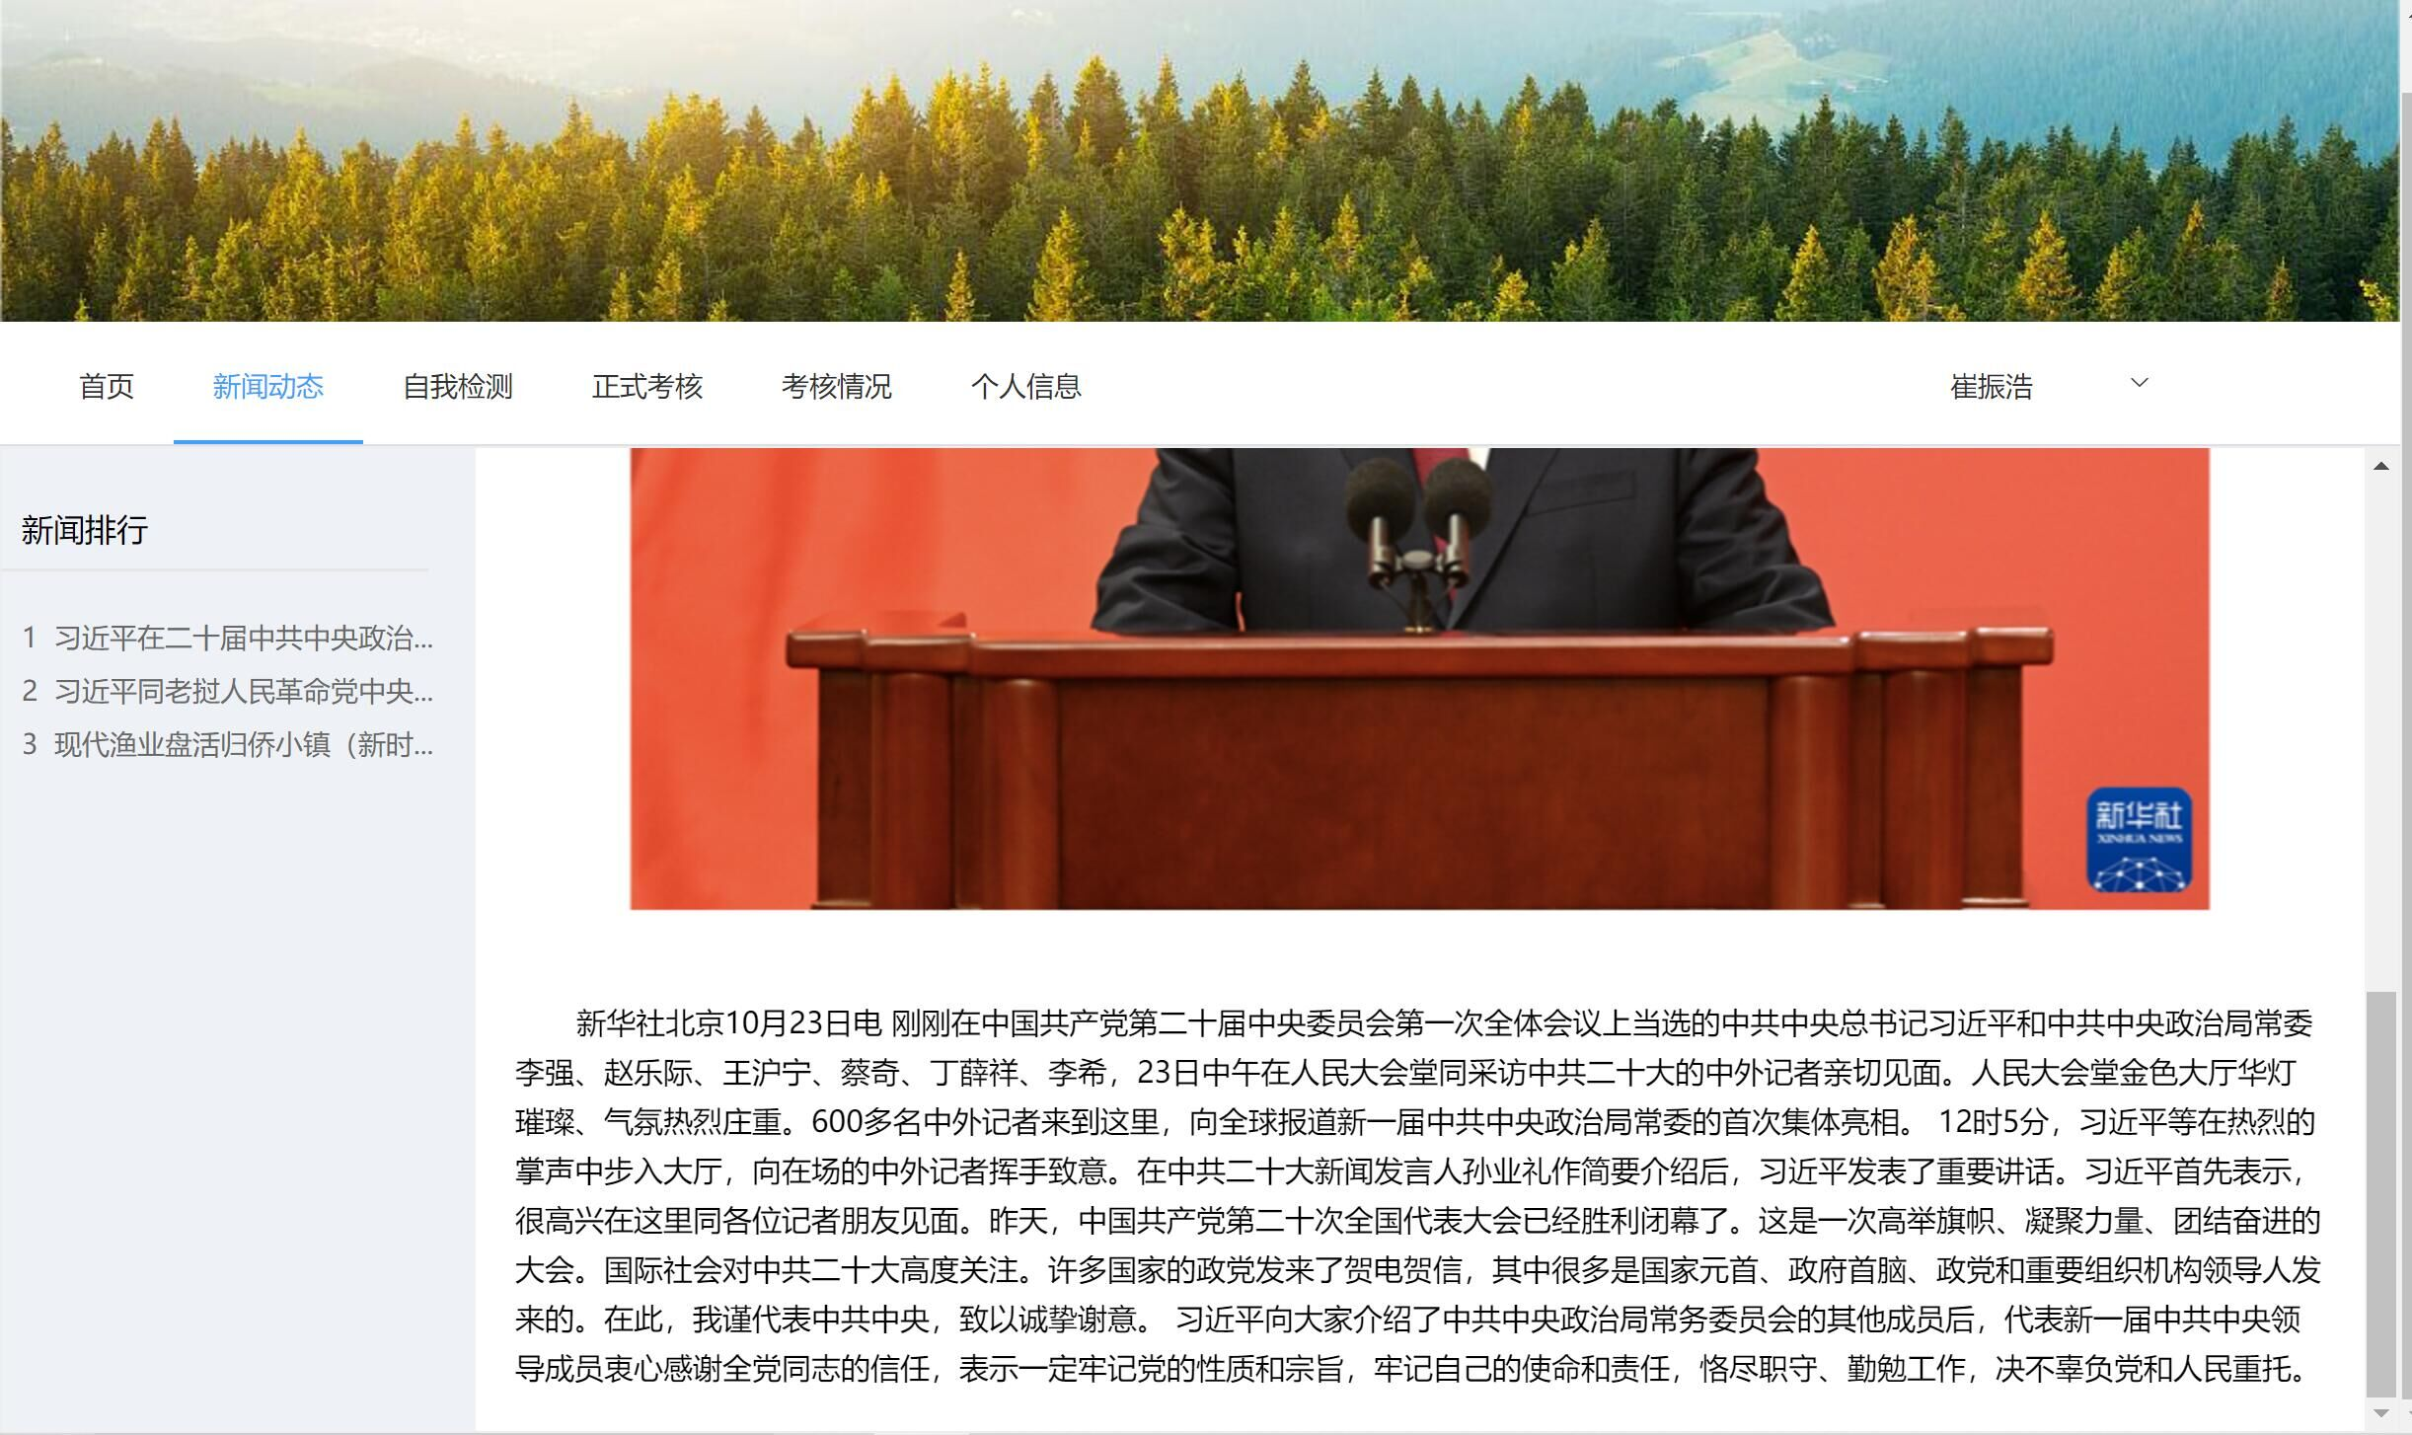
Fig 3. Article page
(3) Click labels on the top to practice tests and take formal examinations. The questions are displayed sequentially. The objective and subjective questions are in the form of multiple-choice and short answers, respectively.
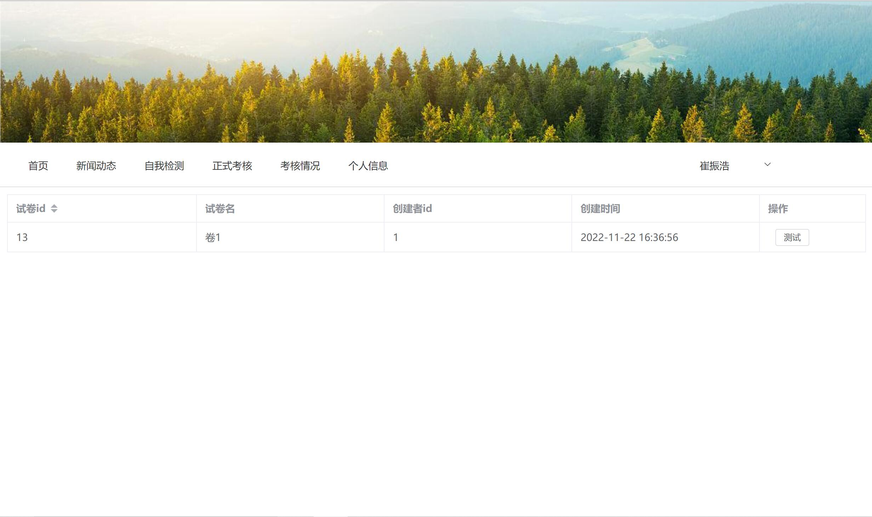
Fig 4. Paper selection page
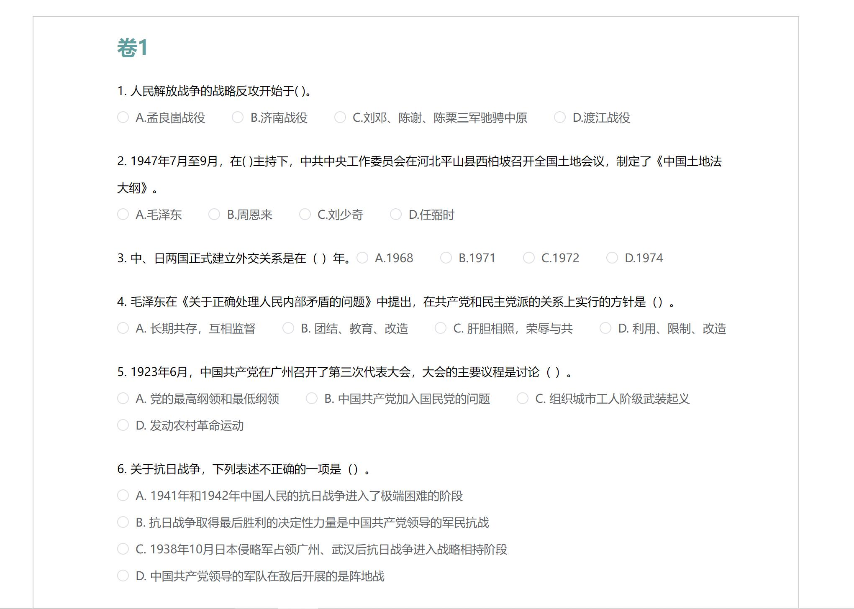
Fig 5. Test page

(4) Click the My Grades label on the left to view the details of each formal examination recorded in a table. Each entry includes the final score, the number of correct questions, and when the score came out.
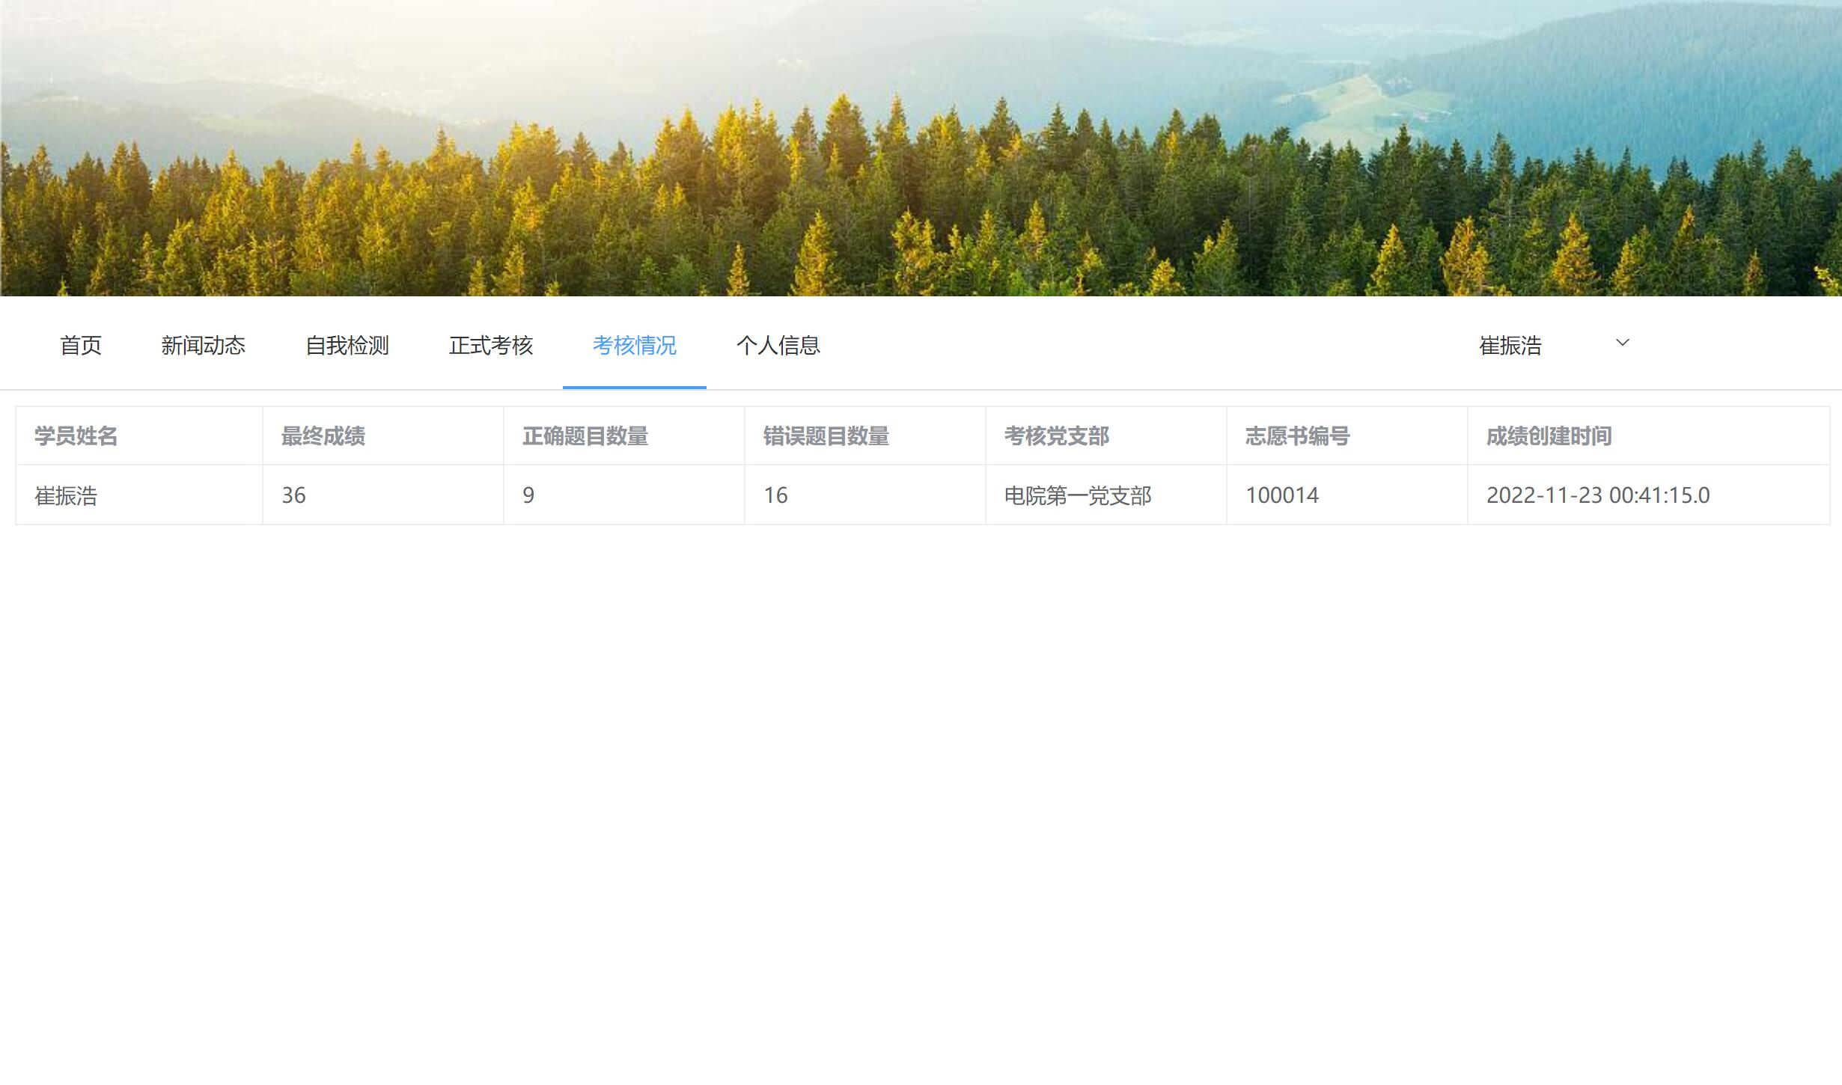
Fig 6. Grades page

(5) Click the Personal Information label to view the information of the current account. The user can modify the entries and click the button to update.
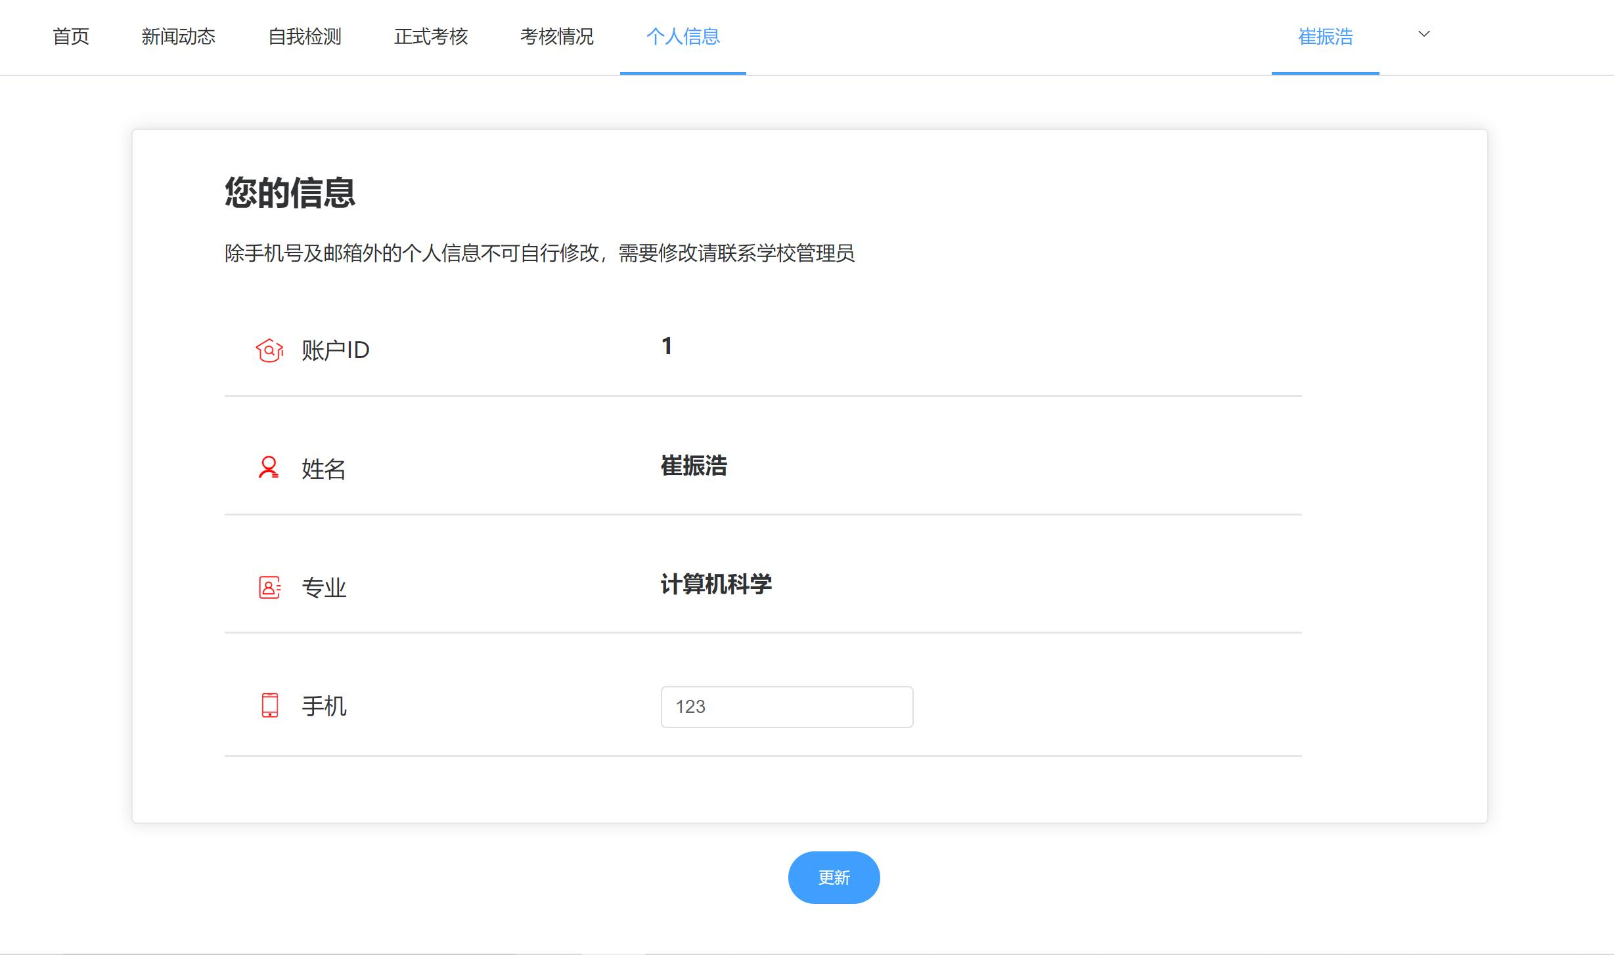
Fig 7. Personal information page

Part II. Sample Scenarios for Faculty
- The log-in page is the same as that used by student users, except that faculty users choose the faculty radio button.
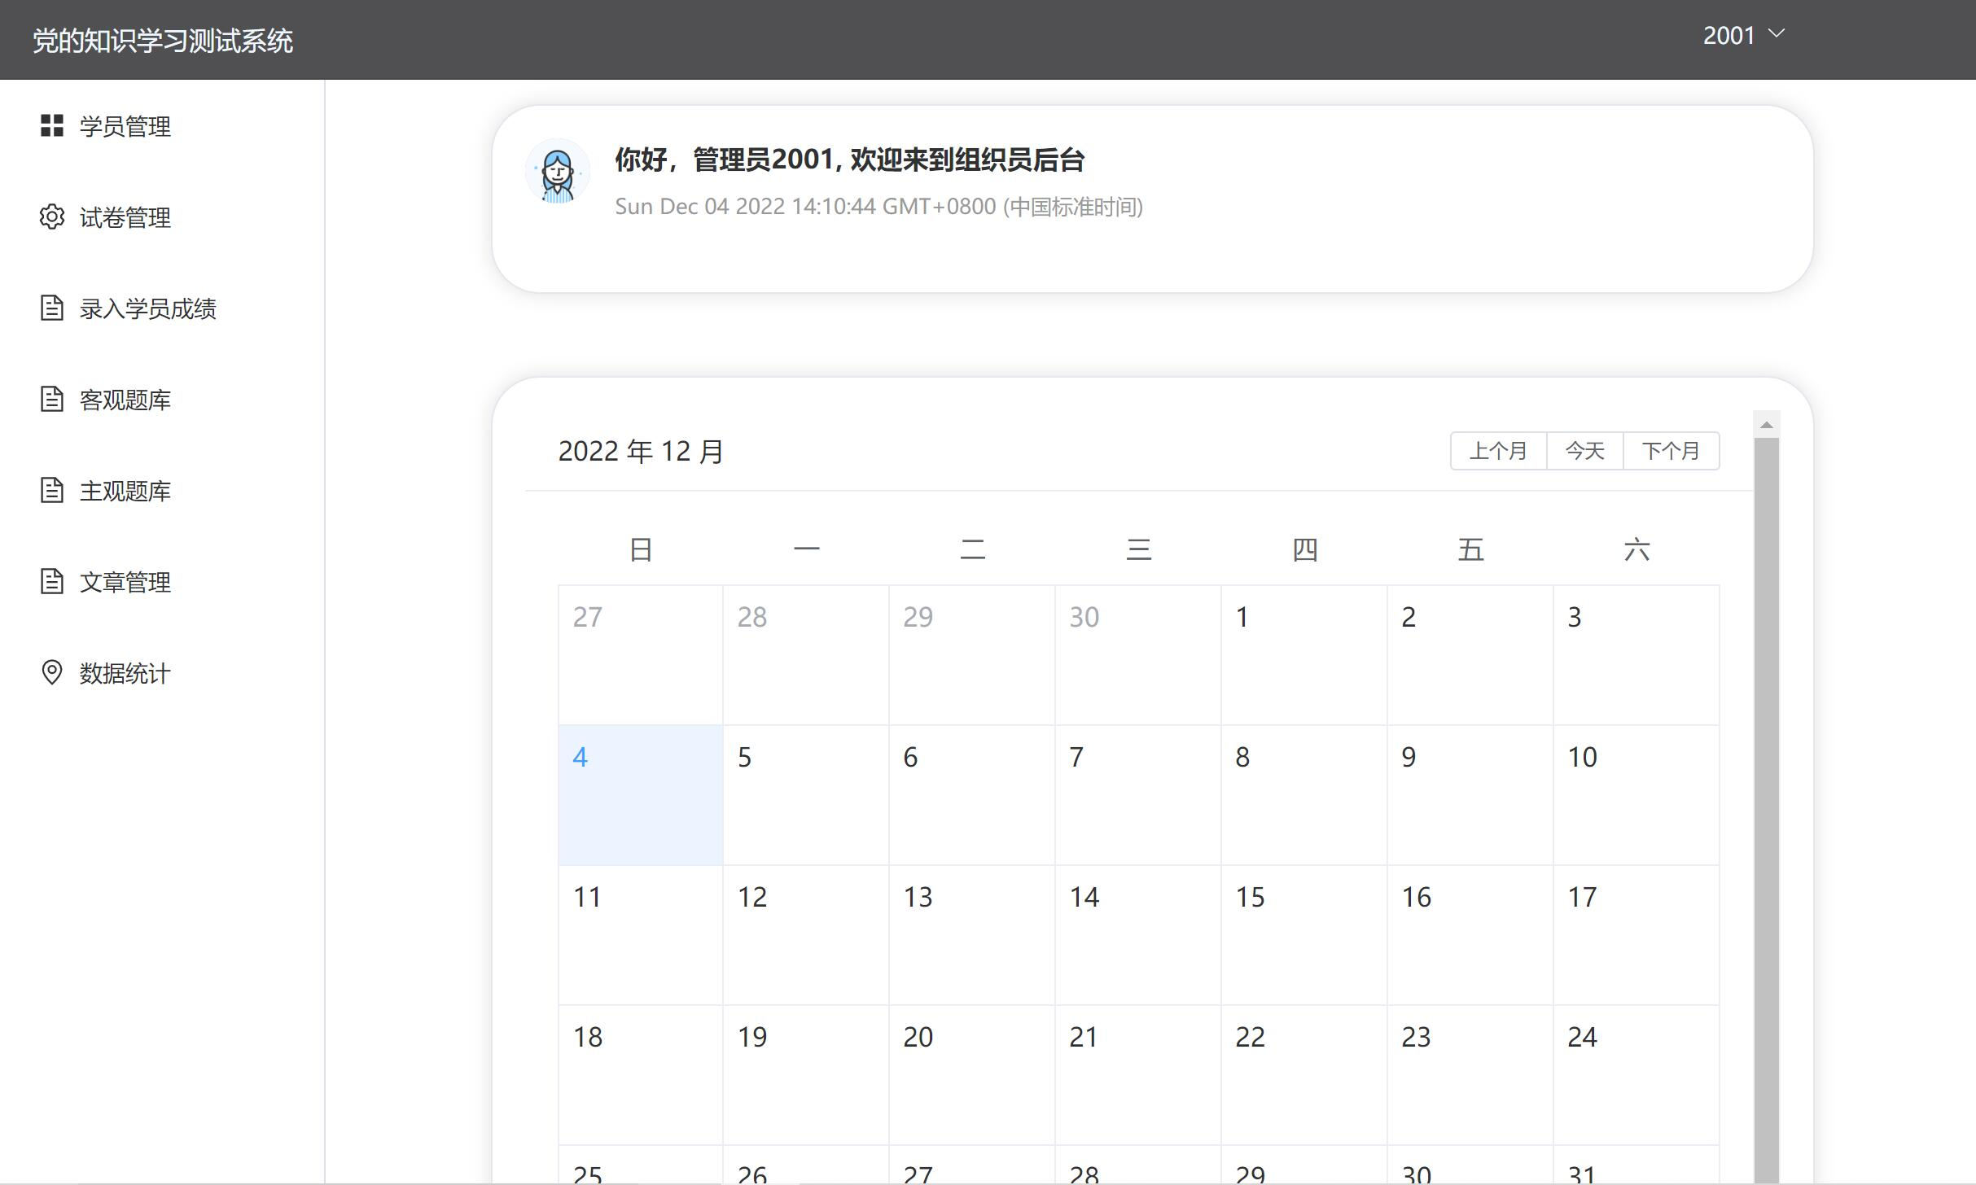
Fig 8. Home page

(2) Faculty users can edit and push articles on the article-editing page. Click the label on the left to enter the editing interface.
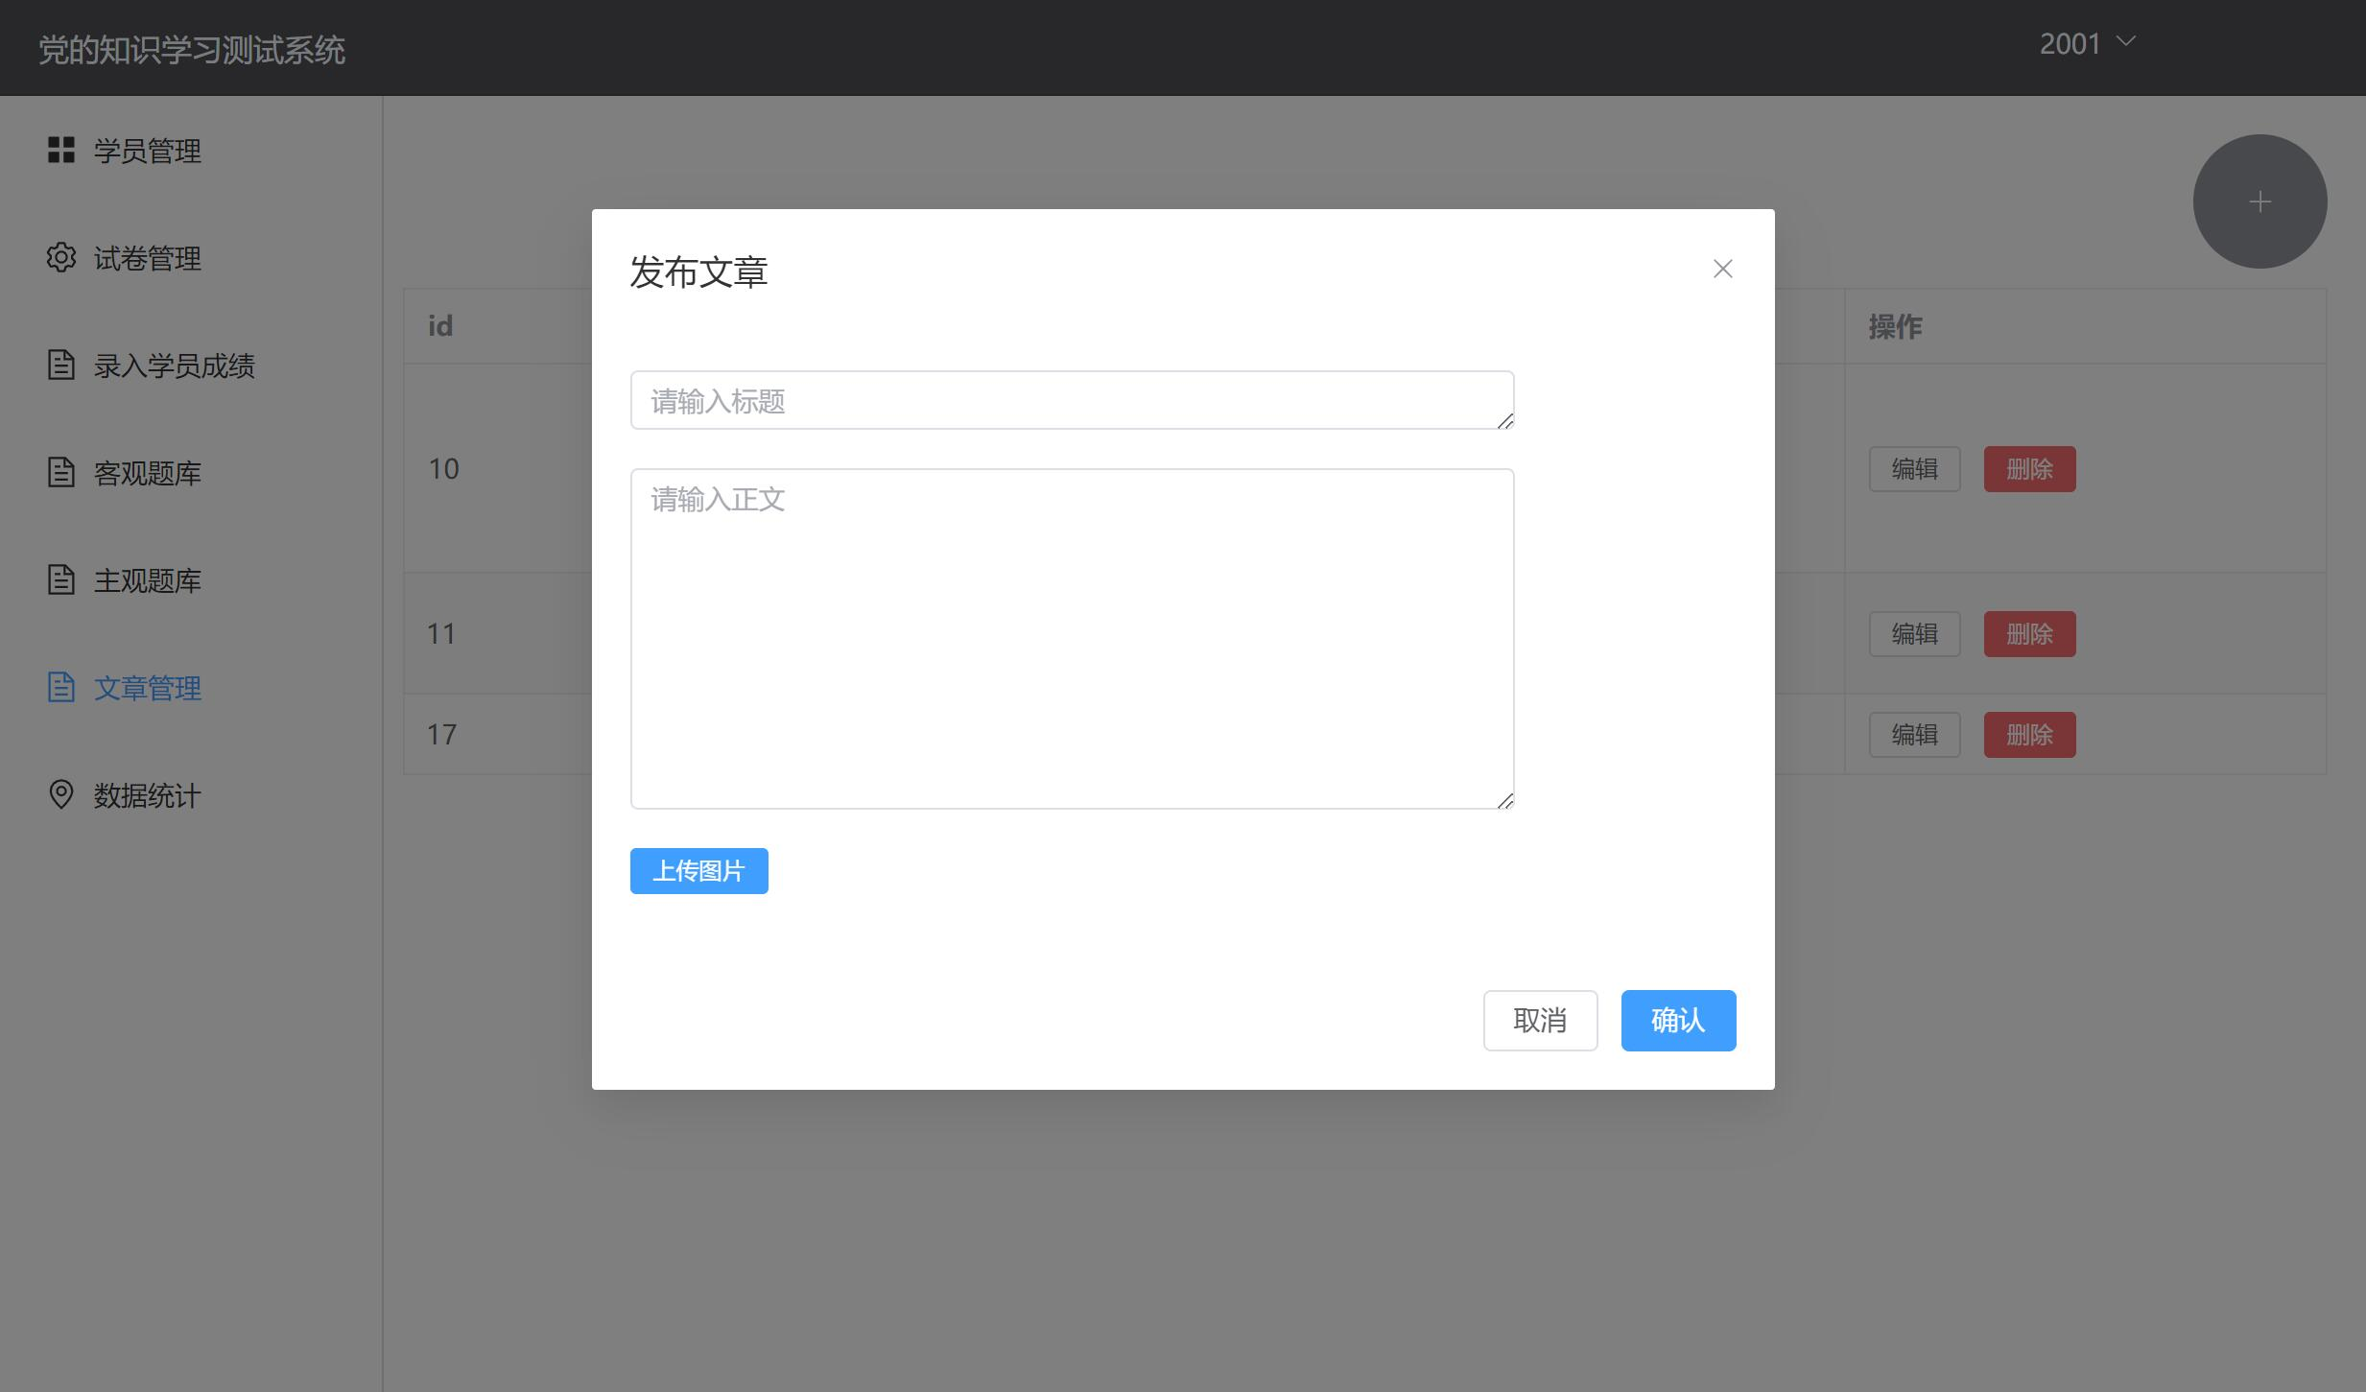
Fig 9. Article editing page
(3) To view the profile of students of the school the faculty user affiliates with, click the Student Management label. The users can check the details of examinations each student has taken. To manage students in this system, faculty users can add new entries, edit current entries, and delete any of them.
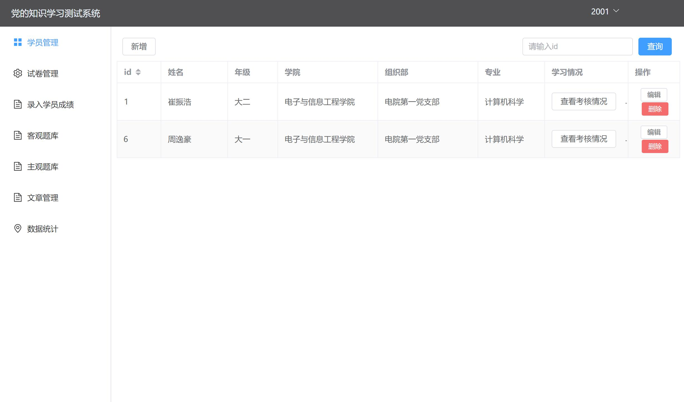
Fig 10. Student management page
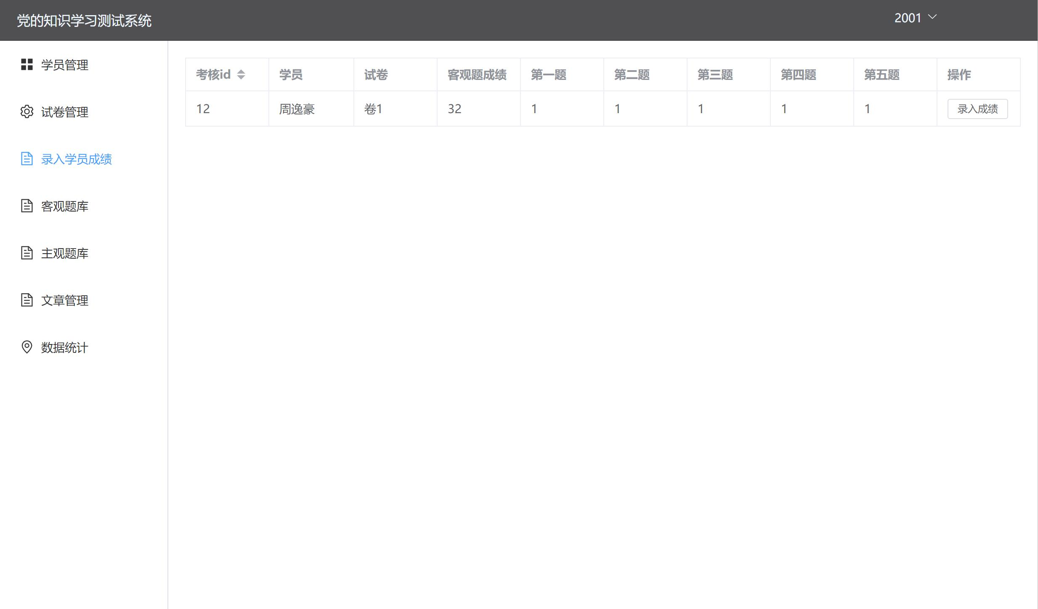
Fig 11. Student grades page
(4) To view and edit the question database, click the Subjective Question Database and the Objective Question Database labels. The description, choice, and answer to each question are in the database table. Faculty users can add new entries, edit current entries, and delete any of them to modify the database.
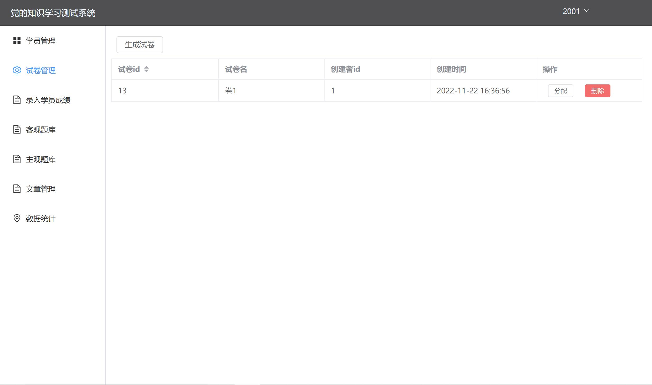
Fig 12. Paper management page
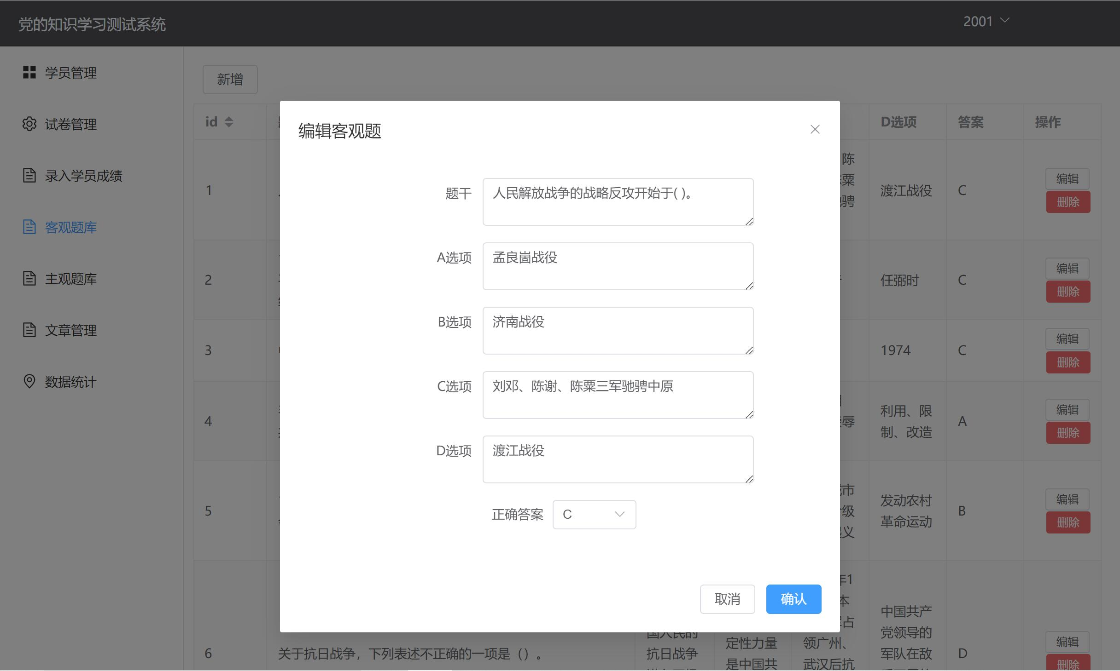
Fig 13. Question editing page
(5) Click the Statistics label to view details of the completion of examinations by students in each school.
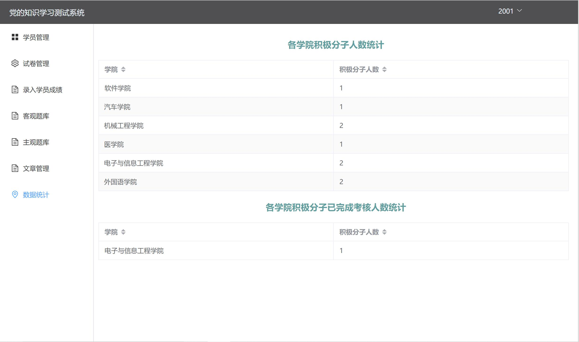
Fig 14. Statistics page

Part III. Sample Scenarios for Administrators
(1) The log-in page, the student management page, the question database management page, and the statistic page are the same as that used by faculty users.

(2) To manage the faculty of each school, click the Organization Management label on the left. Administrator users can view their party branch, school, and other information. The system also provides functionalities for adding, editing, and modifying entries.
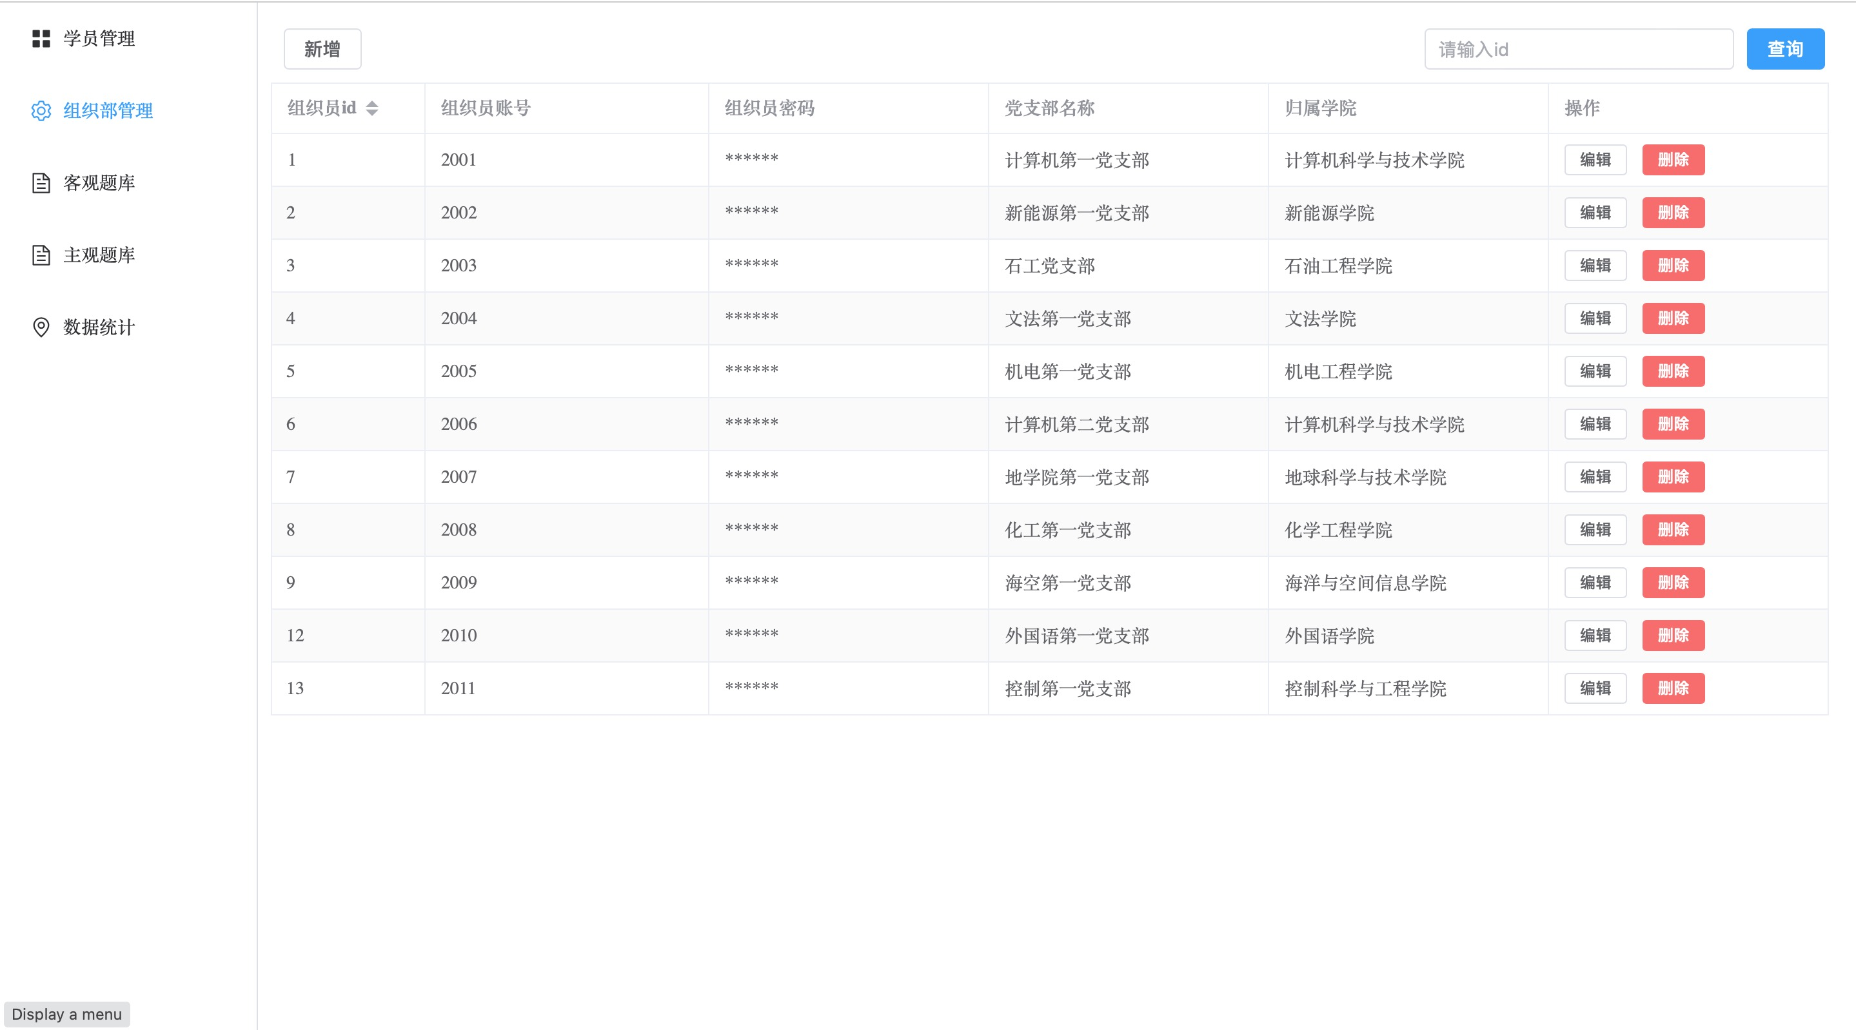
Fig 15. Faculty management page

C.System Architecture and Component Design

System Architecture Introduction
This system is based on Vue, SpringBoot, MySQL, and Java language.
The front-end of the web application is built using Vue and elementUI, and it is responsible for rendering the user interface and handling user input.
The Vue-router library is used to handle routing and page navigation within the application.
The Axios library is used to handle communication between the front-end and back-end of the application.
The back-end of the web application is developed using SpringBoot, and it is responsible for implementing the business logic of the application and for managing the storage and retrieval of data from the database.
The database tier is implemented using MySQL, and it is responsible for managing the storage, retrieval, and manipulation of data in the application.
Overall, the system's architecture is a multi-tiered web application that consists of a front-end built using Vue and elementUI, a back-end developed using SpringBoot and Java, and a database implemented using MySQL. The various components of the application are designed to work together to provide a scalable and maintainable web application.
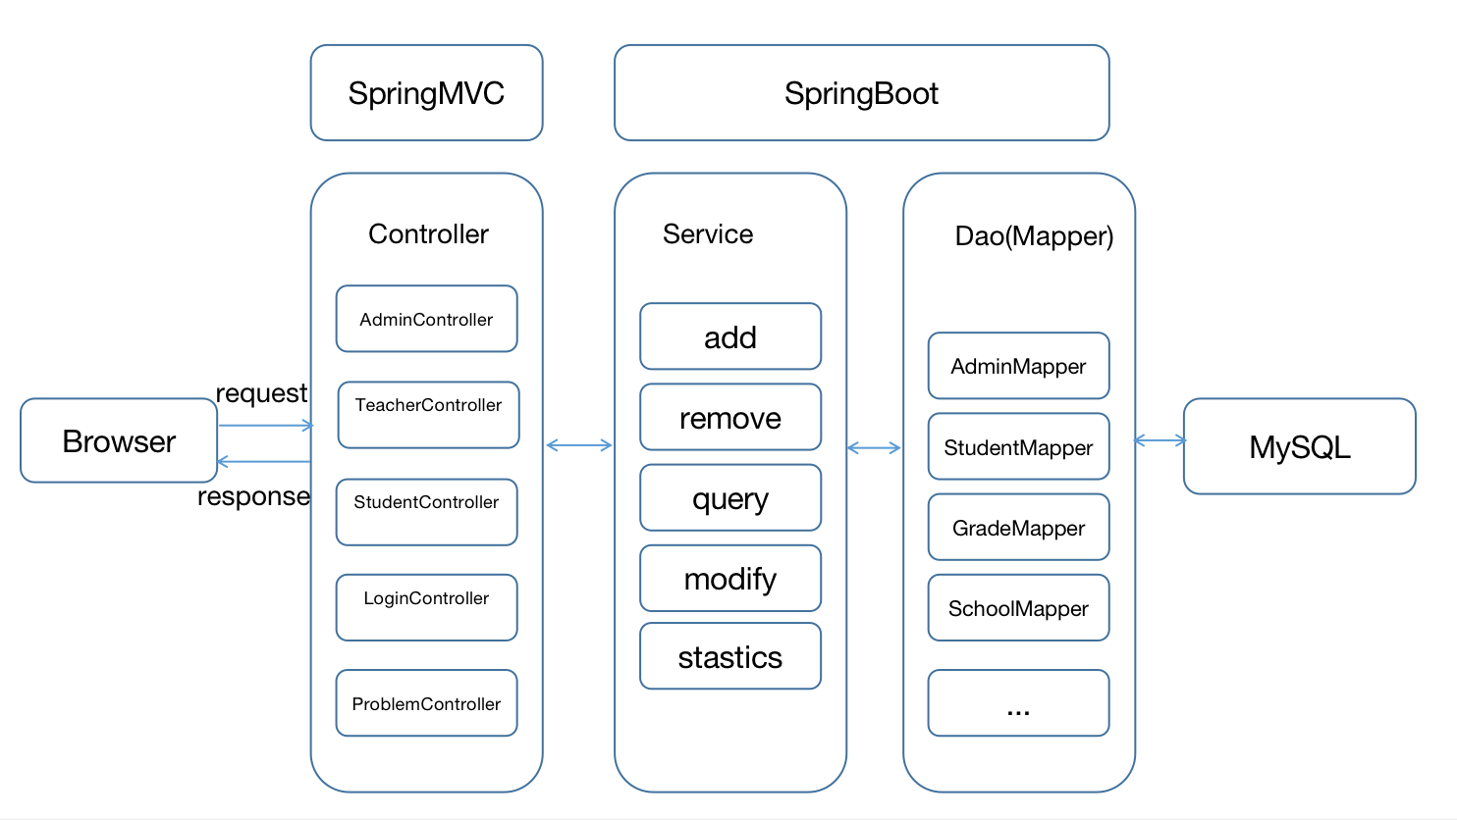
Fig 16. System architecture

(2) Component Design Introduction
This multi-tiered web application based on the Java EE platform consists of four main components: the presentation tier, the business logic tier, the data storage tier, and the database tier.
The presentation tier, also known as the client tier, is the front-end of the web application. This is the part of the application that users interact with directly through their web browser. The presentation tier is responsible for rendering the user interface and for handling user input.
The business logic tier, also known as the middle tier or the application tier, is the part of the application that implements the business logic of the application. This is where the core functionality of the application is implemented.
The data storage tier is the part of the application that manages the storage and retrieval of data from the database. This tier typically consists of components such as Entity Beans, which represent data objects in the application, and Data Access Objects (DAOs), which are used to interact with the database.
The database tier is the lowest level of the application, and it consists of the database management system (DBMS) and the actual data stored in the database. The database tier is responsible for managing the storage, retrieval, and manipulation of data.
These different components are typically designed to work together to provide a seamless and scalable web application. The various components are typically designed to be modular and reusable, allowing developers to easily modify and extend the application as needed.

D.Database Design
The ER Diagram of this system is as shown in Fig 17.
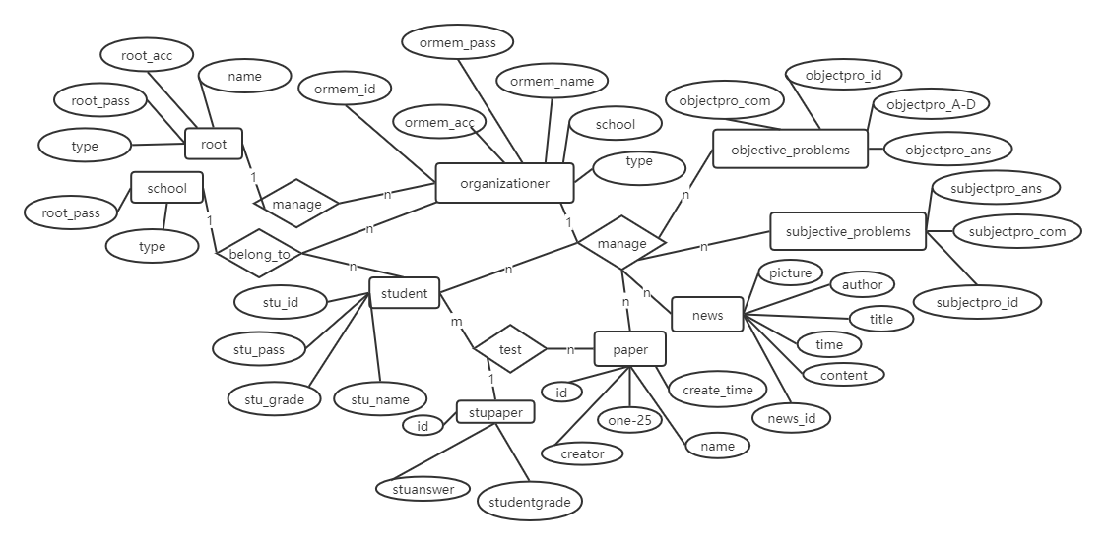
Fig 17. ER Diagram
- Administrator(Account, Password, Type, Name)
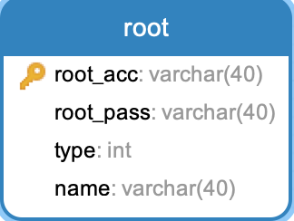
b. Student(ID, Password, Name, Grade, School, Organization, Major, Type, Phone)
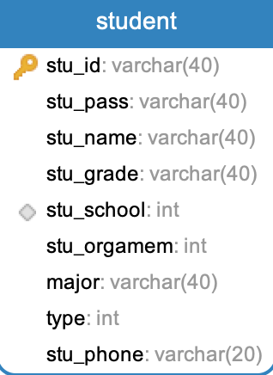
c. Faculty(ID, Type, Number, Password, Name, School)
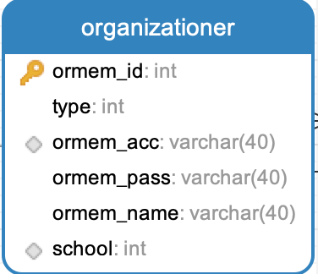
d. Paper(Number, Title, Creator, CreateTime, [Questions])
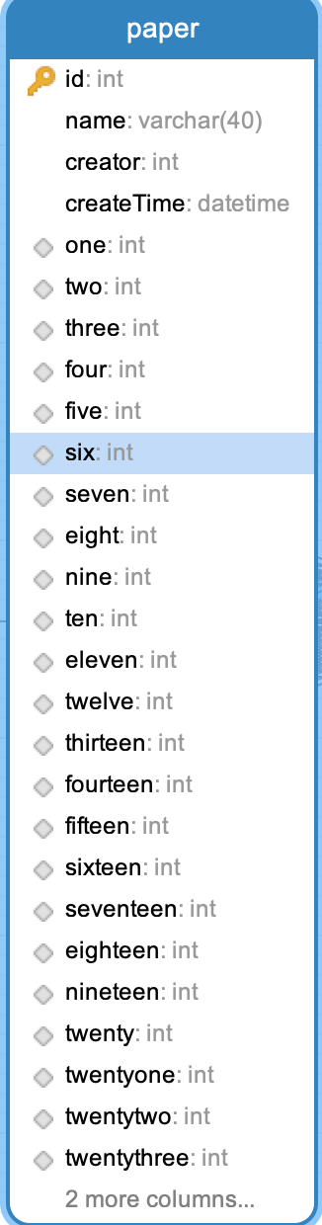
e. School(ID, Name)
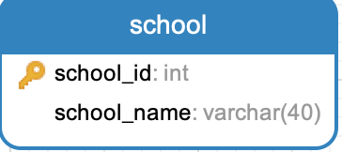
f. ObjectiveQuestion(ID, Description, ChoiceA, ChoiceB, ChoiceC, ChoiceD, CorrectAnswer)
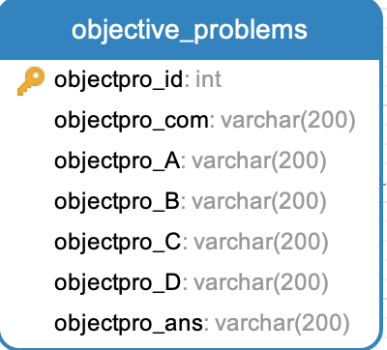
g. SubjectiveQuestion(ID, Description, ReferenceAnswer)
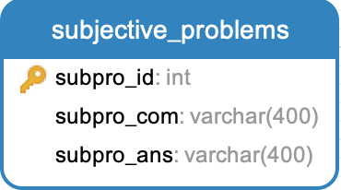
h. PaperGivenStudent(ID, StudentID, PaperID)
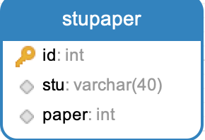

i. StudentAnswer(ID, StudentID, PaperID, ObjectiveQuestionGrade, SubjectiveQuestionGrade, State)
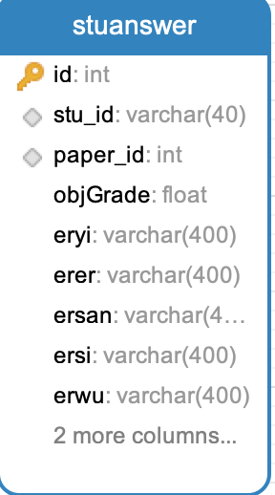
j. Score(Number, StudentNumber, CorrectQuestionNumber, IncorrectQuestionNumber, FacultyNumber, CreationTime)
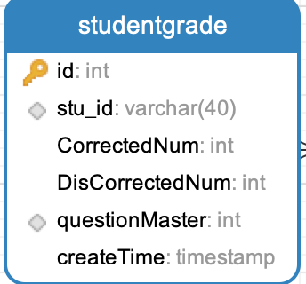
k. News(ID, Picture, Title, Time, Content, Author)
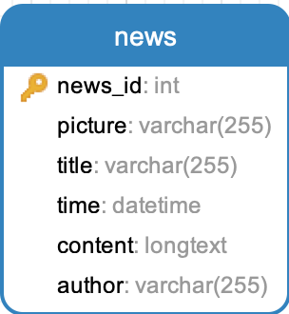

E. Other Technics
The project utilized trigger to implement score calculating, score recoring and many other functionalities.

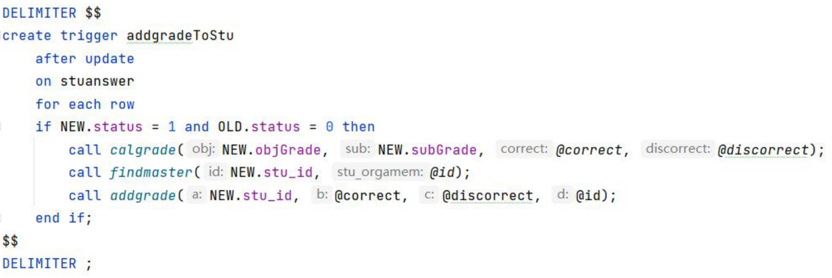
Fig 18. Score entry trigger
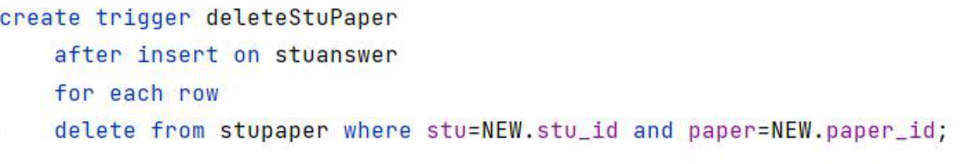
Fig 19. Score deleting trigger

