Data Analysis Report

This report shows some analysis results in the form of tables and charts

It is designed to give users a brief overview about the dataset

Currently, the following analysis methods are supported, including:

* summary, max, fft, stft, cwt

## Data View

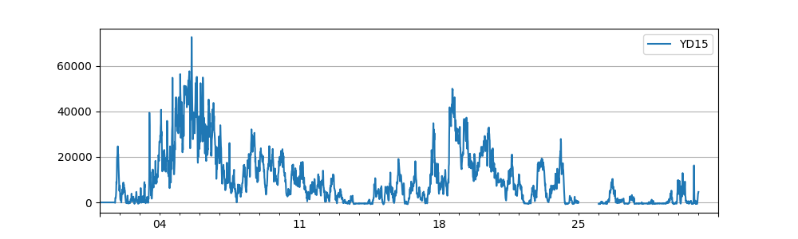

## SUMMARY

Specified statistical indicators, currently support: numbers, mean, variance, minimum, 25% median, 50% median, 75% median, maximum value, missing percentage, stationarity p value

* Analysis Results

|  |  |  |  |  |  |  |  |  |  |
| --- | --- | --- | --- | --- | --- | --- | --- | --- | --- |
|  | YD15 | WINDSPEED | PREPOWER | WINDDIRECTION | TEMPERATURE | HUMIDITY | PRESSURE | ROUND(A.WS,1) | ROUND(A.POWER,0) |
| missing | 0.06418010752688172 | 0.03225806451612903 | 0.03225806451612903 | 0.03225806451612903 | 0.03225806451612903 | 0.03225806451612903 | 0.03225806451612903 | 0.06451612903225806 | 0.06451612903225806 |
| count | 2785.0 | 2880.0 | 2880.0 | 2880.0 | 2880.0 | 2880.0 | 2880.0 | 2784.0 | 2784.0 |
| mean | 9884.635906642729 | 5.493645833333334 | 9637.794652777779 | 196.83263888888888 | 28.619826388888892 | 81.36319444444445 | 1002.8920138888889 | 4.600862068965517 | 10798.044181034482 |
| std | 11827.093086955194 | 2.0540451975938234 | 8863.131911264614 | 52.42764190072575 | 2.8425131800225225 | 12.870883352786588 | 1.8558148450081349 | 1.9471602299773247 | 12237.545329733932 |
| min | -852.0 | 0.3 | 0.0 | 0.0 | 23.7 | 49.0 | 999.0 | 0.6 | -383.0 |
| 25% | 440.0 | 4.1 | 2414.4249999999997 | 200.0 | 26.3 | 71.0 | 1002.0 | 3.0 | 1115.75 |
| 50% | 6010.0 | 5.6 | 6687.85 | 210.0 | 27.8 | 85.0 | 1003.0 | 4.6 | 6913.0 |
| 75% | 15034.0 | 6.9 | 14437.474999999999 | 222.0 | 30.8 | 93.0 | 1004.0 | 5.9 | 15962.5 |
| max | 72719.0 | 11.0 | 37420.5 | 358.0 | 36.0 | 99.0 | 1008.0 | 13.5 | 79817.0 |