# 一、agent模块命令行参数设置

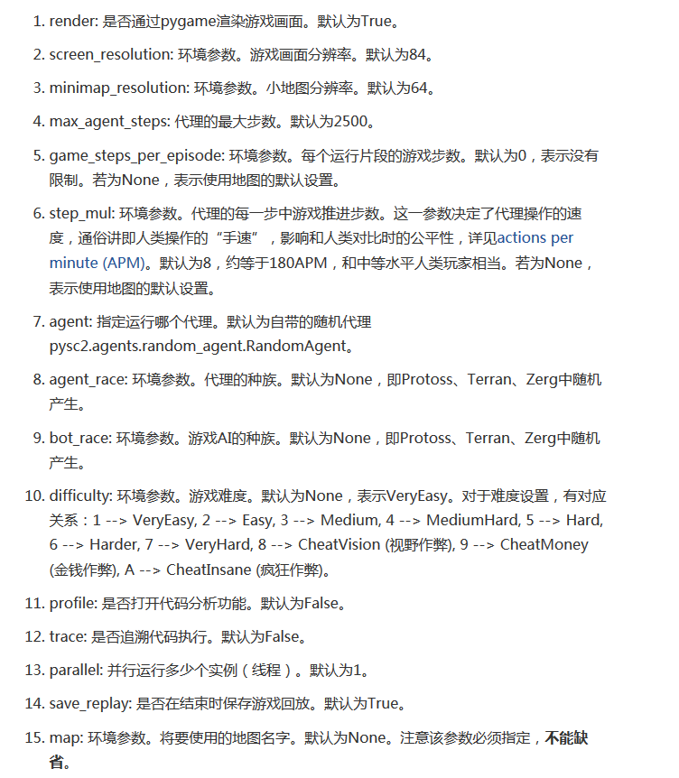

运行Examples:

python -m pysc2.bin.agent --agent pysc2.agents.random_agent.RandomAgent --agent_race T –-bot_race T --map DefeatRoaches –difficulty 1

python -m pysc2.bin.play --map DefeatRoaches --save_replay False

python -m pysc2.bin.agent --agent pysc2.agents.test.test_multi_agent.RandomAgent --map DefeatZerglingsAndBanelings --difficulty 1 --save_replay False

python -m pysc2.bin.agent --agent pysc2.agents.test.test_multi_agent.RandomAgent --map DefeatRoaches --difficulty 1 --save_replay False

python -m pysc2.bin.agent --agent pysc2.agents.test.test_multi_agent.ControllAgents --map DefeatRoaches --difficulty 1 --save_replay False

python -m pysc2.bin.agent --agent pysc2.agents.test.select_unit.ControllUnits --map DefeatRoaches --difficulty 1 --save_replay False

# 自己玩的代码

python -m pysc2.bin.play --map DefeatRoaches --bot_race T --difficulty 1 --save_replay false

# 二、maps 可以自己添加定制地图

maps 模块下

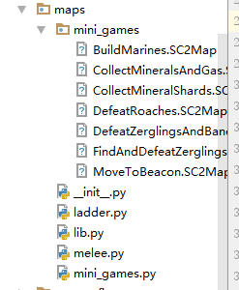

# 三、多agent环境尝试

1. 环境观测量

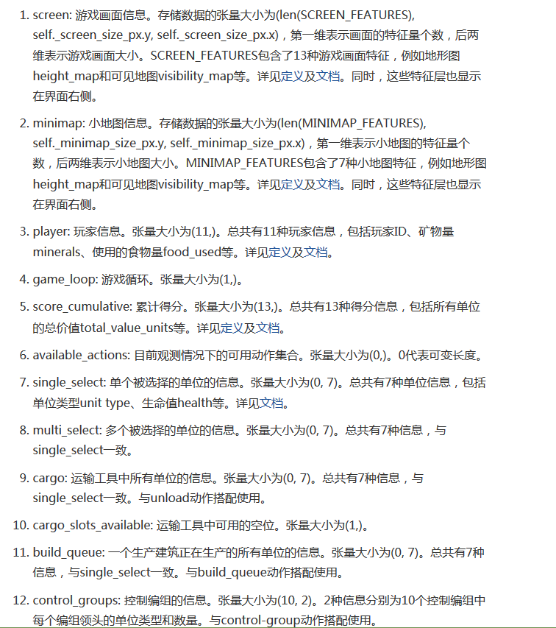

1. Timesteps

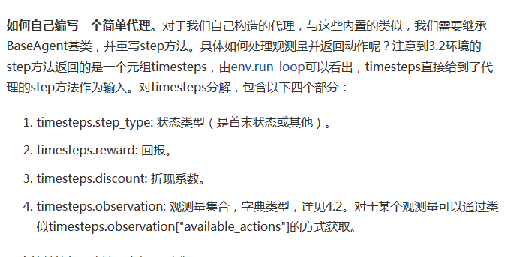

**12 种Observations:**

observations:  
**TimeStep**(step_type=<StepType.FIRST: 0>, **reward**=0, discount=1.0,  
observation={  
**'player'**: array([1, 0, 0, 9, 0, 9, 0, 0, 9, 0, 0]),

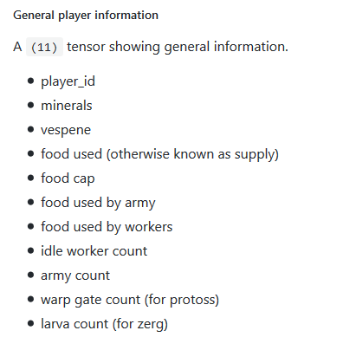

  
**'multi_select':** array(  
[  
 [48, 1, 45, 0, 0, 0, 0],  
 [48, 1, 45, 0, 0, 0, 0],  
 [48, 1, 45, 0, 0, 0, 0],  
 [48, 1, 45, 0, 0, 0, 0],  
 [48, 1, 45, 0, 0, 0, 0],  
 [48, 1, 45, 0, 0, 0, 0],  
 [48, 1, 45, 0, 0, 0, 0],  
 [48, 1, 45, 0, 0, 0, 0],  
 [48, 1, 45, 0, 0, 0, 0]  
]),



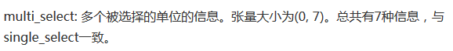  
**'game_loop':** array([8]),

  
**'screen':** array([[[0, 0, 0, ..., 0, 0, 0],  
 [0, 0, 0, ..., 0, 0, 0],  
 [0, 0, 0, ..., 0, 0, 0],  
 ...,  
 [0, 0, 0, ..., 0, 0, 0],  
 [0, 0, 0, ..., 0, 0, 0],  
 [0, 0, 0, ..., 0, 0, 0]],  
  
 [[0, 0, 0, ..., 0, 0, 0],  
 [0, 0, 0, ..., 0, 0, 0],  
 [0, 0, 0, ..., 0, 0, 0],  
 ...,  
 [0, 0, 0, ..., 0, 0, 0],  
 [0, 0, 0, ..., 0, 0, 0],  
 [0, 0, 0, ..., 0, 0, 0]],  
  
 [[0, 0, 0, ..., 0, 0, 0],  
 [0, 0, 0, ..., 0, 0, 0],  
 [0, 0, 0, ..., 0, 0, 0],  
 ...,  
 [0, 0, 0, ..., 0, 0, 0],  
 [0, 0, 0, ..., 0, 0, 0],  
 [0, 0, 0, ..., 0, 0, 0]],  
  
 ...,  
 [[0, 0, 0, ..., 0, 0, 0],  
 [0, 0, 0, ..., 0, 0, 0],  
 [0, 0, 0, ..., 0, 0, 0],  
 ...,  
 [0, 0, 0, ..., 0, 0, 0],  
 [0, 0, 0, ..., 0, 0, 0],  
 [0, 0, 0, ..., 0, 0, 0]],  
  
 [[0, 0, 0, ..., 0, 0, 0],  
 [0, 0, 0, ..., 0, 0, 0],  
 [0, 0, 0, ..., 0, 0, 0],  
 ...,  
 [0, 0, 0, ..., 0, 0, 0],  
 [0, 0, 0, ..., 0, 0, 0],  
 [0, 0, 0, ..., 0, 0, 0]],  
  
 [[0, 0, 0, ..., 0, 0, 0],  
 [0, 0, 0, ..., 0, 0, 0],  
 [0, 0, 0, ..., 0, 0, 0],  
 ...,  
 [0, 0, 0, ..., 0, 0, 0],  
 [0, 0, 0, ..., 0, 0, 0],  
 [0, 0, 0, ..., 0, 0, 0]]]),



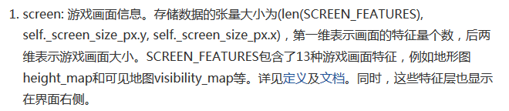  
**'control_groups':**

array([[0, 0],  
 [0, 0],  
 [0, 0],  
 [0, 0],  
 [0, 0],  
 [0, 0],  
 [0, 0],  
 [0, 0],  
 [0, 0],  
 [0, 0]]),

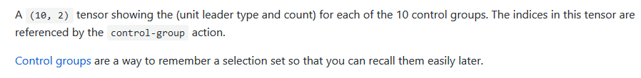

  
**'cargo_slots_available':** array([0]),

  
**'score_cumulative':** array([ 0, 0, 0, 450, 0, 0, 0, 0, 0, 0, 0, 0, 0]),

  
**'available_actions':**  
 array([ 0, 1, 2, 3, 4, 5, 453, 7, 451, 452, 331, 332, 333,  
 334, 12, 13, 274]),



  
**'cargo':** array([], shape=(0, 7), dtype=int32),



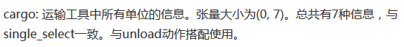  
**'minimap':** array([[[0, 0, 0, ..., 0, 0, 0],  
 [0, 0, 0, ..., 0, 0, 0],  
 [0, 0, 0, ..., 0, 0, 0],  
 ...,  
 [0, 0, 0, ..., 0, 0, 0],  
 [0, 0, 0, ..., 0, 0, 0],  
 [0, 0, 0, ..., 0, 0, 0]],  
  
 [[0, 0, 0, ..., 0, 0, 0],  
 [0, 0, 0, ..., 0, 0, 0],  
 [0, 0, 0, ..., 0, 0, 0],  
 ...,  
 [0, 0, 0, ..., 0, 0, 0],  
 [0, 0, 0, ..., 0, 0, 0],  
 [0, 0, 0, ..., 0, 0, 0]],  
  
 [[0, 0, 0, ..., 0, 0, 0],  
 [0, 0, 0, ..., 0, 0, 0],  
 [0, 0, 0, ..., 0, 0, 0],  
 ...,  
 [0, 0, 0, ..., 0, 0, 0],  
 [0, 0, 0, ..., 0, 0, 0],  
 [0, 0, 0, ..., 0, 0, 0]],  
  
 ...,  
 [[0, 0, 0, ..., 0, 0, 0],  
 [0, 0, 0, ..., 0, 0, 0],  
 [0, 0, 0, ..., 0, 0, 0],  
 ...,  
 [0, 0, 0, ..., 0, 0, 0],  
 [0, 0, 0, ..., 0, 0, 0],  
 [0, 0, 0, ..., 0, 0, 0]],  
  
 [[0, 0, 0, ..., 0, 0, 0],  
 [0, 0, 0, ..., 0, 0, 0],  
 [0, 0, 0, ..., 0, 0, 0],  
 ...,  
 [0, 0, 0, ..., 0, 0, 0],  
 [0, 0, 0, ..., 0, 0, 0],  
 [0, 0, 0, ..., 0, 0, 0]],  
  
 [[0, 0, 0, ..., 0, 0, 0],  
 [0, 0, 0, ..., 0, 0, 0],  
 [0, 0, 0, ..., 0, 0, 0],  
 ...,  
 [0, 0, 0, ..., 0, 0, 0],  
 [0, 0, 0, ..., 0, 0, 0],  
 [0, 0, 0, ..., 0, 0, 0]]]),

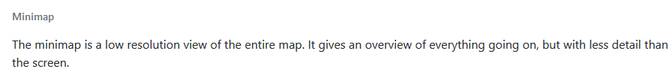

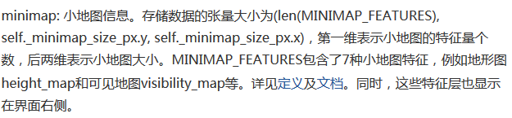  
**'build_queue':** array([], shape=(0, 7), dtype=int32),





**'single_select'**: array([[0, 0, 0, 0, 0, 0, 0]])})

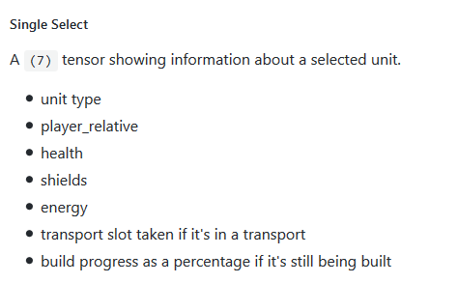



1. 动作函数
2. 参数类型

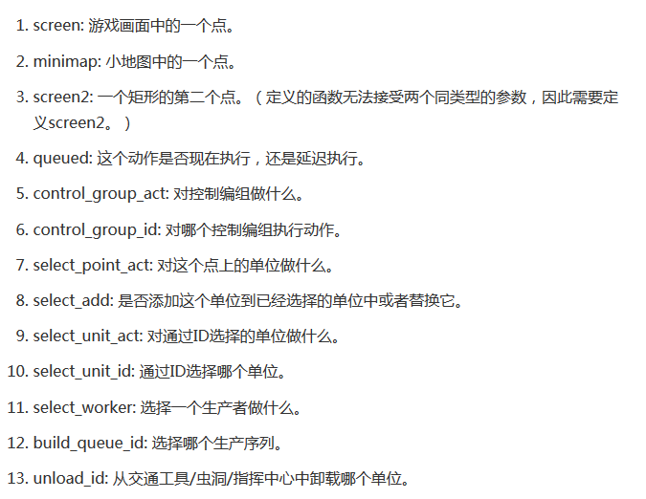

1. 例如：初始化时，可选动作集合：

*[ 0 1 2 3 4 5 453 7 451 452 331 332 333 334 12 13 274]*

[ 0 1 2 3 4 5 453 7 451 452 331 332 333 334 12 13 274]

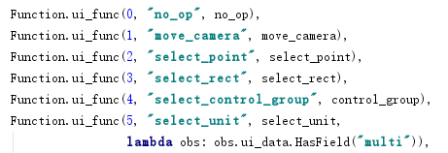

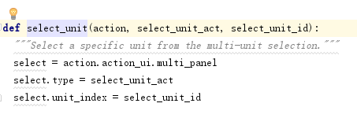







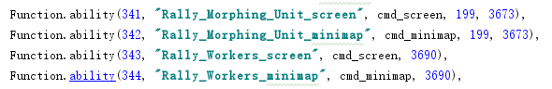





1. 如何根据ID控制每个单位？

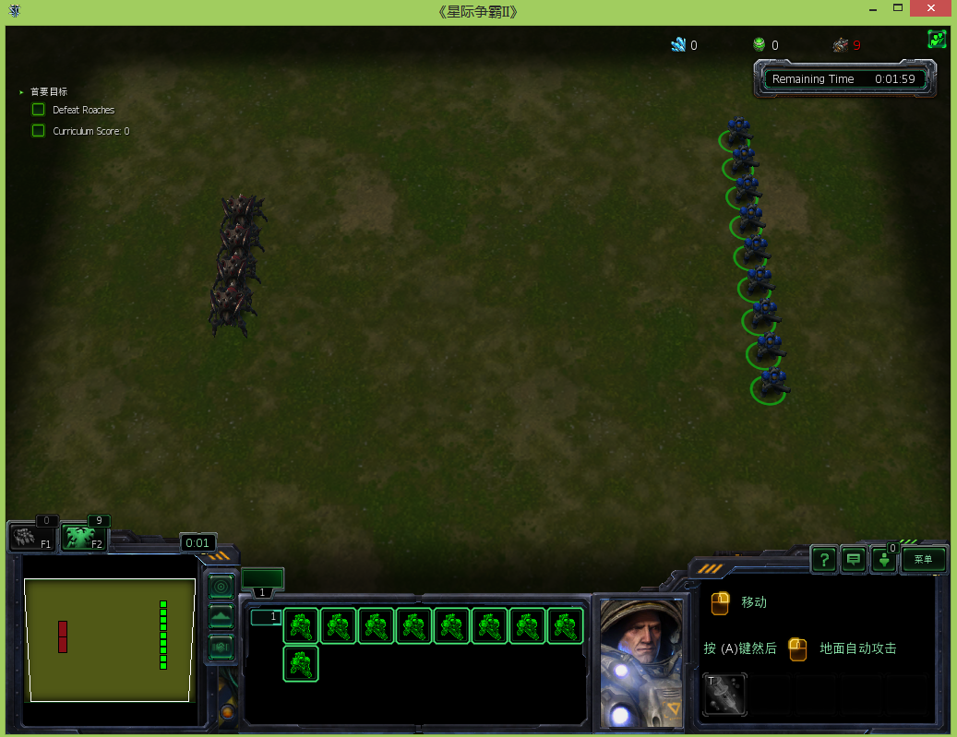

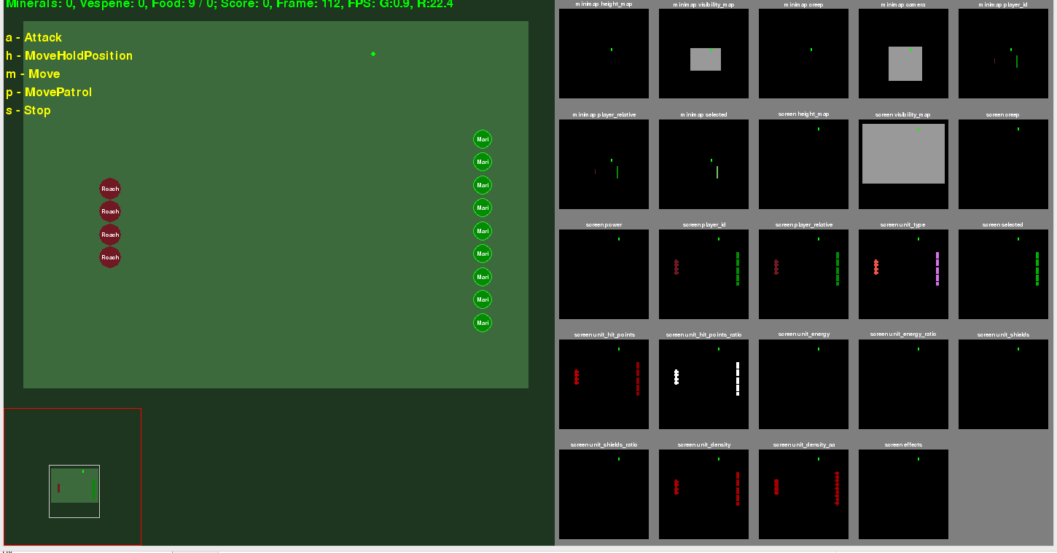

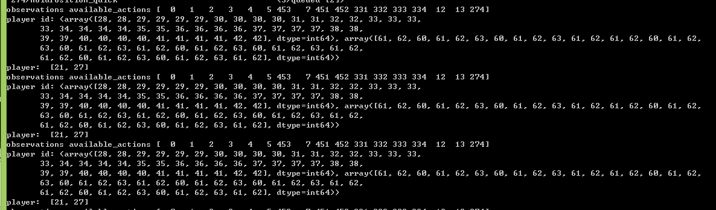

python -m pysc2.bin.agent --agent pysc2.agents.random_agent.RandomAgent --agent_race T –bot_race T --map DefeatRoaches –difficulty 1

# 四、环境探索

1. Game speed：

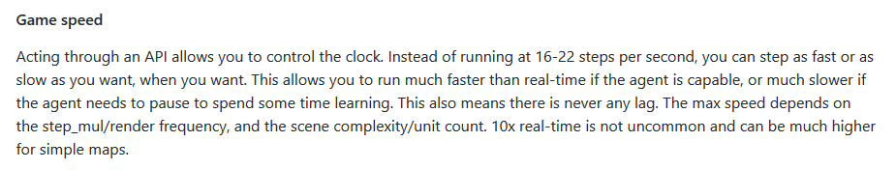

1. S2client-api：sc2-unit

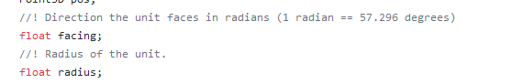

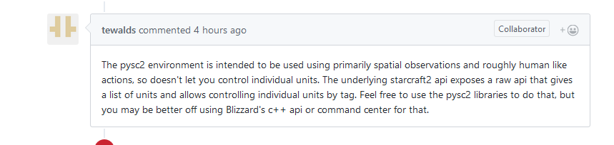

1. Input pre processing
2. 修改 print

Sc2env 249,388行



