Tess Julien

Professor Urness

CS 147

9 October 2018

Assignment 6 Written Responses

1. Gouraud vs Phong shading
   1. Gouraud shading approximates the normal vector at the vertices by normalizing the average of the normal of the polygons that share each vertex. It applies the lighting model to the vertices and calculates the intensity of each vertex. The intensity is calculated for edge pixels and is interpolated for interior pixels. The colors is interpolated for the interior pixels of the polygons. Gouraud shading is implemented in the vertex shader. Gouraud shading can miss specular highlights, so Phong shading can be used instead.
   2. Phong shading calculates the normal at each vertex. It interpolates normal vectors for the interior points of the polygons. The lighting equation is applied to each pixel. Phong shading is implemented in the fragment shader.

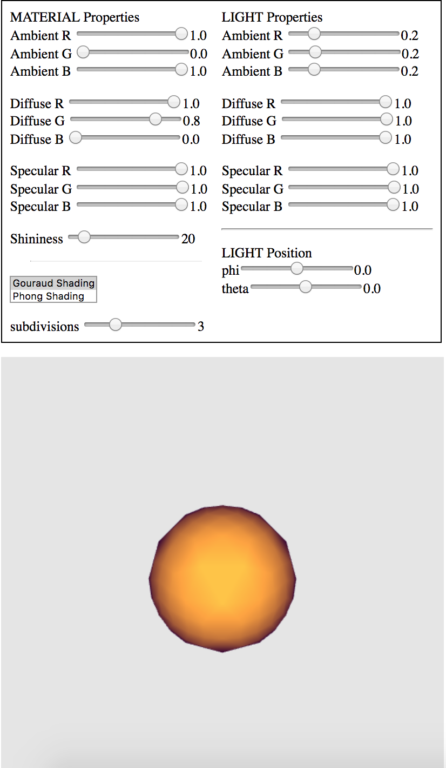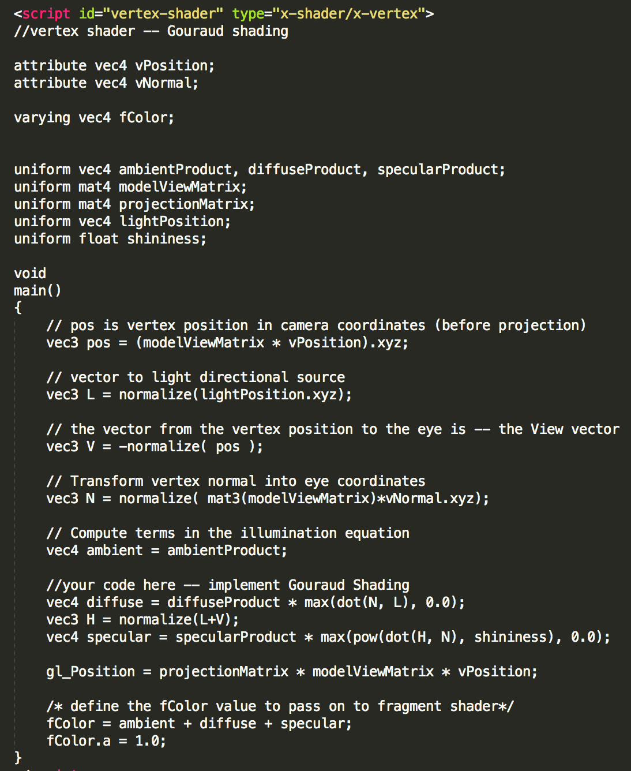

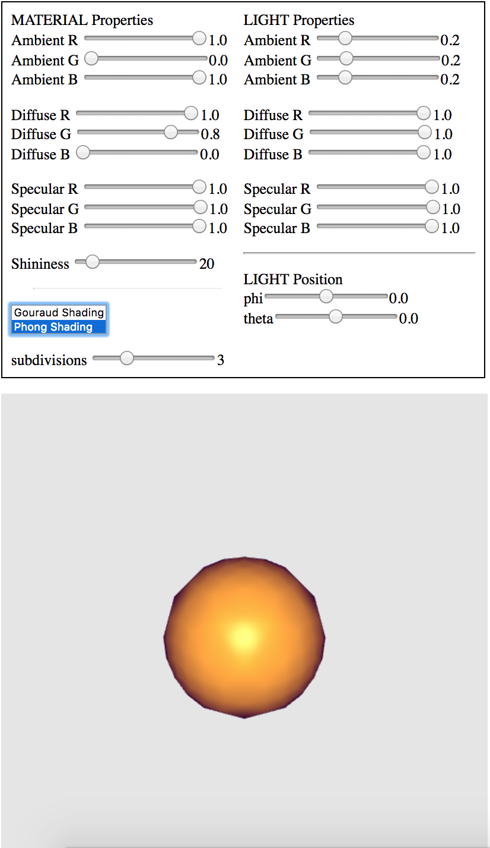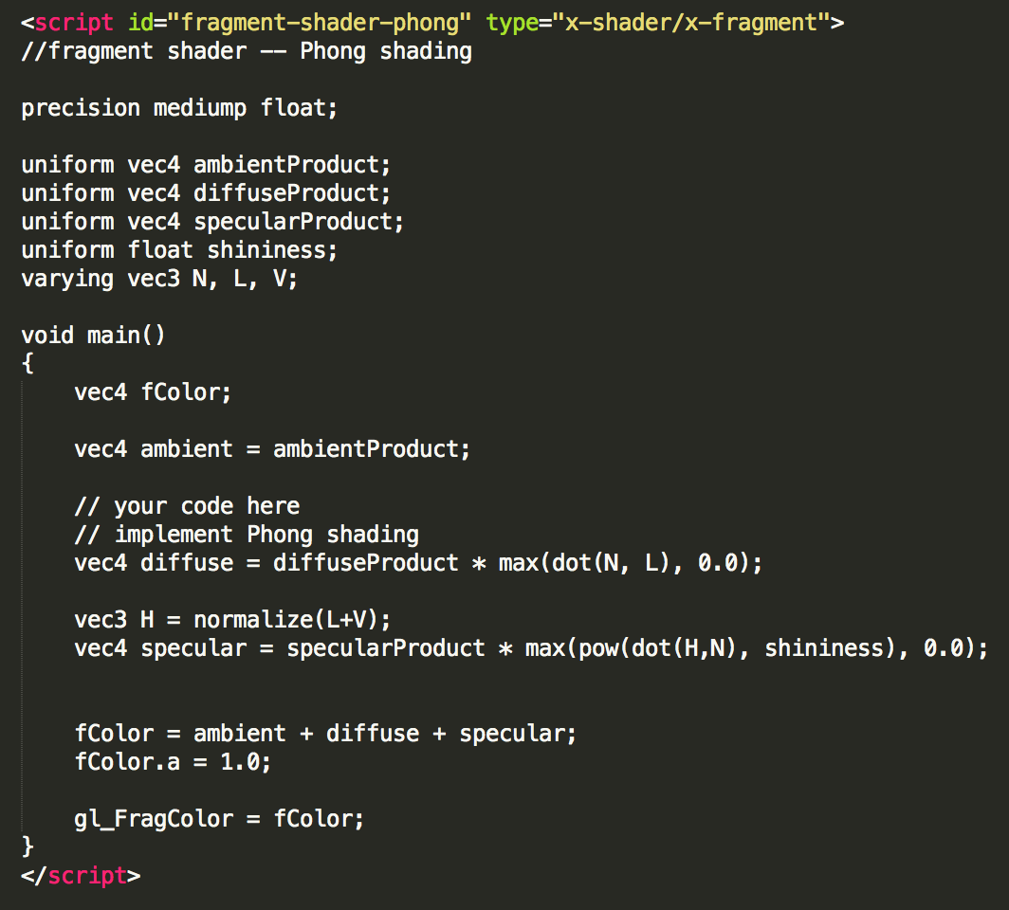

1. Non-physical components of the Phong Reflection Model
   1. Ambient Uniform
      1. Ambient represents the light reflected onto an object’s surface from surrounding objects. The ambient uniform is used because calculating the ambient light based on the light source and the reflections from other surfaces would be very computationally expensive. The ambient light uniform sets a consistent light level based on the light reflected from other objects.
   2. Diffuse reflection approximation
      1. Perfect diffuse reflection would scatter light equally in all directions. The effect is approximated with Lambert’s law, which says diffuse reflection is proportional to the cosine of the angle between the light source and the surface’s normal vector.
   3. Specular component with halfway vector and shininess coefficient
      1. In reality, materials do not diffuse light uniformly; materials reflect light in ways that make them appear shiny with highlights. Calculating the specular highlights is challenging because specular light is not scattered in a symmetric pattern. Using the light reflection vector to calculate specular reflection would require recalculation at each vertex and thus would be very computationally expensive. Thus, a halfway vector, the vector between the viewer and the light source, is used instead. A shininess coefficient is used to affect the size of the specular highlight.