EES 3310/5310 Lab #3

Exercises with the MODTRAN Model

Thomas Ulrich

Lab: Wed. Jan. 24. Due: Wed. Jan. 31

Table of Contents

Fill in R code for the exercises (I have put the comment # TODO in all of the code chunks where you need to do this) and then fill in the answers where I have marked **Answer:**. Be sure to write explanations of your answer and don’t just put numbers with no text.

## Exercise 4.1: Methane

Methane has a current concentration of 1.7 ppm in the atmosphere and is doubling at a faster rate than CO2.

1. **Would an additional 10 ppm of methane in the atmosphere have a larger or smaller impact on the outgoing IR flux than an additional 10 ppm of CO2 at current concentrations?**

* **Hint:** See the suggestion in the lab-03-instructions document.

#current concentrations  
currentConditions = run_modtran(filename = "currentconditions_modtran")  
  
plot_modtran(modtran_data = currentConditions, descr = "Current Conditons")

## Warning: Using `size` aesthetic for lines was deprecated in ggplot2 3.4.0.  
## ℹ Please use `linewidth` instead.  
## This warning is displayed once every 8 hours.  
## Call `lifecycle::last_lifecycle_warnings()` to see where this warning was  
## generated.

## Warning: The `size` argument of `element_line()` is deprecated as of ggplot2 3.4.0.  
## ℹ Please use the `linewidth` argument instead.  
## This warning is displayed once every 8 hours.  
## Call `lifecycle::last_lifecycle_warnings()` to see where this warning was  
## generated.

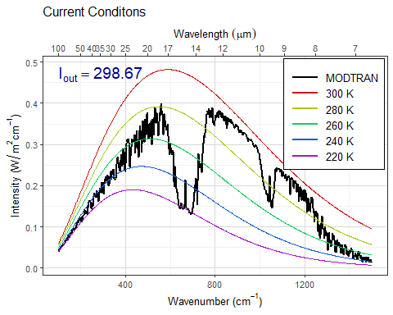

#I_out with current conditions = 298.67  
  
mod_q1ch4 = run_modtran(file.path(data_dir, "modtran_Q1_ch4.txt"), ch4_ppm = 11.7)  
# additional 10 ppm of Methane  
  
mod_q1co2 = run_modtran(file.path(data_dir, "modtran_Q1_co2.txt"), co2_ppm = 410)  
#additional 10 ppm of CO2  
  
plot_modtran(modtran_data = mod_q1ch4, descr = "Methane = 11.7 ppm")

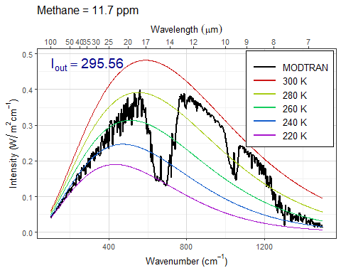

plot_modtran(modtran_data = mod_q1co2, descr = "CO2 = 410 ppm")

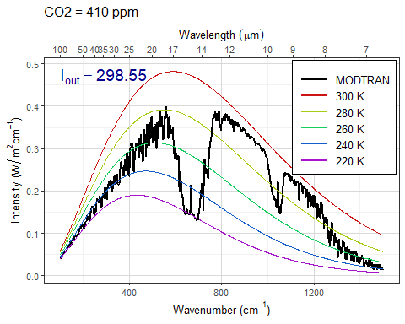

**Answer:** Adding 10 ppm of methane to the atmosphere would have a larger impact on the outgoing infrared radiation than an increase of 10 ppm of CO2. When plotted, the 10 ppm increase in methane would decrease output of Infrared radiation by a value of 3.11, while 10 ppm CO2 increase only decreases it by 0.12.

1. **Where in the spectrum does methane absorb? What concentration does it take to begin to saturate the absorption in this band? Explain what you are looking at to judge when the gas is saturated.**

* **Hints:**  
  See the hints in the lab-03-instructions document.

# TODO  
# Put your R code here

**Answer:** *Put your answer here.* Be sure to show your work and include any data, plots, etc. that you need in order to explain how you came up with your answer.

1. **Would a doubling of methane have as great an impact on the heat balance as a doubling of CO2?**

* **Hint:** See the suggestion in the lab-03-instructions document.

# TODO  
# Put your R code here

**Answer:** *Put your answer here.* Be sure to show your work and include any data, plots, etc. that you need in order to explain how you came up with your answer.

1. **What is the “equivalent CO2” of doubling atmospheric methane? That is to say, how many ppm of CO2 would lead to the same change in outgoing IR radiation energy flux as doubling methane? What is the ratio of ppm CO2 change to ppm methane change?**

# TODO  
# Put your R code here

**Answer:** *Put your answer here.* Be sure to show your work and include any data, plots, etc. that you need in order to explain how you came up with your answer.

## Exercise 4.2: CO2 (Graduate students only)

1. **Is the direct effect of increasing CO2 on the energy output at the top of the atmosphere larger in high latitudes or in the tropics?**

* **Hint:** See the hint in the lab-03-instructions document.

# TODO  
# Put your R code here

**Answer:** *Put your answer here.* Be sure to show your work and include any data, plots, etc. that you need in order to explain how you came up with your answer.

1. **Set pCO2 to an absurdly high value of 10,000 ppm. You will see a spike in the CO2 absorption band. What temperature is this light coming from? Where in the atmosphere do you think this comes from?**

* **Now turn on clouds and run the model again. Explain what you see. Why are night-time temperatures warmer when there are clouds?**
* **Hint:** See the hint in the lab-03-instructions document and for the second part of this exercise, try using “altostratus” clouds.

# TODO  
# Put your R code here

**Answer:** *Put your answer here.* Be sure to show your work and include any data, plots, etc. that you need in order to explain how you came up with your answer.

## Exercise 4.3: Water vapor

Our theory of climate presumes that an increase in the temperature at ground level will lead to an increase in the outgoing IR energy flux at the top of the atmosphere.

1. **How much extra outgoing IR would you get by raising the temperature of the ground by 5°C? What effect does the ground temperature have on the shape of the outgoing IR spectrum and why?**

* **Hint:** See the hint in the lab-03-instructions document.

# TODO  
# Put your R code here

**Answer:** *Put your answer here.* Be sure to show your work and include any data, plots, etc. that you need in order to explain how you came up with your answer.

1. **More water can evaporate into warm air than into cool air. Change the model settings to hold the water vapor at constant relative humidity rather than constant vapor pressure (the default), calculate the change in outgoing IR energy flux for a 5°C temperature increase. Is it higher or lower? Does water vapor make the Earth more sensitive to CO2 increases or less sensitive?**

* **Note:** By default, the MODTRAM model holds water vapor pressure constant, but you can set it to hold relative humidity constant instead with the option h2o_fixed = "relative humidity", like this: run_modtran(file_name, delta_t = 5, h2o_fixed = "relative humidity").

# TODO  
# Put your R code here

**Answer:** *Put your answer here.* Be sure to show your work and include any data, plots, etc. that you need in order to explain how you came up with your answer.

1. **Now see this effect in another way.**
   * **Starting from the default base case, record the total outgoing IR flux.**
   * **Now double CO2. The temperature in the model stays the same (that’s how the model is written), but the outgoing IR flux goes down.**
   * **Using constant water vapor pressure, adjust the temperature offset until you get the original IR flux back again. Record the change in temperature.**
   * **Now repeat the exercise, but holding the relative humidity fixed instead of the water vapor pressure.**
   * **The ratio of the warming when you hold relative humidity fixed to the warming when you hold water vapor pressure fixed is the feedback factor for water vapor. What is it?**

# TODO  
# Put your R code here

**Answer:** *Put your answer here.* Be sure to show your work and include any data, plots, etc. that you need in order to explain how you came up with your answer.