实验报告
实验第 2 课：题目：设计基于51的数码管控制电路
学号 | 202441401033 | 班级 | 2024级
姓名 | 唐俊 | 团队or个人 | 个人
电路图（并对其中元器件进行标注） | 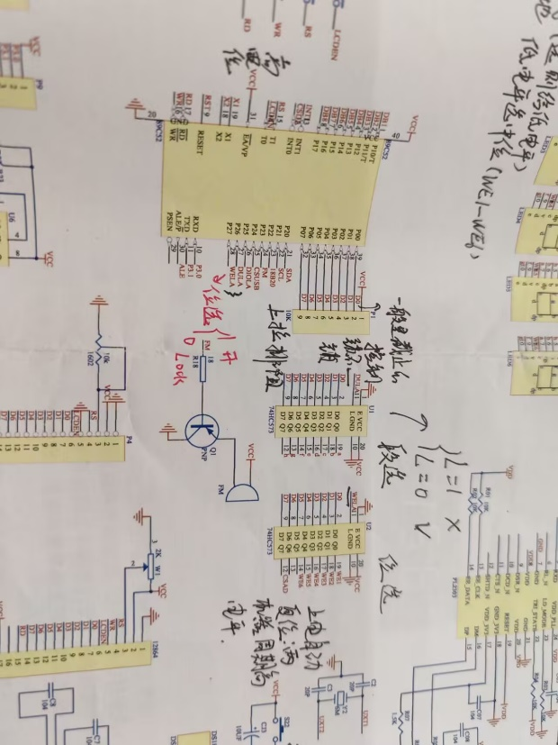
实验一：难度：简单
实验目标 | - 选择任意相邻四个数码管,动态显示你生日的 月与日，例如12月3日“1203”。  - 文字显示延迟 delay：500ms-100ms-10ms-1ms的区别。  - 延迟为多少时显示稳定。
实验代码 并对难点进行标注 | #include<reg52.h>  #define uchar unsigned char  #define uint unsigned int  sbit dl = P2^6;  sbit wl = P2^7;  uchar code table[] = {0x3f, 0x06, 0x5b, 0x4f,  0x66, 0x6d, 0x7d, 0x07,  0x7f, 0x6f, 0x77, 0x7c,  0x39, 0x5e, 0x79, 0x71};  void delayms(uint);  void main()  {  while(1)  {  dl = 1;  P0 = table[0];  dl = 0;  P0 = 0xff;  wl = 1;  P0 = 0xfe;  wl = 0;  delayms(500);  dl = 1;  P0 = table[9];  dl = 0;  P0 = 0xff;  wl = 1;  P0 = 0xfd;  wl = 0;  delayms(500);  dl = 1;  P0 = table[1];  dl = 0;  P0 = 0xff;  wl = 1;  P0 = 0xfb;  wl = 0;  delayms(500);  dl = 1;  P0 = table[4];  dl = 0;  P0 = 0xff;  wl = 1;  P0 = 0xf7;  wl = 0;  delayms(500);  }  }  void delayms(uint xms)  {  uint i, j;  for(i = xms; i > 0; i--)  for(j = 110; j > 0; j--);  }
实验结果 | 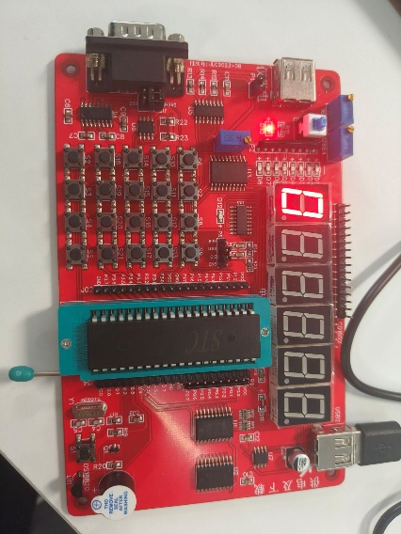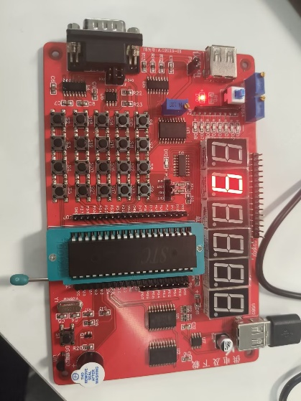  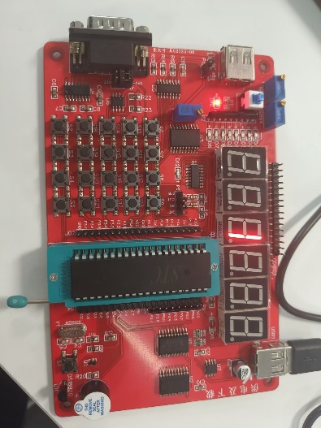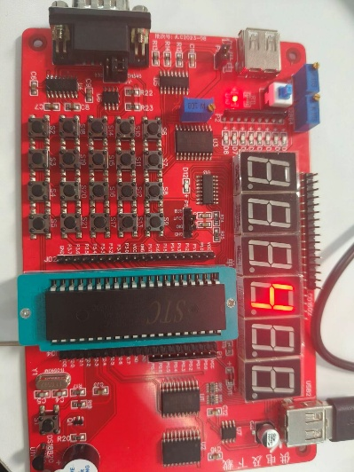  1ms的时候显示稳定
实验二：难度：一般
实验目标 | 1选择任意相邻x个数码管,动态显示任意x个数字，例如生日“12.03”，显示结果如下:1-2-0-3-1203-1-2-0-3-1203-1-2-…,循环显示。 寻找复位按键，长按复位会出现什么？？？
实验代码并对难点进行标注 | #include<reg52.h>  #define uchar unsigned char  #define uint unsigned int  sbit dl = P2^6;  sbit wl = P2^7;  uchar code table[] = {0x3f, 0x06, 0x5b, 0x4f,  0x66, 0x6d, 0x7d, 0x07,  0x7f, 0x6f, 0x77, 0x7c,  0x39, 0x5e, 0x79, 0x71};  void delayms(uint);  void main()  {  uchar i;  while(1)  {  // ????0914  dl = 1;  P0 = table[0];  dl = 0;  P0 = 0xff;  wl = 1;  P0 = 0xfe;  wl = 0;  delayms(500);  dl = 1;  P0 = table[9];  dl = 0;  P0 = 0xff;  wl = 1;  P0 = 0xfd;  wl = 0;  delayms(500);  dl = 1;  P0 = table[1];  dl = 0;  P0 = 0xff;  wl = 1;  P0 = 0xfb;  wl = 0;  delayms(500);  dl = 1;  P0 = table[4];  dl = 0;  P0 = 0xff;  wl = 1;  P0 = 0xf7;  wl = 0;  delayms(500);  // ????0914??  for(i = 0; i < 50; i++)  {  dl = 1;  P0 = table[0];  dl = 0;  P0 = 0xff;  wl = 1;  P0 = 0xfe;  wl = 0;  delayms(5);  dl = 1;  P0 = table[9];  dl = 0;  P0 = 0xff;  wl = 1;  P0 = 0xfd;  wl = 0;  delayms(5);  dl = 1;  P0 = table[1];  dl = 0;  P0 = 0xff;  wl = 1;  P0 = 0xfb;  wl = 0;  delayms(5);  dl = 1;  P0 = table[4];  dl = 0;  P0 = 0xff;  wl = 1;  P0 = 0xf7;  wl = 0;  delayms(5);  }  }  }  void delayms(uint xms)  {  uint i, j;  for(i = xms; i > 0; i--)  for(j = 110; j > 0; j--);  }
实验结果 | 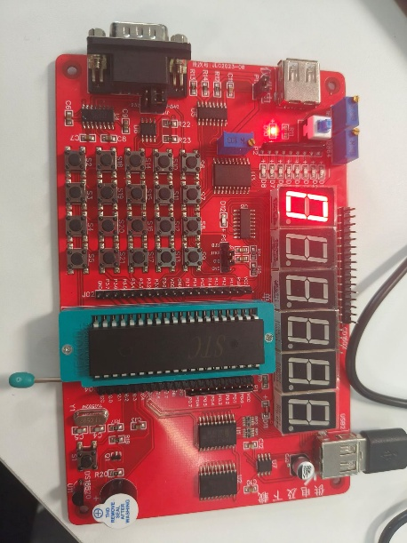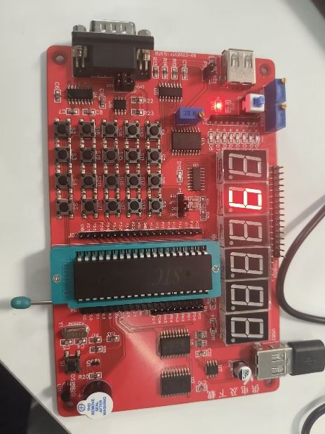  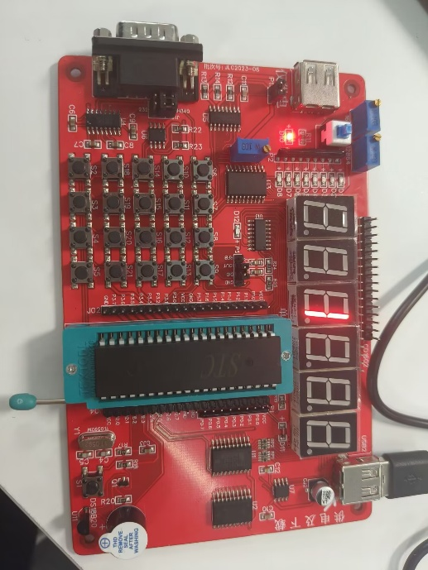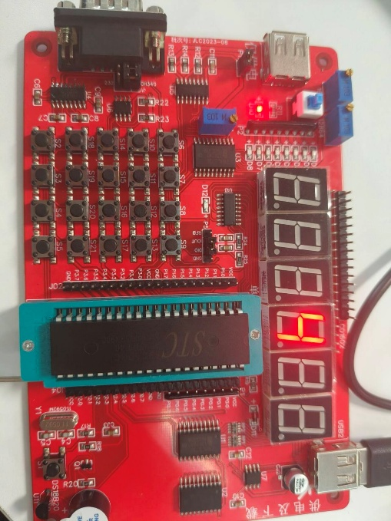  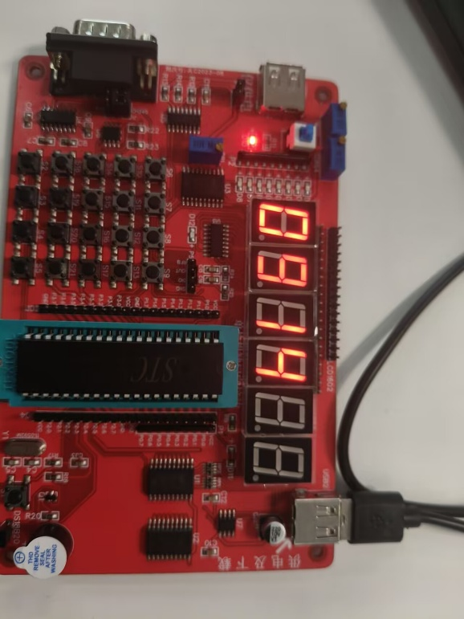  长按复位键，数码管不再显示
实验三：难度：困难
实验目标
实验代码并对难点进行标注
实验结果 | 注：照片及描述
实验总结

