Applications Note
Newick Utilities: high-throughput phylogenetics and tree drawing
Thomas Junier^{1,*} and Evgeny M. Zdobnov¹
¹Department of Genetic Medicine and Development, University of Geneva Medical School, 1 Rue Michel-Servet, 1211 Geneva, Switzerland

Received on XXXXX; revised on XXXXX; accepted on XXXXX

Associate Editor: XXXXXXX

abstract
Summary: The Newick Utilities are a set of Unix command-line programs for working with any number of phylogenetic trees of any size. They aim at automating a range of frequently used tree operations, such as (re)rooting, extracting information (branch lengths, support values, etc), pruning, extracting sub-trees, etc., without user interaction.
Availability and Implementation: C source code is available from http://cegg.unige.ch/newick_utils. The distribution includes a manual and example data. The package is distributed under the GPL.
Contact: thomas.junier@unige.ch
Supplementary Information: Program documentation and examples are available from the above URL.

introduction
Phylogenetics is an essential component of evolutionary biology that summarizes genealogical relationships in the form of trees. Computing and processing single trees of moderate size can be done with user-friendly, interactive programs. However, the age of genomics requires automated mass data processing, be it of large trees (e.g. HIV protease in a whole population of infected patients) or numerous trees (e.g. all 1:1 orthologs in mammals). Automating scaled-up analyses is also essential to avoid human errors.
The ease of automation depends on the type of interface the software offers, and programs that require user interaction are, in general, harder to automate. In addition, constructing computing pipelines requires good interoperation between the (possibly many) programs involved. The ability to read data from standard input and write results on standard output is one way of providing this in a Unix shell environment. Programs that have these properties are termed filters.
Many methods for constructing trees implement a command-line interface (e.g., PhyML (Guindon and Gascuel, 2003)) and thus are easy to automate. The situation is different for tree processing: although there is a large choice of programs for visualizing and/or manipulating trees (e.g. TREEVIEW (Page, 1996), iTOL (Letunic and Bork, 2007)), most have an interactive, graphical interface, which is hard or impossible to automate.
Faced with the need to handle large numbers of trees in automated pipelines, we developed a collection of filters that perform a range of frequently used tree operations (such as (re)rooting, extracting branch lengths, computing support values, pruning, extracting sub-trees, etc.), require no user interaction, and work with any number of trees of any size.

results
We present the Newick Utilities [URL], designed for the automation of a number of tree-processing functions [m.b. not show all of them]:
- nw_clade: extract clades (sub-trees) defined by labels
- nw_condense: simplify trees (e.g. whole clades with the same label)
- nw_distance: extract branch lengths in various ways (from root, from parent, as matrix, etc.)
- nw_display: draw trees as ASCII or SVG (suitable for further edition)
- nw_ed: stream editor: performs operations on matching sub-trees
- nw_indent: show Newick format in indented form
- nw_labels: extract labels (leaf, inner nodes, or both)
- nw_match: reports matches of a tree in a larger tree
- nw_order: order tree nodes (without changing topology)
- nw_prune: discard nodes by label
- nw_rename: rename node labels based on a mapping
- nw_reroot: re-root trees on outgroup, specified by labels
- nw_support: attribute support values to a known tree based on bootstrap replicates
- nw_trim: trims a tree at a certain depth
- nw_topology: extract topological information (by discarding branch length data, etc)

The utilities have the following shared features, many of which are inspired by the “KISS principle” and other “Unix Philosophy” tenets (http://www.faqs.org/docs/artu/ch01s06.html), in view of facilitating automation and interoperability:
- each program performs one function
- no user interaction is required
- the input format is Newick, de facto standard for phylogenetic trees - see http://evolution.genetics.washington.edu/phylip/newicktree.html
- data are read from a file or from standard input; results are written to standard output (no fixed file names)
- there is no limit on the number or size of the input trees.
- all output is plain ASCII text (as Newick trees, ASCII graphics, or SVG);
- all parameters are passed on the command line (no control files)
- all programs are self-documenting (option -h) Example: Bootscanning

A reasonably good performance was one of the goals of this project. To give a rough idea, an SVG image of a 20,000-leaf tree is produced in about 0.5s, re-rooting 900 trees of 17 species takes 0.45 s, and computing bootstrap support for a 35-species tree takes 0.12 s with 1000 replicates (on a 3 GHz Intel Core Duo with 1 Mb RAM running Linux).

Example: Bootscanning

To illustrate interoperation between tree-building applications, Newick Utilities, and various standard shell programs, we show a variant of bootscanning (Salminen, 1995) implemented as a Bash shell script (included in the distribution). The script launches multiple sequence alignment, divides the alignment into evenly-spaced windows (“slices”) of constant size, computes a maximum-likelihood tree for each window, re-roots the trees on the appropriate outgroup, extracts distance information from each tree, and plots the result (figure 1). The whole script is less than 150 lines long (excluding comments).

CONCLUSION

One of the most useful features of Unix shells is the ability to “glue” arbitrary programs together in pipelines or scripts. The Newick Utilities add phylogenetic tree processing capabilities to a shell user's toolkit. Since they have few arbitrary limitations, the utilities can handle large amounts of data; since they are non-interactive, they are easy to automate, and since they are filters, they can easily work with other shell tools.
Funding
This work was supported by the Infectigen Foundation and Swiss National Science Foundation [31003A-125350]
References

Edgar, R.C. (2004) MUSCLE: multiple sequence alignment with high accuracy and high throughput Nucleic Acids Res. 32(5):1792-1797
Guindon, S. and Gascuel, O. (2003) A simple, fast and accurate algorithm to estimate large phylogenies by maximum likelihood. Systematic Biol. 52(5):696-704
Letunic, I. and Bork, P (2007) Interactive Tree Of Life (iTOL): an online tool for phylogenetic tree display and annotation Bioinformatics 23(1):127-128
Page, R. D. M. (1996) TREEVIEW: An application to display phylogenetic trees on personal computers. Computer Applications in the Biosciences 12: 357-358
Rice, P. et al. (2000) EMBOSS: The European Molecular Biology Open Software Suite Trends Genet. 16(6) :276-277
Salminen, M.O. et al. (1995) Identification of breakpoints in intergenotypic recombinants of HIV type 1 by bootscanning. AIDS Res. and Hum. Retrovir. 11:1423-1425

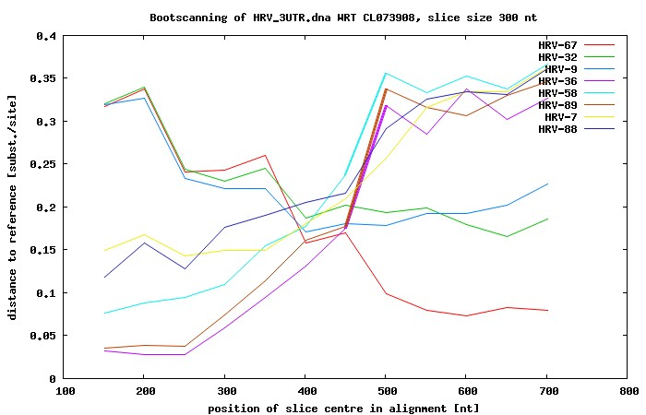
Figure 1: Bootscanning using PhyML, EMBOSS, Muscle, GNUPLOT, Newick Utilities, and standard Unix shell programs. The species with the lowest distance is the reference's nearest neighbor. A recombination breakpoint is predicted near position 450, as the nearest neighbor changes abruptly.

* To whom correspondence should be addressed.

