

Group Members:

|  |  |
| --- | --- |
| **Name** | **TP Number** |
| Teo Jun Jie (Leader) | TP079880 |
| Ng Tian Xin | TP081807 |
| Victor Chia Bing Chen | TP080934 |
| Wong Kelvin | TP081586 |

Module Code: AAPP012-4-2-RWDD

Module Title: Responsive Web Design & Development

Intake Code: UCDF2405ICT(SE)

Assignment Title: TaskFlow (Proposal)

Lecturer: Jeffery Jeselee Sijore

Date Hand Out: Week 3

Date Hand In: Week 5

**TABLE OF CONTENT**

**1.0** **Title of the Website** 3

**2.0 Objectives of the Project** 4

**3.0 Flow Chart** 5

**4.0 Storyboard** 6

**5.0 ERD Diagram** 13

**6.0 Wireframe** 14

**7.0 Navigational Structure** 21

## **Title of the Website**

Figure 1.1 TaskFlow Logo

TaskFlow represents the ideals of creating a system to help and serve the community by aiding them through task management for workflow and productivity increase. TaskFlow focuses on simplicity and efficiency by helping individuals or teams to get work done faster.

## **2.0 Objectives of the Project**

TaskFlow aims to fulfil multiple objectives with its main purpose being to create a positive impact on society. TaskFlow helps by providing:

* Task Management. To give users a seamless way to create, track and prioritize tasks through functionalities like deadlines and reminders.
* Time Tracking. To let users to keep in check of their spent time on different tasks to improve their time efficiency.
* Goal Setting. To help users to set short- or long-term goals for project progress and duration tracking.
* Team Collaborations. To provide users with an easy way to enable task and project sharing between each other, allowing teamwork among members.
* Report Analysis. To give users insights on their productivity by letting them check on parts where they can improve on.
* Responsive Web Design. To make sure that the website is accessible for users on different devices like laptops, desktops or mobile devices.

## **3.0 Flow Chart**

Figure 3.0 Landing Page

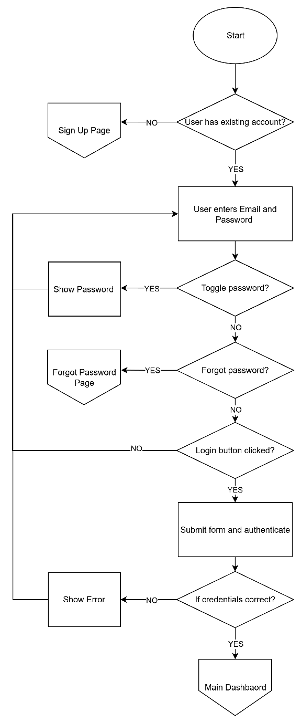

Figure 3.1 Login Page

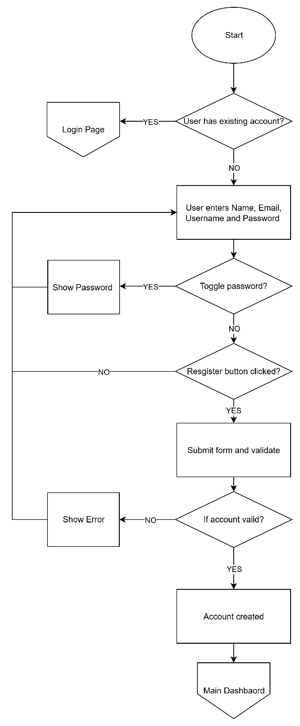

Figure 3.2 Sign Up Page

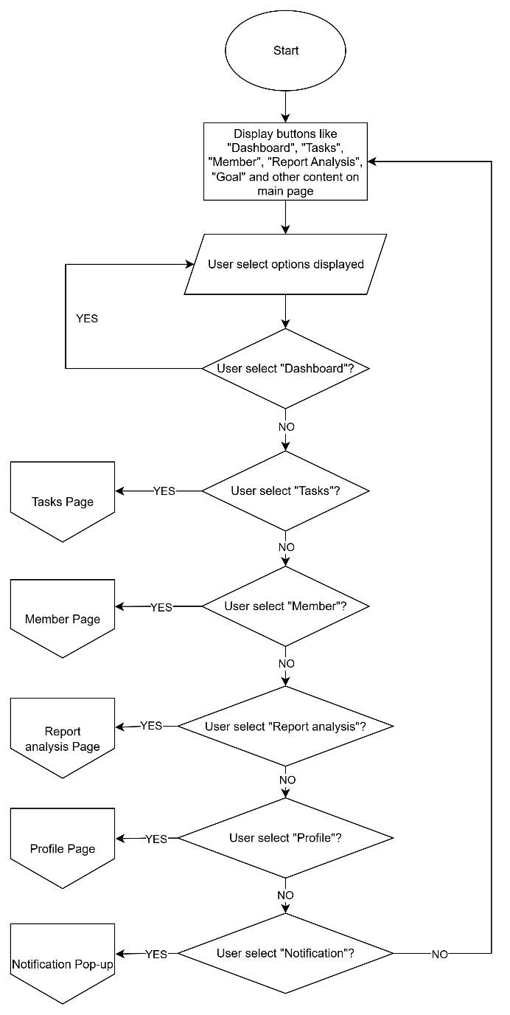

Figure 3.3 Dashboard

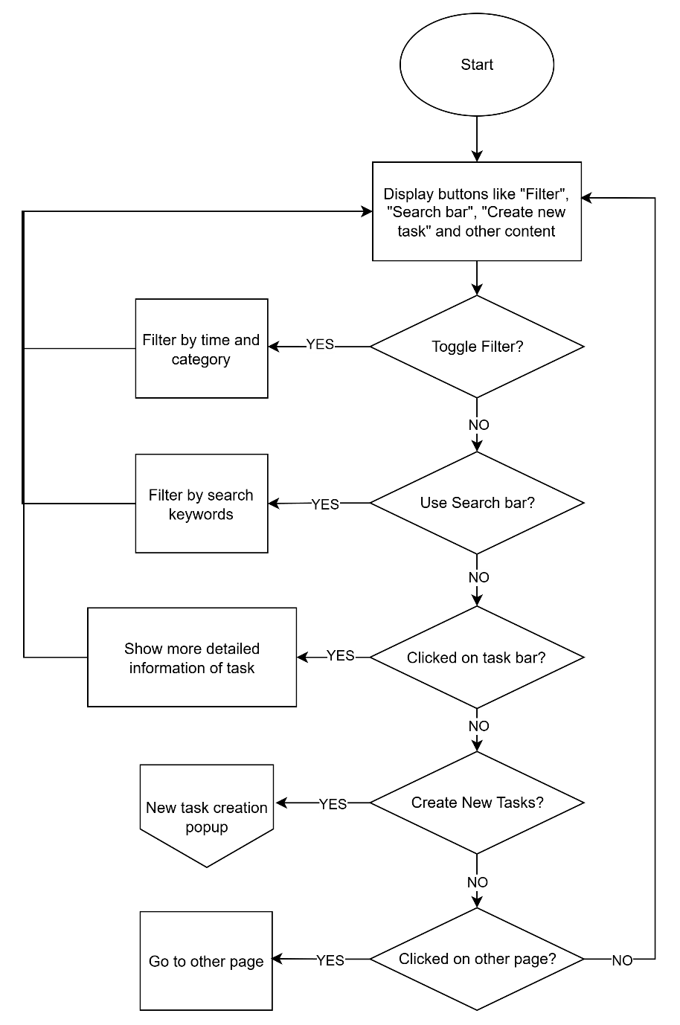

Figure 3.4 Task Page

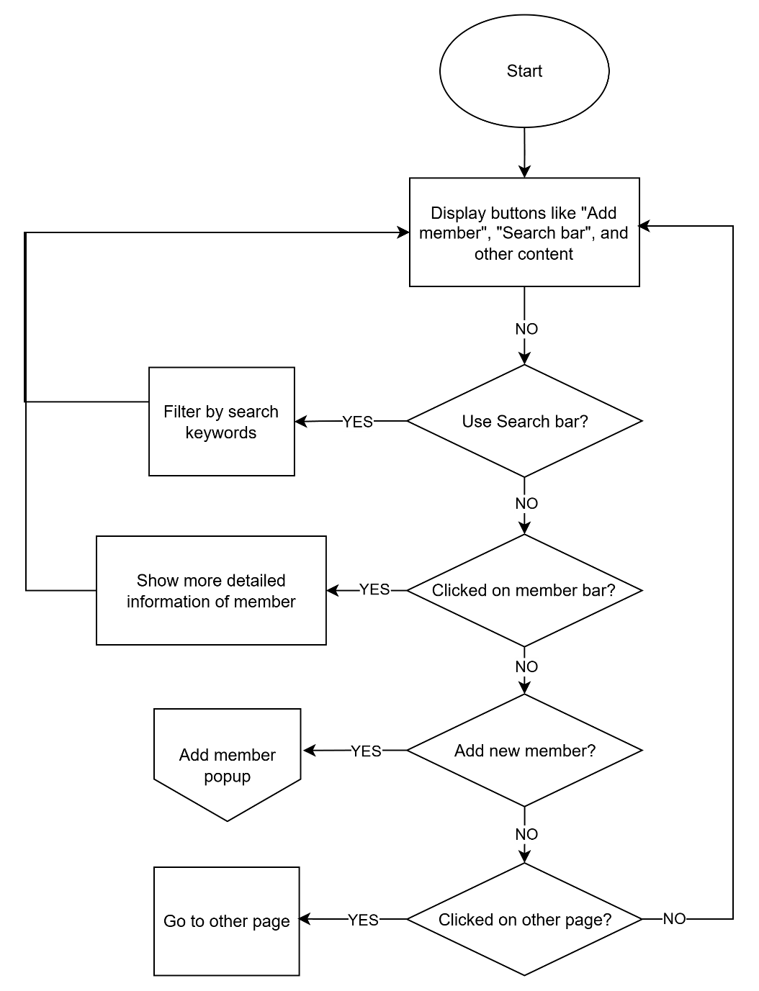

Figure 3.5 Member Page

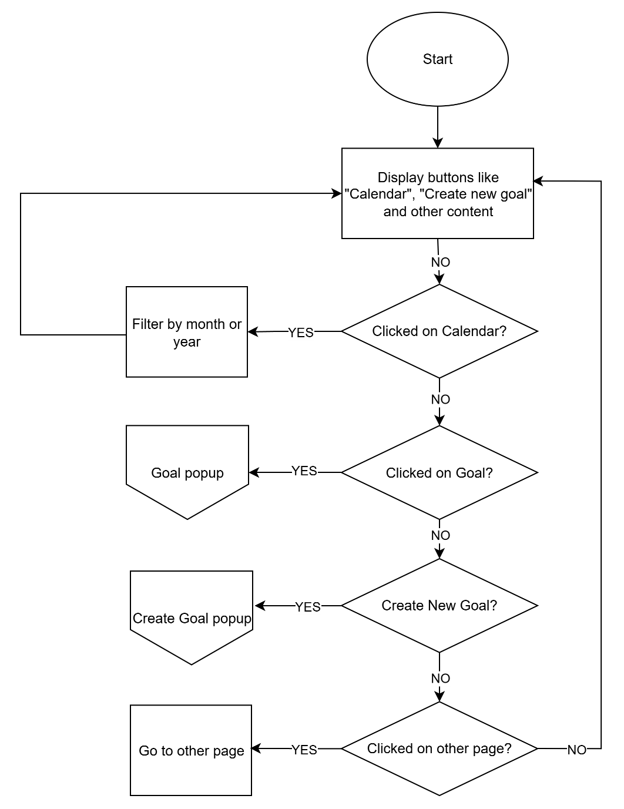

Figure 3.6 Goal Page

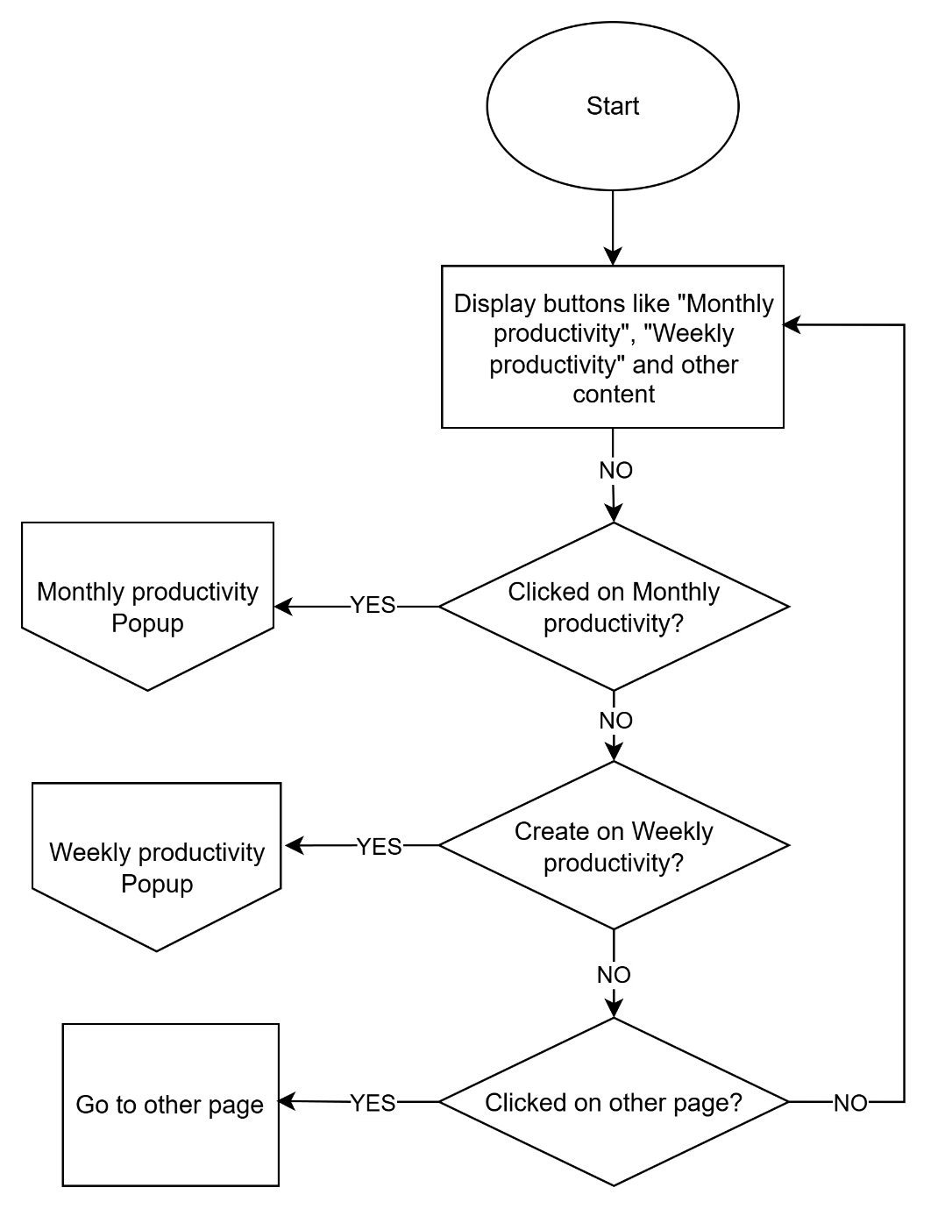

Figure 3.7 Analysis Page

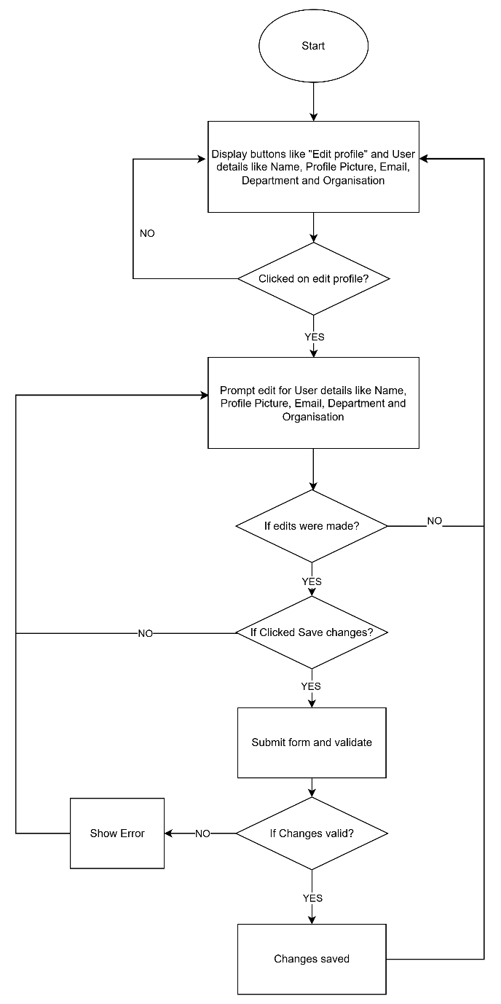

Figure 3.8 Profile Page

## **4.0 Storyboard**

Figure 4.0 Main Page to Sign Up to Dashboard

Figure 4.1 Task Page to Task Details

Figure 4.2 Task Page to Create Task

Figure 4.3 Goal Page to Goal Details

Figure 4.4 Goal Page to Create Goal

Figure 4.5 Member Page

Figure 4.6 Report Analysis

Figure 4.7 Profile Page to Edit Profile

## **5.0 ERD Diagram**

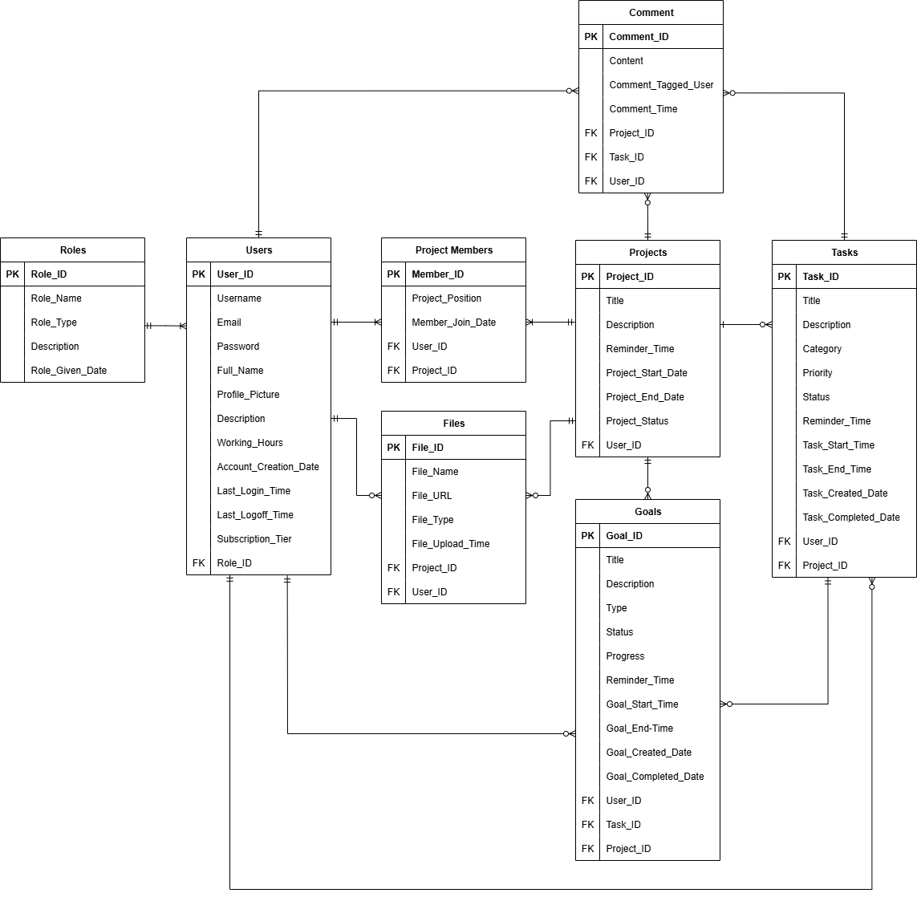

Figure 5.0 ERD Diagram

## **6.0 Wireframe**

Figure 6.0 Home Page

Figure 6.1 Sign in Page

Figure 6.2 Dashboard

Figure 6.3 Task Page

Figure 6.4 Task Details Page

Figure 6.5 Task Create

Figure 6.6 Team members

Figure 6.7 Goals Page

Figure 6.8 Goal Details

Figure 6.9 Goal Create

Figure 6.10 Report Analysis Page

Figure 6.11 Profile Page

Figure 6.12 Profile Edit

## **7.0 Navigational Structure**

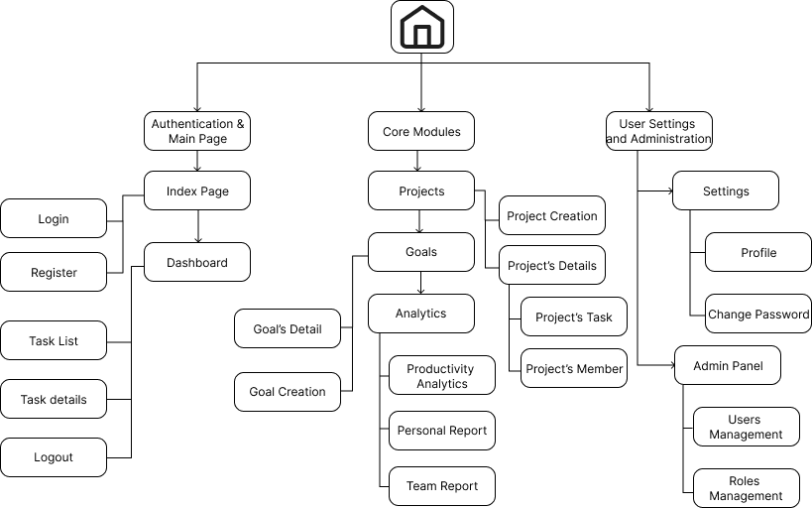

Figure 7.0 Navigational Structure