
Group Members:
Name | TP Number
Teo Jun Jie (Leader) | TP079880
Ng Tian Xin | TP081807
Victor Chia Bing Chen | TP080934
Wong Kelvin | TP081586

Module Code: AAPP012-4-2-RWDD
Module Title: Responsive Web Design & Development
Intake Code: UCDF2405ICT(SE)
Assignment Title: TaskFlow (Proposal)
Lecturer: Jeffery Jeselee Sijore
Date Hand Out: Week 3
Date Hand In: Week 5

TABLE OF CONTENT
1.0 Title of the Website 3
2.0 Objectives of the Project 4
3.0 Flow Chart 5
4.0 Storyboard 6
5.0 ERD Diagram 13
6.0 Wireframe 14
7.0 Navigational Structure 21

Title of the Website

Figure 1.1 TaskFlow Logo
TaskFlow represents the ideals of creating a system to help and serve the community by aiding them through task management for workflow and productivity increase. TaskFlow focuses on simplicity and efficiency by helping individuals or teams to get work done faster.

2.0 Objectives of the Project
TaskFlow aims to fulfil multiple objectives with its main purpose being to create a positive impact on society. TaskFlow helps by providing:
- Task Management. To give users a seamless way to create, track and prioritize tasks through functionalities like deadlines and reminders.
- Time Tracking. To let users to keep in check of their spent time on different tasks to improve their time efficiency.
- Goal Setting. To help users to set short- or long-term goals for project progress and duration tracking.
- Team Collaborations. To provide users with an easy way to enable task and project sharing between each other, allowing teamwork among members.
- Report Analysis. To give users insights on their productivity by letting them check on parts where they can improve on.
- Responsive Web Design. To make sure that the website is accessible for users on different devices like laptops, desktops or mobile devices.

3.0 Flow Chart
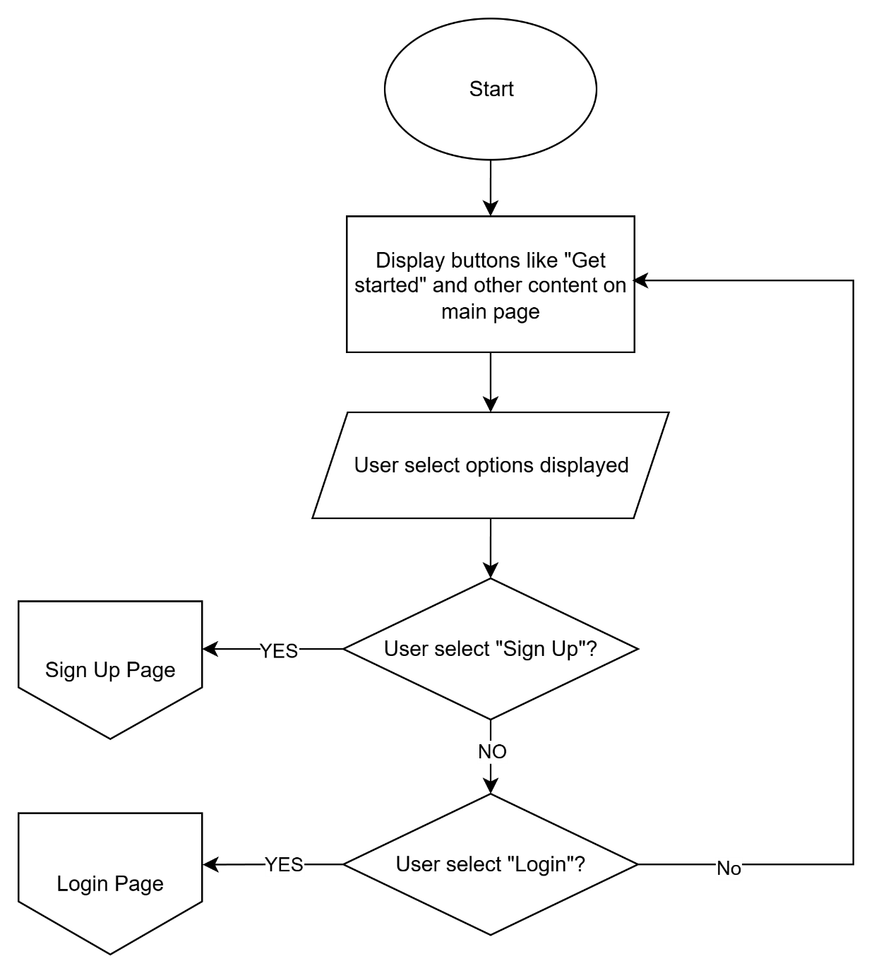
Figure 3.0 Landing Page
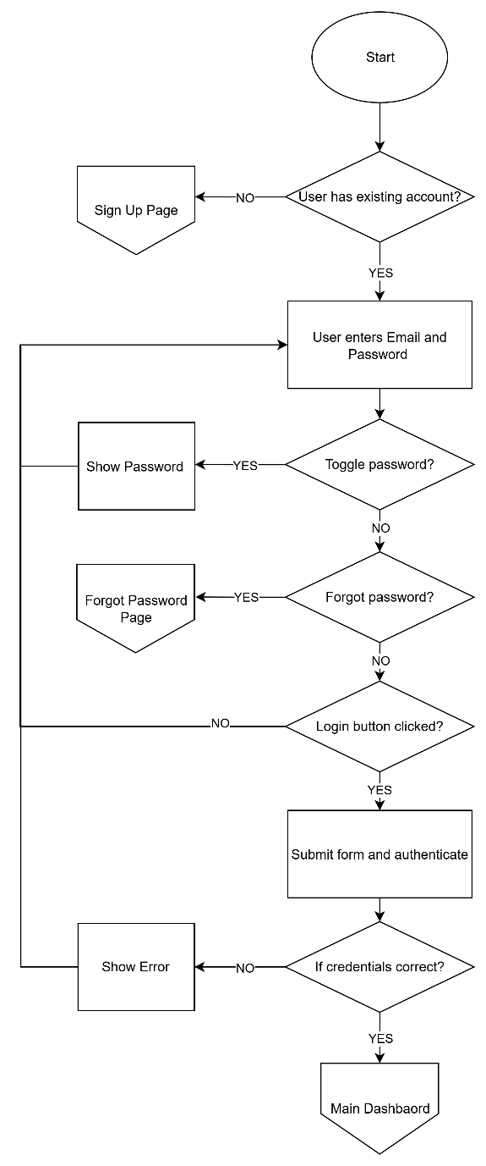
Figure 3.1 Login Page
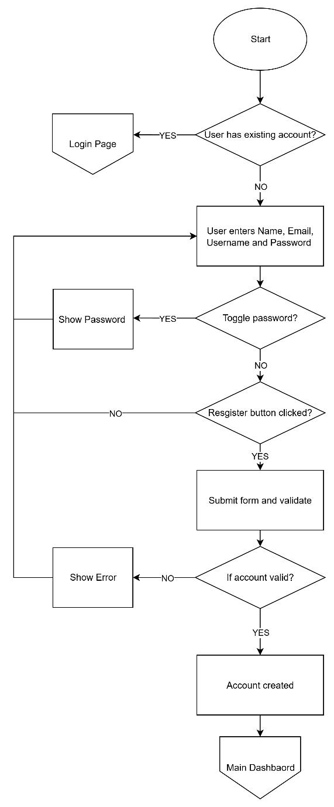
Figure 3.2 Sign Up Page
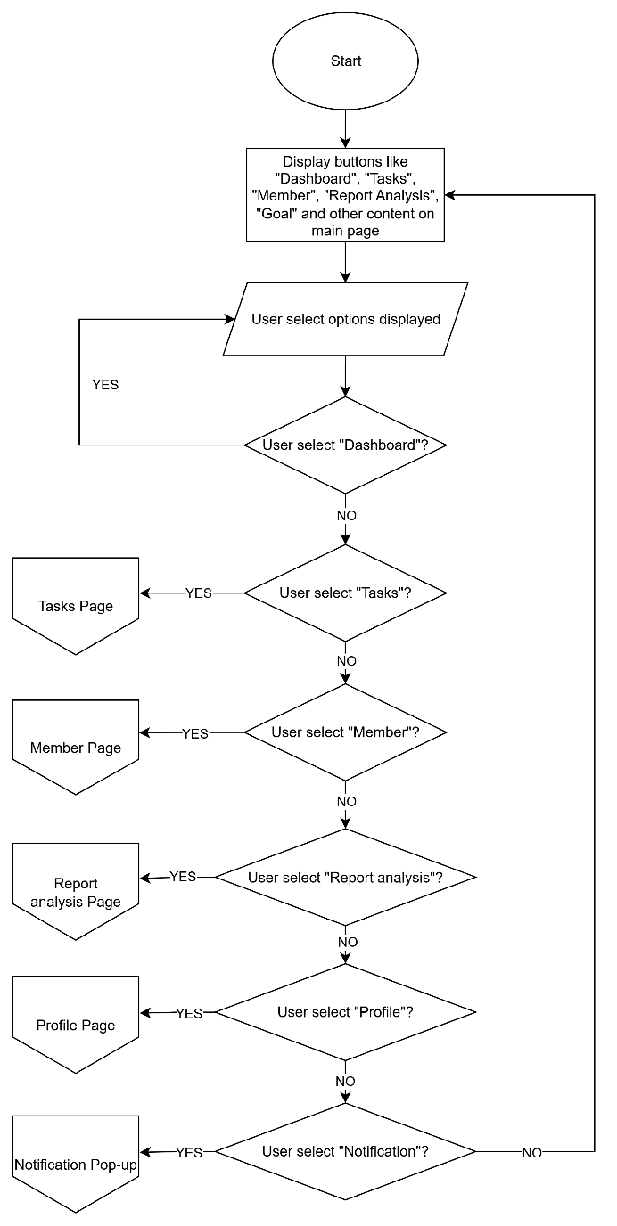
Figure 3.3 Dashboard
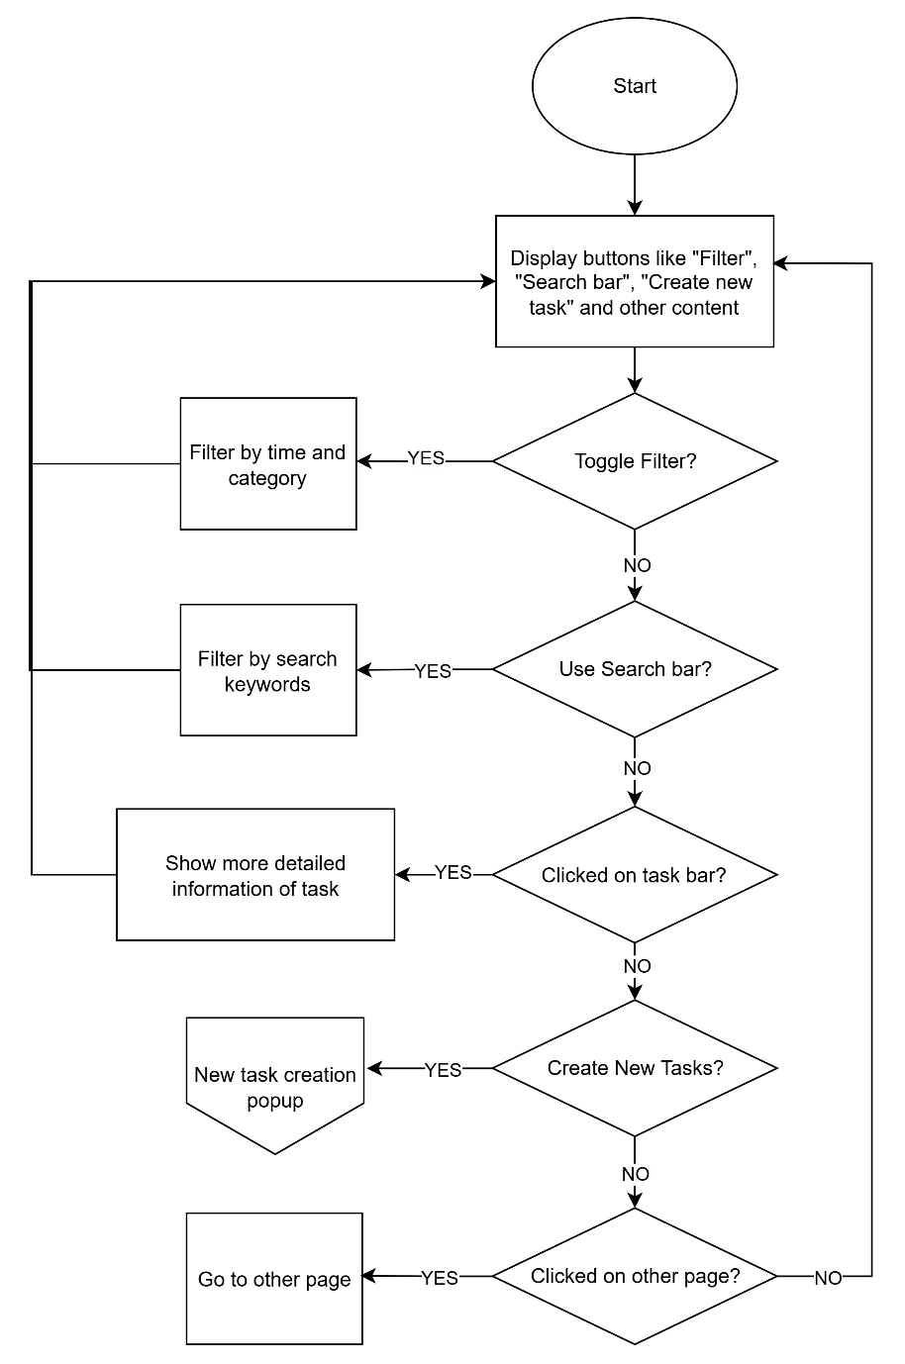
Figure 3.4 Task Page
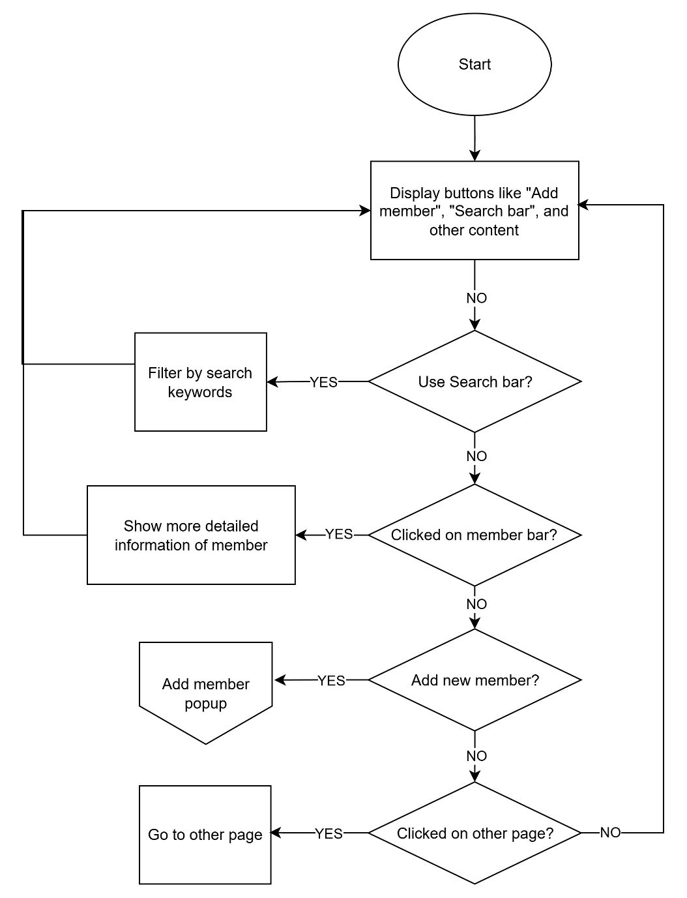
Figure 3.5 Member Page
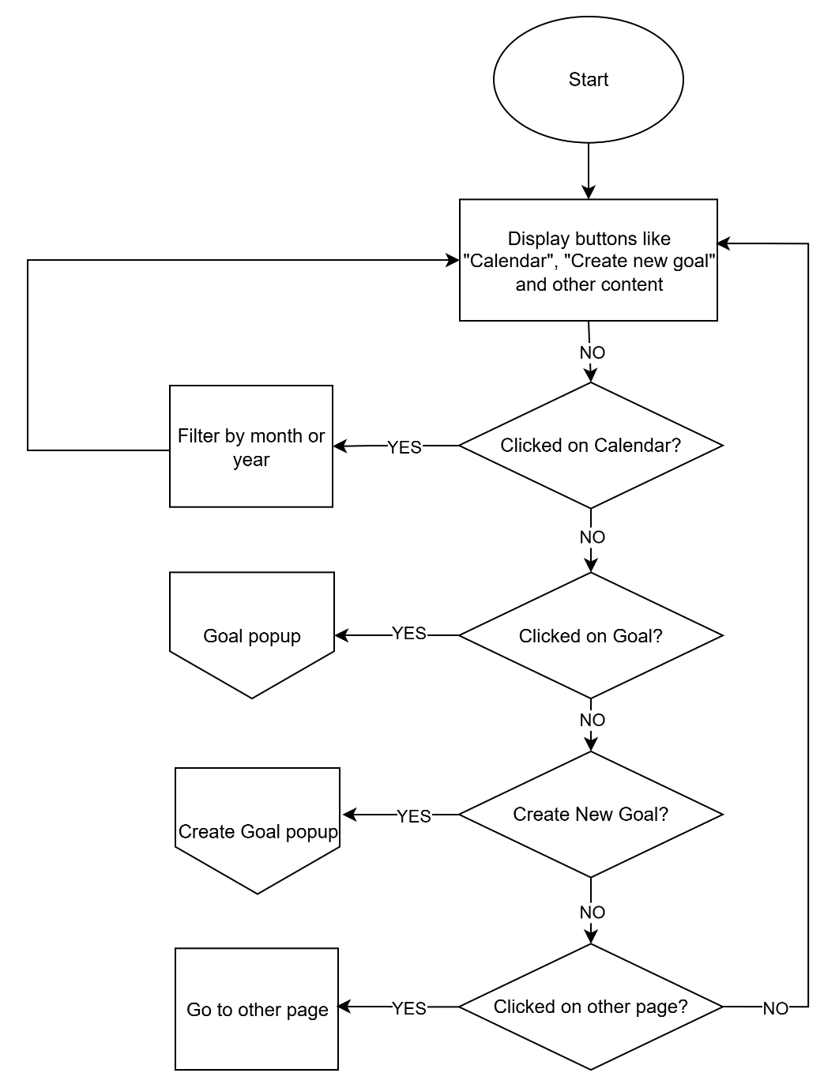
Figure 3.6 Goal Page
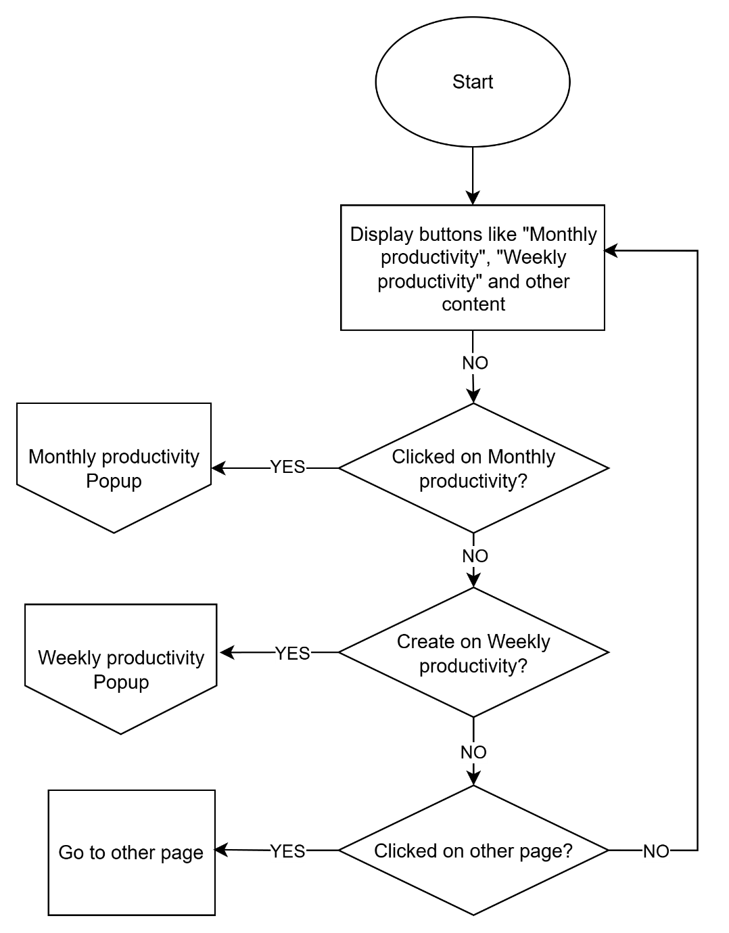
Figure 3.7 Analysis Page
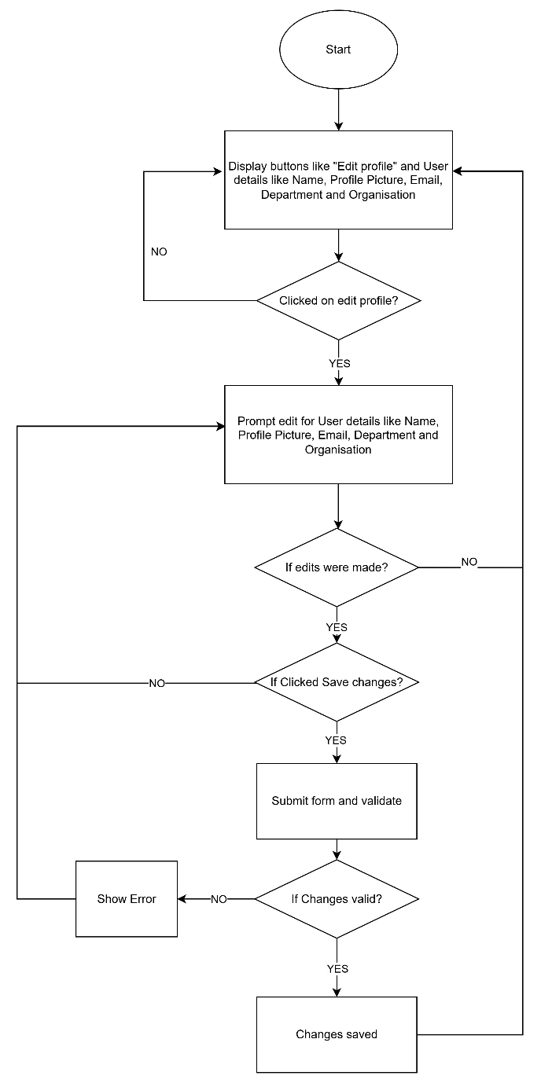
Figure 3.8 Profile Page

4.0 Storyboard
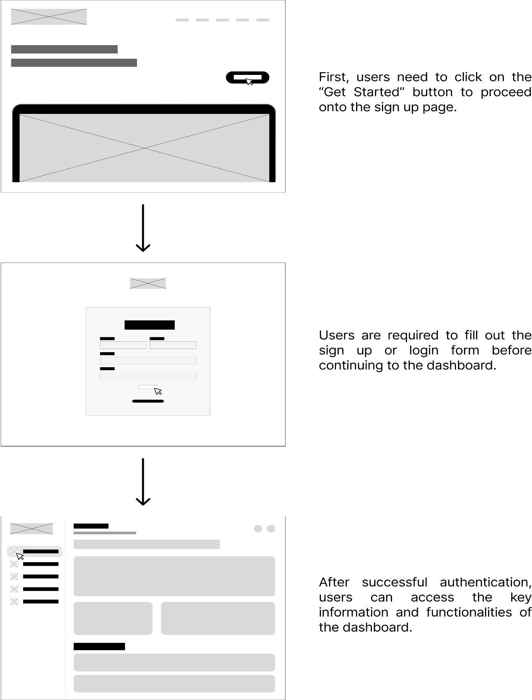
Figure 4.0 Main Page to Sign Up to Dashboard

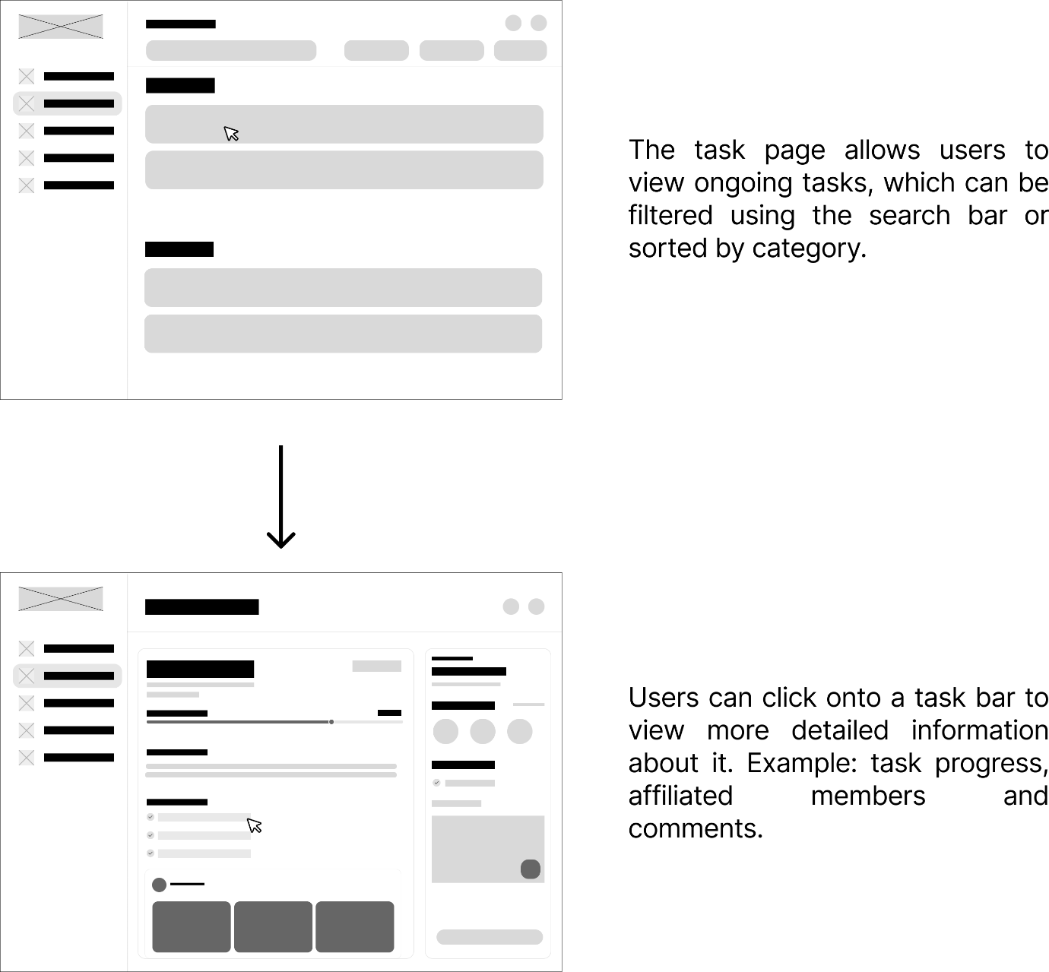
Figure 4.1 Task Page to Task Details

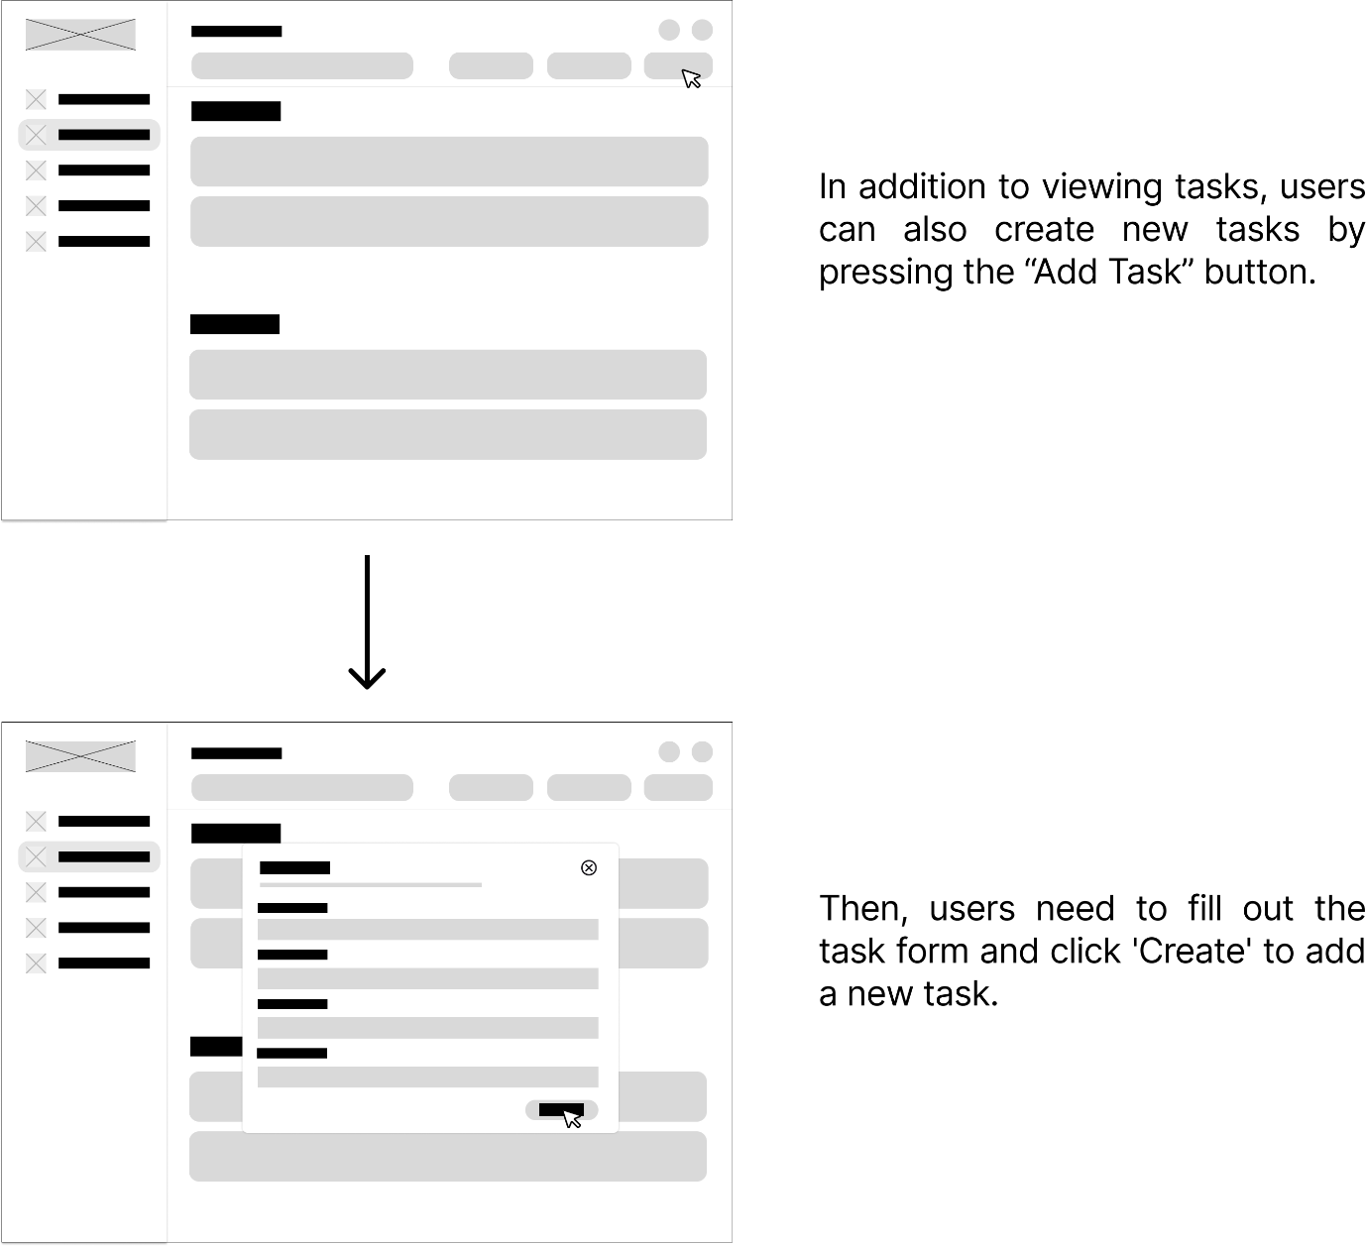
Figure 4.2 Task Page to Create Task

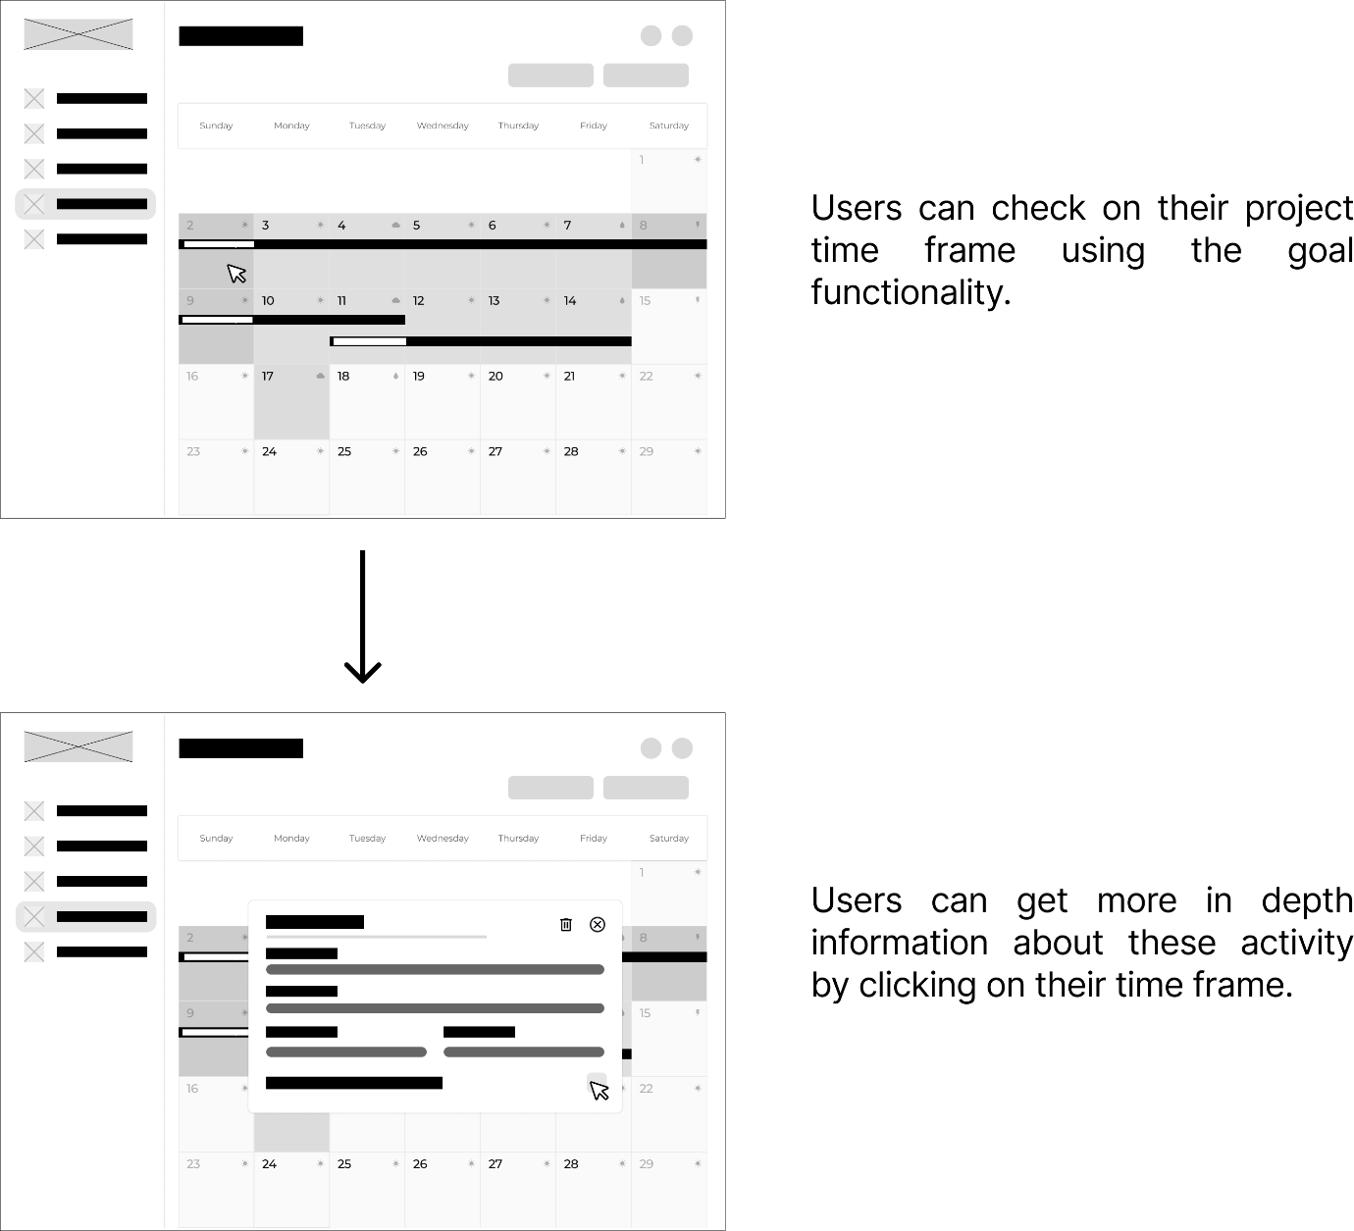
Figure 4.3 Goal Page to Goal Details

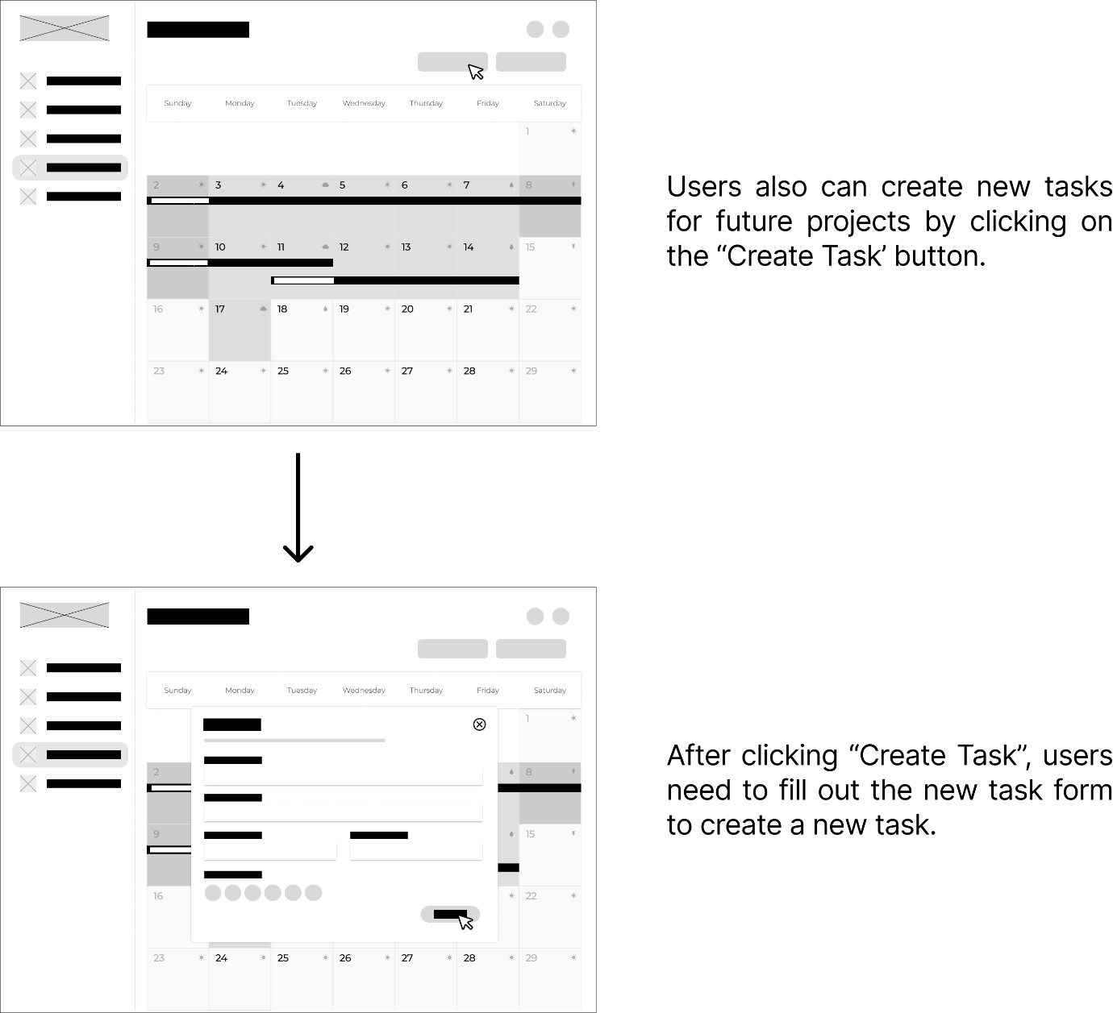
Figure 4.4 Goal Page to Create Goal

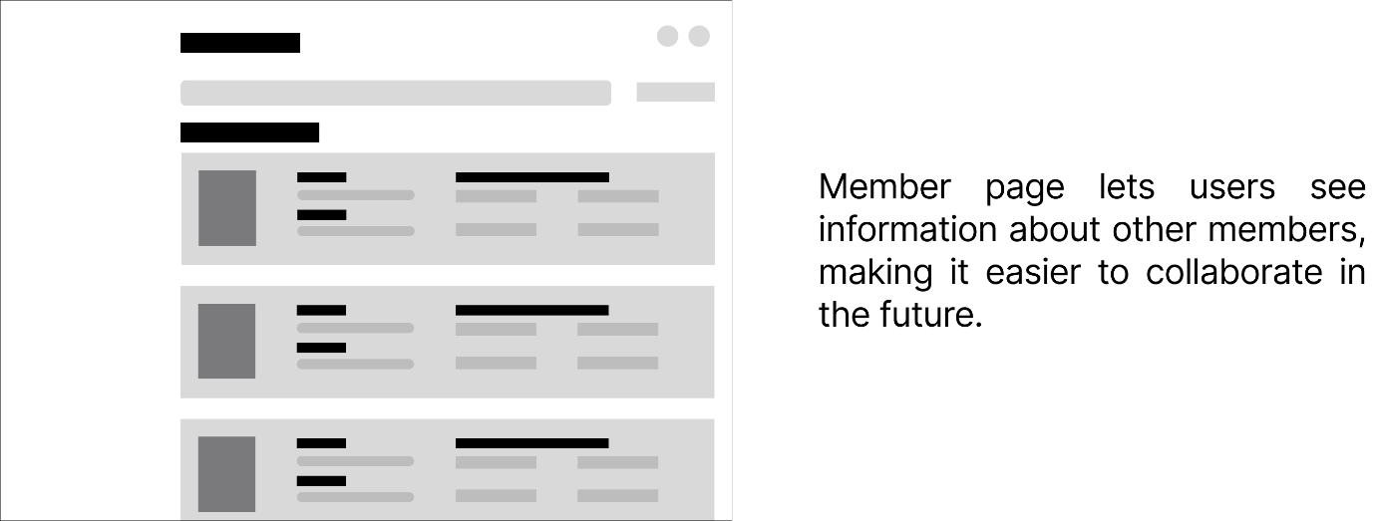
Figure 4.5 Member Page

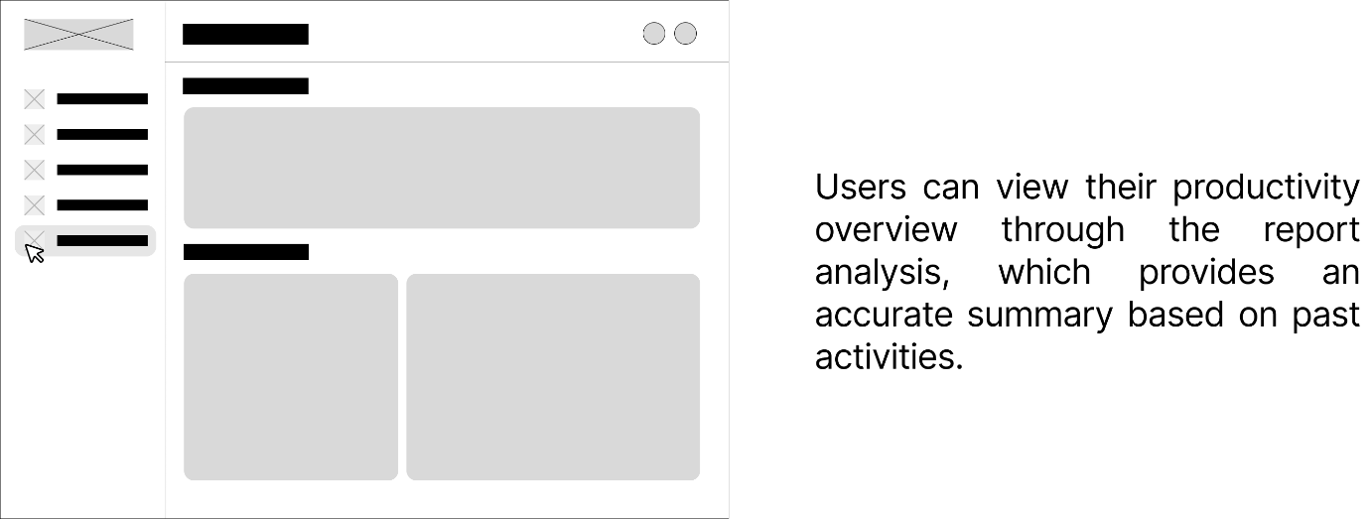
Figure 4.6 Report Analysis

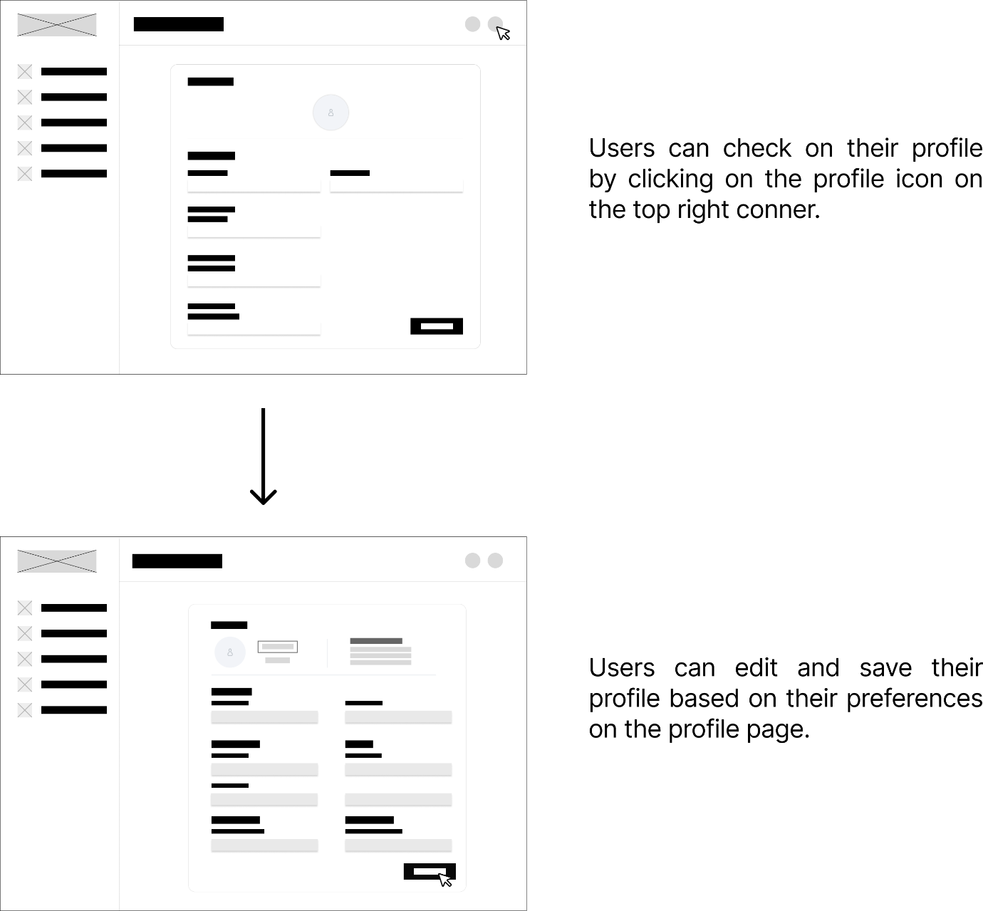
Figure 4.7 Profile Page to Edit Profile

5.0 ERD Diagram
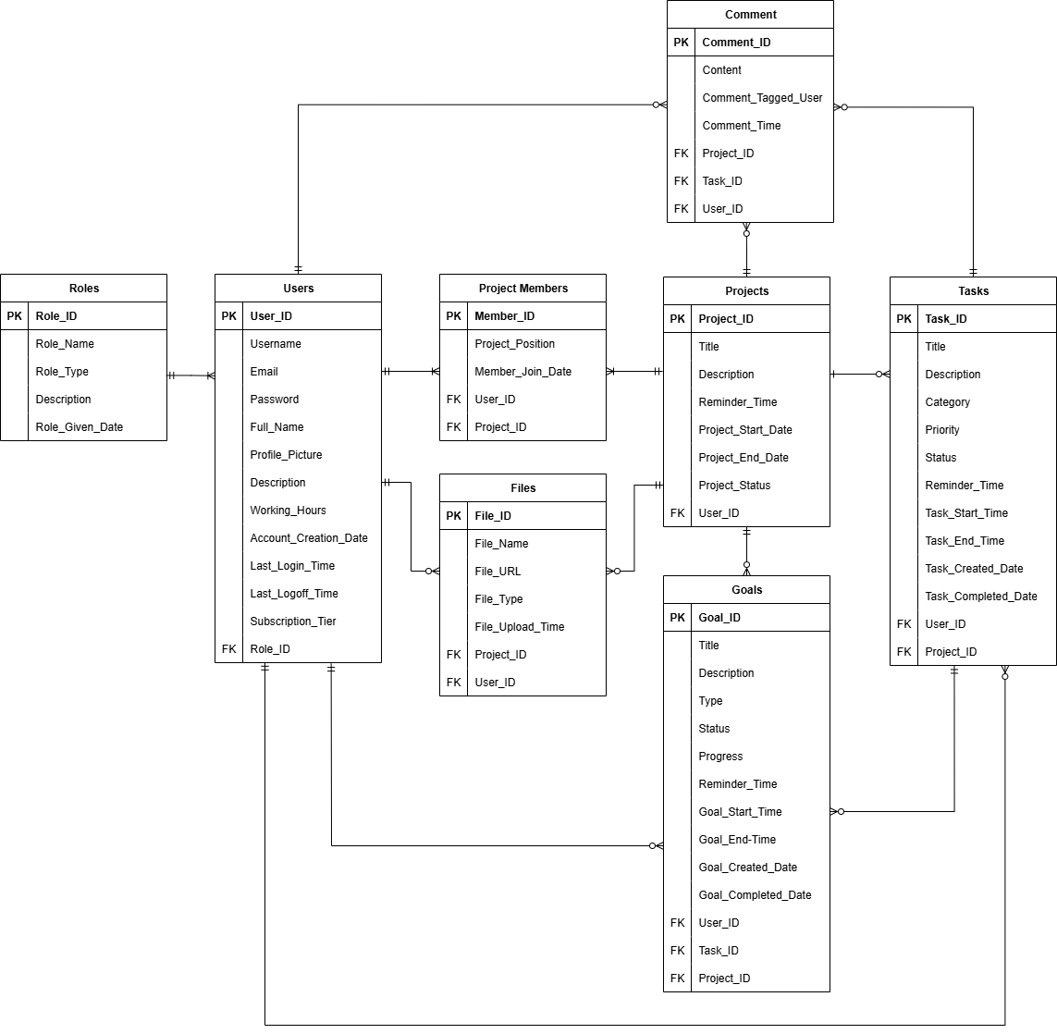
Figure 5.0 ERD Diagram

6.0 Wireframe
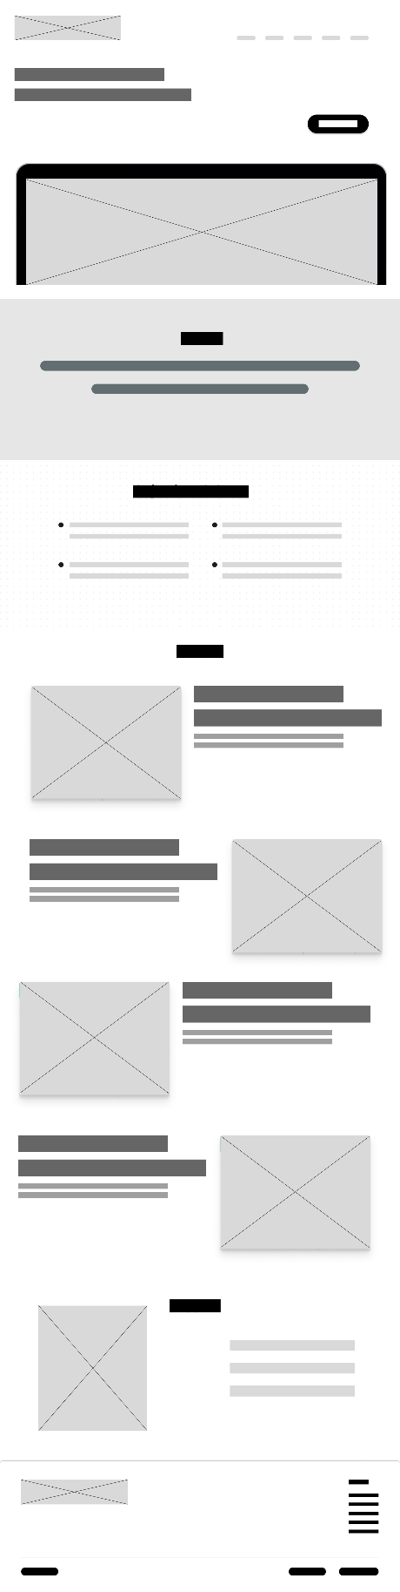
Figure 6.0 Home Page
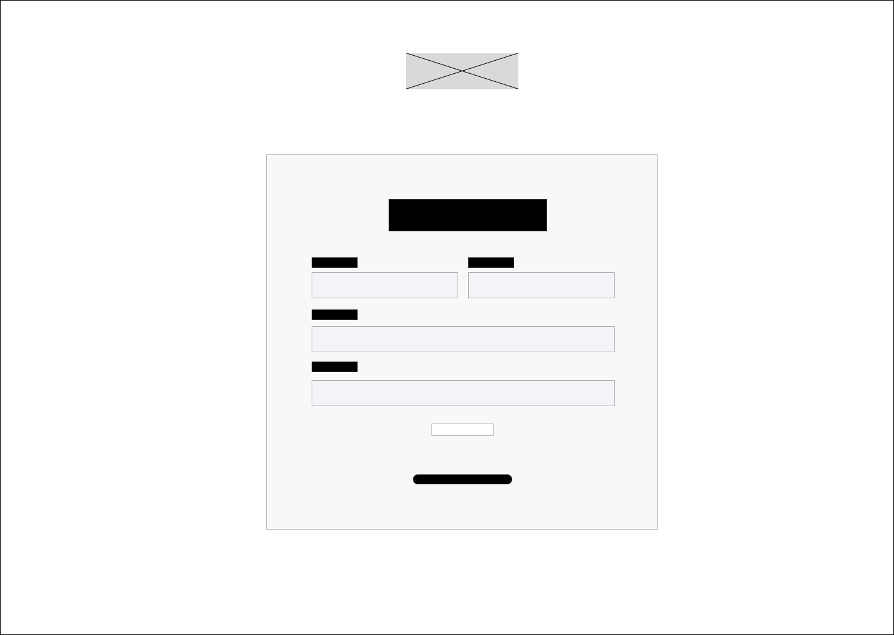
Figure 6.1 Sign in Page
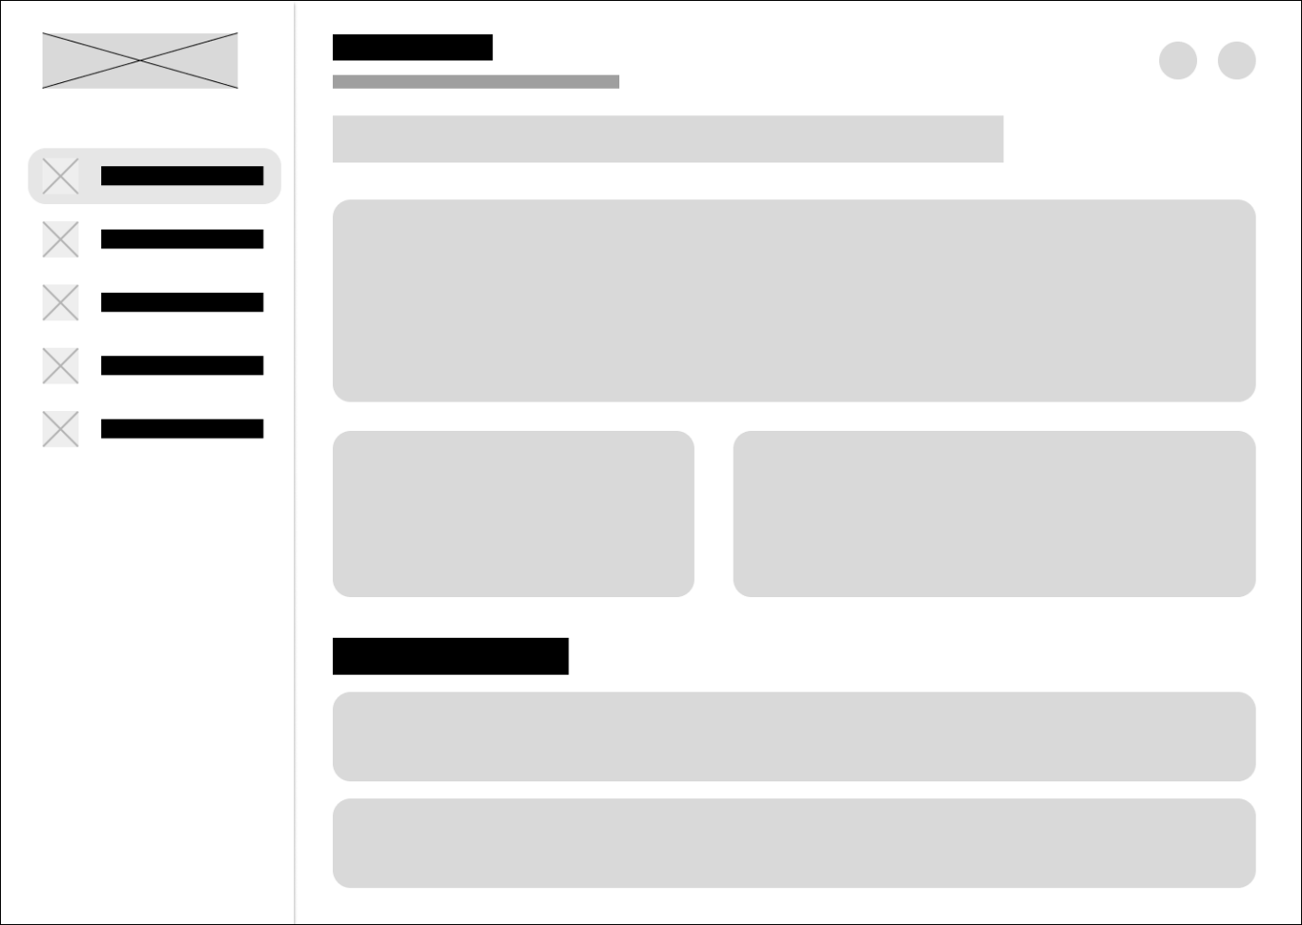
Figure 6.2 Dashboard
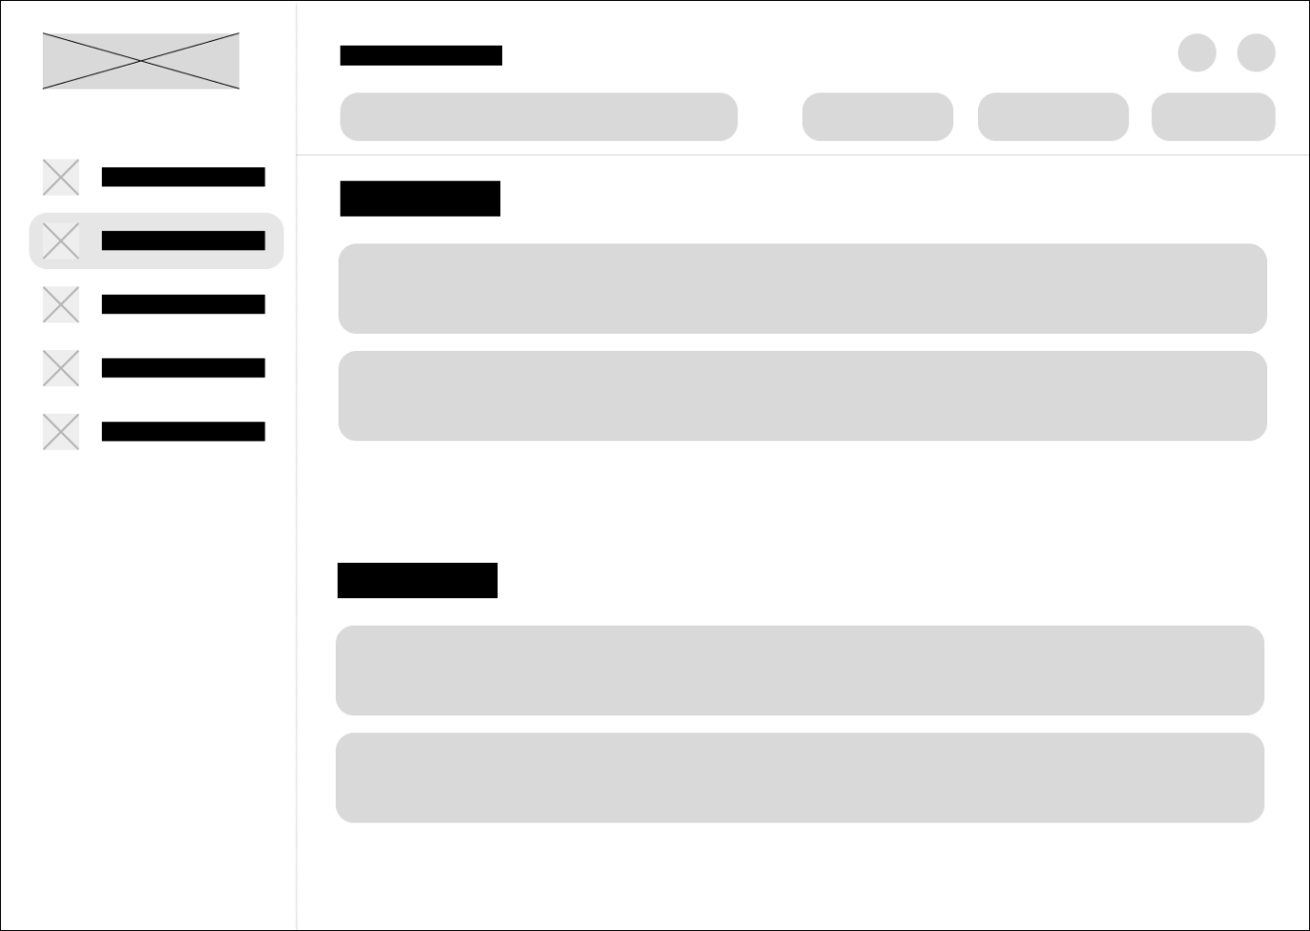
Figure 6.3 Task Page
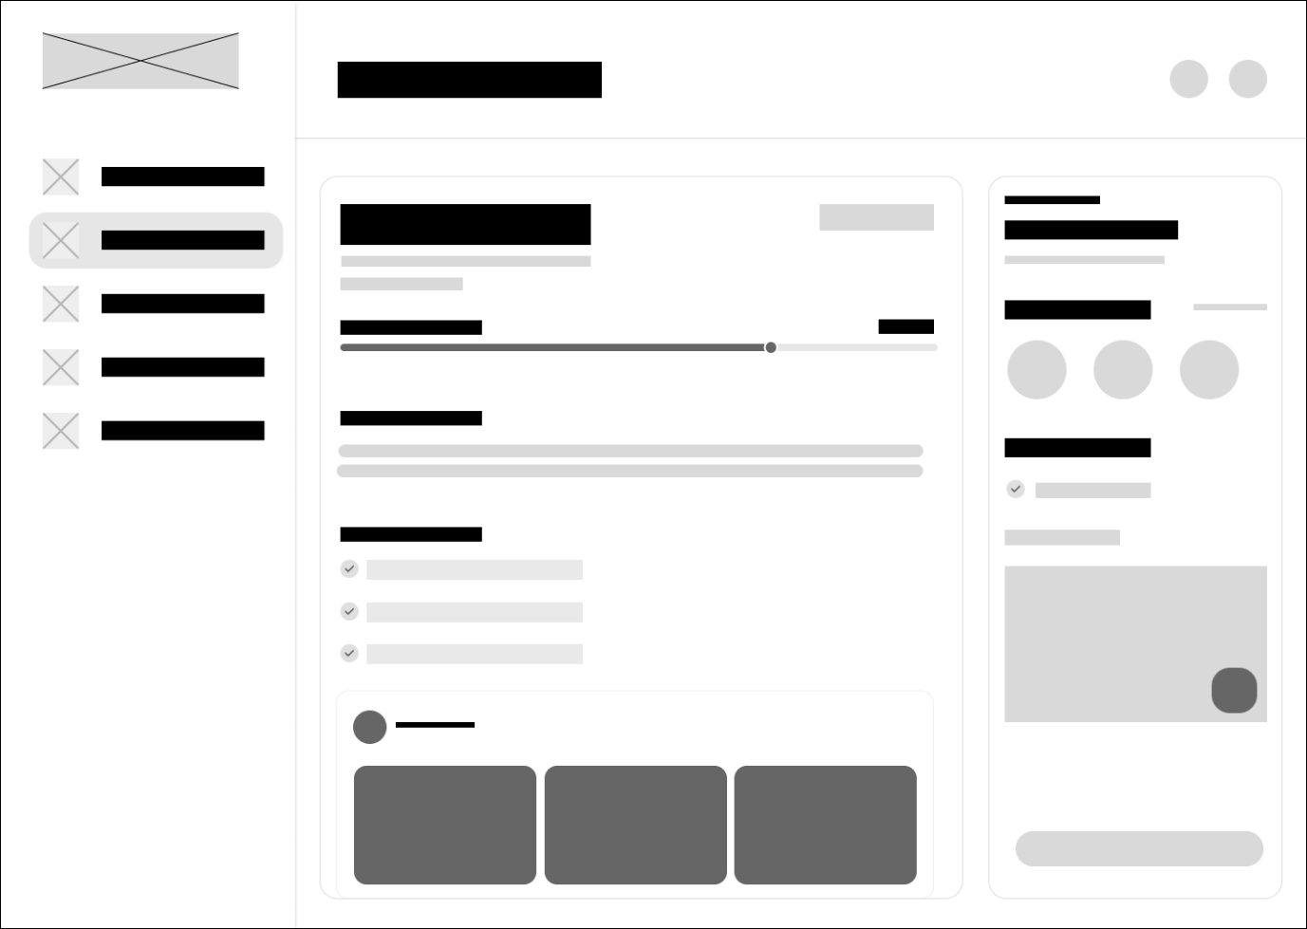
Figure 6.4 Task Details Page
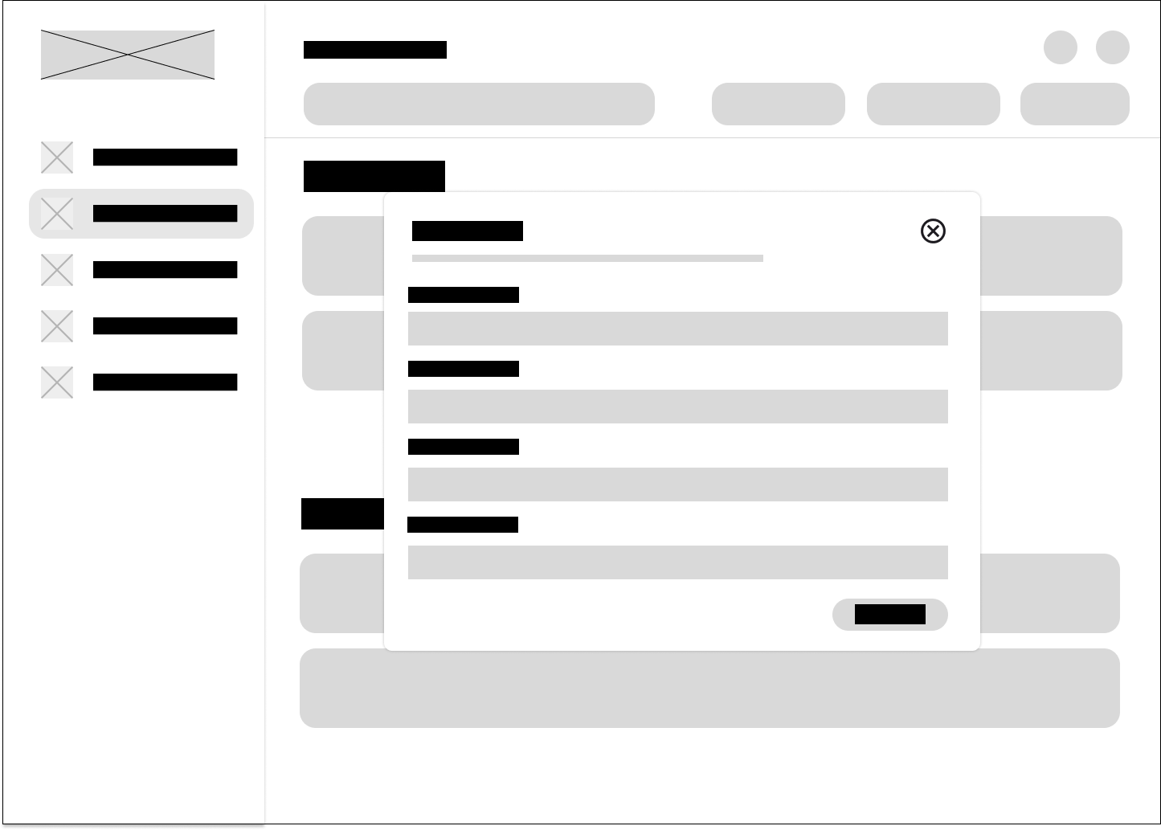
Figure 6.5 Task Create
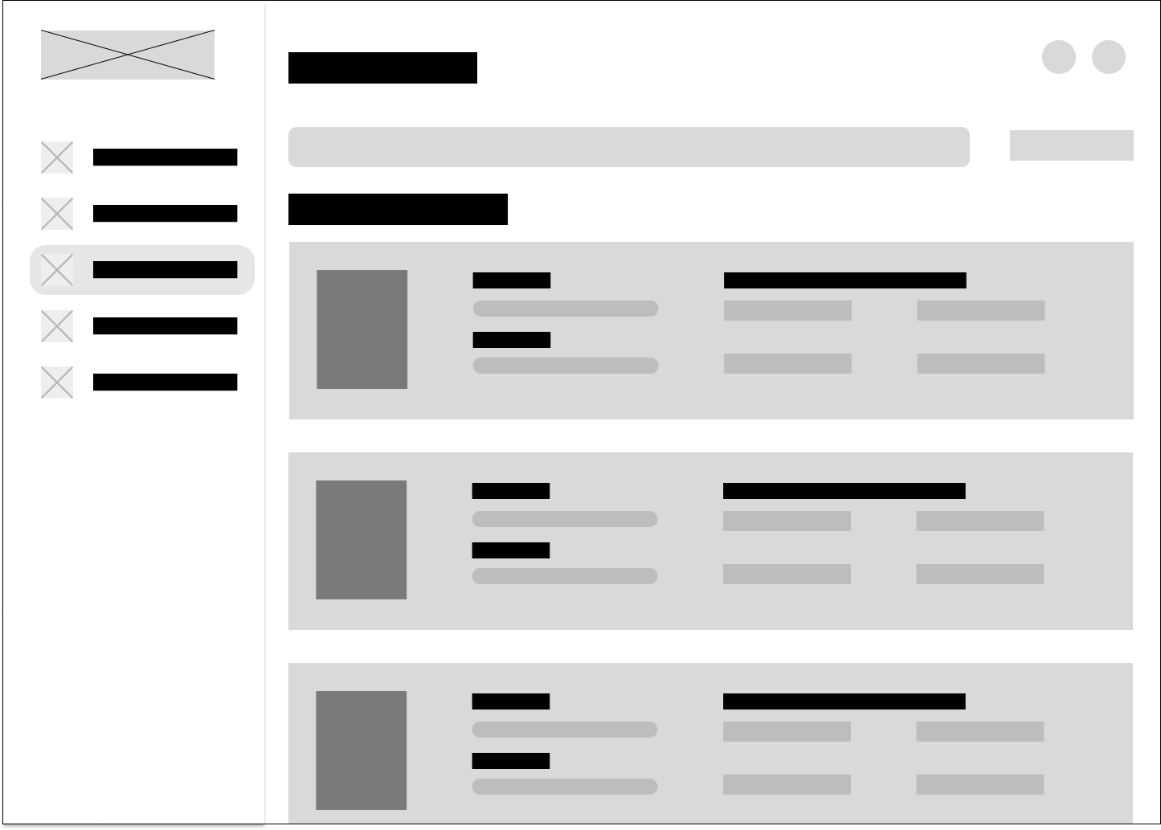
Figure 6.6 Team members
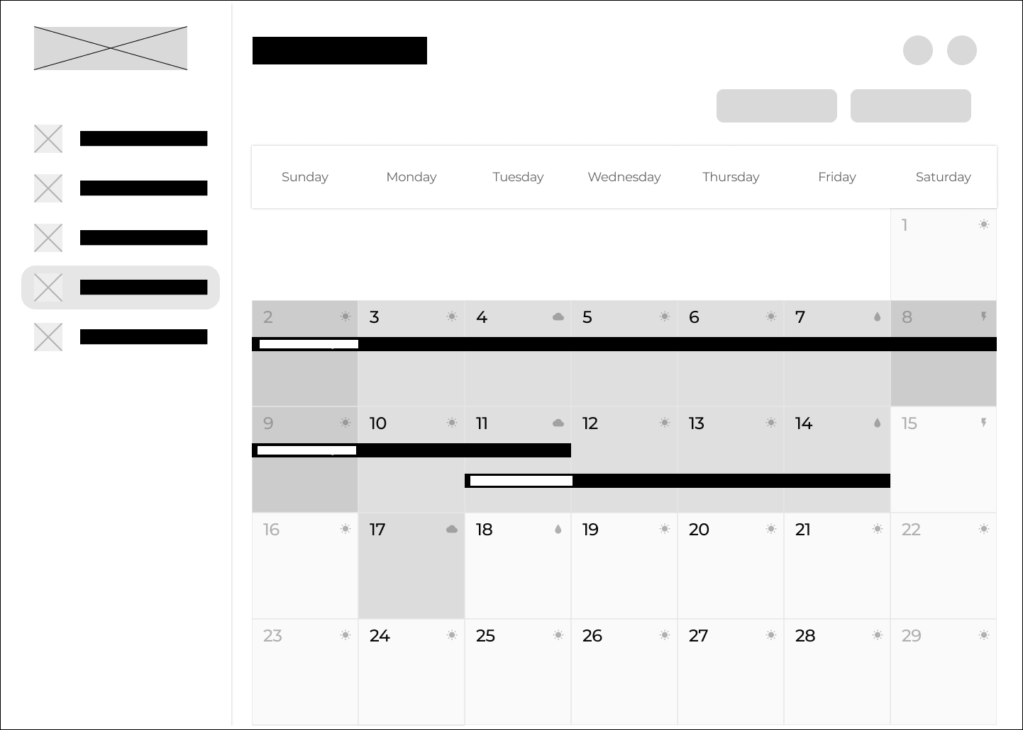
Figure 6.7 Goals Page
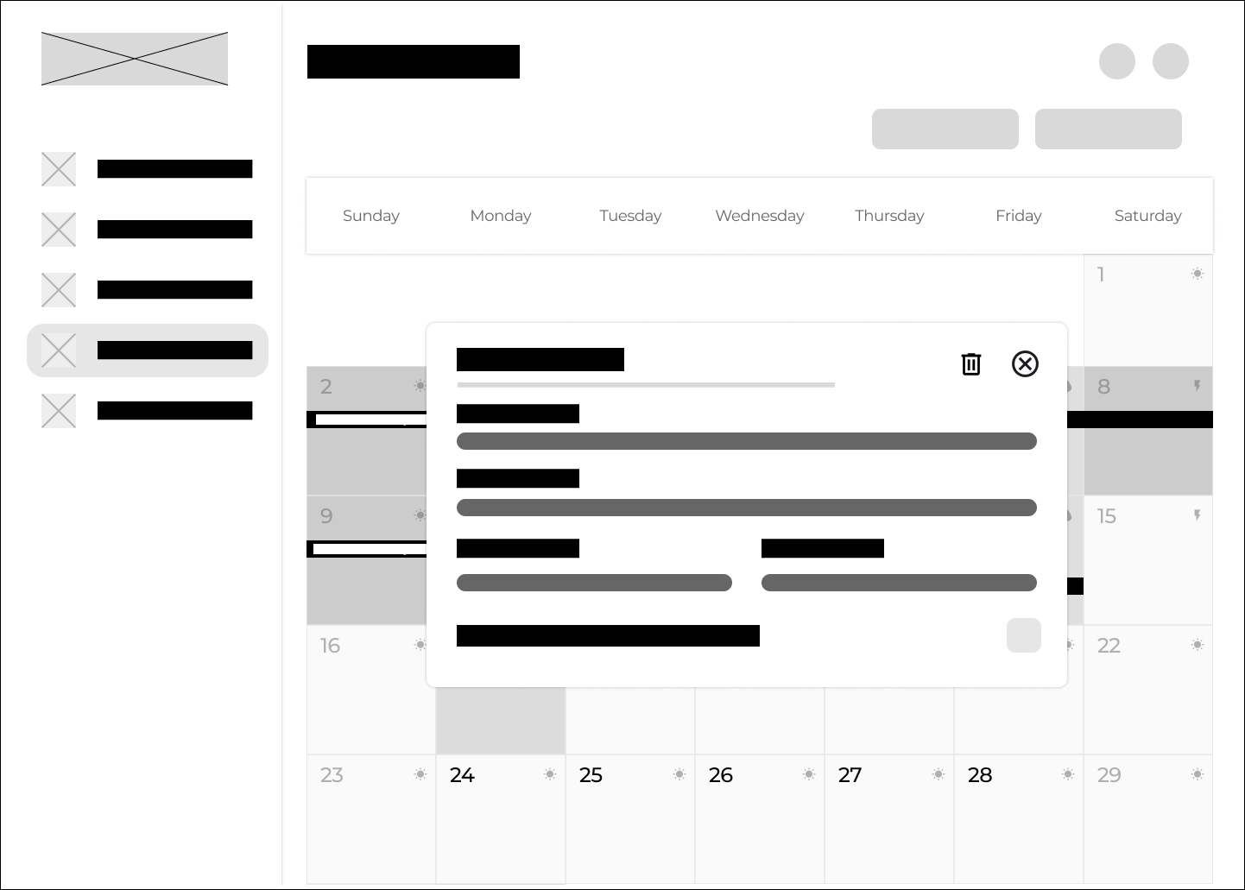
Figure 6.8 Goal Details
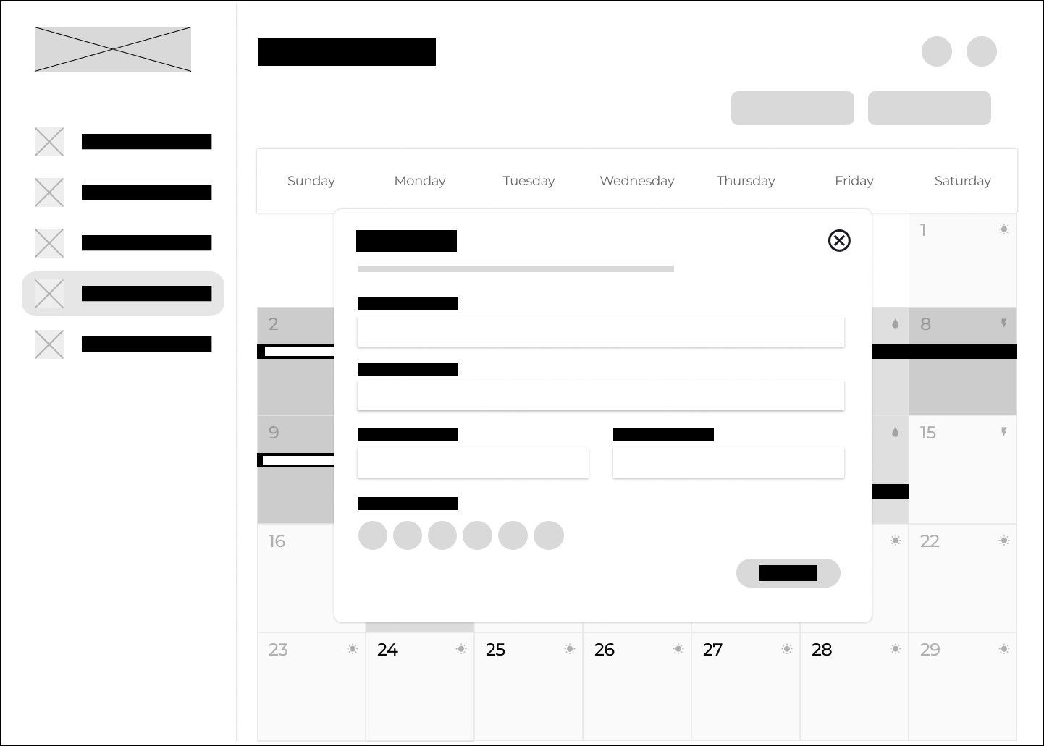
Figure 6.9 Goal Create
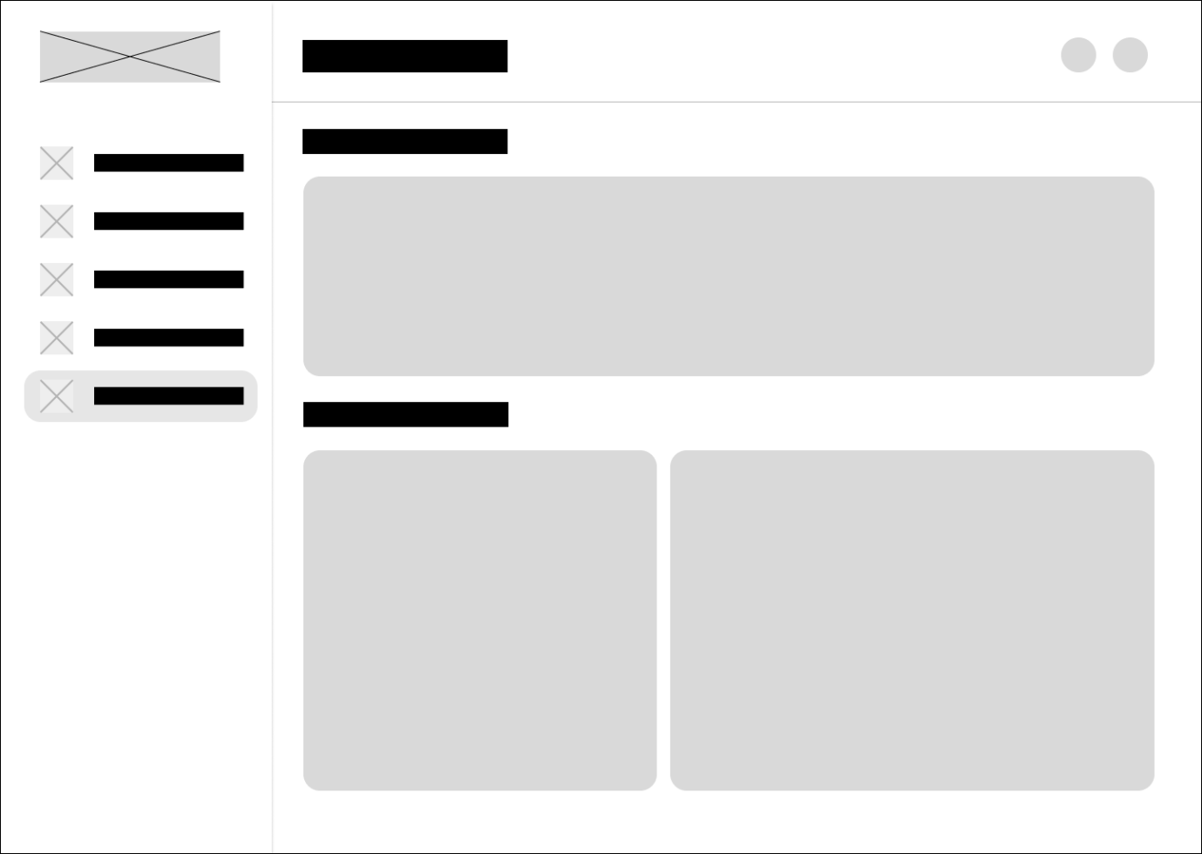
Figure 6.10 Report Analysis Page
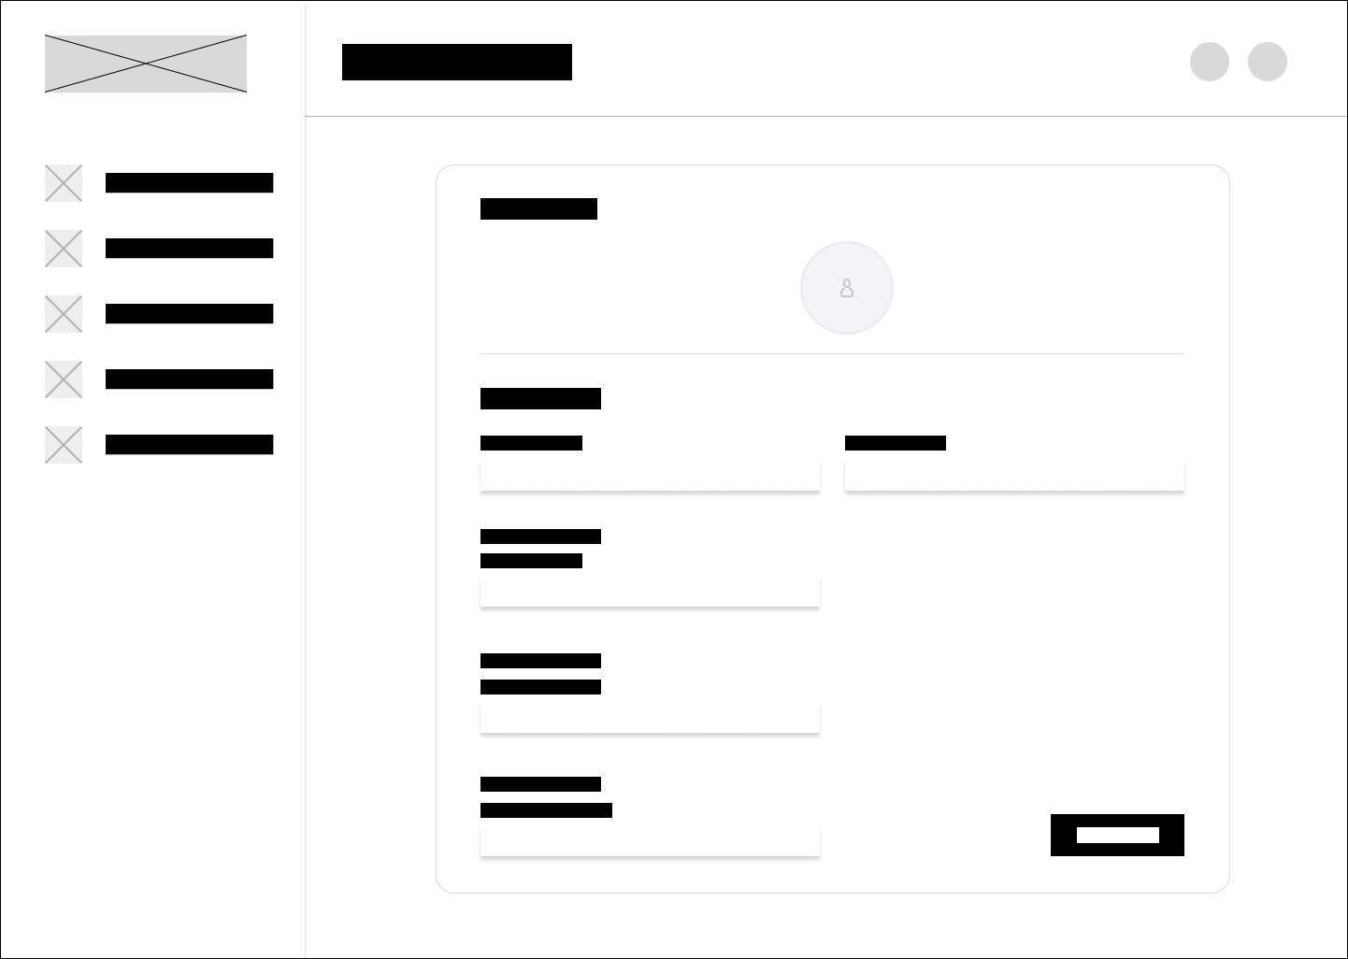
Figure 6.11 Profile Page
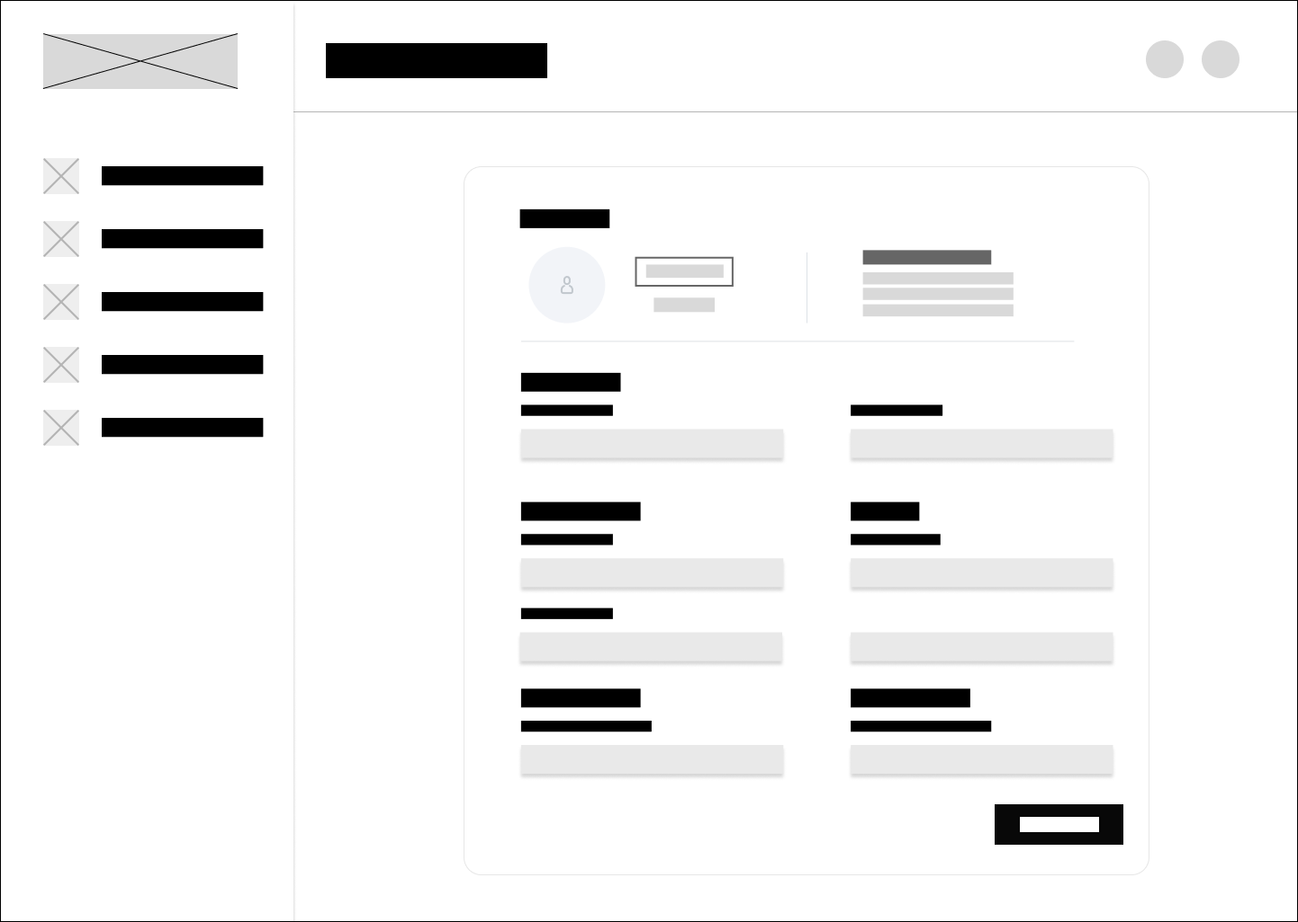
Figure 6.12 Profile Edit

7.0 Navigational Structure
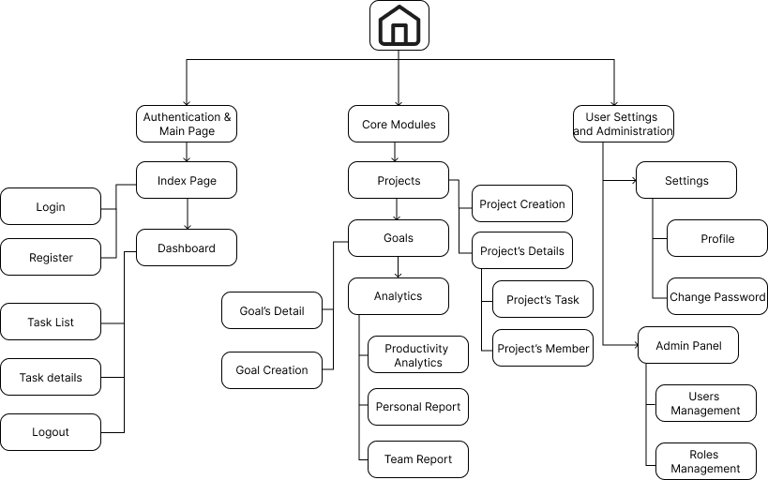
Figure 7.0 Navigational Structure

