AMU_R
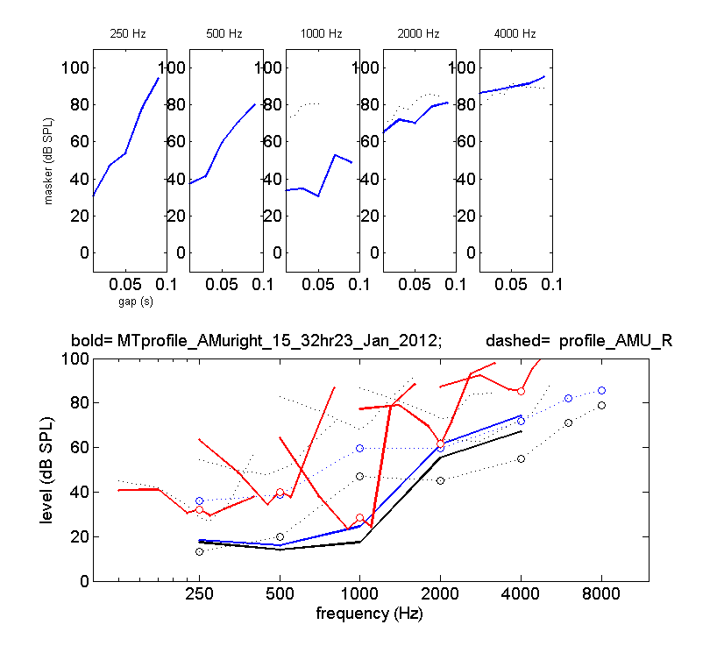

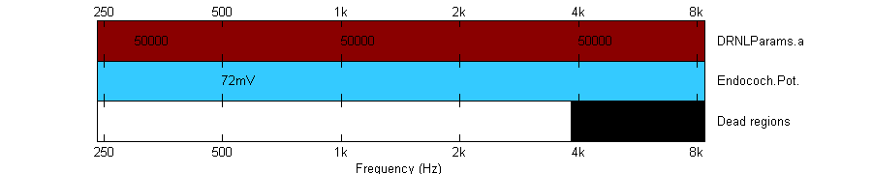
Suggestions:
- Try only DRNLParams.a to match thresholds, no dead regions, no Et reduction
- 8ms/500ms

ARA_L

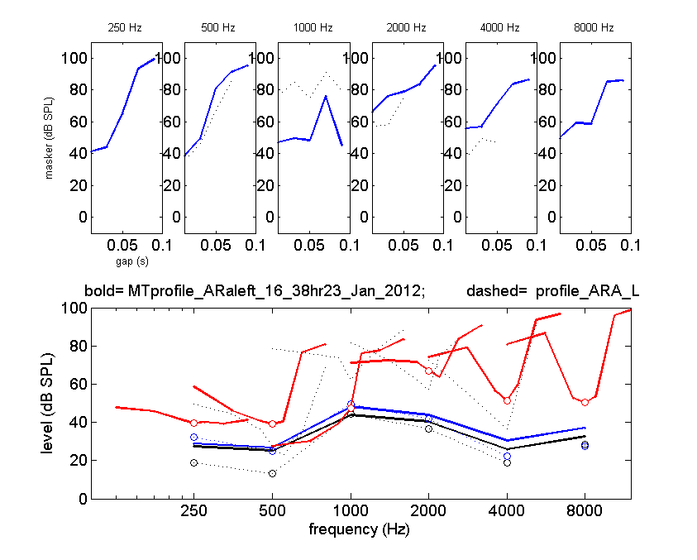

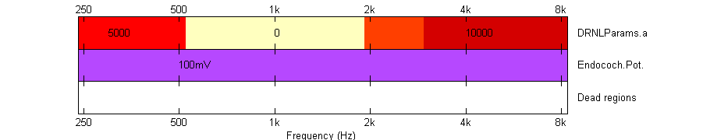
Suggestions:
- Try a smooth DRNLParams.a transition around 500 Hz instead of a steep one
- 16ms/250ms

ATY_L
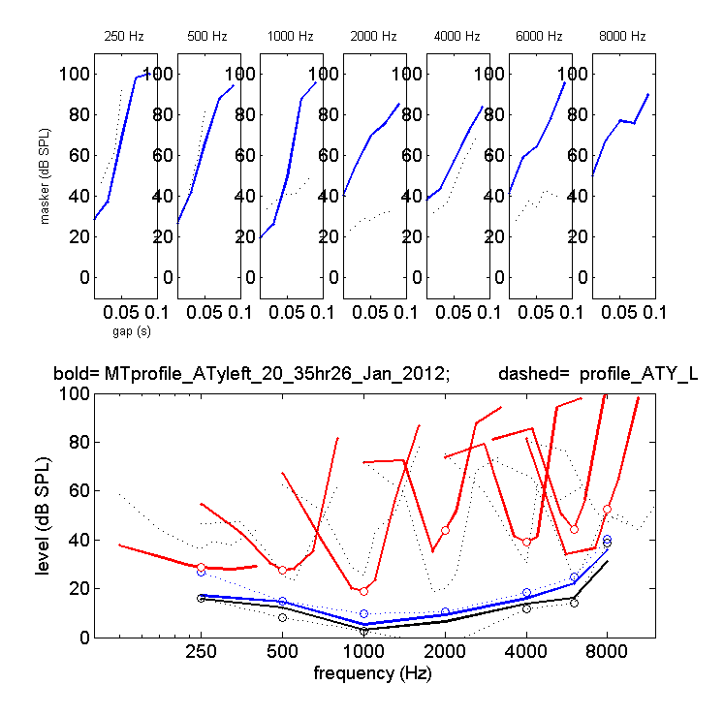
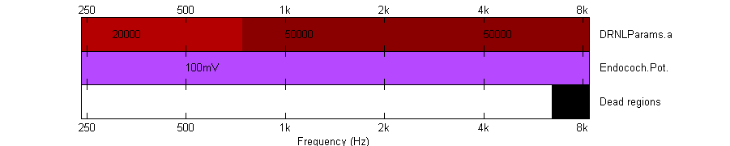
Suggestions:
- Try to lower thresholds at 2000 and increase thresholds at 8000 Hz using DRNLParams.a
- No dead regions
- 16ms/250ms
AYA_L

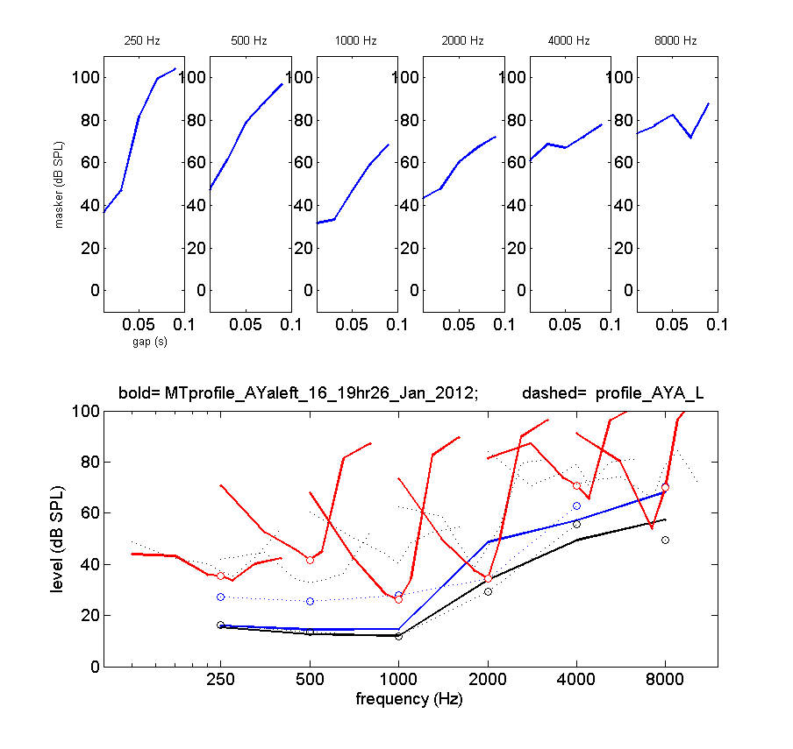
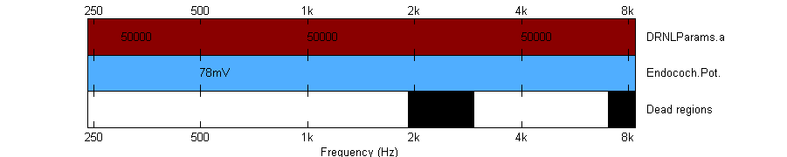
Suggestions:
- Dont model! TMCs are missing.
- 8ms/500ms

BCR_L
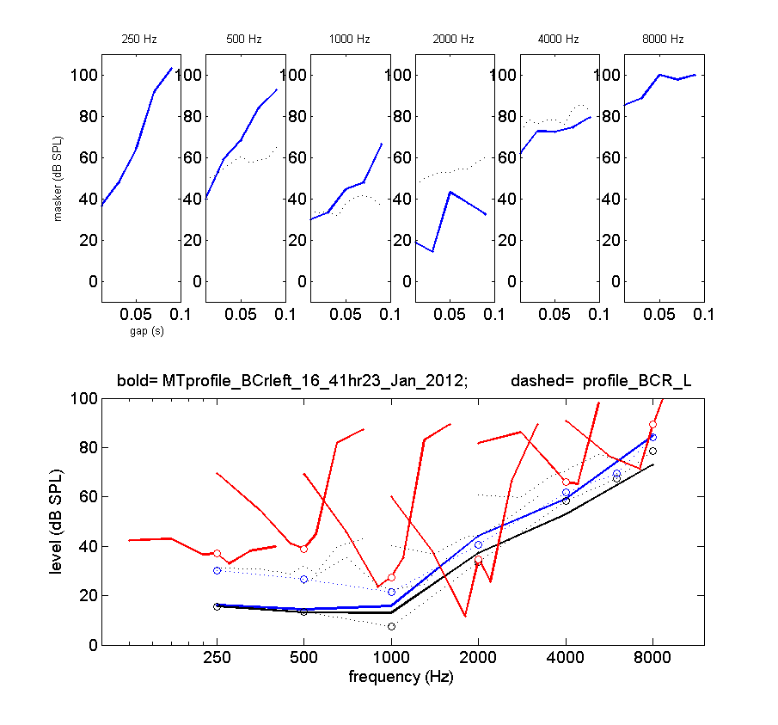

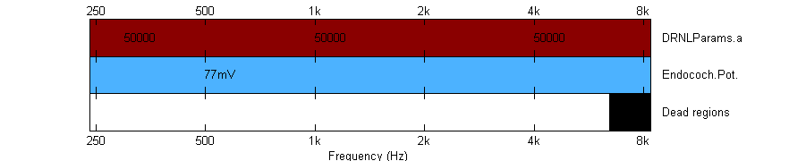
Suggestions:
- Looks like there is little compression left, so try to model just with DRNLParams.a
- 8ms/500ms

BHA_R
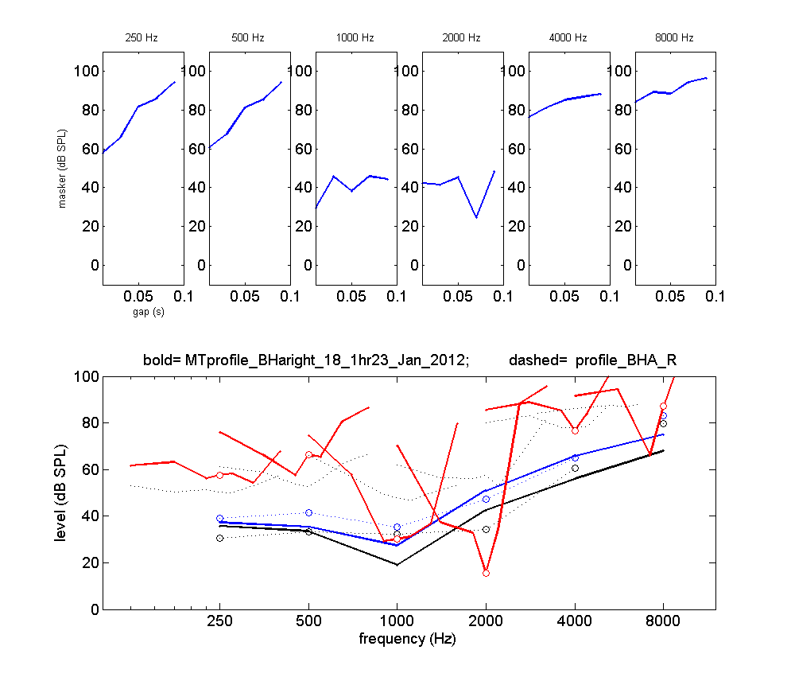

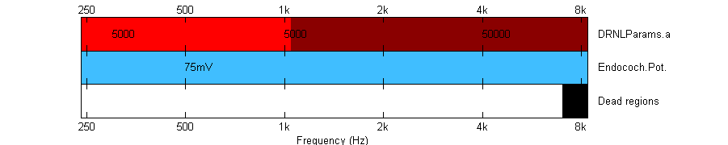
Suggestions:
- Dont model! TMCs are missing.
- If modelled then with DRNLParams.a = 5000 throughout
- 16ms/250ms

BME_L
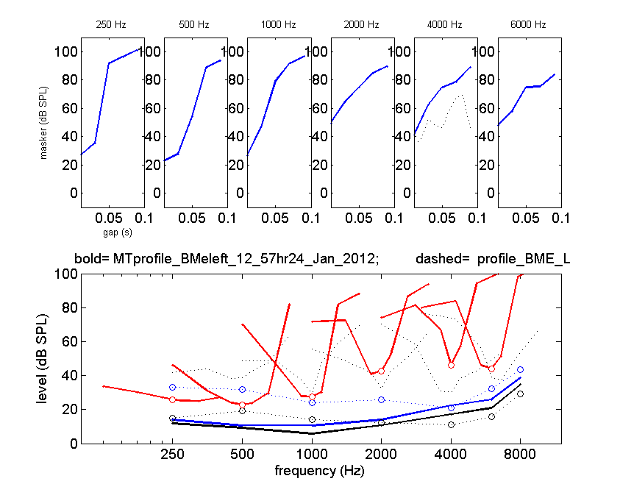

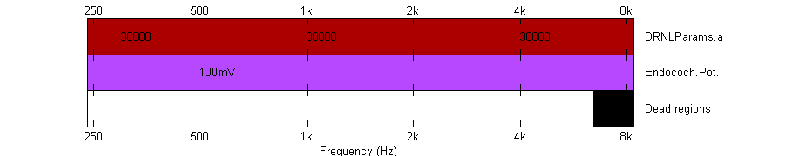
Suggestions:
- Try to model only with DRNLParams.a
- 8ms/500ms

BME_R
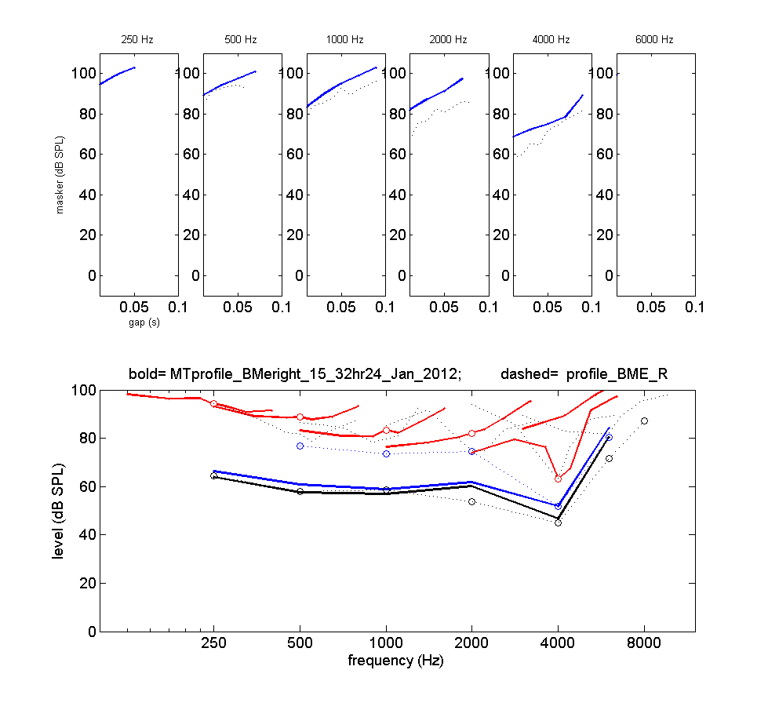

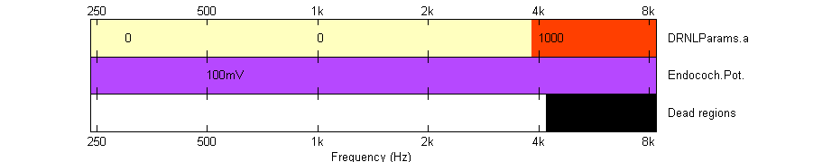
Suggestions:
- Try to model without dead regions, just DRNLParams.a instead at 0
- 8ms/500ms

CFO_R

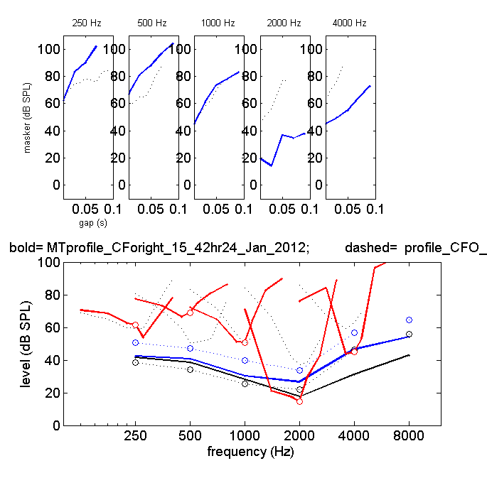
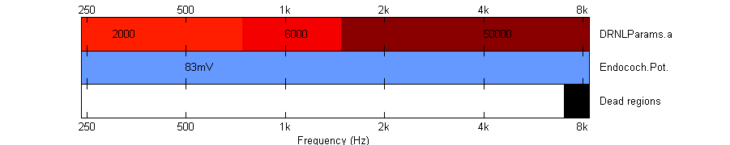
Suggestions:
- 8ms/500ms

CWA_L
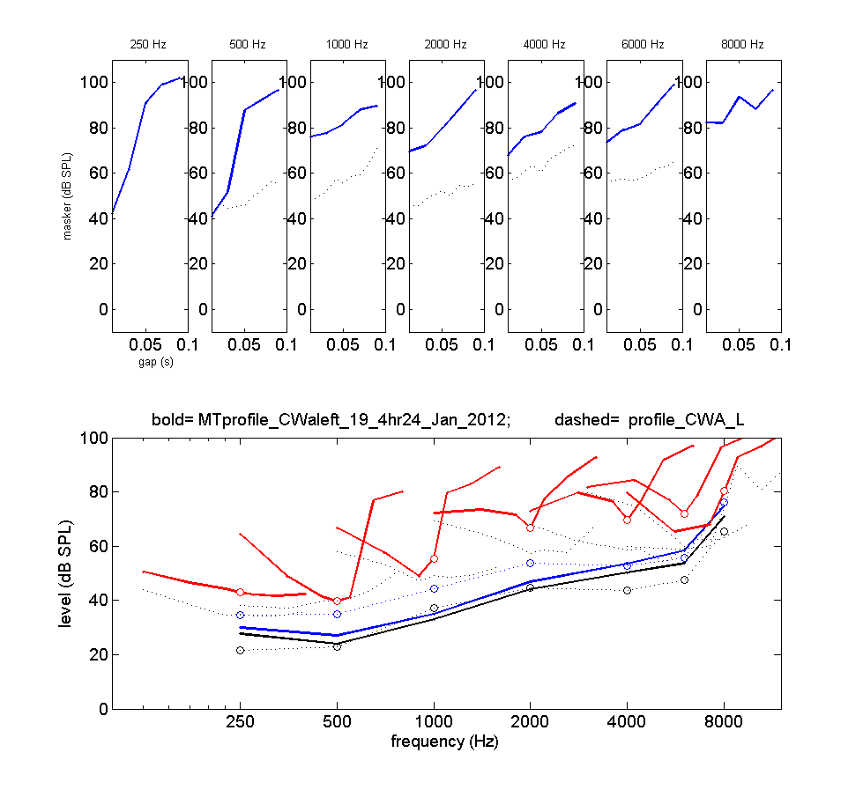

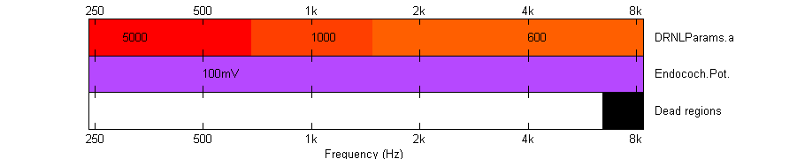
Suggestions:
- Set DRNLParams.a = 0 at 8000Hz instead of dead regions
- 8ms/500ms

DBR_R
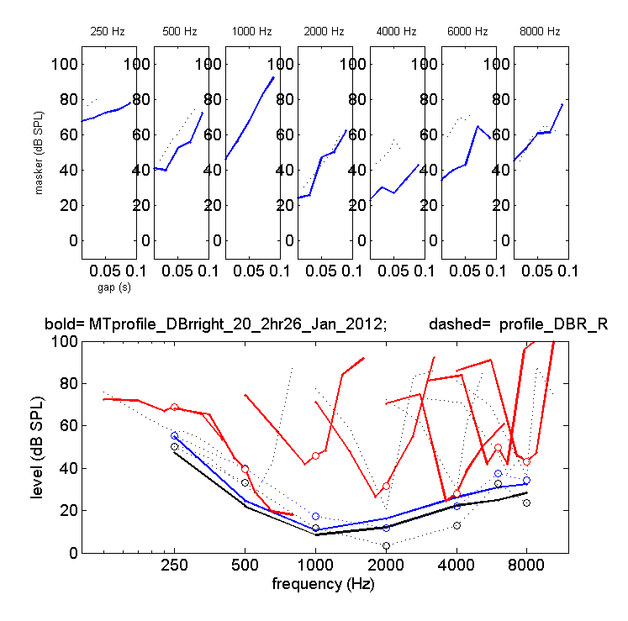
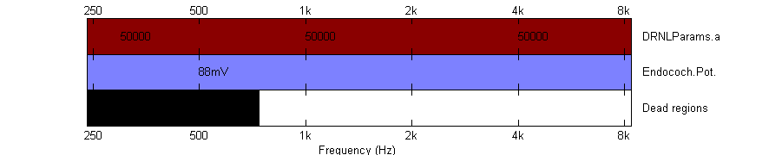
Suggestions:
- Try to model without endocochlear potential reduction, perhaps only with DRNLParams.a frequency-dependent
- 16ms/250ms
DJE_L
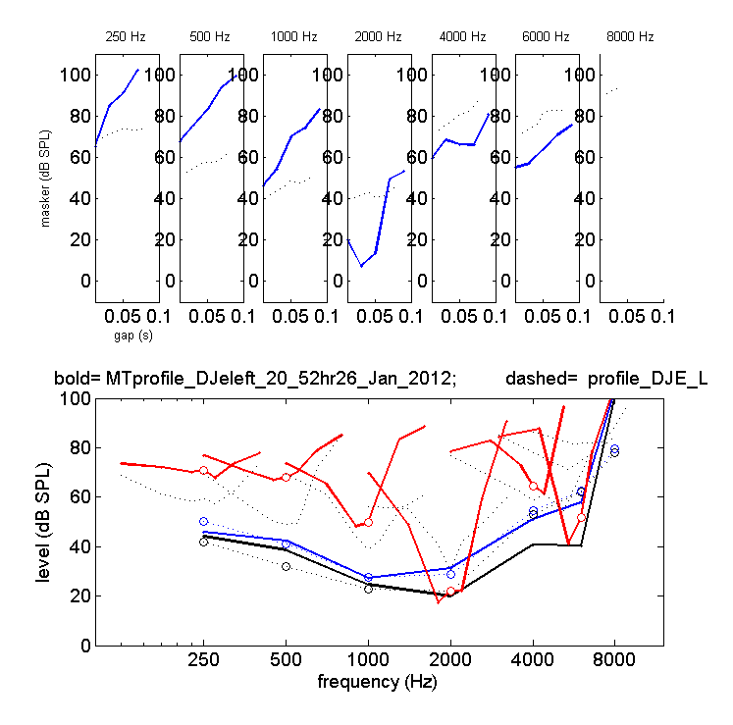
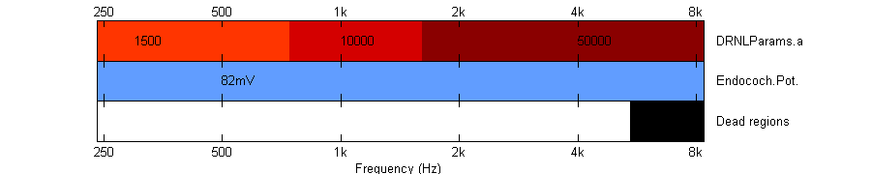
Suggestions:
- Try to model without endocochlear potential reduction, perhaps only with DRNLParams.a frequency-dependent
- 16ms/250ms
DLE_R
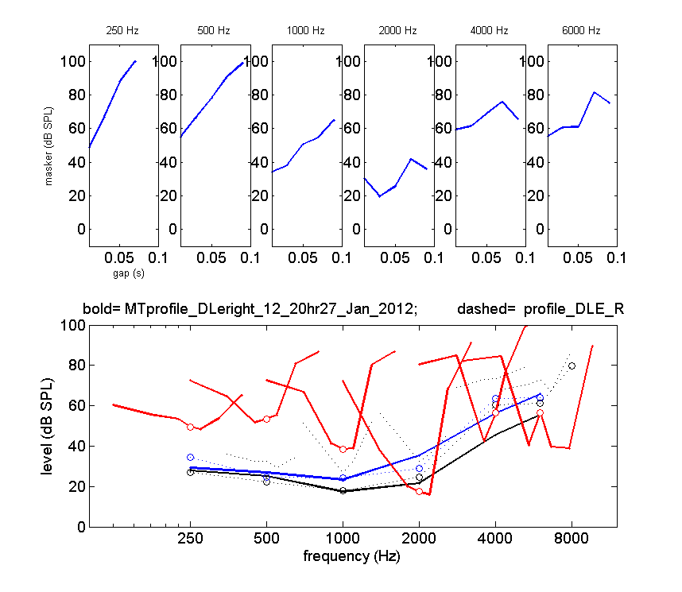

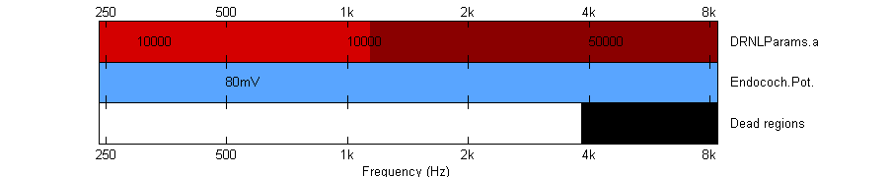
Suggestions:
- Dont model! TMCs are missing.
- 16ms/250ms

DPA_L

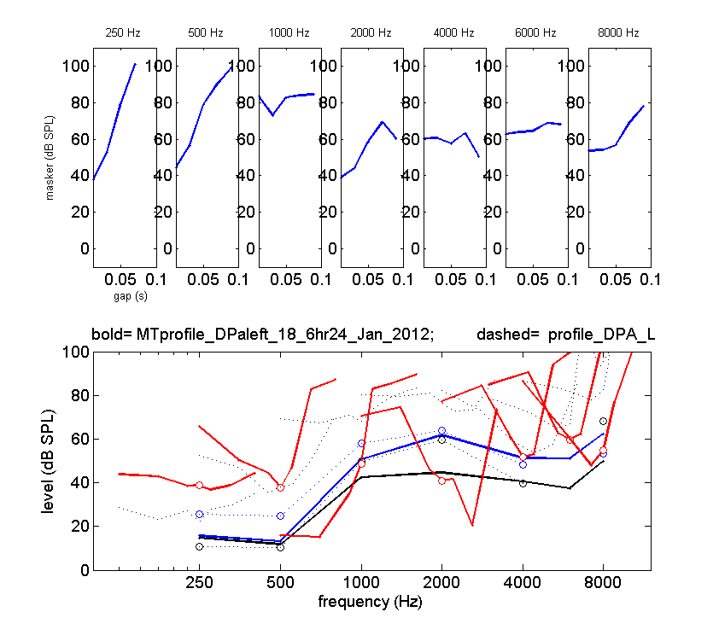

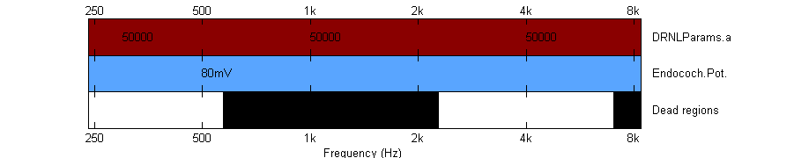
Suggestions:
- Dont model! TMCs are missing.
- 8ms/100ms
DPE_L

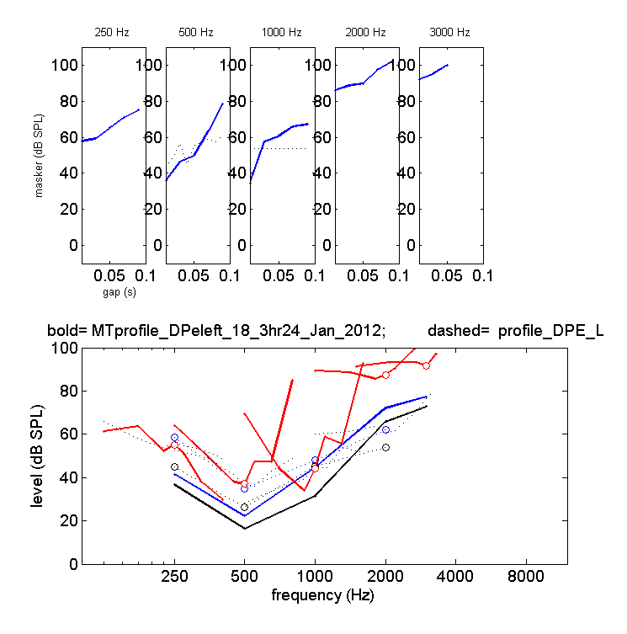

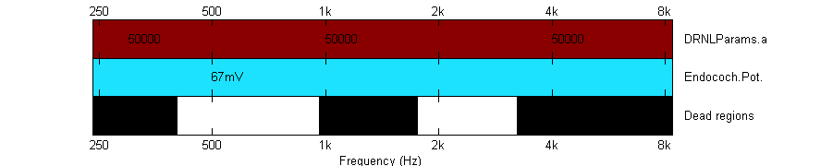
- 8ms/500ms
ECR_L

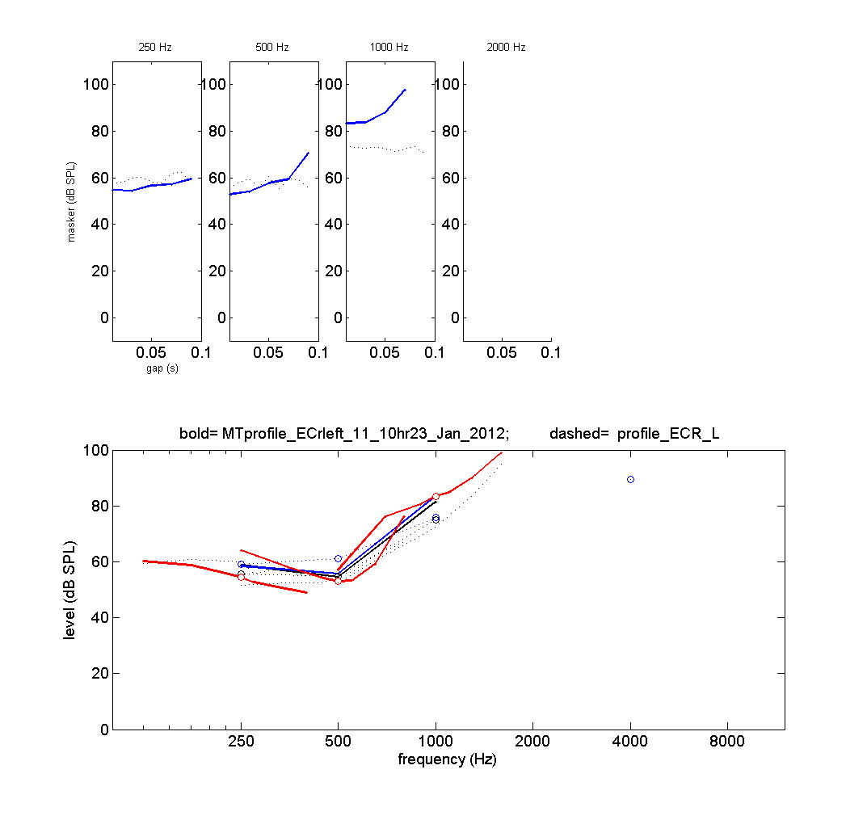

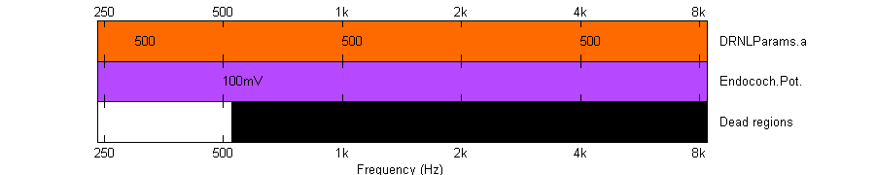
- 8ms/500ms
- Th0 was increased for this. This has to be reviewed when modelling again
GJO_R

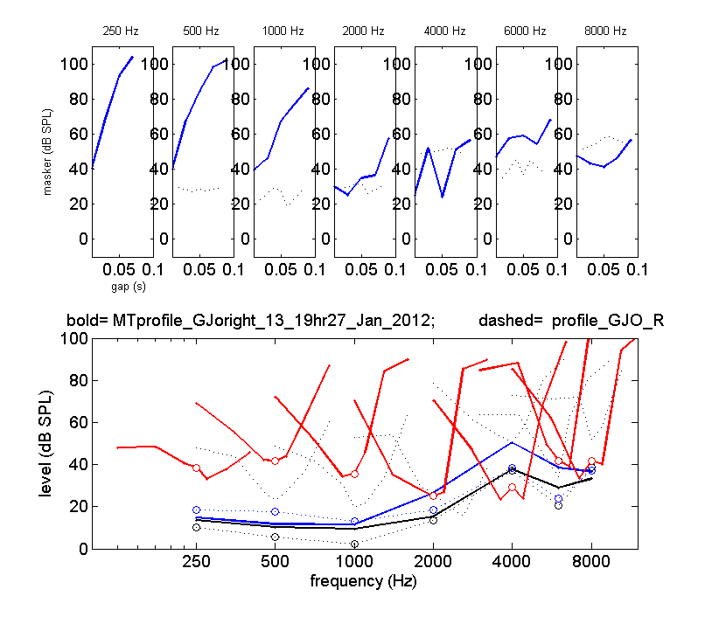

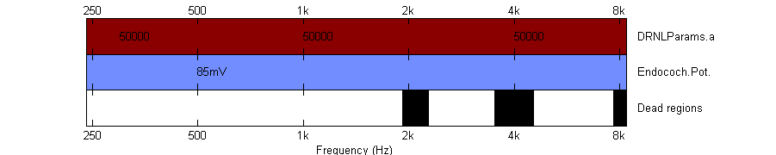
Suggestions:
- Try to model only with dead regions
- 16ms/250ms
HBO_R

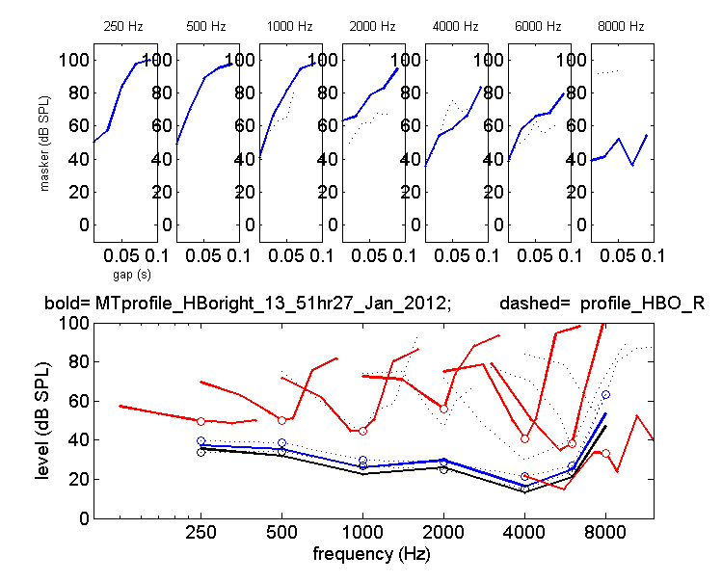

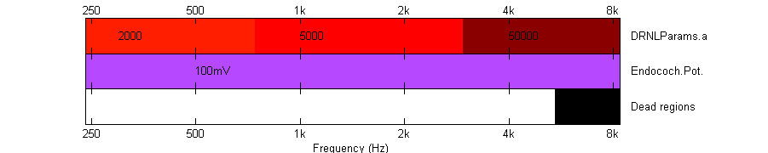
Suggestions:
- Try to model only with DRNLParams.a
- 16ms/250ms

INE_L

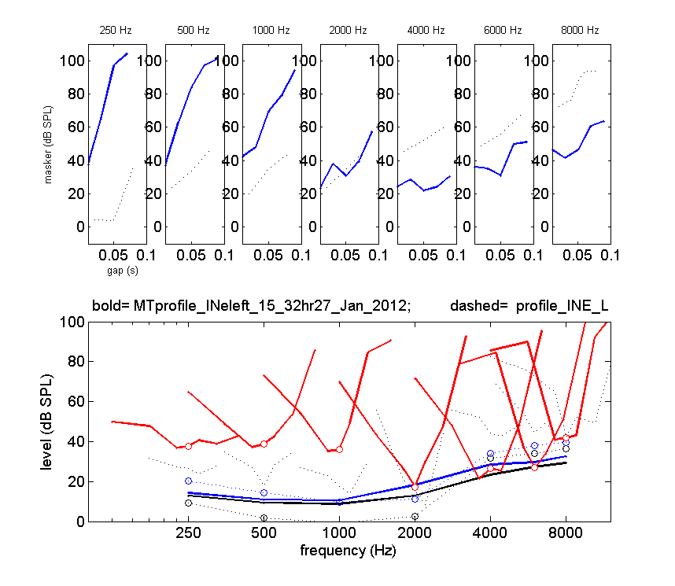

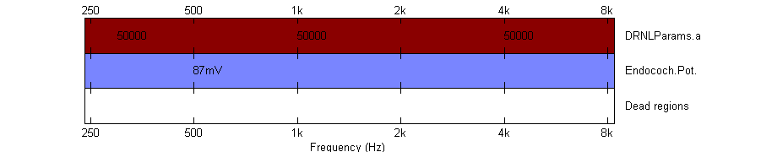
Suggestions:
- Model with a slightly higher endocochlear potential reduction
- 16ms/250ms

JDO_R
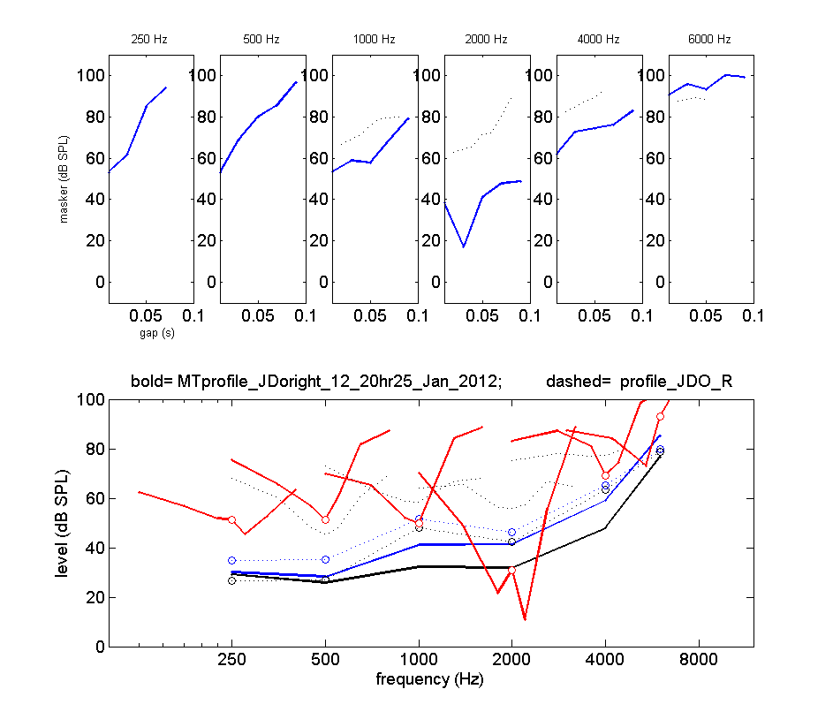

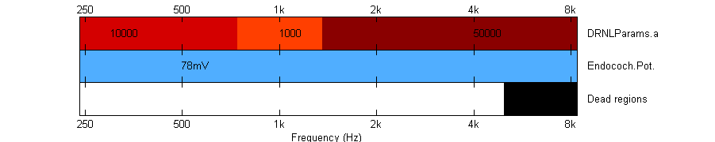
Suggestions:
- Model with a slightly higher endocochlear potential reduction, try to avoid DRNLParams.a
- 16ms/250ms

JFI_R
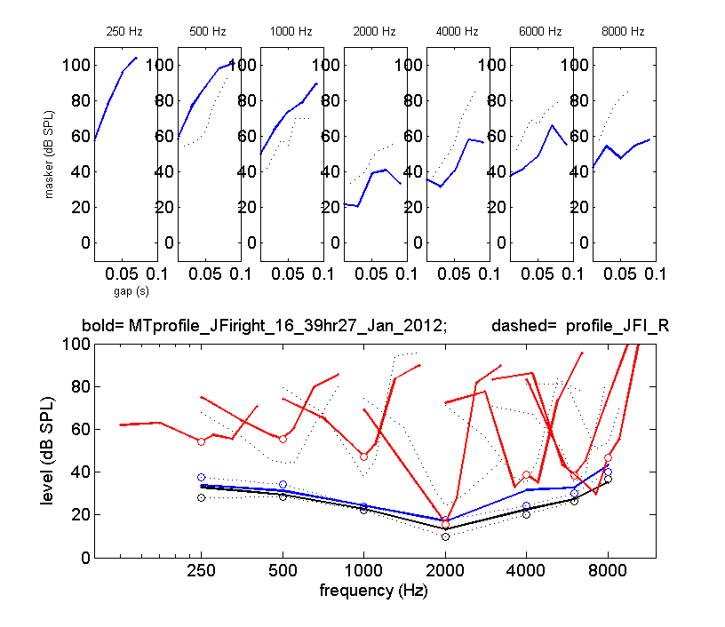

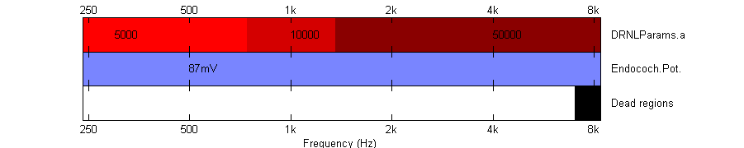
- 16ms/250ms

JFL_R

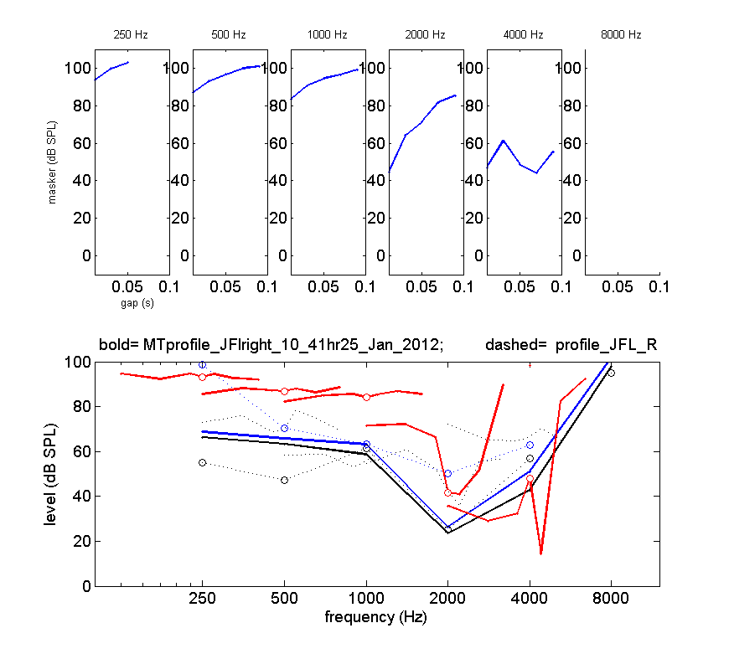

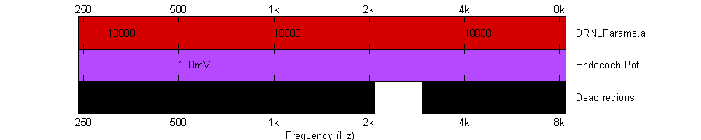
- Dont model, TMCs are missing
- 8ms/500ms

JHO_L
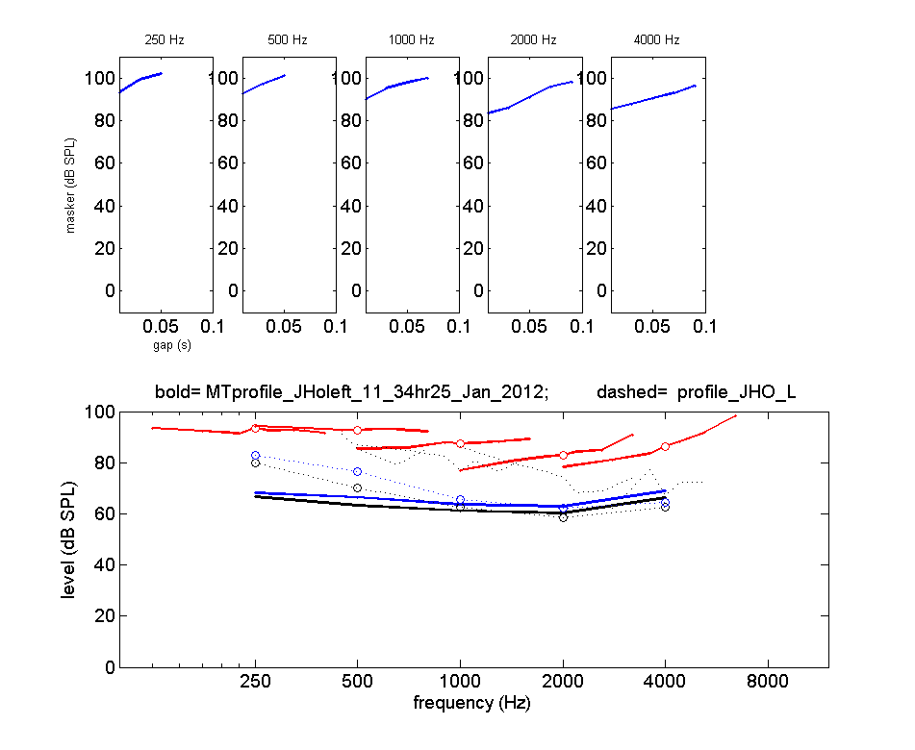

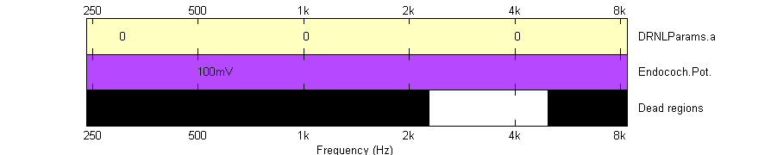
- 16ms/250ms

JJO_L
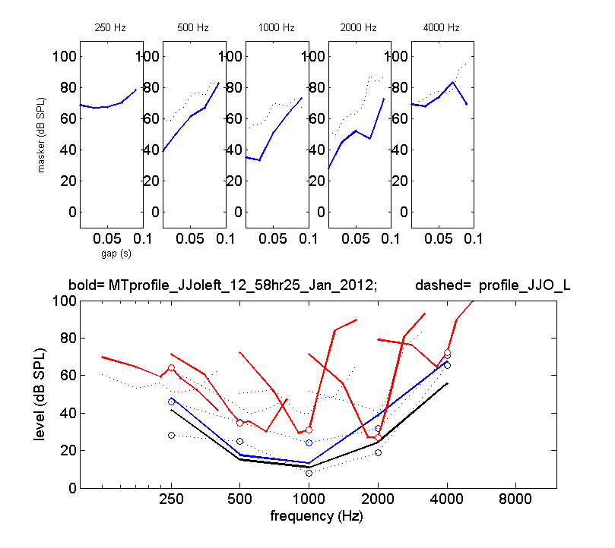

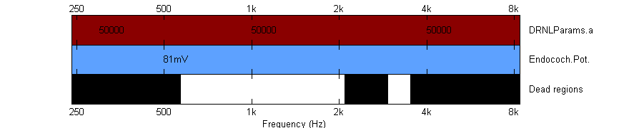
Suggestions:
- Is endocochlear potential reduction really necessary?
- 8ms/500ms

JPA_R
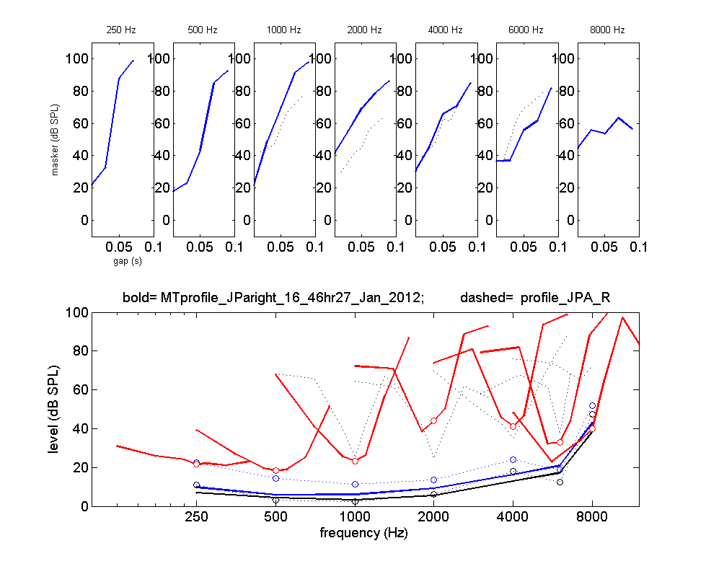

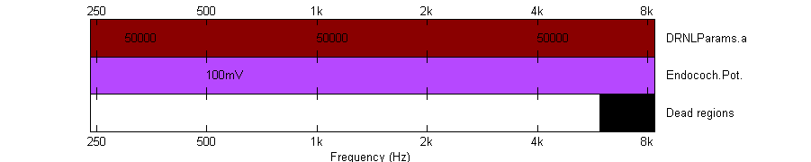
- 16ms/250ms

JPR_L
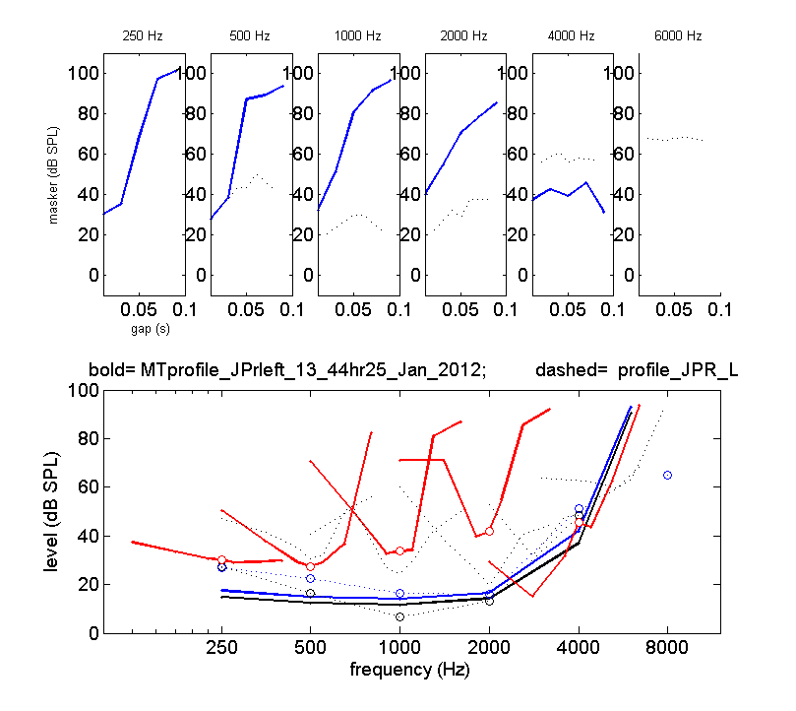

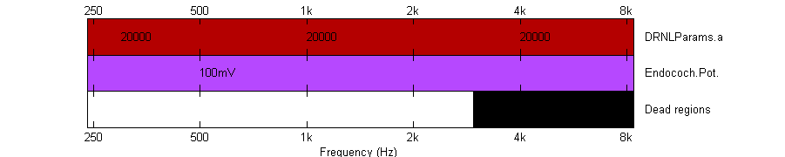
- 16ms/250ms
- Try to model without dead regions, just DRNLParams.a frequency-dependent

JSA_L
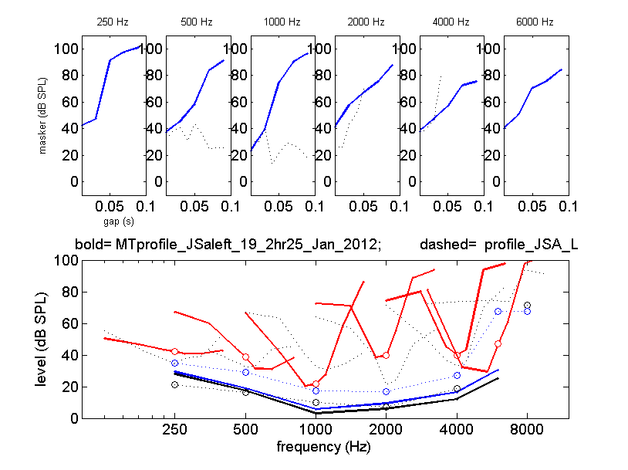

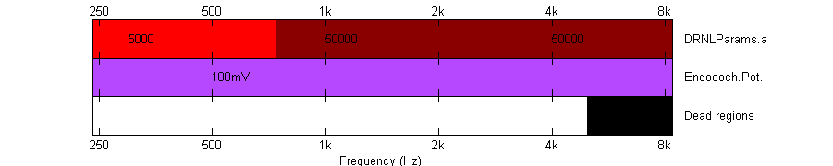
- 8ms/500ms
- Try to model without dead regions, just DRNLParams.a frequency-dependent

JSI_L

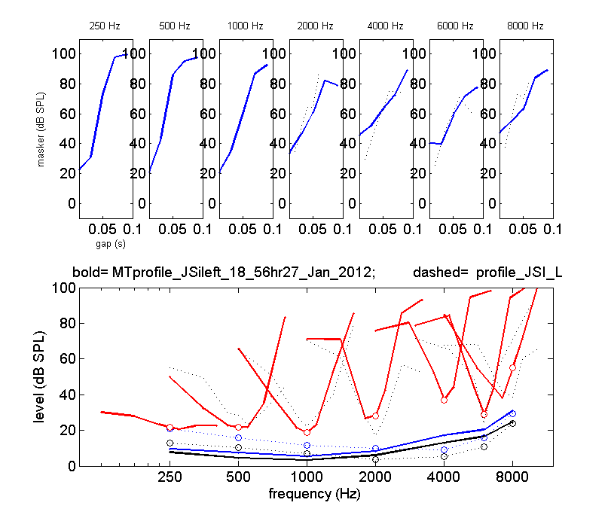

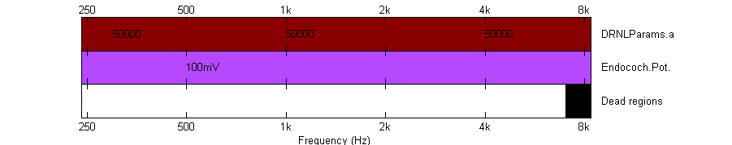
- 16ms/250ms

JTH_R
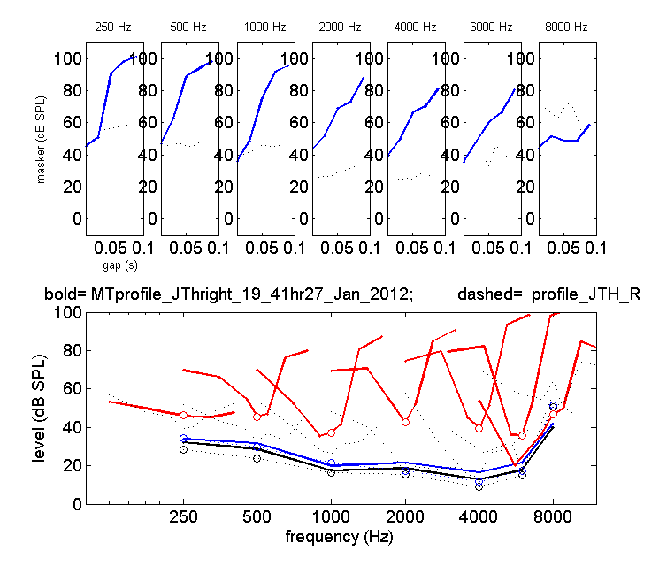

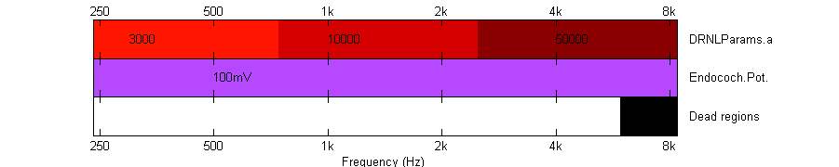
- 16ms/250ms
- Avoid dead regions, just DRNLParams.a change

KBE_L
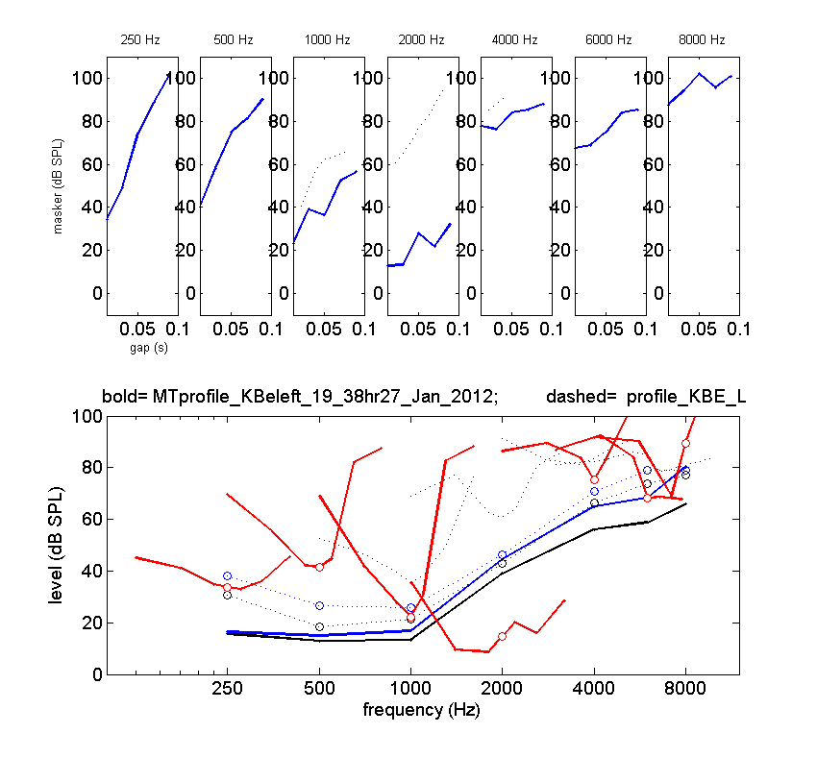

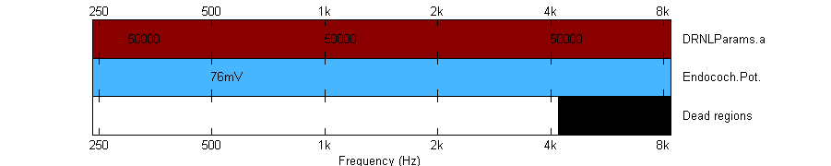
- Extend dead region to also the 4 kHz channel and keep it at the 250 Hz channel
- 16ms/250ms

KBR_L
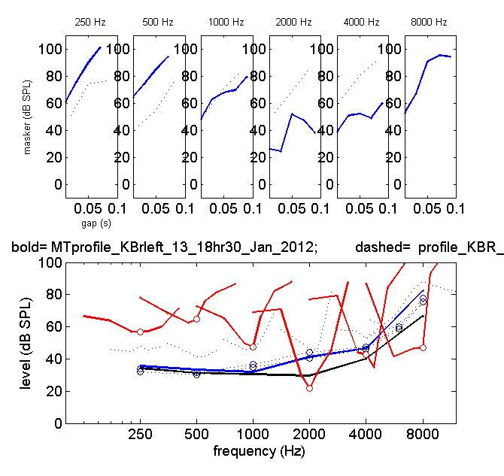

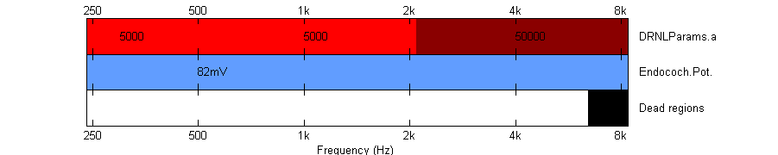
- 16ms/250ms
- Try to avoid dead region and set DRNLParams.a to zero in that region

KFR_R
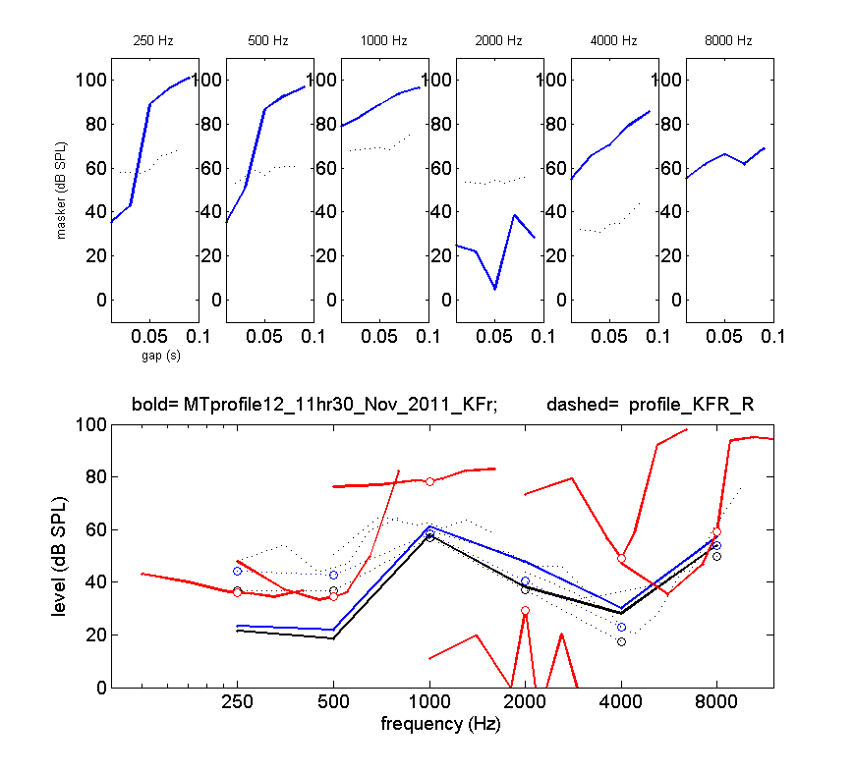

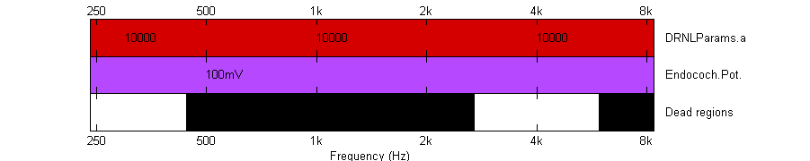
Suggestions:
- Look at Manasa’s solution
- A-only and dead-only solution!
- 16ms/250ms
KJO_L

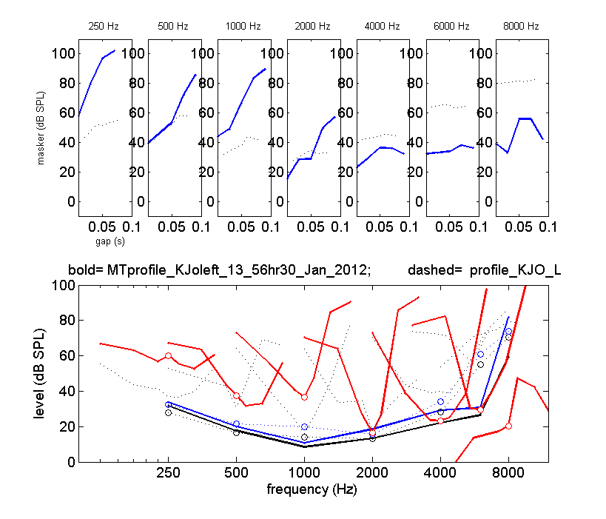

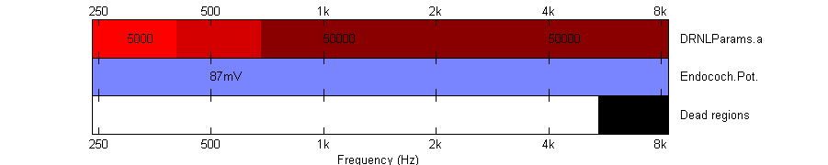
Suggestions:
- 16ms/250ms

LAD_R
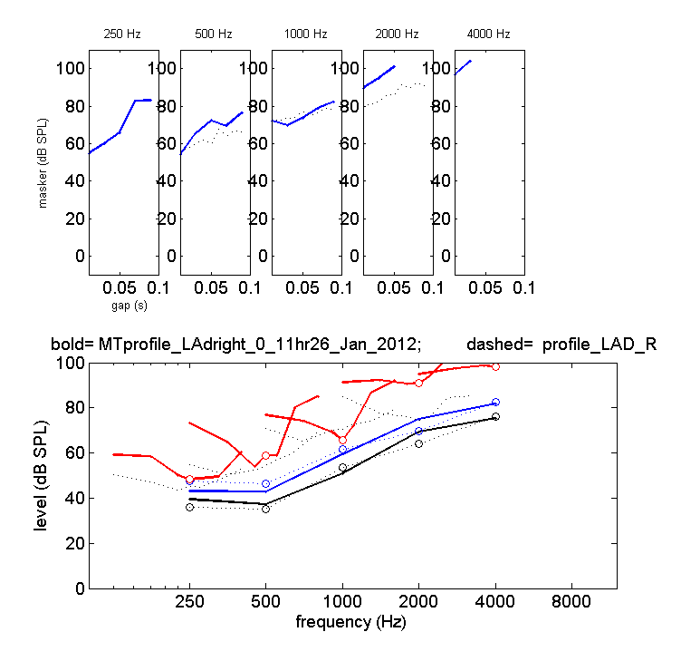
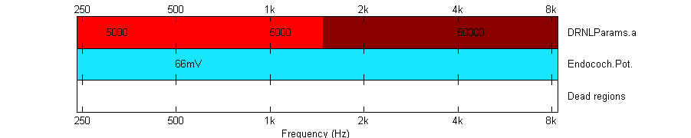
Suggestions:
- Try a-only solution
- 8ms/500ms

LBR_L
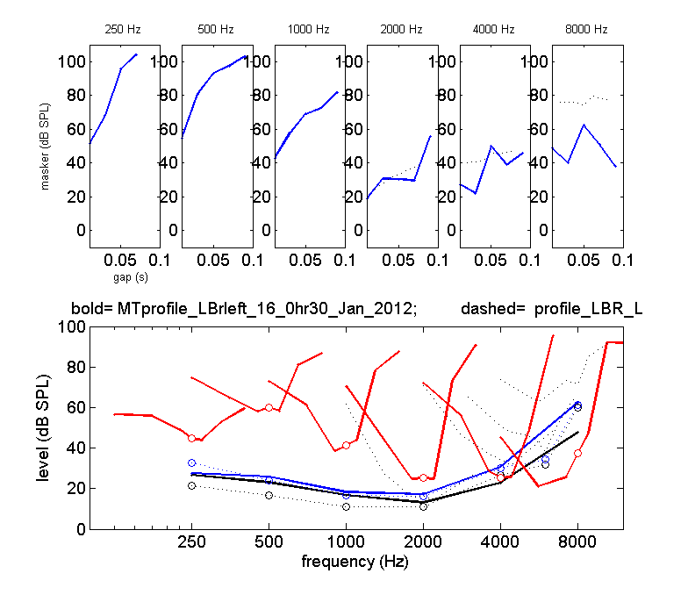

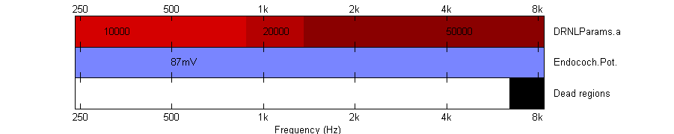
- 16ms/250ms
- Try to set DRNLParams.a to zero at 8000 Hz and avoid dead regios

LKE_R
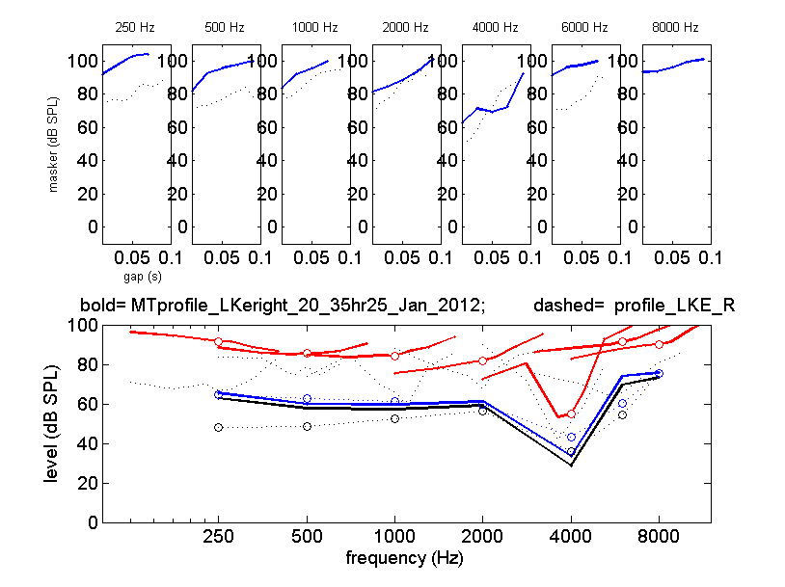

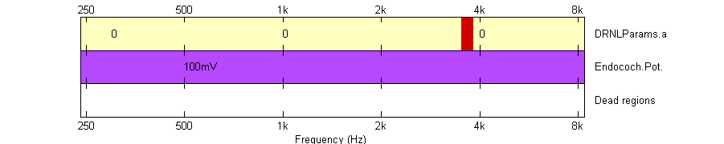
Suggestions:
- 8ms/500ms

MFR_L
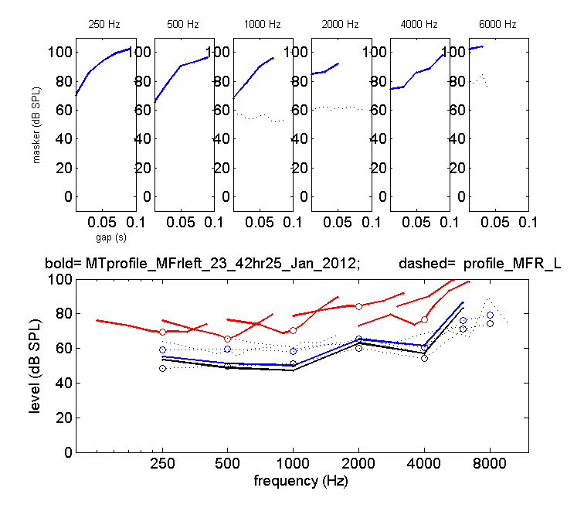

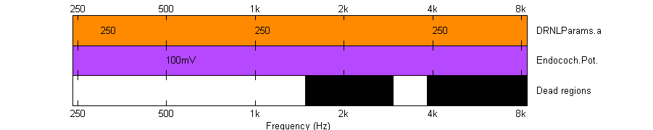
Suggestions:
- 8ms/500ms
- Try to avoid dead regions and set DRNLParams.a to zero from 4000 Hz onwards

MNO_L
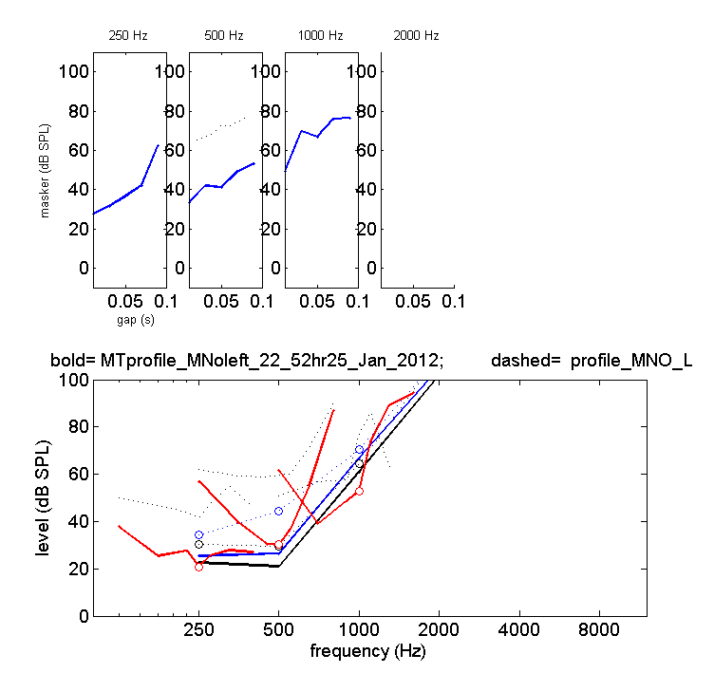
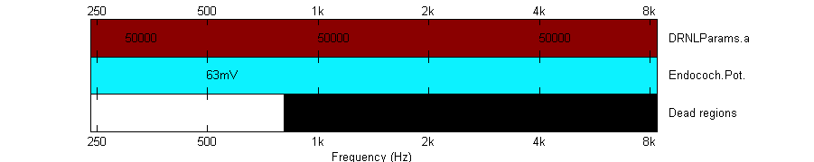
Suggestions:
- Maybe bigger drop in Et without dead regions
- 16ms/250ms

PBU_L
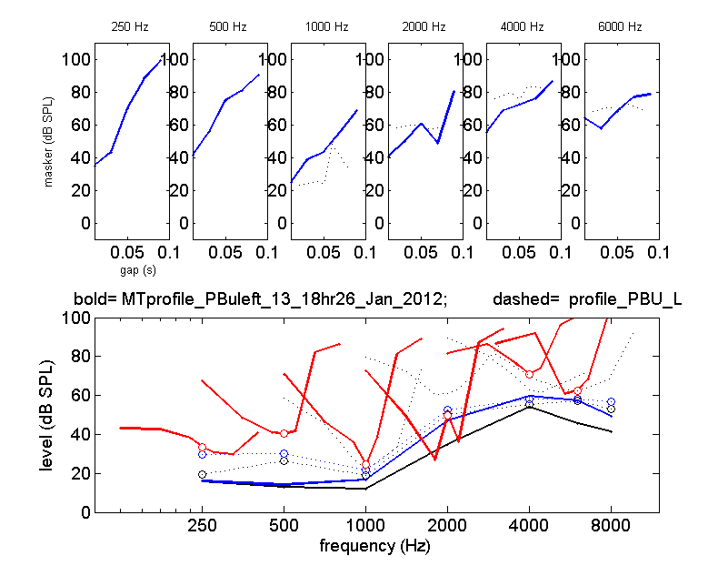

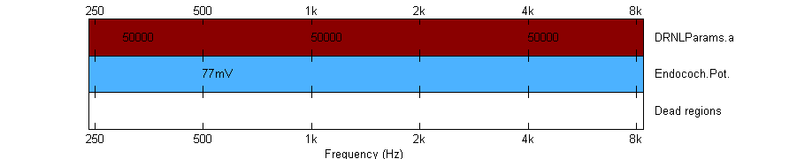
Suggestions:
- Good, model again and try to find out what goes wrong at 2000 Hz (this is nearly everywhere)
- 16ms/250 ms

POS_L
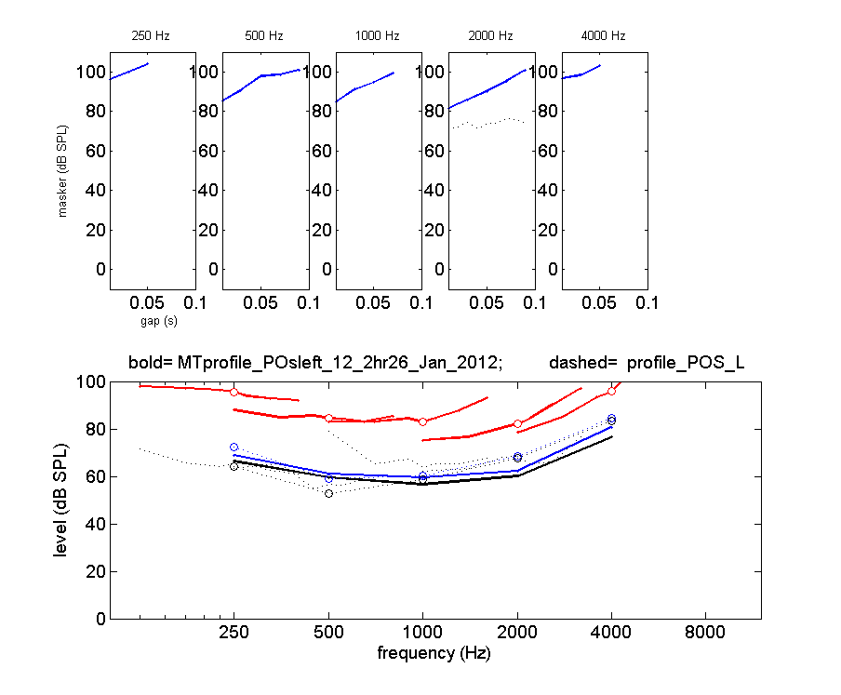

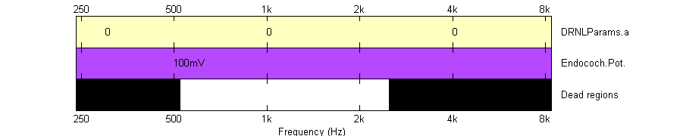

- 8ms/500 ms

PRO_L
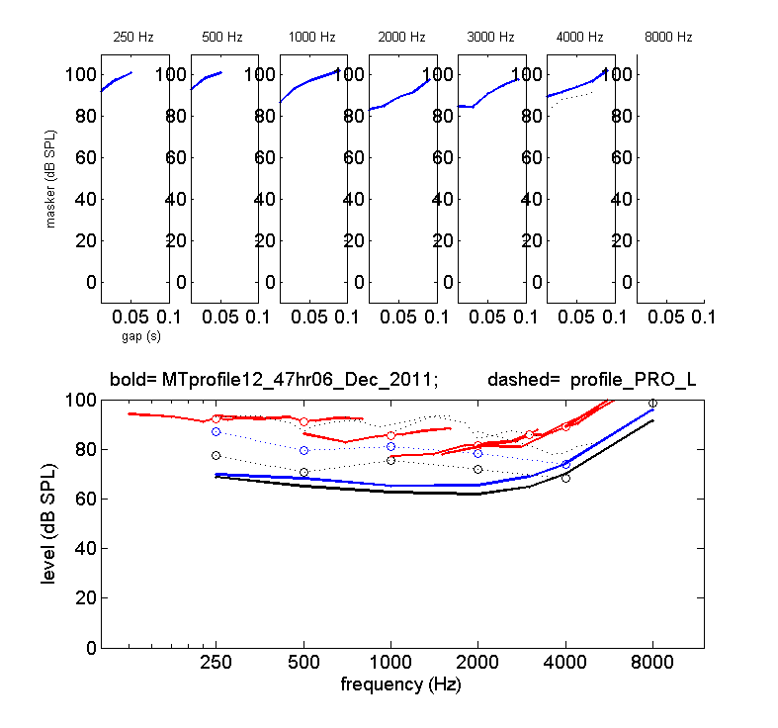

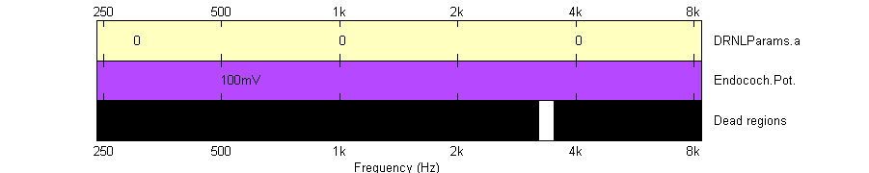
Suggestions:
- Try to model again when perhaps IFMCs are closer to absolute threshold
- 8ms/500ms
PTO_R
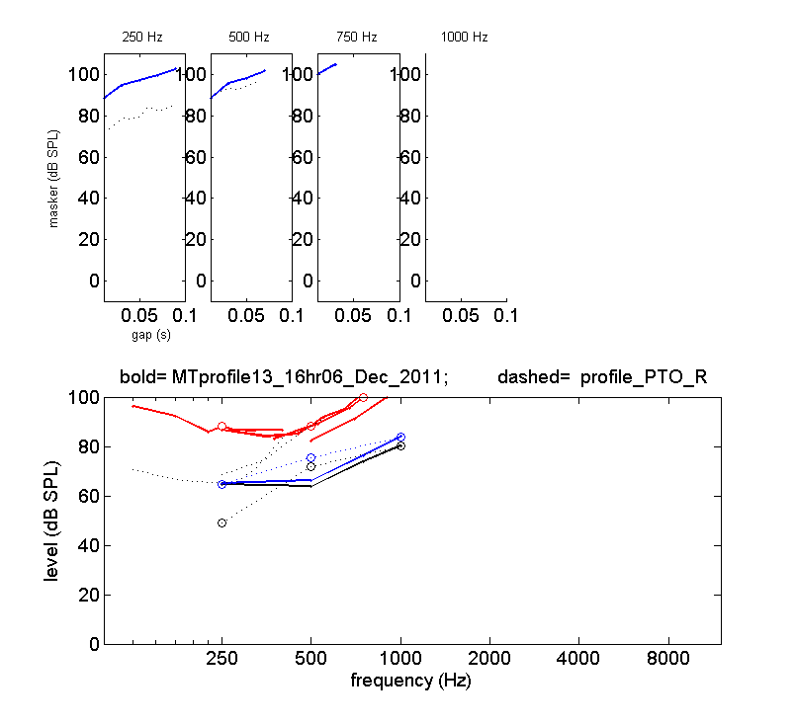

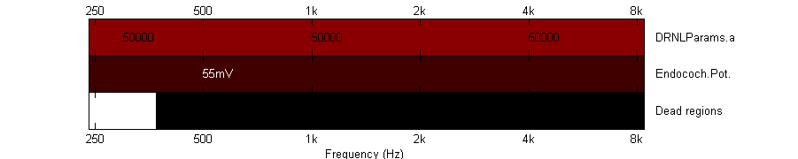
- 8ms/500ms
- Try to model without dead regions

RBL_L
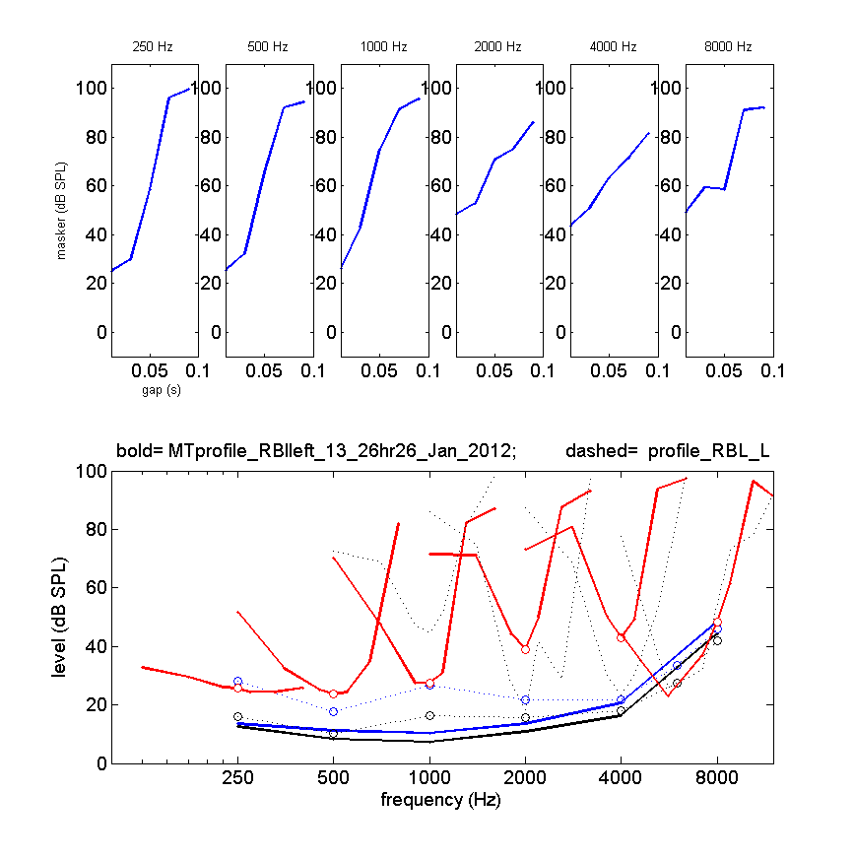

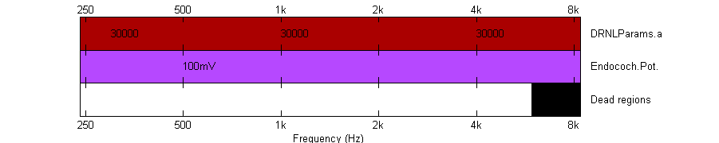
- Dont model, TMCs are missing
- 16ms/250ms
- If modeling, try to avoid dead region, rather set DRNLParams.a to zero
RME_R
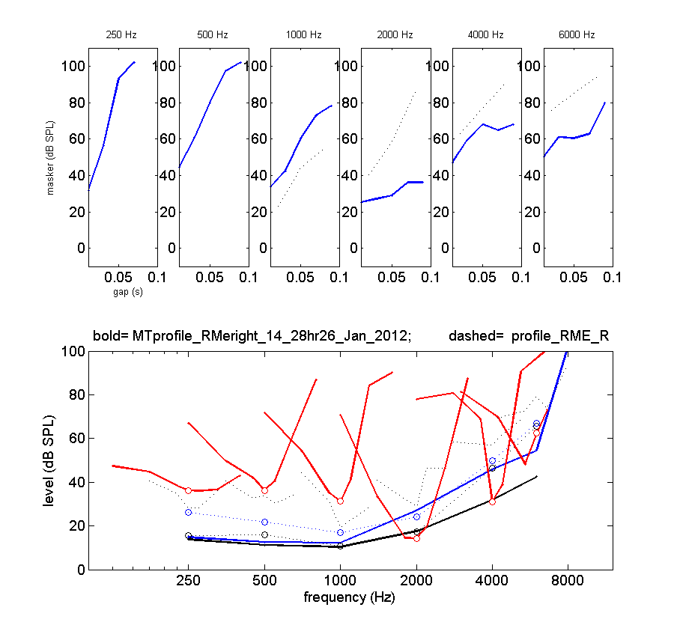

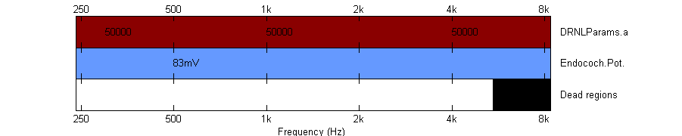
- 16ms/250ms
- Lower Et a little bit

SFO_R
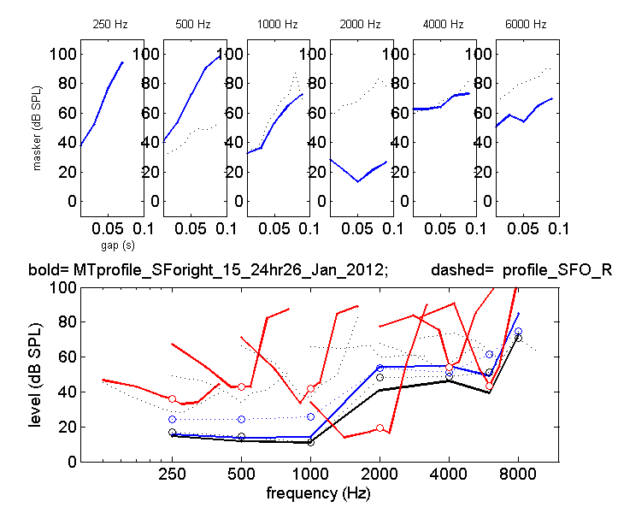

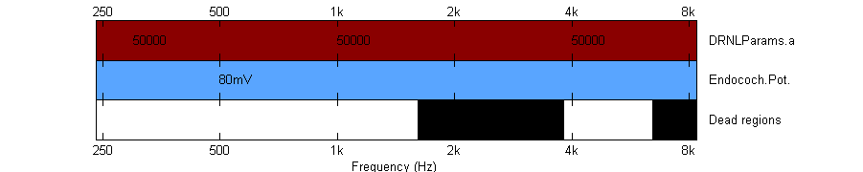
Suggestions:
- More DRNLA problem than an endo-problem
- 8ms/500ms

