Neutron Reproduction Factors
  - Selected nuclear fuels, evaluated with JEFF-4.0 (2025) nuclear data
Johann van Rooyen
2026-10-22
Table of contents

1. Introduction
This notebook accompanies an introductory course on the four-factor formula for the infinite multiplication factor,
$$k_{∞}=η f p ε,$$
as it is taught to nuclear reactor operators. It concentrates on the one factor that is fixed by the nuclear fuel itself: the neutron reproduction factor $η$.
When a nucleus of a nuclear fuel absorbs a neutron, one of two things happens: the nucleus fissions and releases on average $\overset{‾}{ν}$ new neutrons, or it simply captures the neutron and gets rid of the excitation energy by emitting γ-rays. The neutron reproduction factor $η$ counts the net result: the average number of fission neutrons emitted per neutron absorbed in the fuel. For a single nuclide and a neutron of energy $E$,
$$η(E)=\frac{\overset{‾}{ν}(E) σ_{f}(E)}{σ_{a}(E)}=\frac{\overset{‾}{ν}(E) σ_{f}(E)}{σ_{f}(E)+σ_{γ}(E)}=\frac{\overset{‾}{ν}(E)}{1+α(E)}, α(E)=\frac{σ_{γ}(E)}{σ_{f}(E)}, (1)$$
where $σ_{f}$ is the (n,f) fission cross section, $σ_{γ}$ the (n,γ) radiative-capture cross section, $σ_{a}=σ_{f}+σ_{γ}$ the absorption cross section and $α$ the capture-to-fission ratio. For the actinides other absorption channels, such as (n,p) or (n,α), are negligible.
Equation 1 shows that $η$ is $\overset{‾}{ν}$ “taxed” by capture: every capture is a neutron lost without producing a fission.
This notebook
- reads evaluated JEFF-4.0 pointwise cross sections $σ_{f}(E)$, $σ_{γ}(E)$ and fission-neutron yields $\overset{‾}{ν}(E)$ for ten isotopes of uranium and plutonium, $​^{238}Pu$ included, and checks the data,
- builds and plots $η(E)$ from ${10}^{−5}$ eV to 20 MeV,
- averages $η$ over a thermal reactor spectrum and over the fission spectrum. Every integral is split into one sub-integral per decade of energy, evaluated with an exact quadrature rule, and every result is given with its 1σ numerical error,
- calculates the thermal $η$ that enters the four-factor formula - for pure nuclides and for low-enriched uranium - works through a $k_{∞}$ example and shows how $η$ changes with the moderator temperature, and
- explains why a sphere of $​^{238}Pu$ metal can become critical with comparative ease (Section 10).

2. Theory: the four- and six-factor formulae

2.1 The neutron life cycle
A chain reaction is self-sustaining when every generation of neutrons produces, on average, exactly as many neutrons in the next generation. This is expressed by the effective multiplication factor
$$k_{eff}=\frac{\text{number of neutrons in generation }i+1}{\text{number of neutrons in generation }i}, (2)$$
with $k_{eff}<1$ subcritical, $k_{eff}=1$ critical and $k_{eff}>1$ supercritical.
Follow one generation of $N$ fast neutrons, born in fission, through a thermal reactor:
- Fast fission, $ε$. A few fast neutrons cause fission in $​^{238}U$ (and other fissionable nuclides) before they slow down: $N→εN$ fast neutrons, with $ε$ slightly above 1.
- Fast non-leakage, $P_{FNL}$. Some fast neutrons leak out of the core while slowing down.
- Resonance escape, $p$. While slowing down through the resonance region (about 1 eV to 10 keV) some neutrons are captured in the large capture resonances of $​^{238}U$; the fraction $p$ escapes capture and becomes thermal.
- Thermal non-leakage, $P_{TNL}$. Some thermal neutrons diffuse out of the core.
- Thermal utilisation, $f$. Of all thermal neutrons absorbed in the core, only the fraction $f$ is absorbed in the fuel; the rest is absorbed in moderator, coolant, cladding, structural material, control rods, soluble boron and fission-product poisons.
- Reproduction, $η$. Every thermal neutron absorbed in the fuel produces $η$ new fast neutrons - and the cycle starts again.

2.2 The six-factor and four-factor formulae
The product of the six factors is the six-factor formula
$$k_{eff}=η f p ε P_{FNL} P_{TNL}, (3)$$
and for an infinitely large core, where nothing leaks out ($P_{FNL}=P_{TNL}=1$), the four-factor formula
$$k_{∞}=η f p ε. (4)$$
The non-leakage probabilities depend on the size and shape of the core through the geometric buckling $B^{2}$. In modified one-group diffusion theory $P_{FNL}≈exp\left(−B^{2}τ\right)$ and $P_{TNL}≈1/\left(1+L^{2}B^{2}\right)$, where $τ$ is the Fermi age (the slowing-down area) and $L$ the thermal diffusion length.
Table 1: The six factors of the neutron life cycle; the values are indicative ranges only.
Factor | Physical meaning | Determined by | Indicative value, large LWR core
$η$​ | fission neutrons per thermal neutron absorbed in fuel | fuel nuclides, spectrum | 1.8 - 2.0
$f$​ | fraction of thermal absorptions that occur in fuel | fuel / moderator / absorber amounts | 0.7 - 0.95
$p$​ | probability to escape resonance capture | fuel-to-moderator ratio, lattice geometry | 0.6 - 0.9
$ε$​ | gain from fast fission | fuel lattice | 1.02 - 1.08
$P_{FNL}$​ | fast neutrons that do not leak out | core size and reflector | 0.95 - 0.98
$P_{TNL}$​ | thermal neutrons that do not leak out | core size and reflector | 0.98 - 0.995

2.3 Reactivity
Operators rarely work with $k$ itself, but with the reactivity
$$ρ=\frac{k−1}{k}, (5)$$
usually expressed in pcm ($1 pcm={10}^{−5}$). Because $k$ is a product of factors, small relative changes of the factors simply add up:
$$\frac{Δk}{k}≈\frac{Δη}{η}+\frac{Δf}{f}+\frac{Δp}{p}+\frac{Δε}{ε}, (6)$$
and near criticality $Δρ≈Δk/k$. A useful rule of thumb follows: near criticality, a 1 % change of any one factor is worth about 1000 pcm (demonstrated in Section 9.3).

2.4 What the operator changes
Table 2: How operating actions and phenomena act on the factors of the four-factor formula.
Action or phenomenon | Factor mainly affected | Effect on $k$
Boration / dilution of the coolant (soluble boron) | $f$​ | boration lowers $k$, dilution raises it
Control-rod insertion | $f$ (and leakage) | lowers $k$
Fuel temperature rise (Doppler broadening of the $​^{238}U$ resonances) | $p$​ | lowers $k$ promptly: negative fuel temperature coefficient
Moderator temperature rise (lower water density, warmer thermal neutrons) | $p$ and leakage; $f$ rises if much boron is dissolved; $η$ of $​^{239}Pu$ falls | usually lowers $k$: negative moderator temperature coefficient
Xenon-135 and samarium-149 build-up | $f$​ | lowers $k$
Fuel burnup ($​^{235}U$ consumed, plutonium and fission products built up) | $η$ and $f$ | lowers $k$ over the cycle

2.5 Why $η$ is special
- $η$ is the only factor that is fixed by the nuclear properties of the fuel (and the neutron spectrum). All other factors are set by the design and the operating state: moderator-to-fuel ratio, lattice geometry, materials, boron, control rods and temperatures.
- Because $f$, $p$ and the non-leakage probabilities can never exceed 1 and $ε$ is only slightly larger than 1, $η$ sets an upper bound: $k_{∞}≤η ε$. A fuel with $η<1$ can never sustain a thermal chain reaction, however clever the design.
- In the four-factor formula $η$ refers to thermal neutrons: absorption in the resonances of $​^{238}U$ is already counted in $p$, and fission by fast neutrons in $ε$. The $η$ of the four-factor formula is therefore the reproduction factor of the thermal group ($E<0.625$ eV), calculated in Section 9.
- $\overset{‾}{ν}$ counts neutrons per fission, $η$ counts neutrons per absorption. $​^{239}Pu$ has a much larger $\overset{‾}{ν}$ than $​^{235}U$ at thermal energies (2.87 versus 2.44), but it also captures many more thermal neutrons ($α≈0.36$ versus 0.17). Its thermal $η$ (2.11) is therefore hardly better than that of $​^{235}U$ (2.08) and clearly worse than that of $​^{233}U$ (2.30, with $α≈0.085$). These values are calculated from the JEFF-4.0 data in Section 6.4.

2.6 $η$ of a fuel mixture
Real fuel contains several nuclides $i$ with atom densities $N_{i}$. Production and absorption rates add up, so
ηfuel=i​Ni νi σf,ii​Ni σa,i. (7)
For uranium with a $​^{235}U$ atom fraction $e$, and neglecting the tiny thermal fission cross section of $​^{238}U$,
$$η_{U}(e)≈\frac{{\overset{‾}{ν}}^{235} σ_{f}^{235}}{σ_{a}^{235}+\frac{1−e}{e} σ_{a}^{238}}. (8)$$
The $​^{238}U$ term in the denominator “dilutes” the fuel: natural uranium has a thermal $η$ of only about 1.33, uranium with 4 % $​^{235}U$ about 1.89 (Section 9.2). With $η≈1.33$ the product $f p ε$ must exceed about 0.75 - which is why natural-uranium reactors need excellent moderators such as heavy water or graphite.

2.7 Breeding: why $η$ must exceed 2
Consider the fate of the $η$ neutrons produced per neutron absorbed in fissile fuel. One of them must be absorbed in fissile fuel again to keep the chain going. To replace the fissile nucleus that was just destroyed, a second neutron must be captured in fertile material: $​^{238}U(n,γ)$ leads to $​^{239}Pu$, and $​^{232}Th(n,γ)$ leads to $​^{233}U$. The remainder, $L$ per absorption, is lost by leakage and by parasitic capture in coolant, structure, control material and fission products. Neglecting the small bonus from fast fission in fertile material, the conversion ratio (fissile atoms produced per fissile atom destroyed) is approximately
$$C≈η−1−L, (9)$$
and breeding ($C>1$; $C$ is then called the breeding ratio) requires
$$η>2+L. (10)$$
Since the losses $L$ are never zero, $η$ must exceed 2 by a clear margin. In a thermal spectrum only $​^{233}U$ (thermal $η≈2.3$) leaves such a margin - demonstrated with the thorium / $​^{233}U$ fuel of the Shippingport Light Water Breeder Reactor (1977 - 1982). In a fast spectrum the $η$ of $​^{239}Pu$ rises to about 3 (Table 4), the basis of the fast breeder reactor.

2.8 Averaging $η$ over a neutron spectrum
In a reactor the neutrons have a whole distribution of energies, described by the neutron fluence rate per unit energy $φ(E)$, in $MeV^{−1} cm^{−2} s^{−1}$. The physically meaningful spectrum-averaged reproduction factor is a ratio of reaction rates: the production rate of fission neutrons divided by the absorption rate,
$$⟨η⟩=\frac{∫\overset{‾}{ν}(E) σ_{f}(E) φ(E) dE}{∫σ_{a}(E) φ(E) dE}=\frac{∫η(E) σ_{a}(E) φ(E) dE}{∫σ_{a}(E) φ(E) dE}. (11)$$
The second form shows that $η(E)$ must be weighted with the absorption rate $σ_{a}(E) φ(E)$. A tempting simplification is the plain flux-weighted mean
$$⟨η⟩_{φ}=\frac{∫η(E) φ(E) dE}{∫φ(E) dE}, (12)$$
which weights $η(E)$ by where the neutrons are instead of by where they are absorbed. The two agree when $η(E)$ varies little over the spectrum - as for the fissile nuclides in a thermal spectrum - but can differ enormously otherwise. For $​^{238}U$ in a thermal spectrum almost every absorption is a thermal or resonance capture, so Equation 11 gives nearly zero; Equation 12, however, gives full weight to the few percent of fast flux in which $η(E)$ of $​^{238}U$ exceeds 2. Both averages are calculated in Section 8; Equation 11 is the one that belongs in Equation 4, Equation 3 and Equation 10.

2.9 Fissile and fissionable nuclides
When a target nucleus $​^{A}X$ absorbs a neutron of kinetic energy $E_{n}$, it forms the compound nucleus $​^{A+1}X^{*}$ with excitation energy
$$E^{*}=S_{n}+\frac{A}{A+1} E_{n}, (13)$$
where $S_{n}$ is the neutron separation energy of the compound nucleus. Fission proceeds readily once $E^{*}$ exceeds the fission barrier, which is about 6 MeV for all the compound nuclei considered here. Nuclear pairing makes the difference: a target with an odd number of neutrons forms an even-$N$ compound nucleus and gains the pairing energy as well, so that $S_{n}$ alone exceeds the barrier and even neutrons of zero kinetic energy cause fission.
Table 3: Neutron separation energy of the compound nucleus formed by neutron absorption.
Target | Compound nucleus | $S_{n}$ (MeV) | Class
$​^{233}U$​ | $​^{234}U^{*}$​ | 6.84 | fissile
$​^{235}U$​ | $​^{236}U^{*}$​ | 6.55 | fissile
$​^{239}Pu$​ | $​^{240}{Pu}^{*}$​ | 6.53 | fissile
$​^{241}Pu$​ | $​^{242}{Pu}^{*}$​ | 6.31 | fissile
$​^{238}Pu$​ | $​^{239}{Pu}^{*}$​ | 5.65 | fissionable, strong sub-threshold fission
$​^{240}Pu$​ | $​^{241}{Pu}^{*}$​ | 5.24 | fissionable, fertile
$​^{238}U$​ | $​^{239}U^{*}$​ | 4.81 | fissionable (threshold about 1 MeV), fertile

Even-$N$ targets need extra kinetic energy to fission: they have a fission threshold and are called fissionable; those that turn into fissile nuclides by neutron capture ($​^{238}U$, $​^{240}Pu$, $​^{232}Th$) are also called fertile. The smaller the gap between $S_{n}$ and the barrier, the lower the effective threshold - a point that turns out to be the key to $​^{238}Pu$ (Section 10).

3. Python set-up

3.1 Packages and settings
All warnings are switched on (see the comments in the next cell), so that a numerical problem, or a feature that will be removed from a future version of NumPy, SciPy, pandas or Matplotlib, is reported instead of passing silently.
Working in VS Code. The notebook is written for VS Code with the Jupyter and Quarto extensions. Quarto cross-references (such as Equation 1) and the computed values inside the markdown tables appear as plain text in the notebook view; they are filled in when the notebook is rendered with Render_with_Quarto.cmd. All results are also printed by the code cells.
import os
import math
import warnings
import pandas as pd
import numpy as np
import matplotlib.pyplot as plt
import matplotlib as mpl
from scipy.interpolate import PchipInterpolator # shape-preserving cubic interpolation
from IPython.display import display
# --- Warnings are switched ON -------------------------------------------------
# 'default' shows every warning once per code location - including
# DeprecationWarning and PendingDeprecationWarning, which Python normally hides.
# They announce features that will stop working in future versions of NumPy,
# SciPy, pandas or Matplotlib.
warnings.simplefilter('default')
# Two warnings are purely cosmetic and outside our control. They are silenced
# individually, by their exact message, so that nothing else is hidden:
# * openpyxl: the xlsx files carry no default cell style (Excel formatting only)
warnings.filterwarnings('ignore', message='Workbook contains no default style',
category=UserWarning)
# * matplotlib-inline still uses an old traitlets mechanism (inside the library)
warnings.filterwarnings('ignore', message='.*_figure_formats_changed is deprecated',
category=DeprecationWarning)
import pint
from pint import UnitRegistry
u = pint.UnitRegistry()
u.setup_matplotlib(True)
Q_ = u.Quantity
# Set default parameters:
plt.rc('lines', linewidth=5)
plt.rc('figure', figsize=(12,9))
plt.rc('axes', titlesize=30)
plt.rc('axes', labelsize=26)
plt.rc('legend', fontsize=20)
plt.rc('xtick', labelsize=22)
plt.rc('ytick', labelsize=22)
plt.rc('lines', markersize=14)
# MatPlotLib settings:
%matplotlib inline
# The inline backend is configured programmatically rather than with %config,
# because IPython's line-magic variable expansion treats {...} as a format
# field: `%config InlineBackend.figure_formats = {'svg'}` raises
# "NameError: name 'svg' is not defined". Assigning to the singleton config
# object is the equivalent, quoting-safe form.
#
# * `figure_formats` (a set) supersedes the deprecated singular
# `figure_format` trait.
# * The inline backend crops with bbox_inches='tight' by default (still the
# trait default in matplotlib-inline 0.2.x), which overrides the
# constrained-layout padding and makes the notebook preview differ from the
# saved SVG/PDF files. Disable the crop so display and file output agree.
from matplotlib_inline.config import InlineBackend
_inline_cfg = InlineBackend.instance()
_inline_cfg.figure_formats = {'svg'}
_inline_cfg.print_figure_kwargs = {'bbox_inches': None}
# Matplotlib's print_figure() resolves bbox_inches=None through
# rcParams['savefig.bbox'] (mpl._val_or_rc), so pin that rcParam to make
# "no crop" explicit rather than merely relying on the current default.
plt.rcParams['savefig.bbox'] = None
# Use the 'constrained' layout engine globally (the modern successor to
# tight_layout: it solves the layout at draw time and honours colorbars,
# suptitles and legends placed outside the axes).
plt.rcParams['figure.constrained_layout.use'] = True
plt.rcParams['figure.constrained_layout.w_pad'] = 0.15 # inches, left+right outer pad (default ~0.042)
plt.rcParams['figure.constrained_layout.h_pad'] = 0.15 # inches, top+bottom outer pad (default ~0.042)
plt.rcParams['figure.constrained_layout.wspace'] = 0.02 # fraction of subplot width between axes
plt.rcParams['figure.constrained_layout.hspace'] = 0.02 # fraction of subplot height between axes
# 'dejavuserif' already selects the DejaVu Serif math faces. The
# mathtext.rm / .it / .bf rcParams are consulted ONLY when
# mathtext.fontset == 'custom', so setting them alongside 'dejavuserif' would
# have no effect and is therefore omitted.
mpl.rcParams['font.family'] = ['DejaVu Serif']
mpl.rcParams['mathtext.fontset'] = 'dejavuserif'
labelpad_x = 12
labelpad_y = 8
position_title_y = 1.025
# Line widths:
lw_grid_major = 1.25
lw_grid_minor = 0.75
#
lw_hlines = 2.0
lw_vlines = 2.0
# Colours:
color_grid_major = 'xkcd:charcoal'
color_grid_minor = 'xkcd:grey'
color_hlines = 'xkcd:Cherry'
color_vlines = 'xkcd:Rouge'

3.2 Input and output folders
Input data are read from the sub-folder Data_read; graphs are written to GraphBank_write in three formats: SVG and PDF (vector) and PNG (1200 dpi).
# Folder convention: *_read = input only (never written by this notebook)
# *_write = output written by this notebook
# Paths for i/o:
path_cwd_abs = os.getcwd()
#
path_xs_inp_rel = r'Data_read/xs_nf_ng/' # Neutron-induced fission and neutron capture cross-sections
path_yfn_inp_rel = r'Data_read/yield_fn/' # Yield of fission neutrons
path_nspec_inp_rel = r'Data_read/NeutronSpectra/' # Neutron spectra for various fission reactors
path_graphs_out_rel = r'GraphBank_write/' # Output graphs
#
path_xs_inp_abs = os.path.join(path_cwd_abs, path_xs_inp_rel)
path_nspec_inp_abs = os.path.join(path_cwd_abs, path_nspec_inp_rel)
path_yfn_inp_abs = os.path.join(path_cwd_abs, path_yfn_inp_rel)
path_graphs_out_abs = os.path.join(path_cwd_abs, path_graphs_out_rel)
# Data source files (os.path.join rather than string concatenation, so the
# separator is correct regardless of whether the *_rel paths end in a slash):
spreadsheet_xs_nf = os.path.join(path_xs_inp_abs, 'xs_nf_actinides.xlsx')
spreadsheet_xs_nγ = os.path.join(path_xs_inp_abs, 'xs_ng_actinides.xlsx')
spreadsheet_nspec = os.path.join(path_nspec_inp_abs, 'neutron_spectrum_fission_reactors.xlsx')
spreadsheet_yfn = os.path.join(path_yfn_inp_abs, 'yield_fission_neutrons.xlsx')

3.3 Line styles and line widths
# LineStyles
# High
ls1 = 'solid'
lw1 = 5
# Medium
ls2 = (0, (3, 1, 3, 1))
lw2 = 4
# Low
ls3 = (0, (2, 1, 1, 1))
lw3 = 3
lw_grid_major = 1.00
lw_grid_minor = 0.75

3.4 Colour scheme
# Set consistent colour scheme:
color_n = 'xkcd:grassy green'
color_vlines = 'xkcd:Rouge'
color_grid_major = 'xkcd:Charcoal'
color_grid_minor = 'xkcd:Grey'
color_vspans = 'xkcd:Pale Green'
color_u232 = 'xkcd:cerise'
color_u233 = 'xkcd:electric blue'
color_u234 = 'xkcd:dark cyan'
color_u235 = 'xkcd:violet blue'
color_u236 = 'xkcd:ultramarine'
color_u238 = 'xkcd:sapphire'
color_pu238 = 'xkcd:light royal blue'
color_pu239 = 'xkcd:rouge'
color_pu240 = 'xkcd:emerald'
color_pu241 = 'xkcd:burgundy'

3.5 Uniform graph format
The helper add_to_plot() gives every graph the same look (title, axis labels, legend, scales, grid) and saves it to GraphBank_write.
# Add standardised features to plots:
def add_to_plot(fig, axes, title, xlabel, ylabel, xlims, ylims, xscale, yscale, ncol_legend, file_name):
fig.patch.set_linewidth(3)
fig.patch.set_edgecolor('xkcd:black')
axes.set_title(title, y=position_title_y)
axes.set_xlabel(xlabel, labelpad=labelpad_x)
axes.set_ylabel(ylabel, labelpad=labelpad_y)
axes.legend(loc='best', ncol=ncol_legend, framealpha=0.95)
axes.set_xscale(xscale)
axes.set_yscale(yscale)
axes.set_xlim(xlims)
axes.set_ylim(ylims)
# Minor ticks are deliberately suppressed: an 11-decade logarithmic energy
# axis would otherwise be swamped by minor grid lines. Since there are then
# no minor tick locations, a which='minor' grid can never be drawn, so only
# the major grid is requested (drawing both axes in one call).
# To turn minor grids on, swap minorticks_off() for minorticks_on() and add:
# axes.grid(visible=True, which='minor', axis='both',
# color=color_grid_minor, linestyle='dotted',
# linewidth=lw_grid_minor, alpha=0.6)
axes.minorticks_off()
axes.grid(visible=True, which='major', axis='both', color=color_grid_major,
linestyle='dashed', linewidth=lw_grid_major, alpha=0.8)
if fig.get_layout_engine() is None:
fig.set_layout_engine('constrained')
# Vector output (svg, pdf) plus a 1200 dpi raster (png). dpi='figure' is
# Matplotlib's default and leaves the vector files unchanged. Two
# deliberate omissions:
# * no bbox_inches='tight' - it would re-crop the canvas and defeat the
# constrained-layout padding chosen in rcParams.
# * no transparent=True - it forces the figure *and* axes patches to
# 'none', which contradicts facecolor='white' and would reintroduce the
# very display-vs-file mismatch this configuration avoids.
for fmt, dpi in (('svg', 'figure'), ('pdf', 'figure'), ('png', 1200)):
fig.savefig(os.path.join(path_graphs_out_abs, f'{file_name}.{fmt}'),
format=fmt, dpi=dpi, facecolor='white', edgecolor='black')
# plt.show() takes no figure argument; the inline backend's signature is
# show(close=None, block=None), so plt.show(fig) would silently bind the
# figure to `close`. display() renders this specific figure.
display(fig)
plt.close(fig)
return

4. Nuclear data
The nuclear data are pointwise tables from the evaluated nuclear data library JEFF-4.0, stored in Excel workbooks with one sheet per nuclide. Energies are in MeV, cross sections in barn ($1 b={10}^{−24} cm^{2}$). Ten isotopes of uranium and plutonium are included - $​^{232}U$ to $​^{238}U$ and $​^{238}Pu$ to $​^{241}Pu$ - plus the fertile $​^{232}Th$.

4.1 Fission cross sections $σ_{f}(E)$
$σ_{f}(E)$ is the probability, expressed as an effective target area, that a neutron of energy $E$ causes fission. $​^{232}Th$ is read as well; it is the fertile parent of $​^{233}U$.
# Each sheet holds one nuclide: column 0 = incident-neutron energy (MeV),
# column 1 = the tabulated quantity. Row 0 is skipped; row 1 (header=[1])
# holds the column names used below.
cols_read = [ 0, 1 ]
df_xs_nf_th232 = pd.read_excel(spreadsheet_xs_nf,
sheet_name='Th232',
dtype=np.float64,
usecols=cols_read,
header=[1],
index_col=None,
nrows=None)
# print(df_xs_nf_th232.head(20))
# print(df_xs_nf_th232.tail(20))
df_xs_nf_u232 = pd.read_excel(spreadsheet_xs_nf,
sheet_name='U232',
dtype=np.float64,
usecols=cols_read,
header=[1],
index_col=None,
nrows=None)
df_xs_nf_u233 = pd.read_excel(spreadsheet_xs_nf,
sheet_name='U233',
dtype=np.float64,
usecols=cols_read,
header=[1],
index_col=None,
nrows=None)
df_xs_nf_u234 = pd.read_excel(spreadsheet_xs_nf,
sheet_name='U234',
dtype=np.float64,
usecols=cols_read,
header=[1],
index_col=None,
nrows=None)
df_xs_nf_u235 = pd.read_excel(spreadsheet_xs_nf,
sheet_name='U235',
dtype=np.float64,
usecols=cols_read,
header=[1],
index_col=None,
nrows=None)
df_xs_nf_u236 = pd.read_excel(spreadsheet_xs_nf,
sheet_name='U236',
dtype=np.float64,
usecols=cols_read,
header=[1],
index_col=None,
nrows=None)
df_xs_nf_u238 = pd.read_excel(spreadsheet_xs_nf,
sheet_name='U238',
dtype=np.float64,
usecols=cols_read,
header=[1],
index_col=None,
nrows=None)
df_xs_nf_pu238 = pd.read_excel(spreadsheet_xs_nf,
sheet_name='Pu238',
dtype=np.float64,
usecols=cols_read,
header=[1],
index_col=None,
nrows=None)
df_xs_nf_pu239 = pd.read_excel(spreadsheet_xs_nf,
sheet_name='Pu239',
dtype=np.float64,
usecols=cols_read,
header=[1],
index_col=None,
nrows=None)
df_xs_nf_pu240 = pd.read_excel(spreadsheet_xs_nf,
sheet_name='Pu240',
dtype=np.float64,
usecols=cols_read,
header=[1],
index_col=None,
nrows=None)
df_xs_nf_pu241 = pd.read_excel(spreadsheet_xs_nf,
sheet_name='Pu241',
dtype=np.float64,
usecols=cols_read,
header=[1],
index_col=None,
nrows=None)
eng_nf_th232_vec = df_xs_nf_th232['eng_MeV'].to_numpy()
xs_nf_th232_vec = df_xs_nf_th232['xs_nf_barn'].to_numpy()
#
eng_nf_u232_vec = df_xs_nf_u232['eng_MeV'].to_numpy()
xs_nf_u232_vec = df_xs_nf_u232['xs_nf_barn'].to_numpy()
#
eng_nf_u233_vec = df_xs_nf_u233['eng_MeV'].to_numpy()
xs_nf_u233_vec = df_xs_nf_u233['xs_nf_barn'].to_numpy()
#
eng_nf_u234_vec = df_xs_nf_u234['eng_MeV'].to_numpy()
xs_nf_u234_vec = df_xs_nf_u234['xs_nf_barn'].to_numpy()
#
eng_nf_u235_vec = df_xs_nf_u235['eng_MeV'].to_numpy()
xs_nf_u235_vec = df_xs_nf_u235['xs_nf_barn'].to_numpy()
#
eng_nf_u236_vec = df_xs_nf_u236['eng_MeV'].to_numpy()
xs_nf_u236_vec = df_xs_nf_u236['xs_nf_barn'].to_numpy()
#
eng_nf_u238_vec = df_xs_nf_u238['eng_MeV'].to_numpy()
xs_nf_u238_vec = df_xs_nf_u238['xs_nf_barn'].to_numpy()
#
eng_nf_pu238_vec = df_xs_nf_pu238['eng_MeV'].to_numpy()
xs_nf_pu238_vec = df_xs_nf_pu238['xs_nf_barn'].to_numpy()
eng_nf_pu239_vec = df_xs_nf_pu239['eng_MeV'].to_numpy()
xs_nf_pu239_vec = df_xs_nf_pu239['xs_nf_barn'].to_numpy()
#
eng_nf_pu240_vec = df_xs_nf_pu240['eng_MeV'].to_numpy()
xs_nf_pu240_vec = df_xs_nf_pu240['xs_nf_barn'].to_numpy()
#
eng_nf_pu241_vec = df_xs_nf_pu241['eng_MeV'].to_numpy()
xs_nf_pu241_vec = df_xs_nf_pu241['xs_nf_barn'].to_numpy()

4.2 Radiative-capture cross sections $σ_{γ}(E)$
$σ_{γ}(E)$ describes the (n,γ) reaction, in which the neutron is absorbed without fission. For fissile nuclides it is the neutron “tax” in Equation 1; for fertile nuclides it is the breeding reaction.
# Each sheet holds one nuclide: column 0 = incident-neutron energy (MeV),
# column 1 = the tabulated quantity. Row 0 is skipped; row 1 (header=[1])
# holds the column names used below.
cols_read = [ 0, 1 ]
df_xs_nγ_th232 = pd.read_excel(spreadsheet_xs_nγ,
sheet_name='Th232',
dtype=np.float64,
usecols=cols_read,
header=[1],
index_col=None,
nrows=None)
df_xs_nγ_u232 = pd.read_excel(spreadsheet_xs_nγ,
sheet_name='U232',
dtype=np.float64,
usecols=cols_read,
header=[1],
index_col=None,
nrows=None)
df_xs_nγ_u233 = pd.read_excel(spreadsheet_xs_nγ,
sheet_name='U233',
dtype=np.float64,
usecols=cols_read,
header=[1],
index_col=None,
nrows=None)
df_xs_nγ_u234 = pd.read_excel(spreadsheet_xs_nγ,
sheet_name='U234',
dtype=np.float64,
usecols=cols_read,
header=[1],
index_col=None,
nrows=None)
df_xs_nγ_u235 = pd.read_excel(spreadsheet_xs_nγ,
sheet_name='U235',
dtype=np.float64,
usecols=cols_read,
header=[1],
index_col=None,
nrows=None)
df_xs_nγ_u236 = pd.read_excel(spreadsheet_xs_nγ,
sheet_name='U236',
dtype=np.float64,
usecols=cols_read,
header=[1],
index_col=None,
nrows=None)
df_xs_nγ_u238 = pd.read_excel(spreadsheet_xs_nγ,
sheet_name='U238',
dtype=np.float64,
usecols=cols_read,
header=[1],
index_col=None,
nrows=None)
df_xs_nγ_pu238 = pd.read_excel(spreadsheet_xs_nγ,
sheet_name='Pu238',
dtype=np.float64,
usecols=cols_read,
header=[1],
index_col=None,
nrows=None)
df_xs_nγ_pu239 = pd.read_excel(spreadsheet_xs_nγ,
sheet_name='Pu239',
dtype=np.float64,
usecols=cols_read,
header=[1],
index_col=None,
nrows=None)
df_xs_nγ_pu240 = pd.read_excel(spreadsheet_xs_nγ,
sheet_name='Pu240',
dtype=np.float64,
usecols=cols_read,
header=[1],
index_col=None,
nrows=None)
df_xs_nγ_pu241 = pd.read_excel(spreadsheet_xs_nγ,
sheet_name='Pu241',
dtype=np.float64,
usecols=cols_read,
header=[1],
index_col=None,
nrows=None)
# Make NumPy arrays from Pandas DataFrames:
eng_nγ_th232_vec = df_xs_nγ_th232['eng_MeV'].to_numpy()
xs_nγ_th232_vec = df_xs_nγ_th232['xs_ng_barn'].to_numpy()
eng_nγ_u232_vec = df_xs_nγ_u232['eng_MeV'].to_numpy()
xs_nγ_u232_vec = df_xs_nγ_u232['xs_ng_barn'].to_numpy()
eng_nγ_u233_vec = df_xs_nγ_u233['eng_MeV'].to_numpy()
xs_nγ_u233_vec = df_xs_nγ_u233['xs_ng_barn'].to_numpy()
eng_nγ_u234_vec = df_xs_nγ_u234['eng_MeV'].to_numpy()
xs_nγ_u234_vec = df_xs_nγ_u234['xs_ng_barn'].to_numpy()
eng_nγ_u235_vec = df_xs_nγ_u235['eng_MeV'].to_numpy()
xs_nγ_u235_vec = df_xs_nγ_u235['xs_ng_barn'].to_numpy()
eng_nγ_u236_vec = df_xs_nγ_u236['eng_MeV'].to_numpy()
xs_nγ_u236_vec = df_xs_nγ_u236['xs_ng_barn'].to_numpy()
eng_nγ_u238_vec = df_xs_nγ_u238['eng_MeV'].to_numpy()
xs_nγ_u238_vec = df_xs_nγ_u238['xs_ng_barn'].to_numpy()
eng_nγ_pu238_vec = df_xs_nγ_pu238['eng_MeV'].to_numpy()
xs_nγ_pu238_vec = df_xs_nγ_pu238['xs_ng_barn'].to_numpy()
eng_nγ_pu239_vec = df_xs_nγ_pu239['eng_MeV'].to_numpy()
xs_nγ_pu239_vec = df_xs_nγ_pu239['xs_ng_barn'].to_numpy()
eng_nγ_pu240_vec = df_xs_nγ_pu240['eng_MeV'].to_numpy()
xs_nγ_pu240_vec = df_xs_nγ_pu240['xs_ng_barn'].to_numpy()
eng_nγ_pu241_vec = df_xs_nγ_pu241['eng_MeV'].to_numpy()
xs_nγ_pu241_vec = df_xs_nγ_pu241['xs_ng_barn'].to_numpy()

4.3 Fission-neutron yields $\overset{‾}{ν}(E)$
$\overset{‾}{ν}(E)$ is the average total number of neutrons emitted per fission: prompt neutrons (emitted within about ${10}^{−14}$ s) plus delayed neutrons (emitted seconds to minutes later by fission products). The delayed neutrons are less than 1 % of the total, but they are what makes a reactor controllable.
# Each sheet holds one nuclide: column 0 = incident-neutron energy (MeV),
# column 1 = the tabulated quantity. Row 0 is skipped; row 1 (header=[1])
# holds the column names used below.
cols_read = [0, 1]
df_yield_fn_u232 = pd.read_excel(spreadsheet_yfn,
sheet_name='U232',
dtype=np.float64,
usecols=cols_read,
header=[1],
index_col=None,
nrows=None)
df_yield_fn_u233 = pd.read_excel(spreadsheet_yfn,
sheet_name='U233',
dtype=np.float64,
usecols=cols_read,
header=[1],
index_col=None,
nrows=None)
df_yield_fn_u234 = pd.read_excel(spreadsheet_yfn,
sheet_name='U234',
dtype=np.float64,
usecols=cols_read,
header=[1],
index_col=None,
nrows=None)
df_yield_fn_u235 = pd.read_excel(spreadsheet_yfn,
sheet_name='U235',
dtype=np.float64,
usecols=cols_read,
header=[1],
index_col=None,
nrows=None)
df_yield_fn_u236 = pd.read_excel(spreadsheet_yfn,
sheet_name='U236',
dtype=np.float64,
usecols=cols_read,
header=[1],
index_col=None,
nrows=None)
df_yield_fn_u238 = pd.read_excel(spreadsheet_yfn,
sheet_name='U238',
dtype=np.float64,
usecols=cols_read,
header=[1],
index_col=None,
nrows=None)
df_yield_fn_pu238 = pd.read_excel(spreadsheet_yfn,
sheet_name='Pu238',
dtype=np.float64,
usecols=cols_read,
header=[1],
index_col=None,
nrows=None)
df_yield_fn_pu239 = pd.read_excel(spreadsheet_yfn,
sheet_name='Pu239',
dtype=np.float64,
usecols=cols_read,
header=[1],
index_col=None,
nrows=None)
df_yield_fn_pu240 = pd.read_excel(spreadsheet_yfn,
sheet_name='Pu240',
dtype=np.float64,
usecols=cols_read,
header=[1],
index_col=None,
nrows=None)
df_yield_fn_pu241 = pd.read_excel(spreadsheet_yfn,
sheet_name='Pu241',
dtype=np.float64,
usecols=cols_read,
header=[1],
index_col=None,
nrows=None)
# Make NumPy arrays from Pandas DataFrames:
eng_yield_fn_u232_vec = df_yield_fn_u232['eng_MeV'].to_numpy()
yield_fn_u232_vec = df_yield_fn_u232['yield_fn'].to_numpy()
eng_yield_fn_u233_vec = df_yield_fn_u233['eng_MeV'].to_numpy()
yield_fn_u233_vec = df_yield_fn_u233['yield_fn'].to_numpy()
eng_yield_fn_u234_vec = df_yield_fn_u234['eng_MeV'].to_numpy()
yield_fn_u234_vec = df_yield_fn_u234['yield_fn'].to_numpy()
eng_yield_fn_u235_vec = df_yield_fn_u235['eng_MeV'].to_numpy()
yield_fn_u235_vec = df_yield_fn_u235['yield_fn'].to_numpy()
eng_yield_fn_u236_vec = df_yield_fn_u236['eng_MeV'].to_numpy()
yield_fn_u236_vec = df_yield_fn_u236['yield_fn'].to_numpy()
eng_yield_fn_u238_vec = df_yield_fn_u238['eng_MeV'].to_numpy()
yield_fn_u238_vec = df_yield_fn_u238['yield_fn'].to_numpy()
eng_yield_fn_pu238_vec = df_yield_fn_pu238['eng_MeV'].to_numpy()
yield_fn_pu238_vec = df_yield_fn_pu238['yield_fn'].to_numpy()
eng_yield_fn_pu239_vec = df_yield_fn_pu239['eng_MeV'].to_numpy()
yield_fn_pu239_vec = df_yield_fn_pu239['yield_fn'].to_numpy()
eng_yield_fn_pu240_vec = df_yield_fn_pu240['eng_MeV'].to_numpy()
yield_fn_pu240_vec = df_yield_fn_pu240['yield_fn'].to_numpy()
eng_yield_fn_pu241_vec = df_yield_fn_pu241['eng_MeV'].to_numpy()
yield_fn_pu241_vec = df_yield_fn_pu241['yield_fn'].to_numpy()

4.4 Neutron spectrum $φ(E)$ of the selected reactor
The neutron fluence rate per unit energy, $φ(E)$, of the selected reactor is read from the sheet PWR_LI of the spectrum workbook. It is a strongly thermalised spectrum (Section 8).
# The spectrum workbook contains several spectra; 'component' selects the sheet.
component = 'PWR_LI'
df_fluence_rate_n = pd.read_excel(spreadsheet_nspec,
sheet_name=component,
dtype=np.float64,
usecols=cols_read,
header=[1],
index_col=None,
nrows=None)
# Make NumPy arrays from Pandas DataFrames:
eng_φ_vec = df_fluence_rate_n['eng_MeV'].to_numpy()
φ_vec = df_fluence_rate_n['fluence_rate'].to_numpy()

4.5 Energy grid for the graphs
All energy-dependent functions are plotted on one fine grid of $G$ points, equally spaced in $logE$, from $E_{min}={10}^{−5}$ eV to $E_{max}=20$ MeV.
The upper limit of exactly 20 MeV - for the graphs and for every integral (Section 8.2) - has two reasons. Physically, practically no fission neutrons are born above about 19 MeV (Section 8.5). And 20 MeV is the upper end of the evaluated data: the tables of $​^{238}Pu$, the capture cross section and $\overset{‾}{ν}$ of $​^{241}Pu$, and $\overset{‾}{ν}$ of $​^{232}U$ end there. Beyond the last tabulated point an interpolating polynomial is extrapolated and invents values: for $​^{238}Pu$, $η$ would climb to about 7 at 30 MeV.
# 1.0E-11 MeV = 1.0E-05 eV (well below thermal energies) up to exactly 20 MeV:
# the evaluated data end at 20 MeV, and practically no fission neutrons are born
# above about 19 MeV. The tiny offset of E_min keeps the grid inside the
# tabulated range.
# Neutron energy range and its partition:
E_min = 1.000001E-11
E_max = 20.0
E_min_log = np.log10(E_min)
E_max_log = np.log10(E_max)
# Number of points of the fine energy grid used for the graphs:
G = 99999
E_fine = np.logspace(E_min_log, E_max_log, num=G)

4.6 Quality check of the data
Before any calculation every data table is checked: the energies must increase strictly, the values must not be negative, and the table must cover the full energy range from $E_{min}$ to $E_{max}$. A failed check is reported as a warning. When a new nuclide is added to the workbooks, this cell is the first test.
# Every table: (energies in MeV, tabulated values)
data_tables = {
'σ_f Th-232': (eng_nf_th232_vec, xs_nf_th232_vec),
'σ_γ Th-232': (eng_nγ_th232_vec, xs_nγ_th232_vec),
'σ_f U-232': (eng_nf_u232_vec, xs_nf_u232_vec),
'σ_γ U-232': (eng_nγ_u232_vec, xs_nγ_u232_vec),
'ν̄ U-232': (eng_yield_fn_u232_vec, yield_fn_u232_vec),
'σ_f U-233': (eng_nf_u233_vec, xs_nf_u233_vec),
'σ_γ U-233': (eng_nγ_u233_vec, xs_nγ_u233_vec),
'ν̄ U-233': (eng_yield_fn_u233_vec, yield_fn_u233_vec),
'σ_f U-234': (eng_nf_u234_vec, xs_nf_u234_vec),
'σ_γ U-234': (eng_nγ_u234_vec, xs_nγ_u234_vec),
'ν̄ U-234': (eng_yield_fn_u234_vec, yield_fn_u234_vec),
'σ_f U-235': (eng_nf_u235_vec, xs_nf_u235_vec),
'σ_γ U-235': (eng_nγ_u235_vec, xs_nγ_u235_vec),
'ν̄ U-235': (eng_yield_fn_u235_vec, yield_fn_u235_vec),
'σ_f U-236': (eng_nf_u236_vec, xs_nf_u236_vec),
'σ_γ U-236': (eng_nγ_u236_vec, xs_nγ_u236_vec),
'ν̄ U-236': (eng_yield_fn_u236_vec, yield_fn_u236_vec),
'σ_f U-238': (eng_nf_u238_vec, xs_nf_u238_vec),
'σ_γ U-238': (eng_nγ_u238_vec, xs_nγ_u238_vec),
'ν̄ U-238': (eng_yield_fn_u238_vec, yield_fn_u238_vec),
'σ_f Pu-238': (eng_nf_pu238_vec, xs_nf_pu238_vec),
'σ_γ Pu-238': (eng_nγ_pu238_vec, xs_nγ_pu238_vec),
'ν̄ Pu-238': (eng_yield_fn_pu238_vec, yield_fn_pu238_vec),
'σ_f Pu-239': (eng_nf_pu239_vec, xs_nf_pu239_vec),
'σ_γ Pu-239': (eng_nγ_pu239_vec, xs_nγ_pu239_vec),
'ν̄ Pu-239': (eng_yield_fn_pu239_vec, yield_fn_pu239_vec),
'σ_f Pu-240': (eng_nf_pu240_vec, xs_nf_pu240_vec),
'σ_γ Pu-240': (eng_nγ_pu240_vec, xs_nγ_pu240_vec),
'ν̄ Pu-240': (eng_yield_fn_pu240_vec, yield_fn_pu240_vec),
'σ_f Pu-241': (eng_nf_pu241_vec, xs_nf_pu241_vec),
'σ_γ Pu-241': (eng_nγ_pu241_vec, xs_nγ_pu241_vec),
'ν̄ Pu-241': (eng_yield_fn_pu241_vec, yield_fn_pu241_vec),
'φ spectrum': (eng_φ_vec, φ_vec),
}
n_failed = 0
for name, (E, values) in data_tables.items():
increasing = np.all(np.diff(E) > 0) # energies strictly increasing
non_negative = np.all(values >= 0) # no negative values
covers_range = (np.min(E) <= E_min) and (np.max(E) >= E_max) # no extrapolation needed
if not (increasing and non_negative and covers_range):
n_failed += 1
warnings.warn(f'Data check failed for {name}: increasing={increasing}, '
f'non-negative={non_negative}, covers {E_min:.1e} - {E_max:.1f} MeV={covers_range} '
f'(table: {np.min(E):.2e} - {np.max(E):.2e} MeV)')
print(f'{len(data_tables)} data tables checked, {n_failed} failed.')
33 data tables checked, 0 failed.

4.7 Continuous functions by PCHIP interpolation
The tables are turned into continuous functions with a PCHIP interpolant (piecewise cubic Hermite interpolating polynomial). Unlike an ordinary cubic spline, PCHIP preserves the shape of the data: between two tabulated points it never overshoots, so a cross section next to a sharp resonance can never become negative or develop artificial wiggles. (Evaluated pointwise data are constructed for linear interpolation; PCHIP reproduces the tabulated points exactly and is smooth in between.)

4.7.1 Fission cross sections
# σ_nf_<nuclide>(E): fission cross section in barn, E in MeV
x = eng_nf_th232_vec
y = np.real(xs_nf_th232_vec)
σ_nf_th232 = PchipInterpolator(x, y, extrapolate=None)
x = eng_nf_u232_vec
y = xs_nf_u232_vec
σ_nf_u232 = PchipInterpolator(x, y, extrapolate=None)
x = eng_nf_u233_vec
y = xs_nf_u233_vec
σ_nf_u233 = PchipInterpolator(x, y, extrapolate=None)
x = eng_nf_u234_vec
y = xs_nf_u234_vec
σ_nf_u234 = PchipInterpolator(x, y, extrapolate=None)
x = eng_nf_u235_vec
y = xs_nf_u235_vec
σ_nf_u235 = PchipInterpolator(x, y, extrapolate=None)
x = eng_nf_u236_vec
y = xs_nf_u236_vec
σ_nf_u236 = PchipInterpolator(x, y, extrapolate=None)
x = eng_nf_u238_vec
y = xs_nf_u238_vec
σ_nf_u238 = PchipInterpolator(x, y, extrapolate=None)
x = eng_nf_pu238_vec
y = xs_nf_pu238_vec
σ_nf_pu238 = PchipInterpolator(x, y, extrapolate=None)
x = eng_nf_pu239_vec
y = xs_nf_pu239_vec
σ_nf_pu239 = PchipInterpolator(x, y, extrapolate=None)
x = eng_nf_pu240_vec
y = xs_nf_pu240_vec
σ_nf_pu240 = PchipInterpolator(x, y, extrapolate=None)
x = eng_nf_pu241_vec
y = xs_nf_pu241_vec
σ_nf_pu241 = PchipInterpolator(x, y, extrapolate=None)

4.7.2 Radiative-capture cross sections
# σ_nγ_<nuclide>(E): radiative-capture cross section in barn, E in MeV
x = eng_nγ_th232_vec
y = xs_nγ_th232_vec
σ_nγ_th232 = PchipInterpolator(x, y, extrapolate=None)
x = eng_nγ_u232_vec
y = xs_nγ_u232_vec
σ_nγ_u232 = PchipInterpolator(x, y, extrapolate=None)
x = eng_nγ_u233_vec
y = xs_nγ_u233_vec
σ_nγ_u233 = PchipInterpolator(x, y, extrapolate=None)
x = eng_nγ_u234_vec
y = xs_nγ_u234_vec
σ_nγ_u234 = PchipInterpolator(x, y, extrapolate=None)
x = eng_nγ_u235_vec
y = xs_nγ_u235_vec
σ_nγ_u235 = PchipInterpolator(x, y, extrapolate=None)
x = eng_nγ_u236_vec
y = xs_nγ_u236_vec
σ_nγ_u236 = PchipInterpolator(x, y, extrapolate=None)
x = eng_nγ_u238_vec
y = xs_nγ_u238_vec
σ_nγ_u238 = PchipInterpolator(x, y, extrapolate=None)
x = eng_nγ_pu238_vec
y = xs_nγ_pu238_vec
σ_nγ_pu238 = PchipInterpolator(x, y, extrapolate=None)
x = eng_nγ_pu239_vec
y = xs_nγ_pu239_vec
σ_nγ_pu239 = PchipInterpolator(x, y, extrapolate=None)
x = eng_nγ_pu240_vec
y = xs_nγ_pu240_vec
σ_nγ_pu240 = PchipInterpolator(x, y, extrapolate=None)
x = eng_nγ_pu241_vec
y = xs_nγ_pu241_vec
σ_nγ_pu241 = PchipInterpolator(x, y, extrapolate=None)

4.7.3 Fission-neutron yields
# yield_fn_<nuclide>(E): average total number of neutrons per fission, ν̄(E)
x = eng_yield_fn_u232_vec
y = yield_fn_u232_vec
yield_fn_u232 = PchipInterpolator(x, y, extrapolate=None)
x = eng_yield_fn_u233_vec
y = yield_fn_u233_vec
yield_fn_u233 = PchipInterpolator(x, y, extrapolate=None)
x = eng_yield_fn_u234_vec
y = yield_fn_u234_vec
yield_fn_u234 = PchipInterpolator(x, y, extrapolate=None)
x = eng_yield_fn_u235_vec
y = yield_fn_u235_vec
yield_fn_u235 = PchipInterpolator(x, y, extrapolate=None)
x = eng_yield_fn_u236_vec
y = yield_fn_u236_vec
yield_fn_u236 = PchipInterpolator(x, y, extrapolate=None)
x = eng_yield_fn_u238_vec
y = yield_fn_u238_vec
yield_fn_u238 = PchipInterpolator(x, y, extrapolate=None)
x = eng_yield_fn_pu238_vec
y = yield_fn_pu238_vec
yield_fn_pu238 = PchipInterpolator(x, y, extrapolate=None)
x = eng_yield_fn_pu239_vec
y = yield_fn_pu239_vec
yield_fn_pu239 = PchipInterpolator(x, y, extrapolate=None)
x = eng_yield_fn_pu240_vec
y = yield_fn_pu240_vec
yield_fn_pu240 = PchipInterpolator(x, y, extrapolate=None)
x = eng_yield_fn_pu241_vec
y = yield_fn_pu241_vec
yield_fn_pu241 = PchipInterpolator(x, y, extrapolate=None)

5. Fission-neutron yields $\overset{‾}{ν}(E)$

5.1 The three principal fissile nuclides
fig, axes = plt.subplots(nrows=1, ncols=1, sharex=True, sharey=True)
#
x = eng_yield_fn_u233_vec
y = yield_fn_u233_vec
axes.plot(x, y, label=r'$\mathrm{^{233}U}$',
color=color_u233, linestyle=ls1, linewidth=lw1, marker=None, alpha=0.9)
#
x = eng_yield_fn_u235_vec
y = yield_fn_u235_vec
axes.plot(x, y, label=r'$\mathrm{^{235}U}$',
color=color_u235, linestyle=ls1, linewidth=lw1, marker=None)
#
x = eng_yield_fn_pu239_vec
y = yield_fn_pu239_vec
axes.plot(x, y, label=r'$\mathrm{^{239}Pu}$',
color=color_pu239, linestyle=ls1, linewidth=lw1, marker=None, alpha=0.8)
#
title = 'Yield of fission neutrons'
xlabel = 'Energy of incident neutron (MeV)'
ylabel = r'Yield of fission neutrons, $\overline{\nu}(E)$'
xlims = [E_min, 40]
ylims = [2, 7]
xscale = 'log'
yscale = 'linear'
ncol_legend = 1
file_name = 'yield_fn_u233_u235_pu239_logE'
#
add_to_plot(fig, axes, title, xlabel, ylabel, xlims, ylims, xscale, yscale, ncol_legend, file_name)
Figure 1: Average total fission neutron yield for the principal fuel isotopes - logarithmic energy scale
Figure 1 shows that $\overset{‾}{ν}$ is almost constant from thermal energies up to about 100 keV. It is largest for $​^{239}Pu$ (2.87 at 0.0253 eV) and smaller for $​^{233}U$ (2.50) and $​^{235}U$ (2.44). Fission of plutonium releases a few MeV more energy than fission of uranium, and part of this surplus appears as excitation of the fission fragments, which they shed by emitting additional neutrons.
On a linear energy axis (Figure 2) $\overset{‾}{ν}$ rises almost linearly with the incident-neutron energy, by roughly 0.13 - 0.15 neutrons per MeV: the additional excitation energy brought in by the neutron mainly heats the fission fragments, which cool down by “evaporating” more neutrons.
fig, axes = plt.subplots(nrows=1, ncols=1, sharex=True, sharey=True)
#
x = eng_yield_fn_u233_vec
y = yield_fn_u233_vec
axes.plot(x, y, label=r'$\mathrm{^{233}U}$',
color=color_u233, linestyle=ls1, linewidth=lw1, marker=None, alpha=0.9)
#
x = eng_yield_fn_u235_vec
y = yield_fn_u235_vec
axes.plot(x, y, label=r'$\mathrm{^{235}U}$',
color=color_u235, linestyle=ls1, linewidth=lw1, marker=None)
#
x = eng_yield_fn_pu239_vec
y = yield_fn_pu239_vec
axes.plot(x, y, label=r'$\mathrm{^{239}Pu}$',
color=color_pu239, linestyle=ls1, linewidth=lw1, marker=None, alpha=0.8)
#
xlims = [-0.1, 20.2]
xscale = 'linear'
yscale = 'linear'
file_name = 'yield_fn_u233_u235_pu239_linE'
#
add_to_plot(fig, axes, title, xlabel, ylabel, xlims, ylims, xscale, yscale, ncol_legend, file_name)
Figure 2: Average total fission neutron yield for the fuel isotopes U-233, U-235, and Pu-239 - linear energy scale

5.2 Fissionable isotopes of uranium
fig, axes = plt.subplots(nrows=1, ncols=1, sharex=True, sharey=True)
#
x = eng_yield_fn_u232_vec
y = yield_fn_u232_vec
axes.plot(x, y, label=r'$\mathrm{^{232}U}$',
color=color_u232, linestyle=ls1, linewidth=lw1, marker=None)
#
x = eng_yield_fn_u234_vec
y = yield_fn_u234_vec
axes.plot(x, y, label=r'$\mathrm{^{234}U}$',
color=color_u234, linestyle=ls1, linewidth=lw1, marker=None, alpha=0.9)
#
x = eng_yield_fn_u236_vec
y = yield_fn_u236_vec
axes.plot(x, y, label=r'$\mathrm{^{236}U}$',
color=color_u236, linestyle=ls1, linewidth=lw1, marker=None, alpha=0.8)
#
x = eng_yield_fn_u238_vec
y = yield_fn_u238_vec
axes.plot(x, y, label=r'$\mathrm{^{238}U}$',
color=color_u238, linestyle=ls1, linewidth=lw1, marker=None, alpha=0.8)
#
xlims = [-0.1, 20.2]
ylims = [2, 7]
xscale = 'linear'
yscale = 'linear'
file_name = 'yield_fn_u232_u234_u236_u238_logE'
add_to_plot(fig, axes, title, xlabel, ylabel, xlims, ylims, xscale, yscale, ncol_legend, file_name)
Figure 3: Average total fission neutron yield for fissionable isotopes of uranium

5.3 Fission-neutron yields of $​^{238}Pu$, $​^{240}Pu$ and $​^{241}Pu$
fig, axes = plt.subplots(nrows=1, ncols=1, sharex=True, sharey=True)
#
x = eng_yield_fn_pu238_vec
y = yield_fn_pu238_vec
axes.plot(x, y, label=r'$\mathrm{^{238}Pu}$',
color=color_pu238, linestyle=ls1, linewidth=lw1, marker=None)
#
x = eng_yield_fn_pu240_vec
y = yield_fn_pu240_vec
axes.plot(x, y, label=r'$\mathrm{^{240}Pu}$',
color=color_pu240, linestyle=ls1, linewidth=lw1, marker=None)
#
x = eng_yield_fn_pu241_vec
y = yield_fn_pu241_vec
axes.plot(x, y, label=r'$\mathrm{^{241}Pu}$',
color=color_pu241, linestyle=ls1, linewidth=lw1, marker=None, alpha=0.9)
#
xlims = [-0.1, 20.2]
ylims = [2, 7.0]
xscale = 'linear'
yscale = 'linear'
file_name = 'yield_fn_pu238_pu240_pu241_linE'
#
add_to_plot(fig, axes, title, xlabel, ylabel, xlims, ylims, xscale, yscale, ncol_legend, file_name)
Figure 4: Average total yield of fission neutrons, for other isotopes of plutonium
$​^{238}Pu$ emits on average 2.91 neutrons per fission induced by a thermal neutron - about as many as $​^{239}Pu$ (2.87) - and, like every nuclide, more at higher incident-neutron energies (Figure 4).

6. Building the functions $η(E)$

6.1 The spectrum as a continuous function
# ϕ_n(E): neutron fluence rate per unit energy (MeV⁻¹ cm⁻² s⁻¹), E in MeV
x = eng_φ_vec
y = φ_vec
ϕ_n = PchipInterpolator(x, y, extrapolate=None)

6.2 Spot check of an interpolated cross section
At low energies the fission cross section of $​^{233}U$ follows the 1/v law, $σ∝1/v∝1/\sqrt{E}$: from ${10}^{−10}$ to ${10}^{−8}$ MeV (two decades in energy) it falls by one decade. Above about 1 eV the resonance region begins, and in the MeV region the cross section is only about 2 b.
# Spot values of the interpolated U-233 fission cross section.
# 0.0253 eV (2.53E-08 MeV) is the conventional 'thermal' energy: kT at 20 °C,
# which corresponds to the most probable neutron speed of 2200 m/s.
# Testing:
σ = σ_nf_u233
print('σ(1.1E-11) = ', "{:.2e}".format(σ(1.1E-11)), 'barn')
print('σ(1.0E-10) = ', "{:.2e}".format(σ(1.0E-10)), 'barn')
print('σ(1.0E-09) = ', "{:.2e}".format(σ(1.0E-09)), 'barn')
print('σ(1.0E-08) = ', "{:.2e}".format(σ(1.0E-08)), 'barn')
print('σ(1.0E-07) = ', "{:.2e}".format(σ(1.0E-07)), 'barn')
print('σ(1.0E-06) = ', "{:.2e}".format(σ(1.0E-06)), 'barn')
print('σ(1.0E-05) = ', "{:.2e}".format(σ(1.0E-05)), 'barn')
print('σ(1.0E-04) = ', "{:.2e}".format(σ(1.0E-04)), 'barn')
print('σ(1.0E-03) = ', "{:.2e}".format(σ(1.0E-03)), 'barn')
print('σ(1.0E-02) = ', "{:.2e}".format(σ(1.0E-02)), 'barn')
print('σ(1.0E-01) = ', "{:.2e}".format(σ(1.0E-01)), 'barn')
print('σ(1.00000) = ', "{:.2e}".format(σ(1.00000)), 'barn')
print('σ(2.00000) = ', "{:.2e}".format(σ(2.00000)), 'barn')
print('σ(3.00000) = ', "{:.2e}".format(σ(3.00000)), 'barn')
print('σ(4.00000) = ', "{:.2e}".format(σ(4.00000)), 'barn')
print('σ(5.00000) = ', "{:.2e}".format(σ(5.00000)), 'barn')
print('σ(6.00000) = ', "{:.2e}".format(σ(6.00000)), 'barn')
print('σ(7.00000) = ', "{:.2e}".format(σ(7.00000)), 'barn')
print('σ(8.00000) = ', "{:.2e}".format(σ(8.00000)), 'barn')
print('σ(9.00000) = ', "{:.2e}".format(σ(9.00000)), 'barn')
print('σ(10.0000) = ', "{:.2e}".format(σ(10.0000)), 'barn')
print('σ(12.0000) = ', "{:.2e}".format(σ(12.0000)), 'barn')
print('σ(19.9000) = ', "{:.2e}".format(σ(19.9000)), 'barn')
σ(1.1E-11) = 2.57e+04 barn
σ(1.0E-10) = 8.52e+03 barn
σ(1.0E-09) = 2.69e+03 barn
σ(1.0E-08) = 8.51e+02 barn
σ(1.0E-07) = 2.61e+02 barn
σ(1.0E-06) = 1.38e+02 barn
σ(1.0E-05) = 1.05e+02 barn
σ(1.0E-04) = 5.37e+01 barn
σ(1.0E-03) = 2.34e+01 barn
σ(1.0E-02) = 3.82e+00 barn
σ(1.0E-01) = 2.22e+00 barn
σ(1.00000) = 1.84e+00 barn
σ(2.00000) = 1.96e+00 barn
σ(3.00000) = 1.85e+00 barn
σ(4.00000) = 1.69e+00 barn
σ(5.00000) = 1.57e+00 barn
σ(6.00000) = 1.64e+00 barn
σ(7.00000) = 2.07e+00 barn
σ(8.00000) = 2.27e+00 barn
σ(9.00000) = 2.29e+00 barn
σ(10.0000) = 2.26e+00 barn
σ(12.0000) = 2.17e+00 barn
σ(19.9000) = 2.29e+00 barn

6.3 The functions $η(E)$
Equation 1 is coded once for every nuclide:
# η(E) = ν̄(E) σ_f(E) / (σ_f(E) + σ_γ(E)) (eq-eta-E)
# The functions accept a scalar energy or a NumPy array of energies (MeV).
def nrf_u232(E):
return (yield_fn_u232(E) * σ_nf_u232(E)) / (σ_nf_u232(E) + σ_nγ_u232(E))
def nrf_u233(E):
return (yield_fn_u233(E) * σ_nf_u233(E)) / (σ_nf_u233(E) + σ_nγ_u233(E))
def nrf_u234(E):
return (yield_fn_u234(E) * σ_nf_u234(E)) / (σ_nf_u234(E) + σ_nγ_u234(E))
def nrf_u235(E):
return (yield_fn_u235(E) * σ_nf_u235(E)) / (σ_nf_u235(E) + σ_nγ_u235(E))
def nrf_u236(E):
return (yield_fn_u236(E) * σ_nf_u236(E)) / (σ_nf_u236(E) + σ_nγ_u236(E))
def nrf_u238(E):
return (yield_fn_u238(E) * σ_nf_u238(E)) / (σ_nf_u238(E) + σ_nγ_u238(E))
def nrf_pu238(E):
return (yield_fn_pu238(E) * σ_nf_pu238(E)) / (σ_nf_pu238(E) + σ_nγ_pu238(E))
def nrf_pu239(E):
return (yield_fn_pu239(E) * σ_nf_pu239(E)) / (σ_nf_pu239(E) + σ_nγ_pu239(E))
def nrf_pu240(E):
return (yield_fn_pu240(E) * σ_nf_pu240(E)) / (σ_nf_pu240(E) + σ_nγ_pu240(E))
def nrf_pu241(E):
return (yield_fn_pu241(E) * σ_nf_pu241(E)) / (σ_nf_pu241(E) + σ_nγ_pu241(E))

6.4 Thermal point values (0.0253 eV)
At the thermal reference energy of 0.0253 eV the four fissile nuclides compare as follows; $​^{238}Pu$ is added for contrast. The capture-to-fission ratio $α$ explains the ranking of $η$ better than $\overset{‾}{ν}$ does. (These are values of the interpolated data at one energy - no integration, hence no numerical error.)
# Thermal (2200 m/s) values of ν̄, σ_f, σ_γ, α and η for the fissile nuclides
# and, for contrast, for Pu-238:
E_th = 2.53E-08 # MeV (= 0.0253 eV)
thermal_point = {
'U-233': (yield_fn_u233, σ_nf_u233, σ_nγ_u233),
'U-235': (yield_fn_u235, σ_nf_u235, σ_nγ_u235),
'Pu-238': (yield_fn_pu238, σ_nf_pu238, σ_nγ_pu238),
'Pu-239': (yield_fn_pu239, σ_nf_pu239, σ_nγ_pu239),
'Pu-241': (yield_fn_pu241, σ_nf_pu241, σ_nγ_pu241),
}
print('Nuclide ν̄ σ_f (b) σ_γ (b) α η')
for name, (ν, σ_f, σ_γ) in thermal_point.items():
α = σ_γ(E_th) / σ_f(E_th) # capture-to-fission ratio
η = ν(E_th) / (1 + α) # eq-eta-E, written with α
print(f'{name:8}{ν(E_th):7.3f}{σ_f(E_th):10.1f}{σ_γ(E_th):10.1f}{α:9.3f}{η:8.3f}')
Nuclide ν̄ σ_f (b) σ_γ (b) α η
U-233 2.499 532.9 45.2 0.085 2.304
U-235 2.437 586.1 99.4 0.170 2.083
Pu-238 2.910 16.0 534.9 33.505 0.084
Pu-239 2.873 750.7 271.4 0.362 2.110
Pu-241 2.941 1023.7 364.0 0.356 2.170

6.5 $η$ of enriched uranium
Equation 8 evaluated at 0.0253 eV shows how quickly $η$ of uranium fuel rises with enrichment - and that it saturates: above about 20 % enrichment the $​^{238}U$ absorptions hardly matter any more. (Point values at 0.0253 eV; the thermal-group values that belong in the four-factor formula follow in Section 9.2.)
# Thermal η of uranium as a function of the U-235 atom fraction e (eq-eta-mixture):
# production = N5 ν5 σf5 + N8 ν8 σf8, absorption = N5 σa5 + N8 σa8, N8/N5 = (1-e)/e
def eta_uranium(e, E=E_th):
r = (1 - e) / e # N(U-238) / N(U-235)
production = yield_fn_u235(E)*σ_nf_u235(E) + r*yield_fn_u238(E)*σ_nf_u238(E)
absorption = (σ_nf_u235(E) + σ_nγ_u235(E)) + r*(σ_nf_u238(E) + σ_nγ_u238(E))
return production / absorption
print('U-235 atom fraction η (0.0253 eV)')
for e, label in [(0.00711, 'natural'), (0.03, ''), (0.05, ''), (0.20, 'HALEU limit'), (0.93, 'HEU')]:
print(f' {e:8.2%} {label:12}{eta_uranium(e):8.3f}')
U-235 atom fraction η (0.0253 eV)
0.71% natural 1.346
3.00% 1.849
5.00% 1.939
20.00% HALEU limit 2.051
93.00% HEU 2.083

7. Energy dependence of $η(E)$
The following graphs show $η(E)$ for each nuclide over the full energy range, followed by comparisons of the fissile and the fertile uranium isotopes.
fig, axes = plt.subplots(nrows=1, ncols=1, sharex=True, sharey=True)
#
x = E_fine
y = nrf_u232(E_fine)
axes.plot(x, y, label=r'$\mathrm{^{232}U}$', color=color_u232,
linestyle=ls1, linewidth=lw1, marker=None)
title = 'Neutron reproduction factor'
ncol_legend = 1
xlabel = 'Energy of incident neutron (MeV)'
ylabel = r'Neutron reproduction factor $\eta$'
xlims = [1E-11, 35]
ylims = [0, 7.5]
xscale = 'log'
yscale = 'linear'
file_name = 'nrf_u232_logE'
add_to_plot(fig, axes, title, xlabel, ylabel, xlims, ylims, xscale, yscale, ncol_legend, file_name)
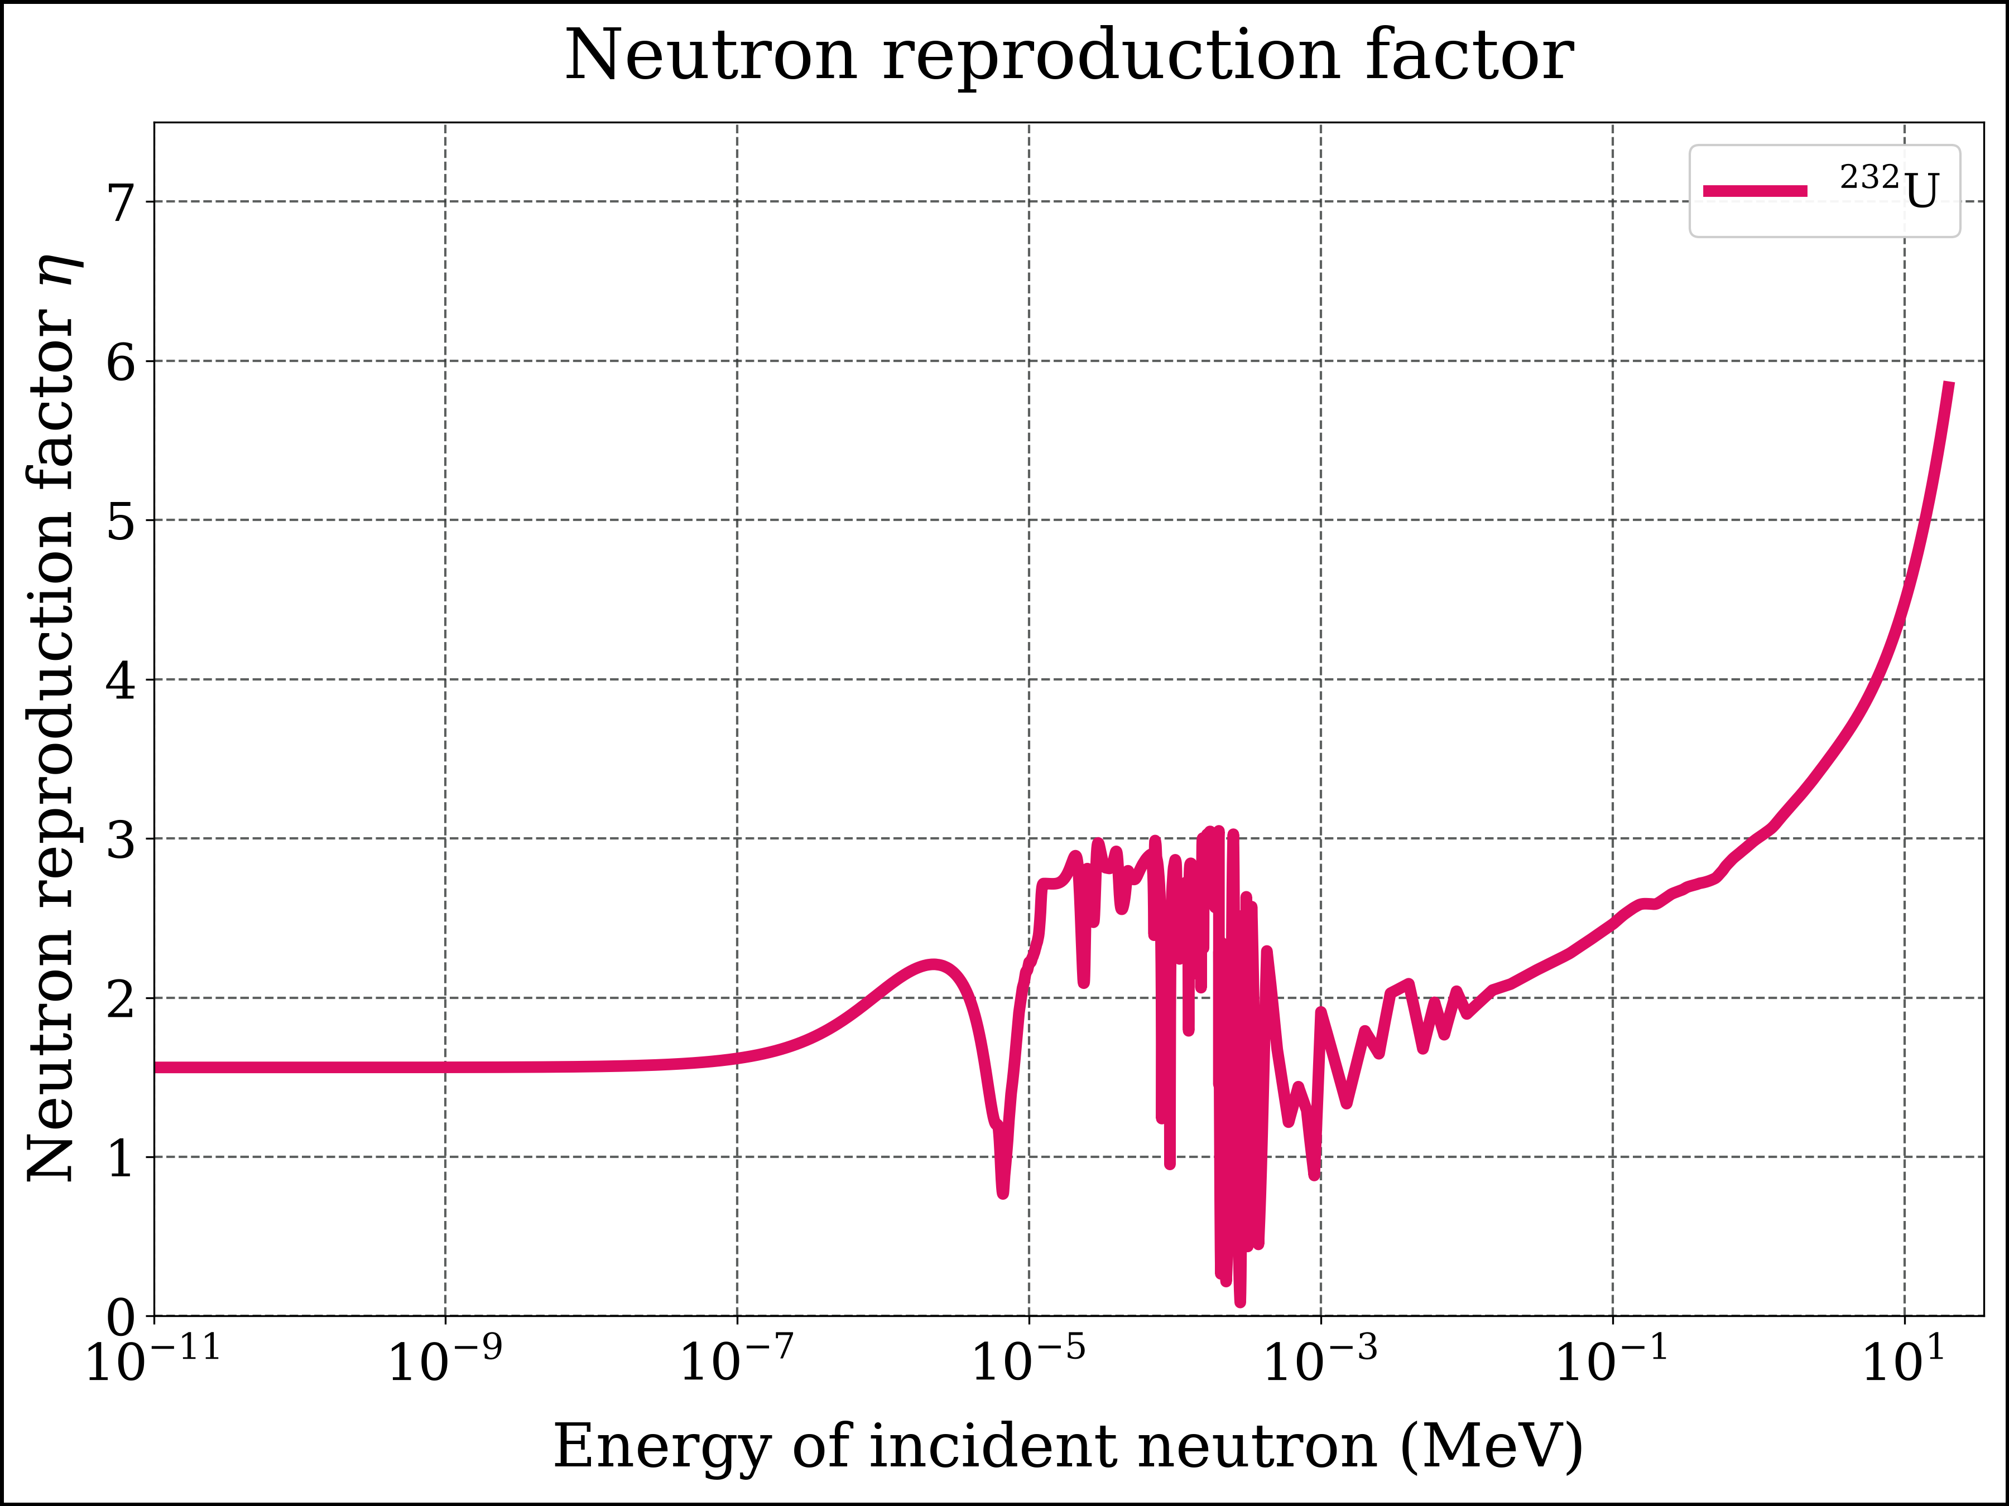
Figure 5: Neutron reproduction factor for U-232
x = E_fine
y = nrf_u233(E_fine)
fig, axes = plt.subplots(nrows=1, ncols=1, sharex=True, sharey=True)
axes.plot(x, y, label=r'$\mathrm{^{233}U}$', color=color_u233, linestyle=ls1, linewidth=lw1, marker=None)
xlims = [1E-11, 35]
ylims = [0, 7.5]
xscale = 'log'
yscale = 'linear'
file_name = 'nrf_u233_logE'
add_to_plot(fig, axes, title, xlabel, ylabel, xlims, ylims, xscale, yscale, ncol_legend, file_name)
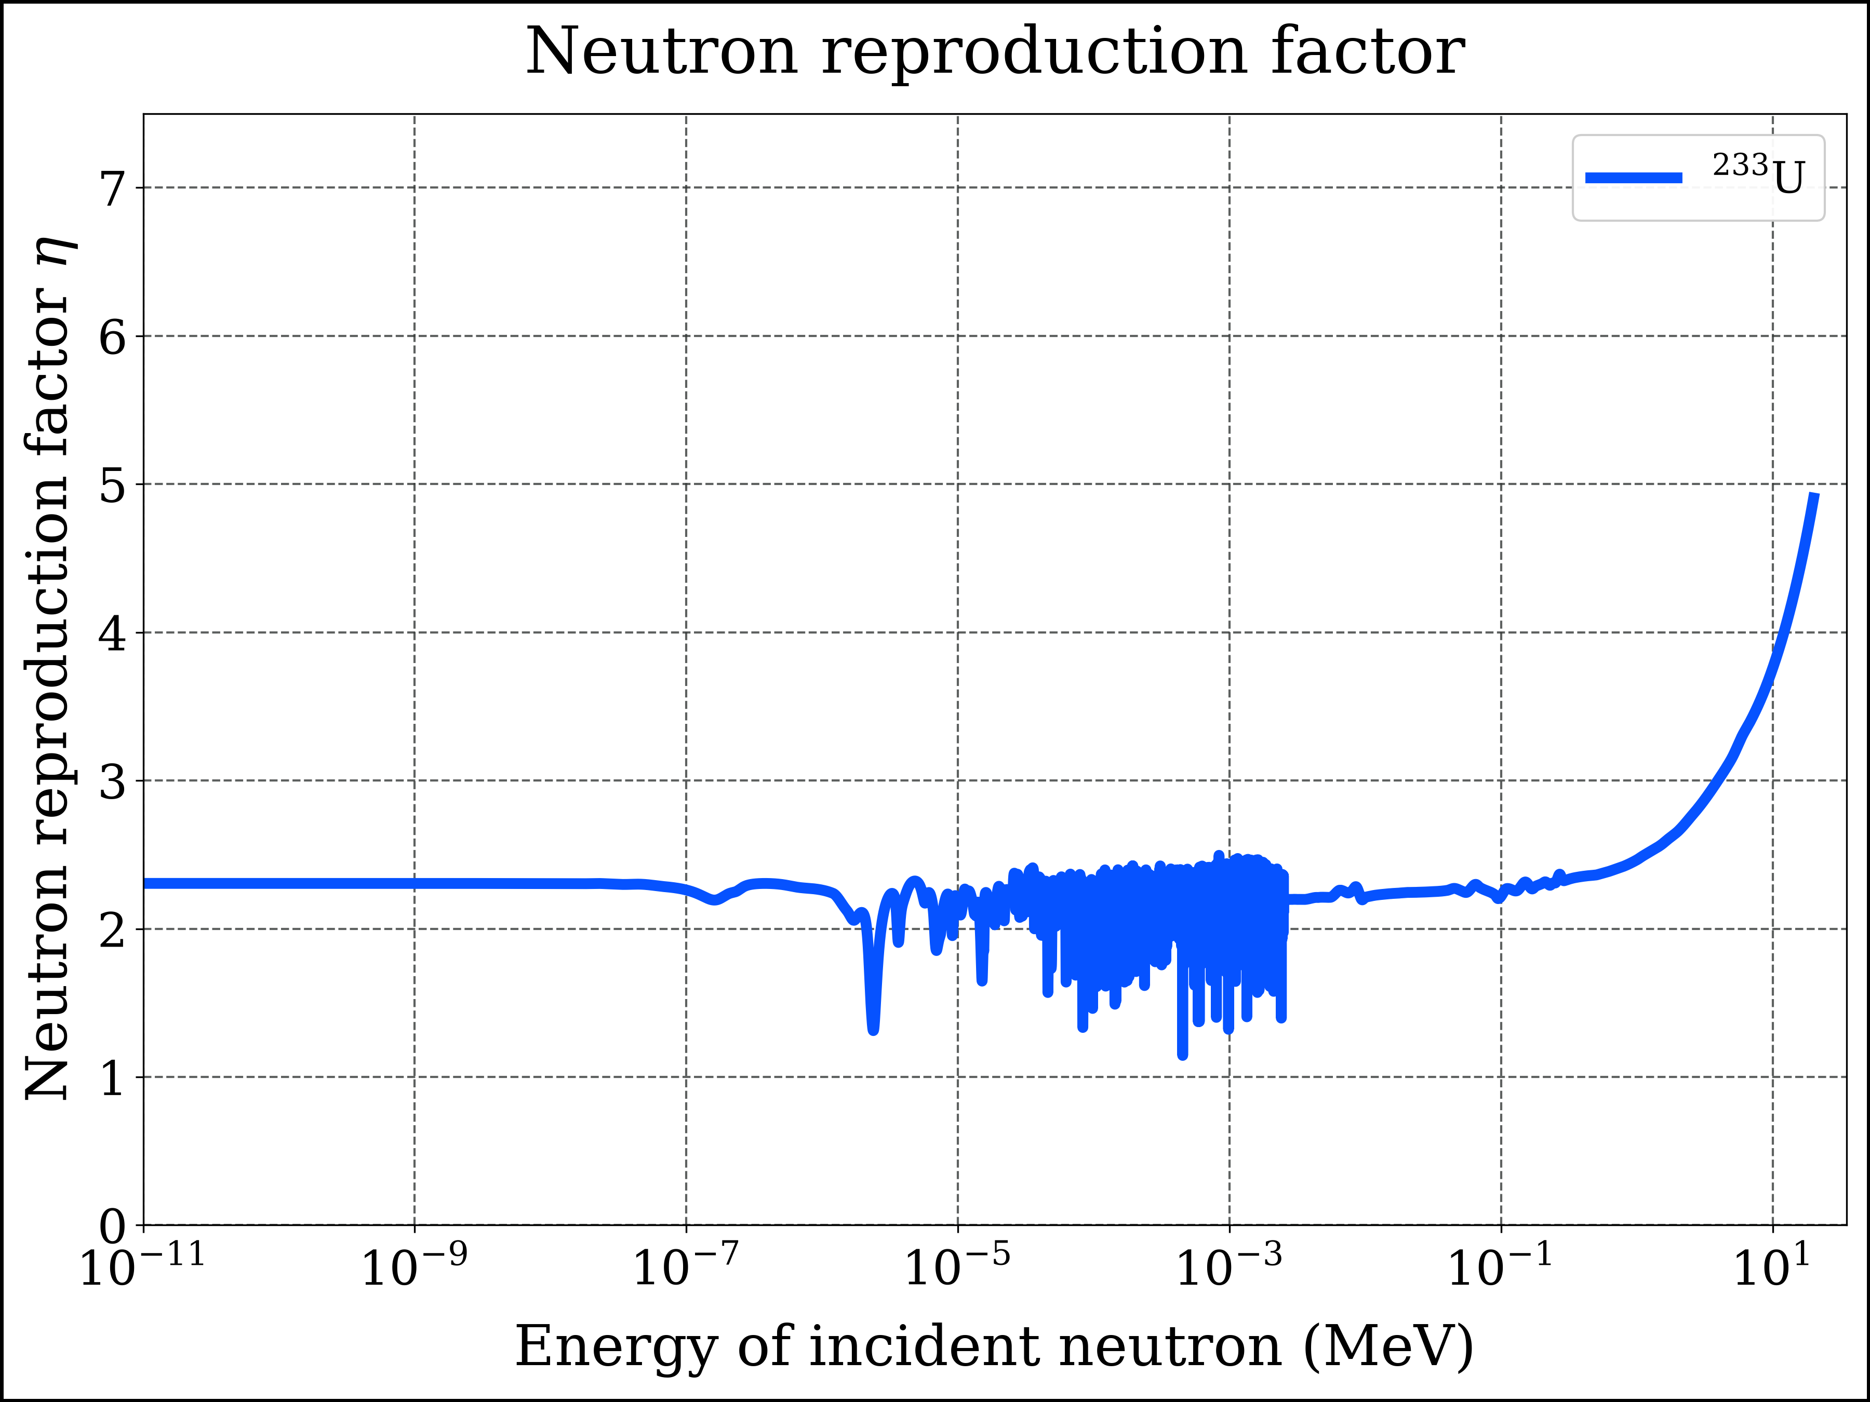
Figure 6: Neutron reproduction factor for U-233
x = E_fine
y = nrf_u234(E_fine)
fig, axes = plt.subplots(nrows=1, ncols=1, sharex=True, sharey=True)
axes.plot(x, y, label=r'$\mathrm{^{234}U}$', color=color_u234, linestyle=ls1, linewidth=lw1, marker=None)
xlims = [1E-11, 35]
ylims = [-0.05, 7.5]
xscale = 'log'
yscale = 'linear'
file_name = 'nrf_u234_logE'
add_to_plot(fig, axes, title, xlabel, ylabel, xlims, ylims, xscale, yscale, ncol_legend, file_name)
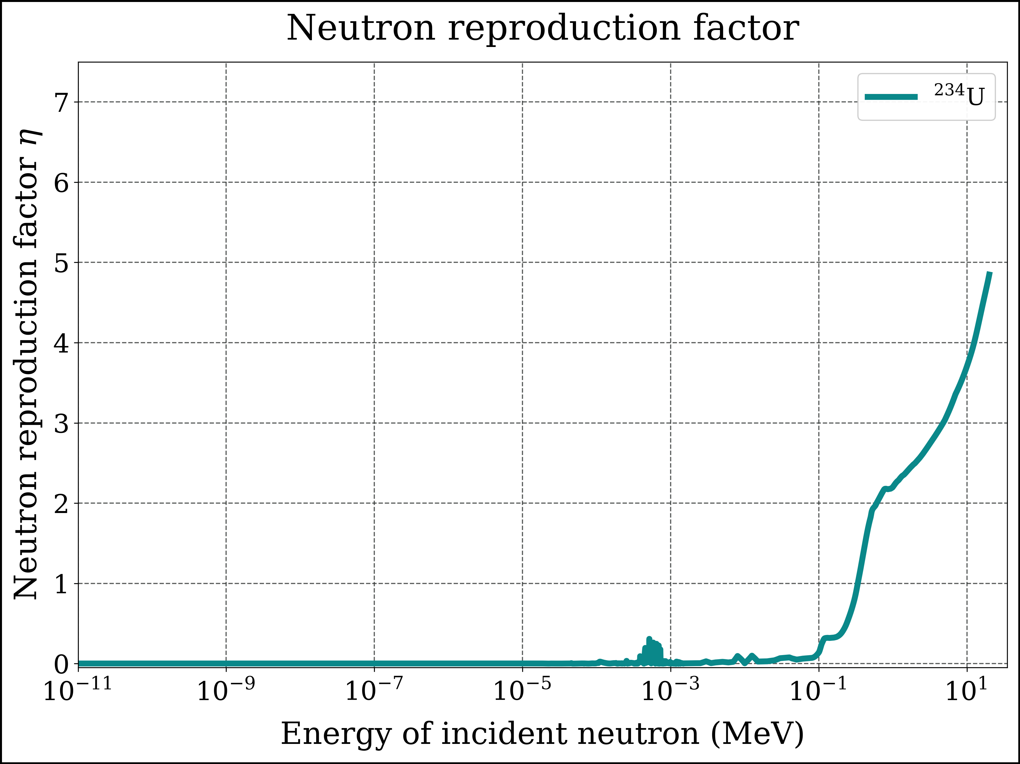
Figure 7: Neutron reproduction factor for U-234
x = E_fine
y = nrf_u235(E_fine)
fig, axes = plt.subplots(nrows=1, ncols=1, sharex=True, sharey=True)
axes.plot(x, y, label=r'$\mathrm{^{235}U}$',
color=color_u235, linestyle=ls1, linewidth=lw1, marker=None)
#
xlims = [1E-11, 35]
ylims = [0, 7.5]
xscale = 'log'
yscale = 'linear'
file_name = 'nrf_u235_logE'
#
add_to_plot(fig, axes, title, xlabel, ylabel, xlims, ylims, xscale, yscale, ncol_legend, file_name)
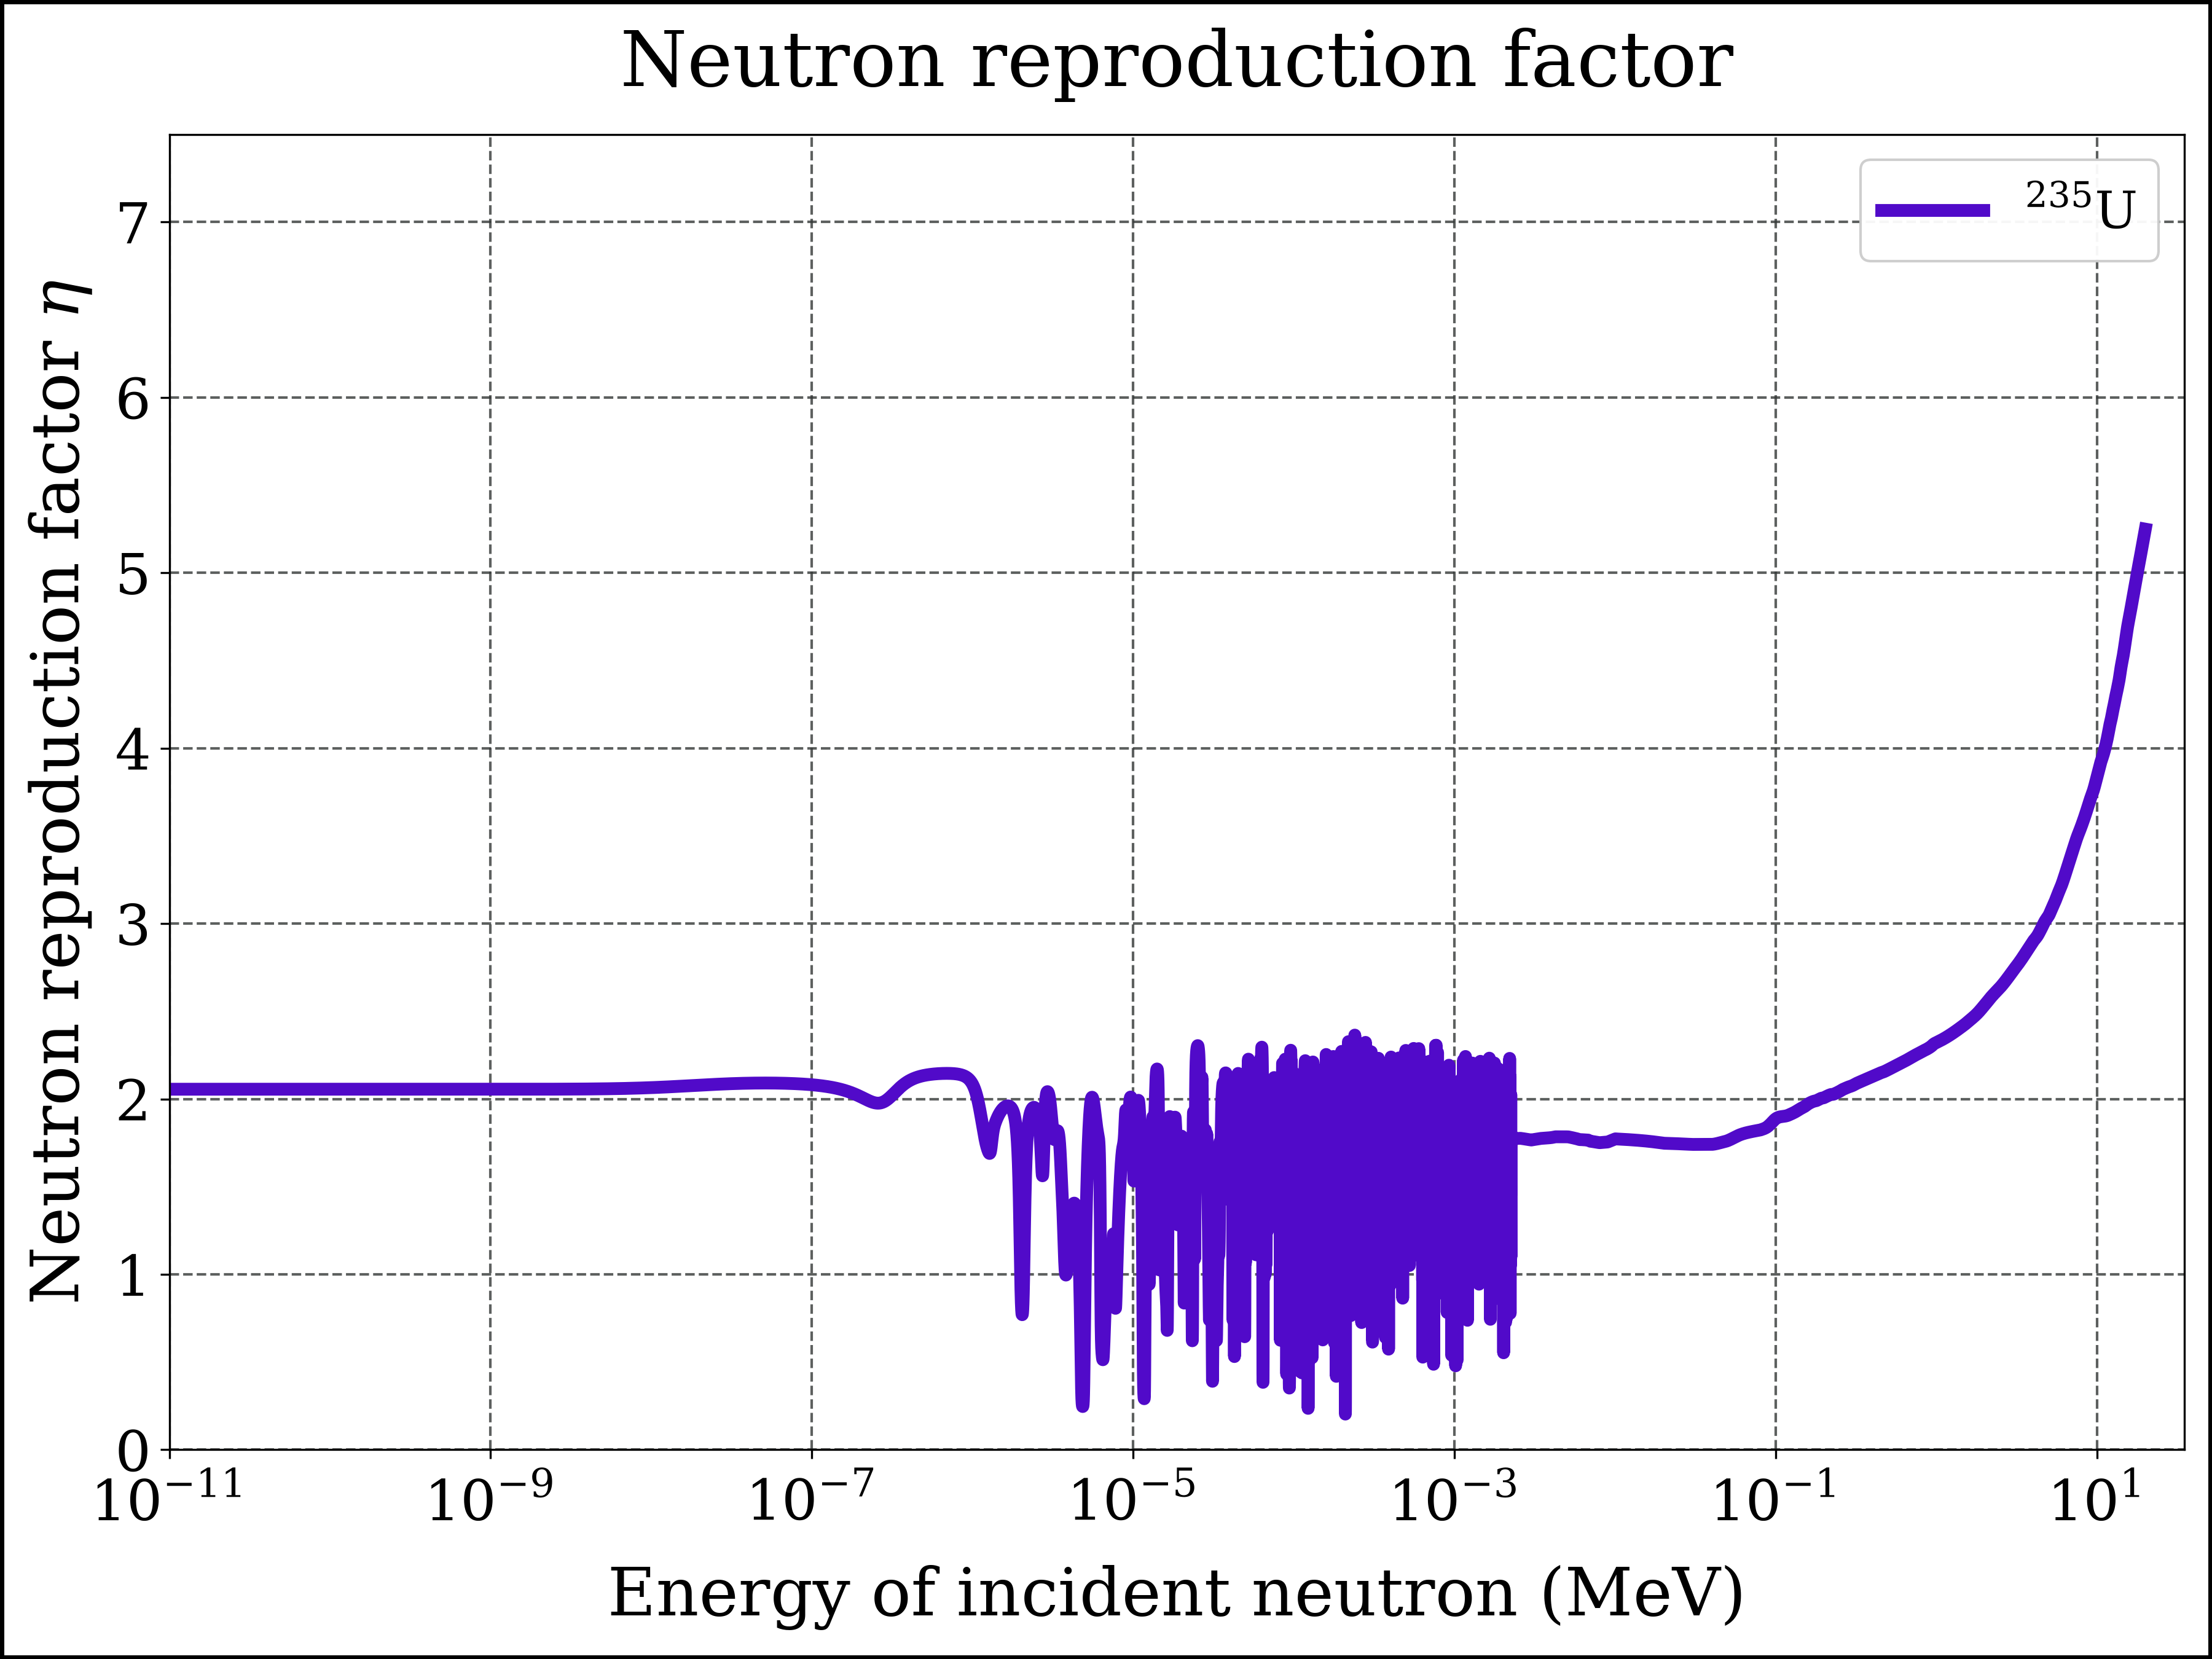
Figure 8: Neutron reproduction factor for U-235
x = E_fine
y = nrf_u236(E_fine)
fig, axes = plt.subplots(nrows=1, ncols=1, sharex=True, sharey=True)
axes.plot(x, y, label=r'$\mathrm{^{236}U}$',
color=color_u236, linestyle=ls1, linewidth=lw1, marker=None)
#
xlims = [1E-11, 35]
ylims = [-0.05, 7.5]
xscale = 'log'
yscale = 'linear'
file_name = 'nrf_u236_logE'
#
add_to_plot(fig, axes, title, xlabel, ylabel, xlims, ylims, xscale, yscale, ncol_legend, file_name)
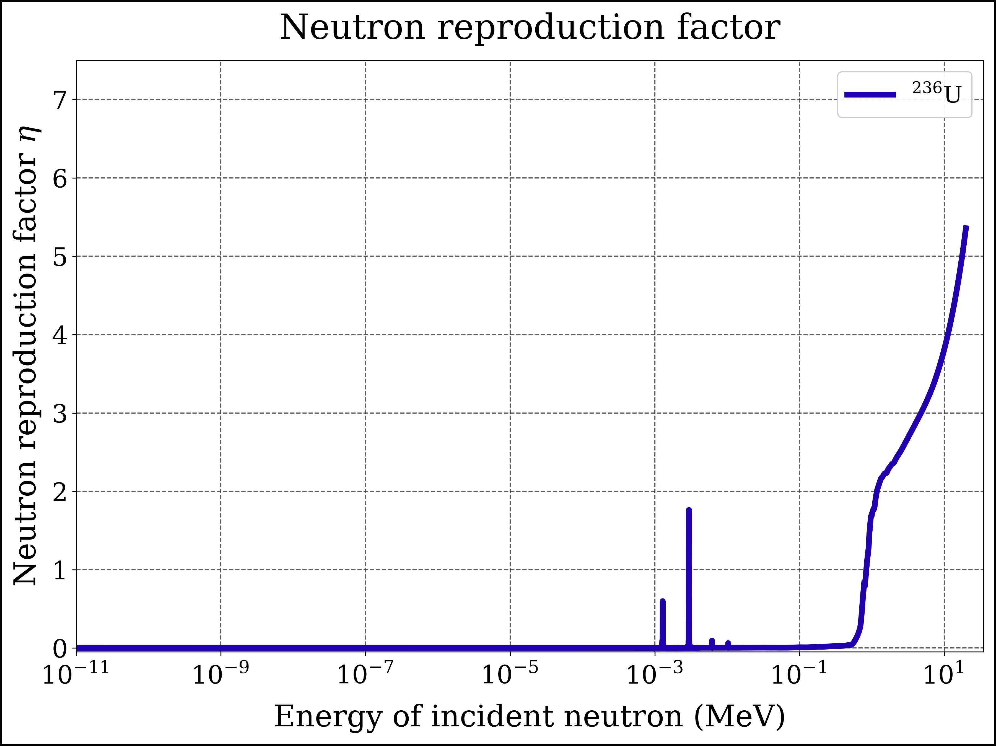
Figure 9: Neutron reproduction factor for U-236
x = E_fine
y = nrf_u238(E_fine)
fig, axes = plt.subplots(nrows=1, ncols=1, sharex=True, sharey=True)
axes.plot(x, y, label=r'$\mathrm{^{238}U}$',
color=color_u238, linestyle=ls1, linewidth=lw1, marker=None)
#
xlims = [1E-11, 35]
ylims = [-0.05, 7.5]
file_name = 'nrf_u238_logE'
#
add_to_plot(fig, axes, title, xlabel, ylabel, xlims, ylims, xscale, yscale, ncol_legend, file_name)
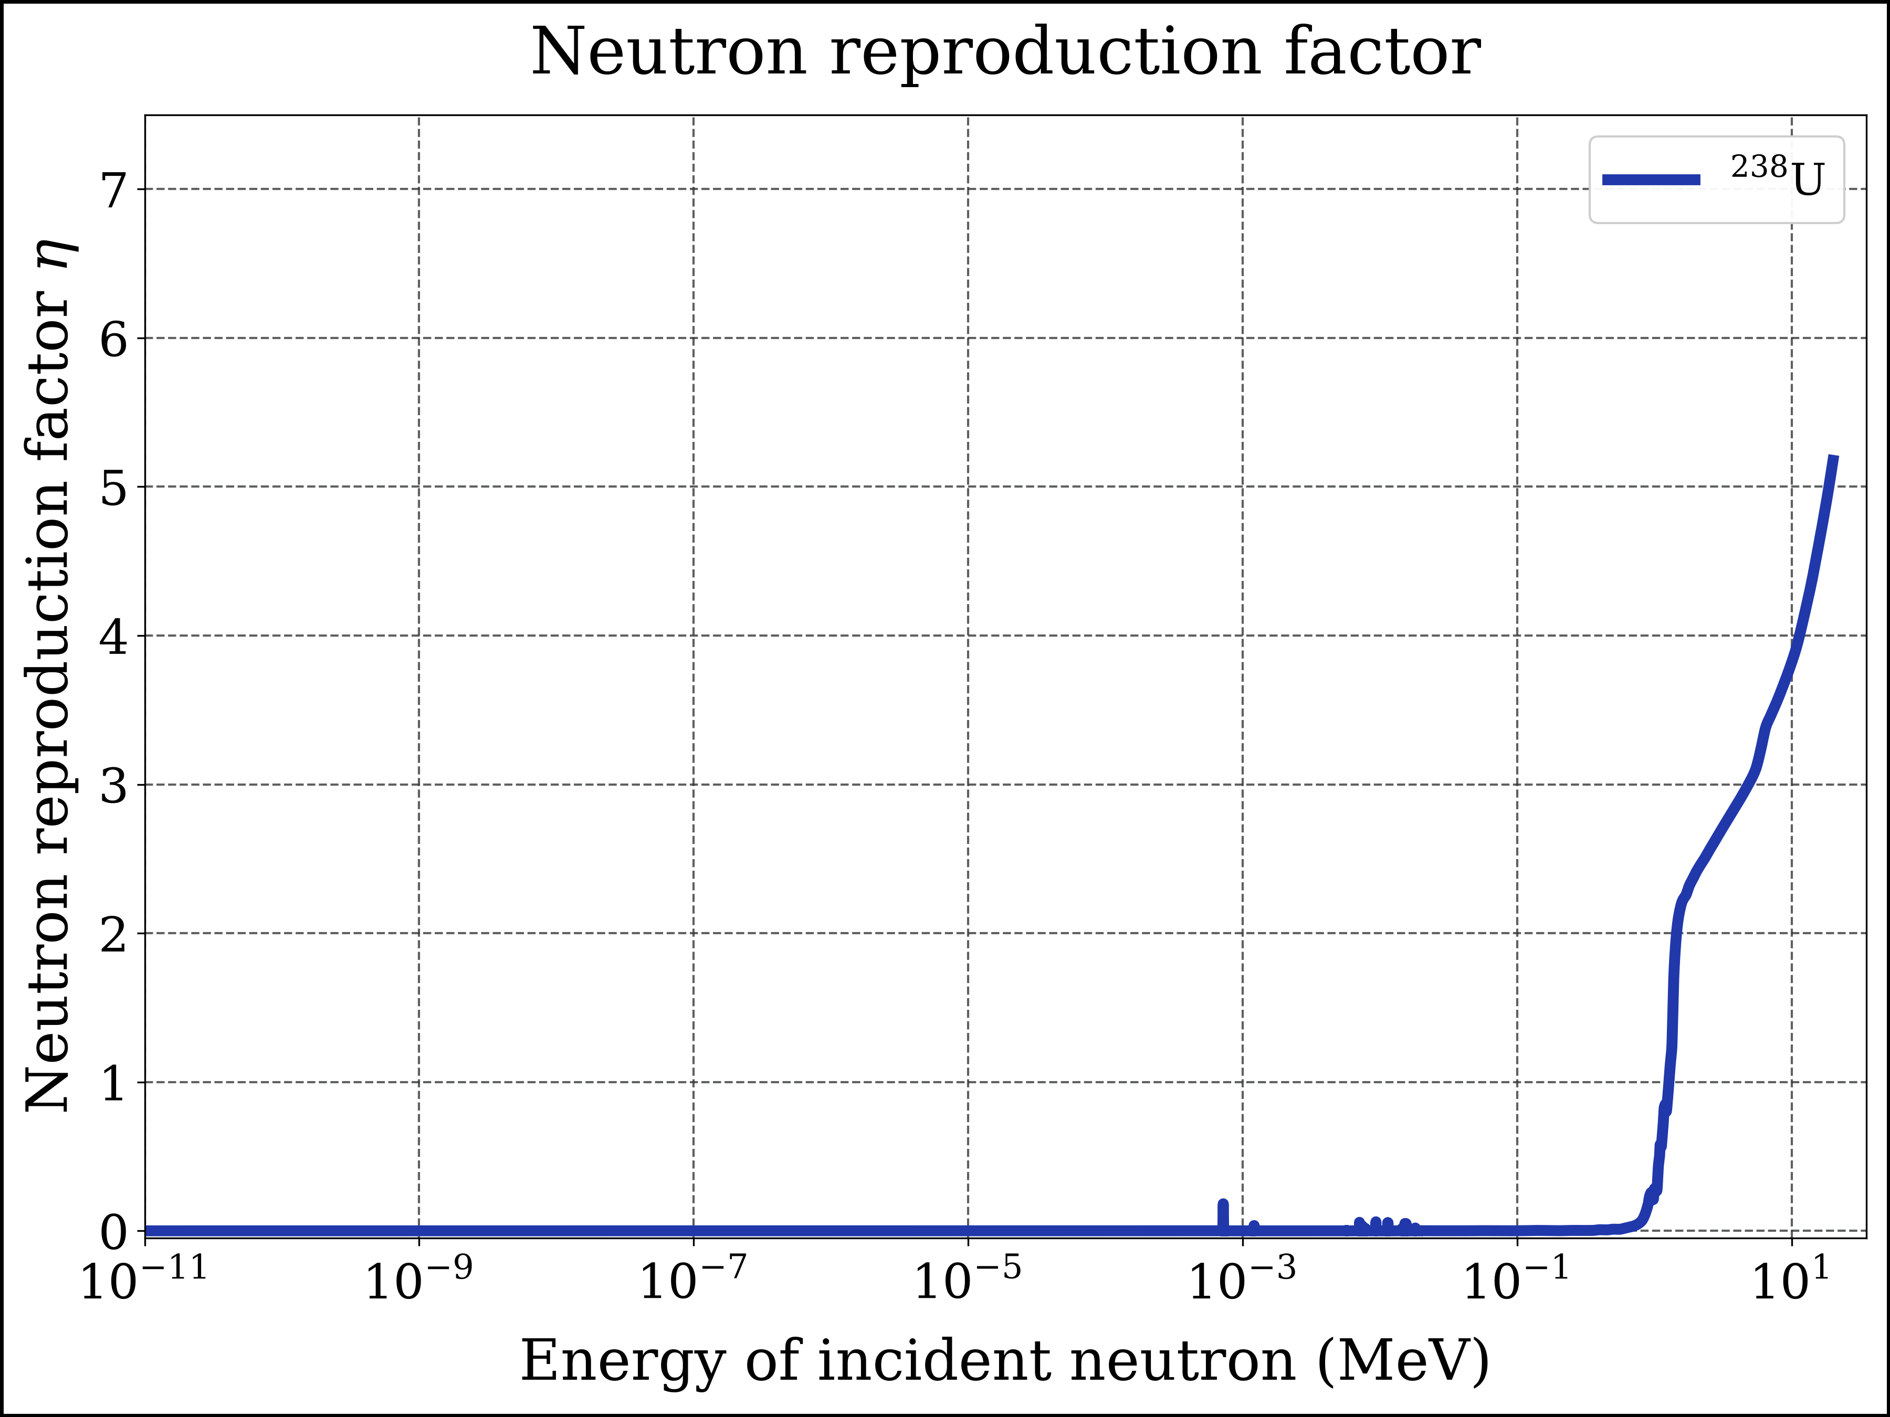
Figure 10: Neutron reproduction factor for U-238
x = E_fine
y = nrf_pu238(E_fine)
fig, axes = plt.subplots(nrows=1, ncols=1, sharex=True, sharey=True)
axes.plot(x, y, label=r'$\mathrm{^{238}Pu}$',
color=color_pu238, linestyle=ls1, linewidth=lw1, marker=None)
#
xlims = [1E-11, 35]
ylims = [0, 7.5]
file_name = 'nrf_pu238_logE'
#
add_to_plot(fig, axes, title, xlabel, ylabel, xlims, ylims, xscale, yscale, ncol_legend, file_name)
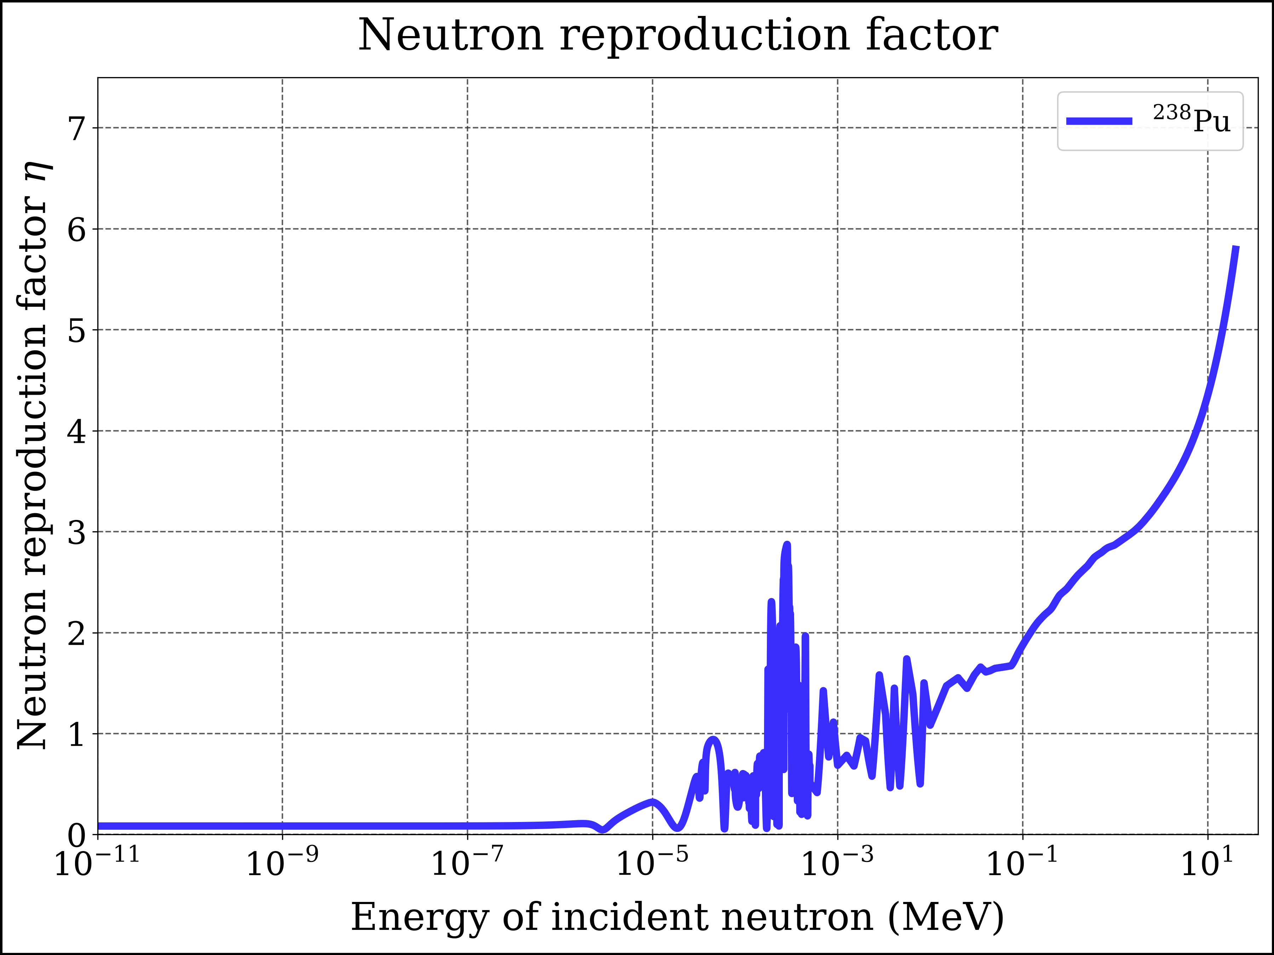
Figure 11: Neutron reproduction factor for Pu-238
x = E_fine
y = nrf_pu239(E_fine)
fig, axes = plt.subplots(nrows=1, ncols=1, sharex=True, sharey=True)
axes.plot(x, y, label=r'$\mathrm{^{239}Pu}$',
color=color_pu239, linestyle=ls1, linewidth=lw1, marker=None)
#
xlims = [1E-11, 35]
ylims = [0, 7.5]
file_name = 'nrf_pu239_logE'
#
add_to_plot(fig, axes, title, xlabel, ylabel, xlims, ylims, xscale, yscale, ncol_legend, file_name)
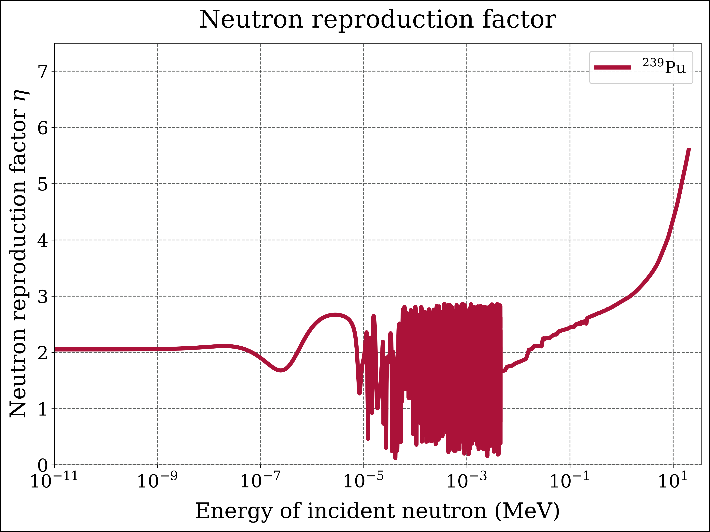
Figure 12: Neutron reproduction factor for Pu-239
x = E_fine
y = nrf_pu240(E_fine)
fig, axes = plt.subplots(nrows=1, ncols=1, sharex=True, sharey=True)
axes.plot(x, y, label=r'$\mathrm{^{240}Pu}$',
color=color_pu240, linestyle=ls1, linewidth=lw1, marker=None)
#
xlims = [1E-11, 35]
ylims = [-0.05, 7.5]
file_name = 'nrf_pu240_logE'
#
add_to_plot(fig, axes, title, xlabel, ylabel, xlims, ylims, xscale, yscale, ncol_legend, file_name)
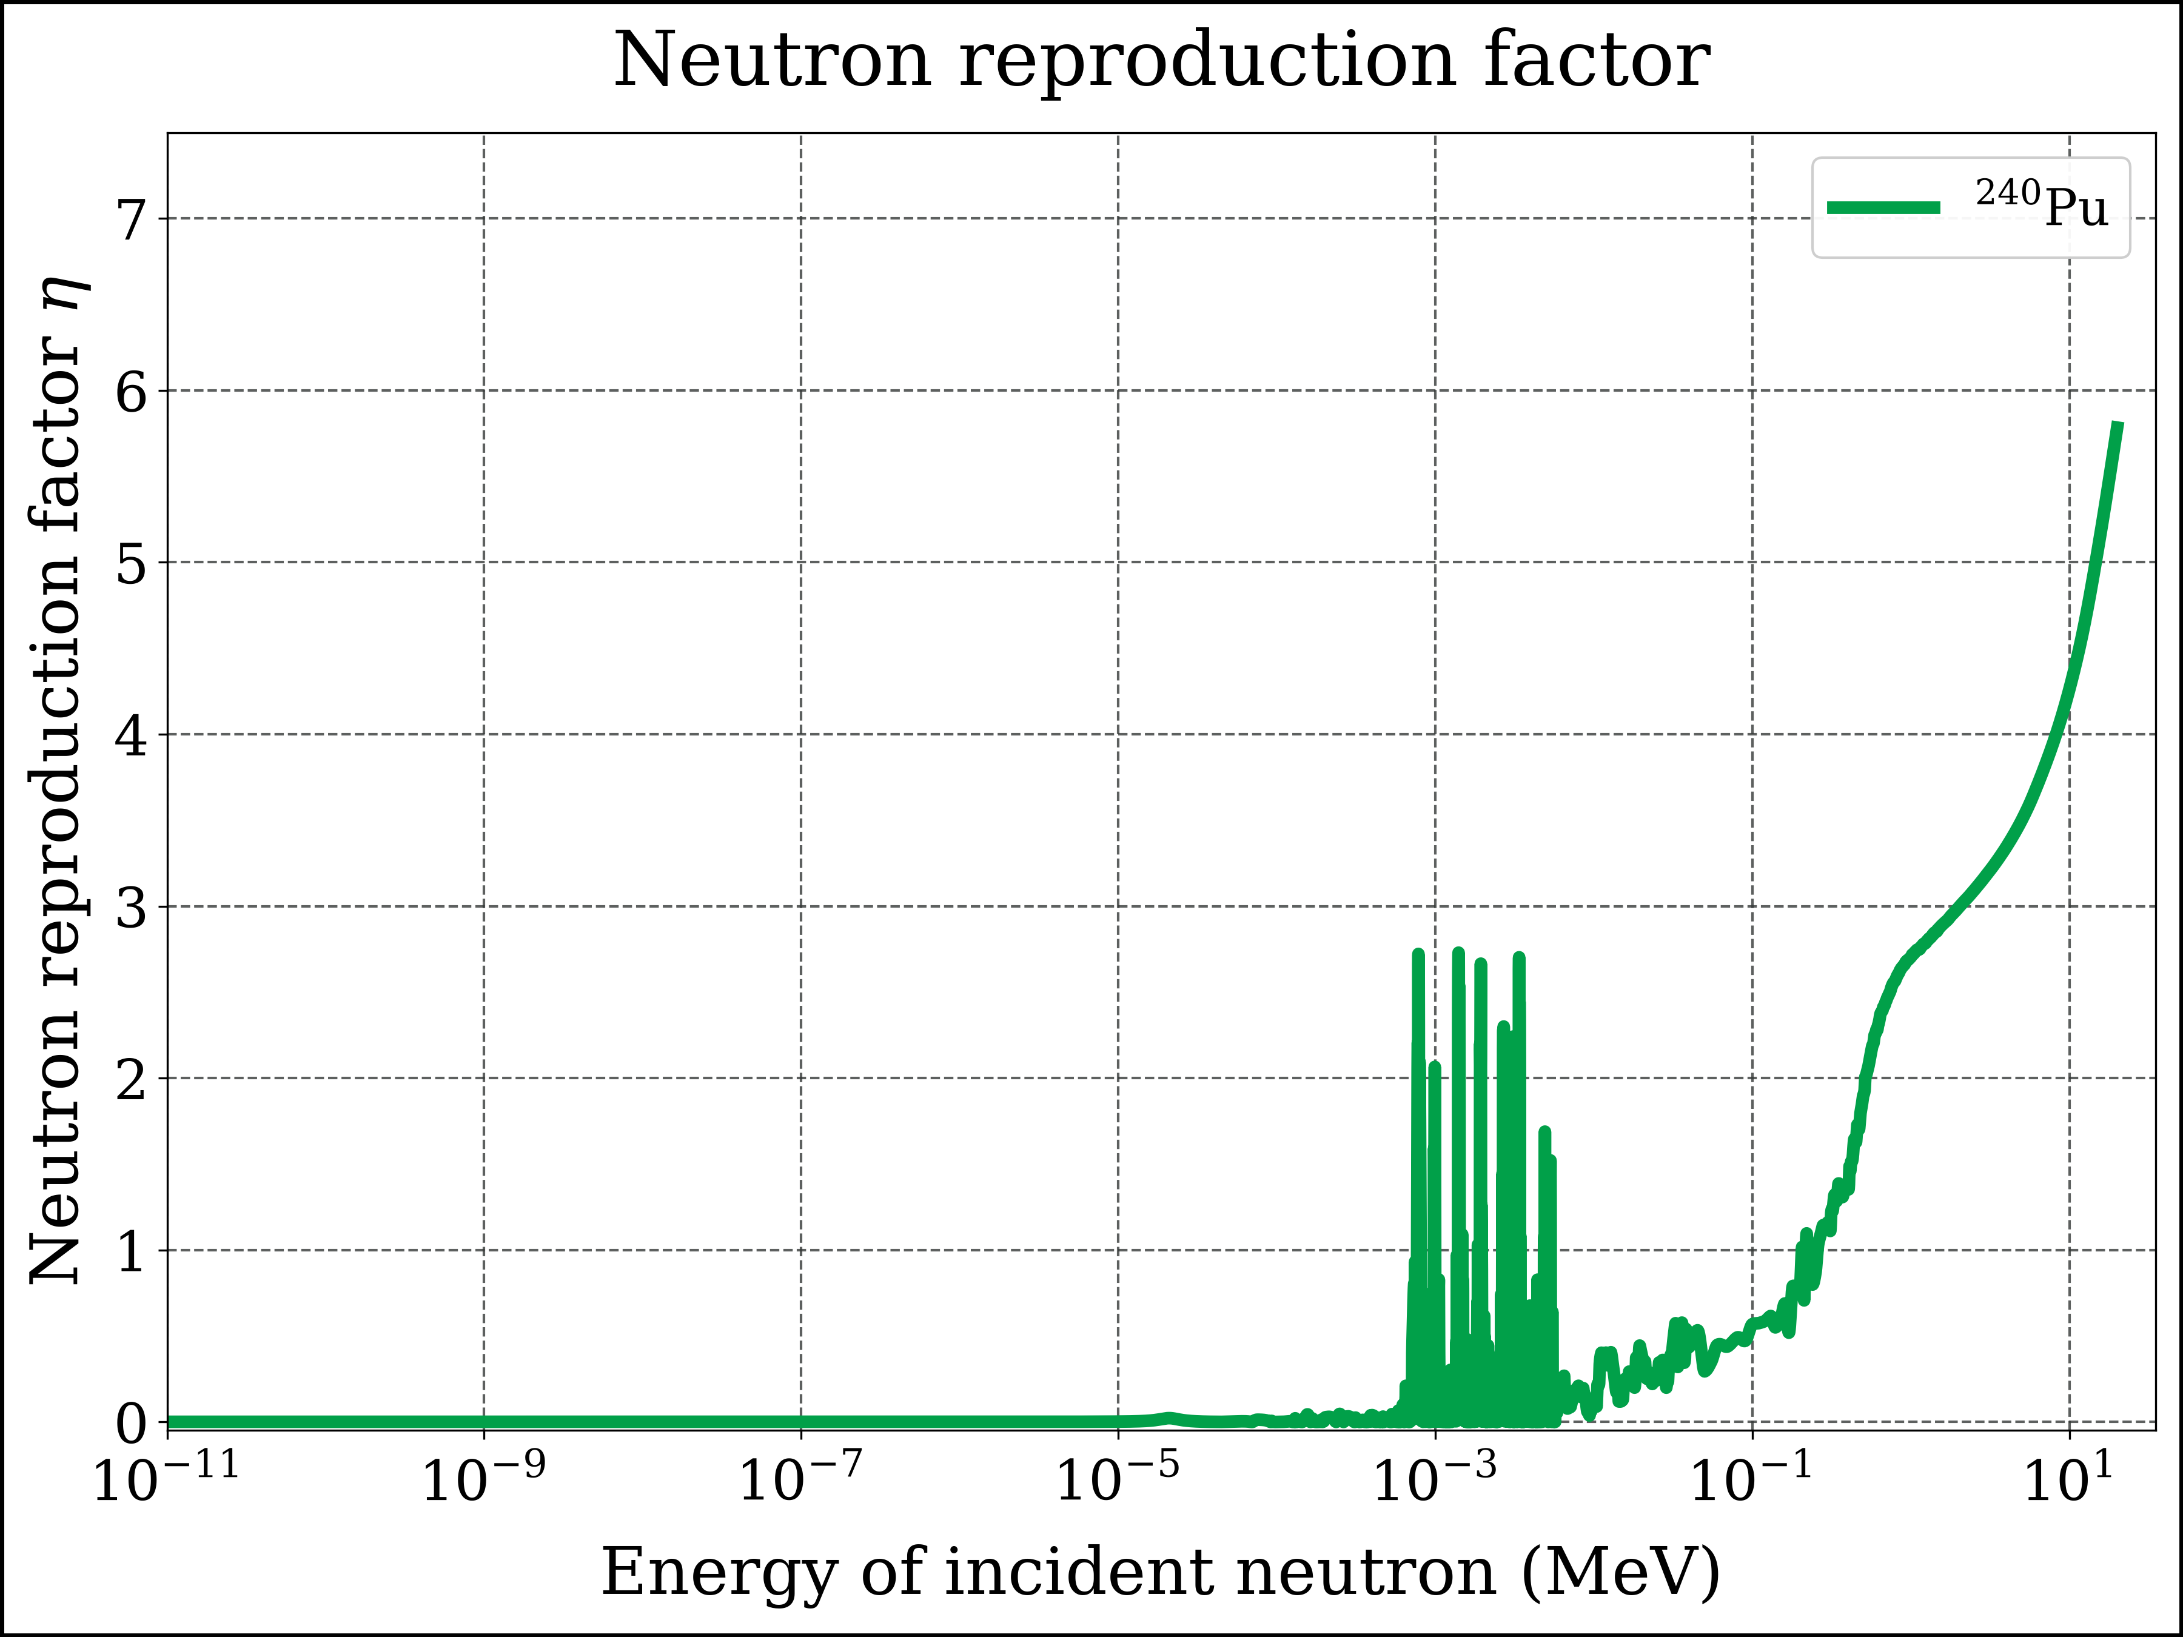
Figure 13: Neutron reproduction factor for Pu-240
x = E_fine
y = nrf_pu241(E_fine)
fig, axes = plt.subplots(nrows=1, ncols=1, sharex=True, sharey=True)
axes.plot(x, y, label=r'$\mathrm{^{241}Pu}$',
color=color_pu241, linestyle=ls1, linewidth=lw1, marker=None)
xlims = [1E-11, 35]
ylims = [0, 7.6]
file_name = 'nrf_pu241_logE'
add_to_plot(fig, axes, title, xlabel, ylabel, xlims, ylims, xscale, yscale, ncol_legend, file_name)
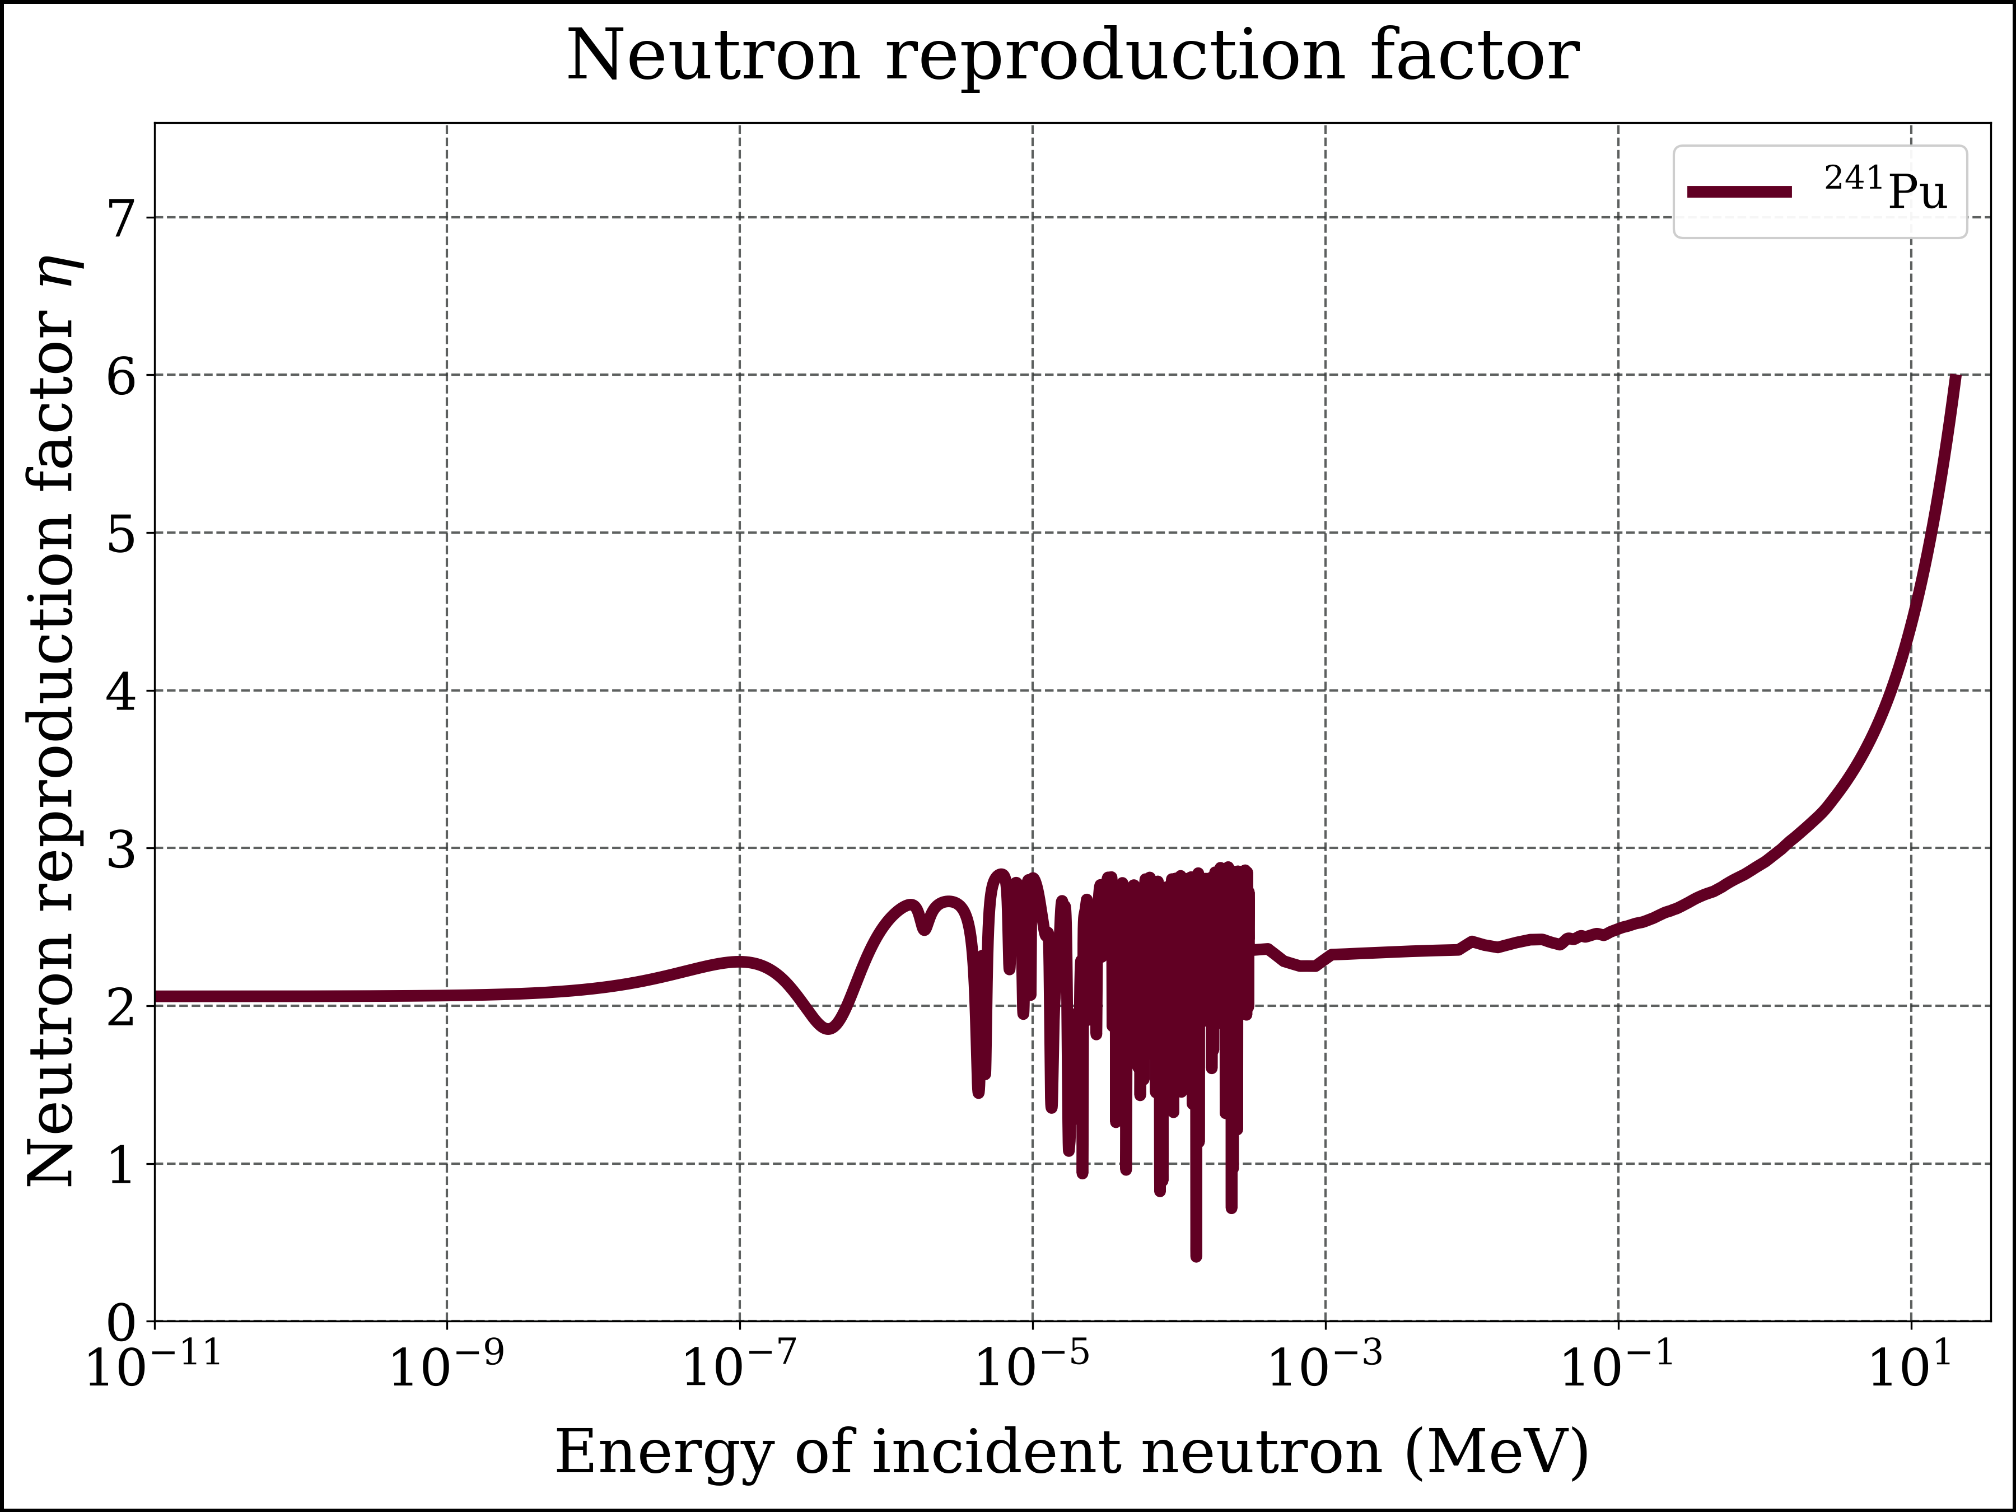
Figure 14: Neutron reproduction factor for Pu-241

7.1 Comparisons
fig, axes = plt.subplots(nrows=1, ncols=1, sharex=True, sharey=True)
#
x = E_fine
y = nrf_u235(E_fine)
axes.plot(x, y, label=r'$\mathrm{^{235}U}$',
color=color_u235, linestyle=ls1, linewidth=lw1, marker=None, alpha=1.00)
#
y = nrf_u233(E_fine)
axes.plot(x, y, label=r'$\mathrm{^{233}U}$',
color=color_u233, linestyle=ls1, linewidth=lw1, marker=None, alpha=0.85)
#
y = nrf_pu239(E_fine)
axes.plot(x, y, label=r'$\mathrm{^{239}Pu}$',
color=color_pu239, linestyle=ls1, linewidth=lw1, marker=None, alpha=0.70)
#
xscale = 'log'
yscale = 'linear'
xlims = [1E-11, 35]
ylims = [0, 7]
file_name = 'nrf_u233_u235_pu239_logE'
add_to_plot(fig, axes, title, xlabel, ylabel, xlims, ylims, xscale, yscale, ncol_legend, file_name)
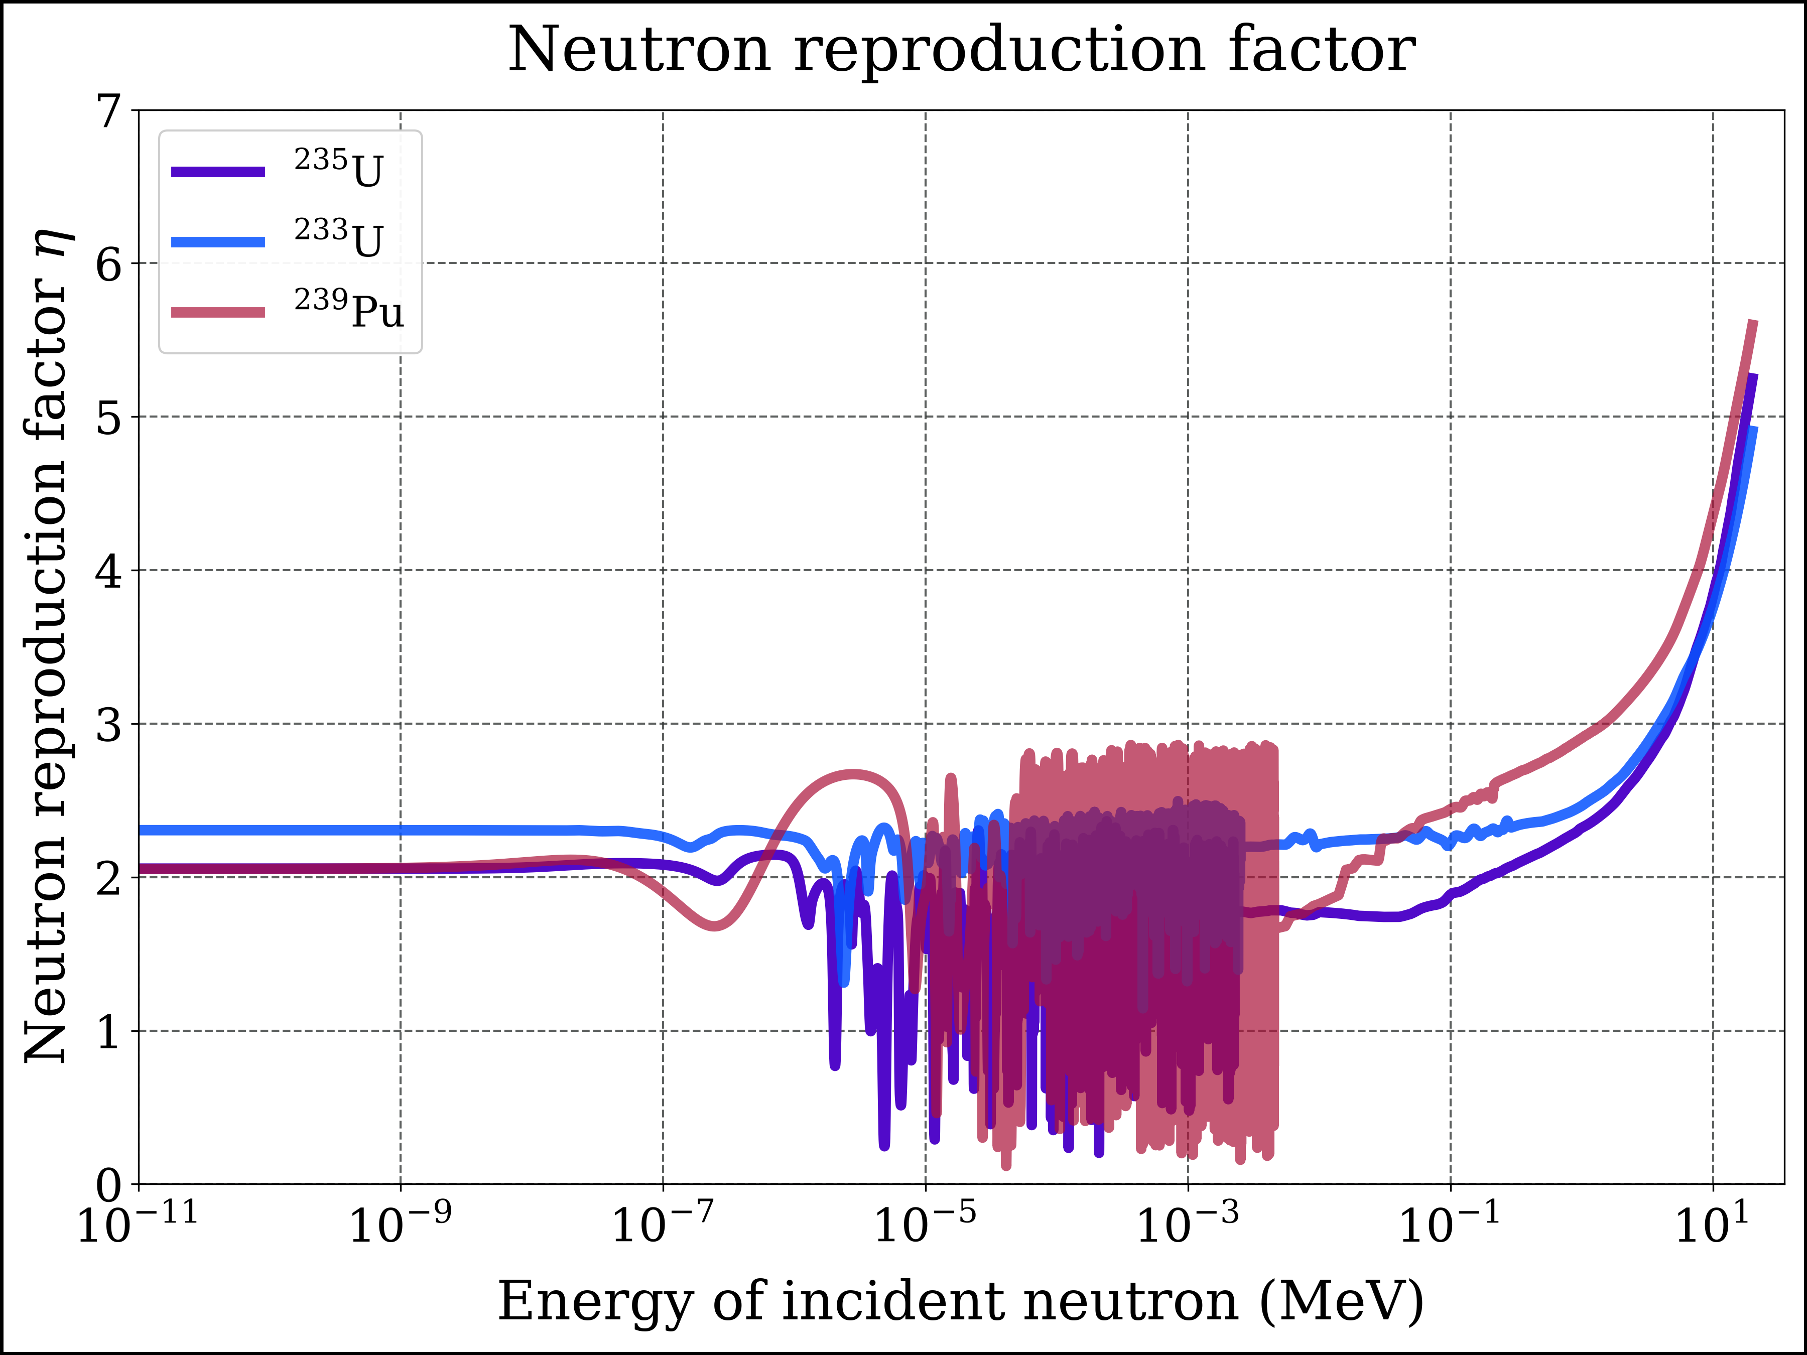
Figure 15: Neutron reproduction factor for the 3 principal fissile actinides: U-233, U-235 and Pu-239 (logarithmic scaling of energy axis)
fig, axes = plt.subplots(nrows=1, ncols=1, sharex=True, sharey=True)
#
x = E_fine
y = nrf_u235(E_fine)
axes.plot(x, y, label=r'$\mathrm{^{235}U}$',
color=color_u235, linestyle=ls1, linewidth=lw1, marker=None, alpha=1.00)
#
y = nrf_u233(E_fine)
axes.plot(x, y, label=r'$\mathrm{^{233}U}$',
color=color_u233, linestyle=ls1, linewidth=lw1, marker=None, alpha=0.85)
#
y = nrf_pu239(E_fine)
axes.plot(x, y, label=r'$\mathrm{^{239}Pu}$',
color=color_pu239, linestyle=ls1, linewidth=lw1, marker=None, alpha=0.70)
#
xscale = 'linear'
yscale = 'linear'
xlims = [-0.15, 20.2]
ylims = [0, 7]
file_name = 'nrf_u233_u235_pu239_linE'
add_to_plot(fig, axes, title, xlabel, ylabel, xlims, ylims, xscale, yscale, ncol_legend, file_name)
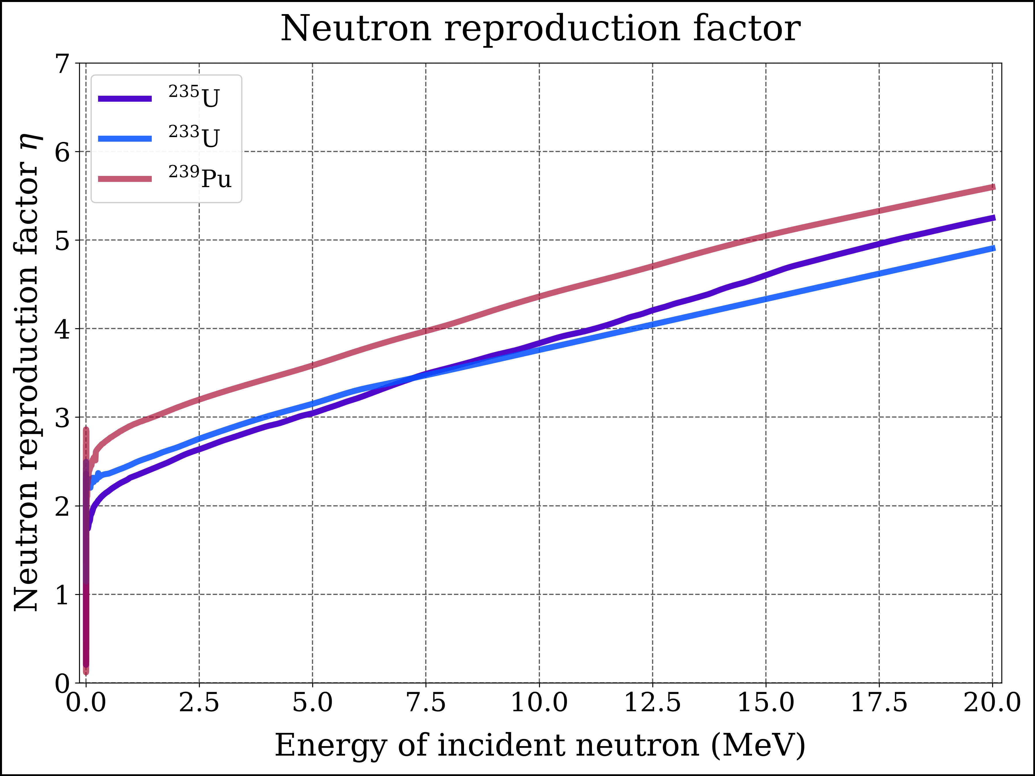
Figure 16: Neutron reproduction factor for the 3 principal fissile actinides: U-233, U-235 and Pu-239 (linear scaling of energy axis)
fig, axes = plt.subplots(nrows=1, ncols=1, sharex=True, sharey=True)
#
x = E_fine
y = nrf_pu238(E_fine)
axes.plot(x, y, label=r'$\mathrm{^{238}Pu}$',
color=color_pu238, linestyle=ls1, linewidth=lw1, marker=None, alpha=1.00)
#
y = nrf_pu239(E_fine)
axes.plot(x, y, label=r'$\mathrm{^{239}Pu}$',
color=color_pu239, linestyle=ls1, linewidth=lw1, marker=None, alpha=0.70)
#
xscale = 'linear'
yscale = 'linear'
xlims = [-0.15, 20.2]
ylims = [0, 7.5]
file_name = 'nrf_pu238_pu239_linE'
add_to_plot(fig, axes, title, xlabel, ylabel, xlims, ylims, xscale, yscale, ncol_legend, file_name)
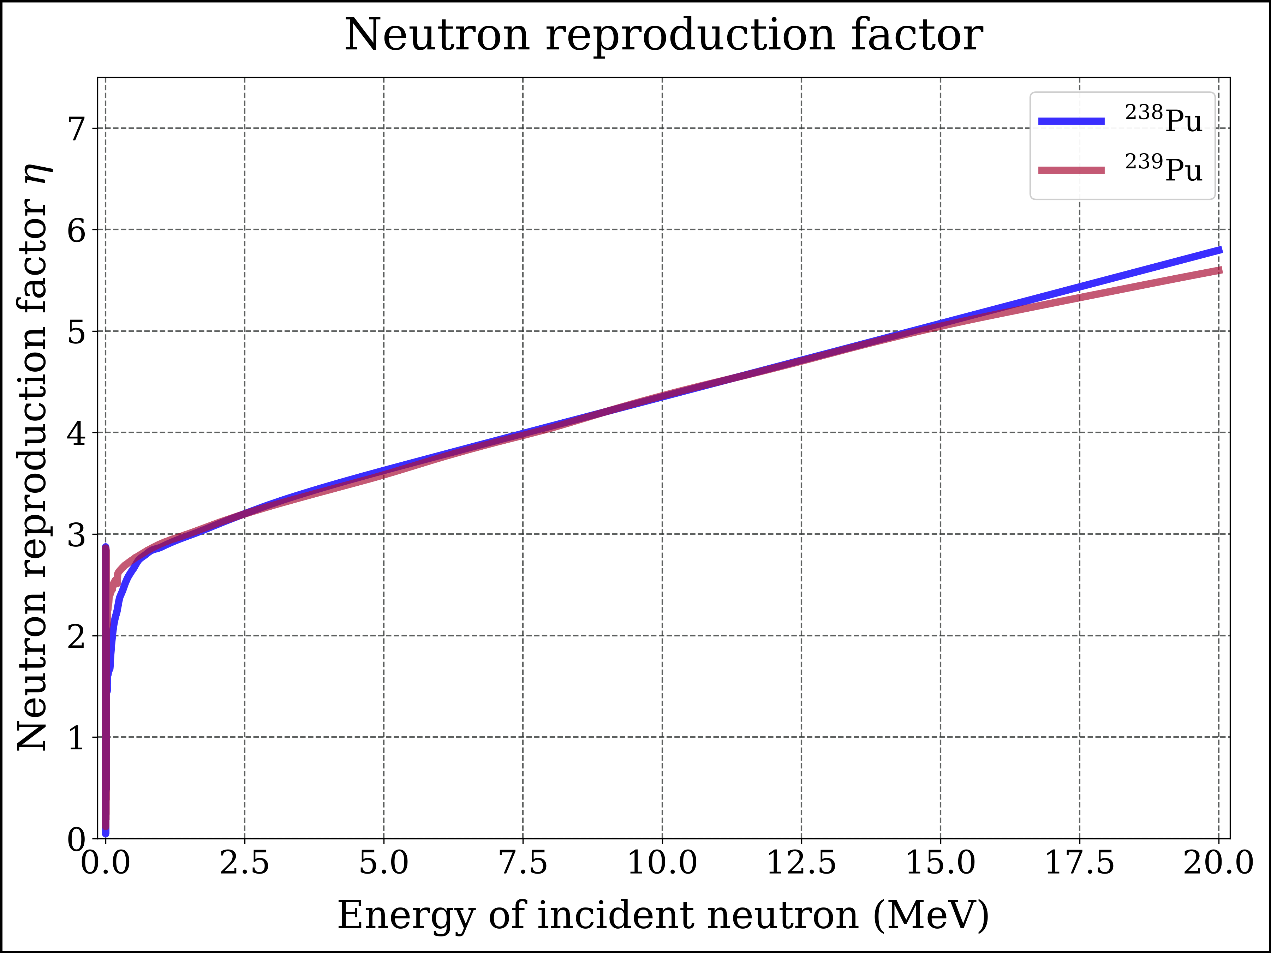
Figure 17: Neutron reproduction factor for Pu-238 and Pu-239 (linear scaling of energy axis)
Commentary. Figure 17 compares $​^{238}Pu$ with $​^{239}Pu$ on a linear energy axis. Above about 1 MeV the two curves are practically identical, and above about 3 MeV the $η$ of $​^{238}Pu$ is even marginally higher. In this energy range the fission cross section of $​^{238}Pu$ is actually larger than that of $​^{239}Pu$ (2.04 b against 1.75 b at 1 MeV), and capture competes only weakly ($α$ is a few percent): almost every fast neutron absorbed in $​^{238}Pu$ causes a fission. The “mediocre” fission cross section of $​^{238}Pu$ is a property of slow neutrons. Below about 1 MeV capture competes more strongly, and $η$ of $​^{238}Pu$ falls below that of $​^{239}Pu$ (Figure 11). The consequences are discussed in Section 10.
fig, axes = plt.subplots(nrows=1, ncols=1, sharex=True, sharey=True)
#
x = E_fine
y = nrf_u234(E_fine)
axes.plot(x, y, label=r'$\mathrm{^{234}U}$',
color=color_u234, linestyle=ls1, linewidth=lw1, marker=None, alpha=1.00)
#
y = nrf_u236(E_fine)
axes.plot(x, y, label=r'$\mathrm{^{236}U}$',
color=color_u236, linestyle=ls1, linewidth=lw1, marker=None, alpha=0.85)
#
y = nrf_u238(E_fine)
axes.plot(x, y, label=r'$\mathrm{^{238}U}$',
color=color_u238, linestyle=ls1, linewidth=lw1, marker=None, alpha=0.85)
#
xscale = 'log'
yscale = 'linear'
xlims = [1E-11, 40]
ylims = [-0.05, 7]
file_name = 'nrf_u234_u236_u238_logE'
add_to_plot(fig, axes, title, xlabel, ylabel, xlims, ylims, xscale, yscale, ncol_legend, file_name)
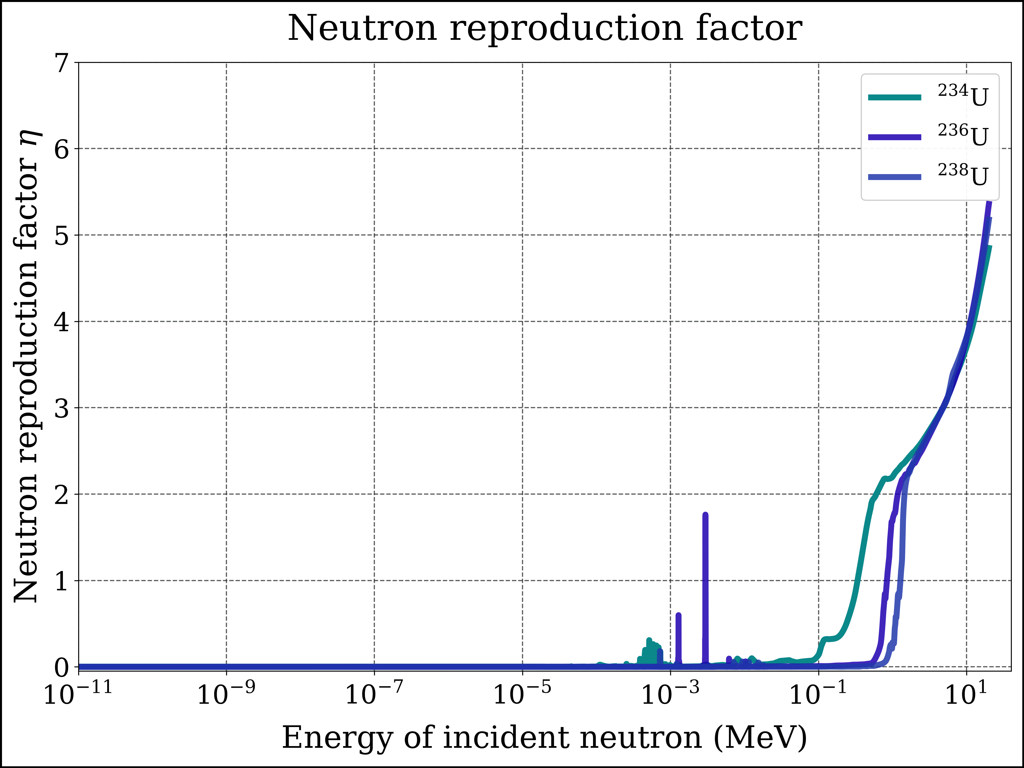
Figure 18: Neutron reproduction factor for 3 fissionable actinides: U-234, U-236 and U-238

7.2 What the curves show
- Thermal region ($E≲0.1$ eV). Both $σ_{f}$ and $σ_{γ}$ of the fissile nuclides follow approximately the 1/v law, so their ratio $α$ - and with it $η$ - is nearly constant. $​^{239}Pu$ is the exception: $η$ dips to about 1.7 near 0.25 eV, on the flank of its large 0.3 eV resonance, which has a high capture fraction. This makes the thermal $η$ of plutonium fuel sensitive to the temperature of the neutron population (Section 9.4).
- Resonance region (about 1 eV to 10 keV). Thousands of resonances: in capture-dominated resonances $η$ collapses (to about 0.2 for $​^{235}U$ and 0.1 for $​^{239}Pu$), in fission-dominated ones it peaks. A spectrum average smooths this structure out.
- Fast region ($E≳0.1$ MeV). $α$ falls steeply while $\overset{‾}{ν}$ rises, so $η$ increases. At 1 MeV, $η≈2.47$ for $​^{233}U$, 2.32 for $​^{235}U$ and 2.91 for $​^{239}Pu$: plutonium is the natural fuel of fast breeder reactors.
- Even-$N$ nuclides ($​^{234}U$, $​^{236}U$, $​^{238}U$, $​^{240}Pu$). Below the fission threshold $η≈0$: almost every absorption is a capture. Above the threshold $η$ climbs to 2 - 3; for $​^{238}U$ it crosses $η=1$ at about 1.3 MeV (Figure 18). $​^{240}Pu$ also shows isolated fission-dominated resonances in the keV region - sub-threshold fission.
- $​^{238}Pu$ is even-$N$ too, and for thermal neutrons capture wins by far ($η≈0.08$). But it has no sharp threshold: $η$ exceeds 1 already at about 10 keV and reaches the level of $​^{239}Pu$ above 1 MeV (Figure 11, Figure 17).
All curves end at 20 MeV, the upper end of the tabulated data.

8. Spectrum-averaged reproduction factors

8.1 The thermal reactor spectrum
fig, axes = plt.subplots(nrows=1, ncols=1, sharex=True, sharey=True)
#
x = eng_φ_vec
y = φ_vec
axes.plot(x, y, label=r'$\varphi_{n}(E)$',
color=color_n, linestyle=ls1, linewidth=lw1, marker=None)
#
title = 'Neutron spectrum'
xlabel = 'Neutron energy (MeV)'
ylabel = r'Neutron spectrum $\left(\mathrm{MeV^{-1}\;cm^{-2}\;s^{-1}}\right)$'
xlims = [E_min, E_max*1.25]
ylims = [1E-4, 1E10]
xscale = 'log'
yscale = 'log'
file_name = 'neutron_fluence_rate_spectrum'
add_to_plot(fig, axes, title, xlabel, ylabel, xlims, ylims, xscale, yscale, ncol_legend, file_name)
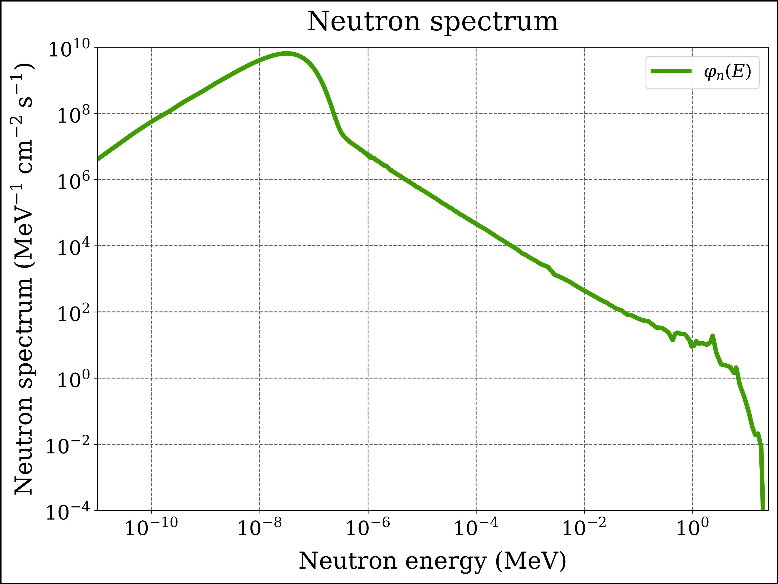
Figure 19: Neutron fluence rate in the nuclear reactor for which spectrum-averaged effective neutron reproduction factors are quantified
Figure 19 shows the two characteristic features of a thermal-reactor spectrum: the Maxwellian thermal peak around 0.025 eV, where neutrons are in thermal equilibrium with the moderator, and the slowing-down region, in which $φ(E)∝1/E$, connecting it with the fission neutrons in the MeV range.

8.2 Numerical integration: decade by decade
Every spectrum average is a ratio of energy integrals from $E_{min}={10}^{−5}$ eV to $E_{max}=20$ MeV. Each integral is split into sub-integrals that cover one decade of energy each - ${10}^{−5}$ to ${10}^{−4}$ eV, ${10}^{−4}$ to ${10}^{−3}$ eV, …, 1 to 10 MeV and 10 to 20 MeV - and the sub-integrals are summed:
EminEmaxg(E) dE=k​EkEk+1g(E) dE. (14)
Splitting by decades suits the physics: over 12 decades the integrands change by many orders of magnitude, and on a logarithmic energy scale every decade carries its own, equally important structure (thermal peak, resonances, fast region). As a bonus, each sub-integral shows where in energy the reactions happen (Section 8.4).
Quadrature rule. Inside each decade the integral is evaluated with composite Gauss-Legendre quadrature on the tabulated energy grid: every interval between two consecutive tabulated energies is integrated with an $n$-point Gauss-Legendre rule, which is exact for polynomials up to degree $2n−1$. Between two tabulated energies every PCHIP interpolant is a cubic polynomial, so the integrand $\overset{‾}{ν} σ_{f} φ$ is a polynomial of degree 9 - and already the 5-point rule integrates it exactly; we use 16 points (exact up to degree 31). No resonance can be missed, because every resonance is described by tabulated points, and those points are interval boundaries. In addition, the fine plotting grid E_fine (about 8 000 points per decade, i.e. intervals narrower than 0.03 % of the energy) is added as interval boundaries in every integral, so that integrands which are not polynomials - $η(E) φ(E)$, the fission spectrum and the Maxwellian - are integrated just as accurately.
1σ error. Each sub-integral is evaluated with 16 and with 8 points; the 16-point value is used and the difference $|I_{16}−I_{8}|$ serves as a (conservative) 1σ error estimate. The contributions of the hundreds of thousands of intervals are summed with math.fsum, which adds floating-point numbers without accumulating round-off. Errors of the decades are added in quadrature, and for a ratio $q=x/y$ the relative errors are added in quadrature:
$$σ_{q}=|q| \sqrt{{\left(\frac{σ_{x}}{x}\right)}^{2}+{\left(\frac{σ_{y}}{y}\right)}^{2}}. (15)$$
What the 1σ error does - and does not - include. Because the quadrature is exact for the interpolated data, the numerical 1σ errors below are at the level of floating-point round-off (about ${10}^{−16}$ relative); only the flux-weighted mean $⟨η⟩_{φ}$ of two nuclides, whose integrand is a ratio of polynomials with steep features, shows up to ${10}^{−10}$. These numbers say that the integration is exact - not that the physics is known to 16 digits. Larger, systematic effects are, first, the upper limit of 20 MeV: it leaves out the $2×{10}^{−7}$ of all fission neutrons that are born above 20 MeV (Section 8.5), which affects the fission-spectrum averages at the ${10}^{−7}$ level - negligible, but far larger than the round-off. Second, the interpolation between tabulated points (a test with linear instead of PCHIP interpolation changed the thermal $⟨η⟩$ by $2×{10}^{−5}$ relative for $​^{235}U$ and by $5×{10}^{−4}$ for $​^{239}Pu$, whose 0.3 eV resonance lies where the 181-point spectrum table is coarse) and, above all, the uncertainties of the evaluated nuclear data themselves, typically a few tenths of a percent.
Why not scipy.integrate.quad? Adaptive Gauss-Kronrod quadrature chooses its own sampling points. Over the full energy range it misses most of the resonances: in an earlier version of this notebook it returned $⟨η⟩_{φ}=0.31$ for $​^{235}U$ instead of 2.08, and the warning that hinted at the failure had been switched off. Applied decade by decade it comes close - but only to about ${10}^{−8}$ relative - and it reports hundreds of round-off warnings in the resonance decades. The trapezoidal rule on E_fine reaches only about ${10}^{−6}$ relative accuracy.
# --- Energy segments: one per decade of energy --------------------------------
def decade_segments(E_low, E_high):
"""Split [E_low, E_high] at every power of ten in between: one segment per
decade of energy (the first and the last segment may be shorter)."""
segments = []
lower = E_low
for k in range(-11, 3): # powers of ten from 1E-11 to 1E+02 MeV
if E_low < 10.0**k < E_high:
segments.append((lower, 10.0**k)) # one complete (or first, partial) decade
lower = 10.0**k
segments.append((lower, E_high)) # the last (partial) decade
return segments
E_thermal = 6.25E-07 # MeV (0.625 eV): upper end of the thermal group
decades = decade_segments(E_min, E_max) # whole energy range
thermal_decades = decade_segments(E_min, E_thermal) # thermal group only
print(f'The integrals are split into {len(decades)} decades:')
for a, b in decades:
print(f' {a * 1E6:9.2e} eV - {b * 1E6:9.2e} eV')
# --- Gauss-Legendre quadrature --------------------------------------------------
# Nodes x and weights w of the n-point rule on the reference interval [-1, 1]:
x_gl16, w_gl16 = np.polynomial.legendre.leggauss(16) # exact for polynomials up to degree 31
x_gl8, w_gl8 = np.polynomial.legendre.leggauss(8) # exact for polynomials up to degree 15
def gauss_legendre(f, points, x_gl, w_gl):
"""Composite Gauss-Legendre rule: integrate f(E) over every interval between
two consecutive energies in `points` (sorted) and add up the results."""
h = np.diff(points) # widths of the intervals
mid = np.convolve(points, [0.5, 0.5], mode='valid') # mid-points: average of neighbours
E = mid.reshape(-1, 1) + np.outer(h / 2, x_gl) # nodes: one row per interval
per_interval = h / 2 * np.sum(f(E) * w_gl, axis=1) # integral over each interval
return math.fsum(per_interval) # exact summation, no round-off build-up
def integral_segment(f, a, b, breakpoints):
"""Integral of f(E) from a to b, and its 1σ error estimate.
All breakpoints between a and b become interval boundaries: np.clip moves
the points outside [a, b] onto a or b, and np.unique sorts the result and
removes duplicates. The 16-point value is the result; its difference from
the 8-point value is the (conservative) 1σ error estimate."""
points = np.unique(np.clip(np.append(breakpoints, [a, b]), a, b))
value_16 = gauss_legendre(f, points, x_gl16, w_gl16)
value_8 = gauss_legendre(f, points, x_gl8, w_gl8)
return value_16, abs(value_16 - value_8)
def integral(f, breakpoints, segments=decades):
"""Sum of the sub-integrals over all segments (decades).
Returns (value, 1σ error); the errors of the segments are added in quadrature."""
values, errors = [], []
for a, b in segments:
value, error = integral_segment(f, a, b, breakpoints)
values.append(value)
errors.append(error)
return math.fsum(values), math.sqrt(math.fsum(e**2 for e in errors))
def breakpoints_of(*interpolants):
"""Interval boundaries for the quadrature: the fine grid E_fine (about 8 000
points per decade) plus all tabulated energies of the given PCHIP interpolants."""
return np.concatenate([E_fine] + [g.x for g in interpolants])
# --- Error propagation for (value, 1σ) pairs -------------------------------------
def ratio(numerator, denominator):
"""q = x / y; relative errors added in quadrature (eq-error-ratio)."""
(x, σ_x), (y, σ_y) = numerator, denominator
q = x / y
return q, abs(q) * np.sqrt((σ_x / x)**2 + (σ_y / y)**2)
def add(first, second):
"""x + y; errors added in quadrature."""
(x, σ_x), (y, σ_y) = first, second
return x + y, np.hypot(σ_x, σ_y)
def pm(pair, decimals=4):
"""A (value, 1σ) pair as text: 'value ± 1σ'."""
value, sigma = pair
return f'{value:.{decimals}f} ± {sigma:.1e}'
# --- Nuclear data of every nuclide: (ν̄(E), σ_f(E), σ_γ(E), η(E)) -----------------
nuclides = {
'U-232': (yield_fn_u232, σ_nf_u232, σ_nγ_u232, nrf_u232),
'U-233': (yield_fn_u233, σ_nf_u233, σ_nγ_u233, nrf_u233),
'U-234': (yield_fn_u234, σ_nf_u234, σ_nγ_u234, nrf_u234),
'U-235': (yield_fn_u235, σ_nf_u235, σ_nγ_u235, nrf_u235),
'U-236': (yield_fn_u236, σ_nf_u236, σ_nγ_u236, nrf_u236),
'U-238': (yield_fn_u238, σ_nf_u238, σ_nγ_u238, nrf_u238),
'Pu-238': (yield_fn_pu238, σ_nf_pu238, σ_nγ_pu238, nrf_pu238),
'Pu-239': (yield_fn_pu239, σ_nf_pu239, σ_nγ_pu239, nrf_pu239),
'Pu-240': (yield_fn_pu240, σ_nf_pu240, σ_nγ_pu240, nrf_pu240),
'Pu-241': (yield_fn_pu241, σ_nf_pu241, σ_nγ_pu241, nrf_pu241),
}
The integrals are split into 13 decades:
1.00e-05 eV - 1.00e-04 eV
1.00e-04 eV - 1.00e-03 eV
1.00e-03 eV - 1.00e-02 eV
1.00e-02 eV - 1.00e-01 eV
1.00e-01 eV - 1.00e+00 eV
1.00e+00 eV - 1.00e+01 eV
1.00e+01 eV - 1.00e+02 eV
1.00e+02 eV - 1.00e+03 eV
1.00e+03 eV - 1.00e+04 eV
1.00e+04 eV - 1.00e+05 eV
1.00e+05 eV - 1.00e+06 eV
1.00e+06 eV - 1.00e+07 eV
1.00e+07 eV - 2.00e+07 eV

8.3 $⟨η⟩$ in the thermal reactor spectrum
# Character of the spectrum: fractions of the total neutron fluence rate
φ_points = breakpoints_of(ϕ_n)
φ_total = integral(ϕ_n, φ_points)
φ_thermal = integral(ϕ_n, φ_points, thermal_decades)
φ_fast = integral(ϕ_n, φ_points, decade_segments(0.1, E_max))
thermal_fraction = ratio(φ_thermal, φ_total)
fast_fraction = ratio(φ_fast, φ_total)
print(f'Thermal fraction (E < 0.625 eV): {pm(thermal_fraction)}')
print(f'Fast fraction (E > 0.1 MeV): {pm(fast_fraction)}')
print()
eta_phi = {} # flux-weighted mean of η(E) (eq-eta-flux)
eta_rr = {} # ratio of reaction rates (eq-eta-rr)
print('Nuclide <η>_φ (flux-weighted) <η> (ratio of reaction rates)')
for name, (ν, σ_f, σ_γ, η) in nuclides.items():
points = breakpoints_of(ν, σ_f, σ_γ, ϕ_n)
production = integral(lambda E: ν(E) * σ_f(E) * ϕ_n(E), points) # fission neutrons produced
absorption = integral(lambda E: (σ_f(E) + σ_γ(E)) * ϕ_n(E), points) # neutrons absorbed
eta_rr[name] = ratio(production, absorption)
eta_phi[name] = ratio(integral(lambda E: η(E) * ϕ_n(E), points), φ_total)
print(f'{name:8} {pm(eta_phi[name])} {pm(eta_rr[name])}')
Thermal fraction (E < 0.625 eV): 0.8351 ± 1.0e-17
Fast fraction (E > 0.1 MeV): 0.0798 ± 7.5e-18
Nuclide <η>_φ (flux-weighted) <η> (ratio of reaction rates)
U-232 1.7647 ± 3.9e-15 1.6088 ± 2.8e-16
U-233 2.3034 ± 1.7e-16 2.2873 ± 2.3e-16
U-234 0.1719 ± 1.6e-10 0.0051 ± 6.3e-19
U-235 2.0802 ± 1.8e-16 2.0761 ± 2.0e-16
U-236 0.1307 ± 2.9e-13 0.0191 ± 1.5e-18
U-238 0.1167 ± 5.3e-15 0.0185 ± 3.0e-18
Pu-238 0.3740 ± 1.5e-10 0.0868 ± 1.1e-17
Pu-239 2.0959 ± 3.2e-16 2.0043 ± 6.1e-17
Pu-240 0.2136 ± 8.7e-13 0.0020 ± 2.5e-19
Pu-241 2.2999 ± 4.1e-15 2.1943 ± 6.5e-17

8.4 Where are the neutrons absorbed?
Splitting the integrals into decades has a bonus: every sub-integral tells where in energy the reactions take place. The next cell lists the absorption rate of $​^{235}U$ and $​^{238}U$ in each decade of the thermal reactor spectrum, as a percentage of the total.
share = {} # absorption rate per decade, % of the total
max_error = 0.0 # largest 1σ numerical error of an entry, %
for name in ['U-235', 'U-238']:
ν, σ_f, σ_γ, η = nuclides[name]
points = breakpoints_of(ν, σ_f, σ_γ, ϕ_n)
absorption = lambda E: (σ_f(E) + σ_γ(E)) * ϕ_n(E)
total, σ_total = integral(absorption, points)
share[name] = []
for a, b in decades:
value, error = integral_segment(absorption, a, b, points)
share[name].append(100 * value / total)
max_error = max(max_error, 100 * error / total)
print('Energy decade (eV) U-235 U-238')
for (a, b), u235, u238 in zip(decades, share['U-235'], share['U-238']):
print(f'{a * 1E6:8.0e} - {b * 1E6:7.0e} {u235:7.2f} % {u238:7.2f} %')
print(f'(1σ numerical error of every entry < {max_error:.0e} %)')
# Sums over the thermal region (below 1 eV) and the resonance region (1 eV - 1 keV):
below_1eV = {}
resonance = {}
for name in ['U-235', 'U-238']:
below_1eV[name] = sum(s for (a, b), s in zip(decades, share[name]) if b <= 1.0E-06)
resonance[name] = sum(s for (a, b), s in zip(decades, share[name]) if a >= 1.0E-06 and b <= 1.0E-03)
Energy decade (eV) U-235 U-238
1e-05 - 1e-04 0.01 % 0.01 %
1e-04 - 1e-03 0.44 % 0.19 %
1e-03 - 1e-02 11.50 % 4.98 %
1e-02 - 1e-01 78.72 % 37.11 %
1e-01 - 1e+00 8.71 % 4.73 %
1e+00 - 1e+01 0.21 % 25.47 %
1e+01 - 1e+02 0.26 % 22.36 %
1e+02 - 1e+03 0.08 % 3.68 %
1e+03 - 1e+04 0.02 % 0.50 %
1e+04 - 1e+05 0.01 % 0.19 %
1e+05 - 1e+06 0.01 % 0.10 %
1e+06 - 1e+07 0.01 % 0.68 %
1e+07 - 2e+07 0.00 % 0.01 %
(1σ numerical error of every entry < 4e-15 %)
In $​^{235}U$ 99.4 % of all absorptions occur below 1 eV. In $​^{238}U$, by contrast, 52 % take place in the resonance region between 1 eV and 1 keV - mainly in its giant capture resonances at 6.7, 20.9 and 36.7 eV. These resonance captures are exactly what the resonance escape probability $p$ of the four-factor formula accounts for; the thermal absorptions in $​^{238}U$ appear in $η$ of the fuel mixture (Section 9.2).
Caution. The cross sections are infinitely dilute (unshielded) values. In a real fuel rod the $​^{238}U$ resonances are strongly self-shielded: at the resonance energies the flux collapses inside the rod, so the actual resonance absorption is much smaller than these percentages suggest. The resonance escape probability of a real lattice is calculated with effective, self-shielded resonance integrals.

8.5 $⟨η⟩$ in a fast, unmoderated spectrum
Without a moderator the neutrons stay fast. The extreme case is the fission spectrum $χ(E)$, the energy distribution of neutrons at birth. For thermal fission of $​^{235}U$ it is well described by the Watt formula
$$χ(E)=0.453 e^{−1.036 E} sinh\sqrt{2.29 E}, E\text{ in MeV}, (16)$$
normalised to one neutron. In a bare sphere of fissile metal - such as the Los Alamos critical assemblies Godiva (highly enriched uranium) and Jezebel (plutonium) - the spectrum is only slightly softer than $χ(E)$, because the neutrons lose some energy in inelastic collisions before they cause fission, are captured or escape. $χ(E)$ is therefore a good model of an unmoderated fast system. How many fission neutrons are born above 19 MeV and above $E_{max}=20$ MeV - practically none - is calculated below.
Spectra are usually compared per unit lethargy, $u=ln(E_{0}/E)$: on a logarithmic energy axis the area under $E φ(E)$ is proportional to the number of neutrons in that energy range (Figure 20).
def χ(E):
"""Watt fission spectrum, thermal fission of U-235 (eq-watt); E in MeV, unit: MeV⁻¹."""
return 0.453 * np.exp(-1.036 * E) * np.sinh(np.sqrt(2.29 * E))
# χ(E) is smooth: breakpoints_of() without arguments gives the fine grid E_fine.
χ_total = integral(χ, breakpoints_of())
χ_mean = ratio(integral(lambda E: E * χ(E), breakpoints_of()), χ_total)
χ_below_1MeV = ratio(integral(χ, breakpoints_of(), decade_segments(E_min, 1.0)), χ_total)
print(f'∫χ(E) dE (0 - 20 MeV) = {pm(χ_total, 6)} (the Watt fit is normalised to 1 within 0.12 %)')
print(f'Mean energy = {pm(χ_mean, 3)} MeV')
print(f'Born below 1 MeV = {pm(χ_below_1MeV, 3)}')
# Fission neutrons born above 19 MeV and above E_max = 20 MeV (outside all integrals):
E_high = np.logspace(np.log10(19.0), 2, 2001) # fine grid from 19 to 100 MeV
for E_cut in [19.0, E_max]:
value, sigma = ratio(integral(χ, E_high, decade_segments(E_cut, 100.0)), χ_total)
print(f'Born above {E_cut:4.1f} MeV = {value:.2e} ± {sigma:.1e}')
∫χ(E) dE (0 - 20 MeV) = 1.001186 ± 5.6e-17 (the Watt fit is normalised to 1 within 0.12 %)
Mean energy = 1.981 ± 1.1e-16 MeV
Born below 1 MeV = 0.310 ± 5.8e-17
Born above 19.0 MeV = 5.40e-07 ± 1.1e-22
Born above 20.0 MeV = 2.26e-07 ± 5.4e-23
fig, axes = plt.subplots(nrows=1, ncols=1, sharex=True, sharey=True)
#
x = E_fine
y = E_fine * ϕ_n(E_fine) / np.max(E_fine * ϕ_n(E_fine))
axes.plot(x, y, label='Thermal reactor spectrum',
color=color_n, linestyle=ls1, linewidth=lw1, marker=None)
#
x = E_fine
y = E_fine * χ(E_fine) / np.max(E_fine * χ(E_fine))
axes.plot(x, y, label=r'Fission spectrum $\chi(E)$',
color=color_pu239, linestyle=ls2, linewidth=lw2, marker=None)
#
title = 'Neutron spectra per unit lethargy'
xlabel = 'Neutron energy (MeV)'
ylabel = r'$E\,\varphi(E)$ (normalised)'
xlims = [E_min, E_max*1.25]
ylims = [0, 1.1]
xscale = 'log'
yscale = 'linear'
ncol_legend = 1
file_name = 'spectra_per_lethargy'
add_to_plot(fig, axes, title, xlabel, ylabel, xlims, ylims, xscale, yscale, ncol_legend, file_name)
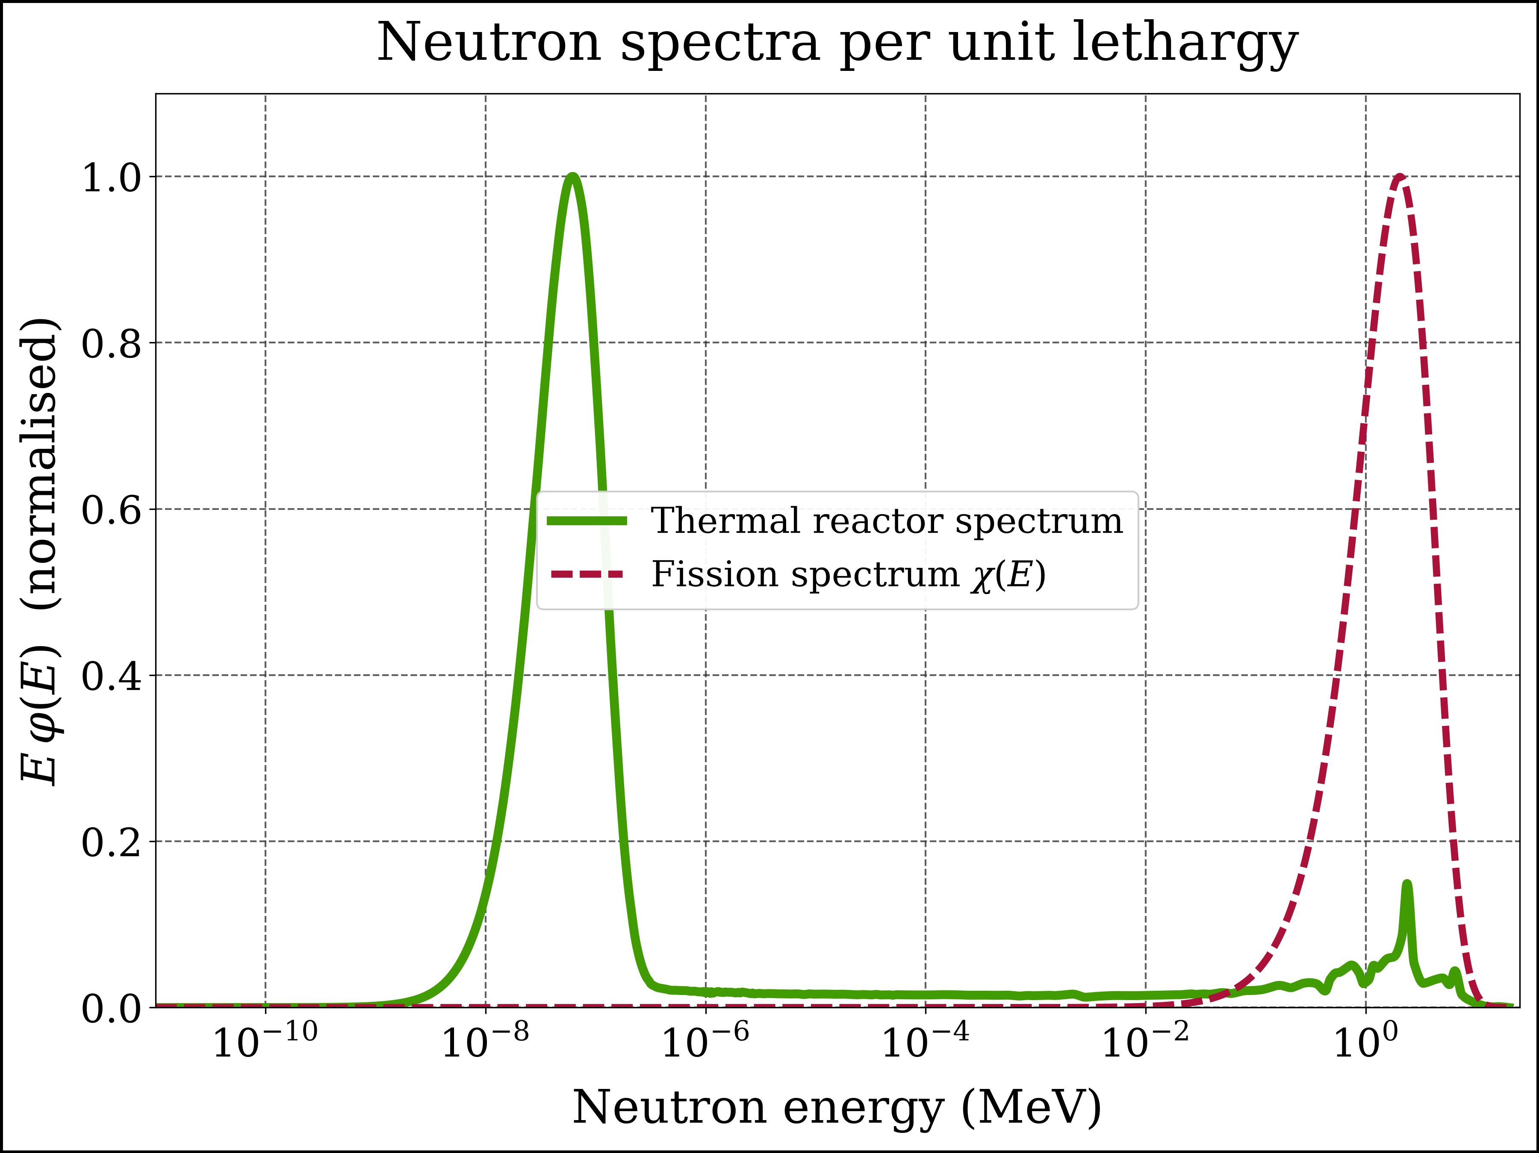
Figure 20: Thermal reactor spectrum and fission spectrum per unit lethargy, each normalised to a maximum of 1
eta_chi = {} # <η> in the fission spectrum (eq-eta-rr with φ = χ)
alpha_chi = {} # <α> = capture rate / fission rate
sigma_f_chi = {} # fission cross section averaged over the fission spectrum (b)
print('Nuclide <η> <α> <σ_f> (b)')
for name, (ν, σ_f, σ_γ, η) in nuclides.items():
points = breakpoints_of(ν, σ_f, σ_γ)
production = integral(lambda E: ν(E) * σ_f(E) * χ(E), points)
fission = integral(lambda E: σ_f(E) * χ(E), points)
capture = integral(lambda E: σ_γ(E) * χ(E), points)
eta_chi[name] = ratio(production, add(fission, capture))
alpha_chi[name] = ratio(capture, fission)
sigma_f_chi[name] = ratio(fission, χ_total)
print(f'{name:8} {pm(eta_chi[name])} {pm(alpha_chi[name])} {pm(sigma_f_chi[name], 3)}')
Nuclide <η> <α> <σ_f> (b)
U-232 3.2241 ± 4.3e-16 0.0601 ± 1.7e-18 2.058 ± 1.3e-16
U-233 2.6232 ± 2.5e-16 0.0318 ± 3.7e-18 1.895 ± 1.1e-16
U-234 2.4550 ± 4.1e-16 0.0918 ± 8.8e-18 1.201 ± 1.3e-16
U-235 2.4685 ± 2.5e-16 0.0788 ± 9.9e-18 1.223 ± 1.4e-16
U-236 2.2823 ± 3.5e-17 0.1930 ± 1.7e-17 0.567 ± 3.1e-17
U-238 2.2644 ± 3.3e-16 0.2340 ± 4.8e-17 0.309 ± 5.8e-17
Pu-238 3.0729 ± 4.4e-16 0.0503 ± 3.6e-18 1.961 ± 1.1e-16
Pu-239 3.0642 ± 5.0e-16 0.0353 ± 4.0e-18 1.799 ± 1.1e-16
Pu-240 2.9218 ± 3.2e-16 0.0670 ± 2.9e-18 1.372 ± 8.1e-17
Pu-241 3.0625 ± 3.1e-16 0.0448 ± 5.0e-18 1.628 ± 1.1e-16

8.6 Summary
Table 4: Spectrum-averaged neutron reproduction factors (ratio of reaction rates, Equation 11) and capture-to-fission ratios, with their 1σ numerical errors.
Nuclide | $⟨η⟩$, thermal reactor spectrum | $⟨η⟩$, fission spectrum | $⟨α⟩$, fission spectrum
$​^{232}U$​ | 1.6088 ± 2.8e-16 | 3.2241 ± 4.3e-16 | 0.0601 ± 1.7e-18
$​^{233}U$​ | 2.2873 ± 2.3e-16 | 2.6232 ± 2.5e-16 | 0.0318 ± 3.7e-18
$​^{234}U$​ | 0.0051 ± 6.3e-19 | 2.4550 ± 4.1e-16 | 0.0918 ± 8.8e-18
$​^{235}U$​ | 2.0761 ± 2.0e-16 | 2.4685 ± 2.5e-16 | 0.0788 ± 9.9e-18
$​^{236}U$​ | 0.0191 ± 1.5e-18 | 2.2823 ± 3.5e-17 | 0.1930 ± 1.7e-17
$​^{238}U$​ | 0.0185 ± 3.0e-18 | 2.2644 ± 3.3e-16 | 0.2340 ± 4.8e-17
$​^{238}Pu$​ | 0.0868 ± 1.1e-17 | 3.0729 ± 4.4e-16 | 0.0503 ± 3.6e-18
$​^{239}Pu$​ | 2.0043 ± 6.1e-17 | 3.0642 ± 5.0e-16 | 0.0353 ± 4.0e-18
$​^{240}Pu$​ | 0.0020 ± 2.5e-19 | 2.9218 ± 3.2e-16 | 0.0670 ± 2.9e-18
$​^{241}Pu$​ | 2.1943 ± 6.5e-17 | 3.0625 ± 3.1e-16 | 0.0448 ± 5.0e-18

Thermal spectrum. The selected spectrum is strongly thermalised: a fraction 0.835 ± 1.0e-17 of the fluence rate lies below 0.625 eV and only 0.080 ± 7.5e-18 above 0.1 MeV. $​^{233}U$ has the highest $⟨η⟩$ (2.2873 ± 2.3e-16) and is the only fuel with a useful margin above 2 (Equation 10). $​^{235}U$ (2.0761 ± 2.0e-16) and $​^{239}Pu$ (2.0043 ± 6.1e-17) can sustain a chain reaction but cannot breed in a thermal spectrum. Note that $​^{239}Pu$ ends up below $​^{235}U$ here, although its value at 0.0253 eV is higher (Section 6.4): the spectrum reaches into its 0.3 eV resonance, where $η$ dips to about 1.7 (Section 9.4). For the even-$N$ nuclides the flux-weighted mean overstates $η$ many times over - for $​^{238}U$ 0.1167 ± 5.3e-15 instead of 0.0185 ± 3.0e-18 - exactly as anticipated in Section 2.8.
Fission spectrum. In the fast spectrum $α$ is small for all fissile nuclides and $η$ of $​^{239}Pu$ climbs to 3.0642 ± 5.0e-16, well above $​^{235}U$ (2.4685 ± 2.5e-16): a fast plutonium reactor has about one spare neutron per absorption for breeding and to cover losses. $​^{238}Pu$ reaches 3.0729 ± 4.4e-16, the highest value of all plutonium isotopes (Section 10).
A warning about the even-$N$ nuclides. In the fission spectrum $​^{238}U$ (2.2644 ± 3.3e-16) and $​^{240}Pu$ (2.9218 ± 3.2e-16) also show $⟨η⟩>2$ - yet a sphere of $​^{238}U$ can never be made critical, and $​^{240}Pu$ needs about 40 kg. $η$ counts the neutrons that are absorbed; it says nothing about the neutrons that are scattered. In a fast system the decisive competition is between fission on the one hand and inelastic scattering, capture and leakage on the other. Inelastic collisions quickly push neutrons below the fission threshold of $​^{238}U$ (about 1 MeV), after which they can no longer cause fission. This is the key to Section 10.

9. The four-factor formula in practice

9.1 $η$ of thermal neutrons
In the four-factor formula $η$ is the reproduction factor of thermal neutrons: absorptions in the resonance region are accounted for by $p$, fissions by fast neutrons by $ε$. It is obtained from Equation 11 by restricting both integrals to the thermal group, $E<0.625$ eV - here simply the first five decade segments, the last of which ends at 0.625 eV.
eta_th = {} # η of thermal neutrons: the η of the four-factor formula
rates_th = {} # thermal-group (production, absorption) rates per atom
print('Nuclide thermal η')
for name, (ν, σ_f, σ_γ, η) in nuclides.items():
points = breakpoints_of(ν, σ_f, σ_γ, ϕ_n)
production = integral(lambda E: ν(E) * σ_f(E) * ϕ_n(E), points, thermal_decades)
absorption = integral(lambda E: (σ_f(E) + σ_γ(E)) * ϕ_n(E), points, thermal_decades)
rates_th[name] = (production, absorption)
eta_th[name] = ratio(production, absorption)
print(f'{name:8} {pm(eta_th[name])}')
Nuclide thermal η
U-232 1.5866 ± 2.9e-16
U-233 2.2907 ± 2.3e-16
U-234 0.0016 ± 3.4e-20
U-235 2.0793 ± 2.0e-16
U-236 0.0001 ± 1.2e-20
U-238 0.0000 ± 2.2e-21
Pu-238 0.0845 ± 1.1e-17
Pu-239 2.0049 ± 6.1e-17
Pu-240 0.0007 ± 1.3e-19
Pu-241 2.1938 ± 4.4e-17
For the fissile nuclides the thermal $η$ hardly differs from the whole-spectrum value in Table 4, because almost all their absorptions are thermal (Section 8.4). For $​^{238}U$, $​^{240}Pu$ and $​^{238}Pu$ it is far below 1: thermal neutrons absorbed in them are captured.

9.2 Low-enriched uranium fuel
With Equation 7 the thermal $η$ of uranium fuel follows from the thermal-group production and absorption rates of $​^{235}U$ and $​^{238}U$. The enrichment $e$ is the $​^{235}U$ atom fraction; for uranium it differs from the weight fraction by only about 1 %.
def eta_thermal_uranium(e):
"""Thermal η of uranium with U-235 atom fraction e (eq-eta-mixture)."""
(P_5, σP_5), (A_5, σA_5) = rates_th['U-235']
(P_8, σP_8), (A_8, σA_8) = rates_th['U-238']
r = (1 - e) / e # N(U-238) / N(U-235)
production = (P_5 + r * P_8, np.hypot(σP_5, r * σP_8))
absorption = (A_5 + r * A_8, np.hypot(σA_5, r * σA_8))
return ratio(production, absorption)
print('U-235 atom fraction thermal η')
for e, label in [(0.00711, 'natural'), (0.03, ''), (0.04, ''), (0.05, ''),
(0.20, 'HALEU limit'), (0.93, 'HEU')]:
print(f' {e:7.2%} {label:12} {pm(eta_thermal_uranium(e))}')
U-235 atom fraction thermal η
0.71% natural 1.3244 ± 1.4e-16
3.00% 1.8369 ± 1.8e-16
4.00% 1.8938 ± 1.8e-16
5.00% 1.9296 ± 1.9e-16
20.00% HALEU limit 2.0459 ± 2.0e-16
93.00% HEU 2.0786 ± 2.0e-16
Natural uranium reaches only $η=$ 1.3244 ± 1.4e-16, uranium with 4 % $​^{235}U$ 1.8938 ± 1.8e-16. The gain from enrichment flattens out: above about 20 % the $​^{238}U$ absorptions hardly matter any more.

9.3 Worked example: $k_{∞}$ and reactivity
Take a fresh PWR fuel lattice with 4 % enriched uranium. The thermal $η$ comes from the data above. For the other three factors we use illustrative teaching values - in practice they depend on the lattice design and are calculated with a lattice code: $ε=1.03$, $p=0.75$ and $f=0.92$ (no soluble boron).
# Illustrative teaching values for a fresh PWR fuel lattice at operating
# temperature, without soluble boron (not the data of a specific plant):
ε = 1.03 # fast fission factor
p = 0.75 # resonance escape probability
f = 0.92 # thermal utilisation
η, σ_η = eta_thermal_uranium(0.04) # thermal η of 4 % enriched uranium (JEFF-4.0)
k_inf = η * f * p * ε # four-factor formula (eq-four-factor)
σ_k_inf = k_inf * σ_η / η # only η carries a (numerical) error here
ρ = (k_inf - 1) / k_inf # reactivity (eq-reactivity)
print(f'η = {pm((η, σ_η))}')
print(f'k∞ = η f p ε = {pm((k_inf, σ_k_inf))}')
print(f'ρ = (k∞ - 1) / k∞ = {ρ:.4f} = {ρ * 1E5:,.0f} pcm')
print()
# Thermal utilisation for which the lattice is exactly critical (k∞ = 1):
f_critical = 1 / (η * p * ε)
print(f'k∞ = 1 requires f = {f_critical:.4f}')
# Rule of thumb: at criticality a 1 % change of f is worth about 1000 pcm
k_1pct = η * (1.01 * f_critical) * p * ε
Δρ_1pct = (k_1pct - 1) / k_1pct
print(f'Raising f by 1 % from the critical value changes ρ by {Δρ_1pct * 1E5:,.0f} pcm')
η = 1.8938 ± 1.8e-16
k∞ = η f p ε = 1.3459 ± 1.3e-16
ρ = (k∞ - 1) / k∞ = 0.2570 = 25,701 pcm
k∞ = 1 requires f = 0.6836
Raising f by 1 % from the critical value changes ρ by 990 pcm
The fresh lattice has $k_{∞}=$ 1.3459 ± 1.3e-16, an excess reactivity of about 25,701 pcm. To operate at $k=1$ this excess must be held down. Without leakage, the thermal utilisation would have to be reduced to $f=$ 0.684 - in a PWR mainly with soluble boron in the coolant (Table 2). In a real core leakage ($P_{FNL}$, $P_{TNL}$), xenon, samarium and burnable absorbers take part of the excess; the rest is compensated by boron, which is gradually diluted as the fuel burns up. Near criticality a 1 % change of $f$ is worth 990 pcm - the rule of thumb of Section 2.3.

9.4 $η$ and the moderator temperature
Thermal neutrons are in approximate equilibrium with the moderator; their energy distribution is close to a Maxwell-Boltzmann spectrum
$$φ_{M}(E)=\frac{E}{(k_{B}T)^{2}} e^{−E/k_{B}T}, (17)$$
with $k_{B}T=0.0253$ eV at 20 °C and 0.0494 eV at 300 °C. As the moderator heats up, the thermal neutrons become faster. How $η$ responds depends on the nuclide:
k_B = 8.617333E-11 # Boltzmann constant, MeV/K
def maxwellian(E, T_C):
"""Maxwell-Boltzmann neutron fluence-rate spectrum per unit energy at the
temperature T_C (°C), normalised to 1 (eq-maxwellian); E in MeV."""
kT = k_B * (T_C + 273.15)
return E / kT**2 * np.exp(-E / kT)
T_moderator_C = np.arange(20, 401, 20) # moderator temperatures, °C
maxwell_decades = decade_segments(E_min, 1.0E-05) # up to 10 eV (> 100 kT): the whole Maxwellian
eta_maxwell = {} # thermal η versus temperature
eta_20C = {} # (value, 1σ) at 20 °C
eta_300C = {} # (value, 1σ) at 300 °C
for name in ['U-233', 'U-235', 'Pu-239', 'Pu-241']:
ν, σ_f, σ_γ, η = nuclides[name]
points = breakpoints_of(ν, σ_f, σ_γ)
values = []
for T in T_moderator_C:
production = integral(lambda E: ν(E) * σ_f(E) * maxwellian(E, T), points, maxwell_decades)
absorption = integral(lambda E: (σ_f(E) + σ_γ(E)) * maxwellian(E, T), points, maxwell_decades)
η_T, σ_η_T = ratio(production, absorption)
values.append(η_T)
if T == 20:
eta_20C[name] = (η_T, σ_η_T)
if T == 300:
eta_300C[name] = (η_T, σ_η_T)
eta_maxwell[name] = np.array(values)
print(f'{name:8} 20 °C: {pm(eta_20C[name])} 300 °C: {pm(eta_300C[name])}')
U-233 20 °C: 2.2955 ± 2.6e-16 300 °C: 2.2777 ± 3.7e-16
U-235 20 °C: 2.0790 ± 2.0e-16 300 °C: 2.0750 ± 4.1e-16
Pu-239 20 °C: 2.0481 ± 2.4e-16 300 °C: 1.8940 ± 1.9e-16
Pu-241 20 °C: 2.1832 ± 2.0e-16 300 °C: 2.1975 ± 2.7e-16
fig, axes = plt.subplots(nrows=1, ncols=1, sharex=True, sharey=True)
#
x = T_moderator_C
y = eta_maxwell['U-233']
axes.plot(x, y, label=r'$\mathrm{^{233}U}$',
color=color_u233, linestyle=ls1, linewidth=lw1, marker=None)
#
y = eta_maxwell['U-235']
axes.plot(x, y, label=r'$\mathrm{^{235}U}$',
color=color_u235, linestyle=ls1, linewidth=lw1, marker=None)
#
y = eta_maxwell['Pu-239']
axes.plot(x, y, label=r'$\mathrm{^{239}Pu}$',
color=color_pu239, linestyle=ls1, linewidth=lw1, marker=None)
#
y = eta_maxwell['Pu-241']
axes.plot(x, y, label=r'$\mathrm{^{241}Pu}$',
color=color_pu241, linestyle=ls1, linewidth=lw1, marker=None)
#
title = 'Thermal neutron reproduction factor'
xlabel = 'Moderator temperature (°C)'
ylabel = r'$\eta$ of thermal neutrons'
xlims = [0, 420]
ylims = [1.8, 2.4]
xscale = 'linear'
yscale = 'linear'
ncol_legend = 2
file_name = 'eta_thermal_vs_moderator_temperature'
add_to_plot(fig, axes, title, xlabel, ylabel, xlims, ylims, xscale, yscale, ncol_legend, file_name)
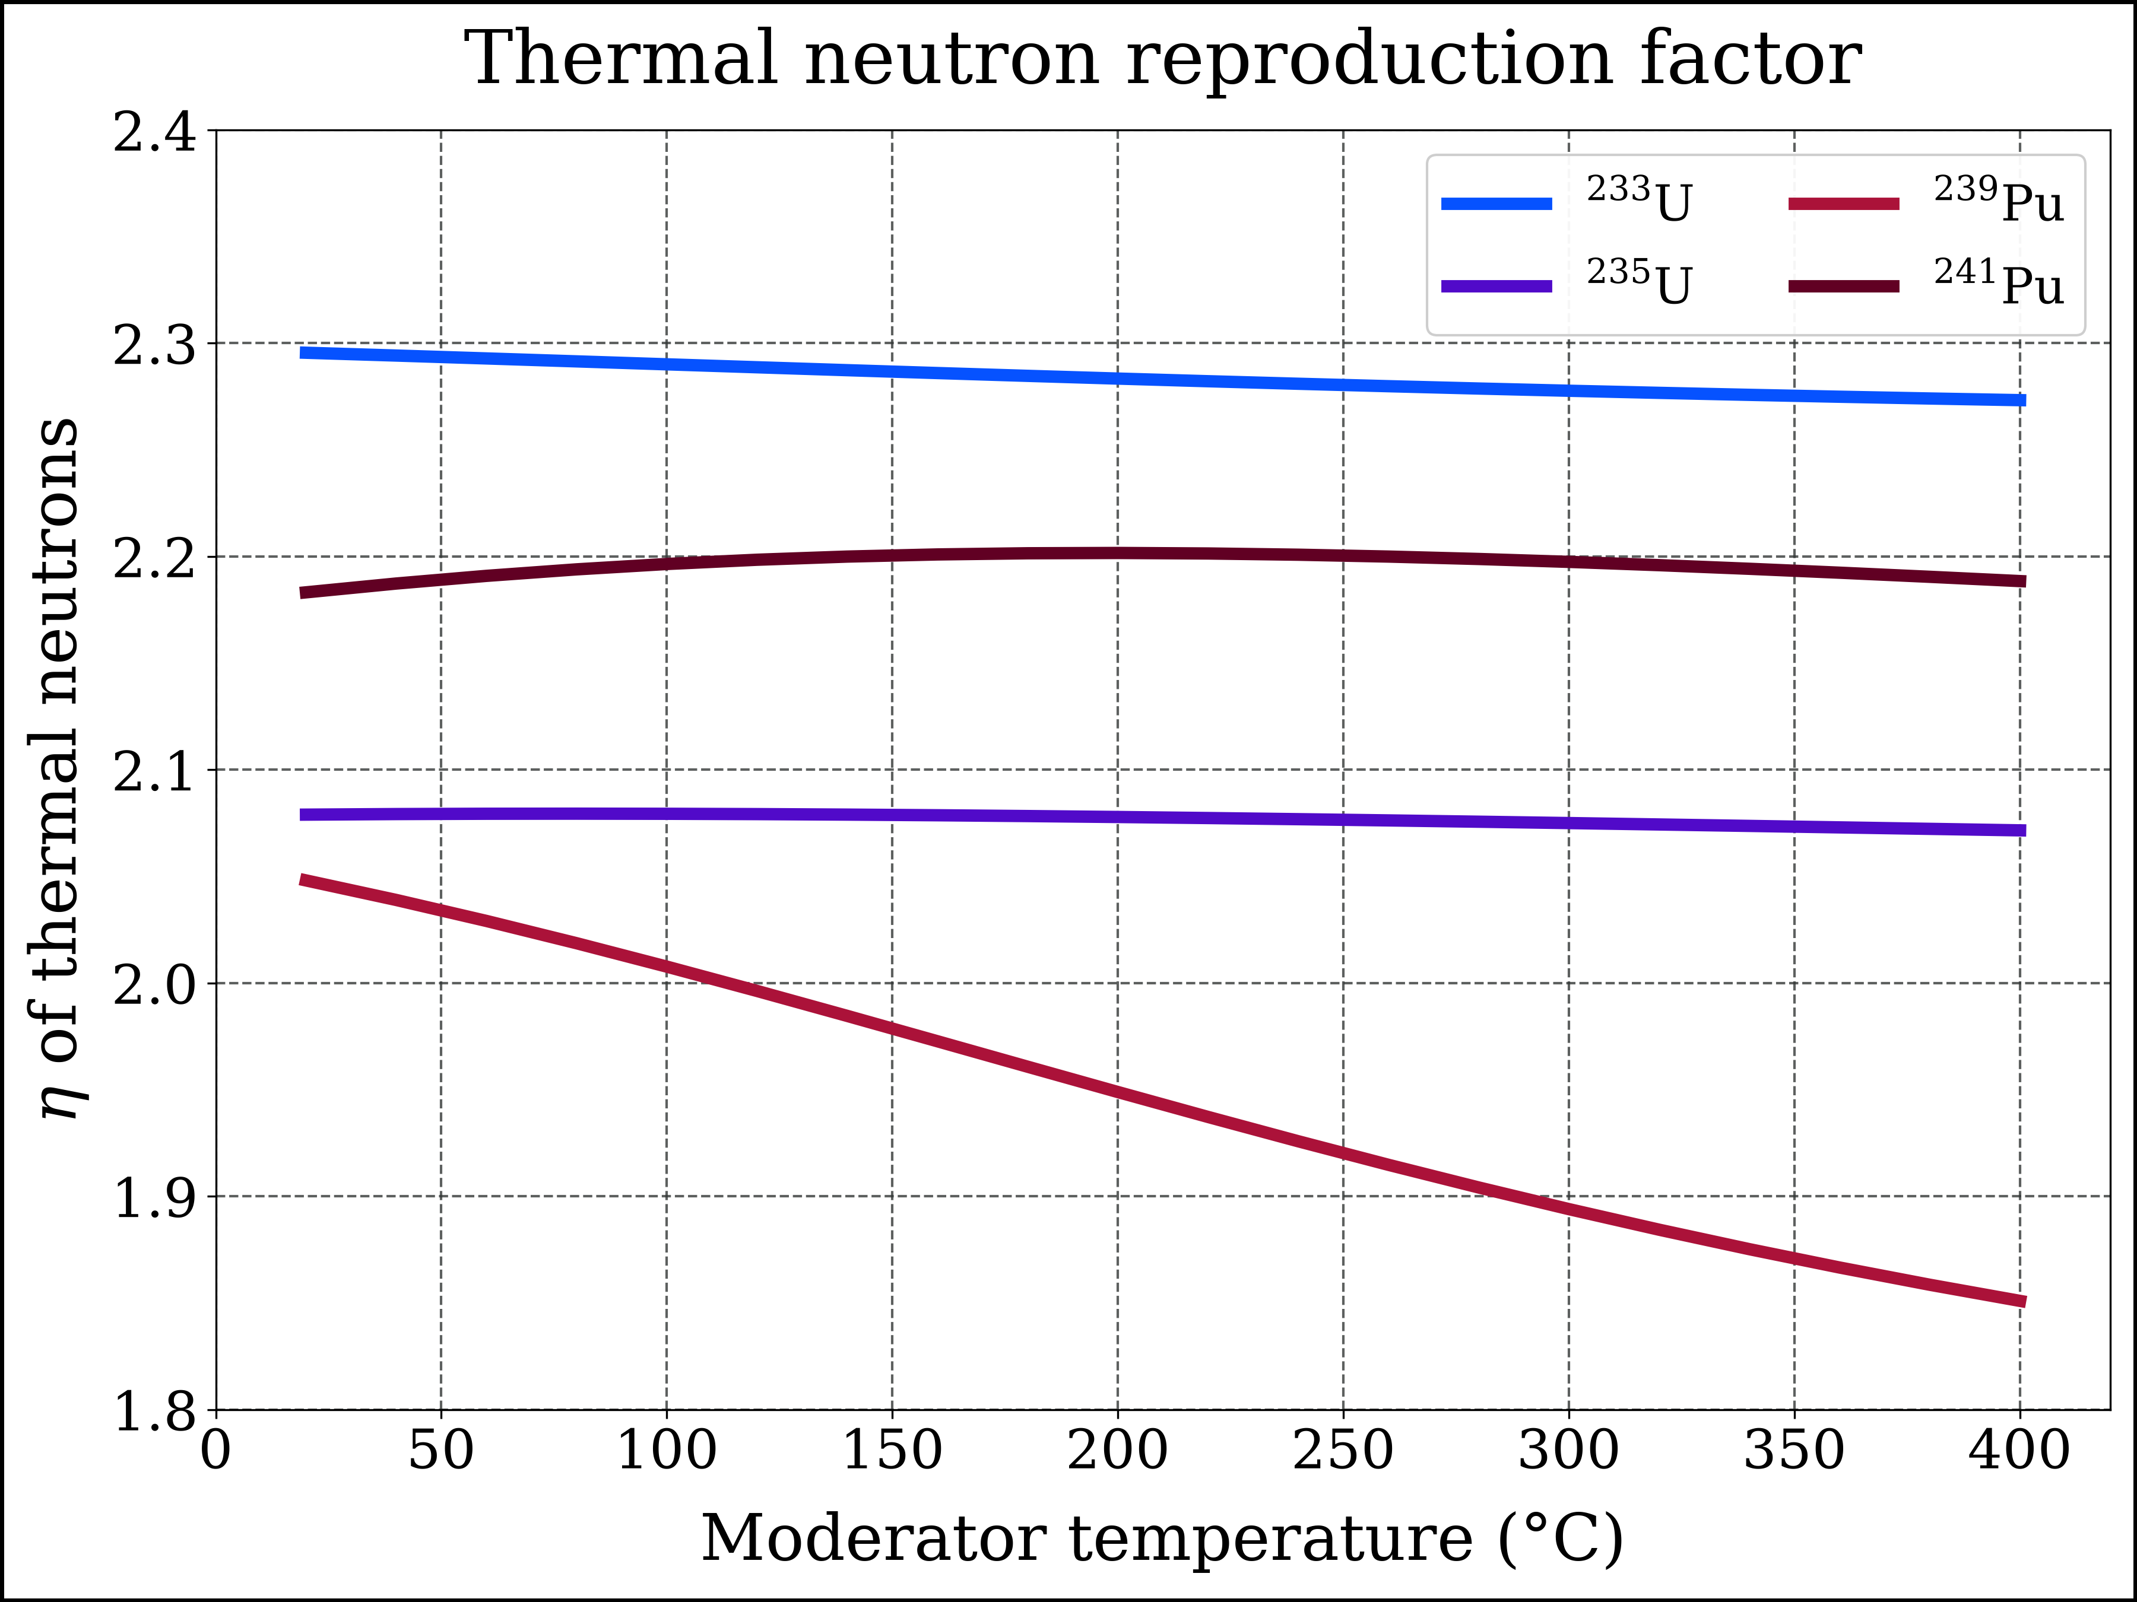
Figure 21: Reproduction factor of thermal neutrons (Maxwellian spectrum) versus moderator temperature
Figure 21 shows the result:
- $​^{235}U$: $η$ is almost independent of temperature (2.0790 ± 2.0e-16 at 20 °C, 2.0750 ± 4.1e-16 at 300 °C).
- $​^{239}Pu$: $η$ falls markedly, from 2.0481 ± 2.4e-16 to 1.8940 ± 1.9e-16, because the warmer neutrons overlap more and more with its capture-rich 0.3 eV resonance.
- $​^{241}Pu$ changes little, and $​^{233}U$ decreases slowly.
Operational consequence. As plutonium builds up during burnup - or in a core with MOX fuel - heating the moderator lowers $η$ of the fuel. This adds a negative contribution to the moderator temperature coefficient, which therefore becomes more negative towards the end of a cycle and in plutonium-bearing cores.
In a real core the thermal spectrum is somewhat “hardened” by absorption - the effective neutron temperature is higher than the moderator temperature - so the curves are indicative rather than exact.

10. The secret of plutonium-238
At first sight $​^{238}Pu$ is a poor nuclear fuel. For thermal neutrons the JEFF-4.0 data give a fission cross section of only 16.0 b - compared with 751 b for $​^{239}Pu$ - and a capture cross section of 535 b. (Mughabghab’s Atlas of Neutron Resonances lists 17.9 ± 0.4 b and 540 ± 7 b.) With $\overset{‾}{ν}=$ 2.91, its thermal reproduction factor is only $η=$ 0.084, and averaged over the thermal group 0.0845 ± 1.1e-17. In a thermal reactor $​^{238}Pu$ is a neutron absorber, not a fuel.
Yet a bare sphere of $​^{238}Pu$ metal (density about 19.8 g/cm³) is calculated to become critical at only 9 - 10 kg - as little as $​^{239}Pu$, and far less than $​^{235}U$:
Table 5: Bare-sphere critical masses of metallic actinides (compiled values; see References).
Nuclide (bare metal sphere) | Critical mass (kg) | Sphere diameter (cm)
$​^{238}Pu$​ | 9.04 - 10.07 | 9.5 - 9.9
$​^{239}Pu$​ | 10 | 9.9
$​^{241}Pu$​ | 12 | 10.5
$​^{233}U$​ | 15 | 11
$​^{240}Pu$​ | 40 | 15
$​^{235}U$​ | 52 | 17
$​^{238}U$​ | not critical at any mass | -

The next cell compares $​^{238}Pu$ with its neighbours at three energies: thermal, 30 keV (neutrons slowed down by inelastic collisions) and 1 MeV (fission neutrons).
# Point values of the interpolated JEFF-4.0 data (no integration -> no numerical error)
print('Energy Nuclide σ_f (b) σ_γ (b) ν̄ η')
for E, label in [(E_th, '0.0253 eV'), (3.0E-02, '30 keV'), (1.0, '1 MeV')]:
for name in ['Pu-238', 'Pu-239', 'Pu-240', 'U-238']:
ν, σ_f, σ_γ, η = nuclides[name]
print(f'{label:10} {name:8} {σ_f(E):11.5f} {σ_γ(E):12.5f} {ν(E):8.3f} {η(E):8.3f}')
print()
Energy Nuclide σ_f (b) σ_γ (b) ν̄ η
0.0253 eV Pu-238 15.96592 534.94047 2.910 0.084
0.0253 eV Pu-239 750.70543 271.43241 2.873 2.110
0.0253 eV Pu-240 0.07460 285.59773 2.783 0.001
0.0253 eV U-238 0.00002 2.68884 2.390 0.000
30 keV Pu-238 0.74680 0.62876 2.911 1.580
30 keV Pu-239 1.69868 0.46156 2.852 2.242
30 keV Pu-240 0.10154 0.68243 2.787 0.361
30 keV U-238 0.00007 0.43850 2.394 0.000
1 MeV Pu-238 2.04004 0.12973 3.055 2.872
1 MeV Pu-239 1.75080 0.06825 3.020 2.906
1 MeV Pu-240 1.53001 0.12245 2.921 2.704
1 MeV U-238 0.01593 0.12490 2.510 0.284
How can a nuclide with such a poor thermal fission cross section be as “good” as $​^{239}Pu$? The secret has three parts.
- No moderator - no thermal neutrons. In a bare metal sphere the neutrons never reach thermal energies. They are born with the fission spectrum (mean energy 1.98 ± 1.1e-16 MeV, Figure 20) and are slowed down only by inelastic collisions, to some tens or hundreds of keV, before they cause fission, are captured or leak out. The “mediocre” thermal fission cross section - and the large thermal capture cross section - simply never come into play. The thermal value is the wrong yardstick.
- The largest fast-fission cross section of all plutonium isotopes. Averaged over the fission spectrum, the JEFF-4.0 data give $⟨σ_{f}⟩=$ 1.961 ± 1.1e-16 b for $​^{238}Pu$, against 1.799 ± 1.1e-16 b for $​^{239}Pu$, 1.628 ± 1.1e-16 b for $​^{241}Pu$ and 1.372 ± 8.1e-17 b for $​^{240}Pu$ (the same ranking as the ENDF/B-VII.1 values of Pritychenko and Mughabghab). Capture takes only a small share ($⟨α⟩=$ 0.050 ± 3.6e-18), and $\overset{‾}{ν}$ is high, so its fast $η$ (3.0729 ± 4.4e-16) is the highest of all plutonium isotopes (Table 4, Figure 17).
- Practically no fission threshold. $​^{238}Pu$ has an even number of neutrons, but its compound nucleus $​^{239}{Pu}^{*}$ is formed with $S_{n}=5.65$ MeV (Table 3), only a fraction of an MeV below the fission barrier of about 6 MeV - much closer than $​^{241}{Pu}^{*}$ (5.24 MeV) or $​^{239}U^{*}$ (4.81 MeV). Fission by tunnelling through the top of the barrier is therefore strong even at low neutron energies (sub-threshold fission). At 30 keV the fission cross section of $​^{238}Pu$ is still 0.75 b - larger than its capture cross section (0.63 b) - whereas $​^{240}Pu$ fissions with only 0.102 b against 0.68 b capture, and $​^{238}U$ practically not at all (6.9e-05 b).
The third point is the real secret. As shown in Section 8.6, a high $η$ in the fission spectrum is not enough: $​^{238}U$ and $​^{240}Pu$ have it too. What a fast chain reaction needs is that neutrons which have been scattered down can still cause fission. In $​^{238}U$ they fall below the threshold and are lost; in $​^{240}Pu$ that happens below a few hundred keV; in $​^{238}Pu$ fission keeps competing successfully with capture all the way down to the keV range. Fast $η$, fast fission cross section and the absence of a threshold together make $​^{238}Pu$ behave like a fissile nuclide in an unmoderated system.
Why only theoretically? $​^{238}Pu$ decays by α emission with a half-life of 87.7 years and produces about 0.57 W of heat per gram. A 9.5 kg sphere would generate some 5.4 kW of decay heat - it would glow and could not be handled without active cooling. That same heat makes $​^{238}Pu$ the fuel of choice for radioisotope thermoelectric generators on deep-space missions.

11. Conclusions
- The neutron reproduction factor $η=\overset{‾}{ν}/(1+α)$ is the fuel-dependent factor of the four-factor formula. It sets an upper limit $k_{∞}≤η ε$, and breeding requires $η>2+L$.
- In the four-factor formula $η$ is the thermal $η$. For uranium with 4 % $​^{235}U$ the JEFF-4.0 data give 1.8938 ± 1.8e-16, for natural uranium only 1.3244 ± 1.4e-16.
- Operators act on $k$ mainly through $f$ (boron, control rods). Temperature feedback acts through $p$ (Doppler effect), through the moderator density, and through the thermal spectrum: $η$ of $​^{239}Pu$ falls markedly with moderator temperature, which makes the moderator temperature coefficient of plutonium-bearing cores more negative.
- Spectrum averages of $η$ must be ratios of reaction rates (Equation 11). A flux-weighted mean of $η(E)$ is a different quantity and grossly overstates $η$ of the even-$N$ nuclides in a thermal spectrum.
- Splitting every integral into decades and integrating the tabulated data exactly (Gauss-Legendre) makes the numerical error negligible; the real uncertainty of the results lies in the nuclear data.
- $​^{233}U$ has the highest $η$ in a thermal spectrum (2.2873 ± 2.3e-16) and is the principal candidate fuel for a thermal breeder (thorium / $​^{233}U$ cycle).
- $​^{239}Pu$ is the principal fuel of fast breeder reactors: in a fast spectrum its $η$ rises to 3.0642 ± 5.0e-16.
- $η$ alone does not decide whether a fast system can go critical. Fission must also out-compete inelastic down-scattering below the fission threshold - which is why $​^{238}Pu$, poor for thermal neutrons but excellent for fast neutrons and almost without a fission threshold, has a critical mass as small as that of $​^{239}Pu$.

11.1 Additional facts
- A major issue with $​^{233}U$ fuel is the high dose rate around fuel assemblies. It is caused by the inevitable contaminant $​^{232}U$, whose decay chain contains $​^{208}Tl$, which emits a hard 2.6 MeV γ-ray.
- The delayed-neutron fractions of $​^{233}U$ (about 0.0026) and $​^{239}Pu$ (about 0.0021) are much smaller than that of $​^{235}U$ (about 0.0065). The reactivity range between delayed and prompt criticality is correspondingly narrower, which makes reactor control more demanding.

References
- J. R. Lamarsh, A. J. Baratta, Introduction to Nuclear Engineering, 3rd ed., Prentice Hall (2001) - neutron life cycle, four- and six-factor formulae, reactivity, conversion and breeding, Watt fission spectrum.
- J. J. Duderstadt, L. J. Hamilton, Nuclear Reactor Analysis, Wiley (1976) - spectrum averaging of cross sections, one-group diffusion theory.
- OECD Nuclear Energy Agency, JEFF-4.0 - Joint Evaluated Fission and Fusion nuclear data library (2025) - source of the cross sections and fission-neutron yields used in this notebook, $​^{238}Pu$ included.
- S. F. Mughabghab, Atlas of Neutron Resonances, 5th ed., Elsevier (2006) - thermal cross sections of $​^{238}Pu$ for comparison.
- B. Pritychenko, S. F. Mughabghab, Neutron Thermal Cross Sections, Westcott Factors, Resonance Integrals, Maxwellian Averaged Cross Sections and Astrophysical Reaction Rates Calculated from Major Evaluated Data Libraries, BNL report, arXiv:1208.2879 (2012) - fission-spectrum-averaged fission cross sections of the plutonium isotopes for comparison.
- Wikipedia, Critical mass (table of bare-sphere critical masses) and Plutonium-238, accessed 6 October 2026.

