 **FINTECHATHON 2017  
  
<R2P Platform>** *<Requirement No.>*

|  |  |  |  |
| --- | --- | --- | --- |
| Version | Date | Author | Version Summary |
| 1.0 | 29-Nov-2017 | Victor Guo |  |
|  |  |  |  |
|  |  |  |  |
|  |  |  |  |

**Table of Contents**

1 Objectives 3

2 Business Requirements 4

2.1 Current Situation 4

2.1.1 Case 15, BO is Wang,Chen(1510855) from GBS China/GFS. 4

2.2 New Requirements 4

2.2.1 Case 15, BO is Wang,Chen(1510855) from GBS China/GFS. 4

3 High-Level Design / Solution Overview 5

3.1 Current Design (If has) 5

3.2 New Design 5

3.3 Dependence (If has) 5

3.4 Technology Infrastructure 5

3.5 Data Model / Data Flow (if has) 6

3.6 Tools / Environment 6

• Development tools: IntelliJ, Android Studio and Xcode. 6

• Coding Language: Html5, CSS3, JAVA SDK, Android SDK and IOS SDK. 6

• Running Environment: Chrome, Linux and Mobile App. 6

• Hardware: Scanner. 6

3.7 Important KPIs of Improvement 6

• Saving 20+hour man day per month. 6

3.8 Demonstration 7

3.9 Testing 7

3.10 Estimation 7

4 Deliverables 8

5 Team Structure 9

# Objectives

The Purpose of this POC is to provide an executive solution to resolve payment process issue for AO Department Staff.

The new system can:

* Improve 10 multiple work efficiency.
* Reduce manual mistake to Zero.
* Normalize payment criteria.
* Realize mobile OA.

# Business Requirements

## Current Situation

### Case 15, BO is Wang,Chen(1510855) from GBS China/GFS.

User is from AO department, currently her main problem is on payment process.

* User needs to manually input VAT invoice information into different systems for many times.
* User needs to manually compare the VAT invoice information with SCB tax BRCC and国家金税系统/增值税认证平台 for double verification.
* User needs to manually send verification email to notify proper stakeholder.

## New Requirements

### Case 15, BO is Wang,Chen(1510855) from GBS China/GFS.

User wants to have below processes

* Input data once, and use anywhere.
* Using hardware to scan invoice QRCode / BarCode to replace the manual input.
* There is email trigger AI system. This system can send email to different stakeholder depending on different payment case.
* Using golden source data to compare automatically, no need manual verification in future.
* Provide Mobile(Android / IOS) App and Website.

# High-Level Design / Solution Overview

## Current Design (If has)

There is no system to support, the stakeholder manually do it.

## New Design

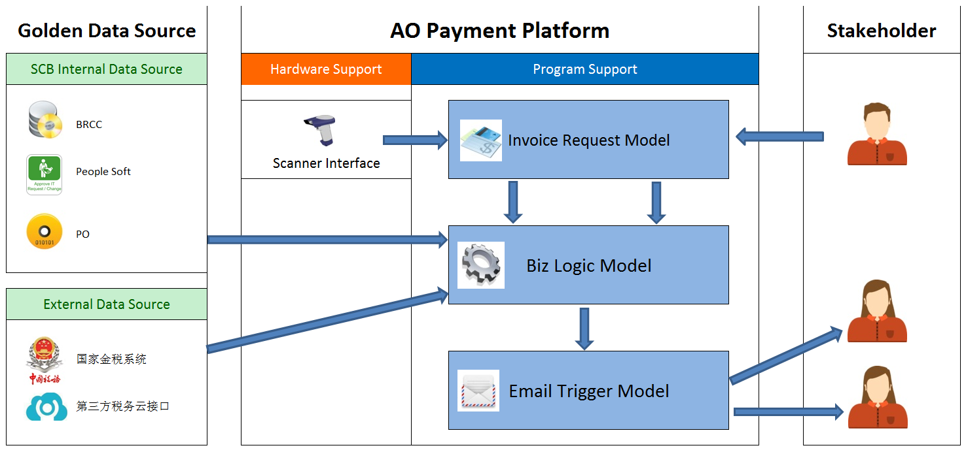

## Dependence (If has)

* Golden Data Source

## Technology Infrastructure

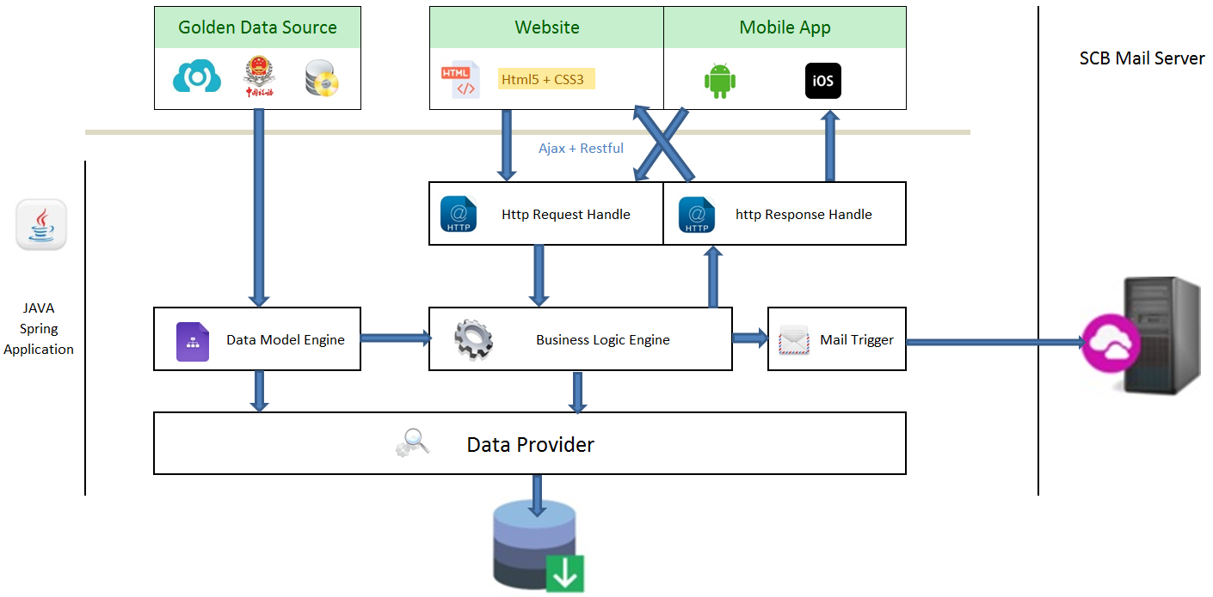

## Data Model / Data Flow (if has)

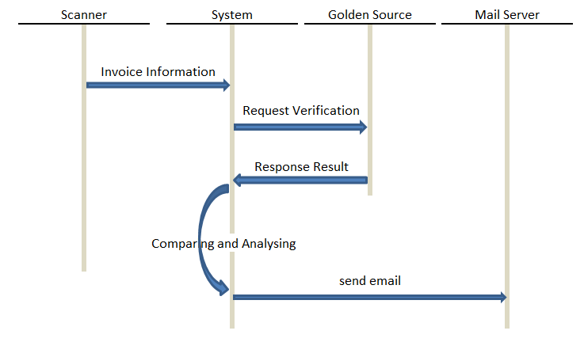

## Tools / Environment

## Development tools: IntelliJ, Android Studio and Xcode.

## Coding Language: Html5, CSS3, JAVA SDK, Android SDK and IOS SDK.

## Running Environment: Chrome, Linux and Mobile App.

## Hardware: Scanner.

## Important KPIs of Improvement

## Saving 20+hour man day per month.

* Saving $3000 per year.
* No need manual input, so reduce manual mistake from 3% to Zero.

The above estimation is only for AO payment process. But the solution is also suitable for other payment department, such as GBS China / Trade.

* Saving 119 hours per month for Trade payment process.

## Demonstration

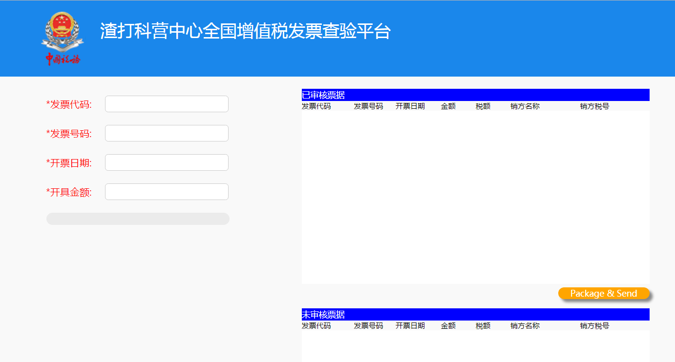

## Testing

*Provide testing evidence*

## Estimation

Give a high level estimation on delivery

# Deliverables

Deliverables

| # | Deliverable | Media |
| --- | --- | --- |
| 1 | PoC Document | Word |
| 2 | Source Code | Zip |
| 3 | PoC Demo | PPT/Video |
| 4 | Evidence for improvement (if any exists), results, logs etc | file |
|  |  |  |

**How to deliver the POC?**

We will share the details shortly; please keep following us on [Bridge](https://thebridge.zone1.scb.net/community/functions/global-ito/gbs/gbs-china/fintechathon-2017).

**For any questions please contact** **Liam, Li (1490627).**

# Team Structure

*(List the names of each individual occupying the role. Some roles can have the same person filling them.)*

Roles and Responsibilities

| Role | Name(s) + Bank Id | Core Responsibilities |
| --- | --- | --- |
| Team Leader | Victor Guo 1464202 | Technology |
| Team Member | Xia, TianAi 1441180 | Business Analyst |
|  |  |  |
|  |  |  |
|  |  |  |
|  |  |  |
|  |  |  |
|  |  |  |
|  |  |  |
|  |  |  |
|  |  |  |
|  |  |  |
|  |  |  |
|  |  |  |